Page 46 No 26

Program3.7b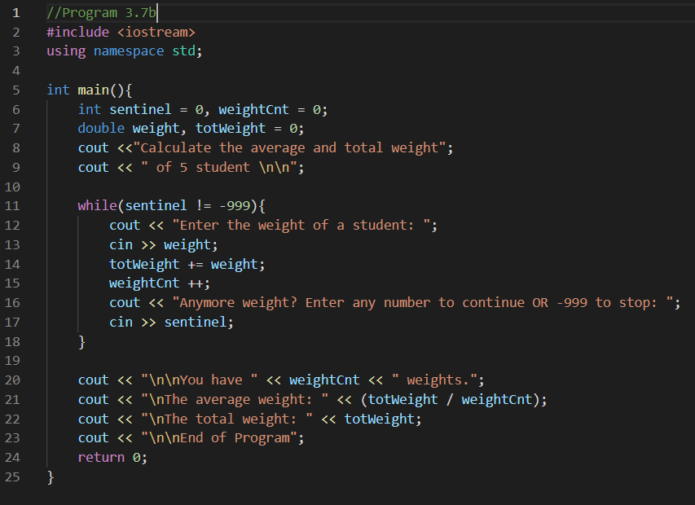  
Output:

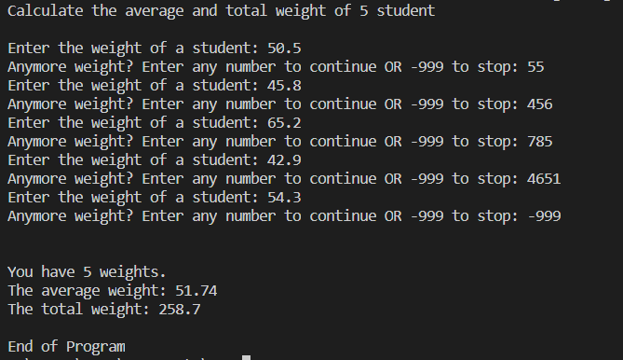

Output (Program3.7):

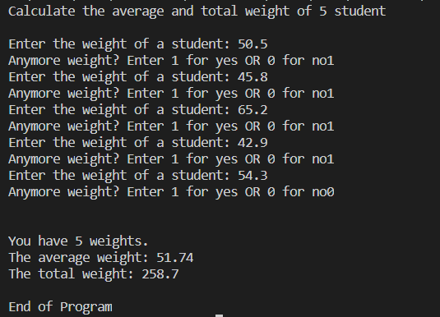

a) Sentinel control structure

b) Value of variable sentinel that will end the loop is -999.