

**UHMT1012: GRADUATE SUCCESS ATTRIBUTE**

**SESSION 2019/2020**

**ROADSIDE STALL INNOVATION**

**LEGO TRUCK**

**GROUP MEMBERS:**

|  |  |
| --- | --- |
| **NAME** | **MATRICS NO** |
| **MUHAMAD ADLI HANIS BIN ABDUL SHUKOR** | **A19EC0091** |
| **JACK LEE** | **A19EC0057** |
| **CHIN WEI XIANG** | **A19EC0187** |
| **NEEVASHINI A/P KUPPUSAMY** | **B17CS3020** |
| **R.NARENDRAN** | **A19EC0113** |
| **NUR MINHALINA BINTI ABDUL RAZAK** | **A19EC0135** |
| **SHAMEMA AFRUZA JOUTY** | **A19EC4028** |
| **ABIR BIN RAHMAN BHUIYAN** | **A19EC4025** |

**LECTURER’S NAME: DR. HAZINAH BINTI KUTTY MAMMI**

|  |  |  |
| --- | --- | --- |
| **NO** | **CONTENT** | **PAGES** |
| **1** | **INTRODUCTION** | 3 |
| **2** | **PROBLEMS AND ISSUES** | 4 |
| **3** | **THE SOLUTION IDEA** | 5 |
| **4** | **WORKING OF THE SOLUTION** | 5 |
| **5** | **A SIMPLE DISCUSSION OF THE SOLUTION** | 6 |
| **6** | **HOW IT WORKS IN COMMUNITY LIVING** | 6 |
| **7** | **CONCLUSION** | 7 |
| **8** | **APPENDIX** | 8 |

**1.0 INTRODUCTION**

The roadside business has been one of the common businesses in our country. It can often be seen either around the housing area or even in the city. Many of the roadside businesses sells various food and drinks that are delicious. However, there are still some issues and problems faced regarding the roadside businesses as the current way of the business is not perfect yet. The environment also should be in clean and good condition. This will have a bad impression on the stall if the drain outside was clogged with garbage and the corridor strewn with tissue papers. Therefore, our group decided to identify these problems and issues to create a way to solve these issues so that the roadside business can be conducted without any problems.

**2.0 PROBLEMS AND ISSUES**

**Cleanliness and Health Issues**

One of the most common issues faced by the roadside stalls is that the cleanliness is very difficult to take care of due to the food waste. The garbages are often being thrown around the area near the stalls. This causes the stall’s surroundings to be very dirty and the pests will grow around the area such as the rats, mosquitoes, and the lizards.

**Space Occupied**

The second issue is that the roadside stalls often occupied too much space. Just by judging from the tables and chairs, the stalls will occupy some part of the major road and it is very dangerous for both the drivers and the customers. Also, at the same time, too much space occupied means it will be very difficult for the stalls owners to tidy up and clean up each time they close their stalls.

**No Garbage Container**

Thirdly, the roadside stalls often worry about the garbage problems. There is always not enough place for them to keep the garbage, which causes their customers to litter around the area. Littering around the area will indirectly causes the surrounding of the stalls to become less comfortable and also will cause the stall owners to lose their customers.

**3.0 THE SOLUTION IDEA**

To solve the problems mentioned before, we have come up with an idea of a food truck but with some modifications. We decided to modify the food truck so that there will be a function to keep the surrounding of the stalls clean.

**4.0 WORKING OF THE SOLUTION**

Firstly, the food truck will have the folded table and folded chair attached to the side of the truck. This means that there only be minimum space required for the business to be conducted. Also, this will ease the seller to clean up and tidy up the things after business hour is over. Secondly, the truck will be equipped with a system called Self-Service Cleanup system (SSC). This is a system which can helps to clean up the customer’s waste using water conveyor machine. Used dishes is flow into the garbage container which consists of 2 nets. One is used to separate between dishes and water and the other one is to neutralize the water to be recycle back into the conveyor machine. There will be a hole at the other side of the table which will allow the customers to throw in their dishes and the food wastes. They will just have to open it up and then just put the dishes into it without having them to walk around and look for the garbage bins.

**5.0 A SIMPLE DISCUSSION OF THE SOLUTION**

As previously discussed, the problem of cleanliness often happens mostly because the customers are lazy to find the garbage bins to throw their rubbish. With the design of our Lego Truck, they will not have to walk around and instead they can just throw the rubbish using the SSC system. Besides that, this will also make the seller’s work easier as he can focus on preparing the food for the customer and provide better services to the customers. Furthermore, the folded chairs and the table will allow the seller to use less space to conduct his business. Less space occupied for a roadside business means more safety for both the customers and the road users.

**6.0 HOW IT WORKS IN COMMUNITY LIVING**

This food truck innovation can actually help people that come to eat at the food truck to maintain the cleanliness of the surrounding. Most people that come at the food truck to eat does not think about the cleanliness of the surrounding but with the help of "Lego Truck" can really keep the surrounding clean. After applying the solution, this will solve our problems in a sense that if everyone is aware then there is no one to make mistakes. It will take time to fully remove the problem but this process can remove the problem by root and it will make our society better.

**7.0 CONCLUSION**

There is no doubt if waste is disposed at the designated areas by the public, indirectly it will affect the appearance of a city yet even worst becoming breeding place for the pests that can spread several diseases like malaria, dengue, West Nile virus and many more to the citizens. However, there will be also required extra funds to hire a cleaner to clean-up the littered area. So, with the brilliant innovation “Lego Truck” which implement the Self-Service Clean (SSC) system which can solve customer’s littering rubbish problem, and it is easy to setup and convenient for the seller and the buyer. Lastly, the “Lego Truck” has the potential to become a standard to the roadside business because it has fulfilled all the important measures such as cleanliness, minimize space, trash disposal and many more.

**8.0 APPENDIX**

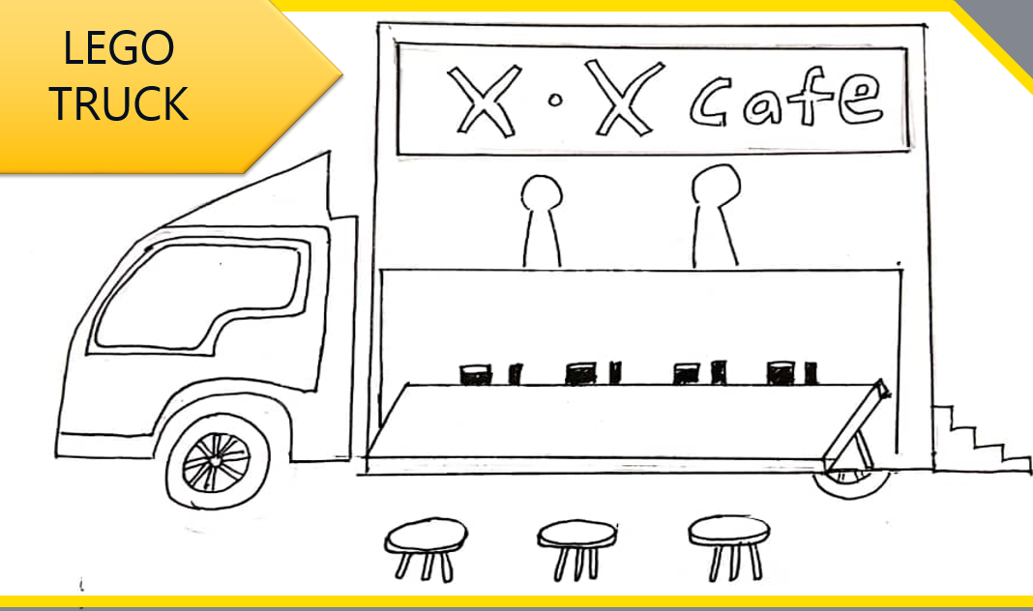

1. Basic design of the food truck

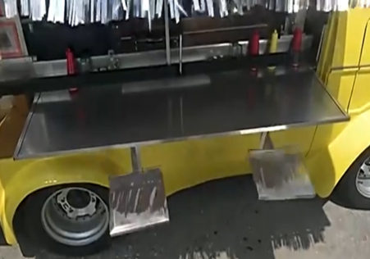

1. Basic concept about the table and chair

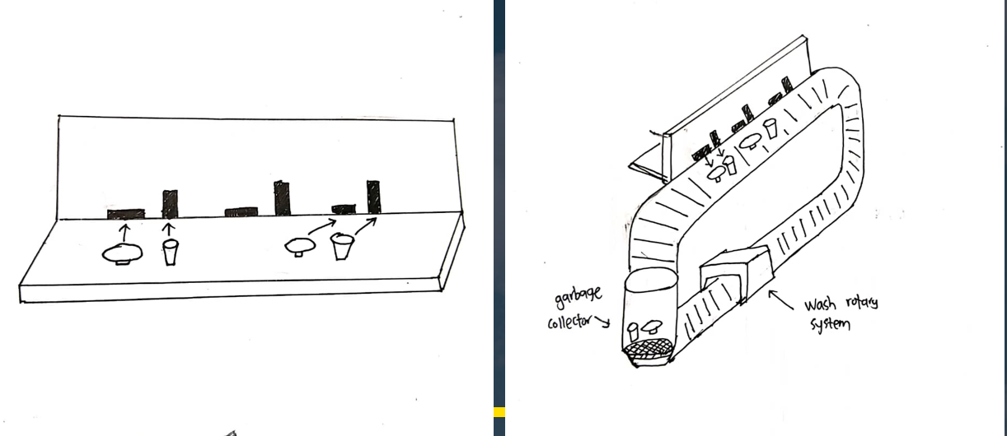

1. The SSC (Self-Service Cleaning) system