**INTRODUCTION**

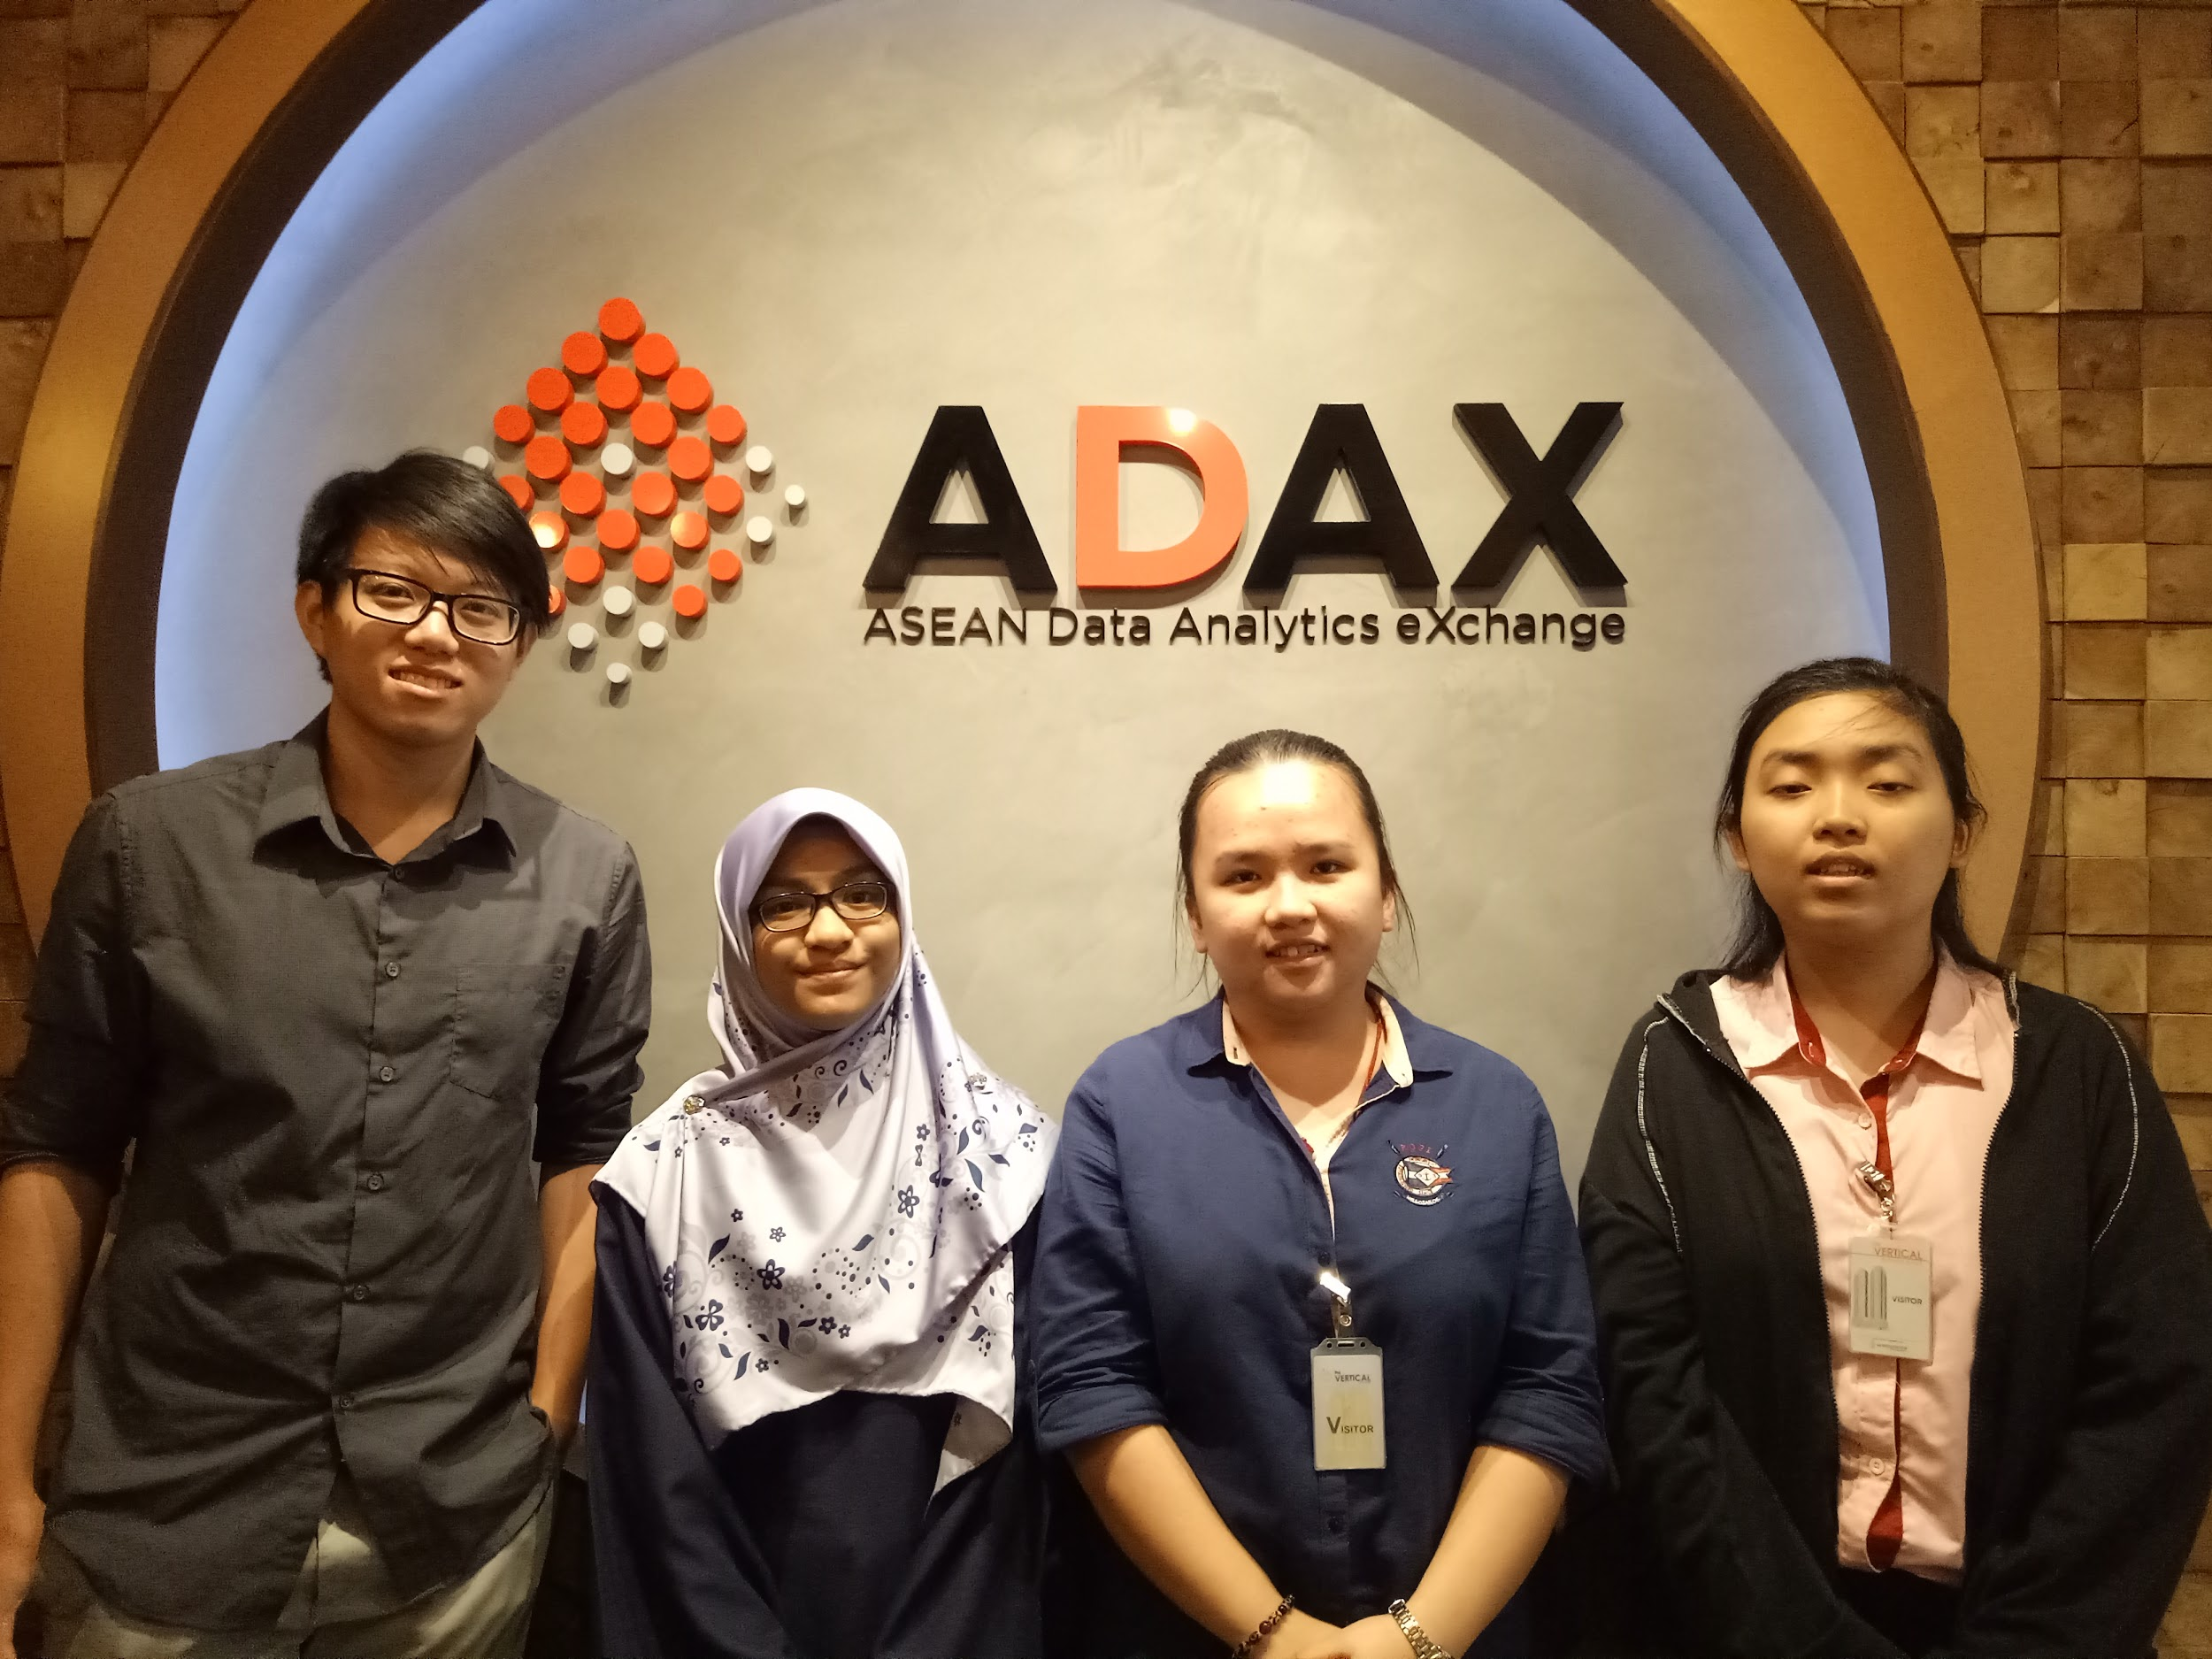

Picture 1

Picture 1 shows the group members for the ADAX report.

On 27.10.2018(Saturday), the department from the School of Computing organised an industrial visit for all the data engineering students and some of the software engineering students. The students were given a chance to visit ASEAN Data Analytics eXchange (ADAX) which located in Bangsar South, Kuala Lumpur. When the students arrived ADAX, they had their breakfast at ADAX. Before the students visited ADAX, they were given some briefings by four speakers, that were Mr. Mohammad Nazir, Mdm. Josephine, Mr Gan Chun How and Dr. Mark Chia to make them more understand about ADAX.

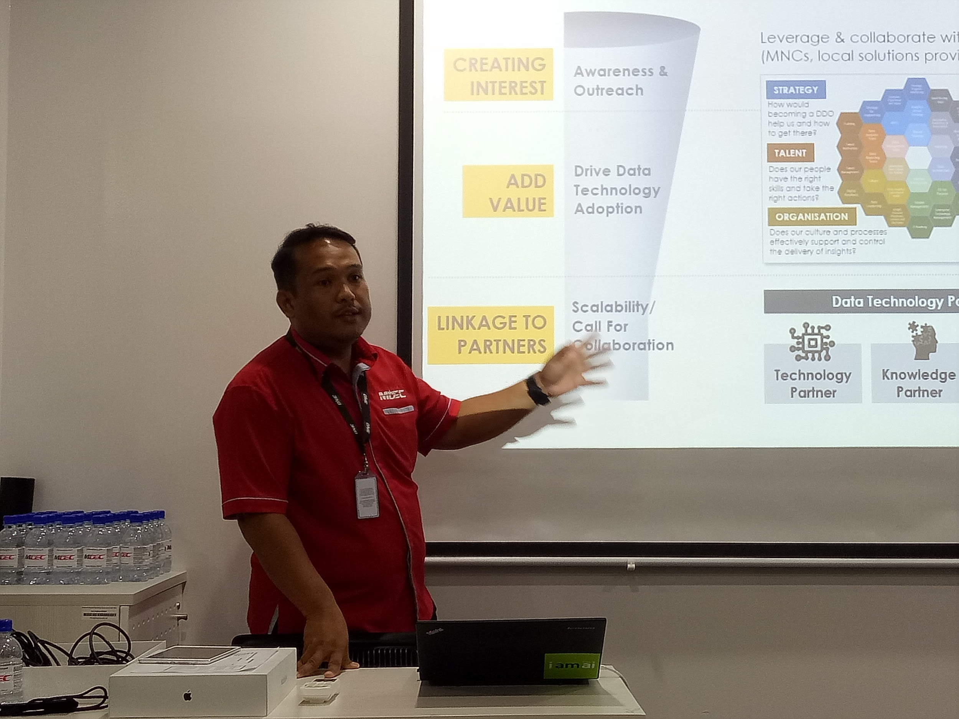

Picture 2

Picture 2 shows the photo of Mr.Mohammad Nazir during the briefing session.

Mr. Mohammad Nazir works as an officer who in charge of data science in ADAX. According to Mr. Mohammad Nazir, he explained that ADAX is an initiative by Malaysia Digital Economy Corporation (MDEC) which acts as a one-stop hub to pull the data technology ecosystem together to create solutions and adopt the technology. He also introduced us about the history of ADAX and also mentioned about the vision and mission of ADAX. He said that ADAX has already facilitated the development of nearly data professionals with the help of MDEC and ADAX has collaboration with some universities including University Malaya (UM), University Technology Malaysia (UTM), University Malaysia Sarawak (UNIMAS) and others. He mentioned that MDEC offered a programme named “ Datacamp For Classroom” to the universities’ students. The topics covered including R programming, Python programming, data visualization and others.

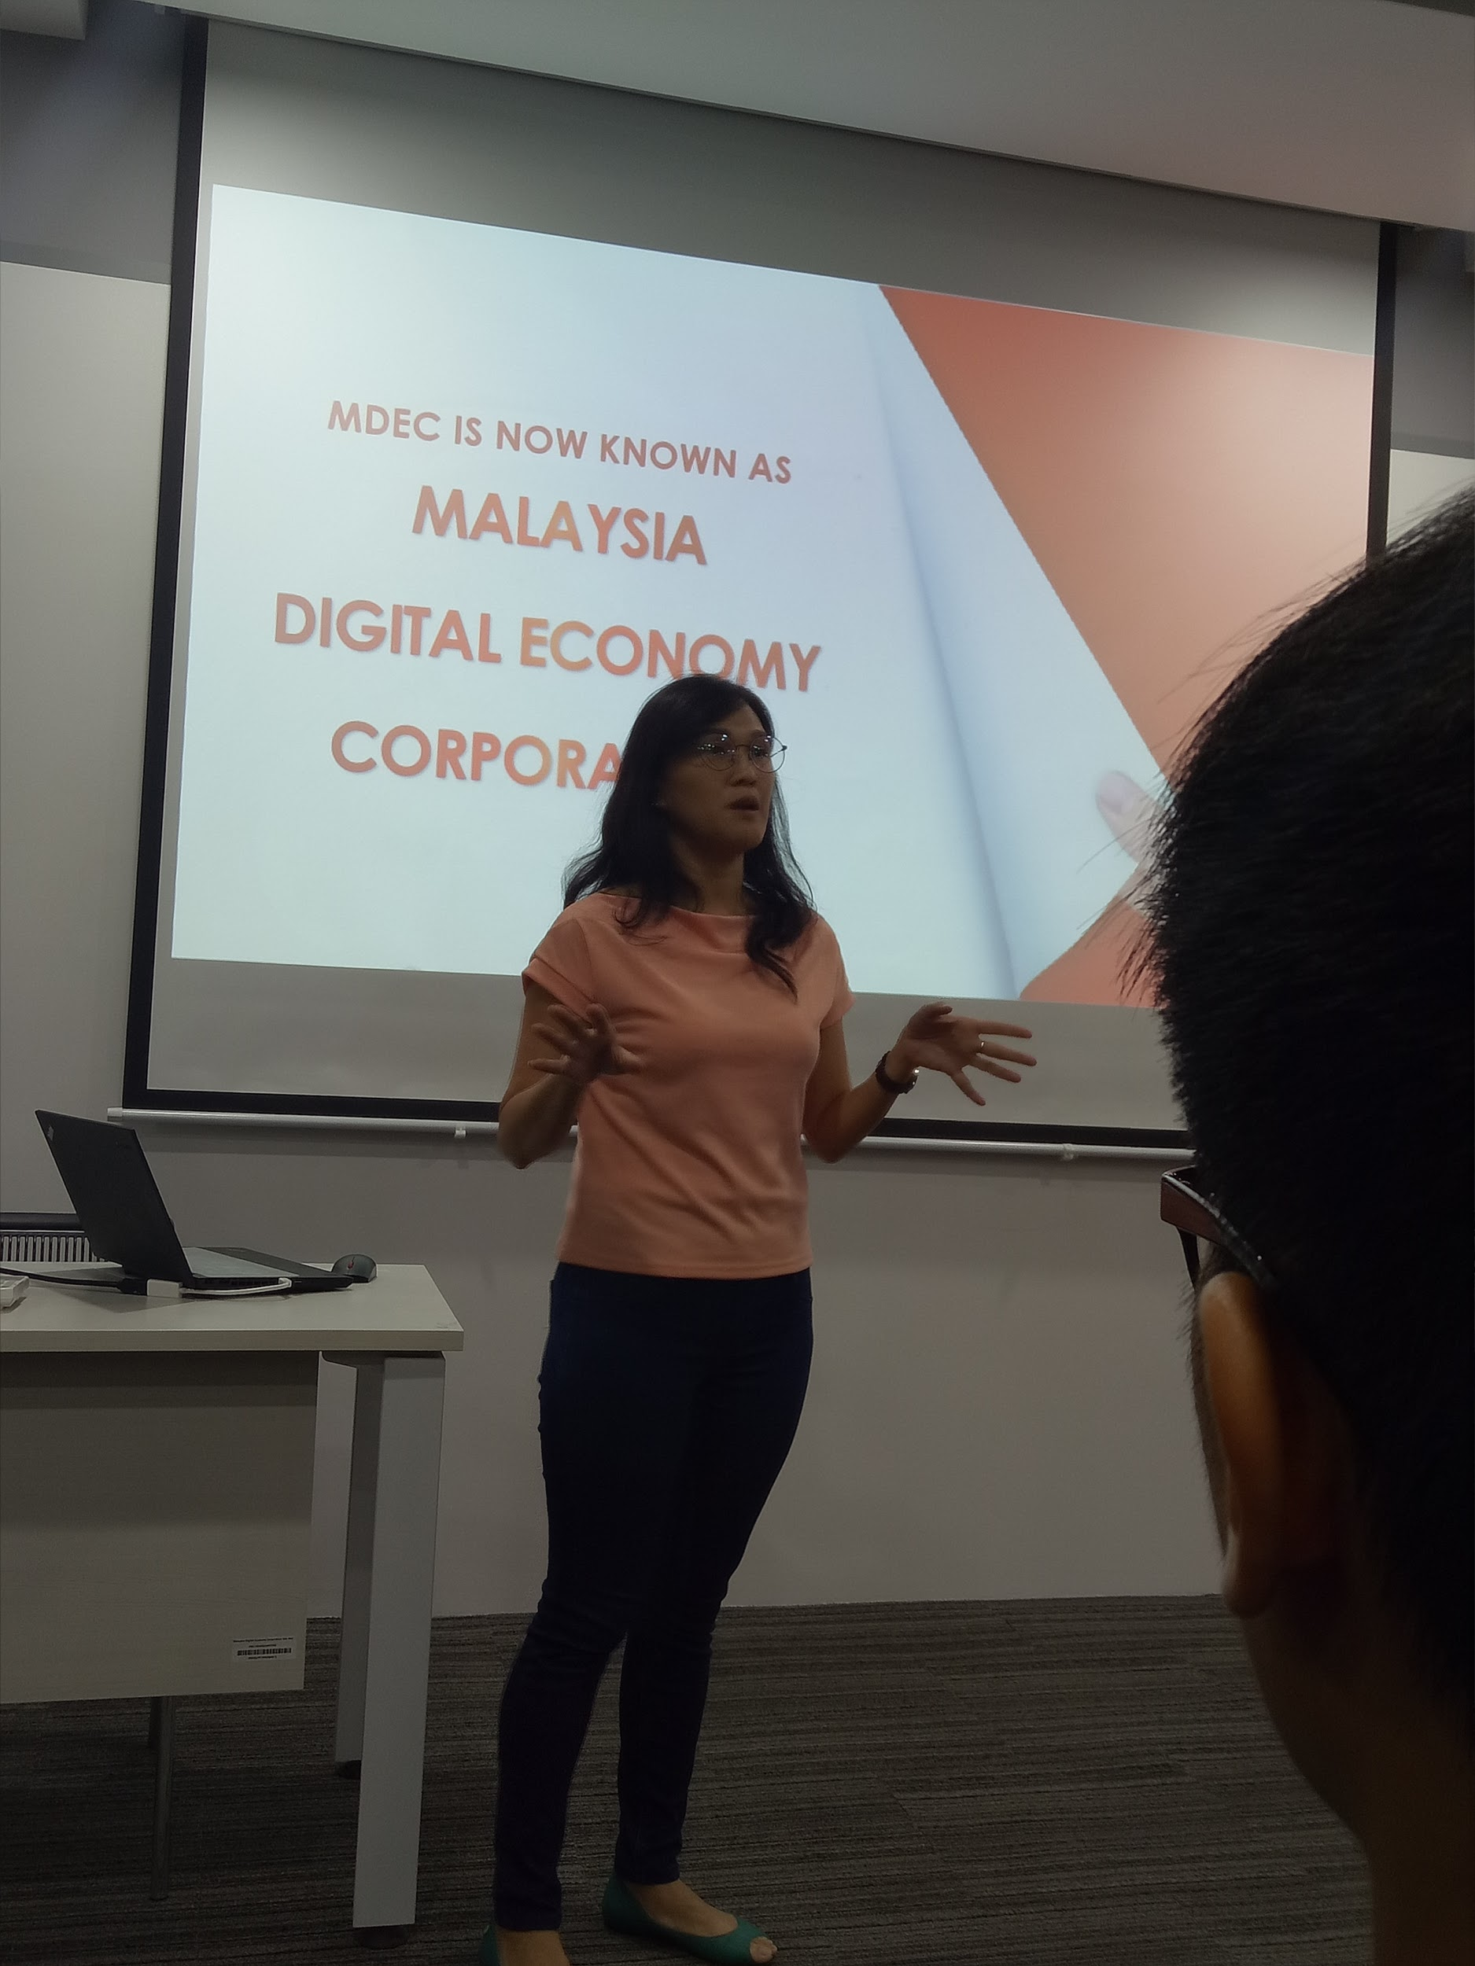

Picture 3

Picture 3 shows the photo of Mdm. Josephine during the briefing session.

Mdm. Josephine is also one of the officer who in charge of premier digital tech in ADAX. She explained to the students about the objectives of Premier Digital Tech IHL’s Ecosystem and also benefits that can we get through the Premier Digital Tech programme. Mdm. Josephine also mentioned that in 2017, 8 Premier Digital Tech Universities and 5 Preferred Digital Tech Polytechnics were recognized as top institutions of higher learnings that can deliver first-class theoretical and practical training by Ministry of Higher Education (MOHE) and MDEC. UTM is one of the premier digital tech universities which are recognized and awarded by MOHE and MDEC.

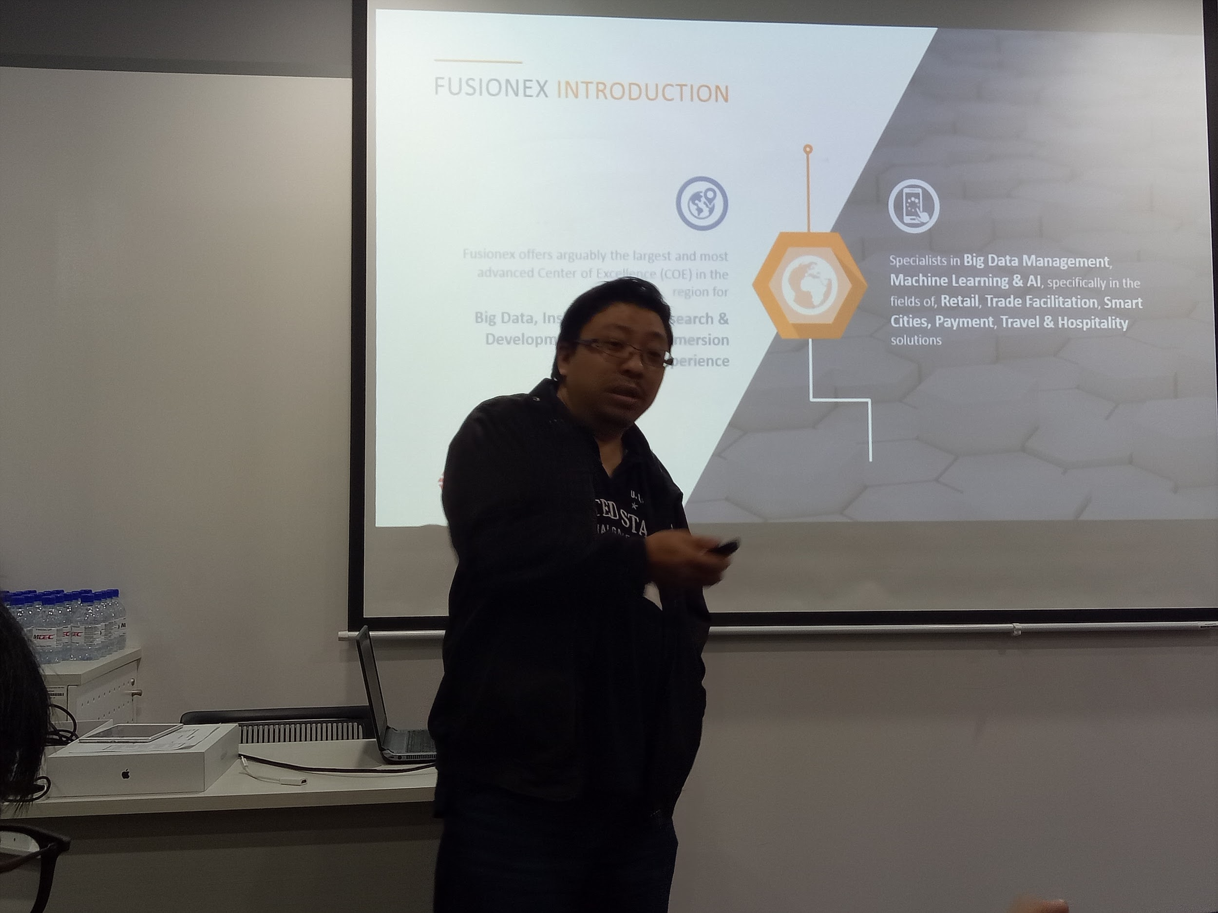

Picture 4

Picture 4 shows the photo of Mr. Gan Chun How during the briefing session.

Mr. Gan Chun How works as a solution architect in FUSIONEX. He briefed us about the introduction of FUSIONEX. He explained that FUSIONEX offers the largest and the most advanced Centre of Excellence (COE) in the region for big data, insights-driven research and development as well as immersion experience. In other words, FUSIONEX is a one-stop global platform and solutions provider as it has more than 120 data scientists, data analysts and AI researchers.

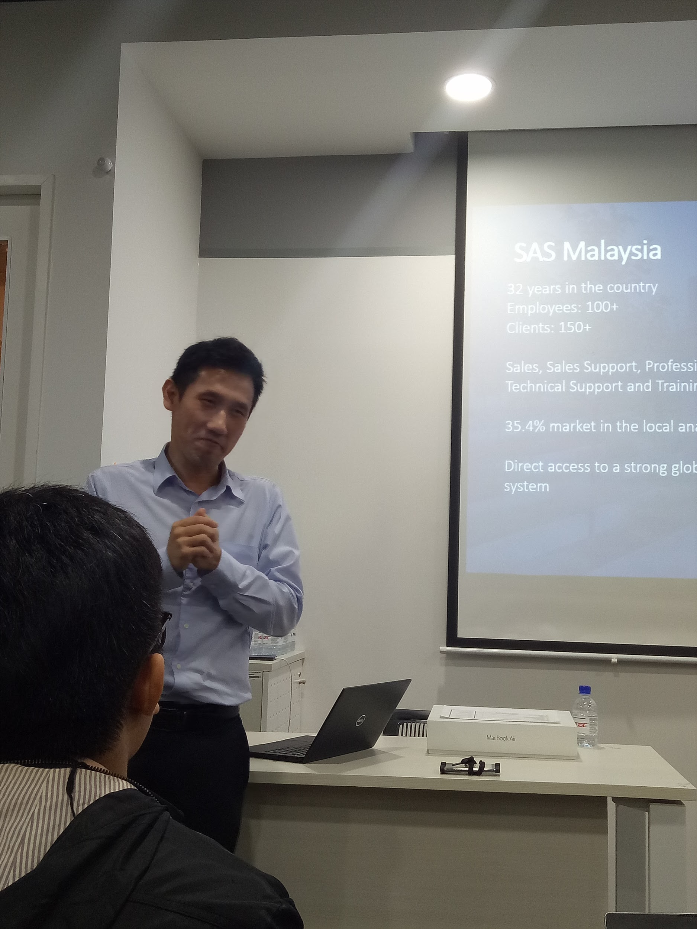

Picture 5

Picture 5 shows the photo of Dr Mark Chia during the briefing session.

Lastly, Dr Mark Chia works as a technician in Statistical Analysis Systems (SAS) Malaysia. Dr Mark ever studied in Singapore, Australia and United Kingdom and he is pro in the field of electrical engineering, maths and computer science and also semiconductor in manufacturing. He introduced SAS Malaysia to the students. He mentioned that in 2017, analysts ranked SAS a leader or leader equivalent in more than 30 reports. According to Dr Mark, there are a few banks, government sectors, commercial sectors and public universities in Malaysia are the customers of SAS including Public Bank, Malaysia Deposit Insurance Corporation (PIDM), Celcom, UTM and others.

After the briefing session, the person-in-charge brought the students to have a visit ADAX including the office, meeting rooms and some facilities in ADAX. The students also enjoyed the scenery of Kuala Lumpur through the window of ADAX. Before the students left ADAX, they also had their lunch at there.

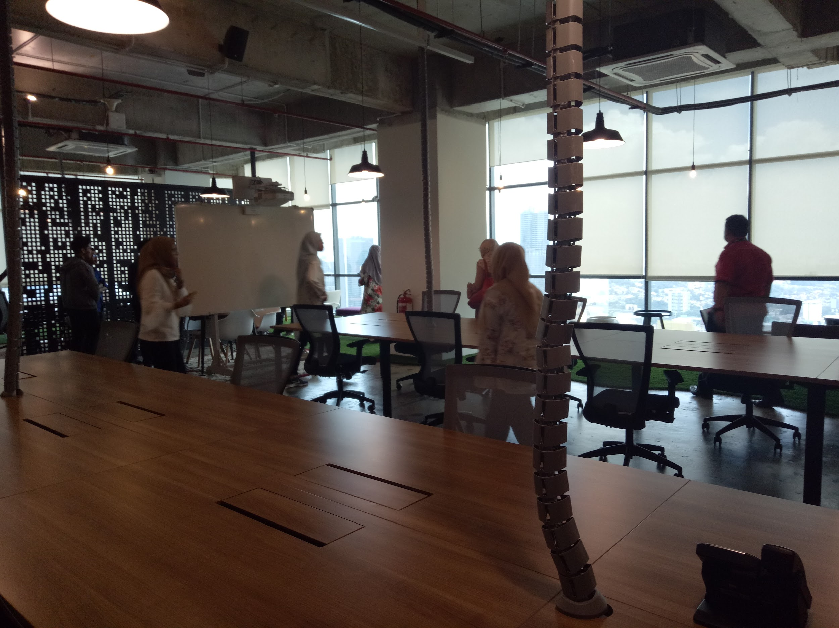

Picture 6

Picture 6 shows the meeting room of ADAX.

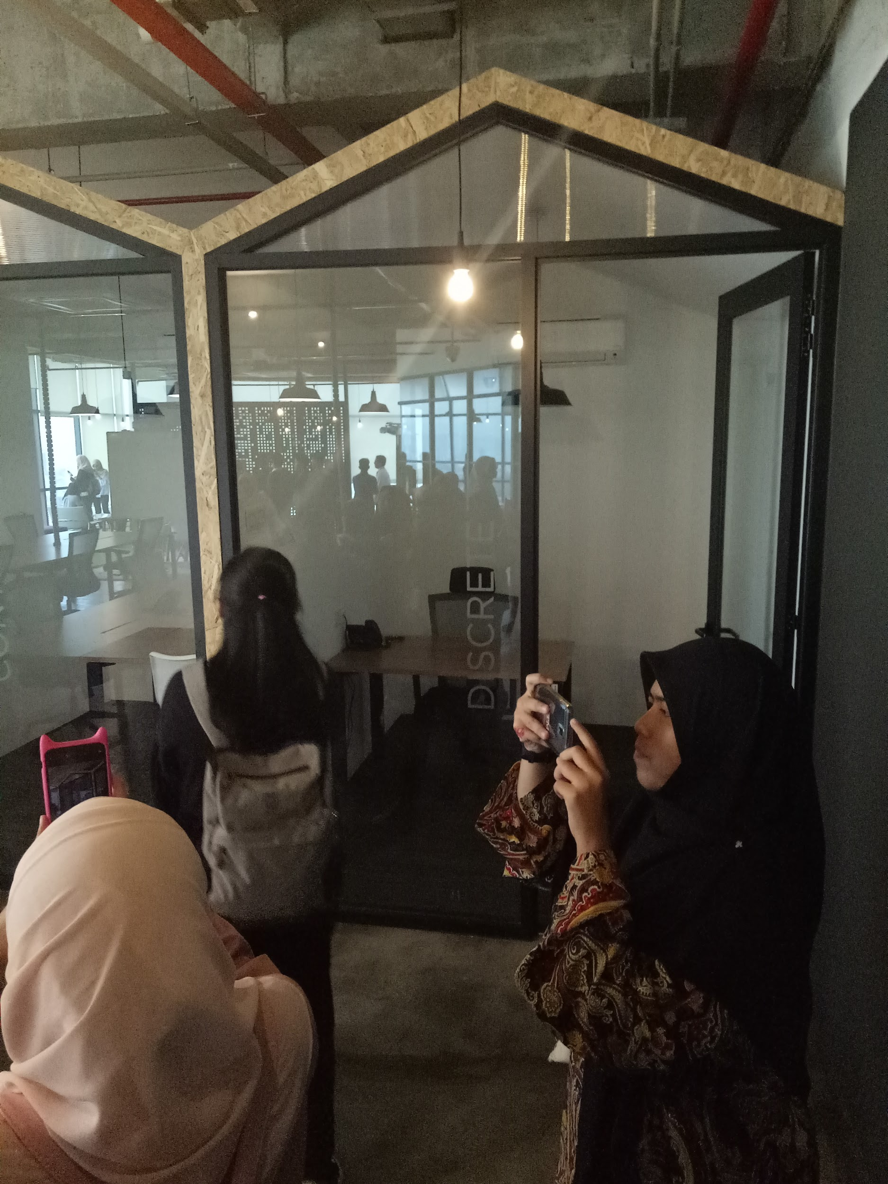

Picture 7

Picture 7 shows the personal office of ADAX.

ADAX is an organisation focus on development of data science graduates. After the visit, I notice there are few jobs inside the field of data science. Therefore, I do some research regarding the jobs and I realise that the different of the job is quite crucial because there are differences between the field. It is important to understand the requirement and job specification of the field in data science.

First of all, data engineer is in charge of the data pipelines and manage the database of a company. Data engineer must make sure that the data is organised. The database must work efficiently so that it is can ease the management of the database. Data engineer must master the SQL and learn some software like Apache Spark and Hadoop.

Next, the second job would be data analyst. Data analyst would translate data into actionable business insights. Data visualization is the main task for a data analyst. Data analyst will work together with technical team, marketing team and business strategy team. Data analyst will analyse the prototype and design the business modal. Data analyst will come out with a plan including the demand, marketing and business value. Data analyst is important so that the data science team would not waste their valuable time to solve problem that do not have any business value. Data analyst will generate solid income to a company. Data analyst have to learn Excel, SQL and Tableau.

Furthermore, data scientist is responsible for cleaning and exploring the database. Data scientist also convert datasets into digestible conclusion. Prototype will be tested and optimized by them before implementation. Data scientist will work with large amount of data every day. Therefore, data scientist will require to learn SQL, Python, TensorFlow and Flask.

In addition, machine learning engineer will build, optimize and deploy machine learning prototype to production. Machine learning engineer will implement suitable machine learning algorithms. The prototype is mainly regarding artificial intelligence so prototype will be able to collect and analyse data and work efficiently in artificial intelligence. Python, scikit-learn, SQL or MongoDB are required to learn.

Lastly, machine learning researcher is a job focus on doing research. Machine learning researcher will solve challenging problems in data science and deep learning. They will improve the accuracy of the prototype by the database. When there is a large database, machine learning researcher can analyse the data to convert it into possible outcomes that will occur according to the inputs or surroundings and thus increase the accuracy of the prototype. The larger the database, the higher the accuracy of the prototype. Therefore, machine learning researcher need to learn SQL, Python and TensorFlow.

In a nutshell, there are many job in the data science field and the requirement and job specification is different as well. So, make a wise choice and decide which job we desire to work with before learning a specific programming language or software skill. It is important to bear in mind that we must decide the job path so that we have a clear target to aim for the job. Even though there are many job in the field, but I may vary according to the company. A small scale or early-stage startup company might enlarge the job scope for a certain position. Therefore, it is encourage to learn as much as possible to strengthen our skill and increase our market value.

**Detailed description**

ASEAN Data Analytics eXchange ( ADAX ) is an organization initiated by Malaysia Digital Economy Corporation ( MDEC ) to develop a data technology ecosystem that can catalyse the development of talent, promotion of technology and proliferation of adoption. ADAX is a platform to build a critical mass of talent pool in the Big Data Analytics category while developing and cultivating the collaboration between business, startup, academia and professional so that Data Analytics will become the main stream of business innovation and decision making.

ADAX has a mission to nurture 20,000 data professionals by 2020. Therefore, ADAX cooperate with the local university such as University Teknologi Malaysia ( UTM ) to facilitate more data professionals. Thus, undergraduate and postgraduate courses are customized to generate more data professionals. Besides, ADAX is playing a vital role in developing talent. ADAX cooperate with private sector, industry organisations and Non-Government Organisation ( NGO ) to hold events, workshops, hackathons or meetups. ADAX proliferates adoption with preparing a go-to place for undergraduate and postgraduate. The demand of data professional currently quite high for data-driven enterprise, so ADAX develops partnership program such as Technology Partner, Knowledge Partner, Training Partner and Community Partner. The program is carried out stage by stage with creating interest among community, adding value towards data technology and linking partners in collaboration.

According to the news in Business Insider Malaysia, ADAX had managed to achieve a development of data professionals. Within a year, ADAX successfully promoted 1,800 individuals from 298 companies across 19 industries. There are three types of services provided by ADAX such as Innovation Lab, Talent Development and Starts-ups. Innovation Lab is set up to experience and test the analytics solution before implementation is being made. Innovation Lab is using sandbox concept where a company can modify and test run the analytics solution and keep improving to reach perfection. Talent Development is about organizing courses, technical classes or hackathon. Through these events, ADAX can encourage the learning of big data and promote the importance of data science to community. Lastly, Starts-ups is an activity to innovate more analytics products and mentors from different industries and fields can scout for potential product. The potential product will be funded and continue to develop it until it can be implemented. Starts-ups can build networks as part of ADAX platform and cooperate with the company that interested in the products.

**REFLECTION**

Through this industrial visit, we have a chance to get exposure to the real workstations which related to the field of data engineering. This can make us more understand about this field. Besides, we also obtain the opportunity to get the senior experts to explain about the company functions. From this explanation, we can understand end-to-end at all levels in a company.

Furthermore, we have a face-to-face session with the experts of the organization through this industrial visit. This allows us to ask questions regarding the field of data engineering including our career paths in the future. We also have the chance to expose some interesting facts and the latest technologies from the briefing sessions.

In short, we can learn new knowledge practically in a real-time environment as we can have some interactions with the experience workers. Thus, we obtain a lot of benefits from this industrial visit.

In the era of modern technologies, everything is related to technologies. Nowadays, the big data are complex and massive that the traditional data processing application is unable to deal with them. Thus, as a student of data engineering, we need to try our best to improve ourselves in order to create and design a new technology to deal with the big data in the future.

In order to improve our potential in the industry, we should always keep our technical skills up to date. For example, we should not only learn some of the common programming languages such as C++, Python and C language, but we can learn the latest programming languages from the source of Internet. Because of the fast-pace change in our world, we should always keep learning even though we graduated from the universities. Lifelong learning will enable us remain current about the cutting-edge technologies which are relevant in the industry.

Besides, we also need to learn some soft skills to improve our potential in the industry. As an example, communication is a critical soft skill. As a data engineer, we must able to communicate with the clients to describe the data that we processed and explain to them about the analysis of the data. Clear and effective communication skill is required for the purpose of conveying the complex technical information to the non-technical professionals.

Lastly, we should always being creative in order to success in the industry. All data engineers are described as “creative problem-solvers” as they design, create and innovate the programme. For us, creativity means we are able to make something out of nothing. A successful data engineer has the sense of creativity which will make him to find the most elegant solutions to the challenges that he faced.