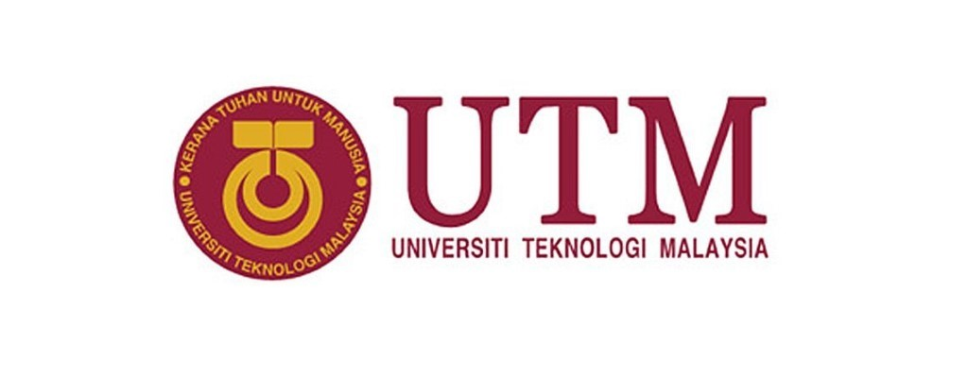
GROUP MEMBERS:
NAME | MATRIC NO
LEE SZE YUAN | A19EC0068
MUHAMMAD IRFAN DANIEL BIN ABD KARIM | A19EC0197
MOHAMMAD SAFWAN BIN AZHAR | A19EC0191

TOPIC :VISIT TO PETRONAS DIGITAL COLLABORATION CENTRE
NAME OF LECTURER: Dr Aryati Bakri
SUBJECT : SCSP 1513-02 TECHNOLOGY AND INFORMATION SYSTEM

Table of Contents
INTRODUCTION 1
DETAILED DESCRIPTION 4
1.0 organization structure, services, achievements, etc 4
2.0 Group Technical Data (GTD) in PETRONAS 6
2.1 Surface Team 9
2.2 Sub-surface Team 10
REFLECTION 12
1. Lee Sze Yuan 12
2. Muhammad Irfan 14
3. Mohammad Safwan 15
CONCLUSION 16
REFERENCE 17

INTRODUCTION
On 27th September 2019, department of School of Computing, University Of Technology, Malaysia has held an industrial visit which Led by our lecturer, Dr. Aryati Bakri to the PETRONAS KLCC for all Data Engineering student. 36 out of 40 students in Data Engineering Class had taken part in this industrial visit. This visit provides a chance for students to learn organisation structure, achievements, services of PETRONAS and also learn how data is changing today’s PETRONAS. Besides, students are also given a chance to visit and observe the working environment of PETRONAS and have an engagement session with UTM students who are currently doing their internship in PETRONAS.
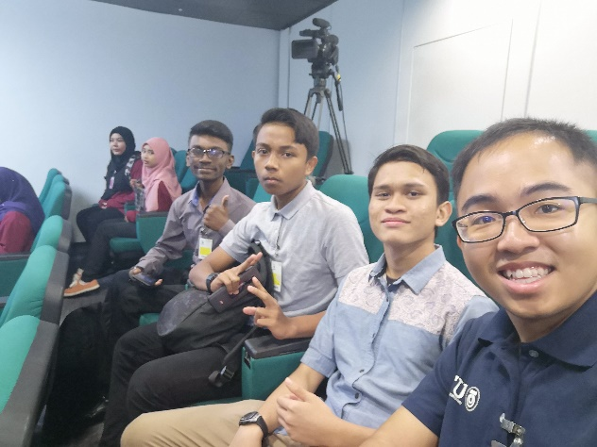
Figure 1.1: Data Engineering Students in PDCC Viz 2
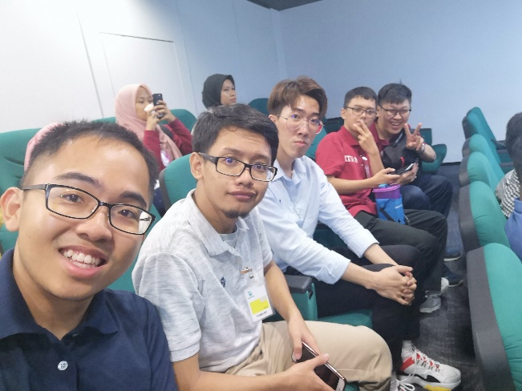
Figure 1.2: Data Engineering Students in PDCC Viz 2
On that day, about 8 a.m., our group had arrived at the lobby of KLCC. The person in charge welcomed us and gave us a simple explaining of tentative of that day. As shown in figure 1.1 and 1.2, she led us to venue of the talk, PETRONAS Digital Collaboration Centre (PDCC) Viz 2. After the students had a small refreshment, they were being seated, then the talk began.
Focus of this talk is to explain the basic organisation structure of PETRONAS and explain Group Technical Data (GTD) in detail. At the beginning of the talk, the speaker, Mrs. Atiqah gave us a safety briefing and introduction to the team which organised this talk. After that, the she played a video that give us a clear idea about what is PDCC and its task in Petronas. From the video, she further explained how PDCC contributes to PETRONAS.
Then, she started to explain the basic organisation structure of PETRONAS with the help of MICROSOFT POWERPOINT slideshow. So, we learned that how Group Technical Data (GTD) cooperating with others PETRONAS DEPARTMENTS. Then, based on the focus of the talk, she further explained in detail about the GTD is helping PETRONAS become more data-driven. Next, another video was played to let us know GTD’s daily tasks , their achievements and current challenges. After that, the speaker passed her mic to the GTD personnel. GTD personnel ,Mr. Akmal and Mrs. Iqah gave us further clarification about the GTD and their responsibility. We learned that GTD is separated into 2 main teams, one is Surface Team and another one is Sub-surface Team. Surface Team deal with data that produce in daily basis, while sub-surface deal with data that are recorded and stored in the past.
Coming up next, there is a Q&A session. We asked the GTD personnel questions about Artificial Intelligence, Big data, Cybersecurity, Cloud. They also answered all our questions with patience. For example, one of us asked about PETRONAS prefer to stored their data in server or Cloud. Then, the speaker told us that almost 98 % of PETRONAS’ s data is stored in server. Although it might sound old-fashioned and space-consuming, but they explained that storing data in Cloud storage will charge PETRONAS every time they upload their data to Cloud. This choice of action will increase the cost of PETRONAS’s business and this is unfavourable. So, they choose to store data in their own server.
Then, after the talk, the person in charge brought us to tower 3 office to meet our seniors who are doing internship there and have an engagement with them. Like what is shown
in the Figure 1.3, during the meeting, our seniors shared a lot of cool experience of working in PETRONAS. They talked about how the work here improved them and what is the task/projects they are dealing with now. They answered our questions and also gave us a lot of advices and encouragement.
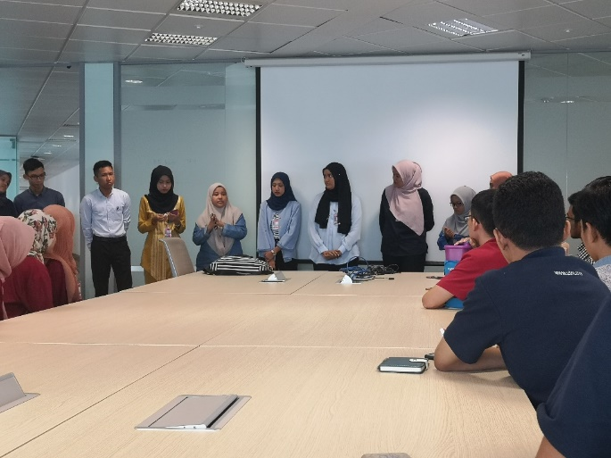

Figure 1.3: UTM: students meet seniors who are doing internships at PETRONAS

Finally, the person in charge took us to have a stroll at PETRONAS GTD office. This is for us to have a close look at the working environment and what is the daily tasks of the staff.

DETAILED DESCRIPTION

1.0 organization structure, services, achievements, etc
From the explanation of the Mrs. Atiqah of the talk, we learned that there are several departments in PETRONAS. From figure 1.4, we can see that there are “Upstream”, “Downstream” , “Geo Gas and New Energy”, “Petronas Digital Collaboration Centre” and “Project Delivery & Technology”
Upstream unit is responsible for exploration. Their main task is to find out new petrol sources. Then, they develop the resources so that they can deliver long term value to all their stakeholders. They have these oil and gas resources both in Malaysia and abroad. (PETRONAS GLOBAL, 2019)
While Downstream unit’s task is mainly about refining and trading. This is a strategic role in PETRONAS because they refine the raw petrol into high quality, value added products. In other words, they are enhancing the value of PETRONAS’s petroleum resources. Then, they sell and trade their product. (DOWNSTREAM | PETRONAS, 2019)
Last but not least, Geo Gas and New Energy unit is in charge of research and technology. From the speaker’s sharing, they keep on working on new technology or method to process the oil and gas in a more efficient and also environment-friendly way. While they also determined to find new sources of renewable and sustainable energy. This is one of the efforts of PETRONAS in respond to global environment crisis.
Then after explaining Upstream, Downstream and Geo Gas and New Energy, she told us that apart from their main business, PETRONAS have also form various departments that help and sustain PETRONAS’s business. For example, Project Delivery & Technology (PD&T) and PETRONAS Digital Collaboration Centre (PDCC). Main focus of these 2 units are to maintain PETRONAS business sustainability. For example, PD&T which are governed under Malaysia PETRONAS Management (MPM) is a department leading research and technology. (PETRONAS MALAYSIA PETROLEUM MANAGEMENT, 2019) They are like internet consultant of PETRONAS especially for Upstream and Downstream units. They serve and give advice to others PETRONAS department. They are accountable for developing, plan and delivery technical method. (PETRONAS PD&T, 2019)
Then, under PD&T, there is a group which specialise in Data Engineering and Science field. It is the Group Technical Data (GTD). They make use of data by “dig out” all the valuable information from data. Then, they provide the valuable information to others PETRONAS unit. These information will help them in various aspects. Their work has made a lot of contributions in PETRONAS’s business.

Figure 1.4: Organisation Structure of PETRONAS

2.0 Group Technical Data (GTD) in PETRONAS
At first, Mrs. Atiqah gave us a simple introduction to GTD. It established since 1974. They are governed under PETRONAS Project Delivery and Technology (PD&T). During that time, they only do data management and assist upstream, downstream units (PETRONAS ANNUAL REPORT 2017, 2017). For instance, whenever Upstream or Downstream Unit need data as reference, GTD will find out the correct data for them to use and refer to. However, since 2016, they had changed their direction of focus. From her explanation, we learned that they started to looking deep into the hidden potential value of the data. They start to think about “what is the value of Data”, “what can we obtain from data”, “what will change if we fully utilise these data” and etc. Those data they are dealing with are being recorded and stored in PETRONAS since the founding of PETRONAS. Their goal is to use these data to help PETRONAS’s business by turning PETRONAS into a data driven organisation.
Next, she explained to us what is GTD. They are custodian of Petronas Technical data (PTD). GTD composed of people from various background. As shown in Figure 1.5, 53% come from engineering background, 29% come from IT background and 18% come from Accounting Background. Members of GTD have access to all technical data. This allow them to govern and steer the data for a better new standard. They are also able to guard and safekeep data. Guarding and safekeeping is to minimise risk of loss of things like core sample, project data, engineering designs and etc. For example, if a project of PETRONAS has made a fault which may bring loss to their business, GTD will immediately find out the previous suitable data to analyse and to form a solution. They sort their technical data by scientific disciple like geoscience, project and etc. Besides, they use data to prove the reliability of business. They also provide services like data services and knowledge management in PETRONAS. The key achievement of GTD in 2018 is Integrated Data Governance (IDGovernance) (PETRONAS ANNUAL REPORT 2017, 2017)

Figure 1.5: Percentage of Members in GTD according to their background

Then, to fill our curious about what is technical data and how it helps PETRONAS They explained to us that through analytics, we can obtain various useful information and knowledge. Data is unprocessed form of Information or Knowledge. After the correct procedure (like data cleaning), we can then obtain the knowledge hidden inside it. Then, GTD can provide these knowledge to other PETRONAS units through knowledge management. This let PETRONAS gain business insight and succeed in their business. So, the more data PETRONAS has, PETRONAS can achieve more in their business. Knowledge derived from data can facilitate operation, decision, board level, management and business, because through data, PETRONAS can make accurate decision. (Big Data Oils The Futue of Oil&Gas, 2017) For example, before PETRONAS going to bid for a foreign field, PETRONAS will buy data and analysed first. Through analysis, they gain all the details like advantage and disadvantages of the foreign field. Then, they will decide to bid for it or not. (Predicting"sweet spot", 2016)
GTD don’t make profit for PETRONAS, but contribute to it. For example, in the past few years, the useful information gained from data that delivered by GTD already worth RM 5.3 billion and has helped the PETRONAS’ s business. Then, they estimated currently, they have more than 70 petabytes of data. These data worth Rm 80 billion to PETRONAS. (PETRONAS GTD , 2019)

As shown in figure 1.6, GTD is separated into 2 main team. One is Surface team, another one is Subsurface team.

Figure 1.6: Group Structure of GTD

2.1 Surface Team
From here, GTD Surface Team Personnel, Mr. Akmal explained to us that Surface Team deal with data that produced by whole PETRONAS business on daily basis. They are driven by data that already have in PETRONAS. They are in charge of daily data analytics and finding. They use ETL and SQL knowledge for data structure to build a data pipeline. This data pipeline is to ensure data flow to data delivery. Besides, through surface team personnel sharing, we learned that data preparation takes much more time (70%) than data analytics (30%). So, they will spend most of their time to carry out the pre-data operation which include data capturing, data indexing, data loading, data preparation and data delivery, then they will do the data analytics and Techno forecasting. Besides, they sort data according to discipline like Well, HSE, Production Ops, ASSET Integrity, Project and Data Delivery. (PETRONAS GTD , 2019)

2.2 Sub-surface Team
Then, GTD Sub-surface Team personnel, Mrs. Iqah explained to us that compared to Surface Team, they have an even more challenging task. Normally, they have to deal with data that produced by monthly basis. their task is to make sure them being recorded and prioritised to online. Now, they have a total of 40 petabytes of data waiting them to deal with and there is only 10% of data are online and ready to be used. (PETRONAS GTD , 2019) Besides, they have to record these data in format required. Some of the data even come from 1970s. So, this make their task become more challenging. Besides, they will do test to see which part of data should be deal with first. This is to minimise loss and maximise profits. (Predicting"sweet spot", 2016)
Finally, the speaker ended their talk by sharing with us the main goal and challenges that GTD is facing now. The current goal of GTD is to turn Petronas into a more data driven organisation. But now they have various challenges. Like I shown in Figure 1.7, their AI technology is still not mature enough, they are also lack of adequate talent and good sensors technology to capture data. Sub surface Team don’t have enough data analytics tool, Surface Team trying to introduce machine learning into their task, so they can bring automation. So, they need more fresh graduates to help them brainstorm solutions and use pattern-based analytics.

Figure 1.7: Challenges faced by GTD

REFLECTION

Lee Sze Yuan
Through this visit to PDCC, I have learned a lot of things. First, the greatest impact that it brings to me is realising how useful data. Before the visit, I always think that Data and AI can only have relation with IT and Computer Science related industries/companies like Google, Intel, etc. I never expect it is also related to oil and gas industry like PETRONAS. This trip has truly opened my mind. I realise that data can be really termed “all- inclusive”. Data can be any in any form and have various usage. Besides, I always don’t understand how data/statistic can affect our future. But now, I learned that DATA = KNOWLEDGE, INFORMATION, INSIGHT. The more data we have, the more we know about the past and also the future. In my view, data is the record of everything happens in every second. For me, data is like a person’ s life experience, the more experienced we are, the less mistake we make and the more accurate we are in making the right decision. For example, PETRONAS use geoscience data to see whether a field is potential/ suitable for their business goal or not. This visit has also made me more interested to data science/ engineering and determined to my study. Because I learned that data scientist/ engineer can also contribute to the society/ world just like scientist/ engineer of other fields too.
Previously, I only think of getting a 4 flat in my study, then it will be enough for me to get a job as data engineer. I realise it is a big NO! I realized this is not enough to achieve my goal or to get me to where I want. I have to put more effort in other things like my E-portfolio, personal project, hackathon and etc. These are the things that can help me to achieve my goal. While, this visit also makes me realise my weakness, the things I am lacking of if I want to become a professional data engineer. For example, I realized my knowledge about IT and Computer Science is really poor. For example, I found that my understanding about Cloud and AI is only at a very surface level after listening to their discussion. Then, I also realised I should not be satisfied with what I learnt from classes. I should be more “greedy” in seeking for new knowledge/ skills that I can’t get in normal class. So, I planned to start research on what is the skill, certification, knowledge that Data Engineer really need in order to cope with challenges in real life working. For example, I already planned to learn SQL by myself first. This is to improve my potential in the industry. Besides, now I will spend time surfing internet researching the knowledge of popular things like Big Data, AI, Data-driven and etc.

Muhammad Irfan
I'm inspired by on how Petronas handle the organization. The system used by them are well-arranged suitable to multi-millionaire company even in their small circle. Based on their slide presentation, I gained a lot of knowledge on how data works from how it generate until how it will be stored. Data is an important element to predict what is our next move or planning to make the greater outcome in future. This stuff can be applicable in business such as in Petronas where the data engineers can predict where to find the best place for oil mining or the best company to collaborate with. My view about data engineer's career became more wide in scope of work and field.
Personally, I really interested to join this company to develop my skills with my friends in future as early as the internship program. In addition, their hospitality also was one of the best in my life as a student. The first speaker can explained well about their structure. My information in data management and process improved after the second speaker and last but not least, the third speaker opened our eyes to see the challenges faced by data engineers in real life. The questions by my course mates really help me to understand more even some of them were the question that I never thought before. Our UTM seniors, who are in their internship at there gave us the useful tips to excel in data engineering course. And my last point is I love their working environment because of the friendly staff, cutting-edge devices used and the scenery, which is on the top of Malaysia.

Mohammad Safwan
It was a very amazing experience for me to be given a chance to have a visit to one of Malaysia’s biggest companies, Petronas SDN. BHD. We came to Petronas tower 3 knowing nothing about it’s GTD Team but we came back with full of knowledge. From the visit, I learned that Petronas Sdn. Bhd. is and will always become committed in improving their technical data team each and every year. This has inspired me to keep on trying my best in order to become a really great data engineer in the future. Petronas Sdn. Bhd. data management team works really hard everyday as they need to deal with a really big scale amount of data. The way they put all their efforts so they could produce a really great result and can make their customers happy is so amazing and brilliant. This has made me realize that data engineer is not an easy job because you have to stay alert with all the data and to scan the errors that might have occurred in the system. Nevertheless, this kind of challenges will help you to improve your skills in managing data. A data engineer needs to master the skills of design, build and manage a large amount of data. Therefore, I need to actually explore more so I can increase my knowledge and strengthen my skills in managing data specifically in conducting database. I am very eager to join any seminar or workshop that maybe done by a lot of companies locally in the future as this can be my chance to develop my skills in data engineering.
The presentation given by the person in charge was really understandable and informative. She explained about their technical data team by using some English words to make sure that everyone can simply catch up with everything. We were also brought to take a tour into their office. Upon seeing the workers there, I somehow felt so touched and mesmerized with the commitment they made for great results. We were also got the chance to meet our seniors who are currently doing their internship there. They shared too is some tips and motivation on how to become a great data engineering student. It is all about being hardworking and work as a team so we can create a really wonderful learning environment and good understanding about all the subjects. To sum up, being a data engineer is so challenging but can be overcome with efforts and by being passionate into learning new things.

CONCLUSION
From this trip, we, our team has truly learned a lot of knowledge about data science and engineering. Although some of us are from Computer science background, but all three of us have no idea what is data science and engineering at all before this trip. We don’t know what are the things that can be considered as data and what is the uses of data. So, through the journey in this visit, we gain a lot of knowledge. We realised that data is so important and can create so much impact to this world. Let’s take PETRONAS as example, they have made use of data and created a profit of RM 5.3 billion by using the information gained from the data. Not just in PETRONAS, in any field, any industries, in any place, there is data. The data has a lot of potential to change the world. In agriculture, in logistic, in education and etc. Data can always bring change to that field. Data can make us a better future. After this visit, we are determined to our study We want to become a Data Engineer. We want to take part in the process of changing the world. We believe we can do that! Now we need data(knowledge) that can help us to become the Data Engineer.

REFERENCE
(Big Data Oils The Futue of Oil&Gas, 2017)
Retrieved form: https://themalaysianreserve.com/2017/04/03/big-data-oils-the-future-of-oil-gas/

(DOWNSTREAM | PETRONAS, 2019)
Retrieved form: https://www.petronas.com/our-business/downstream

(PETRONAS ANNUAL REPORT 2017, 2017)
Retrieved form: https://www.petronas.com/ws/sites/default/files/2018-08/petronas-annual-report-2017_0.pdf

(PETRONAS GLOBAL, 2019)
Retrieved form: https://www.petronas.com/

(PETRONAS PD&T, 2019)
Retrieved form: https://www.petronas.com/our-business/project-delivery-and-technology

(PETRONAS MALAYSIA PETROLEUM MANAGEMENT, 2019)
Retrieved form: https://platinum.petronas.com/MPM/Pages/About-MPM.aspx

(Predicting"sweet spot", 2016)
Retrieved form: http://ngis.mygeoportal.gov.my/sites/default/files/SlideNGIS7/3.%20KERTAS%203_SYAHARUDDIN.pdf

(UPSTREAM | PETRONAS, 2019)
Retrieved form: https://www.petronas.com/our-business/upstream

