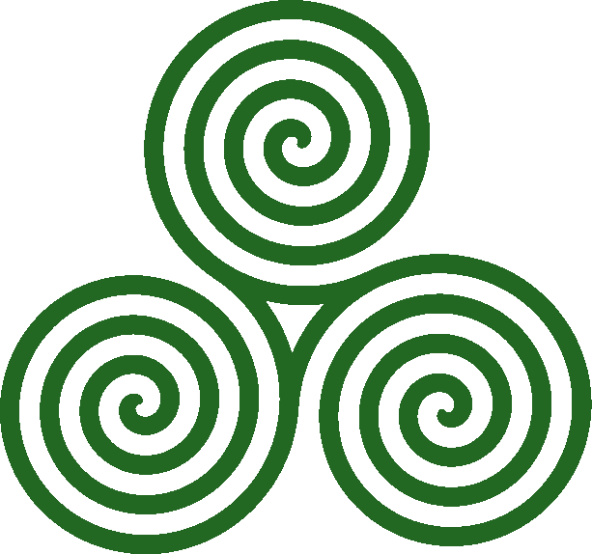

**KATHARO NAUTILUS EST since 2011**

**FACULTY OF MECHANICAL ENGINEERING**

**SMK 2332**

**NAVAL ARCHITECTURE 1**

**PROJECT INNOVATIVE BOAT MODEL DESIGN**

**FINAL REPORT**

**KATHARÓ NAUTILUS**

**MUHAMMAD ASYRAF BIN MOHD SHUISMA AM090305 (L)**

**NUR SHAFIRA BINTI AHMAD AM090224**

**TEE SHI FENG AM090265**

**LECTURER NAME: DR KOH KHO KING**

**28 FEBRUARY 2011**

**ABSTRACT**

Students need to develop the skills of critical thinking, problem solving associated with report writing communication appropriately at University and to fulfill the obligations of their future employment. Thus we have this project – marinnovation boat design competition. In this project, we are required to build a boat with non conventional propulsion system i.e. we cannot use any motorized component to move our vessels. The project also is conjunction with the convocation of University Technology Malaysia with the innovation festival that to show the visitors the innovative and creativity of the students. In the report we will explain in a detailed the development of idea of the final product, the construction process, evaluation of systems, calculations. Besides the technical part of the project as listed above, we are going to discuss in the report the problem we face and how we discuss to tackle the problem. The essence of learning will be highlighted also in this report. The methodology we use in the project are consult the lecturer and related field personnel, online and book research of the supporting material, and the field trip and stimulate experiments are carried out.

**ACKNOWLEDGMENTS**

Thanks are extended to the University Technology of Malaysia and the

Faculty of Mechanical Engineering for providing project funding and platform. The writers would like to thank the head of department of marine technology, Associate Professor Dr Zamani, for his ongoing support and endorsement of this project, as well as our lecturer Dr Koh Kho King who contributed his ideas, expertise and advice. Thanks are extended to the staff of faculty and friends that willingly contributed.

**DISCLAIMER**

We want to declare that the following are our own work, unless otherwise referenced, as define by the university’s policy on the plagiarism.

**TABLE OF CONTENTS**

|  |  |  |
| --- | --- | --- |
| NO | TITTLE | PAGE |
|  | COVER PAGE |  |
|  | PRELIMINARY PAGE |  |
|  | TABLE OF CONTENTS |  |
|  | FINAL DESIGN SPECIFICATIONS |  |
|  | HULL OPTIMIZATION |  |
|  | PROPULSION SYSTEM   * Mousetrap * Pop-pop |  |
|  | CONSTRUCTION PROCESS   * Hull * Mousetrap system * Copper tube system |  |
|  | EVALUATIONS AND TESTING   * Hull form strength * The boiler testing * Soda and vinegar reaction test * Copper coil performance * Mousetrap testing |  |
|  | CALCULATIONS AND ESTIMATIONS |  |
|  | COSTING |  |
|  | PROBLEMS ENCOUNTERED |  |
|  | CONCLUSIONS |  |
|  | APPENDIX   * APPENDIX 1— * APPENDIX 2— * APPENDIX 3 – * APPENDIX 4— * APPENDIX 5&6 -- |  |

**FINAL DESIGN SPECIFICATION**

After 5 weeks of discussion and construction has been done. The boat is named **KATHARÓ NAUTILUS**. The name implied that we are ‘green sailor’ and we will be sail further by using green energy ship. The ship major materials are made from the polystyrene, plywood, some of the metal rods, fiber glass, aluminum plate, and PVC pipe.

Our hull form is catamaran. The ship hull is made from polystyrene and the deck is made from plywood. The dimension of the modal is 0.9 in length, 0.7m in breadth and the height from keel to uppermost of the deck is 0.7m. The expected draught is 0.03m. It will be paint with the blue color to make it have a better appearance. The polystyrene is 15cm in height and deck’s thickness is about 3cm.

The propulsion system we use is the hybrid system, a combination of the mousetrap and copper coil system. The mousetrap system is consists of a paddle wheel, a connecting rod, a hinge and 4 mousetraps. The paddle wheel is made from PVC pipe combined with the curved aluminum plate. Its length is 25cm and with the diameter of 3cm. the holder that fixes on deck is 7cm x 2.5cm x 3cm. the flat dimension of the aluminum plate is 10cm x 7cm and there are 4 of them. The mousetrap dimension is 4’in x 7’in. The connecting rod is made from hexagon cross sectioned copper sod which has the length is 25cm. the synchronizer is a steel plate which length is 44cm.

The copper coil system is used the copper tube in length of 45cm. this is because we want to drill a hole let it pass through. As our catamaran is quite height, the tube need to be relatively long. The fire source is liquefied mixture of alcohol and fuel which give out blue flame. The height of the container of the fire source will be around 5cm. the power of both propulsion systems will be discussed in the calculations.

**The detailed drawing of orthographic is shown in Appendix 1**

**The general arrangement top view is in appendix 2.**

**HULL OPTIMIZATION**

The hull form we choose is the catamaran hull form because we think that catamaran is faster. Firstly, the hull form we use. We use catamaran with the front view is slim and curvy shape at the side and flat in middle. This is because catamaran hull form will have higher buoyancy as the force distributed at the side. The wetted surface is reduced to ensure the hull have lower resistance in the water. When the hull encounter wave, it will slide by following the waveform. Then it will lessen the power to drive the vessel. Durable is to guide us to the material that we used to withstand all weights and resistance. Since the material in the hull is the plywood around 0.9m x 0.7m and polystyrene about the same size with the epoxy coating, this will certainly durable throughout the competition. The coating is to give the hull a smooth surface that to reduce the water resistance and boundary layer thickness. Besides that we want to strengthen our hull structure thus we use the mesh and epoxy mixture to match the deck and the hull.

The hull selection that we have discussed and done in the PCC and there are 3: high buoyancy, durable and less drag force. There are some elementary characteristic that we do not put in the chart like waterproof, stable and etc. the rational that we put the buoyancy as the main because the ship has to be able to carry a 0.5kg weight and all propulsion system. Besides that, the buoyancy is needed to overcome the wave that we need to face on day 2. Buoyancy will then define the way we need to focus on the hull design and optimization. Durable is necessary because we need to be able to run 90m which is quite long and we have to tackle the 10cm height wave. The durable include the type material that we can use. Durable is also the need to win the competition which can withstand the propulsion system we developed. Lastly less drag force, this is the goal of many engineers to design that the boat or ship will have less drag to give higher performance. And as in this time around we are not allowed to use any conventional propulsion system like motor; we have less propulsion power to be produced like the use of mousetrap and balloon. Thus reduce the drag force will be a major task for us like surface preparation and hull form design. By the guidance of three main characteristic of above, we will toward the design that will at least meet the requirement.

**PROPULSION SYSTEM**

After several discussions and consultancy, we have decided to use the hybrid propulsion system to ensure our boat will reach the 90m destination. This is a huge challenge to us because usually by using normal pushing force created by balloon, mousetraps are definitely not sufficient. Therefore we use the hybrid system which comprise with a steam powered system and mousetrap initiate system. Here we will elaborate in detail. The mousetraps initiate system consist a total of 4 mousetraps and rods that connecting a shaft then turn to the propeller. By using leverage advantages the spring elastic energy will then turn to the kinetic energy then to drive the vessel. Why we call this as initiate system? It is because we want to have the power to run the boat at the early stage of competition while waiting the steam pressure being formed. The keys to obtain maximum distance: reduce weight, reduce axle friction, and use a long lever for the best mechanical advantage. Use a small diameter axle and large diameter wheels. Each time the axle turns around, so does the wheel; a larger wheel means the car travels further with each turn of the axle. The tip of a long lever travels a greater distance than the original bar of the trap. This increases the length of string used, and conserves energy (slows the snap of the trap). The boat moves slowly, but it travels farther because spring power is used more efficiently. Overcome friction, use traction, exploit "mechanical advantage", and minimize mass to achieve the maximum distance for our boat.

Copper tube system that we use is the ultimate methods for us since we really do not manage to build our own steam boiler as we are not able to create enough pressure to make enough thrust to move our boat, then we start to using copper tube system. We will use several tubes that burned with high temperature fire source, the steam will push out and then the copper tube keep contact with the water, once the steam is push out then the water will be sucked in then make it a circulation. Although efficiency is very low, around 0.03% but the consistency is the main factor that we take. The low power output we try to amend by the high power source and multiple outputs. We use rather easy system because we want to make the design simpler and try to improve these existed systems that can make us go further.

**The drawing of the mousetrap system refer to Appendix 3**

**The copper coil system can be referred in Appendix 4.**

**CONSTRUCTION PROCESS**

**HULL**

The hull construction process ca mainly put in to 2 part deck and the hull form. Here I will use chronological way to explain how we complete the hull.

1. The polystyrene and deck is bought from the hardware shop. The equipment we bought is Styrofoam cutter and sandpaper.
2. We begin with the hull form first. The polystyrene we cut to the dimension we needed by knife.
3. We mark the curvy shape on it and then we are using sandpaper to shape it.
4. Then we brought to composite lab to coat with the epoxy to let the surface smooth. We also add the fiberglass layer to strengthen the polystyrene. The epoxy mixture is resins and its hardener. The ratio is 5:3.
5. After we have covered the hull form with the fiberglass layer, we do the grinding to remove the extra unwanted side burr.
6. After that we prepare the wood in the required dimension buy cutting using saw.
7. Then we match the polystyrene and the plywood to do lofting.
8. After done with the lofting, we bring to fabrication lab to cut by using jigsaw.
9. To fit with the mousetrap system, we have done the modifications by cut a small area at the rear to put the water wheel.
10. Then we need to join the 2 main components the deck and the hull.
11. We join by using epoxy under the deck and we coat at the fringe of joining with mesh to act as stiffener.
12. Lastly, we do the surface finish and paint to as decorations.

**The process pictures can be referred to appendix 5.**

**THE MOUSETRAP SYSTEM**

The mousetrap system, we have done several modifications on it like the number of mousetrap increase to 4 with a synchronizer. Here using the chronological way to give a clearer picture.

1. We bought the 4 mousetraps which have dimension of 4’in x 7in.
2. We need to find the material of the connecting rod and synchronizer. Thus we find it in faculty store. The synchronizer is a steel plate to connect all the mousetraps.
3. The support of the shaft holder also found in the store, it is cast iron tube. The 2 wooden blocks is then cut into the required dimension as the firm support on deck.
4. The shaft is made from PVC also found in the store. The aluminum plate as blade is barter from the other group.
5. Then we go to fabrication lab to cut the sharp edges by using the steel cutter.
6. In the lab also we drill the hole on wooden block to fit in the tube holder of the shaft.
7. Then we use nails to firm it and insert the metal tube.
8. The aluminum sheet bend to a curvy shape then by using hot glue to stick on the. To be stronger we make webs on it.
9. Once the shaft and tube fit in, we add some lubricants to reduce friction.
10. The metal plate is welded with the mousetrap.
11. The connecting rod is blazing on the metal plate. The normal welding cannot be done since the rod is copper alloy.
12. Once we weld all these we start to round the thread at rods then to the shaft.
13. The surface finish is needed to make them a neat appearance.

**The pictures of process please refer to Appendix 6.**

**COPPER TUBE SYSTEM**

The main components are the copper tube, container of fuel, and the combustion shield. Here are the procedures to fabricate the system.

1. The copper tube is bended to a 2.5 cm diameter using s solid cylinder as the shaping solid.
2. Once it is shaped, we need to check the hole is it over deform to ensure the water and steam path is smooth.
3. Repeat the steps above to produce 3 more coils.
4. Then we need to make the container to fill the fuel. The material is zinc plate shape into square shape or we use the round container as shaping solid.
5. The burr at the edge is removed by using files.
6. The combustion shield we use the zinc plate make it circular path then seam.
7. Then above the fire source we will have a cover to prevent the air flows and water extinguishes the fire.
8. The cover is made from wood and we join both the material by using hot glue sticks.
9. We drill several holes on the cover and at the side of the zinc plate to ensure enough oxygen to carry out the combustion.
10. We need to drill some holes on the deck that enable copper tube to extend to the water level.
11. The fixture need to be made by using small bearing and hot glue to ensure the copper coil is still.

The overall shield we will use the ductile plastic transparent cover to cover on the deck to let the audience to see the mechanism inside.

**The copper coil making process pictures refer to Appendix 7.**

**The Gantt chart of the construction process refers to Appendix 8.**

**EVALUATIONS AND TESTING**

In order to make our ship move as designed and calculated, testing are certainly need to be carried out.

* **Waterproof and the strength of the boat.**

Before we test we have weight the boat first, the weight about 4.7kg. The dimension we need to measure again to find is there any errors occur. We put the coated into the lake. We examine the draught, the stability and the strength of the boat. The draught we make a mark is about 3.8cm which differ a bit from designed waterline as our weight differ also. Then we measure the trim to use for the calculation later. We also check the stability by inspection. We see the front view has not shown any obvious imbalance, and then we take a rope to move the boat since we have not finished our propulsion system. From there we observe the wave pattern and the smoothness of the hull surface. We then add load and faster the speed to test the joining firmness. We found all things deviate by in an acceptable manner.

* **The boiler testing**

At the first we intend to do the boiler then we need to test for its performance to ensure it can be build enough thrust to move our boat. In the test, we make use a biscuit tin as our boiler and we test on 2 conditions; 1 is opened air and the other is closed air. The water volume to be boiled is known. We test how long does the water boiled. It takes 15 minutes to boil the water. Then on the way of testing we found a problem that the candle will shorten following the time of burning. Then in closed air part, we make a rubber tube to drain out the steam. Besides that we make a manual valve to stop the steam flow in order to build up pressure. After 15 minutes of waiting, we dip the tube into the water and open the valve. It produces fast bubble exhaust in a short time period. The thrust unable to push the water on the small modal we test on. From that we are thinking of our alternative.

**The testing pictures please refer to Appendix 9.**

* **Chemical reaction test**

After we abort the boiler propulsion system due to inefficiency time consuming to build, we change our focus to chemical reaction as the reaction will create the gas effect for vigorous reactant. We tend to use cobalt react with water and burn it in an enclosed space. We get high thrust but explosion occur. We think that is dangerous so we go to sulphuric acid react with the aluminum oxide. Then we get the result of too little of gas been produced. If we need high amount and vigorous reaction, we need fire as catalyst but it is still dangerous as we are unable to control the reaction so we abort. Soda vinegar reaction we test in the bottle, its reaction is slow and do not have enough thrust to move the boat then we totally abort the chemical reaction as our power source.

* **Copper coil test**

Then we look for long lasting system to keep the hope to reach the ultimate 90m destination. Then we think of the pop-pop system that is long lasting. We think we can make some modifications on it then we just try this out. We using the small boat then using the ordinary copper coil system and we manage to create the impulse. Thus the simplicity and do not burden the boat we choose the system and we make some modifications which explained as above.

* **Mousetraps system**

Originally we use mousetrap as initiate system to wait for the pressure to build up. But now we using copper coil system the mousetraps system will shorten the time travel in a certain period. The mousetrap system is a common propulsion system by using leverage advantages to move the toy boat. We just test not on the modal but just on the land to see the function of the system. From the action we saw, we believe the system will function normally.

**The testing pictures please refer to Appendix 10**

**CALCULATIONS AND ESTIMATIONS**

**POP-POP system**

Candle power need to be calculated. Though it is not obvious, the power and the energy delivered by a candle are relatively big. A small birthday candle (mass: 1 gram) delivers approx 35W as heat, and it takes 10 minutes to burn. Corresponding energy: 21kJ. With 2 grams burnt in 5 minutes (data from Professor Le Bot) it means 42kJ and 140W.Constitution: engine made of copper 6x1 (i.e. internal diameter 4mm) with 4 turns around a diameter 25mm. Length of each pipe out of the coil: approx. 300mm. This engine delivered a thrust of 2x17mN for an electrical consumption of 50W. The same thrust was got with a nozzle of the same diameter when using a permanent flow of 14cm3/s; which corresponds to a velocity of 1.11m/s and a power of 5.7mW; i.e. (when multiplying by two because there are two nozzles on this coil) an efficiency of 0.023% rounded to 0.03% to take into account the losses in air. For information, this engine delivered 2x12mN for 25W. The same nozzle exerts 12mN for a permanent flow of 9cm3/s; which corresponds to a velocity of 0.72m/s and to a power of 2,3mW; i.e. an efficiency of roughly 0.02%.

**MOUSETRAP SYSTEM**

Spring constant = 0.11 Nm/radian; torque generated= 0.11xpi=0.3456. The mechanical advantage= the radius of the wheel/the radius of the axle

The radius of the wheel is 10cm; the radius of the axle is 1.25cm. Thus mechanical advantage is 8. The distance travelled that should be travelled= [(the number of string rounded on x 4) + lever arm distance]x 8x 2side

The distance that should be travel is about 4m.

**HULL FORM**

The weight of the ship= 4.5kg

The draught is [4.5/ (1000x0.7x0.1)] = 3.3cm

**COSTING**

**PROBLEMS ENCOUNTERED**

In this project we are facing lots of problem since we are amateur in the ship building. Mainly our problem is divided to hull optimization and propulsion system.

Hull optimization is the key issue that we have to face in order to provide a stable and strong hull to withstand wave. Initially we tend to use the wood for the whole body but think of the weight and the waterproof aspects then we decide to have the combination of wood and polystyrene. Then we are facing the problem that the height of the polystyrene cannot up to the design then after we search fully and finally we manage to have 10cm height of polystyrene. Then we have to think how to make the polystyrene stronger and how to make the joining between the deck and the hull form. After we gather information we decide to use the epoxy and fiber glass coated on the polystyrene. Then we think of the experience in short semester in the composite workshop, then we approach the technician there and they agree us to use the lab’s materials. Then we also consult them how to joining the deck and hull. They suggest at joining seam we put epoxy and mesh to provide the enough strength.

Propulsion systems really discourage us sometime. At first we want to use steam powered system which consists of boiler and after we do the testing it will only has the bubbles. We thought is not enough pressure then we tend to have the pressure control valve like in the pressure cooker but we find the electronic controlled valve which not applicable to our design. We have used all the resources we have but still we cannot found the items we want. Then we make an alternative to use the chemical reaction system but then we carry out experiments to test find it is inefficient or dangerous, then we have to abort to find another alternatives. Then we think of the classic system that is the pop-pop system. But we have to choose the diaphragm or copper coil system. After we weigh their advantages and disadvantages we choose the copper coil system as the steps are simple and modifications can be made. The mousetrap system we face the problem of the paddle wheel is not long enough. This we will solve by using extension of aluminum sheet. The surface of the hull is rough then our solution is to use electric grinder to smooth the surface.

**CONCLUSION**

We have been given a tough task for us to complete. In the way to complete we meet lots of problems and learn lots of things that cannot read and learn from book.

In completing the project, we have sharpened our communication skill as we need to go everywhere to search for material. We have to communicate with the non engineering discipline people. To make them understand we need to use the appropriate manner to explain what actually we want. Through this project also will train us to be able to work in team. As 3 people with different attitude and experience work together, this will certainly train our tolerance and develop understanding. Team-working is very important especially we go outside working play an effective role in the team. The project also trains us to be more versatile and be able to control the stress that we face. As the in the project there are so many things we need to consider and do like design, presentation, producing and report writing. In the mean time we still has lots of assignments from others subjects. This makes us have a better time management to enable us to complete the task in the given time frame.

Despite the soft skills that we gain, technical part we have learnt a great deal also. We are exposed to the design works and how to make the product according to the drawings that we produce. We are also be able to perform the calculations to confirm the theory we have. We have done lots of practical works also. We go to various labs to utilize the lab equipment and consult experienced people. This will familiarize us when come to the undergraduate project. We learn again the composite layer making and welding. This is truly benefiting us even though we cannot win the contest.

The outcome based education is the policy of the university to produce useful graduate to serve the society well. This project is a part of the process towards the outcome and added value on our own development to be a useful and creative engineer that will serve our country to sustain excellently in the immense challenges of globalization.

**APPENDIX 5**

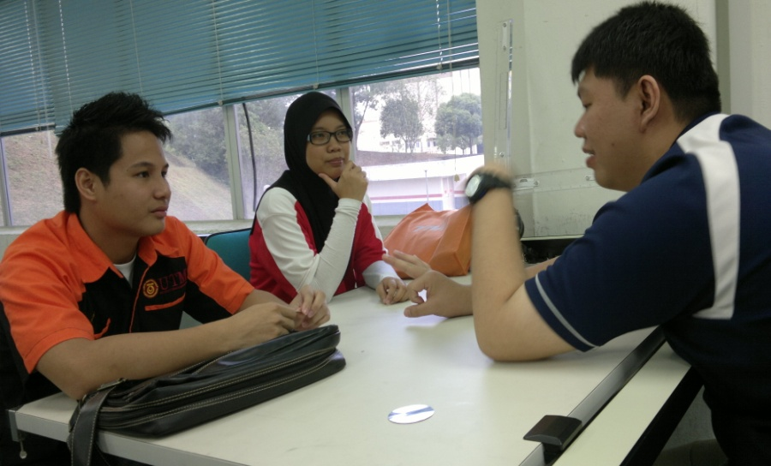

Figure 1 hull form finalize meeting

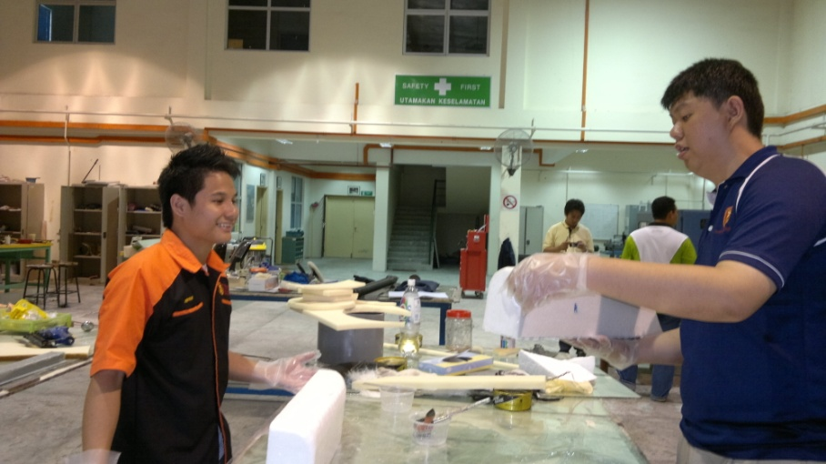

Figure doing coating in the composite lab

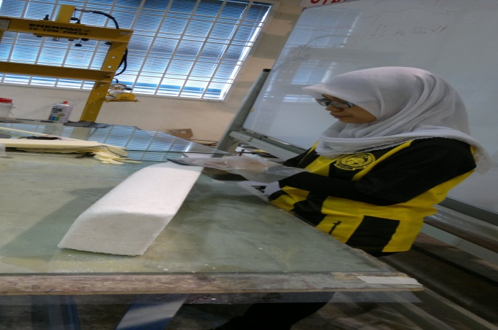

Figure finishing the coating

Prepared by,

…………………………

(TEE SHI FENG)

Checked by,

…………………………

(NUR SHFIRA BINTI AHMAD)

Checked by,

…………………………

(MUHAMMAD ASYRAF BIN MOHD SHUISMA)

Group leader of ”KATHARO NAUTILUS”

Approved and checked by,

…………………………

(DR KOH KHO KING)

Marine Technology Department, Faculty of Mechanical Engineering  
Universiti Teknologi Malaysia  
[www.fkm.utm.my/~koh](http://www.fkm.utm.my/~koh) | [koh@fkm.utm.my](mailto:koh@fkm.utm.my) | 0167627788  
B.Eng, M. Eng. (UTM), PhD (Hiroshima University)