**SEBB 4173 CELL AND MOLECULAR BIOLOGY FOR BIOINFORMATICS**

**CLONING PROJECT**

LECTURER: DR SITI AISYAH BINTI MUALIF

DR NORHANA BINTI JUSOH

SECTION: 01

|  |  |  |
| --- | --- | --- |
| **NO** | **NAME** | **MATRIC NO** |
| **1.** | **FELICIA CHIN HUI FEN** | **A20EC0037** |
| **2.** | **LEE JIA YEE** | **A20EC0063** |
| **3.** | **MEK ZHI QING** | **A20EC0077** |
| **4.** | **ZEREEN TEO HUEY HUEY** | **A20EC0173** |
| **5.** | **GUI YU XUAN** | **A20EC0039** |
| **6.** | **PHANG CHENG YI** | **A20EC0131** |

**INTRODUCTION**

ZIKV is a single-stranded RNA virus which belongs to the family *Flaviviridae*, genus *Flavivirus*. It is transmitted by the bite of infected mosquitoes from the Aedes genus, mainly *Aedes aegypti*, in tropical and subtropical regions. It was first identified in Zika forest of Uganda in 1947 in monkeys then was later identified in humans in 1952 in Uganda and the United Republic of Tanzania. From 2007 to 2016, a large transmission of Zika virus appeared throughout the Americas, Africa, and other regions of the world. So far, a total of 86 countries and territories have reported evidence of mosquito transmitted Zika infection.

The DNA of Zika virus encodes ten proteins, being three structural (protein E, protein C and protein prM) and seven non-structural proteins (NS1, NS2A, NS2B, NS3, NS4A, NS4B and NS5). The gene that was selected for the cloning project is membrane glycoprotein precursor M(pr-M).

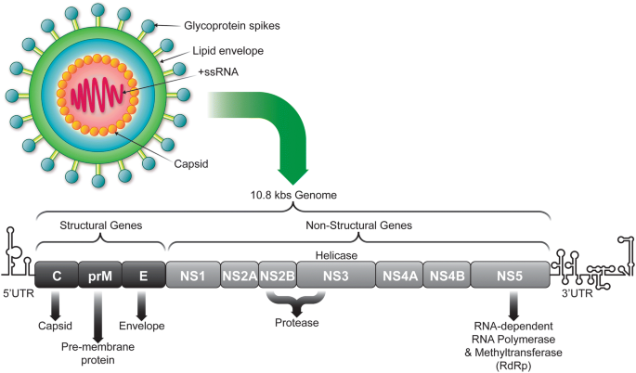

*Figure 1: Genome structure of Zika virus with structural and non-structural genes*

**THE SEQUENCE OF THE DNA**

The complete sequence length of the zika virus is 10807 nt. The genomic sequence of the gene interested starts from location 473 nt to 976 nt in the origin sequence of zika virus.

Genomic sequence:

**473 GCAGAGATCA CTAGACGCGG GAGTGCATAC TACATGTACT TGGATAGGAG**

**523 CGATGCCGGG AAGGCCATTT CGTTTGCTAC CACATTGGGA GTGAACAAGT**

**573 GCCACGTACA GATCATGGAC CTCGGGCACA TGTGTGACGC CACCATGAGT**

**623 TATGAGTGCC CTATGCTGGA TGAGGGAGTG GAACCAGATG ATGTCGATTG**

**673 CTGGTGCAAC ACGACATCAA CTTGGGTTGT GTACGGAACC TGTCATCACA**

**723 AAAAAGGTGA GGCACGGCGA TCTAGAAGAG CCGTGACGCT CCCTTCTCAC**

**773 TCTACAAGGA AGTTGCAAAC GCGGTCGCAG ACCTGGTTAG AATCAAGAGA**

**823 ATACACGAAG CACTTGATCA AGGTTGAAAA CTGGATATTC AGGAACCCCG**

**873 GGTTTGCGCT AGTGGCCGTT GCCATTGCCT GGCTTTTGGG AAGCTCGACG**

**923 AGCCAAAAAG TCATATACTT GGTCATGATA CTGCTGATTG CCCCGGCATA**

**973 CAGT**

**SIZE OF THE DNA AND PROTEIN OF INTEREST**

The protein of interest is the Precursor M (pr-M) protein. It is one of the structural proteins for Zika Virus. There are totally 10.807 kb(base) RNA in Zika virus and only 504 RNA is responsible for the pr-M protein. The size of protein is 168 amino acids which starting from 1 to 168 amino acids and the mass is 18.648 kDa (Dalton).

**1 aeitrrgsay ymyldrsdag kaisfattlg vnkchvqimd lghmcdatms yecpmldegv**

**61 epddvdcwcn ttstwvvygt chhkkgearr srravtlpsh strklqtrsq twlesreytk**

**121 hlikvenwif rnpgfalvav aiawllgsst sqkviylvmi lliapays**



*Figure 2: The sequence of amino acid of pr-M protein*

**ZIKA VIRUS DISEASE**

The infection caused by Zika virus is known as Zika, Zika virus disease or Zika fever. There are a few ways the Zika virus can be transmitted including bite of the infected mosquitoes, transfusion of blood, from pregnancy mother to the foetus and sexual contact. The infected mosquitoes are usually from the Aedes genus and bite during early morning or late evening. If the female who are pregnant infected by Zika virus will have the risk of getting miscarriage while the infants that born may have defect on brain known as microcephaly. The infection of adults will be linked to Guillain-Barre syndrome, neuropathy and myelitis. The incubation period of Zika virus is around 3-14 days and the symptoms of Zika virus infections are usually not obvious. Hence, majority people do not have symptoms after infected. A small group of people will have symptoms such as mild fever, rash, muscle pain and headache. There is no treatment or vaccination to prevent Zika virus and the individuals can only try their best to keep away from mosquitoes.

**ROLE OF THE GENE OR PROTEIN OF THE INTEREST IN PATHOGENESIS**

The Zika Virus consist of 4 structural protein which are capsid, envelope, precursor membrane (prM) and membrane, and 7 non-structural proteins which are NS1, NS2A, NS2B, NS3, NS4A, NS4B, and NS5. The prM protein consists of three domains which are the pr N-terminal domain, a central ectodomain and a C-terminal transmembrane domain. The prM protein plays an important role in the assembly of mature virions through cleavage of prM into M protein. It protects E proteins from premature fusion in the low-pH conditions during transportation in the trans-Golgi network. Besides, the prM protein undergo interaction with E protein in the endoplasmic reticulum. The immature virions are form as the encapsulation of the RNA genome occur with C protein and coverage with a lipid bilayer containing a prM-E protein complex. The mature capsid (C) protein is help in triggers the cleavage of the prM protein by a host protease furin to produce a mature membrane (M) protein and a Pr protein product.

*Figure 3: Mechanisms involved in Zika virus-host cell interactions.*

**CLONING METHOD EMPLOYED**

**Step 1: Extract Zika virus genome from blood sample**

To extract DNA from blood, we apply one-step lysis method.

1. The lysis buffer is added to the sample to lyse red blood cells and white blood cells.
2. Centrifugation is carried out.
3. Nuclei and mitochondria from the white blood cells are sedimented while RNA is remaining in the supernatant.
4. Supernatant is removed.
5. White blood cell nuclei and mitochondria are re-dissolved in denaturation buffer which consist of chaotropic salt and protease to denature the proteins in cell nucleus and mitochondrion.
6. The DNA is precipitated and rehydrated in Tris-EDTA buffer.

*Figure 4: One-Step Lysis Method*

**Step 2: PCR amplification of the DNA and plasmid**

PCR amplification is a technique used to amplify a segment of target gene and produce a large number of copies by using polymerase chain reaction.

**PCR amplification of the gene of interest**

Material:

1. Nucleotide
2. Upstream primer (3’ GGATCCGGATTGTCA 5’)
3. Downstream primer (5’ CGTAACCATCTTAAG 3’)
4. Cofactor: Magnesium chloride (𝑀𝑔𝐶𝑙2)
5. 1 U/uL Taq Polymerase
6. 10x PCR buffer
7. Sterile water
8. 10 mM dNTP

Step 1: Denaturation

Heat the reaction strongly at 96 °C to break the hydrogen bonds holding between complementary base pairs of the DNA strands. This provides a single-stranded template for the next step.

Step 2: Annealing

Cool the reaction to the temperature about 55-65°C in order to let the primers bind to their complementary sequences on the single-stranded template DNA.

Step 3: Extension

Raise the reaction temperatures to 72°C so *Taq* polymerase can extend the primers and synthesize new strands of DNA.

The steps above are repeated about 35-40 times by using a thermal cycler to form copies of DNA from one to billions.

PCR primers are designed:

Upstream region: (135)3’ GGATCCGGATTGTCA 5’ (149) (15 bp)

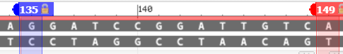

*Figure 5: Primer upstream region*

Downstream region: (1685)5’ CGTAACCATCTTAAG 3’ (1699) (15 bp)

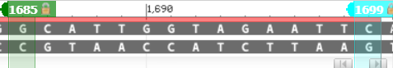

*Figure 6: Primer downstream region*

The PCR primers are inserted into the mixture of DNA which contain the precursor M(pr-M) protein.

Amplified gene: 135 – 1699 (1565 bp) Target gene: 473 – 976 (504 bp)

**PCR amplification of plasmid vector**

Material:

1. Plasmid DNA
2. Upstream primer (3’ GGATCCGGATTGTCA 5’)
3. Downstream primer (5’ CGTAACCATCTTAAG 3’)
4. Cofactor: Magnesium chloride (𝑀𝑔𝐶𝑙2)
5. 1 U/uL Taq Polymerase
6. 10x PCR buffer
7. Sterile water
8. 10 mM dNTP
9. Restriction enzymes (BamHI, EcoRI)

Before the PCR amplification, the plasmid vector has been cut with the restriction enzymes. In this case, the plasmid vector used is pUC19. The process of PCR amplification of plasmid vectors is the same as PCR amplification of genes which are denaturation, annealing and extension.

**Step 3: Purification of the DNA**

In purification step, there are two general procedures will be used which are centrifugation and chemical extraction.

1. The sample is spun at high speed and heavier components will be precipitated to the bottom of tube by centrifugation.
2. The unwanted particles that remain in solution are removed.
3. The precipitate in tube is redissolved by adding water.
4. Phenol is added to the tube to dissolves and denatures the protein.
5. The two layers of solution are formed. Upper layer is water and lower layer is phenol.
6. The mixture is shaken and when stop shaking, the protein will be dissolved in phenol.
7. The water which containing DNA and RNA is sucked off and stored into another test tube.
8. Ribonuclease (RNase) is added to the test tube, and it will convert RNA into tiny fragments.
9. The alcohol is added to the test tube. It will occupy all the water and extrude the larger and less soluble DNA out of the solution while small RNA fragments remain dissolved in the solution.
10. The centrifugation is repeated, and DNA is sedimented to the bottom of test tube.
11. The solution that containing RNA fragments is poured off.
12. The tiny DNA pellets are redissolved using buffer.

*Figure 7: Phenol Extraction remove Proteins*

*Figure 8: Removal of RNA by Ribonuclease*

**Step 4: Cut the DNA and Plasmid by Restriction Enzyme**

The restriction enzymethat used to cut the front DNA part is BamHI. The optimum temperature for incubation of this enzyme is 37˚C.

**Cut Site of Restriction Enzyme BamHI**

For the back DNA part, it is cut by using restriction enzyme EcoRI. The optimum temperature for incubation of this enzyme is also 37˚C.

**Cut Site of Restriction Enzyme EcoRI**

131 473 976 1699

**Cut of Precursor M gene**

*Figure 9: Plasmid pUC19*

b

The plasmid is also cut by the same restriction enzyme at 37˚C.

**Step 5: Separation of the DNA (electrophoresis)**

The electrophoresis is a technique used to separate the DNA fragment and other macromolecules such as protein according to their size and charge. Electrophoresis is done in a gel box which consist of positive charge electrode (anode) and negative charge electrode (cathode) which connected to high voltage source. Agarose is the gels that used in the process of DNA separation for the big DNA fragment, and it has pocket-like indentations called wells for us to place the DNA samples. One of the wells will reserved for the DNA ladder as a reference for the length of DNA fragment. After the DNA samples is added, the salt-containing buffer solution is required to fill the gel box for the current flow. Next, the power is turned on and the DNA fragment will start moving through the gel. The DNA with negative charged will moving toward anode. The shorter pieces of DNA will travel faster and close to the anode compared to the longer pieces of DNA. Ethidium Bromide is used as DNA-binding dye to let the DNA visible when placed under UV light. Once the DNA fragment showed, the DNA band will compare to the DNA ladder and Diagram, engineering drawing
finally cut out the gel that consist of DNA we wanted to undergo DNA extraction.

*Figure 10: The gel electrophoresis*

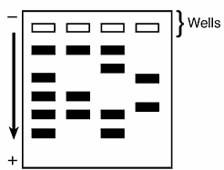

Gene desired (1565bp)

Downstream Region (135bp)

Upstream Region (1698bp)

Tray

*Figure 11: The result of gel electrophoresis*

**Step 6: Ligation of DNA**

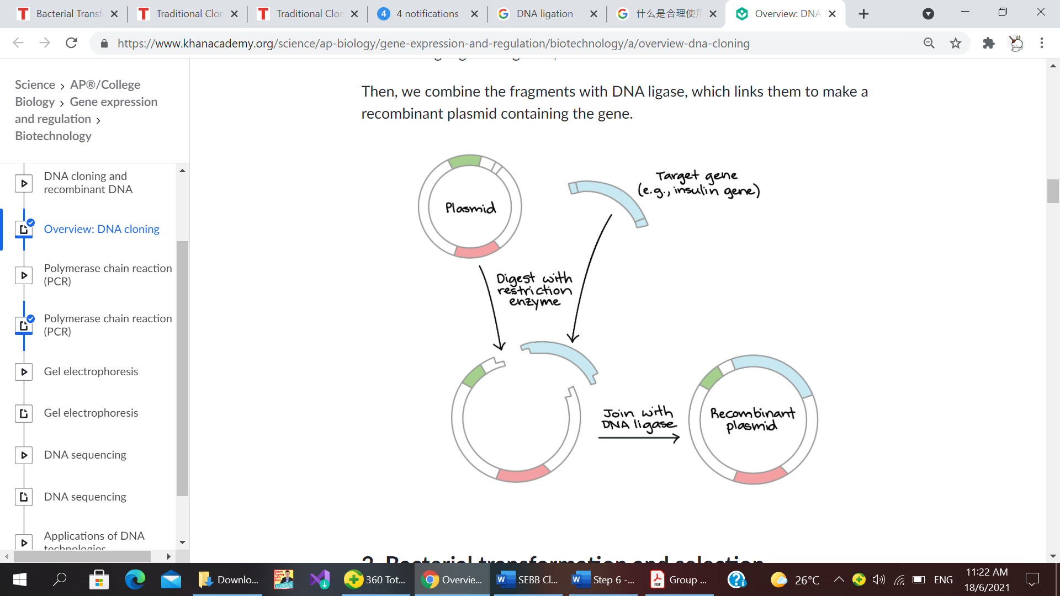

*Figure 12: DNA ligation process*

In the process of DNA ligation, restriction enzymes and DNA ligase are required. The restriction enzymes used to cut the targeted DNA and DNA ligase are BamHI and EcoRI. The same restriction enzymes are used to cut the plasmid vector and targeted DNA so they will have the same sticky ends. Both targeted DNA and the plasmid vector are able to do complementary base pairing and join temporarily together by hydrogen bond since they have the same sticky ends. The sticky ends of targeted DNA and plasmid vector are permanently attached by phosphodiester bonds in the presence of DNA ligase at 22°c to 25°c for 3 hours. At last, the recombinant plasmid is formed.

**Step 7: Transformation**

The r plasmid is then introduced into the bacteria, *E. coli* by transformation process. The method used is chemical transformation.

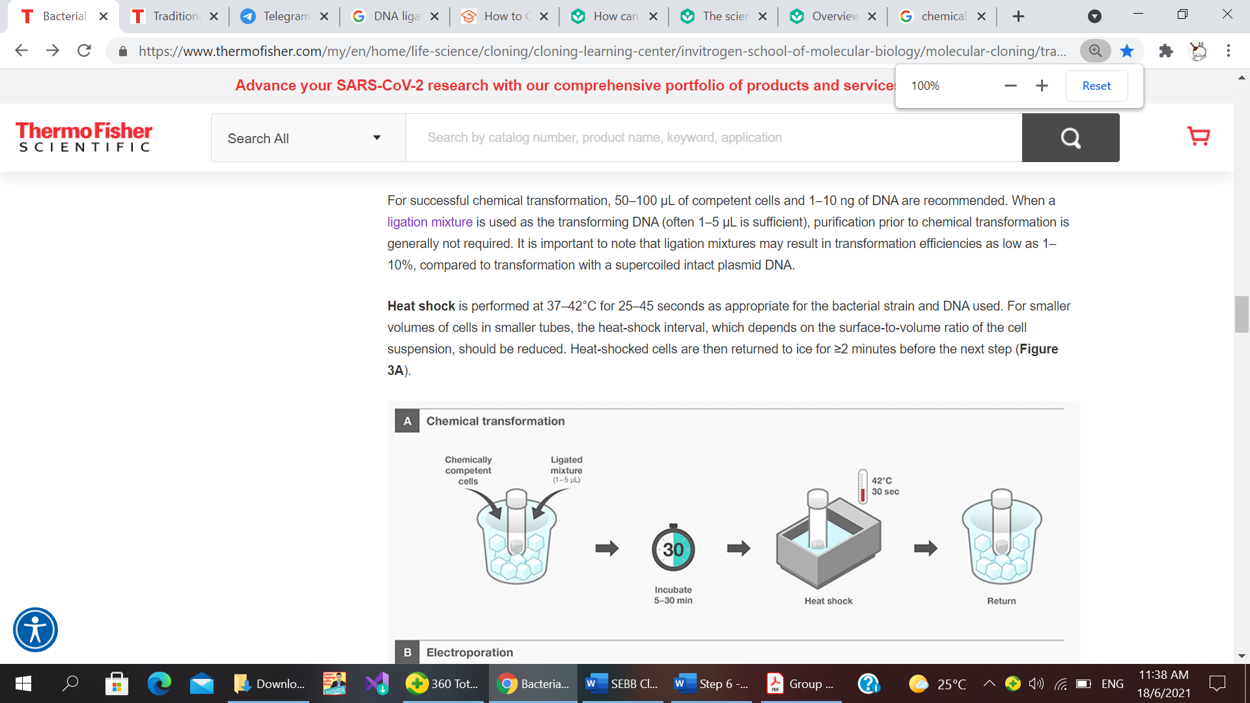

*Figure 13: Chemical transformation process*

Chemical transformation process:

1. Competent cells are prepared by incubating the *E. coli* cells in calcium chloride (CaCl2) to make the cell membrane become more permeable.
2. 50 – 100 µL competent cells are fixed with the 1- 10 ng r-plasmid and incubated on ice for 5 to 30 minutes in a polypropylene tube.
3. Ligation mixture is added to allow efficiency in the transformation process.
4. Heat shocks the polypropylene tube containing the mixture at 37°c to 42°c for 25 to 45 seconds. This is to allow the cell membrane of the *E. coli* to become porous so the r-plasmid are able to enter the cell.
5. The heat shocked cells are then returned to ice for more than 2 minutes.

**Step 8: Selection for the correct clones**

Brute force and ignorance method is used to identify the plasmid that was successfully inserted by cloned DNA. Extract plasmid DNA by cutting the plasmid DNA with the BamH1 and EcoR1 restriction enzyme. The restriction enzyme will separate DNA from the plasmid. If there is no DNA insert in the plasmid, the circular plasmid will be converted to linear molecule of DNA. If the plasmid contains inserted DNA, two pieces of DNA will be produced, one is from original plasmid while one is from the inserted DNA fragment.



RE

RE

Without Inserted DNA

With Inserted DNA

*Figure 14: Result of Brute Force and Ignorance*

**Step 9: Verification of inserted DNA**

Verification of the presence of the insert DNA inside plasmid can be done by gel electrophoresis. Sample of DNA is put into the hole and electrode are connected at the end of the slab. Since DNA is negative charged, hence after switch on the power, DNA will move to the positive electrode. Ethidium bromide is used to locate the DNA fragments. Ethidium bromide strains DNA orange if viewed under UV light. The plasmid contains inserted DNA will produce two bands which the band with larger base pairs is plasmid and smaller base is inserted DNA. Only one band is appearing if there is no inserted DNA in the plasmid.

Tray

Plasmid (2686bp)

Inserted DNA (503bp)

*Figure 15: Result of Gel Electrophoresis*

**CONCLUSION**

Zika virus are uncured and the symptoms are hard to detect as the incubation period of the virus is long which may lead to inevitable harm to human beings, even death. Research has found out that precursor membrane protein plays an important role in assembly of mature virions of the Zika virus. Therefore, by understanding the pr-M protein might help in developing the vaccine against the Zika Virus.

In order to investigate the properties of pr-M protein, targeted genes that encode for pr-M protein are cloned. We have gone through 9 steps in the cloning process in order to obtain the cloning of pr-M protein. First, the Zika virus genome is extracted from the blood sample. Next, the DNA and the vector plasmid are amplified via the polymerase chain reaction to obtain a large number of DNA and vector plasmid. After that, DNA is purified and cut by restriction enzymes. Later, the DNA is separated by electrophoresis. The DNA and plasmid vector are then joined together with the help of DNA ligase to produce the r plasmid. The r plasmid is inserted in the E.coli bacteria via chemical transformation method and is ready for screening. The result of gel electrophoresis of pr-M protein is 503 base pairs.

From this project, we knew the importance of cloning in designing a vaccine for a disease. The Zika virus vaccine has not yet been developed but we hope that with the gene and cloning technology will be able to discover it in the future.

**REFERENCES**

Zika virus (20 July 2018). Retrieved on 15 June 2021, from [https://www.who.int/news-room/fact- sheets/detail/zika-virus](https://www.who.int/news-room/fact-%09sheets/detail/zika-virus)

Strain Details for Zika virus Strain MR766-NIID. Retrieved on 15 June 2021, from [https://www.viprbrc.org/brc/viprStrainDetails.spg?strainName=MR766- NIID&decorator=flavi](https://www.viprbrc.org/brc/viprStrainDetails.spg?strainName=MR766-%09NIID&decorator=flavi)

pUC19 Vector. Retrieved on 16 June 2021, from <https://international.neb.com/products/n3041-puc19-vector#Product%20Information>

PCR basics. Retrieved on 16 June 2021, from [https://www.thermofisher.com/my/en/home/life-science/cloning/cloning-learning- center/invitrogen-school-of-molecular-biology/pcr-education/pcr-reagents- enzymes/pcr-basics.html](https://www.thermofisher.com/my/en/home/life-science/cloning/cloning-learning-%09center/invitrogen-school-of-molecular-biology/pcr-education/pcr-reagents-%09enzymes/pcr-basics.html)

Polymerase Chain Reaction (PCR) Process Steps (21 May 2020). Retrieved on 16 June 2021, from <https://www.coleparmer.com/tech-article/pcr-process-steps-explained>

Molecular cloning and characterization of the genes encoding the proteins of Zika virus (15 July 2017). Retrieved on 15 June 2021, from <https://www.ncbi.nlm.nih.gov/pmc/articles/PMC5729740/>

*Nucleic Acids and Protein Calculations*. (n.d.). 6–8. Retrieved June 18, 2021, from https://www.genemedi.net/i/nucleic-acids-protein-calculation-conversions

*3 Main Steps Involved in the Extraction of DNA*. (n.d.). Retrieved June 17, 2021, from https://www.biotechnologynotes.com/recombinant-dna-technology/3-main-steps- involved-in-the-extraction-of-dna/299

*DNA Extraction Protocol. Choosing Whole Blood DNA Isolation Method*. (n.d.). Retrieved June 17, 2021, from https://bitesizebio.com/30255/how-to-choose-your-method-for-whole- blood-dna-extraction/

*membrane glycoprotein precursor M [Zika virus] - Protein - NCBI*. (n.d.). Retrieved June 17, 2021, from https://www.ncbi.nlm.nih.gov/protein/985757028

*Zika virus, complete genome - Nucleotide - NCBI*. (n.d.). Retrieved June 17, 2021, from https://www.ncbi.nlm.nih.gov/nuccore/226377833

Untitled image. " Overview: DNA cloning" under "Steps of DNA Cloning, 1. Cutting and

Pasting DNA." Khan Academy. Retrieved on 17 June 2021, from <https://www.khanacademy.org/science/ap-biology/gene-expression-and-regulation/biotechnology/a/overview-dna-cloning>

ThermoFisher.(n.d.). *Bacterial Transformation Workflow-4 Main Steps.* Retrieved on 17 June 2021, from [https://www.thermofisher.com/my/en/home/life-science/cloning/cloning- learning-center/invitrogen-school-of-molecular-biology/molecular- cloning/transformation/bacterial-transformation-workflow.html#preparation](https://www.thermofisher.com/my/en/home/life-science/cloning/cloning-%09learning-center/invitrogen-school-of-molecular-biology/molecular-%09cloning/transformation/bacterial-transformation-workflow.html#preparation)

Nambala, P., & Su, W. C. (2018). Role of Zika Virus prM Protein in Viral Pathogenicity and Use in Vaccine Development. *Frontiers in microbiology*, *9*, 1797. <https://doi.org/10.3389/fmicb.2018.01797>

*Gel electrophoresis*. (n.d.). Retrieved from June 21, 2021, from [https://www.khanacademy.org/science/ap-biology/gene-expression-and- regulation/biotechnology/a/gel-electrophoresis](https://www.khanacademy.org/science/ap-biology/gene-expression-and-%09regulation/biotechnology/a/gel-electrophoresis)

Christian, K. M., Song, H., & Ming, G. L. (2019). Pathophysiology and Mechanisms of Zika Virus Infection in the Nervous System. *Annual Review of Neuroscience*, *42*(1), 249–269. <https://doi.org/10.1146/annurev-neuro-080317-062231>

Gratton, R., Agrelli, A., Tricarico, P., Brandão, L., & Crovella, S. (2019). Autophagy in Zika Virus Infection: A Possible Therapeutic Target to Counteract Viral Replication. *International Journal of Molecular Sciences*, *20*(5), 1048. <https://doi.org/10.3390/ijms20051048>