

Semester I 2020/2021

Subject: Technology and Information Systems (SECP1513)

Section: 03

Assignment: Step-by-Step PC Assembly

GROUP NAME/ NUMBER: GROUP 4

1 |  | Name : Tan Yong Sheng  Matric Number : A20EC0157  Phone Number : 019983 9702  E-mail : tys072801@gmail.com
2 |  | Name : Nur Irdina Aliah Binti Abdul Wahab  Matric Number : A20EC0115  Phone Number : 013723 0613  E-mail :irdinaaliah2@gmail.com
3 |  | Name : Nurarissa Dayana Binti Mohd Sukri  Matric Number : A20EC0120  Phone Number : 0148690398  E-mail : nurarissad@gmail.com
4 |  | Name : Terence A/L Loorthanathan  Matric Number : A20EC0165  Phone Number : 01131350164  E-mail : terence@graduate.utm.my
5 |  | Name : Nur Izzah Mardhiah binti Rashidi  Matric Number : A20EC0116  Phone Number : 0129240124  E-mail : nurizzahmardhiah@graduate.utm.my

Table of Content

Table of Content 2
List of Figures 3
Part A : Tools needed to assemble a Personal Computer (PC) 5
1.0 Screwdrivers 5
2.0 Anti-static Mat 5
3.0 Needle-nose pliers 6
4.0 Thermal Paste 6
5.0 Light Source 6
Part B : Sketch of a motherboard layout 7
1.0 Sketch Diagram 7
2.0 Explanation Of Function And Example Of Model 7
Part C : Step-by-Step PC Assembly 13
Step 1 : Installing RAM 13
Step 2 : Install Central Processing Unit (CPU) & Heatsink 14
Step 3 : Install Motherboard 15
Step 4 : Install Hard Drive 16
Step 5 : Install Power Supply 16
Step 6 : Install CD ROM 17
Step 7 : Connect All Cables 17
Step 8 : Installing Graphics Processing Unit (GPU) 19
Step 9 : Connecting All The Peripherals After Closing The Case 20

List of Figures

Figure 1: Screwdriver 5
Figure 2: Anti-static Mat 5
Figure 3: Needle-nose pliers 6
Figure 4: Thermal paste 6
Figure 5: Light source 6
Figure 6: Sketch of motherboard 7
Figure 7: Processor / Central Processing Unit (CPU) 7
Figure 8: Graphic Card, Graphic Adapter, Graphics Controller or Graphics Board 8
Figure 9: USB Cable 8
Figure 10: IDE Cable 9
Figure 11: Slots (IDE, PC) 9
Figure 12: Power Supply 10
Figure 13: Heatsink 10
Figure 14: RAM (Random Access Memory) 11
Figure 15: Hard disk (jumper setting) 11
Figure 16: CD-ROM (Compact Disc Read-Only Memory) 12
Figure 17: SATA Cable (Serial Advanced Technology Attachment) 12
Figure 18: Line up RAM with notch 13
Figure 19: Push down RAM gently 13
Figure 20: CPU 14
Figure 21: Pre-applied Thermal Paste 14
Figure 22: Brackets and Retention Arm 14
Figure 23: Heatsink 15
Figure 24: Standoff Screw Holes 15
Figure 25: Screwing in the motherboard 15
Figure 26: SATA Data Cable 16
Figure 27: SATA Power Cable 16
Figure 28: Power Supply 16
Figure 29: Screw the power supply 16
Figure 30: Plug SATA power and data cable 17
Figure 31: CD ROM 17
Figure 32: 24-pin cable socket in the motherboard 18
Figure 33: Sockets for the cables from case (JFP1 socket) 18
Figure 34: 8-pin cable for CPU power 18
Figure 35: 24-pin cable for the motherboard 18
Figure 36: 8-pin cable socket in the motherboard 18
Figure 37: 4-pins fan cables socket 19
Figure 38: JFP1 socket 19
Figure 39: PCI-e power cable socket in GPU 19
Figure 40: Brackets unscrewed for GPU 19
Figure 41: Inserting the GPU into the PCI-e socket 20
Figure 42: Place the side panels back 20
Figure 43: Place the side panels back 20
Figure 44: Connect all the peripherals 21

Part A : Tools needed to assemble a Personal Computer (PC)

1.0 Screwdrivers

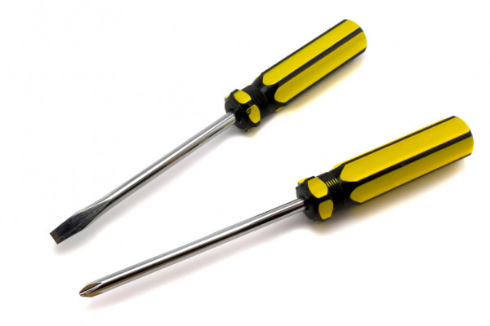
Figure 1: Screwdriver
There are two types of screwdriver, one is Flat-bladed and the other Phillips-head. Their main function is used for screwing and unscrewing screws. The most essential tool used in assembling computers is Phillips-head screwdriver since nearly all types of screws used in computers are Phillips-head. However, keeping a Flat-bladed screwdriver is convenient for getting extra leverage or prying things apart.

2.0 Anti-static Mat
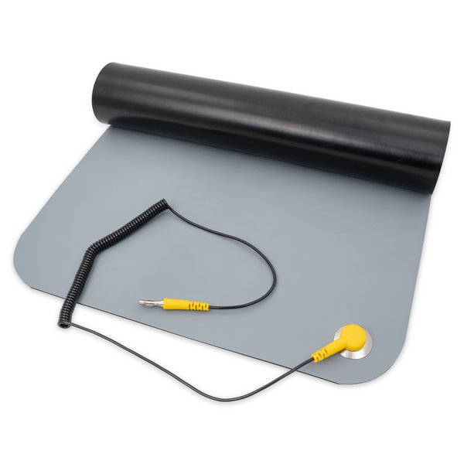
Figure 2: Anti-static Mat
Anti-static mat allows us to ground ourselves and the work surface to prevent damage from electrostatic discharge (ESD). It is important to dissipate the static electricity of individuals or objects and the buildup of static electricity in the work environment to avoid electric discharges on circuits and sensitive electronic components. Another inexpensive way to ground yourself is by using an ESD wrist strap clipped to a grounded object or plugged into the ground socket of any wall outlet.

3.0 Needle-nose pliers
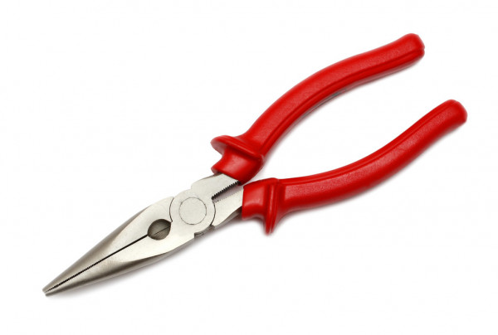
Figure 3: Needle-nose pliers
Needle-nose pliers commonly used to cut and bend small wires but they come in handy for reaching into tight spots when assembling computers. Sometimes the heads of cheap screws get stripped, we can solve this problem using needle-nose pliers to remove it and replace the stripped head crews.

4.0 Thermal Paste


Figure 4: Thermal paste
Thermal paste also known as heat sink compound is a sticky paste that is used as an interface between Central Processing Unit (CPU) heat sinks and heat sources. It is necessary to fill in the microscopic imperfections in computers that could prevent the CPU from cooling properly due to the trap air particles between CPU and the heatsink. Although most CPU coolers come with it, it is better to apply a new layer to ensure freshness.

5.0 Light Source

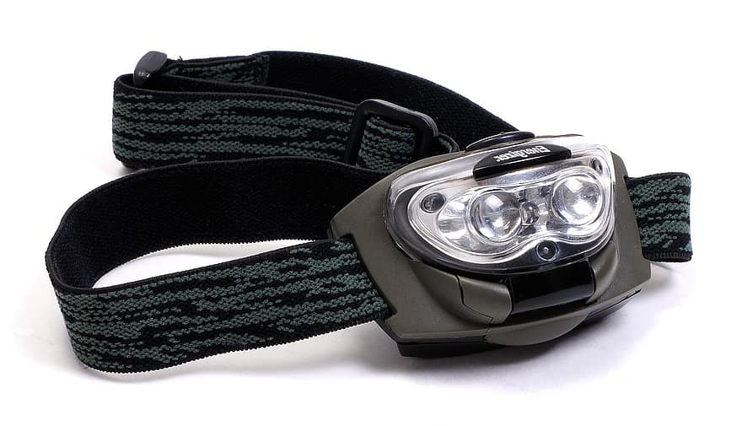
Figure 5: Light source
A headlamp always gives a direct light source for the parts you are working on so no screws are missed and components are properly installed. Considering if personal computer (PC) cases are difficult to see in low light because they can be full of shadows, light sources from headlamps will always point in the right direction.

Part B : Sketch of a motherboard layout

Sketch Diagram

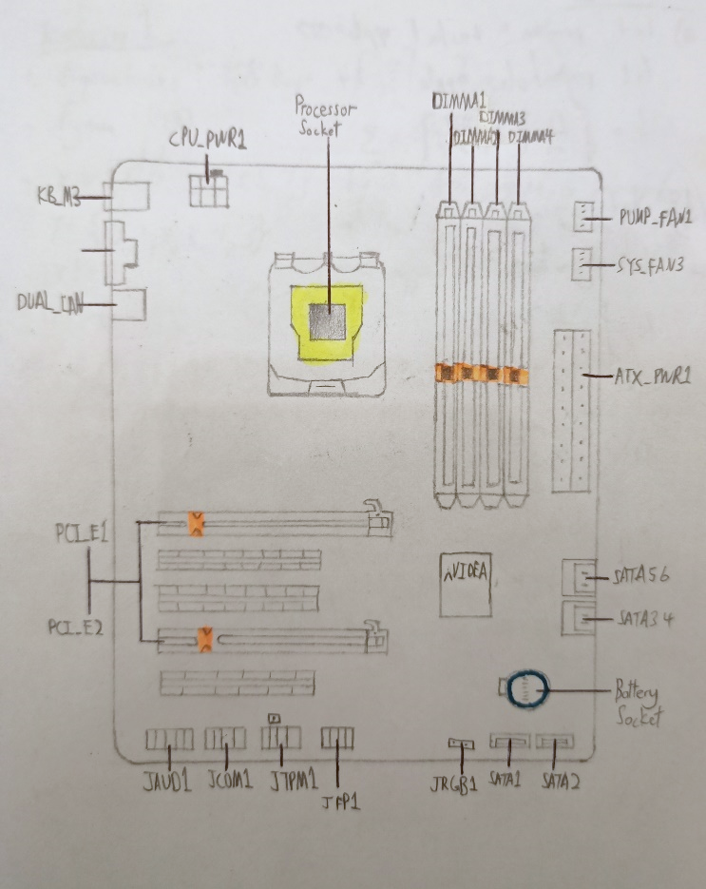
Figure 6: Sketch of motherboard

2.0 Explanation Of Function And Example Of Model

NAME | EXPLANATION
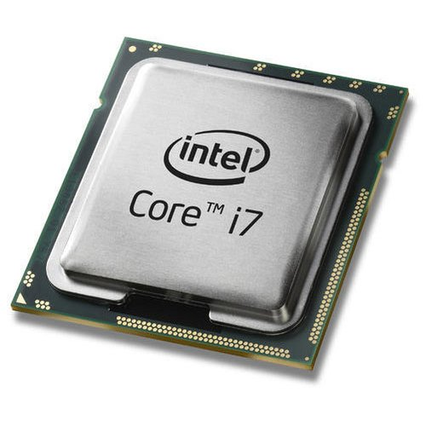  Figure 7: Processor / Central Processing Unit (CPU) | Features- has a small chip that resides in computer and other electronic device. The single chip called microprocessor  Function – receive input and provide the appropriate output.  - It has to basic component  - Control Unit : tells the rest of the computer on how to process out any instructions  - Arithmetic - logic unit (ALU) : perform 2 types of operation :  - Arithmetic :  - addition, subtraction, multiplication, and division  - Logical :  - comparison (=), less than (<), or greater than (>) the other)
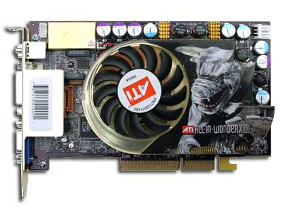  Figure 8: Graphic Card, Graphic Adapter, Graphics Controller or Graphics Board | Features : A type of display adapter or video card. Use advanced graphical technique, features and functions.  Function : It is installed in most computing devices to display graphical data with high clarity, color, definition and overall appearance.
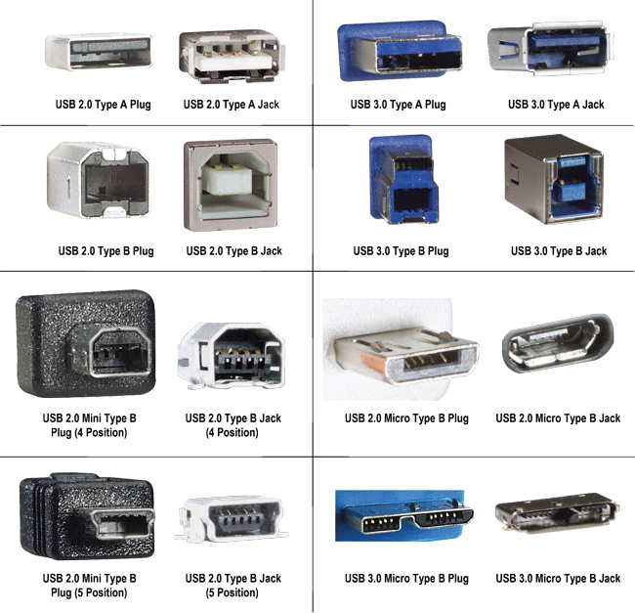  Figure 9: USB Cable | Features : USB stands for “Universal Serial Bus “.  Function : Used mostly to connect computers to peripheral devices such as cameras, camcorders, printers, scanners, and more.
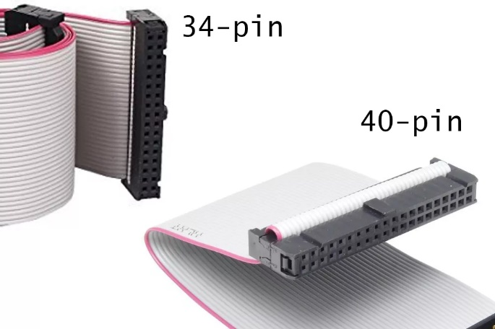  Figure 10: IDE Cable | Features: Implementation of IDE  - PATA(Parallel ATA)  | older |  - SATA(Serial ATA)  | newer |  Function : Refers type of cables and ports used to connect some hard drives and optical drives to each other and to the motherboard
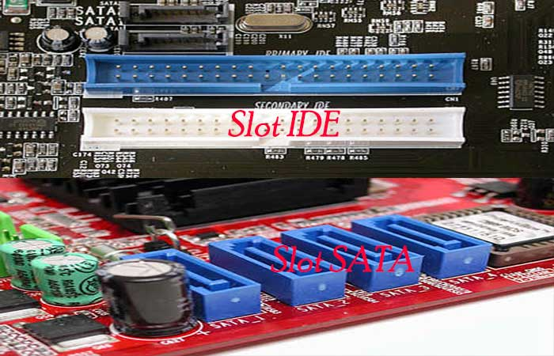  Figure 11: Slots (IDE, PC) | Features of IDE SLOT: longer physical  Features of SATA SLOT: smaller than how IDE slot looks like , do not use to many surface area.  Function : IDE and PC slots has the same function which is connecting hard disk or CD -ROM to motherboard.
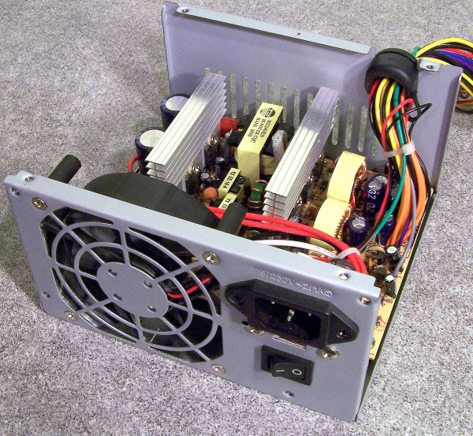  Figure 12: Power Supply | Features: It receives power from an electrical outlet and converts the current from AC (alternating current) to DC (direct current), which is what the computer requires.  Function : Hardware component that supplies power to an electrical device.
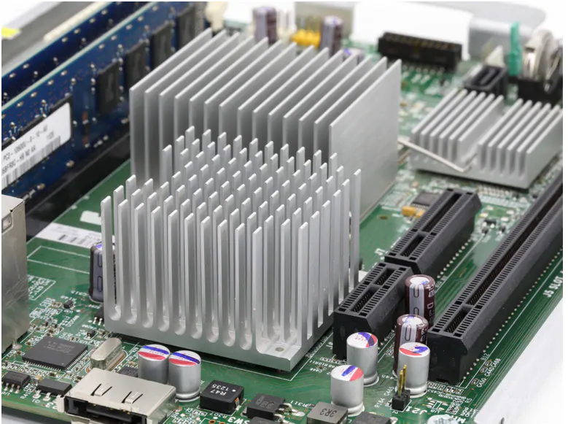  Figure 13: Heatsink | Features: Increasing the device's working surface area and the amount of low-temperature fluid that moves across its enlarged surface area  Function : A component that increases the heat flow away from a hot device.
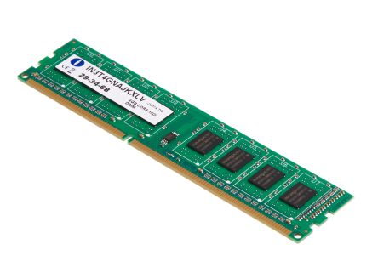  Figure 14: RAM (Random Access Memory) | Features: Type of computer memory  Functions : Temporary or volatile storage because their content are lost if interrupted.  Examples:  - Cache Memory : high-speed holding area for frequently used data and information  - DIMM(dual in-line memory module) : expand memory\  - Virtual memory : divides large prohrams into parts that are reas into Ram as needed.
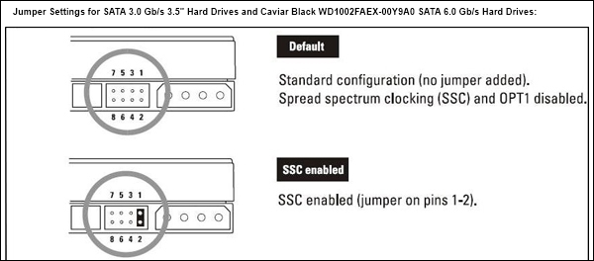  Figure 15: Hard disk (jumper setting) | Features :  - The jumper pins are similar to the pins on the I/O plate on a motherboard  - SATA hard drives  - Offers superior bandwitdth in much smaller package.  Function :  - enable particular settings by placing a jumper shunt onto specific pins—creating an electrical circuit between them.  - enable are hard-coded onto a drive's programmed printed circuit board  - Slave ( Secondary ) hard drive needs no jumper setting  - When a slave drive is installed, the master drive (the primary drive) must have a designated configuration to tell the computer which drive is the primary boot drive.
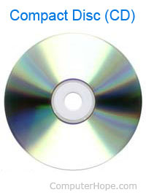  Figure 16: CD-ROM (Compact Disc Read-Only Memory) | Features :  - Contains Audio or software Data which memory is read-only  - Used CD-ROM Drive or Optical Drive to read them  Function : store non-volatile information in the form of a compact disc that is read by optical means
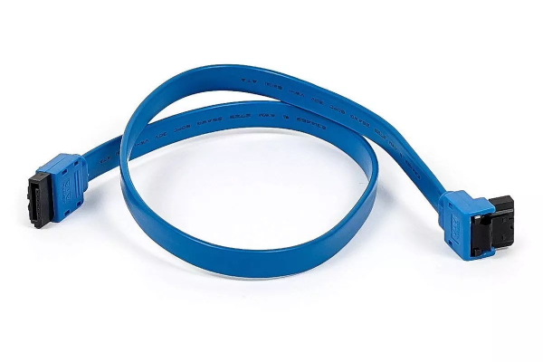  Figure 17: SATA Cable (Serial Advanced Technology Attachment) | Features :  - an IDE standard frist released in 2001  - transfer speed are higher than PATA  Function :  - Connect devices in computer cable Assemblies  - For examples Connect a mass storage device to a host bus adapter such as motherboard like hard disk drives and optical drives

Part C : Step-by-Step PC Assembly

Step 1 : Installing RAM

- Unpack the motherboard and place it on a dry surface which is also non electrostatic.
- Open the RAM slots clips, each RAM slot will have two small clips at either side. Press these down to open them.
- Line up RAM with notch and push down gently in the middle or with two hands in either side of the ram.

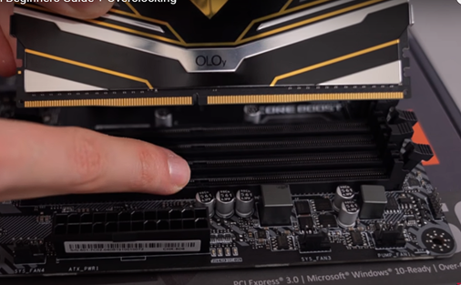
Figure 18: Line up RAM with notch

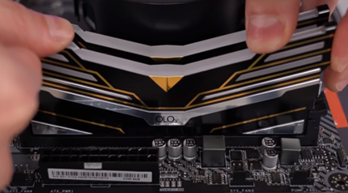

Figure 19: Push down RAM gently

Precaution 1: If the ram is not aligned with the notch before insertion, you will damage the RAM
Precaution 2: Always handle the motherboard by holding the sides.
Tip 1: If you are using more than one memory for example 2 memory sticks (RAM), use your motherboard manual to know which ram slots to prioritize for dual channel memory. Some motherboards come printed to indicate the slots for dual channel memory.
Tip 2: Using your motherboard box as a surface to place the motherboard and work on it is a cheap and great idea.

Step 2 : Install Central Processing Unit (CPU) & Heatsink

- Keep retention arm of the motherboard CPU socket open (Up Position).
- Line up CPU.
- Look for a matching indicator on the corner of CPU and the socket.
- Very gently shift it around.
- Close the retention arm.
- Apply thermal paste to the exposed portion of processor (spread in an even thin layer).
- Align the heatsink above the CPU .
- Clamp the heatsink in place using proper mounting technique by lifting a tab over a mounting clip or screwing the heatsink to the board after removing the brackets, based on your heatsink.
- Plug the power connector for the cooling unit into the fan header on the board.

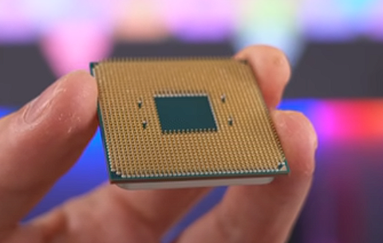
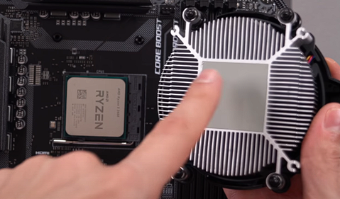
Figure 20: CPU
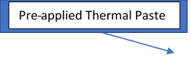
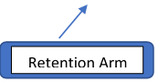
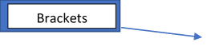
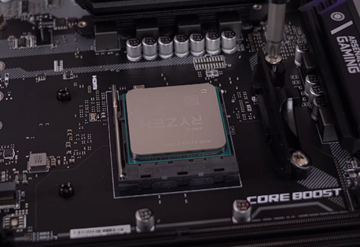
Figure 21: Pre-applied Thermal Paste
Figure 22: Brackets and Retention Arm

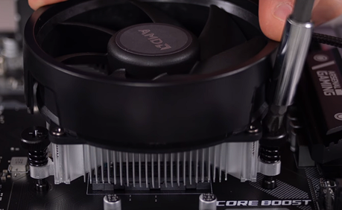
Figure 23: Heatsink
Precaution: When holding your CPU, it is best practice to only touch the sides. Touching the underside or the metal lid can get undesirable residue on them that may affect performance
Tip 1: The matching indicator on the corner of CPU and the socket is normally a triangle.
Tip 2: Use a criss-cross pattern to screw in the heatsink to make it easier.

Step 3 : Install Motherboard

- Measure and install the IO shield by pushing it into a gap at the rear of the case .
- Fit the standoff screws where there are screw holes.
- Put the motherboard in the case.
- Screw the motherboard down.
- If your case did not come screwed in fans. Screw all the fans given or bought now.

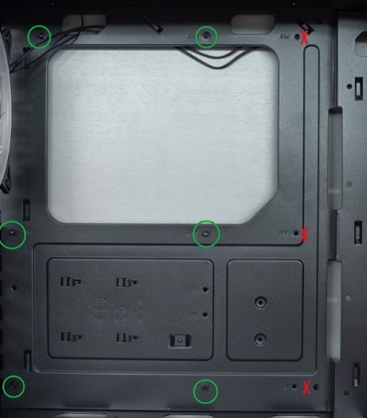
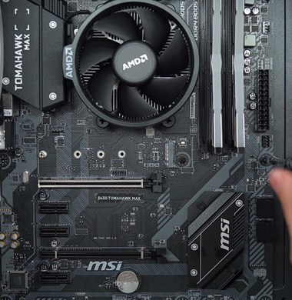
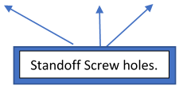
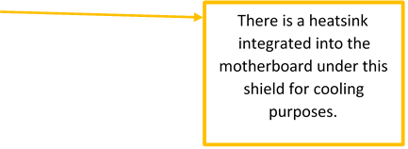

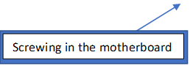

Figure 24: Standoff Screw Holes
Figure 25: Screwing in the motherboard
Precaution: Don’t use a automatic screw driver when screwing the motherboard into the case. You might damage the motherboard.
Tip: Use the crisscross pattern to screw in the motherboard into the case.

Step 4 : Install Hard Drive

- Fit the Hard Disk into a hard disk bay.
- Plug in the SATA Power Cable into the hard disk.
- Plug in the SATA Data Cable gently into the rear of the hard disk and the other end to the IDE slot of the motherboard. A SATA data cable can be also referred to as a type of IDE cable.

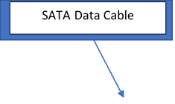
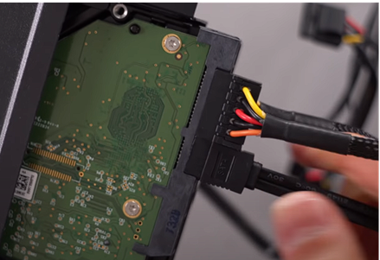
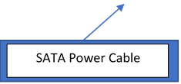
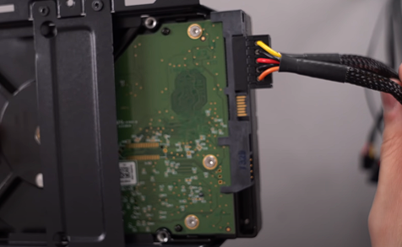
Figure 26: SATA Data Cable
Figure 27: SATA Power Cable

Step 5 : Install Power Supply

- Set the power supply's voltage switch to off.
- Insert the power supply (PSU). The power supply should have a distinct "back" with plugs and a fan, as well as a "bottom" with a fan on it. The "back" should face the back of the case, while the "bottom" should face the internal part of the case.
- Screw the power supply into place.
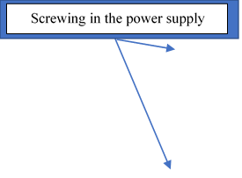
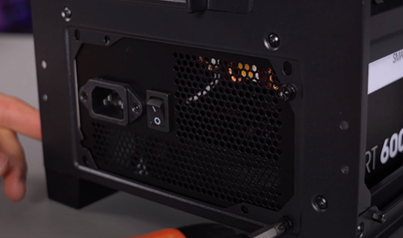
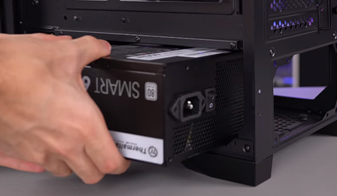
Figure 28
Figure 28: Power Supply

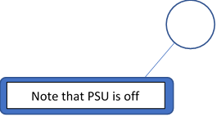

Figure 29: Screw the power supply
Tip 1: Using a module PSU will give you better cable management in the end. As not used cables can be unplugged.
Tip 2: Do not forget to put in the dust filter provided by your case manufacturer for the air intake in the PSU fan area.

Step 6 : Install CD ROM

- Adjust the jumpers on the back of the drive. Most drives use "Master" as the default setting.
- If the CD drive will be an extra one, set the jumper setting to "Slave".
- Slide the CD drive into the drive bay on the computer.
- Plug in the SATA power cable to the PSU and the CD drive.
- Plug in the SATA data cable to the motherboard’s IDE slot from the CD drive. A SATA data cable from a CD ROM can be also referred to as a type of IDE cable.
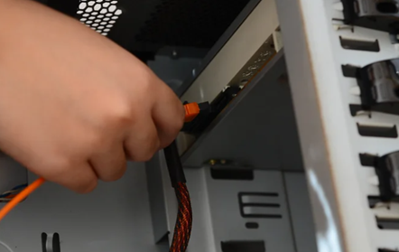
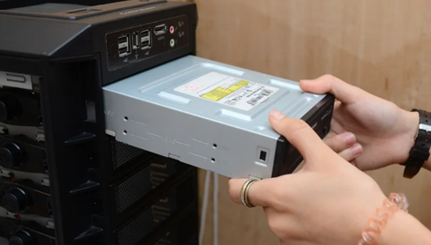
Figure 31: CD ROM
Figure 30: Plug SATA power and data cable
Tip: If your CD drive has a locking mechanism. Fasten the CD-ROM drive with the locking mechanism, to let it steady.

Step 7: Connect All Cables

- Plug in the 24-pin cable from the motherboard to the PSU to provide power to the motherboard.
- Plug in the 8-pin cable for your CPU to the 8-pin socket in the motherboard and the other end to the PSU.
- For IDE drives, align pin 1 (the red edge) to the connector on the CD/DVD drive. Then connect the 4-pin power connector to the drive.
- For SATA drives, align the notch to the connector on the drive. Then connect the SATA power connector (the long one) to the drive.
- Plug in all the cables from your case to the its sockets in the motherboard. Normally these sockets are located at the bottom of the motherboard.
- Plug in all 4-pin fan cables into your motherboard.
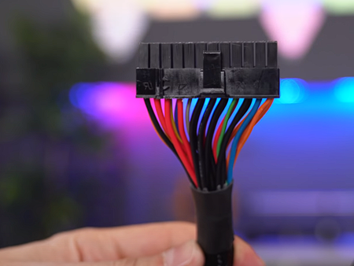
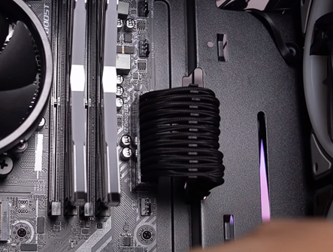
Figure 32: 24-pin cable socket in the motherboard

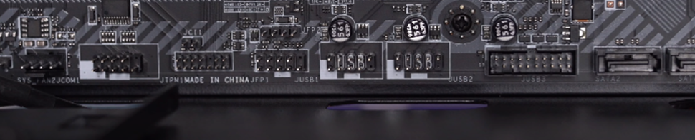
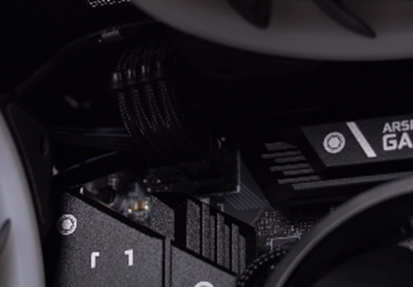
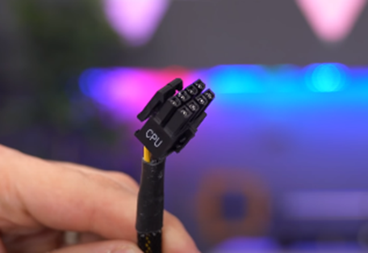
Figure 33: Sockets for the cables from case (JFP1 socket)
Figure 34: 8-pin cable for CPU power

Figure 32 : 24-pin cable for the motherboard
Figure 33 : 24-pin cable socket in the motherboard

Figure 35: 24-pin cable for the motherboard

Figure 36: 8-pin cable socket in the motherboard

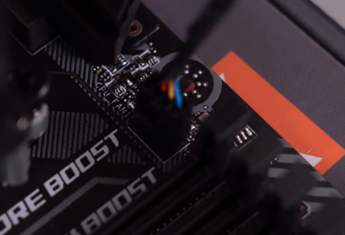
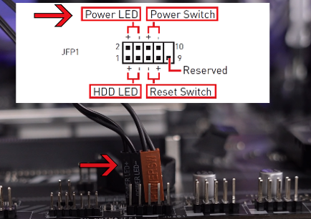
Figure 37: 4-pins fan cables socket
Figure 38: JFP1 socket
Figure 37 : JFP1 socket

Tip: Please tidy your cables at the back of the CPU with cable ties. It makes it easier to close the side panel. Cable management is extremely important.

Step 8: Installing Graphics Processing Unit (GPU)

- Remove the 2 corresponding PCI-e brackets in your case to your motherboard’s first PCI-e slot.
- Insert the GPU (Graphics Processing Unit) straight into the empty PCI-e slot or PC slot after unlocking the pin.
- Apply even pressure to the top until it is fully seated and after you heard the click of the pin of the PCI-e slot locking in place.
- Screw in the GPU to the respective brackets.
- Plug in the PCI-e power cable from your PSU to the GPU to provide power.
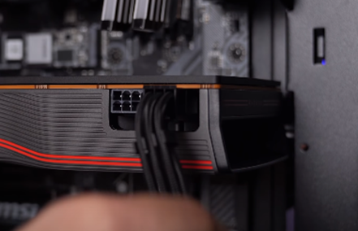
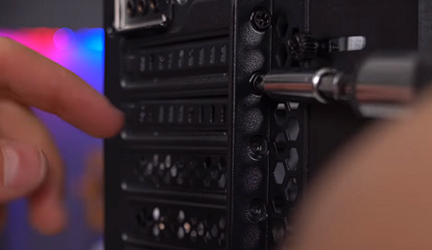
Figure 39: PCI-e power cable socket in GPU
Figure 40: Brackets unscrewed for GPU

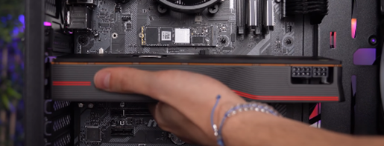
Tip: Please use the top PCI-e socket for your GPU if you need more performance from your GPU and you have more than 1 PCI-e socket.

Figure 41 : Inserting the GPU into the PCI-e socket
Figure 41: Inserting the GPU into the PCI-e socket

Step 9 : Connecting All The Peripherals After Closing The Case

- Place both side panels of the computer case back on after inserting the tabs into the rail slots of the computer, then screw it using the provided screws.
- Connect peripheral devices which include keyboard, mouse, printer and webcams with your CPU by plugging into USB port. Since all of this devices use USB cables.
- Then, connect speakers and microphone into 2.5 mm sockets.
- Finally connect the CPU with monitor by plugging into display ports of the GPU.
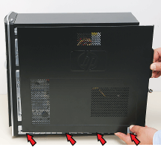
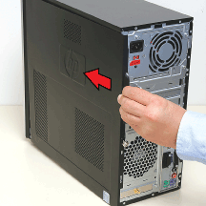
Figure 42: Place the side panels back
Figure 43: Place the side panels back

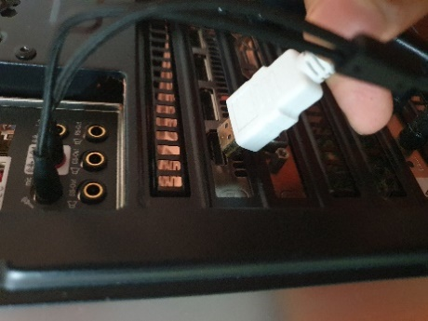
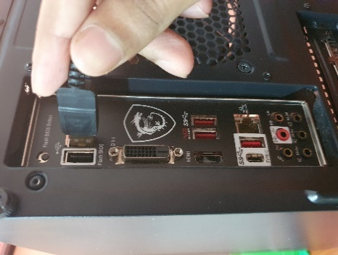
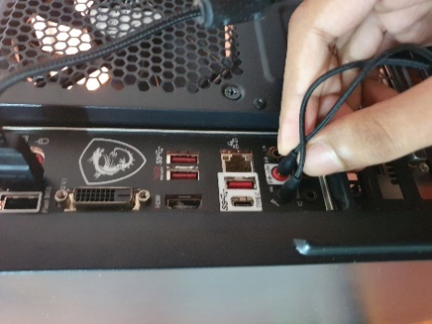
Figure 44: Connect all the peripherals

Precaution : If the CPU used is an APU version (Accelerated Processing Unit) the diplay port used should be the motherboards display port. Because no display card is needed, an APU has a built in CPU and GPU in the chip.

