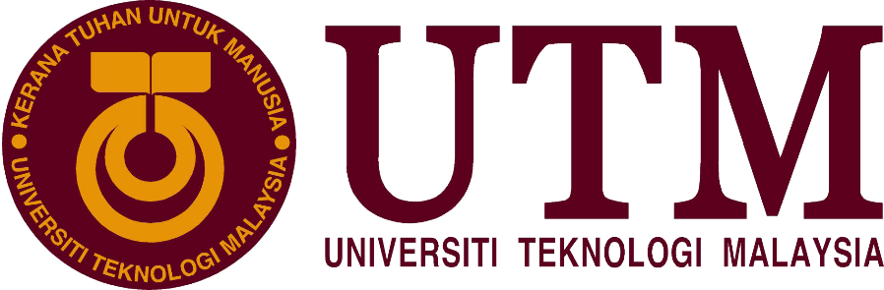

**Industrial Visit Report 2**

# **ASEAN Data Analytics eXchange (ADAX)**

Course/ Section: SCSP/ Section 03

Lecturer’s Name: Dr. Sharin Hazlin Huspi

Group Members: Ng Jing Jie (A18CS0172)

Rachel Lim Jia Chyi (A18CS0236)

Tan Rouxuen (A18CS0257)

Yoo Kah Hoo (A18CS0281)

**Contents**

|  |  |  |
| --- | --- | --- |
| **No** | **Title** | **Page** |
| 1. | Details of journey | 2 |
| 2. | Introduction | 3 |
| 3. | Details of Description | 4 - 15 |
| 4. | Reflection | 16 |
| 5 | Conclusion | 17 |
| 6. | Reference | 18 |

**Details of Journey**

# On 26th October 2018, students of Data Engineering course were arranged to visit ASEAN Data Analytics eXchange (ADAX) in Kuala Lumpur. We were required to gather at the foyer of the building by 8.30 am. Then, we moved into the office and had some breakfast that provided by ADAX. We were giving some talks on big data by some speakers who are Mr. Mohamad Nazir Bin Ismail, Ms. Josephine Ong, Mr. Gan Chun How and Dr. Mark Chia. The talk took 2 hours and a short Q&A session was held for 15 minutes. The question proposed by the students were answered patiently by the speakers. After that, we were led by the staff to visit a few places in their office. The design of the office is very modern and the working environment is very comfortable and stressless. ADAX also provide us lunch before ended the visit at 1.00 pm.

**Introduction**

ADAX is formed by Malaysia Digital Economy Corporation(MDEC) is a one-stop hub to pull the data technology ecosystem together to create the solution and adopt the technology. ADAX was established at the end of 2016 was to build and enhance Malaysia’s big data ecosystem. The aim of ADAX is to build a critical mass of talent pool in big data analytics field.

The focus area of ADAX is on Data Analytics, Data Science, Internet of Things (IoT) and Artificial Intelligence. ADAX collaborate with some training partners and universities such as Celcom, Help University and Universiti Teknologi Malaysia (UTM) to develop talent in this field. ADAX also promote technology about data science and artificial intelligence to community events and it is a soft landing place for global data science and artificial intelligence company. By developing the ecosystem, ADAX foster cooperation among business, start-ups and academia so that data analytics become part of the business innovation and decision making.

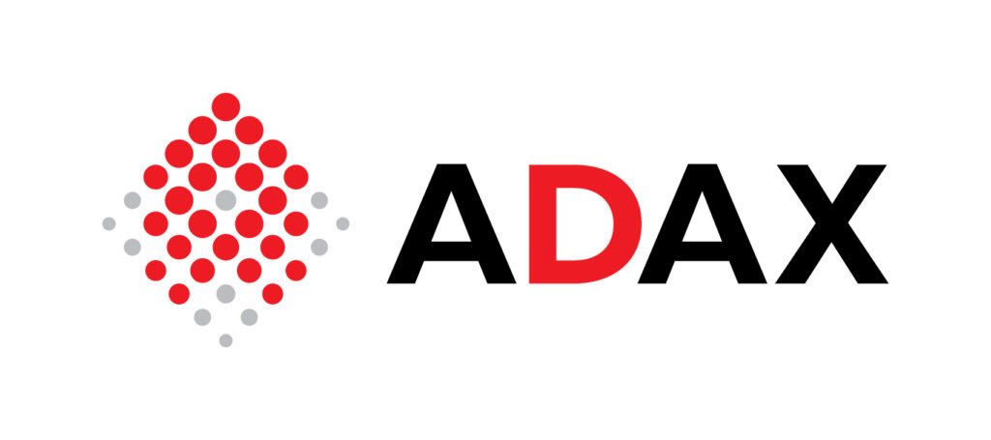

*(Figure 1 : ASEAN Data Analytics eXchange)*

**Details of Description**

The first talk is conducted by Mr Mohamad Nasir who is working in ASEAN Data Analytics eXchange (ADAX). First of all, he gave us a short brief about the introduction of ADAX where it is an initiative by MDEC to enable businesses, governments, academia and professionals to rapidly adopt Data Analytics as a tool to empower decision making and innovation. It can also considered as Data Analytics Exchange Hub for knowledge, information, resources and collaboration for the ASEAN region. The focus areas is on Data Analytic, Data Science, Internet Of Things (IOT) and initiative training workshops Then, he continued with his talk on what is the next move for ADAX. Previously, ADAX was focusing on data professional’s development and Big Data Analysis advocacy and awareness. However, ecosystem development changed the focus to advanced analytics and artificial intelligence since Aug of 2018. ADAX become a hub to catalyse data technology ecosystem that promotes 3 main things. (Figure 2).

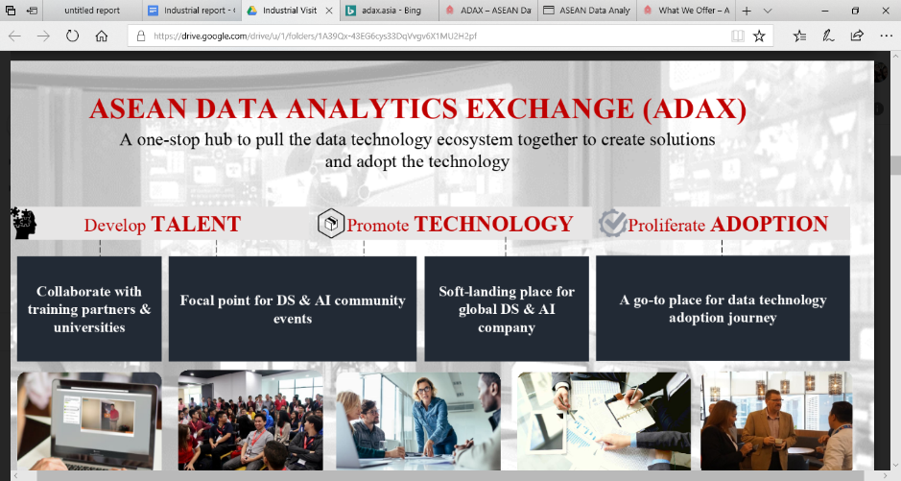

*(Figure 2 : Data Technology Ecosystem: Develop Talent, Promote Technology and Proliferate Adoption)*

*(Source: The slideshow of ADAX)*

ADAX develops talent by collaborating training partners and approaching at University such like Universiti Teknologi Malaysia (UTM).

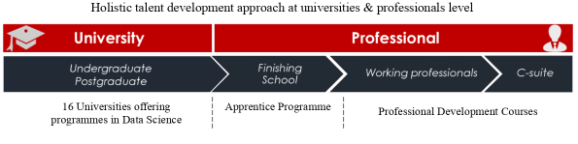

*(Figure 3 : Holistic Talent Development that Approaching at University and Professional Level [Section Developing Talent])*

*(Source: The slideshow of ADAX)*

|  |  |  |
| --- | --- | --- |
| Formal University Initiatives | | |
| Postgraduate programme in Data Science | Undergraduate degree with Data Science specialisation | Data Science module in non-ICT degree courses |
| MMU, APU, UUM, UMS, UKM, **UTM**, UM, USM, UiTM, IIUM | UM, MONASH, SUNWAY UNI, APU, UiTM, UNIMAS, MMU, **UTM**, SWINBURNE, NEW INTI, TAYLOR’S UNI | UiTM, USM, IMU, HENLEY, BUSINESS SCHOOL, UTP, HELP |

*(Table 1: Data Technology Talent Development-University [Section of Developing Talent])*

*(Source: The slideshow of ADAX)*

In the sections of developing talent and promoting technology, ADAX being a focal point for Data Science and Artificial Intelligence community events by working with private sector, university, industry organizations and NGOs on areas like industry pain points and national challenges.

On the other hand, there is a structured program for data technology adoption which means converts from a traditional company to a Data Analytic company by attending the training workshops. The objectives is to accelerate data technology adoption and to develop funnel for high impact use cases (Figure 4).

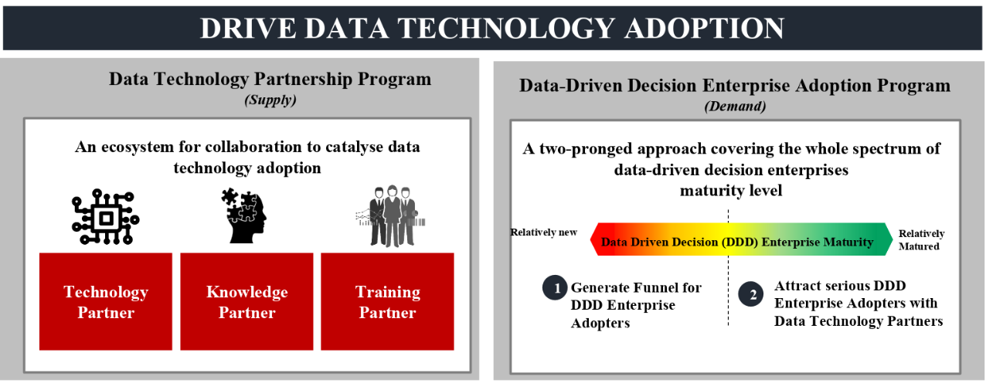

*(Figure 4: Drive Data Technology Adoption [Section Proliferate Adoption])*

*(Source: The slideshow of ADAX)*

The services that available is Training, Advocacy and Partnership.

|  |  |  |
| --- | --- | --- |
| Services Provided | | |
| Training | Advocacy | Partnership |
| ADAX opens doors for training partners seeking appointment via a governance process.  ADAX simplifies quality checks before renewal of training partners. | ADAX acts as a benchmark for big data analytic syllabus and a platform for professional sharing amongst the industry.  ADAX provides crucial knowledge needed for organization that would like to explore the fundamentals of data in other data-driven sectors especially for the purpose of talent development.  ADAX serves as a platform to connect businesses with industry partners. | ADAX are proud partners with key industry players that share similar goals in contributing towards the growth of the BDA ecosystem. |

*(Table 2: The Services Provided In ADAX)*

*(Source: The official website of ADAX)*

Lastly, he had also mentioned about Datacamp for classroom which started from 2017, is an online platform that allows the students to update their knowledge with studying different data topics. It allowed 6 months of access for academics in the platform where the lecturers can also register in it. The topics included is R programming, Python programming and Data visualization. The finisher can be awarded a statement of accomplishment and having full access to entire course curriculum.

The second talk is then conducted by Josephine Ong who also works in ADAX but focusing in different profile as her job scope is talent division which is more looking forward to premier digital technique university. This initiative started from 2017 and UTM is one of the technique university.

She gave the talk about the focus areas of Digital Economy which is all the digital technology namely IOT, Cloud, E-commerce, Big Data Analytic (BDA) and Platform sharing economy. MDEC is helping the industry by promoting these digital technology to them so ADAX is looking forward talents from university to industry.

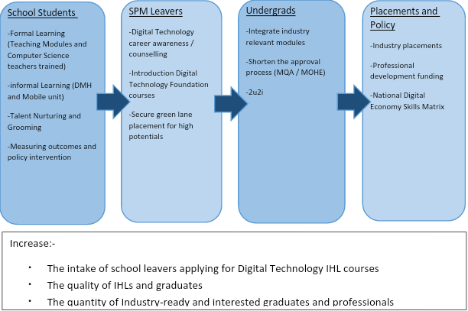

*(Chart 1 : The Things that are been doing by MDEC)*

*(Source: The slideshow of ADAX)*

MDEC is also doing Premier Digital Technology IHLs Ecosystem. Now, there are 8 university that having the Premier Digital Technology IHLs Ecosystem status where UTM is also one of them. The benefit of this status is that students and lecturers can have free training based on the relevant courses so that the graduates can be updated and get into the working environment smoothly by catching up with the industry standard.

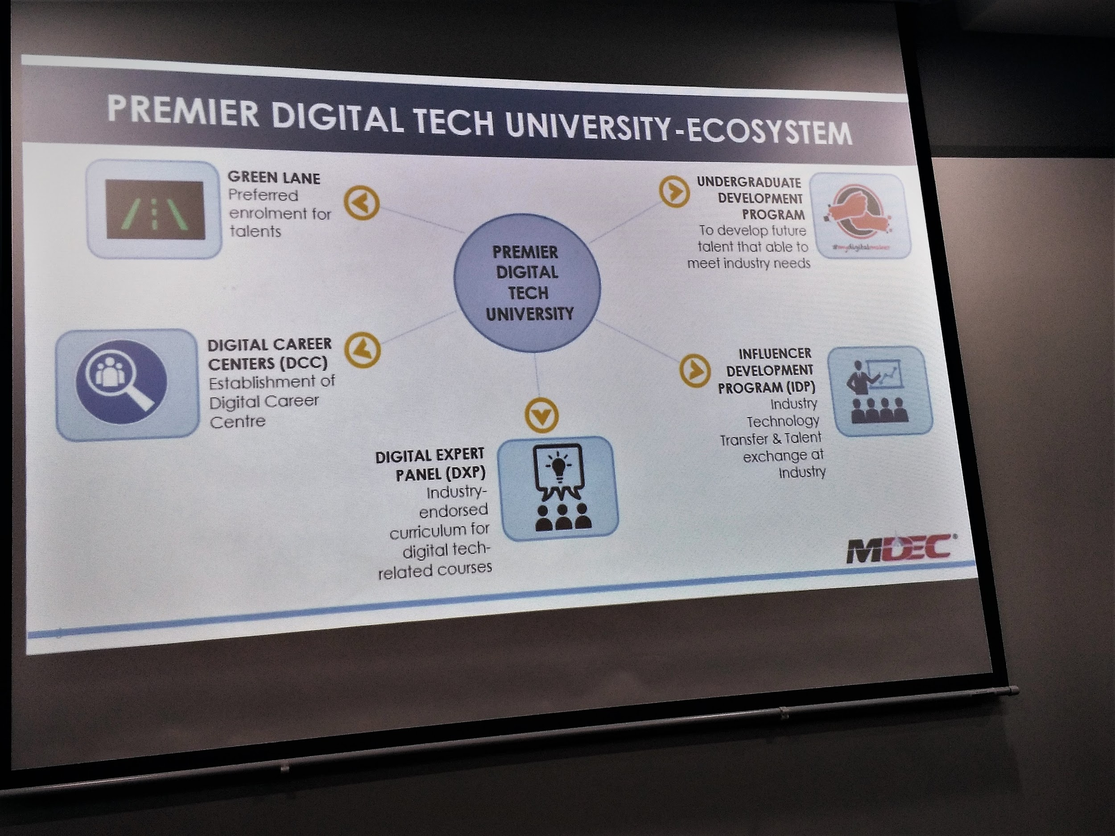

*(Figure 5 : The Program under Premier Digital Technology University)*

*(Source: The slideshow of ADAX)*

After register in Undergraduates Development Programs, students are entitled to go for free soft skills training and one specialization skill based on the courses before going for internship.

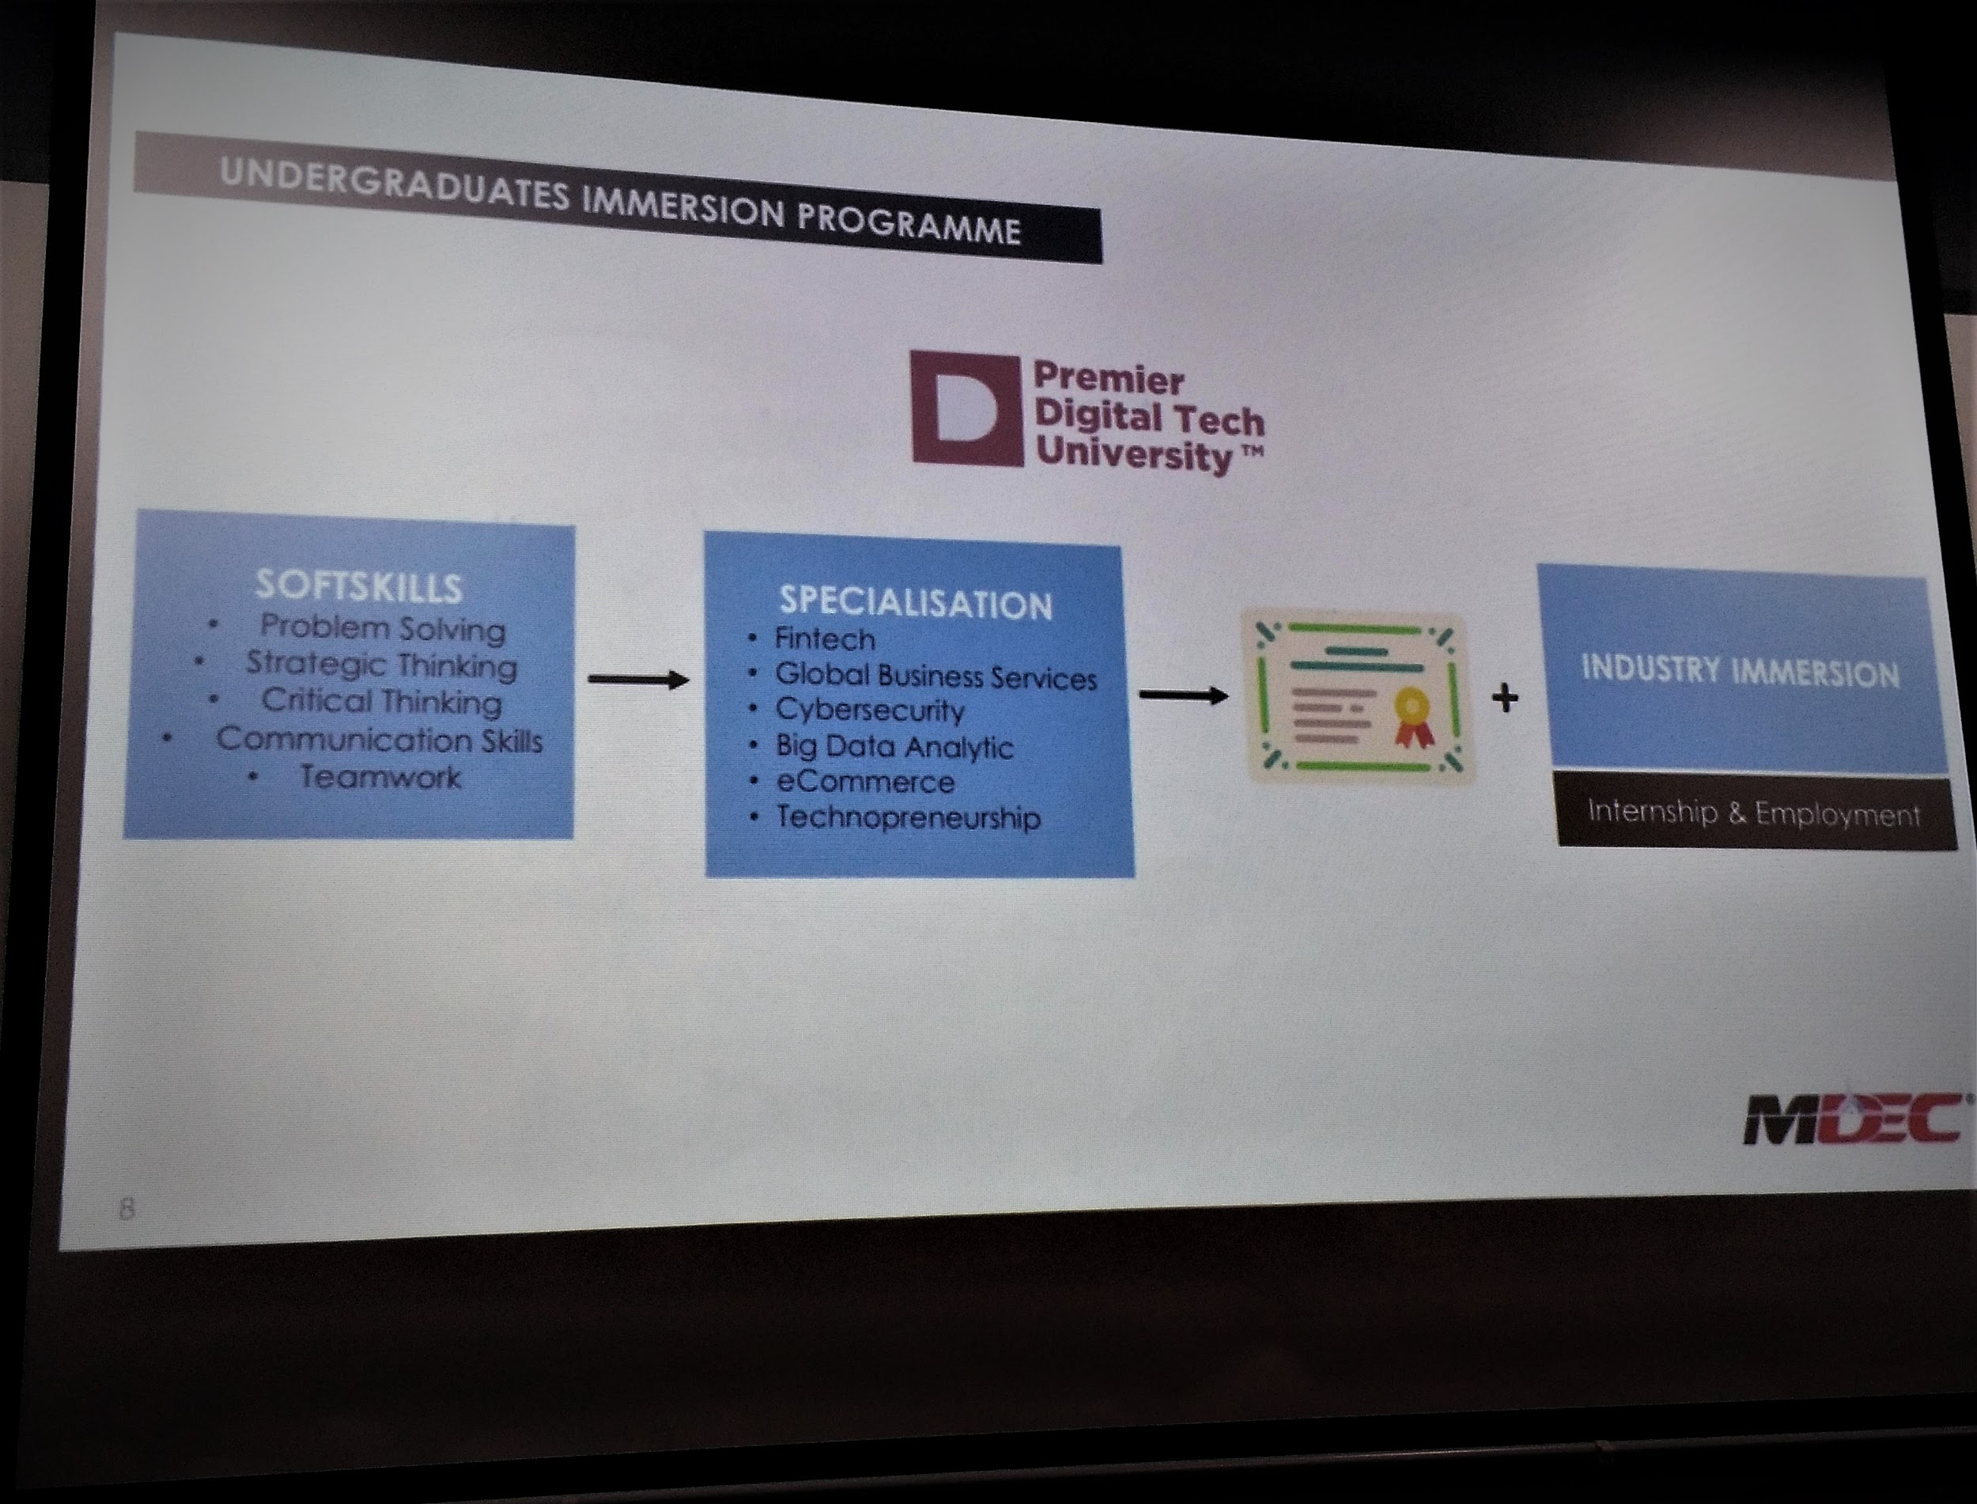

*(Figure 6 : The Undergraduates Development Programs)*

*(Source: The slideshow of ADAX)*

During the Q&A session, a student asked whether the workshop is online or physical training. The speaker answered that usually soft-skill will held in UTM campus while the specialization skill is in Klang Valley physically.

The third speaker is Mr. Gan Chun How, a solution architect from Fusionex International, a big data company with capability in advanced analytics and artificial intelligence. The topic he presented to us is about data science and data scientist.

According to Mr. Gan, data science is a concept of combining few disciplines from different majors in computer science and math, including data engineering, data analytics, software engineering, machine learning, visualization and artificial intelligence, to solve big data problem. In the other hand, data scientist is one of the roles who played in data science life cycle.

There exists a misconception where data scientists are known as “data hero” who are able to analyze all given data and provide appropriate solution, Actually, there is a cycle when providing big data solution to customers known as Data Science Life Cycle, which involve collaboration between data engineers, data scientists and data analyst.

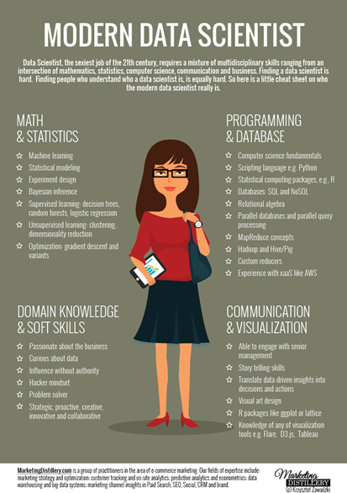

*(Figure 7: Things that what a data scientist should have. According to Mr.Gan, having all of the aspects above is practically impossible )*

*(Source:* [*https://twitter.com/mktngdistillery*](https://twitter.com/mktngdistillery)*)*

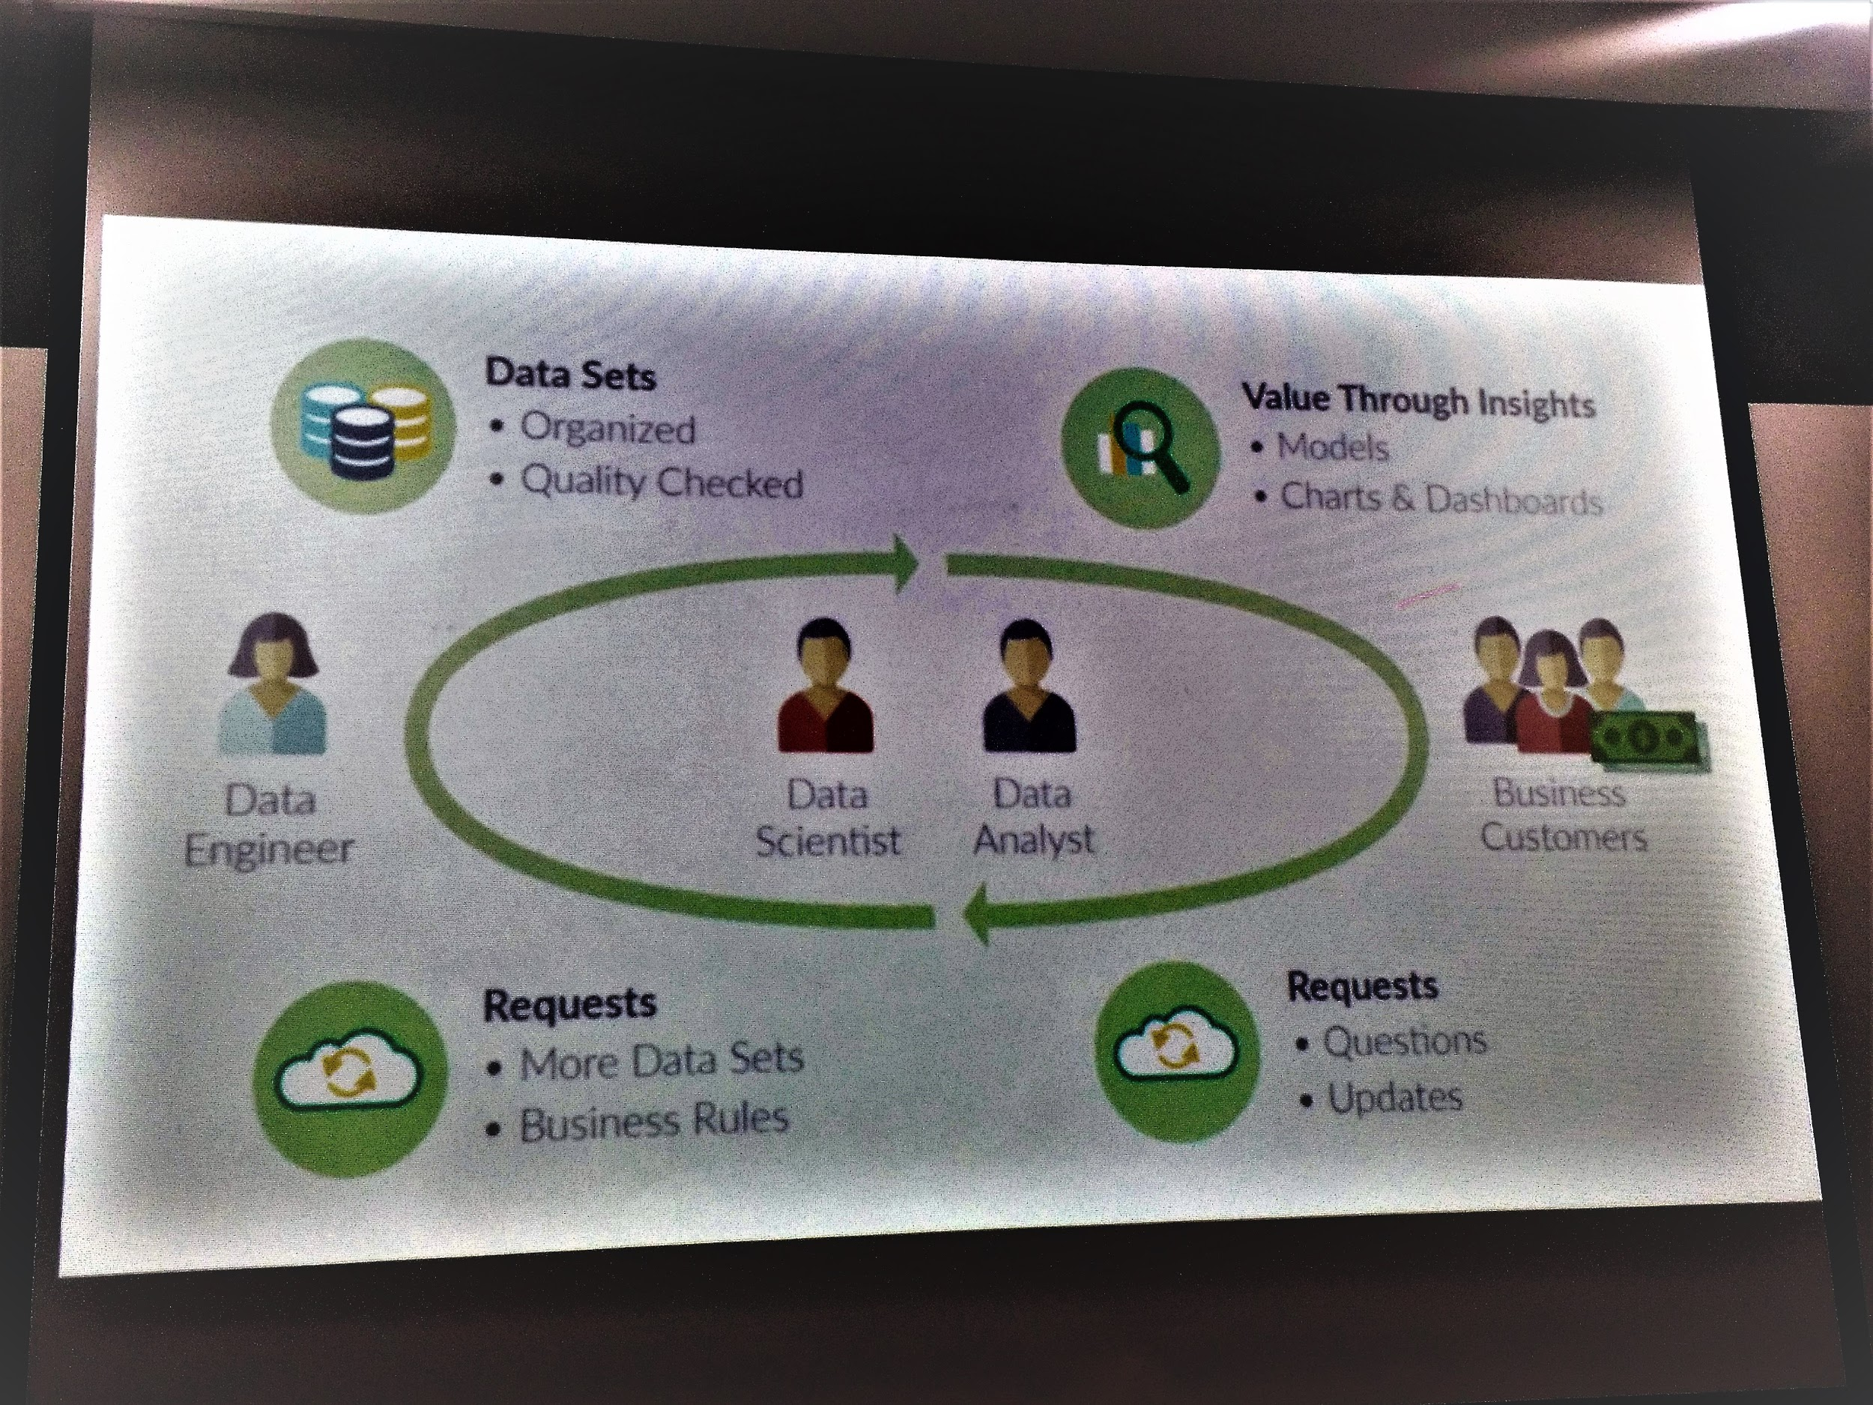

*(Figure 8: Data Science Life Cycle.)*

*(Source: The slideshow of ADAX)*

Finally, Mr. Gan showed us some examples on how big data and artificial intelligence help in solving industrial problems. In a nutshell, big data and artificial intelligence helps in lowering manpower cost, and provide personalized services to targeted clients.

|  |  |  |  |  |
| --- | --- | --- | --- | --- |
| No. | Case | Current Challenge(s) | Solution(s) | Impact(s) |
| 1 | Fresh Food Replenishment using Machine Learning | -Retailers unable to determine the right amount when placing orders with fresh-food suppliers. Either too much or too little will cause wastage or lose sales and customer loyalty respectively. | -Machine-learning algorithm is used to make demand forecasts on historical sales data and other influencing parameters. | -Reductions of up to 80% in out-of-stock rates.  -Declines of more than 10% in write-offs and days of inventory on hand.  -Increment of gross-margin of up to 9%. |
| 2. | Defective Glove Identification using Artificial Intelligence for Glove Manufacturer | -Heavy cost to employ large QA team to manually inspect the quality of the manufactured glove  -Time consuming in QC stage (manual)  -Lower accuracy rate (<50%) on the existing imaging solution identifying the defective gloves thus still require large QA team to perform second round checking. | -Fusionex Image Intelligence solution (powered by Alicloud) is used to received the images captured by the existing imaging system and immediately classify the quality of the gloves and identify the root cause of the defective glove.  -The solution is running on Deep Learning algorithm, with the auto learn and capability on the model. | -Accuracy rate improved up to 96%  -The algorithm able to detect the defective glove within 0.3 seconds for every glove. |
| Other scenarios:   1. “Hangzhou City Brain” Master Plan    1. Using Alibaba Cloud’s AI and deep learning technologies    2. Control the traffics to ease traffic congestions 2. Application (such as online shopping platform in china, Alibaba) utilize big data for personalizing buyers’ shopping experience 3. Data-driven Financial services 4. Refining image search | | | | |
|

*(Table 3: Case Studies and some scenarios on the utilization of big data.)*

*(Source: The slideshow of ADAX)*

Our fourth speaker is Dr Mark Chia, an engineer who worked in data science in SAS, the largest privately-own software company in the world, main in providing end-to-end analytic solutions to customers from different sectors, including financial sector, commercial sector, government sector, and even local and private universities. Dr Mark shared with us about the future of digital economy and the available career path for us.

Nowadays, data are almost everywhere, tracking human activities via electronics devices and internet. The data are utilized by industries to provide personalized user-experience to clients. Through his market observation, he found out that in this era of big data, analytic platform starts to exist and will slowly combine with other platforms in the future.

Besides, he also introduced his version of analytics lifecycle, which is mainly consists of data, discovery, and deployment. Below are the details of an analytics lifecycle:

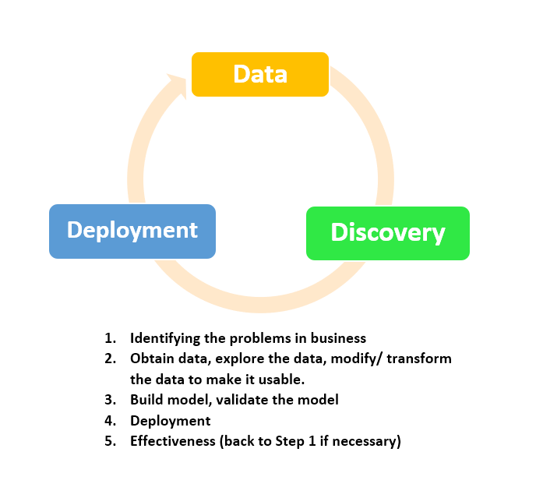

*(Chart 4: Analytic lifecycle)*

*(Source: The slideshow of ADAX)*

After that, Dr Mark shared with us about his thoughts on industrial revolution. In his opinion. 4th Industrial Revolution will be driven by a fusion of physical, biological and digital, known as digital fusion. The 4th industrial revolution will give impact to individual, society, businesses, national agenda point of view, and the world economy. Moreover, he also predicted that for the next industrial revolution, there should exist an advance technologies that gives a massive impact to global development. If that happens, the 5th Industrial Revolution will be driven by quantum computing.

In 4th Industrial Revolution, Internet of Things (IOT) connects machines and humanity. It promises human efficiencies, quality of life, early warnings, and new business models. Dr Mark also emphasized that artificial learning is getting more advanced and it’s replacing manpower, but not replacing humans as long as they unable to define “human life”.

Finally, Dr Mark introduced us on SAS Experimental Analytic Program. It is an intensive and structured 18 months program, aimed to train fresh graduates about SAS technologies, provide mentored work experience within a variety of departments, and develop the graduate to become professionally SAS certified. To join this program, two main criteria is needed: Have good communication skills and willing to learn new things. However, it is not easy to enroll into this program, as in 2016, only 6 among 600 applicants are taken.

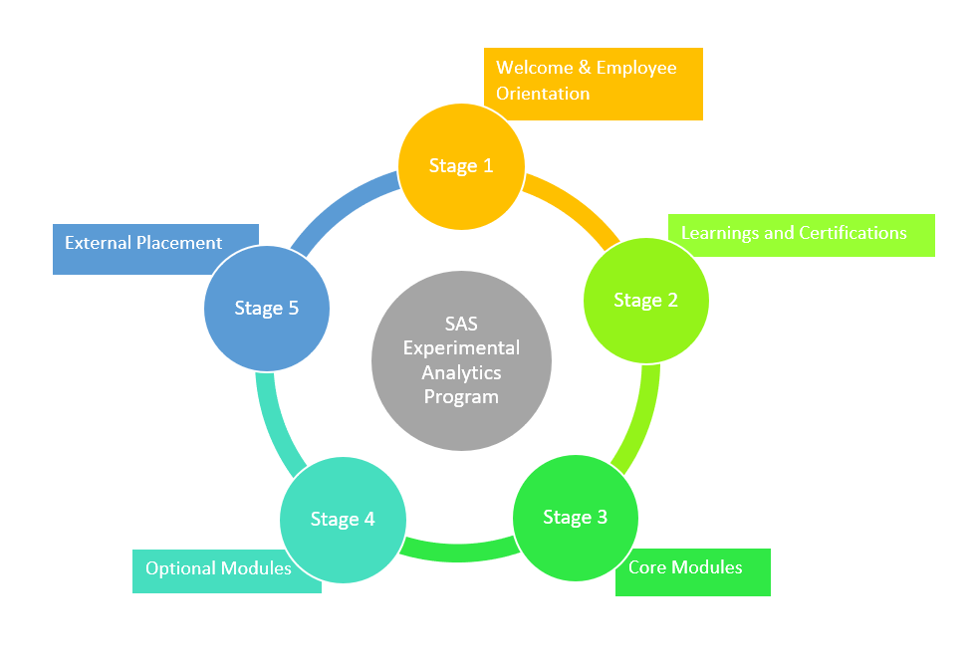

*(Chart 5: SAS Experimental Analytic Program Overview)*

*(Source: The slideshow of ADAX)*

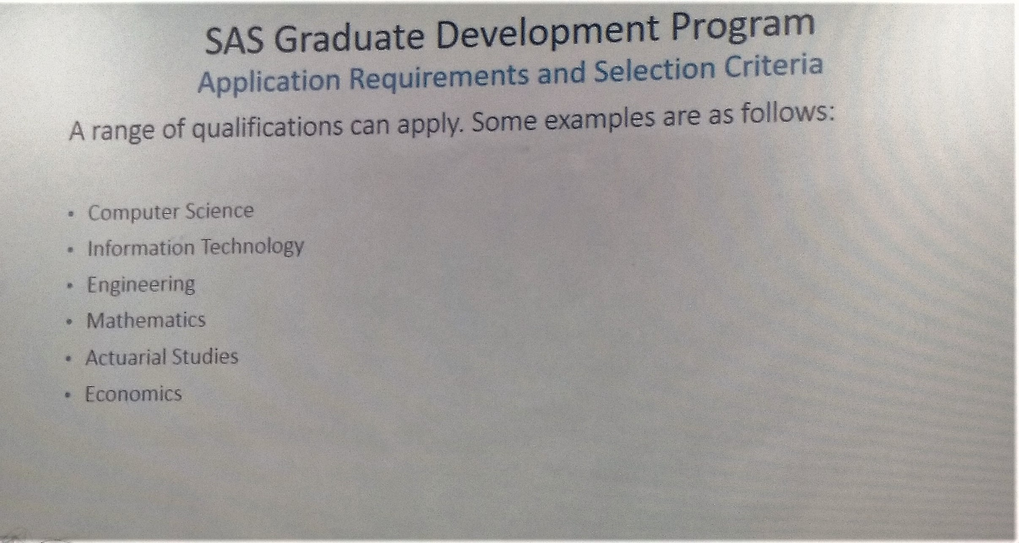

*(Figure 9: Range of Qualifications)*

*(Source: The slideshow of ADAX)*

\

**Reflection**

As we all know this Data Engineering courses is a new courses, we as student still did not have a clear mindset of this courses in the aspect of our future and career path, this industrial visit to ADAX totally change our mind and we are now have a clear mindset on our future.

Throughout the visit in ADAX, the biggest benefits we gained is in the talk session. During the talk, we gained an insight on how ADAX function where ADAX aims to develop the ecosystem and build a critical mass of talent pool in the big data analytics category. This is the time we realized the importance of data analyst and data scientist, and our role as undergraduates in this courses really matter.

Besides of all the talks given during the visit, we had a short tour in the working spaces in ADAX which is truly amazed us, the working environment is so nice and comfortable! Also, it is good to know that ADAX provides a paid finishing school training program in order to develop industry-ready Data Professionals in Malaysia. Other program they offered for example Innovative Lab, Talent Development and Start-Ups is really benefits to us as data engineering student.

We are really appreciate that visiting to ADAX gave us the idea about industry which initially lead us to decide our future career at an early stage. One main thing is, since ADAX have cooperate with few industrial company, it is a definitely good news to us as we can foreseen our bright future. To make this happen, we should be open minded, learn unconditionally from lectures and coursemates, improve our skills and knowledge in computer science. As we all know this road is hard, we should never give up until we achieve our goals which is to be a successful data analytics and data scientist.

**Conclusion**

In conclusion, the role of ADAX in big data analytics is very important, it provides a platform to discover and cultivate talent in the data analytics field. Small and medium enterprises (SMEs) need to wake up in this hyper-connected world to monetize large data sets, by analyzing and gaining insights into hidden patterns, trends and other useful information. Data will become the new gold and it will be the wheel that drives the economy of nations in the future.

**Reference**

1. .<http://adax.asia/>
2. <https://www.massa.net.my/adax/>
3. <https://www.digitalnewsasia.com/digital-economy/mdec-spearhead-bigger-push-big-data-adoption-malaysia>
4. <https://www.digitalnewsasia.com/digital-economy/boosting-data-talent-pool>
5. <https://www.linkedin.com/company/asean-data-and-analytics-exchange-adax->
6. <http://www.massa.net.my/adax/>
7. <http://www.adax.asia>
8. https://twitter.com/mktngdistillery