Name : Prema Karira Anas Sulaiman

Matric : A18CS0320

Assignment 1

1. **Reporting**

Every year, in my college major in graphic and multimedia software (SCSV) there is always a pre-graduation night celebration for graduating seniors. So, the pre-gradution night is a night where all of our majors pay their respects and offerings to seniors who have graduated and are waiting for their graduation day. This event must be attended by all generations and of course our beloved graphic and multimedia software lecturers.

Last year, the pre-gradution night was held on May 13, 2019, at the convention hall of one of the star hotels, Johor Bahru. Not to forget, the pre-gradution night committee provides buses for anyone who does not have vehicle access when going to the pre-gradution night event. At 8 p.m. the bus departs from KTDI to the hotel where the event is being held. After arriving at the convention hall, we were asked to fill out the attendance book and get a small white souvenir.

In the pre-gradution night program, each batch is required to give one attractive appearance such as singing, drama appearances, comedy stories, and so on. At that time, my generation, generation 18 ', presented a comedy drama display with a very funny storyline and interesting to watch. Besides that, the other batches also gave performance offerings. However, I have forgotten what appearance they present. After all the main events are finished, from the lecturers' remarks and others to the memorable video of the seniors who will graduate, the next agenda is to have dinner together. The typical Malaysian food menu is neatly served on white tables ranging from heavy meals to very delicious desserts to be enjoyed together. We enjoy every neatly arranged agenda. After all the events were over, my seniors and I who came from Indonesia took a photo together as a memento at the 2019 pre-gradation night.

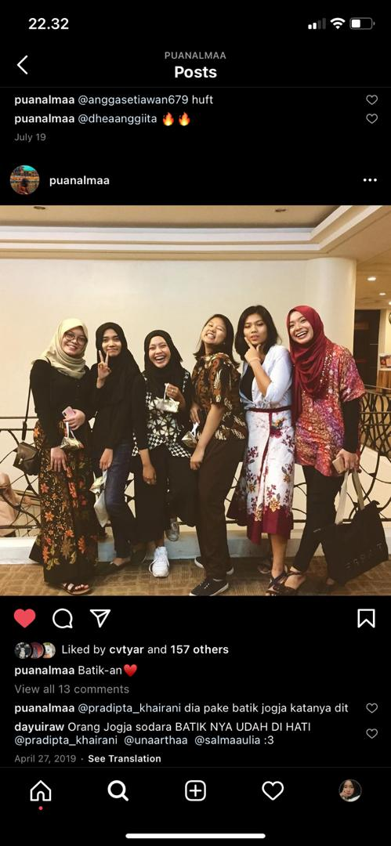

Picture 1: Here is the evidence of joined the MPG event

1. **Responding**

When there was information that all SCSV (Graphic and Multimedia Software) students had to attend this pre-gradation night, I was immediately enthusiastic about joining this event. My expectation is that this event will be an exciting event and we will gather in one room from year 1 to year 4. The dress code used is also very interesting. Malay people look attractive in their “baju kurung” and because I and also my seniors and my friends don't have “baju kurung” so we choose to wear our batik clothes.

And it's true what I expected with the reality that happened. This event is very interesting. Every event I always enjoy it well. I am very happy and also charmed, because I can meet my seniors who are difficult to meet on normal days because they are very busy with their lectures in their third year. However, we still mingled with our Malay friends. Each batch will be placed in a round table group. I and my friends chat with each other as usual. At this event, I also felt that I got to know friends of my age. I feel closer than usual, chatting and joking together at one table. I really felt happy at that time. Meet other seniors and also mingle with peers. Here I feel that they are my new family at UTM.

1. **Relating**

This event is almost the same as the mandala camp event held by the Indonesian Student Association. What the pre-gradution night program has in common with mandala camp is that we gather together with our seniors, become one circle and get to know each other. The difference from the pre-graduation night and also the mandala camp is that the pre-graduation night is held to celebrate the pre-graduation of seniors who will be at graduation. Meanwhile, the mandala camp is an event where juniors and seniors come together to get to know each other and help each other. Seeing the condition of us who have migrated to other countries, so after all the seniors are obliged to help juniors so they don't do anything wrong here.

The pre-graduan night event is one of my favorite shows at SCSV. Because, we were gathered with the seniors to celebrate their pre-graduation night. And happily their juniors will present something interesting to show on that special day. My class performs a comedy drama that is very cute and adorable. We burst out laughing together at a funny scene. The seniors also made an amazing video documentation and it makes us feel sad because soon they will become scholars and leave this UTM. Seeing the bright faces of the seniors at the pre-graduation night is something very unique to me. Where they will take something new in a different world, that is in the world of work. Those happy faces are a reflection of me when I feel like graduating too. I make them my motivation, because I will always fight like them and will ultimately feel what our seniors will feel when graduation. Perhaps, this pre-gradution evening event is the beginning of their happiness before the core graduation event held by UTM and this is the first step of their happiness to become scholars at Universiti Technology Malaysia. Becoming a bachelor is the dream of everyone who is currently pursuing an undergraduate education. Don't forget to always be grateful.

1. **Reasoning**

The most significant aspect in my opinion is that this event teaches us to respect each other, both the old and the young, the old loving the young and the young respecting the old. The purpose of collecting us in one room is to get to know and know each other between seniors and juniors. The juniors prepare and give the best offerings for seniors on this pre-gradution night to celebrate their struggles during this lecture and celebrate the happiness of the seniors before the campus graduation, so that all the generations under them also feel the happiness they feel.

At this event we juniors also felt happiness that cannot be described and expressed in words. Because, we are gathered together in a room with our seniors who will soon explore their new world, that is the world of work where the situation in the world of education and the world of work may be different. As a student majoring in graphics and multimedia software, I feel very grateful to be part of the SCSV (Graphic and Multimedia Software) family. Every year, SCSV always holds events that aim to establish closeness with one another. There are many events held here that always involve juniors and seniors from year 1 to year 4. In every event, we always share knowledge and experiences with each other, what steps should we take for the future in the following semesters, and sharing about other things too such as internships, PSM, theses and others. And at the highlight of this pre-gradution night we are giving the opportunity for our 4th year seniors to become kings in this event, because they have helped us in everything before. The seniors always provide an overview for the future in the coming semester and ideas for us from the experiences they have passed. The seniors here are very kind and humble too.

1. **Reconstructing**

As the next step that I will take from the experiences of the seniors I have to prepare is that I have to be ready with all the challenges in the following semesters. Seeing the closer I am to my thesis, I have to find more references for my thesis title. With the directions of our seniors, we have an increasingly clear view of being able to prepare what to prepare later in the coming semesters.