

SCHOOL OF COMPUTING,

FACULTY OF ENGINEERING,

UNIVERSITI TEKNOLOGI MALAYSIA,

81310 UTM JOHOR BAHRU, JOHOR.

**______________________________________________________________________**

**FIRST SEMESTER SESSION 2018/2019**

**SCSP1513**

**TECHNOLOGY AND INFORMATION SYSTEM**

**TITLE:**

**DESIGN THINKING**

**X-Impact**

**______________________________________________________________________**

**LECTURER: DR AZURAH**

**(**SECTION 08**)**

**PREPARED BY:**

MUHAMMAD DANIAL BIN JEFRI (A18CS0131)

MUHAMMAD AIMAN HAKIM BIN AHMAD RIDZO (A18CS0121)

BADRUL FITRI BIN SHAIFULL NAIM (A18CS0042)

AMIRUL MUKHLIS BIN MOHD AZLI (A18CS0030)

MUHAMMAD SYAFEI BIN SAUPI (A18CS0157)

**DEADLINE: 9 DECEMBER 2018**

**ABSTRACT**

This report will display and explain the graphical representation of the statistic based on our questions that were asked to the interviewee. With these statistics, we will then be able to determine whether or not we should continue with our “X-Impact” project. The questions that were given to the interviewee are:

1. Have you dropped your phone before?

2. How many times have it occured?

3. What cause your phone to drop and where was the impact (front, back, side, corner)

4. Would you purchase this case?

a. If Yes, what is your “point of view” on this product?

b. If No, why and how can we improve on it?

**INTRODUCTION**

Before we are able to conduct or even create the questions listed above, we had to clearly identify why we are doing this interview and what we want to gain or collect from it. We know that our product is about a case that can absorb impact from a fall, saving/protecting the phone from damages. So, we first needed to ensure that people are actually having issues with the phone being damage due to falls. Therefore, we created the questions, how many times you dropped your phone, how frequent and how did it occured.

Then, we also created a questions relating back to our prototype. There is no points in creating a prototype that no one wants to purchase. Therefore, we created the question, “would you purchase this case?” and this question is divided into two outcome. If the interviewee is willing to buy the product, we want to know why they want to buy it. This is because we want to find the ‘niche’ factor in our product. Similarly, if the interviewee says “no”, we want to know why. With this information, we will then know how to improve our prototype for the final product.

**PICTURES FROM THE** **INTERVIEWING**

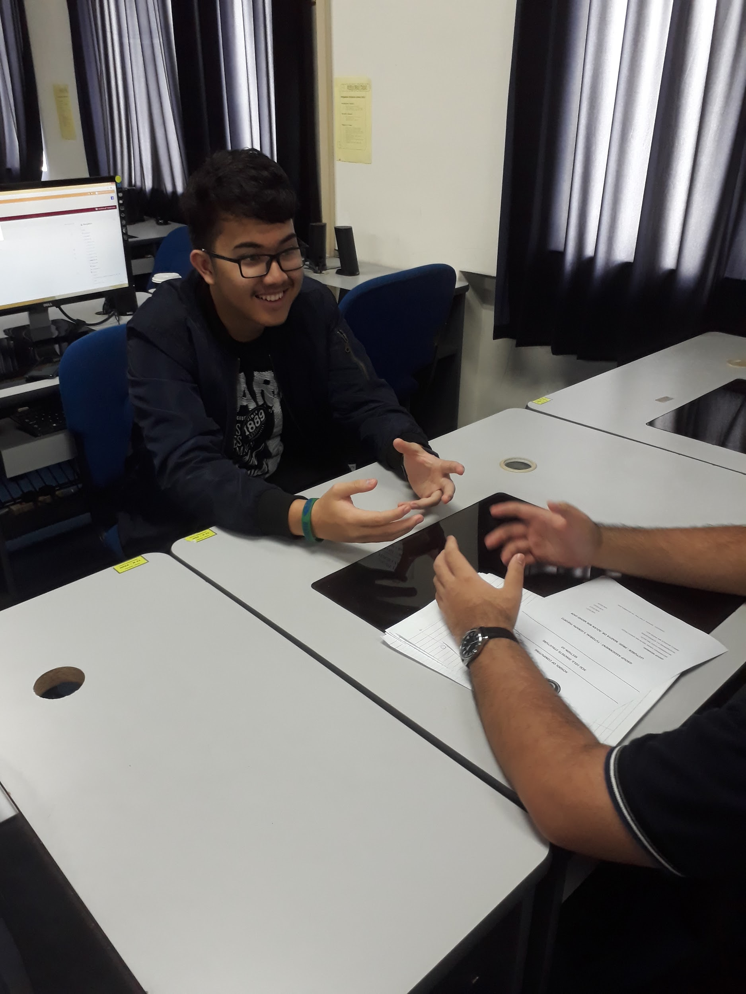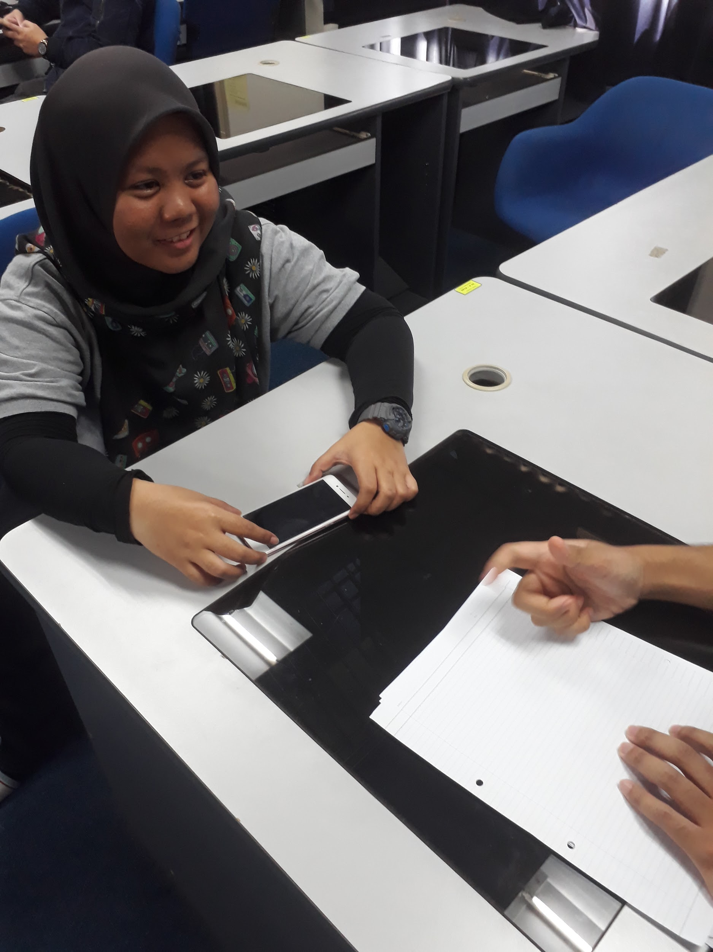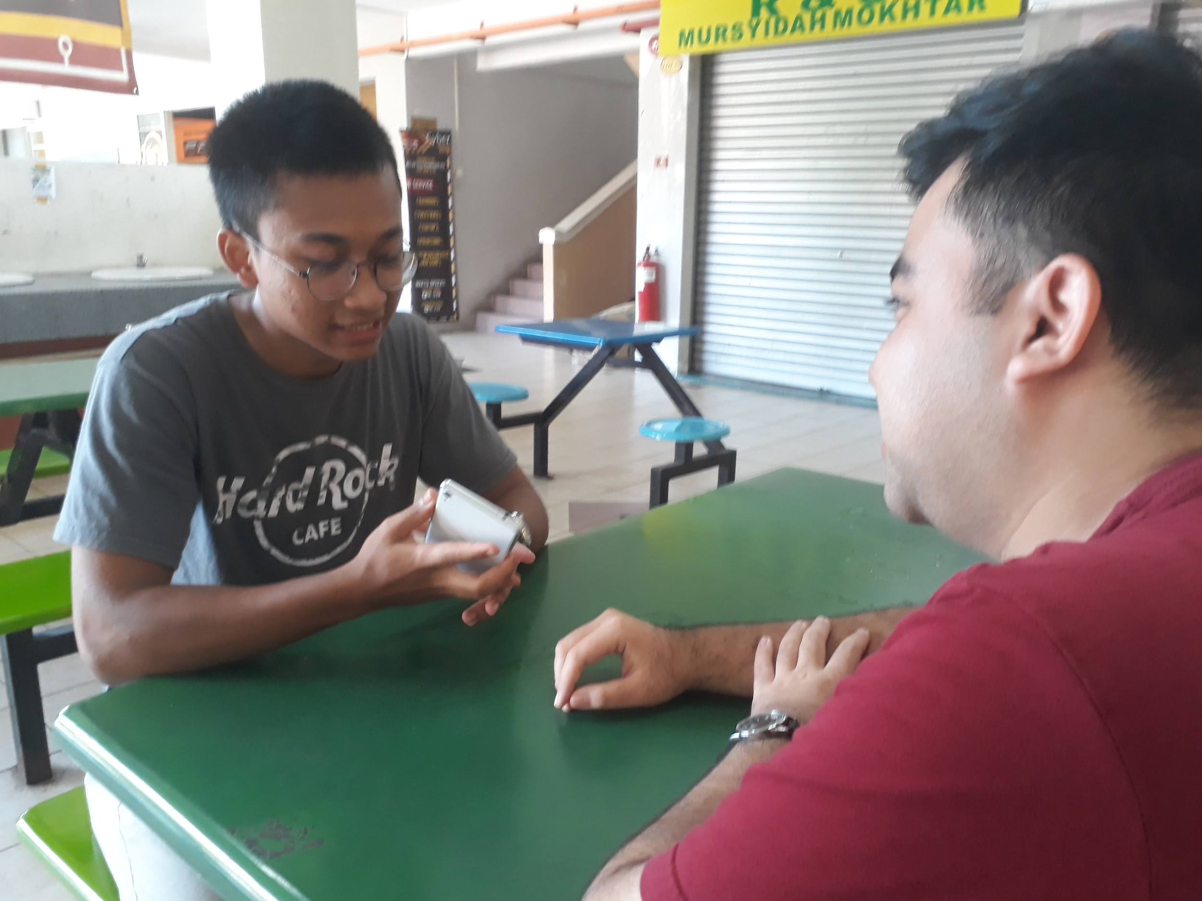

**ANSWERS AND FEEDBACKS FROM THE INTERVIEWEES**

|  |  |
| --- | --- |
| **Name of Interviewee** | **Answers and Feedback** |
| **Interviewee 1: Aris** | 1.Yes.  2.For a several time.  3.Because of the phone doesn’t use any casing and it slip for hand and basically it impact at back.  4a.Yes, I would purchase your product, but I do not like its colour. Maybe you can make the case looks nicer using different colours and design with decent quality material with affordable price. |
| **Interviewee 2: Fitri** | 1.Yes  2.Not more than 10 times.  3.Because of pocket too small to keep a phone.  4b. No, because the case is far to heavy and bulky for my “taste”. Based on the prototype, I think the product should be smaller and more user friendly. |
| **Interviewee 3: Huda** | 1. Yes  2. So many times.  3. Mostly because of carelessness and it impact the front screen.  4a. Yes, I think it would save my expensive phone from screen cracks and/or damage components. |
| **Interviewee 4: Muharir** | 1.Yes.  2.Countless times  3.Slip from hand.  4a.Yes, if it have better quality from my previous casing. |
| **Interviewee 5: Wan Ling** | 1. Yes  2. 3-5 times  3. Slip from pocket and once accid ently kicked the charging cable, causing the phone to fall from the table.  4a. Yes, because I believe the prototype would be a good product to protect my phone and be affordable for students like us. |

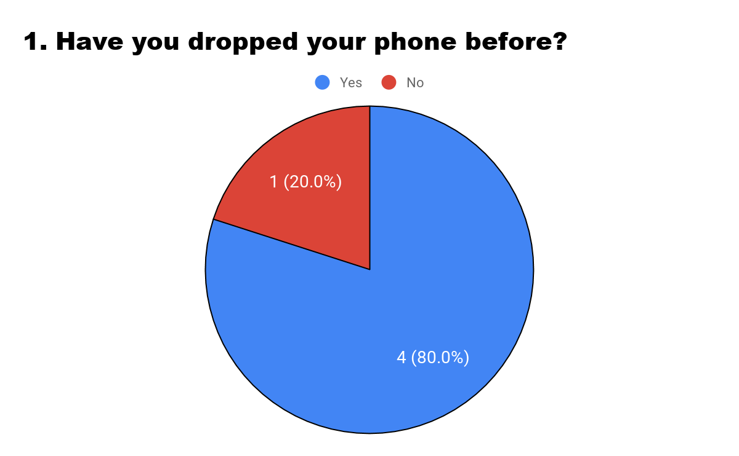

For the first question, which is “Have you dropped your phone before?”, 80% of the people we interviewed said ‘Yes”. From this graph, we can see that majority of phone user has experience with dropping their phone, whether due to accidentally or careless mistake. This statistic futhers back-up our hypothesis, which states that there are more people that has dropped their phone then those that has not experience it yet. This is why we believe that would product can help these people save their phones. We are human and humans make mistakes. However, mistakes like dropping your phones especially newer ones can be a costly mistake.

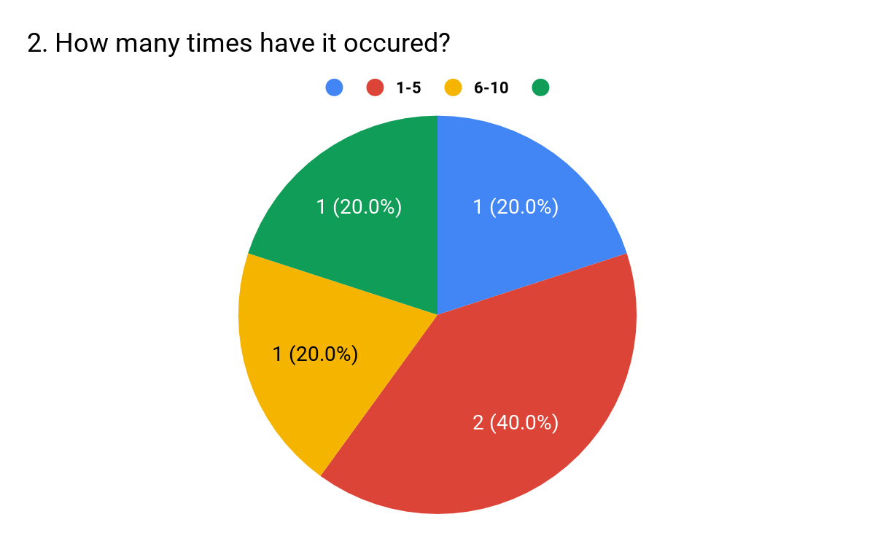

For the second question, which is “How many times have it occured?”, 40% of people we interviewed said that they have dropped their phone between 1-5 times. Although most people we interviewed didn’t drop their phone more than five times, it still can affect the phone like a crack screen or internal damage to the components. If people starts using our case, it would not make how many times they drop the phone as the outcome will always be the same that is the case with absorb all the impact instead of the case. As for the rest of the people, all of them has an even 20 percentage between zero drop (blue), 6-10 times and more than 10 drops (green).

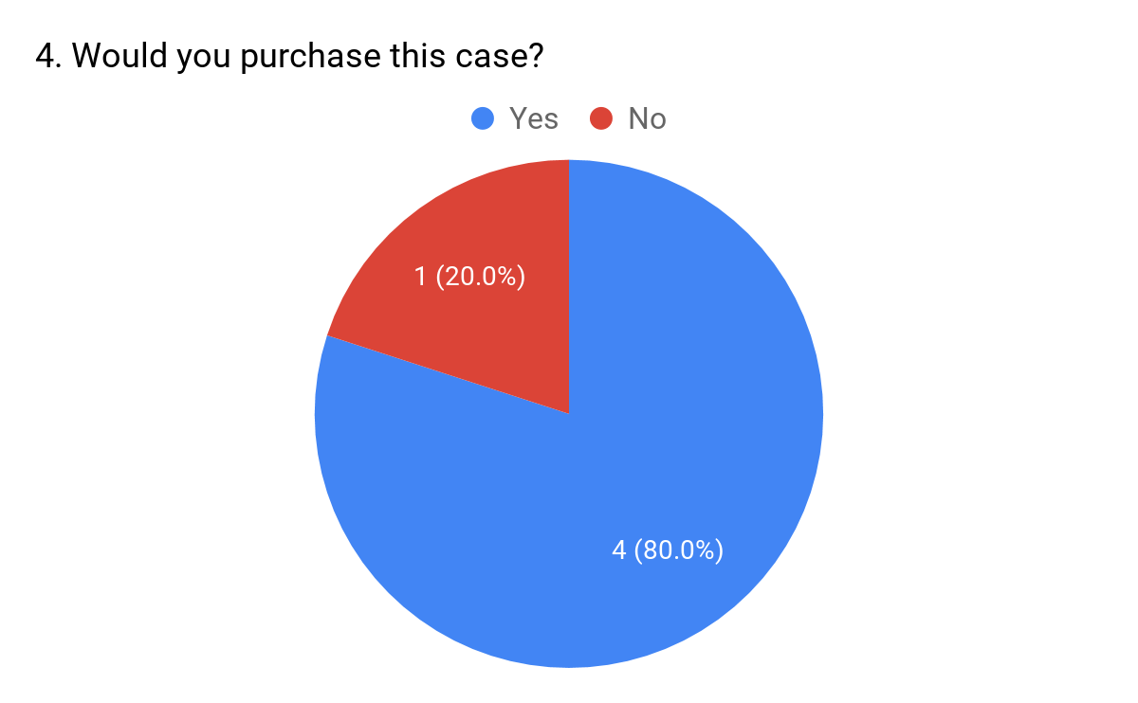

As stated about, we were not only doing this interview to do what issues or problem people are having, but rather to understand their view on our product, whether they would use it or not. This graph is showing the percentage of people who liked and are willing to purchase our product. 80% of the people have shown positive view on our prototype and said they are willing to purchase our case for their phone. One of interviewee said that he will not buy the product based on the prototype given is because the case was too bulky and didn’t have a “cool” design.

To improve this, we will need to find a way to reduce the size of the case and create a more creative design for our product.

**Conclusion**

Although we did not have much time to conduct the interview and we believe that we could have done or use a better methods of collecting the qualitative data, we still believe that this interview has given us a great amount of useful information. In addition, this interview also can be served as a “guidance” for us to understand what we must do now to achieve a “decent” final product. This is because the interviewee not only told us about the issues that they were having, that is dropping their phone numerous of times, but also what their views are regarding the prototype whether it is positive or negative. We were focusing more on the negative aspect that the interviewees believe our product holds like bulky design, not visually interesting and not user-friendly. With all these information, we would then have to re-do our prototype and solve as many drawbacks as possible.