1. Zhège bēibāo yībǎi sìshíjiǔ kuài.

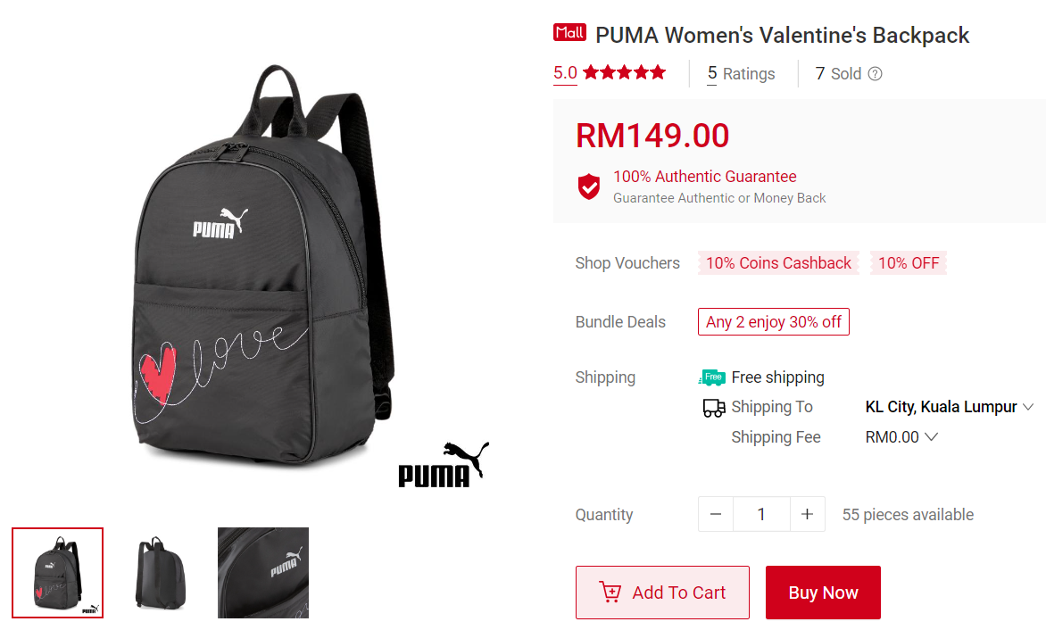

1. Zhège shǒubiǎo wǔshíjiǔ kuài jiǔ máo.

1. Zhège qiánbāo yīshíyī kuài jiǔmáo jiǔ fēn.

1. Nàgè yì sānshíèr kuài jiǔmáo.

