IT Project Management: Importance and Trending

Felicia Chin Hui Fen, Erica Desirae Mauritius, Lue Guo Ming, Mohd Firdaus Bin Zamri, School of Computing, Faculty of Engineering, University Technology Malaysia.

Abstract- This talk will explain to us the importance and trending of IT Project Management. In order to achieve a success of large-scale project, a good project management is required. The dominant explanation of the project management will increase the efficiency of a project.

Keywords—importance, IT Project Management, efficiency

INTRODUCTION
This industrial talk provided us with many helpful information on IT Project Management. The speaker was Mohd Khairul Reeza Ruslan, who is the Head of Project Management Office Commerce Dot Com Sdn Bhd. The program is held on 1st December 2020, from 10.00 a.m. to 11.00 a.m.
There are 6 basic components of project requirements, which are time, cost, quality, scope, risks and benefits. Besides, time, cost and quality will define the project as a “one-off” scope of work. It is a temporary because it has a time limit to complete the project. Furthermore, project only required specific tasks and that is what make it unique. It also has specific goals too. Since a project required both time and cost, there is existed a limit to both of it.

IT PROJECT MANAGEMENT

The Importance of IT Project Management
The importance of the IT Project Management is it ensures there is a proper plan for the project to be executed so that the project is done on time. Secondly, it ensures the cost, time and scope in the project are manage properly. It ensures the risk of the project are managed properly. Moreover, it helps the project executed achieved the goals and quality expected.
In addition, when using the prince 2 in IT Project Management, it provides many advantages. It enables the continued business justification. Besides that, it helps the project team to learn from experiences in the project. Moreover, it helps define the role and responsibilities of all team members during the project. It ensures the project manage by stages and exception. It also helps the team focus on the project and lastly it tailors to suit the project environment. [1]

Trending of IT Project Management
The trending of IT Project Management is the gig economy where people are more reliance on digital and remote team. Next, its trend more focus on use of data analytics and number to understanding customer needs to detailing risks. Moreover, its trend is the use of the automation and artificial intelligence where the AI-powered bots can help to calculate the best project to take on.
Furthermore, its trend is the importance of change management where it helps the organization to adapt and adjust their process, workflow and competencies during a project. Besides that, its trend is method melding where it combines alternatives way during execution of the project to ensure the project complete on time. Next, its trend is advanced project management tools and solutions where it helps in project planning, communication and collaboration between team members, budgets and deadlines of the project and the progress tracking. Lastly, the trend of the IT Project Management is the impact of the emotional intelligence (EQ) where the EQ is the one which help someone to be successful in his or her career. [2]

RELAVANT IT CAREERS
There are a few IT careers that are related in Project Management which are Digital Project Manager, Software Project Manager, Information Technology (IT) Project Manager, Web Designer, Technical Architect, Junior Engineer or Developer, Data Entry Administrator, IT support Analyst.[2, 3]

REFLECTIONS
- Felicia Chin Hui Fen: From the talk, I learnt that the importance of the IT Project Management where it helps reduce the risk and cost when executing the project. Besides that, I also learnt emotional intelligence (EQ) is very important to help us successfully in our career. Finally, I learnt we must always prepared through hardworking so that we will achieve the necessary requirement for the future career.

- Erica Desirae Mauritius: The talk gave really inspirational words and has made me realized about things in life which one of it is my goal. So, my goal is to invent some sort of technology that will benefit people. However, achieving that goal is not an easy task. Hence, after attending the talk, it has taught me to always be passionate in whatever I do and never give up. Moreover, I want to make an improvement of myself to strengthen my potential which is to increase my maturity.

- Mohd Firdaus Bin Zamri: From the talk, I am able to learn the basic components of project requirements. In order to achieve my expectation of the outputs of the project, I need to plan my tasks based on the components. Besides, I can use all of the knowledge, skills, tools and techniques that I have to reach a better outcome. I also can reduce the risks and increase the quality of my projects based on the project management that the speaker mentioned in the talk. Hence, I will be able to achieve the project and become a successful person in my career later.

- Lue Guo Ming: I wish to learn something useful in future from the course I take now. For example, programming language and communication skill. From this talk, I have motivated to plan and manage everything systematically as a project in my life to archive my goal. In my opinion, I manage to make use of my time to do things with purpose and brings benefit so I do not waste my time.

Figures
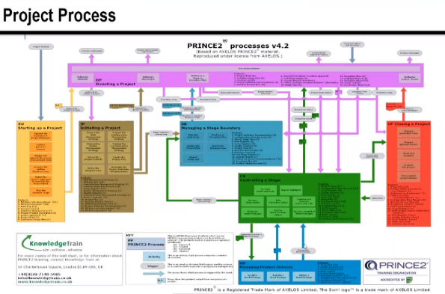

Fig. 1. A Complex Version of Prince2.

Fig. 2. A Simplified Version of Prince2. In a project, there is always a Starting Up which is a starting point. Next, the initiation part and the planning part. Then, execute the project. Once the project is executed, then project will be monitored and controlled in order to achieve the expected quality, the quality is also controlled and the risk is managed properly. Lastly, the closing of the project where this process is to ensure that the goals and objectives are being achieved.[4]

Acknowledgment
We would like to express our deepest appreciation to all those who provided us the possibility to finish this article. We would like to offer our special thanks to lecturer, Dr. Azurah Abd Samah for her patient guidance and advices to help us in completing the article. We would like to express our deepest gratitude to Mr. Mohd Khairul Reeza Ruslan for giving us the information about the importance and trending of IT project management through his talk. We wish to thank various people for their contribution to this article; Dr. Goh Eg Su as the moderator and Dr. Johanna Ahmad as the host of the industry talk.[5]

References
[1] "The 7 Principles, Themes and Processes of Prince 2." ILX Marketing Team. https://www.prince2.com/eur/blog/the-7-principles-themes-and-processes-of-prince2 (accessed 13 December, 2020).
[2] V. Kashyap. "Project Management Trend（2020）：What does the Future Look Like." https://www.proofhub.com/articles/project-management-trends (accessed 13 December, 2020).
[3] B. B. Hering. "9 Porject Management Career Paths: Industries, Salary and More." https://www.flexjobs.com/blog/post/project-management-career-paths/ (accessed 13 December, 2020).
[4] W. Malsam. "Prince 2: An Itroduction to the Project Management Methodology." https://www.projectmanager.com/blog/prince2-methodology (accessed 13 December, 2020).
[5] "GUIDELINES FOR WRITING ACKNOWLEDGEMENTS." https://elc.polyu.edu.hk/FYP/html/ack.htm (accessed 13 Decemeber, 2020).

