

**DISCRETE STRUCTURE (SECI 1013)**



**ASSIGNMENT:**

**TUTORIAL 1**

**SECTION :** 04 – 1 SECRH

**COURSE NAME :** BACHELOR OF COMPUTER SCIENCE –

NETWORK AND SYSTEM SECURITY

**LECTURER’S NAME :** DR. HASWADI BIN HASAN

|  |  |  |
| --- | --- | --- |
| **NO.** | **NAME** | **STUDENT ID** |
| **1.** | ILAMUHIL A/L KATHIRAVAN | A20EC0047 |
| **2.** | MUHAMMAD FADTHUN AMIERRUN BIN MD NOR’AZAM | A20EC0085 |
| **3.** | DIFA EGA ADRIAN | A19EC0229 |

1. Let the universal set be the set **R** of all real numbers and let *A*={*x*∈**R** | 0 < *x* ≤ 2}, *B*={*x*∈**R** | 1 ≤ *x* < 4} and *C*={*x*∈**R** | 3 ≤ *x* < 9}. Find each of the following:
2. *A* ∪ *C*

*A∪ C :* all elements of A and C

*A∪ C* = {*x*∈**R** | 0 < *x* ≤ 2 or 3 ≤ *x* < 9}

*A∪ C* = {*x*∈**R** | 0 < *x* < 9}

1. (*A* ∪ *B*)′

(*A* ∪ *B*)′ : all elements in universal set that are not in *A* ∪ *B*

*A* ∪ *B* = {*x*∈**R** | 0 < *x* ≤ 2 or 1 ≤ *x* < 4}

*(A* ∪ *B)* = {*x*∈**R** | 0 < *x* < 4}

(*A* ∪ *B*)′ = {*x*∈**R** | *x* ≤ 4 or *x* ≥4}

1. *A*′ ∪ *B*′

*A*={*x*∈**R** | 0 < *x* ≤ 2}

*A*′ ={*x*∈ **R** | *x* ≤ 0 or *x* >2}

*B*={*x*∈**R** | 1 ≤ *x* < 4}

*B*′={*x*∈**R** | *x* < 1 or *x* ≥4}

*A*′ ∪ *B*′={ *x* < 1 or *x* >2}

1. Draw Venn diagrams to describe sets *A*, *B*, and *C* that satisfy the given conditions.
2. *A* ∩ *B* = ∅,  *A* ⊆ *C*, *C* ∩ *B* ≠ ∅

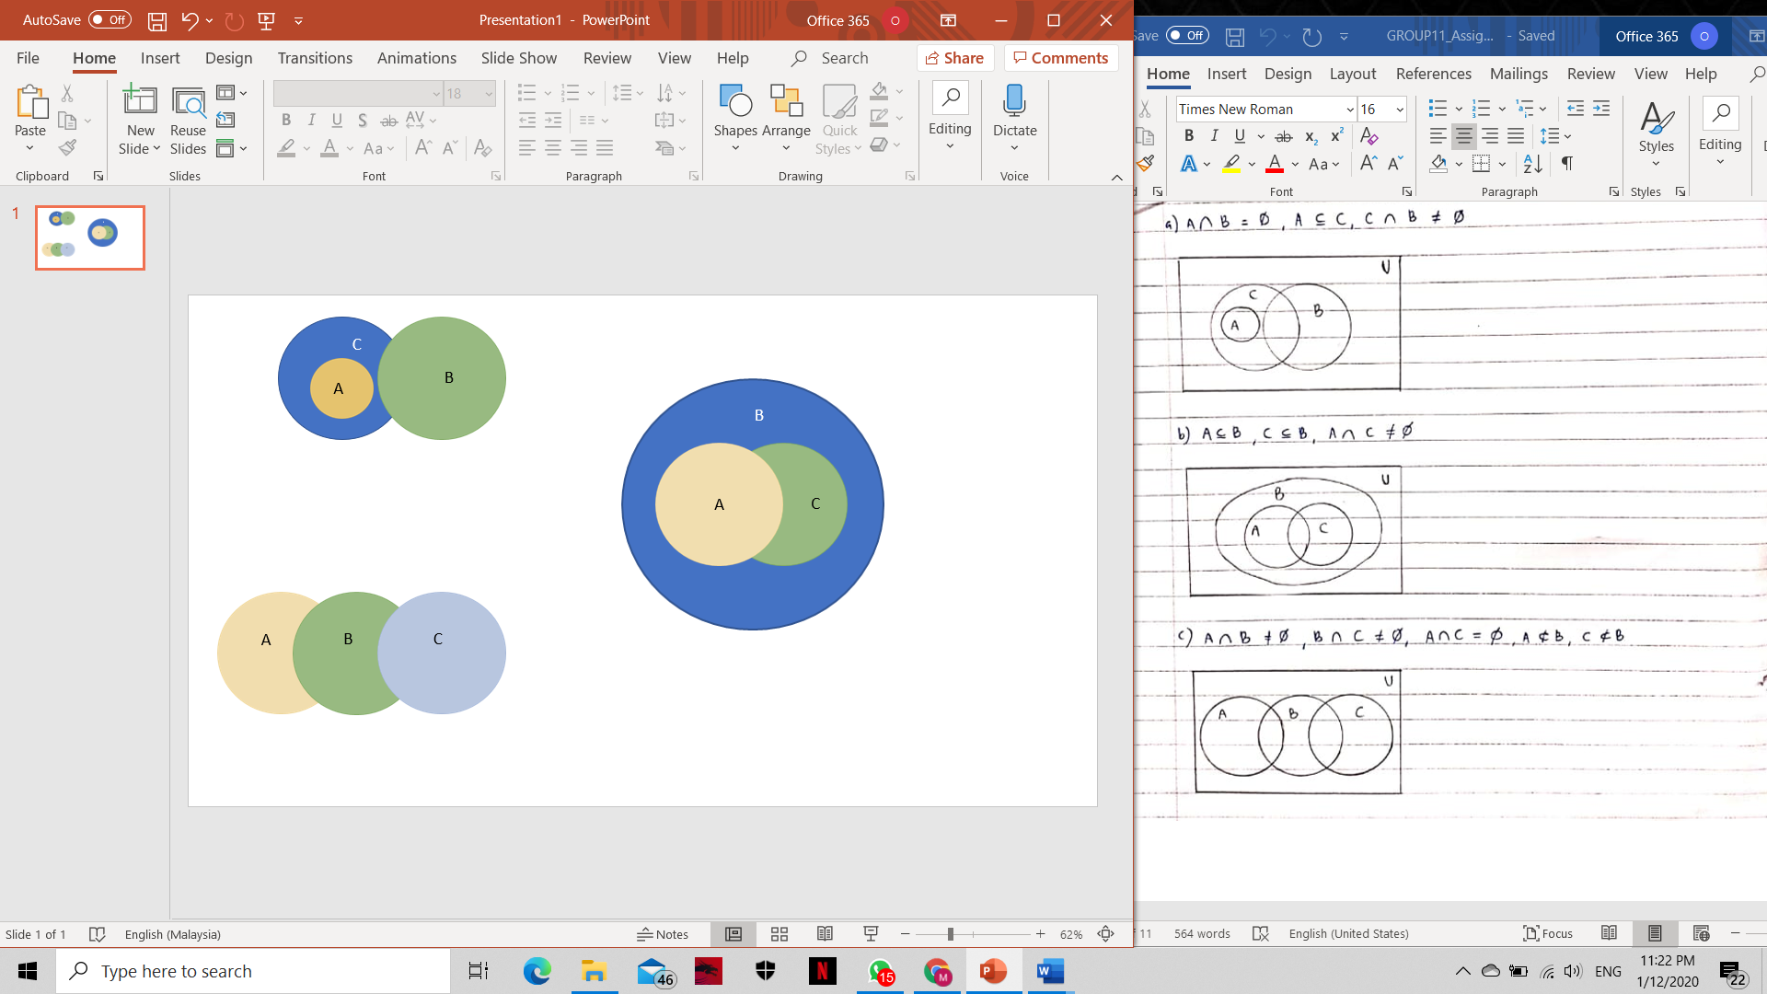

1. *A* ⊆ *B*, *C* ⊆ *B*, *A* ∩ *C* ≠ ∅



1. *A* ∩ *B* ≠ ∅, *B* ∩ *C* ≠ ∅, *A* ∩ *C* = ∅,  *A* ⊄ *B,* *C* ⊄ *B*



1. Given two relations *S* and *T* from *A* to *B*,

*S* ∩ *T* = {(*x,y*) ∈*A*×*B* | (*x,y*) ∈ *S* and (*x,y*) ∈ T}

*S* ∪ *T* = {(*x,y*) ∈*A*×*B* | (*x,y*) ∈ *S* or (*x,y*) ∈ T}

Let *A*={*−*1, 1, 2, 4} and *B*={1,2} and defined binary relations *S* and *T* from *A* to *B* as follows:

For all (*x,y*) ∈*A*×*B*, *x S y* ↔ |*x*| = |*y*|

For all (*x,y*) ∈*A*×*B*, *x T y* ↔ *x− y* is even

State explicitly which ordered pairs are in *A*×*B*, *S*, *T*, *S* ∩ *T*, and *S* ∪ *T*.

=

A={−1, 1, 2, 4}

B={1,2}

A × B = { (-1,1) , (-1,2) , (1,1) , (1,2) , (2,1) , (2,2) , (4,1) , (4,2) }

S = { (-1,1) , (1,1) , (2,2) }

T = { (-1,1) , (1,1) , (2,2) , (4,2) }

S ∩ T = { (-1,1) , (1,1), (2,2) }

S ∪ T = { (-1,1) , (1,1) , (2,2) , (4,2) }

1. Show that ¬ ((¬p∧q) ∨ (¬p∧¬q)) ∨ (p∧q) ≡ p. State carefully which of the laws are used at each stage.

**Answer:**

U=universal set

¬ ((¬p∧q) ∨ (¬p∧¬q)) ∨ (p∧q)

¬ (¬p∧ (q∨ ¬q)) ∨ (p∧q) - Distributive law(Distributivity of intersection over union)

¬ (¬p∧ u) ∨ (p∧q) -De Morgan’s Law

(p∨ ¬U) ∨ (p∧q) -Complement of U and ∅

p∨ (p∧q) -Absorption Law

p ≡¬ ((¬p∧q) ∨ (¬p∧¬q)) ∨ (p∧q)

(Proven)

1. *R*1={(*x,y*)| *x*+*y* ≤6}; *R*1 is from *X* to *Y*; *R*2={(*y,z*)| *y*>*z*}; *R*2 is from *Y* to *Z*; ordering of *X*, *Y*, and *Z*: 1, 2, 3, 4, 5.

Find:

1. The matrix *A*1 of the relation *R*1 (relative to the given orderings)

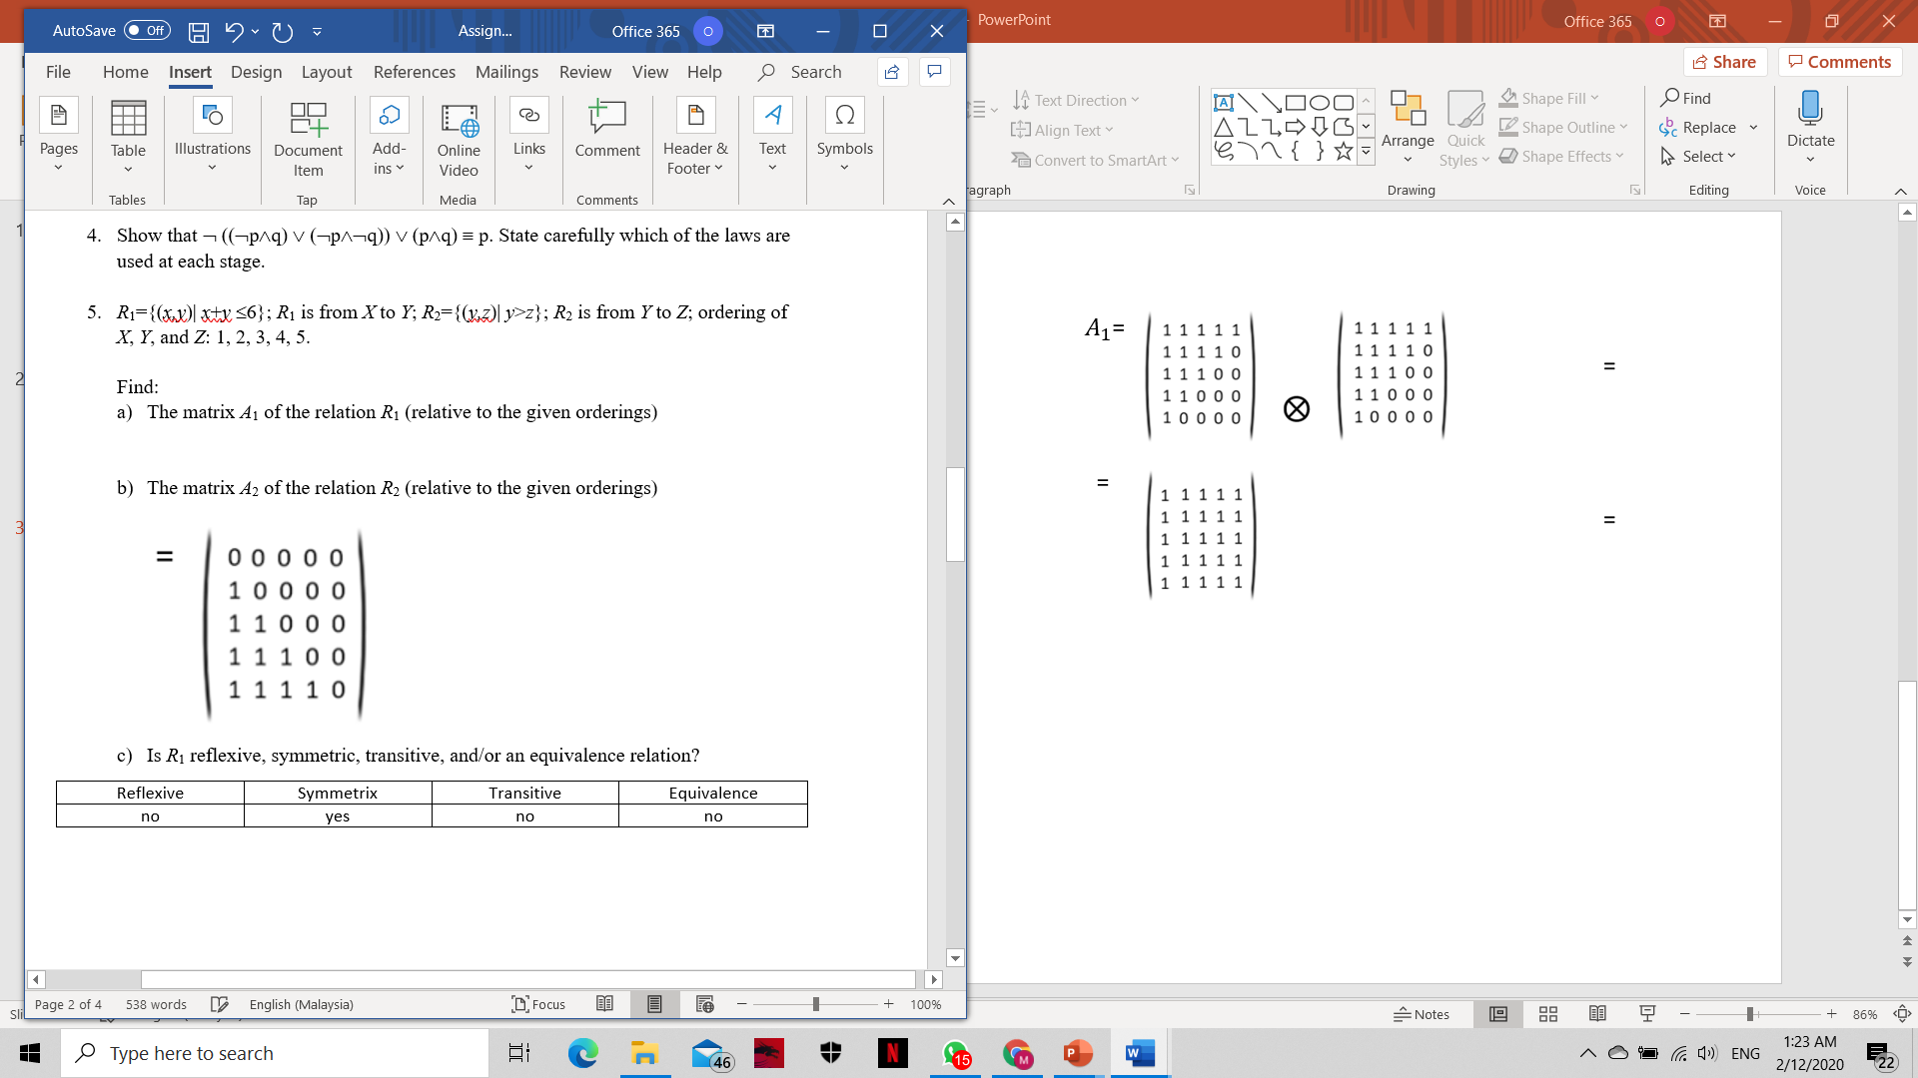

1. The matrix *A*2 of the relation *R*2 (relative to the given orderings)

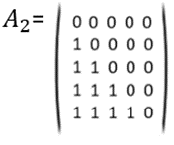

1. Is *R*1 reflexive, symmetric, transitive, and/or an equivalence relation?

|  |  |  |  |
| --- | --- | --- | --- |
| Reflexive | Symmetrix | Transitive | Equivalence |
| no | yes | no | no |

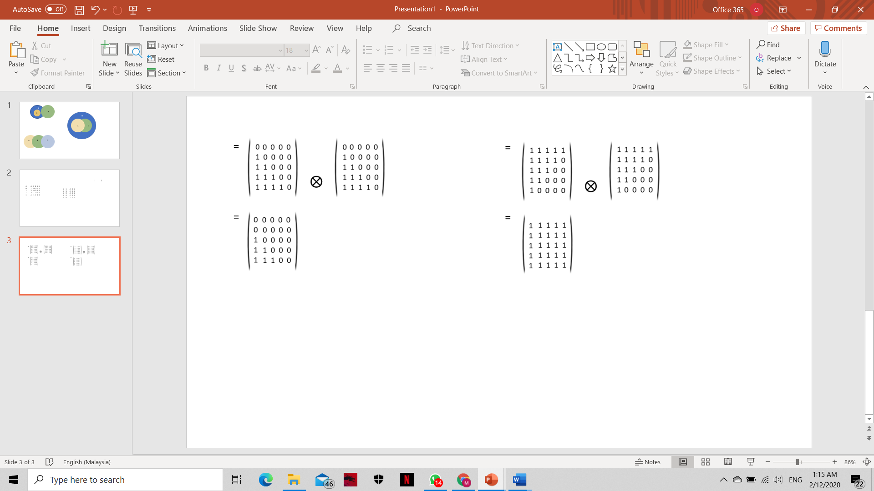

1. Is *R*2 reflexive, antisymmetric, transitive, and/or a partial order relation?

|  |  |  |  |
| --- | --- | --- | --- |
| Reflexive | Asymmetrix | Transitive | Equivalence |
| no | yes | no | no |



1. Suppose that the matrix of relation *R*1 on {1, 2, 3} is

relative to the ordering 1, 2, 3, and that the matrix of relation *R*2 on {1, 2, 3} is

relative to the ordering 1, 2, 3. Find:

1. The matrix of relation *R*1∪ *R*2

**= {(1,1) , (2,2) , (2,3) , (3,1) , (3,3)}**

**= {(1,2) , (2,2) , (3,1) , (3,3)}**

**= {(1,1) , (1,2) , (2,2) , (2,3) , (3,1) , (3,3)}**

1. The matrix of relation *R*1∩ *R*2

**= {(1,1) , (2,2) , (2,3) , (3,1) , (3,3)}**

= **{(1,2) , (2,2) , (3,1) , (3,3)}**

**= {(2,2) , (3,1) , (3,3)}**

1. If *f* :**R→ R** and *g*:**R→ R** are both one-to-one, is *f + g* also one-to-one? Justify your answer.

**Answer:**

*f* :**R→ R** and *g*:**R→ R**

Let’s assume that f(x) =x and g(x)= -x

**R** =set of real numbers

f(x1) =f(x2)

x1=x2 (f is one to one)

g(-x1) =g(-x2)

-x1=-x2

x1=x2 (g is one to one)

f +g=f(x) + g(x)

= x+(-x)

=0

f+g(x)= 0

f+g(1)=f+g(2)=0

Hence,f+g is not one to one .

1. With each step you take when climbing a staircase, you can move up either one stair or two stairs. As a result, you can climb the entire staircase taking one stair at a time, taking two at a time, or taking a combination of one- or two-stair increments. For each integer n≥1, if the staircase consists of n stairs, let *cn* be the number of different ways to climb the staircase. Find a recurrence relation for *c*1, *c*2, …., *cn*.

= number of different ways to climb the staircase

|  |  |  |  |
| --- | --- | --- | --- |
|  | ways |  |  |
| 1 | 1 | 1 |  |
| 2 | 1+1  2 | 2 |  |
| 3 | 1+1+1  2+1  1+2 | 3 |  |
| 4 | 1+1+1+1  2+1+1  1+2+1  1+1+2  2+2 | 5 |  |
| 5 | 1+1+1+1+1  2+1+1+1  1+2+1+1  1+1+2+1  2+2+1  1+1+1+2  1+2+2  2+1+2 | 8 |  |

Recurrence relation is defined by :

, with

1. The Tribonacci sequence (*tn*) is defined by the equations,

*t*0 =0, *t*1 = *t*2 = 1, *tn* = *tn*-1 + *tn*-2 + *tn*-3 for all *n*≥3.

1. Find *t*7.

t7 = t_6+ t_5+ t_4

=(t_5+ t_4+ t_3)+ t_5+ t_4

=2t_5+ 2t_4+ t_3

=2( t_4+ t_3+ t_2 )+ 2t_4+t_3

=4t_4+ t_3+ t_2

=4(t_3+ t_2+ t_1)+ 3t_3+ 〖2t〗_2

=〖7t〗_3+ 〖6t〗_2+ 〖4t〗_1

=7(1+1+0)+6(1)+4(1)

=7(2)+6(1)+4(1)

=14+6+4

=24

t_7=24

1. Write a recursive algorithm to compute *tn*, *n*≥0.

#include <iostream>

using namespace std;

int printTribRec(int n)

{

if (n == 0)

return 0;

if (n == 1 || n == 2)

return 1;

else

return printTribRec(n - 1) + printTribRec(n - 2) + printTribRec(n - 3);

}

void printTrib(int n)

{

for (int i = 1; i < n; i++)

cout << printTribRec(i) << " ";

}

int main() {

int n = i;

printTrib(n);

return 0;

}

Tribonacci

if return 0

else if return 1

else if return

1Else return

For the