**QUESTION 4**

#include <iostream>

using namespace std;

int main()

{

double x = 12345.67;

cout << right << setw (10)<<fixed << setprecision(2)<< x << endl;

cout << left << setw (10)<<fixed << setprecision(2)<< x << endl;

cout << left << setw (10) << fixed << setprecision (5)<< "RM***99.99" << endl;

cout << endl;

cout << "Raining Figures"<< endl;

cout << "---------------"<< endl;

cout << "Month 1 : 450.5 ml"<< endl;

cout << "Month 2 : 321.3 ml"<< endl;

cout << "Month 3 : 99.2 ml"<< endl;

return 0;

}

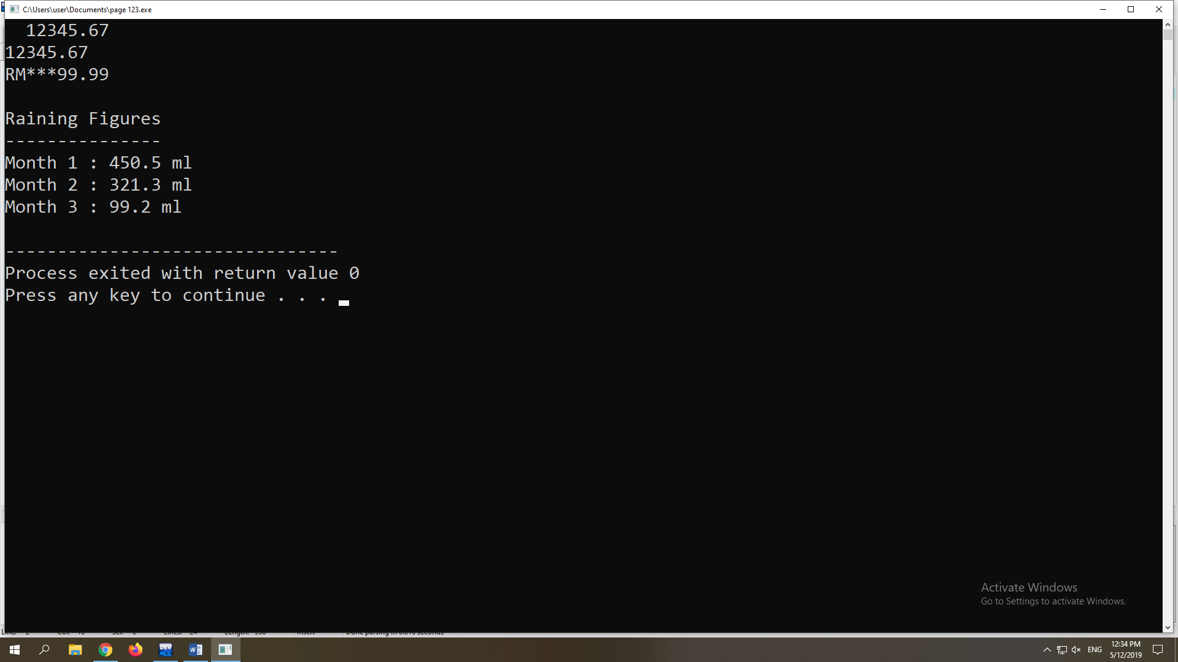

**QUESTION 5**

#include <iostream>

#include <cctype>

using namespace std;

int main()

{

;

int mark , number[];

string name ;

cout << "Please enter your mark : " << endl;

cin >> mark ;

cout << "Please enter your name and father's name : " << endl;

cin >> name ;

getline (cin , name);

cout << "Please enter your ic number : " << endl;

cin >> number[];

return 0;

}

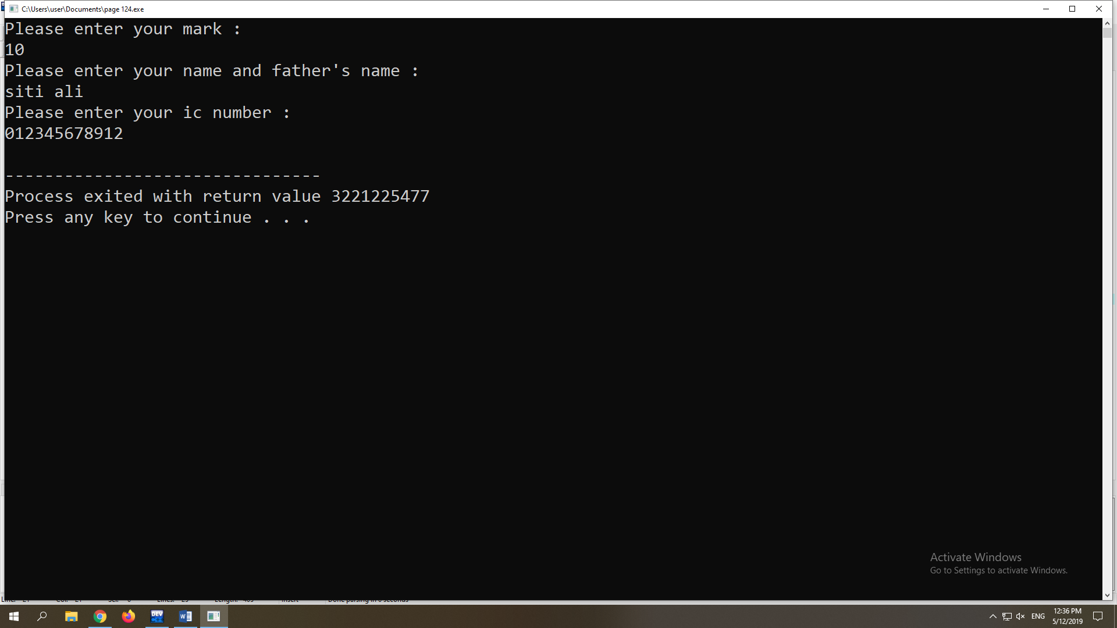

**QUESTION 6**

a.

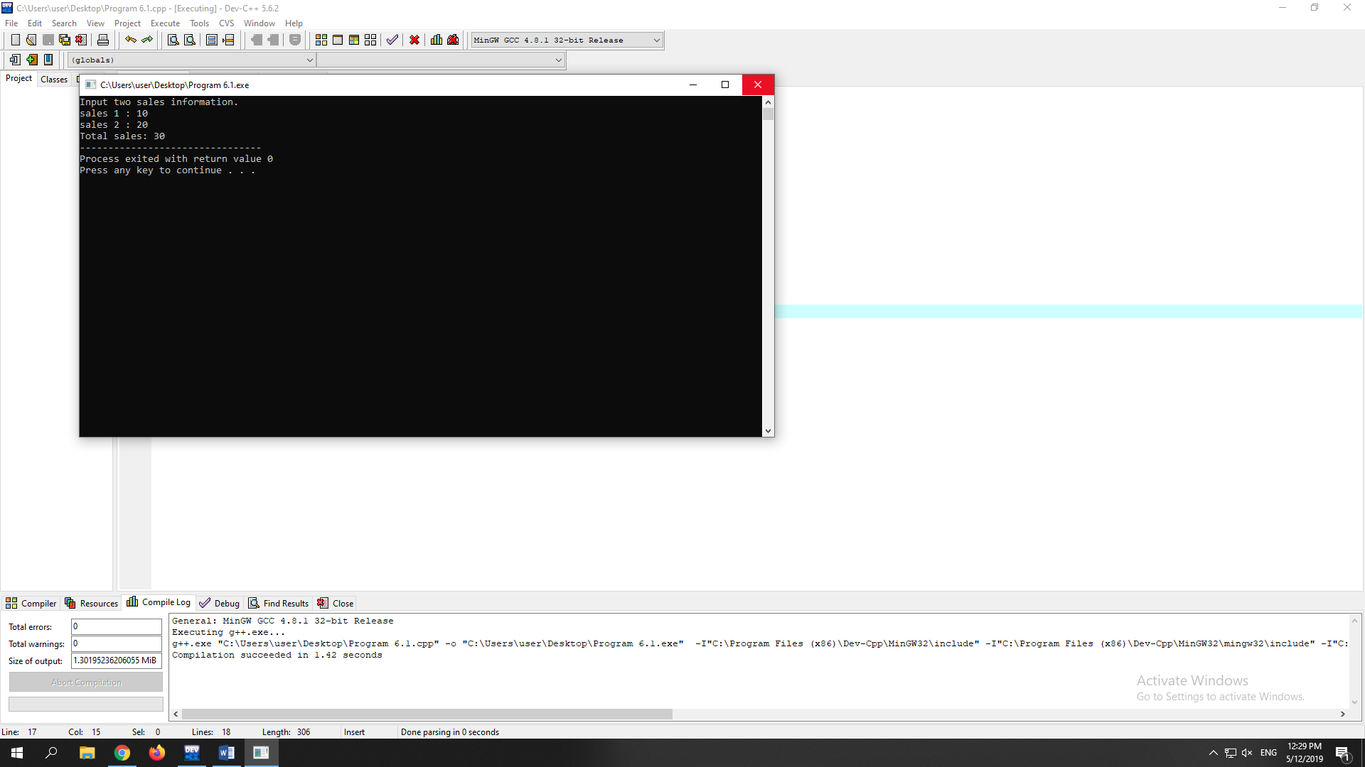

b. Line 2- To ensure sure the input output in the program.

Line 3- To tell the program that user wants to use function in the program.

Line 5- Main function in the program

Line 6- Curly bracket to start the function .

Line 7-Declare variable sales1 and sales2 in float data type.

Line 8- Print Input two sales information to the screen.

Line 9- Print sales 1 to the screen.

Line 10-Prompt user to enter value for sales1 into the program.

Line 11- Print sales 2 to the screen.

Line 12- Prompt user to enter value for sales2 into the program.

Line 13-Print Total sales to the screen.

Line 14- To pause the program execution.

Line 15-It is consider as exit function to the main function.

Line 16- Curly bracket to end the function.

**QUESTION 7**

a. 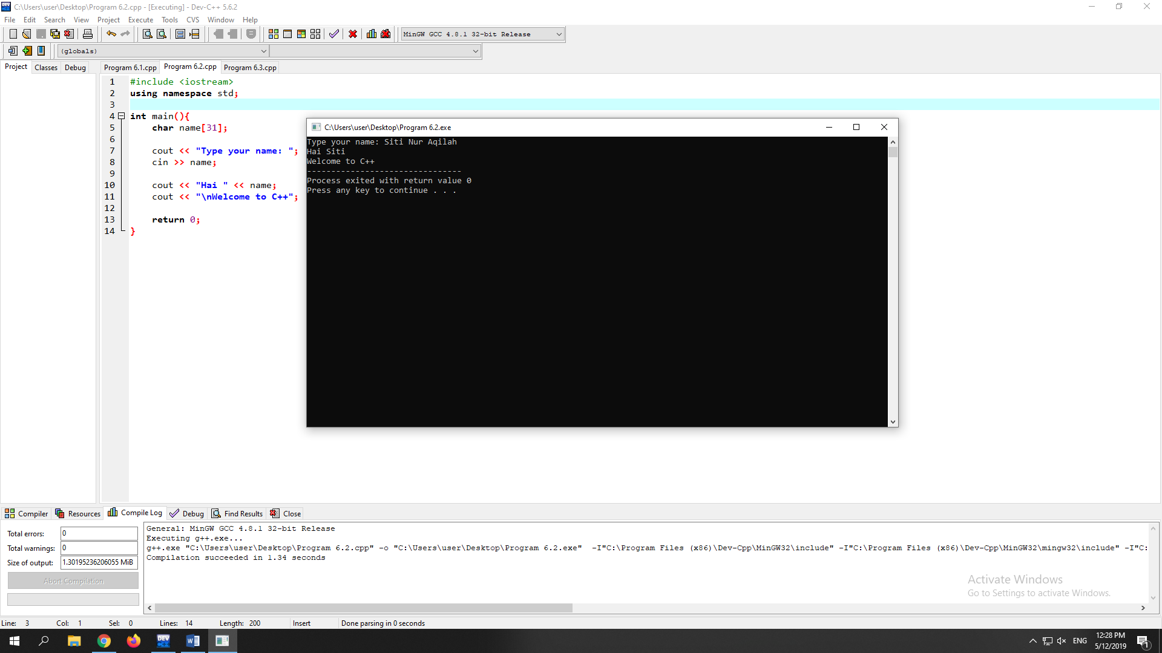

b.

Line 2- To ensure sure the input output in the program.

Line 3- To tell the program that user wants to use function in the program.

Line 5- Main function in the program

Line 6- Curly bracket to start the function .

Line 7 – Array name which store the name’s character that have size of 31 character.

Line 9 – Print type your name to the screen.

Line 10- Prompt user to enter their name into the program.

Line 11- Print Hai to the screen..

Line 12- Print Welcome to C++ to screen.

Line 14- It is consider as exit function to the main function.

Line 15- Curly bracket to end the function.

**QUESTION 8**

a.

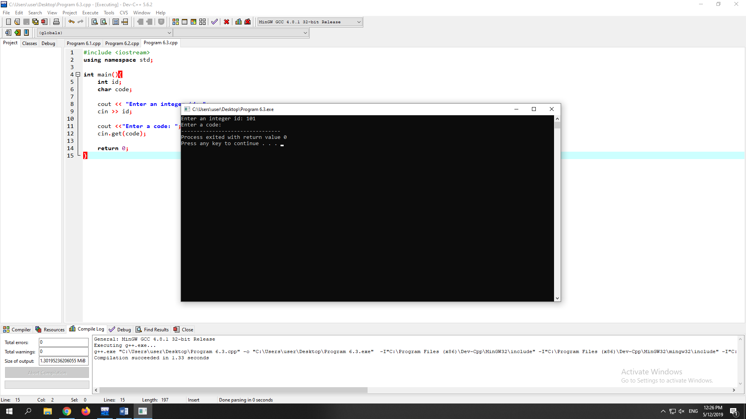

b. Line 2- To ensure sure the input output in the program.

Line 3- To tell the program that user wants to use function in the program.

Line 5- Main function in the program

Line 6- Curly bracket to start the function .

Line 7- Declare variable id into integer data type.

Line 8- Declare variable code into character data type.

Line 10- Print Enter an integer id to the screen.

Line 11- Prompt user to enter id into the program.

Line 12- Print Enter a code.

Line 13 - Reads an input character and store it in code.

Line 15- It is consider as exit function to the main function.

Line 16- Curly bracket to end the function.

I think the program can be improved by changing cin.get to just cin,