

**SKAA 2992**

**WASTEWATER ENGINEERING**

INNOVATIONS ON ENVIRONMENT SOLUTION

**NAME:** NUR ATIKAH BINTI MAT RAPI

**STUDENT NUMBER:** A11KA0142

**DUE DATE:** 23 MAY 2013

**LECTURER:** ASS0C. PROF. DR. AZMI BIN ARIS

**TABLE OF CONTENT**

|  |  |  |
| --- | --- | --- |
| **TOPIC** | **TITLE** | **PAGE** |
| 1.0  1.1  1.2  1.3  1.4 | INTRODUCTION  GREEN BUILDING   * + 1. CONCEPT     2. BENEFITS   GREEN PROCESS AND PRODUCT DESIGN  1.2.1 CONCEPT  1.2.2 BENEFITS  GREEN PURCHASING  1.3.1 CONCEPT  1.3.2 BENEFITS  REFERENCES | 3  3-5  6-7  7-9  9 |

**1.0 INTRODUCTION**

Promoting Environmental Sustainability

Communities are increasingly interested in reducing the environmental footprint of economic activities and are looking to public agencies to encourage sustainable behaviors. Agencies are implementing sustainability initiatives internally and are encouraging other organizations and companies to adopt similar practices. Innovative sustainability practices are targeting buildings and property development, purchasing and production processes, products, and waste generation to cost-effectively lower the material requirements, energy needs, and environmental risk of economic activity.

**1.1 GREEN BUILDING**

* + 1. CONCEPT

Green building practices are reducing environmental impacts by influencing design, construction, and deconstruction choices. Innovative practices are promoting a variety of sustainable building techniques, such as use of green building materials, energy and water-efficient design, and demolition material reuse and recycling. Other innovative practices are taking a broader perspective by facilitating sustainable design at the neighborhood or community level.

Innovative green building practices are:

1. Disseminating information on green building techniques.
2. Developing tools to facilitate green design choices.
3. Leveraging government's ability to lead by example through its building and construction choices.

Agency managers can use these techniques to address specific waste, energy, or water challenges, and to complement broader efforts to encourage environmentally sustainable behaviors.

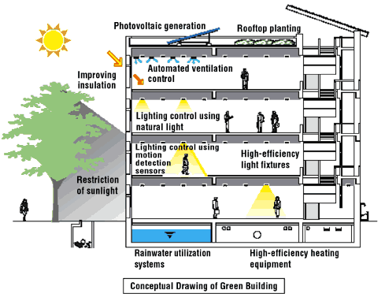

* + 1. BENEFITS

The benefits of building a green home are diverse, but the most widely recognized outcomes are environmental. Reducing the environmental impact of homes is an important step towards fighting global warming and conserving valuable natural resources. However, there are numerous, less publicized benefits of green homes. The first warms the heart of every American savings. Cost has long been considered a deterrent to building a green home, initially turning interested homeowners away. Closer inspection, however, reveals that price increases are generally only a few percentage points higher (a statistic decreasing as green practices become increasingly mainstream). Learning to view these upfront costs as an investment is key. Additional expenses will literally pay for themselves in lower energy and water bills, tax and insurance credits and reduced repair needs.

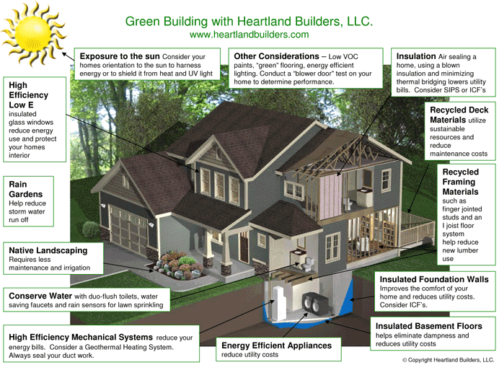

**1.2 GREEN PROCESS & PRODUCT DESIGN**

1.2.1 CONCEPT

Environmental agencies can influence business process and product design decisions that improve environmental outcomes.

Innovative practices frequently:

1. Target specific product constituents, such as toxic chemicals, for pollution prevention, waste minimization, and resource conservation.
2. Partner directly with companies or industry associations, particularly in the product design and development phase, offering design advice and incentives to adopt green processes and products.
3. Support research into environmentally preferable substances and processes.
4. Provide technical assistance and basic tools to small businesses. Agency managers can use innovative practices to help businesses understand the full (and often hidden) costs of process and product design choices.

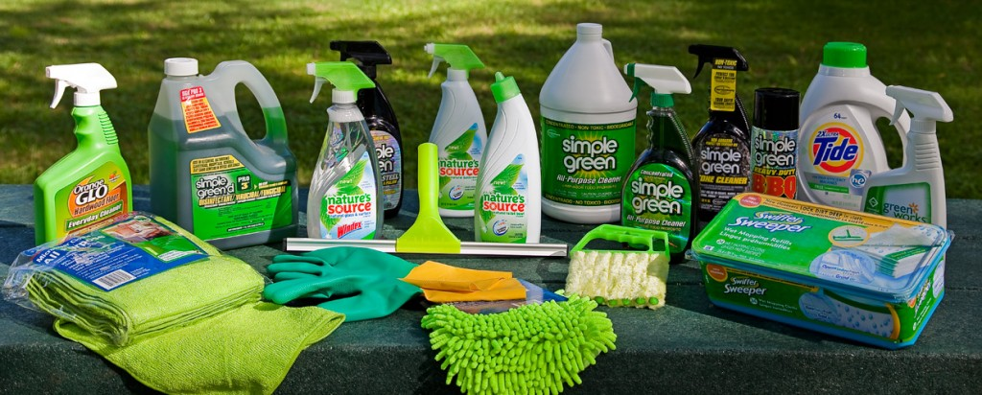

1.2.2 BENEFITS

Green Engineering is the design, commercialization and use of processes and products that are feasible and economical while:

1. Reducing the generation of pollution at the source
2. Minimizing the risk to human health and the environment

As we know green process are environmentally friendly manufacturing and green product are environmentally friendly product.

The Solvent Green process provides multiple benefits to the producers of Hydrocarbon / Organic-based waste:

1. Provides “on-site” conversion of their Hydrocarbon / Organic-based waste stream.
2. Significantly reduces waste management costs.
3. Eliminates the environmental liability of transportation and disposal of these toxic waste materials.
4. Provides a public relations benefit as the waste producer is now seen as a “Green Business” to the surrounding community .
5. Eliminates the cost of having the material transported away.
6. Eliminates waste handling “Tipping Fees”.
7. Eliminates the liability of hazardous waste material being involved in an accidental spill during transportation.
8. Eliminates risks, associated with the practice by transporters, of co-mingling and land filling the waste producer’s waste materials with waste materials from other companies and sources.
9. Accrues the benefit of the sale of the recovered Hydrogen, Carbon Dioxide and Argon gas components.

**1.3 GREEN PURCHASE**

1.3.1 CONCEPT

Government agencies are stimulating demand and developing markets for environmentally preferable production products and services using their purchasing power.

Public agencies are:

1. Changing their own procurement practices.
2. Organizing purchasing alliances to further leverage buying power.
3. Increasing access to information regarding environmental attributes of products and services. Agency managers can use innovative practices to increase the availability of environmentally preferable products and to encourage other organizations to purchase them.

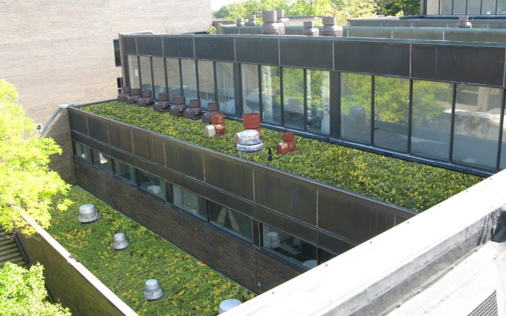 

1.3.2 BENEFITS

At first sight, many "green" alternatives will seem more expensive than standard products. However, a life-cycle assessment may reveal substantial savings. These may be particularly pronounced with, for example, energy-saving products manufactured with less toxic materials. These typically have substantially lower use costs over their lifetime and lower disposal costs.

**1.4 REFERENCES**

1. <http://www.sabmagazine.com/blog/2008/03/15/green-certification/>
2. <http://csr.benq.com/webpage/productinfo/green_practice_03_03_en.aspx>
3. <http://www.suncombustion.com/Solvent%20Green,%20Inc.htm>