Universiti Teknologi Malaysia

**SCSV 2113**

HUMAN COMPUTER INTERACTION

(Session 2020/2021 Semester 2)

School of Computing

Universiti



**LECTURER**

NOR ANITA FAIROS BINTI ISMAIL

(Section 01)

**GROUP NO 5 (Auspicious)**

*Prepared by*

MAIZATUL AFRINA SAFIAH BINTI SAIFUL AZWAN A20EC0204

MADINA SURAYA BINTI ZHARIN A20EC0203

NAYLI NABIHAH BINTI JASNI A20EC0105

MADIHAH BINTI CHE ZABRI A20EC0074

NURFARRAHIN BINTI CHE ALIAS A20EC0121

SAFIRA NURUL IZZA A18CS0323

1. Problem

Nowadays, humans need to familiarize themselves with a very packed schedule. They are required to balance themselves in the aspect of private life and work or study life. This can be a major problem for certain people as humans tend to forget most of the things they should have done. Forgetfulness can happen to anyone which includes the individuals who don't suffer from any diseases such as Alzheimer’s or any other memory-impairing illness. Other than that, not only sickness forgetfulness can be developed as one is too busy focusing on one thing, they tend to forget minor things they should have done. Stress can also be a factor of how forgetfulness can conquer one’s life.



* People are too lazy to make their own schedules manually. (user experience goals)

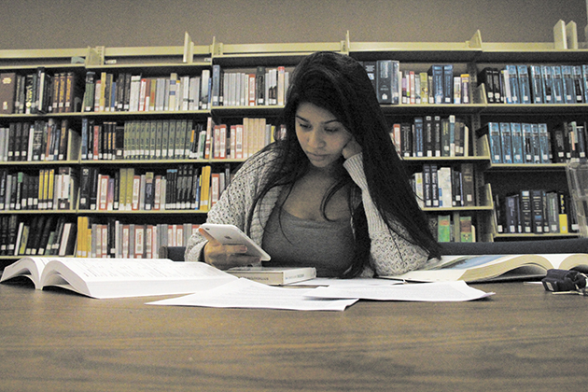

* People tend to disturb by their social media on the phone and waste their time when using scheduled planner apps. (user experience goals)



* Some book planners are heavy to carry around and sticky notes are easy to lose because of the poor glue quality. (usability goals)

1. Proposed Solution

**Vision +**

* An advanced technology that is compact in one spectacle.

This spectacle can be used for multipurposes which either can be a regular spectacles or a programmed lens or both.

* Programmed to arrange humans’ schedule which features a see-through display on the lens using augmented reality.

The lens could connect to other devices and any reminder from the device will automatically be displayed by the see-through feature of the lens.

Hence, the user can avoid distractions from the phone.

* Light and convenience to wear anywhere and anytime (user-friendly).
* This spectacle is also suitable for anyone including for those who have a normal eyesight and for those who suffer from myopic (include automatic adjustable power lens).

1. Target User

* Students - who are busy with their schoolwork and assignments.
* Workers - who are busy with work such as meetings and projects.
* Parents - who are busy with their daily routine and have to manage their kid(s).