**Tutorial 1 (5 marks)**

**1. What is the objective of Gram Stain?**

Gram staining is a most important staining technique in microbiology to differentiate two large group of bacteria based on their cell wall component. By colouring the cells to red or violet colour, we can distinguishes between Gram positive and Gram negative group. Based on the experiment result, Gram positive bacteria contain a highly cross-linked layer of peptidoglycan which can retain the crystal violet colour. After the application of iodine, the iodine and crystal violet form a complex within the peptidoglycan of Gram positive group. However, Gram negative group will not form the CV-I (Crystal-Iodine) complexes due to the loosely distribution of peptidoglycan between the inner and outer cell membrane. After applying the decolourisation, Gram positive group will remains as purple at all, but Grain negative group will change to colourless if apply alcohol and turn pink to red if apply safranin which is a basic dye after the application of alcohol. Therefore, the gram positive organisms and gram negative organisms can be differentiate using this technique.

**2. Describe the principles involve in the gram staining procedure.**

Gram staining can divide into four-part process, which are:

* Crystal violet, the primary stain
* Iodine, the mordant
* Alcohol or Acetone, the decolourizer
* Safranin, the counterstain

Before starting the Gram staining process, a few procedures are required to prepare the sample:

**Step 1:** Transfer the cell of fresh culture to a glass slide by using sterile wire loop.

* If cell is in agar plate, it should be transformed to liquid medium for dilution.

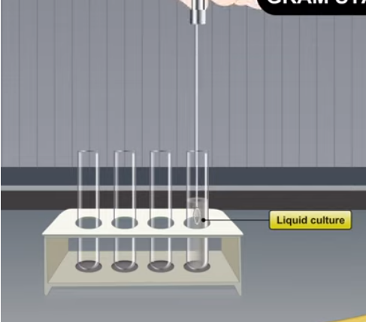

**Step 2:** Spread the suspension over approximately half of the slide to form a thin barely visible film.

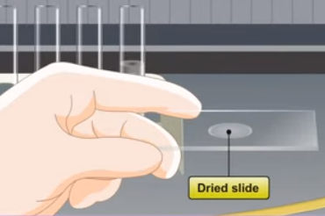**Step 3:** Allow the thin suspension to completely air dry.

**Step 4:** Pick the air-dried slide and passing above the flame of Bunsen burner.

* A picture containing text, indoor

  Description automatically generatedThis action is to fix the bacteria to the slide.

Then, the preparation of slide is following by the **Gram staining process**:

1. Stain with crystal violet for 30 to 40 second

The Gram positive and Gram negative group take up the crystal violet in this step.

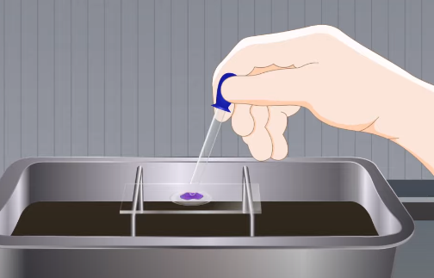

**Crystal violet**

1. Gently rinse off the stain with water

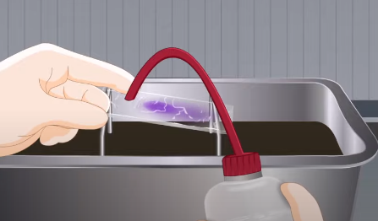

**Water**

1. 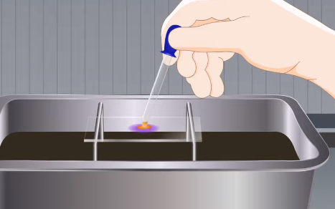Stain with Gram’s iodine solution for one minute

The Gram positive and Gram negative group which already take up crystal violet, and then fixed with iodine forms a crystal violet-iodine complex.



**Iodine**

1. Gently rinse off the stain with water
2. Add a few drops of the decolourizer by picking up the slide and make the slide in an acute angle to let the decolourizer down the slide.

In this step, Gram positive group retain the crystal violet-iodine complex while Gram-negative are decolorized since Gram positive group have higher peptidoglycan content, whereas gram negative group have higher lipid content.



**Decolourizer**

1. Gently rinse off the stain with water
2. Stain with safranin for 20 to 30 second

Since the Gram positive group are already stained purple, they are not affected by the safranin. Gram negative group, which are now colourless, become directly stained by the safranin, which will form pink in colour.

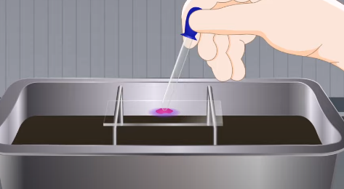

**Safranin**

1. Gently rinse off the stain with water
2. 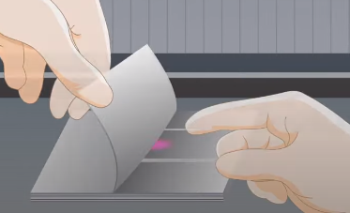Dry the slide with filter paper.



**Filter paper**

1. 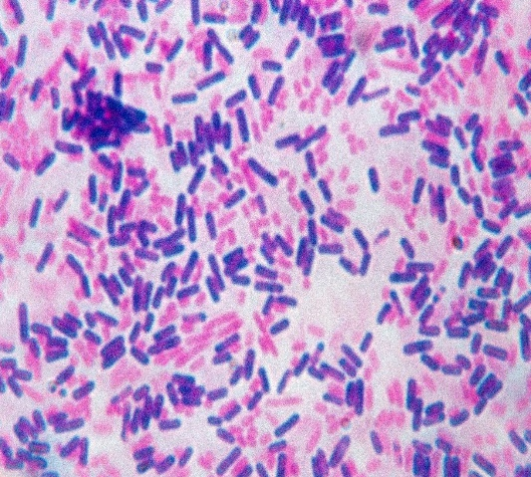Observe the slide using microscope.



**Gram negative in pink**



**Gram positive in purple**

**3. What is the limitation on Gram Stain?**

**a) Preparation of slide:**

* Too many bacteria on the slide could result in under-decolorization; too few could lead to over-decolourisation.
* Cultures more than 24 hours old may lose their ability to retain the crystal violet-iodine complex.
* Smears that are too thick or viscous may retain too much primary stain, making the identification of proper Gram stain reactions difficult.
* The smear must be completely dry before the slide is heat fixed.
* If the slide is not heated enough, all the bacteria will wash off. If it is overheated, the bacteria structural integrity can be damaged.
* Gram stains from patients on antibiotics or antimicrobial therapy may have altered Gram stain reactivity due to the successful treatment.

**b) Gram Staining process:**

* Low concentration of crystal violet may be occur if not use the suitable cultures.
* Make sure the entire smear is evenly decolorized and that you are not under-decolorizing or over-decolourizing.
* Insufficient exposure to iodine may be due to the less crystal violet-iodine complex formed.
* Over-decolorization may result in the identification of false gram-negative results, whereas under-decolorization may result in the identification of false gram-positive results.