**VISION+ MANUAL**

TASK 1: CONNECTING ANY DEVICE WITH VISION+ AND REGISTER

1. Press once on the button at the side of Vision+ spectacle for 3 seconds to turn it on.

2. Turn on the Bluetooth on the device and search for “Vision+”, after that click on it and the spectacle will be connected to the device.

3. A pop-up notification on the device will notify the user upon the installation of Vision+ application and will show a new pop-up window as below.

4. Click on “GO TO APPS”.

5. The device will run the application and displayed as shown below.

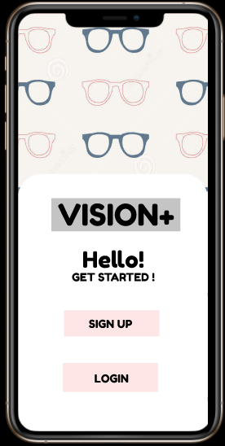

6. First-time users should click in “SIGN UP” and fill all the details needed in the next frame shown below.

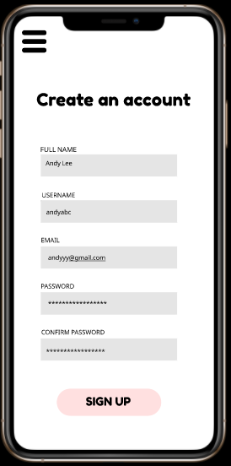

7. After that, users should log into their account.

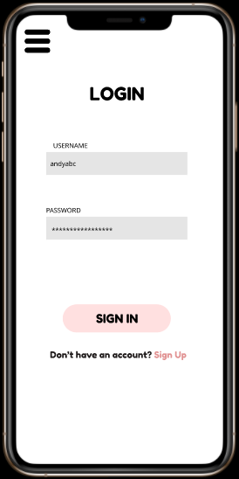

8. Then, it will be ready to use.

TASK 2: SET, VIEW AND DELETE REMINDER

Through voice recognition: -

1. Press twice on the button on the side of the spectacle to start using voice recognition or say “Hey Vision” to start activating Vision+.

2. To set any new reminder, the user should say “Set” then proceed with the reminder instruction as well as the time that the users want to be reminded at. A window will pop up to confirm the reminder, and the user can say “Yes” to set it or say “Cancel” to cancel it.

3. To view the reminder set before, the user can say “View”, and Vision+ will list down the reminder set through the frame of the glass. To exit from view window, the user should say “Done View”.

4. To delete any reminder, the user can say “Delete” and the reminders will be displayed through the glass frame of the spectacle. The user should say “Delete” follow by the reminder set before and a confirmation window will pop up. To agree with deleting the reminder selected the user can say “Delete” or say “Cancel” to cancel the deleting process.

Through Vision+ application on device: -

1. After logging into the application, it goes to home which will display all the reminders. Users can set, view and delete reminders here.

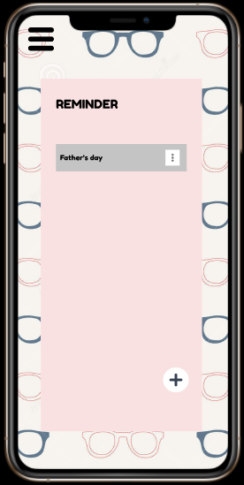

2. To set a new reminder, users can click on + button provided on bottom right screen.

3. It will proceed to another frame in which the user can set the reminder. Then, click on tick icon to set it.

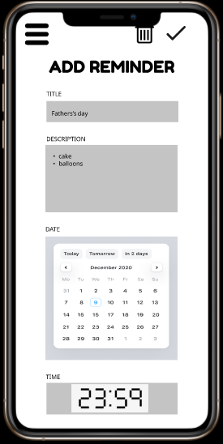

Confirming to set the reminder

4. To delete the reminders, the users can click on edit icon at the end of each reminder and it will proceed to another frame to delete the selected reminder.

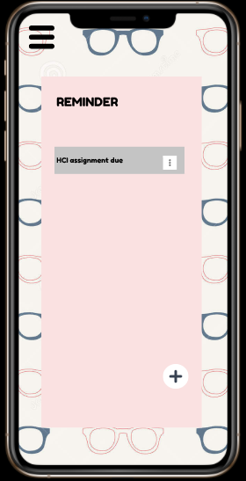



Delete the reminder

TASK 3: KEEP AND CHARGE VISION+

1. Vision+ is complemented with a special case and a wireless charging pod.

2. To charge it, the user should put the spectacle inside the case and put the case on top of the charging pod.

3. To see the battery percentage, the user can check it through the application on the device.

4. At application home frame, the user should click on the settings button provided on top-left of the screen and it will show the settings.

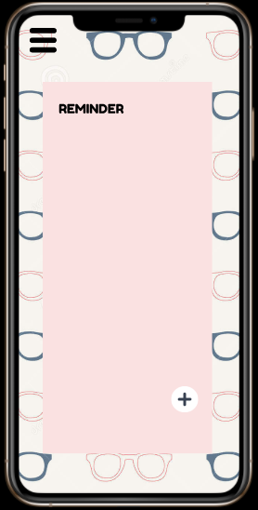

Settings button

5. Click on “VIEW BATTERY” to check battery status.

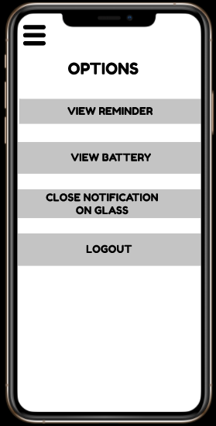

6. It will display on new frame upon the battery status as shown below.

