

**UNIVERSITI TEKNOLOGI MALAYSIA**

**REPORT ON BOOTHS OF NEW ACADEMIA LEARNING INNOVATION (NALI) 2019**

GROUP MEMBERS: 1. ABDUL AZIM BIN ABDUL MALIK (A19EC0002)

2. IZZATUN NADIAH BINTI ABDUL RAHMAN ([A19EC0056](http://elearning.utm.my/19201/user/view.php?id=86978&course=39262))

3. ONG YIN REN (A19EC0204)

4. LEE HUI ZHONG (A19EC0064)

COURSE NAME : TECHONOLOGY AND INFORMATION SYSTEM (SECP1513-07)

LECTURER’S NAME: DR. SARINA BINTI SULAIMAN

**INTRODUCTION**

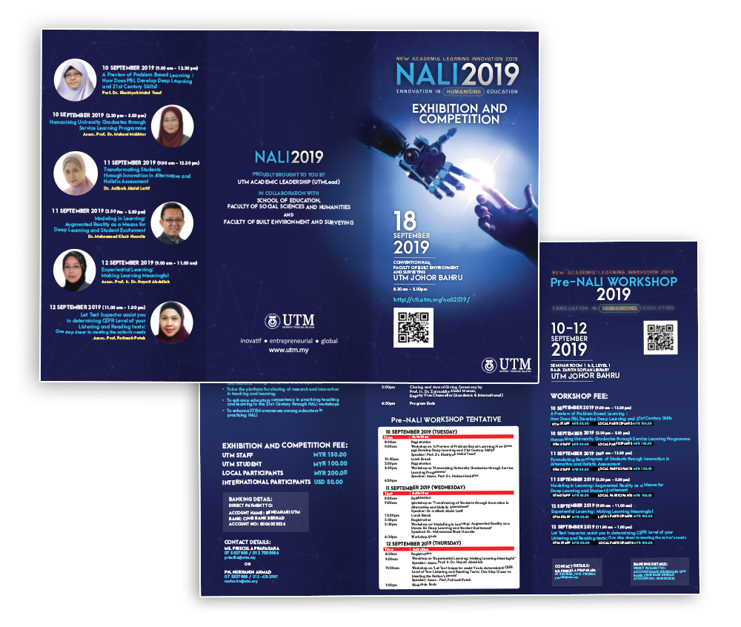 New Academia Learning Innovation (NALI), is an event conducted by UTMLeadership team that focuses on evolving the way of education through technology. The objective of NALI does not revolve in education only, it also prioritize the recognization of the NALI research and innovation in teaching and learning through exhibition and competition. Furthermore, this exhibition also promotes the enhancement of educators throughout the workshop conducted aligned with the 21st century education program. In addition, NALI also provides the platform to create awareness towards Science, Technology, Engineering, Mathematics (STEM) among educators. Lastly, this exhibition opens up the platform for sharing of research and innovation in teaching and learning.

Brochure of NALI 2019

**EXHIBITION BOOTHS**

1. **MOBILE LEARNING APPS FOR LANGUAGE LISTENING SKILLS**

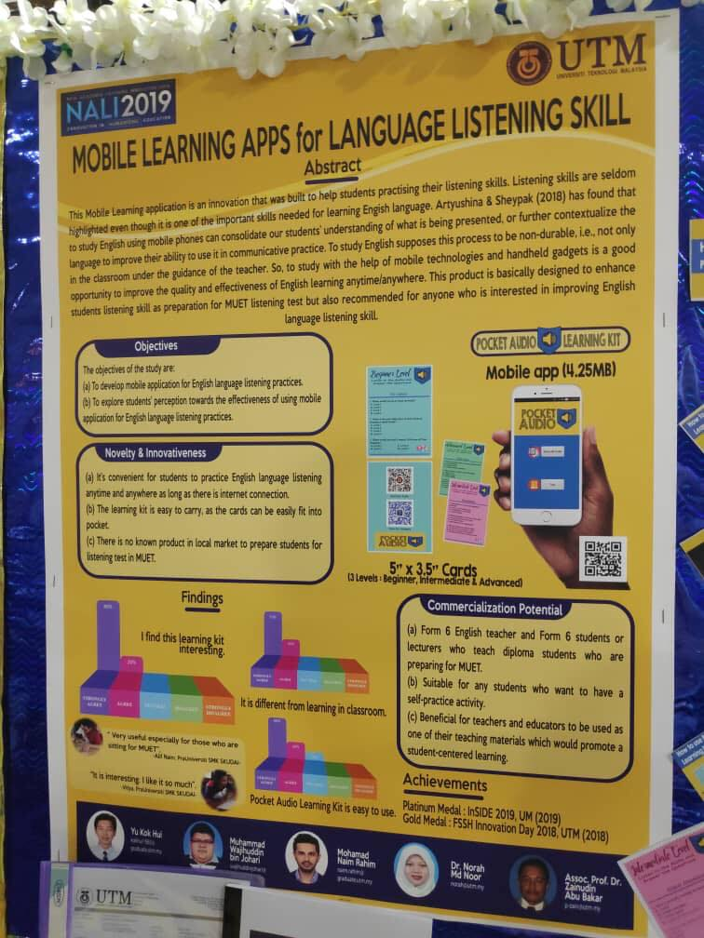The title of the poster is “Mobile Learning Apps for Language Listening Skill.” This mobile application is an innovation that is built to help students practicing their language listening skill especially English language. Listening skill is usually be neglected among the students but it is one of the important skills needed for learning English language. The process in studying English can be held not only under the guidance of the teacher in the school. So, mobile technologies is a very good gadget to improve the quality as well as the effectiveness in learning English anytime and anywhere. This mobile learning application is basically designed to enhance students listening skill as preparation for MUET listening test but anyone who is interested in improving English is also encouraged to use it.

Poster of Mobile Learning Apps for Language Listening Skills

One of the objectives of their invention is to create a platform for students to learn English listening skill conveniently and effectively. Students can use this mobile application with or without network connection which means that students can access to it anywhere in anytime. The following objectives is to develop the usage of mobile learning apps for English listening skill among the students because it is very common and important to know how to access informations provided online in the world of ICT.

There are many innovations of technology nowadays which bring a lot of benefits to all of us especially to the students. They can easily access to all of the technologies to search for information that needed, to improve their learning skill, to do more exercises and other usages. We should do more innovation so as to facilitate the development of educational field in our country for the future generations which can help in the development of the country in different aspects.

1. **HOLOREAD**

HoloRead is a pyramid hologram application which is used as a visualization tool in preschool children’s learning in order to enhance their English literacy. HoloRead is one of the learning tool which based on augmented reality technology, thus this tool provides the three-dimensional (3D) concept of the studied objects to be displayed. Specifically, this application is useful for all government preschool in Malaysia due to the content of HoloRead is in accordance with the syllabus of National Preschool Curriculum Standard. Therefore, this study focuses on the effectiveness of HoloRead towards preschool children’s learning with the consideration of the development process.

The objective of this study is to investigate the effectiveness of HoloRead towards children’s cognitive ability in order to enhance their literacy skills. Literacy is an ability of individual skill to acquire knowledge which is involved of the cognitive process. Thus, a visualization tool which is incorporated with the 3D technology are believed will enhance students’ literacy skills. Therefore, HoloRead becomes an effective visualization tool because of that 3D display appears like floating on the air with 360-degree portrayal of the image. Hence, that display perceived as something magical by children. Besides, HoloRead allows viewers to view that subject learned from different angles due to the pyramid shape of reflective tool has been used to visualize the 3D display. Hence, the display will lead children to predict and interpret from various perspective. Finally, this process will improve their cognitive development and indirectly increase the children’s understanding and achievement. For the entire development process, researcher decided to use ADDIE Model by Rossett (1987) because of this model proposed a systematic step through its five phases which are Analysis, Design, Development, Implementation, and Evaluation.

In the Analysis phase, four elements will be considered to be analysed. The first element is the analysis of learners. This study involved of 50 preschool children from government preschool where 25 children directed for experimental group and another 25 children for control group. The second element is the analysis of instructional goals. The goals of HoloRead development is to help teachers to diversify the current learning tools in order to enhance children’s literacy skills in English language. Then, the third element should take into account is the analysis of instructional development. The hardware used to develop HoloRead is a computer with a specific specification such as Intel i7, Nvidia 960M, 1TB HDD, and 8GB RAM. While Unity and Photoshop are the software that has been used to develop the HoloRead. Finally, researcher needs to analyse the learning objectives that will be covered by the HoloRead. There are two main topics in Communication Core Principle (English) which are related to literacy skills: reading and writing. Next, the second phase is design. A classroom learning tool must be designed effectively by complying with the criteria needed to ensure its effectiveness and usability for learning. Structurally, the preparation of storyboard is one of the important processes in designing phase to depict the actual flow of an application. Third phase is development. In this phase, the HoloRead will be implemented in actual experiment, there are few criteria should be considered. Those criteria include of the size of LED monitor to be used, the size of pyramid prism, and the appropriate class to be used then. Next is Implementation. HoloRead application will be tested in preschool classroom learning in a period of six weeks. This activity will be conducted in computer lab and in the small group consist of four children for each group. Then, each group will be assigned a teacher to guide 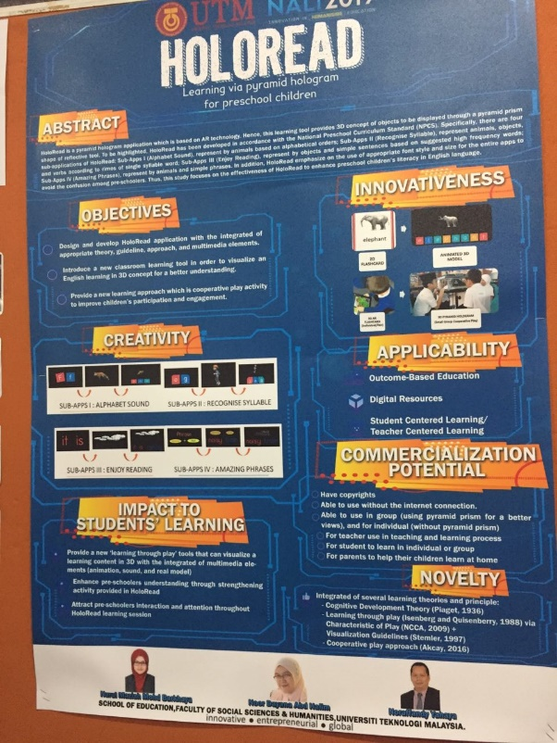and help the children when they learn through HoloRead. The whole interactions and behaviours among children throughout the activity will be recorded using a video recorder. The last phase is Evaluation. In this final phase, the effectiveness of HoloRead will be evaluated through the pre-test and post-test results in order to measure the increment of literacy among preschool children. Apart from the conducted tests, the behavioural patterns in term of interactions will be measured using behavioural checklist and analysed through content analysis. The aim of this measurement is to examine the dominant behaviours in children when they learn through HoloRead.

Brochure of HoloRead

1. **AUTOMOBILE VIRTUAL REALITY MODULE (AVRM)**

Automobile Virtual Reality Module, shortens as AVRM, is designed to provide simulation solution specifically towards vocational students in the field of automobile. AVRM incorporates virtual reality(VR) system to be somewhat of a replacement of real world materials. This system uses VR to run servicing and maintenance work processes. Students are able to disassemble and put back any automobile system while the VR also will guide by giving description and functionality of the parts disassembled. Most importantly, this module is aligned with the national academy and industrial standards, making it a friendly and well-designed systems to be absorbed in the curriculum syllabus.

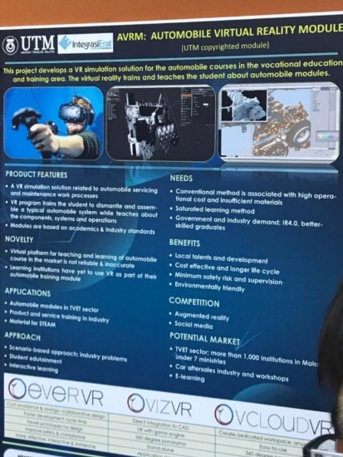 AVRM’s objective is to give students ease of access regarding automobile systems without sacrificing any large amount of funding. While this module is relatively new in the automobile sections, the use of VR nowadays is nothing to be shocked of, so it will not be a shocker if in the near future the implementation of AVRM is widely used as a standard guideline towards any aspired students or rookies in this field. This is especially true when the terms of funding and money comes into play. It is expensive to provide a full practical course when the item in question is automobile. So, by using AVRM, companies will be able to significantly cut costs in providing a platform for their new employees. Besides, AVRM can be used as a long term module thus providing longer life cycle for the module. Even if the AVRM systems might be outdated, if correctly supervised, it can be updated so that any new automobile systems can be installed also.

Next, the safety risk is also greatly decreased. Since it is using a system fully run by a computer, the possibility of any danger towards the clients, such as wrong assembling of parts, can be avoided. Intensive supervision by any seniors is also not required specifically because the VR will provide the information if any errors are detected while students are simulating. Not only will it provides information, it will also let the user to have a repeat as many as they want until no errors are done. Furthermore, it is environmental friendly due to the fact that no raw materials is required.

AVRM Poster

Finally, it is greatly desired if the module is implored much further so that the user can use it as frequently as they want. While it is true that practical approach is still better preferred, it is also important to learn the basics with guide as much as they need. Since the possibility, of ruining the real systems is there if they are given the jo of servicing or maintaining any automobile as their first task.

**TRENDS IN NALI 2019**

The trend of New Academic Learning Innovation is to bring a new learning and teaching style for the students. Teaching style here implies the way of teaching aligned with the new approach of 21st century classroom. It is of the important for the educators to equip themselves with new ways of teaching so that the learning process is not full of theory which usually makes the growth of creativity and critical thinking in student to be stunted. Through multiple experiments, it is shown that student can learn the knowledge much more effectively by the new technology such as VR or mobile application. Therefore, the implementation of new technology such as the one that was mentioned will help to spark interest and curiosity in students’ mind to explore more in the regarded topics. Next, it may also reduce the cost of buying the teaching materials. Since most invention in NALI is powered by a computer, most educators can reuse it for another set of students without having the need to make another identical learning material for another session. Furthermore, NALI can also help the educators competency in practicing teaching and learning in the 21st Century through NALI workshops because most of the workshop in NALI is specific to give inputs to the educators on how to improve learning sessions with students. Besides, the new generation of student are known as “net generation” who are already customary to the technology presented in NALI. Hence, it is easier for the teachers to share their knowledge anywhere and anytime conveniently. NALI also can foster up the new pillar with high thinking skills to our country.

**REFLECTIONS**

As a computer science student, we had learned that technology is widely used not only in our country but around the world especially in education. We must always be updated about the technology that have been used in our country so that we will not be called as an old fashioned. Technology is the best way to attract students’ attention because most of the time, their parents always exposed them with the use of gadget. It can improve their knowledge retention because technology can help to encourage active participation in the classroom. Different forms of technology can be used to experiment with and decide what works best for students in terms of retaining their knowledge. For example, the Holoread using a pyramid hologram in a preschool to enhance their English literacy before entering to primary school. The use of technology-based of visualization tools can grab the children’s attention in learning from the beginning till the end of a class session. Other than that, the mobile learning apps for language listening skill can help student practicing their language listening skill especially in English language. As we know that in Malaysia we used the English language as the second language so it can help student to improve their English language. Automobile Virtual Reality also can improve raise engagement and increase knowledge retention for students of all categories because it teaches student on engine components, systems and operations. Virtual reality can provide students the opportunity to experience the reality of being in an unfamiliar working scenario which is the absolute key to success in vocational training. To sum up, technology has many faces and means, and we should choose the appropriate use of technology to get the most benefits of it. We have to lead the technology, and don’t let the technology leads us. TV, Internet, and mobiles are some examples of technologies we can’t ignore using them in our daily life, and to follow the speed track you need to follow the speed of the technology. Using technology in education has become a common fact in our lives.

jjjj