TECHNOLOGY AND INFORMATION SYSTEM
SECP1513-01
Semester I 2019/2020

INDUSTRIAL VISIT REPORT

Date : 21 October 2019
Time : 3.15 pm
Venue : PSZ, Perpustakaan Sultanah Zanariah, UTM
Lecturer : Dr. Zuraini binti Ali Shah
Group:

NAME | STUDENT ID
NUR IZZAH IZZATI BT. MOHD YUSOF | A19EC0132
ARINA ZAFIRA BINTI AMRAN | A19EC0024
DIVIYA ARUMUGAM | A19EC0041
HAFIZ RIDWAN | A18CS9011

INTRODUCTION

As a computing student, our second industrial visit was to the Sultanah Zanariah Library (PSZ) in University Technology Malaysia. We visited a gallery in PSZ on 21st November 2019 during our Technology and Information System lecture. The gallery is mainly about computers. Computer is an electronic device that process data, collects data and manipulates it based on its program. Computers are the important pill in our modern society because it is used in all fields. Although, the function of computer is always the same, nowadays computers are totally diverse compared to the previous era. This is because, in our current era, computers have all the specification to fulfill our needs. It contains all the modern technology and presents it in a smaller size compare to previous era. The first computer invention is Electronic Numerator Integrator and Computer (ENIAC). It was invented by John Mauchly and J.Presper Eckert. That computer was developed with older technology and appeared much different from modern computers. The comparison are shown below.As time went on, the fabrication process became more efficient and computers became more powerful while at the same time shrinking in size, to the point where we have palm size computers which are more powerful than ENIAC.

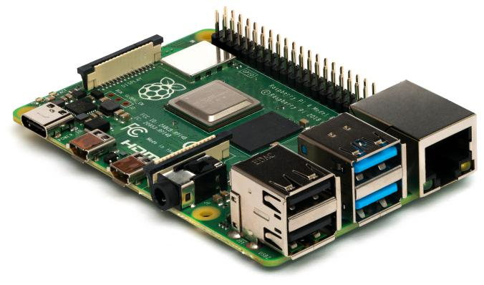

Raspberry pi
PREVIOUS ERA | CURRENT ERA
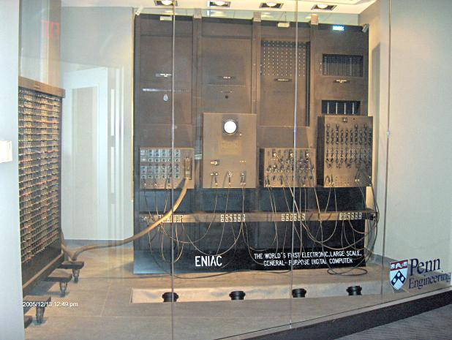 | 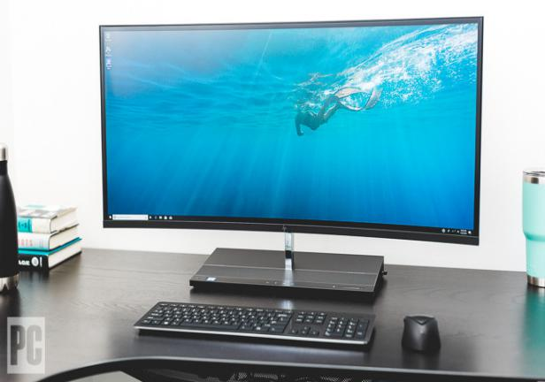

HISTORY COMPONENT OF COMPUTING DEVICES

- IMPACT PRINTER
MODEL: IBM (4245)

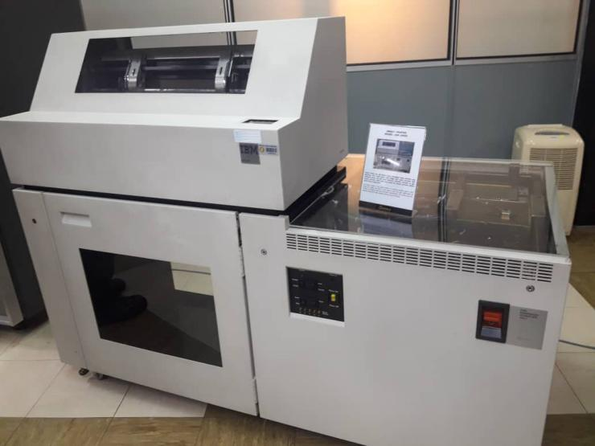

The Impact Printer at Data Matrix Printer is a printing machine used in UTM during the 1990s until 2011. It was used to print the data information of students and staff to meet the University’s requirements. This printer was also capable of printing in high volumes and non-stop for 48 hours.
The Impact Printer using the dot matrix print. In one hour, this printer can printed over ten thousand pieces an very high speed printer.

- MAINFRAME DATA STORAGE
MODEL: IBM (9345B22)

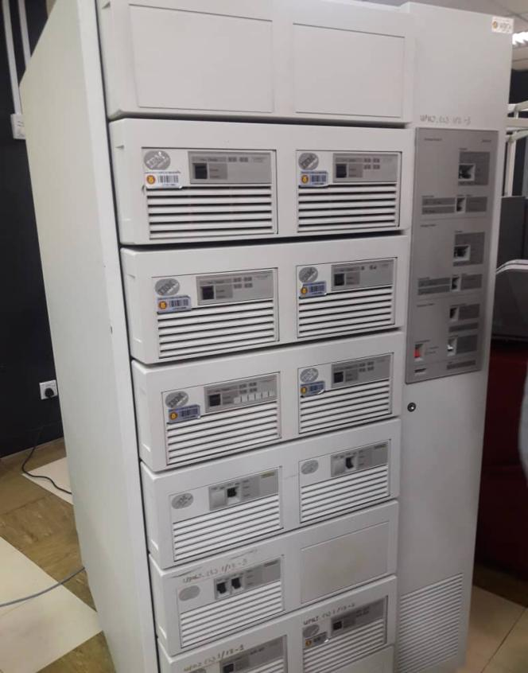

The usage of Mainframe System at UTM began in the 1970s at Computer Office, UTM campus, Kuala Lumpur. It served as a data control of students and the organization.
The mainframe has been used for almost 20 years for various components and functions such as preparing, storing, securing, and printing the University’s information data.
Mainframe is a very big computer after the super computer. In the ICT technology, before we have the computer, we have two area or line for the computer technology. Mainframe is one of the parts of the server. Mainframe have a supercomputer, minicomputer, personal computer and virtual computer.
In our area, mainframe is one set of the computer have a separate equipment. It has backup unit system, terminal, CPU, Hard disk, Network Card and printer.

- MAGNETIC TAPE UNIT
MODEL: IBM (3420)

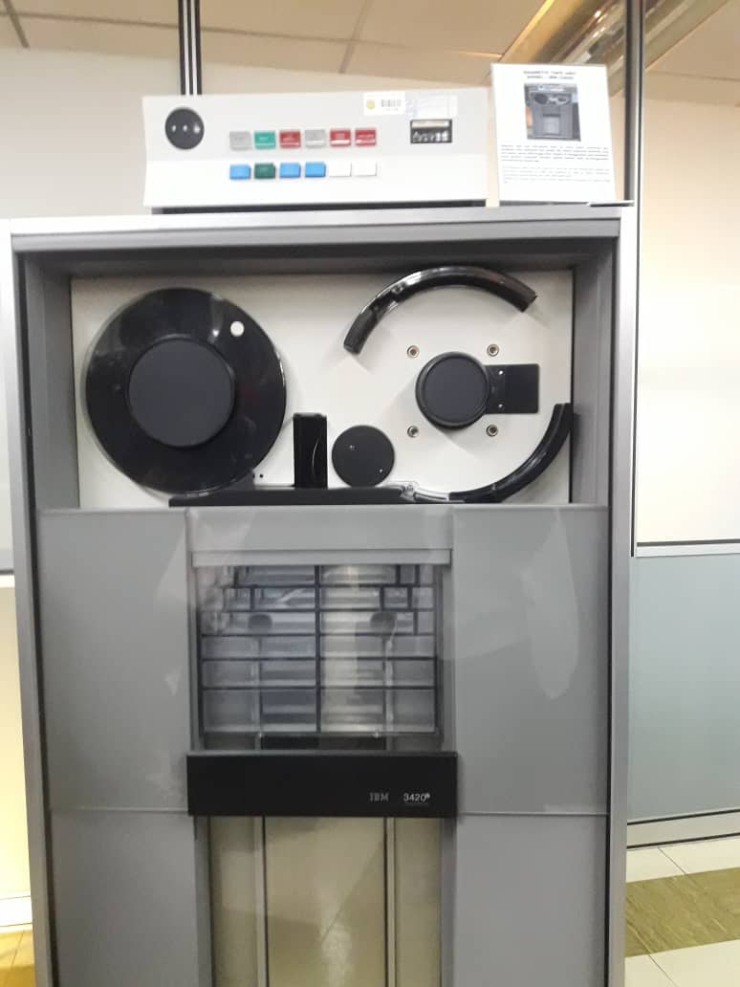

The Magnetic Tape Unit was used as a ‘back up’ for the mainframe system and information database of staff and students as well as other University’s information system during the year 1976 until 2010.
Ignition this model used a round shape tape before converting to square shape tape.

- SERVER MOTHERBOARD
MODEL : IBM (5150)

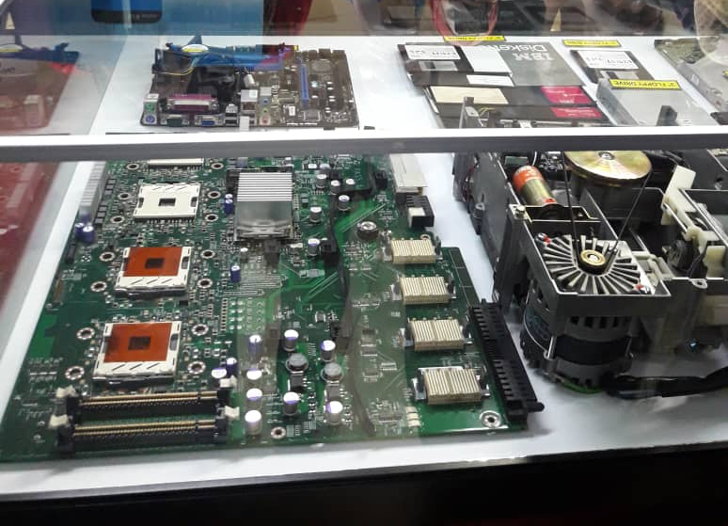

The motherboard for the mainframe have four processor, the reason why server have high device for system application, data analysis and so on. The latest one have 32 processor. For this area, we have cable technology and microfilm technology. UTM has a very big data center compare to other university. UTM have about 700 server.
The floppy disk have 3 type which is 3-inch, 5-inch and 8-inch. In 1997, mainframe using the 3-inch floppy disk but now, the mainframe using the 8-inch floppy disk. The system of mainframe using a disk card.
The hard disk for the mainframe before was very big compare to hard disk now. Before that, the capacity for the storage very small.
Motherboard also has network cable. The orange one is fiber cable and the capacity for the cable is one big above. For the UTP cable is the 100M one big above.Lastly, COX cable is about 10M below. That’s why our network has 10/100/1000. 1000 stand UTP and keysix, 100 stand for the keyfix and 10 stand for the COX. Our technology using mass technology.

- BM PERSONAL COMPUTER 300GL

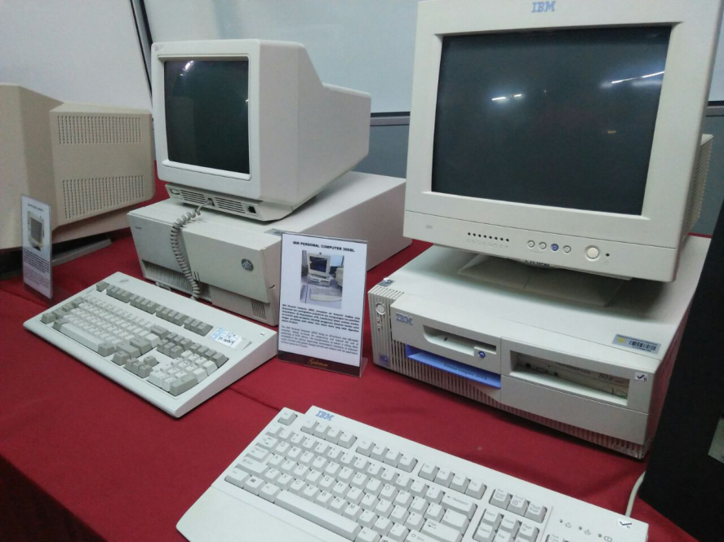

The PC 300GL used the Celeron, Pentium I, Pentium II and Pentium III throughout its lifetime. Celeron-based models had processors clocked at 333, 366, 433, 466, 500 and 533 MHz; Pentium I models had processors clocked at 133, and 166 MHz; Pentium II-based models had processors clocked at 350, 400, 450 MHz; and Pentium III-based models had processors clocked at 450, 500, 533, 550, 600, 667, 733, 800 and 866 MHz.These systems were packaged in two case form-factors, desktop and micro-tower. There were two variants of the desktop case, one with two expansion slots and one with four. Both variants had four drive bays. The micro-tower case had four expansion slots and four drive bays.
The IBM personal Computer 300GL being an all-inclusive and affordable computer , helped increased productivity and reduced the cost of ownership of UTM Library. The transformation of system is taking place constantly in the library . Apparently, technological revolution of computer usage coincides with system change and this was evident with the application of Dynix system for 10 years.

- APPLE MACINTOSH CLASSIC COMPUTER

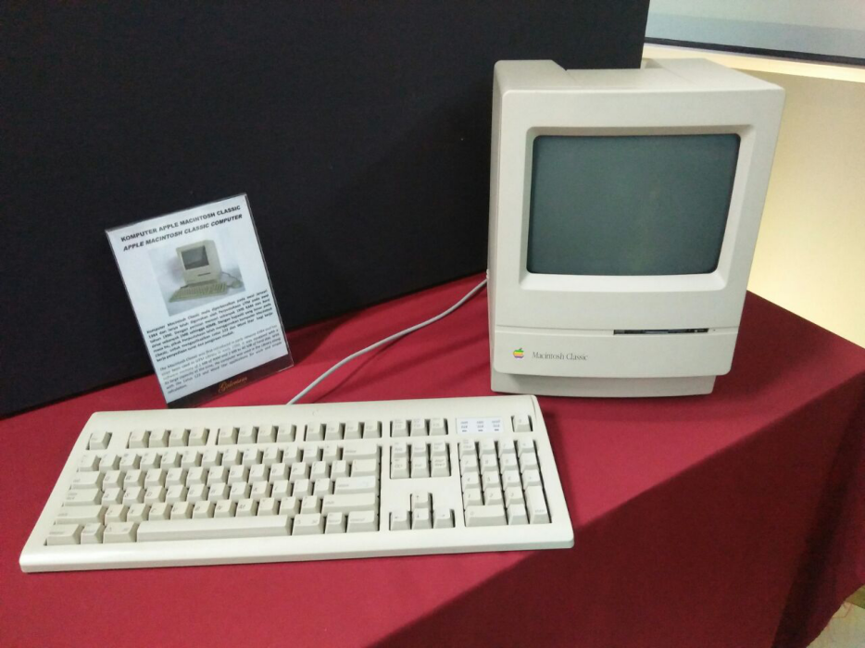

The original Macintosh, released in 1984, was the first personal computer to have a graphical user interface, or GUI. It was in all-in-one machine with a color display and included a mouse and a keyboard. Over the past several decades, Apple has released many new types of Macintosh computers, including all-in-one models, system units , and portable computers.

- IBM P70 MODEL 6554-673

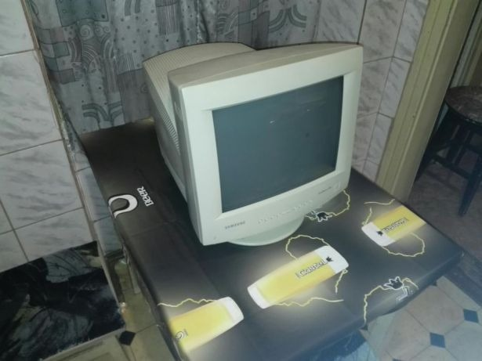

The IBM P70 Model 6553-673 was used in UTM library in early 1998 to contribute to work performance. As much, Library was liable of all modules, databases, software operations and data accessibility. With its ability to support up to 16 MB on disk storage, the computer system provided a performance improvement on desktop operation.
By implementing the VESA DDC 1/2B protocol, the new models of the P70 Color Monitor offers the capability of automatic optimization of monitor performance (Plug and Play).For effective automatic optimization, the attaching system unit must also be hardware- and software-enabled for DDC operation.A DDC-enabled monitor continually sends a stream of data to the attaching system unit through the video signal cable. The functional capabilities of the monitor are encoded in this data. A DDC-enabled system unit can interpret the received data and determine the combination of addressability and refresh rate (display mode) that best uses the capabilities of the monitor.A further benefit provided by Plug and Play is asset management. The DDC data sent by the monitor to the attached system unit includes the monitor serial number and associated identification information. This can be held in the system unit until requested by, for example, a department LAN administrator who wants to check the location of all equipment connected to the LAN.

REFLECTION

Malaysia is one of the countries that striking forward industrial revolution 4.0. Now and into the future,as industry 4.0 unfold, computers are very significant in various field. Computer are used to solve problems in our daily life involving different profession such as mathematics, sciences and statistics. Hence our goal for computing students are to develop students that will achieve an ability to evaluate a problem and identify the computing requirements applicable to its solution. Students also will an ability to use current techniques, skills, and tools necessary for computing practice. Next, Student will attain an ability to apply mathematical foundations, algorithmic principles, and computer science theory in the modelling and design of computer-based systems in a way that illustrates comprehension of the tradeoffs involved in design choices.
Throughout this visit, we can discover the chronology of the computer devices from the past that can be observed from various scope such as the size and the components involved. We can formulate a comparison between the past and today inventions. This visit helps us as a computing students to understand more about the idea of computing cause you can’t know where you are going until you know where you have been. All new technologies, including computers, evolve from an original, but we doesn’t necessarily believe the original no longer has a purpose or is less valued. Vastly our technology is re-upgrade for more advanced usage. From the information we obtained, we can expand more progressive technology which will be beneficial for all.
The action that we need to improve is our communication skills. The potential to communicate effectively with superiors and colleagues is essential, no matter what industry you work in. Communication skill is very important as we work in a team, miscommunication will lead to commotion. Next, analytical and research skill need to be strengthened as this process involve deduction reasoning, drawing hypothesis and applying judgments from the evidence and the output of study to reach a conclusion. Lastly, we need to improve our learning skills. In this industry, we will discover new and foreign stuff so we have to keep learning and don't shy to ask questions. We also have to make reading as our routine to boost our proficiency.

