SCSI 2143 PROBABILITY AND STATISTICAL DATA ANALYSIS

Project I – Descriptive Statistic

Analysis on Student’s Expenses

Mohammad Haikal Aiman, Muharrir, Reihan Rexy Osa Putra, Farel Rivaldo

Section 09

School of Computing, Faculty of Engineering

Universiti Teknologi Malaysia

**Abstract**—This study that we conducted was purposed to finding out how well UTM students when it comes to saving money. We prepared an online questionnaire that we made with google docs, then we sent it through every WhatsApp group possible with a target total of respondents that counts up to 30 people, we managed to collect 111 respondents. After we processed the data, we found that the average spending of UTM students could reach up to RM 600,00 per month (*in average)* and only saves in average RM 125,20 per month.

# Introduction

It really is important to keep track of how you are spending your money. It is the first step to understanding how you are managing your money, and to taking control of your finances. If you lose track of how much you had spent for the last few months or maybe weeks you might be in big trouble.

The kind of trouble that you’ll face is “empty pockets” in all of the sudden, what’s worse is when this trouble occurs when you needed money the most. Sure, you have a lot of friends to help but, you can’t always rely on them, they have their own limits to help you too.

So, we decided to made a survey on student’s expenses. Not only under the purpose of helping the ones that are experiencing this trouble but, also as a reference for those who haven’t reach the stage of trouble, so that they won’t fall under the same hole as the others. The questions in the survey included are the questions that are mainly related to our study.

# METHODOLOGY

The methodology that we use to gather the data is by surveying with a questionnaire that we made with google docs. The target respondents were all UTM students of any faculty, so we send the questionnaire through every reachable WhatsApp groups that have UTM students inside the group. The questions in the survey includes : Gender, Age, ,Nationality (Country), Faculty, Year of Study, Source of Income, Household / Parents Income (in RM), Monthly Allowance (in RM), Monthly Essentials (in RM), Fun Money (in RM), Monthly Savings (in RM), “Where do you turn to in a cash crisis?”, “Are you satisfied with your financial situation?”, “Is university a good value for the money?”.

# RESULTS AND DISCUSSION

The 111 respondents that we have gathered are then moved to Microsoft Excel to be sorted out so that we can process the data to reach a final conclusion. We processed the data using R-Studio Software to create graphs, charts, and histograms of the data that we have gathered.

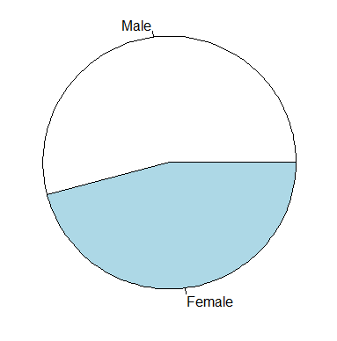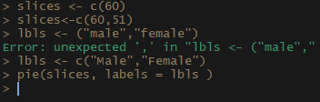

1. Gender Distributions

We differentiate the respondents through the gender distribution so that we know who spends more.

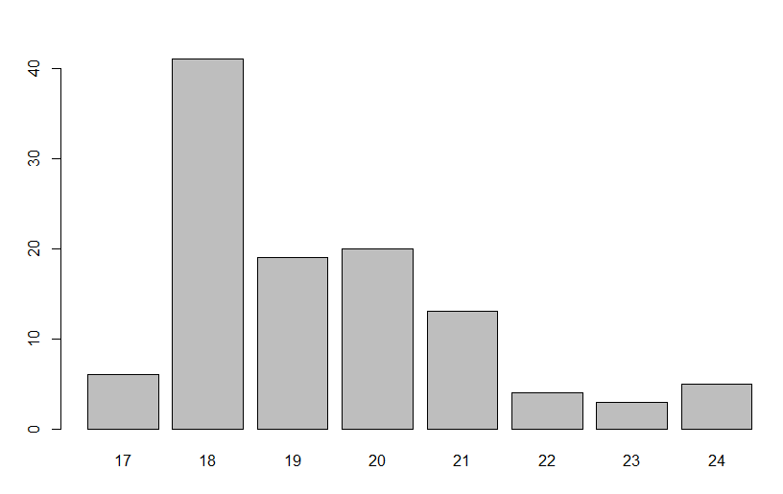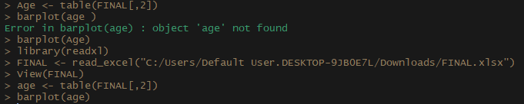

1. Age Distributions

We differentiate the respondents through the age distribution so that we know at what age the respondents spend more.

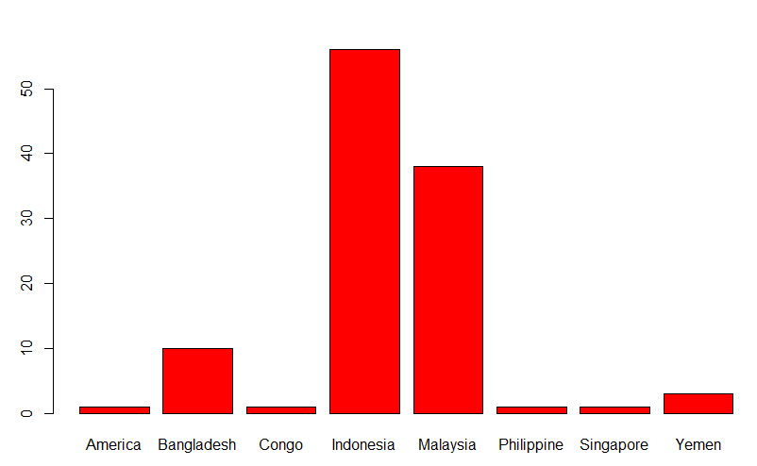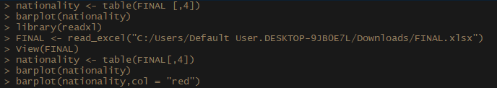

1. Nationality Distributions

We differentiate the respondents through the nationality distribution so that we know at where most of the respondents came from.

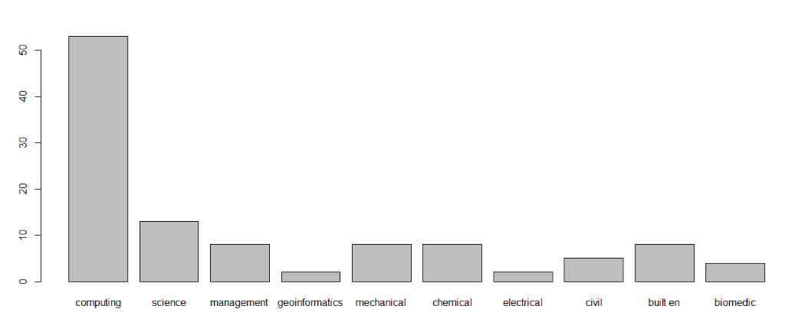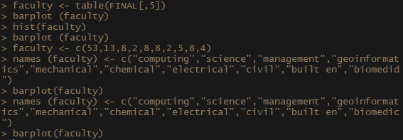

1. Faculty Distributions

We differentiate the respondents through the faculty distribution so that we know at which faculty most of the respondents study.

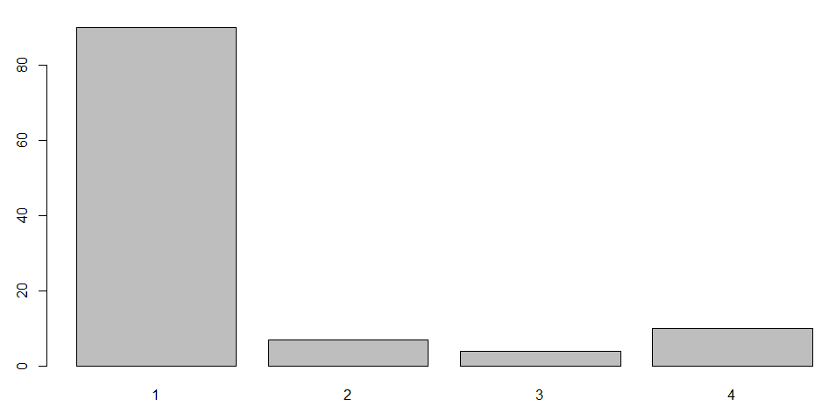

1. Year of Study Distributions

We differentiate the respondents through the year of study distribution so that we know which year most of the respondents are.

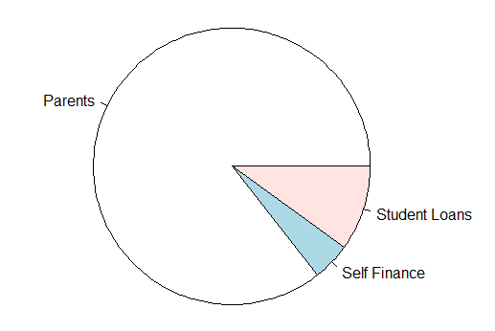

1. Source of Income

We differentiate the respondents through the source of income distribution so that we know which is the most of the respondents’ source of income.

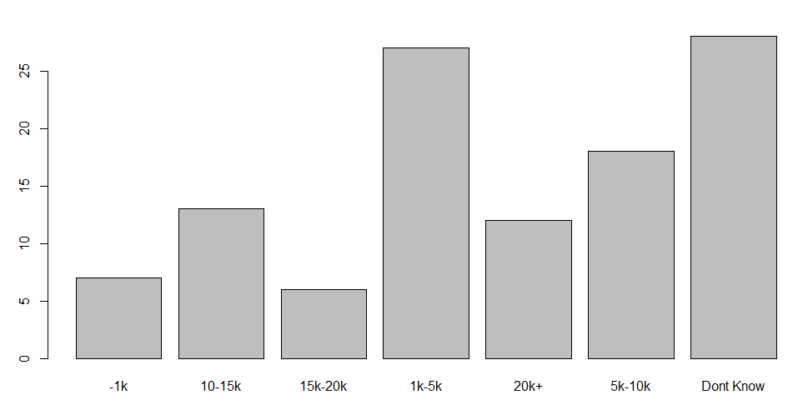

1. Monthly Allowance (RM)

We gather this data to obtain the information about how much do the respondents’ money income per month.

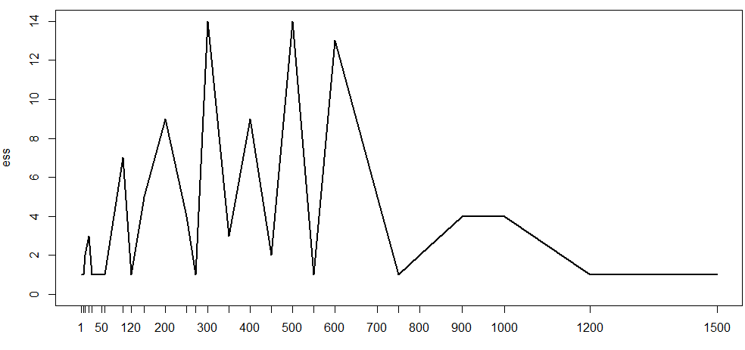

1. Essentials Spent Monthly (RM)

We gather this data to obtain the information about how much do the respondents spend monthly on essentials such as living costs, ride costs, and etc. We also use this data to find the average of the essentials spent per respondent which equals to RM 415.4054.

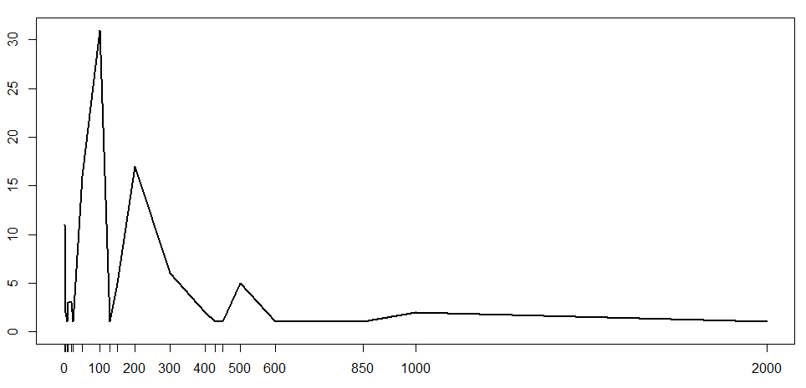

1. Leisure Spent Monthly (RM)

We gather this data to obtain the information about how much do the respondents spend monthly on leisure such as entertainment, expensive foods, and etc. We also use this data to find the average of the leisure money spent per respondent which equals to RM 177.8018.

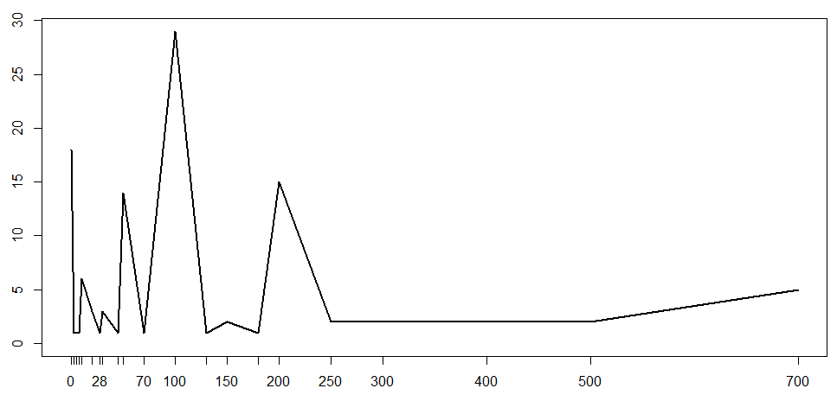

1. Money Saved Monthly (RM)

We gather this data to obtain the information about how much do the respondents saved monthly. We also use this data to find the average of the money saved per respondent which equals to RM 125.9369.

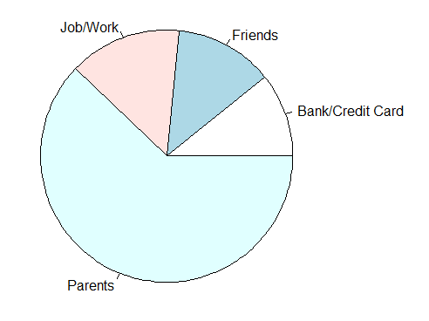

1. Second Option of Income

We gather this data to obtain the information about where do the respondents go when they ran out of money but still needs more for essential needs.

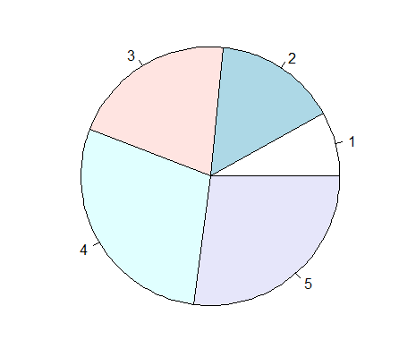

1. Satisfatory Level on Spending

We gather this data to obtain the information about how satisfied are the respondents about their spending habit.

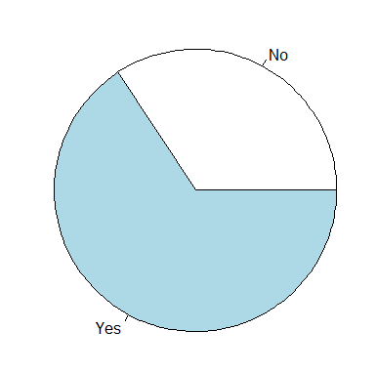

1. Opinion whether university is a good choice to spend money on or not

We gather this data to obtain the information about how much of the students think that going to university which cost is not cheap is worth it or not.

From the study we can conclude that many of the UTM students are around the age of 18 - 20 years old with having the average allowance RM 617.10 per month, and tend to spend averagely RM. 415.40 on monthly essentials and RM. 177.80 on entertainment which sums up to RM 593.20, almost RM 600 each month. Whenever the respondents are short in money, they most of them turn to their parents to ask for more money instead of working on part time jobs or credit/loan from bank, this is not surprising because most of the respondents are in fact international students who are forbidden to get any part time jobs. On average the students save around RM 125.95 each month, which does not resemble a pennywise role model since there are not in a small number of respondents that have the allowance ranged from RM 600-1000 each month.