LAB EXERCISE
QUESTION 1
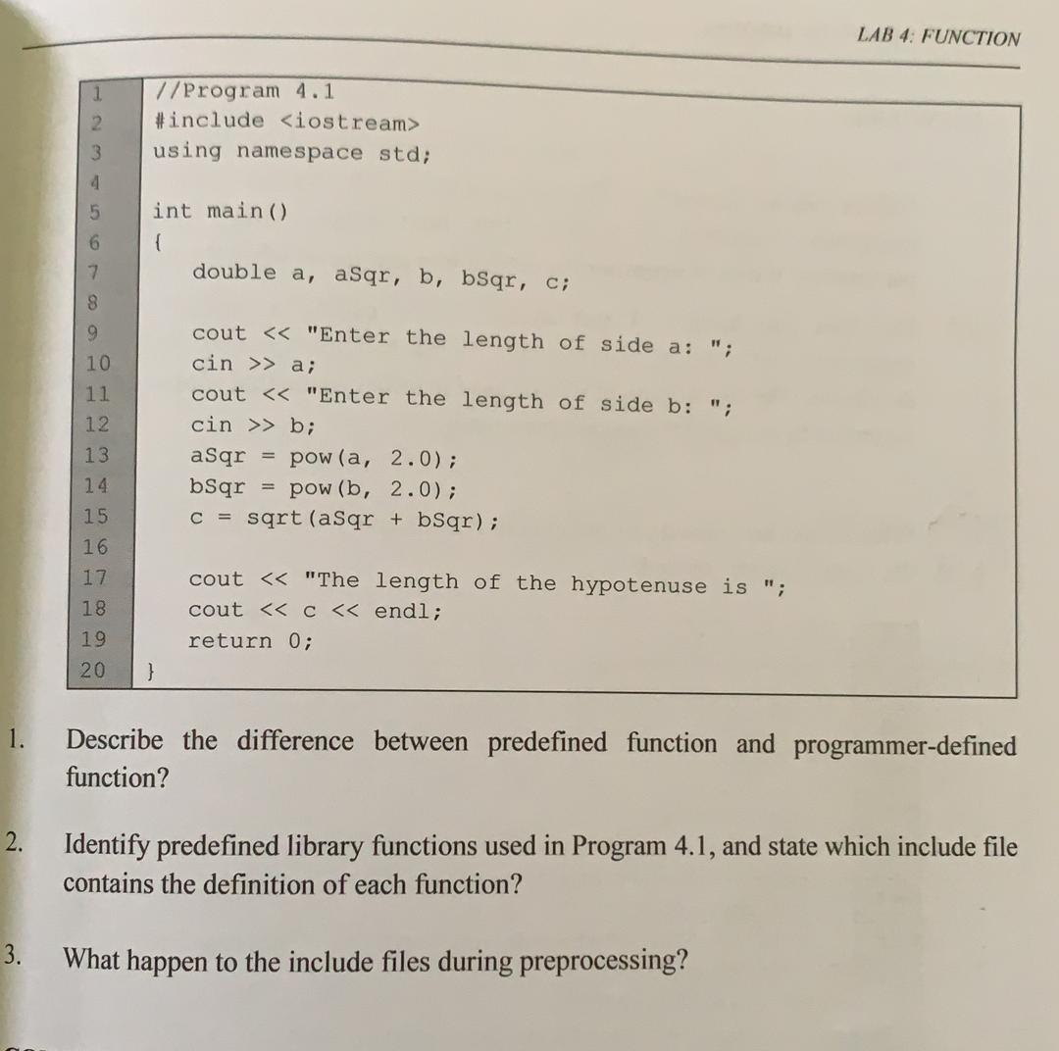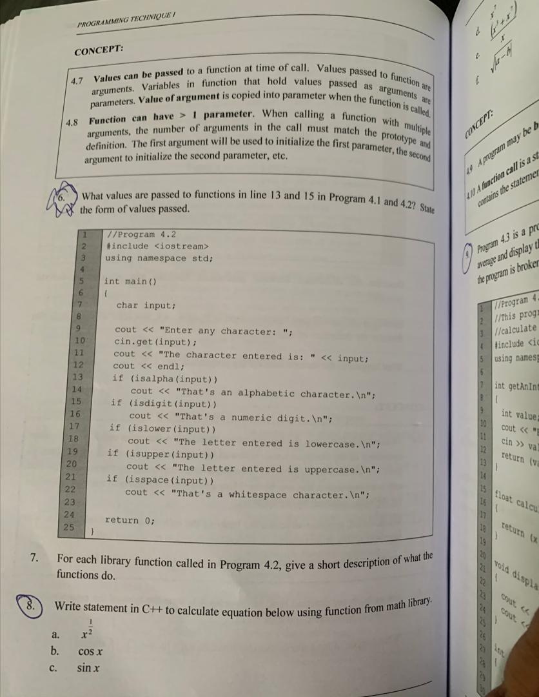
A. Program 4.1
Line 13 = Calculates the value a input by user to the power of 2.0. The result is assigned to variable aSqr.
Line 15 = The total sum of aSqr and bSqr is squared root. The result is assigned to c.
B. Program 4.2
Line 13 = The variable input is true when the user put the input in letter form. Otherwise, it will be considered false and move to the next if statement. When it is true, the output will be “That’s an alphabetic character.”
Line 15 = The variable input needs to be in single positive integer between 0-9. Otherwise, it will be considered false. When it is true, the output will be “That’s a numeric digit”.

QUESTION 2
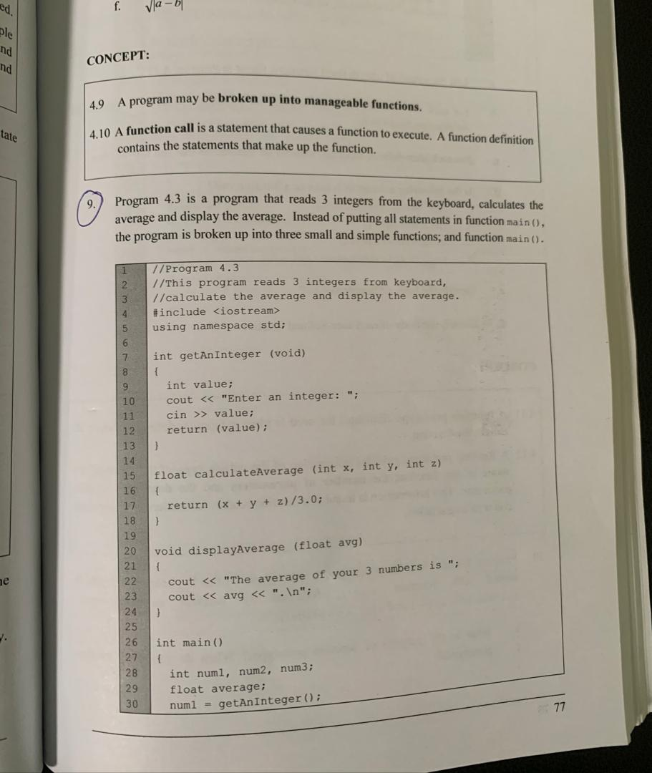
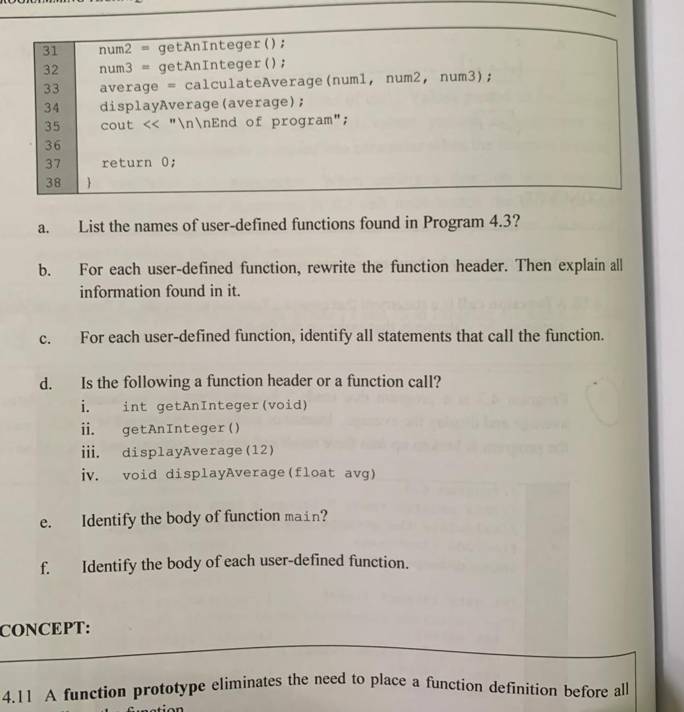

- List of user-defined functions
getAnInteger (), calculateAverage (), displayAverage ()
- int getAnInteger (void)
- 3 integer values input by user is returned to the variable value
- Parameter = void
- Return type = int
- Function name = getAnInteger
float calculateAverage (int x, int y, int z)
- return the result total sum of 3 integers that is divided by 3.0 to the calling function calculateAverage.
- Parameter = int x, int y, int z
- Return type = float
- Function name = calculateAverage
void displayAverage (float average)
- display the result of the average from return value in function calculateAverage
- Parameter = float average
- Return type = void
- Function name = displayAverage

- For function getAnInteger(), the statements that calls the function are from line 30,31 and 32.
num1 = getAnInteger();
num2 = getAnInteger();
num3 = getAnInteger();

For function calculateAverage(), the statement that calls the function is from line 33.
Average = calculateAverage(num1, num2, num3);

For function displayAverage(), the statement that calls the function is from line 34.
displayAverage();

- Function header
ii.) Function calls
iii.) Function calls
iv.) Function header

- The body function main can be found from line 26 to 38.

- int getAnInteger (void) = line 7 to 13
float calculateAverage (int x, int y, int z) = line 15 to 18
void displayAverage (float average) = line 20 to 24

QUESTION 3
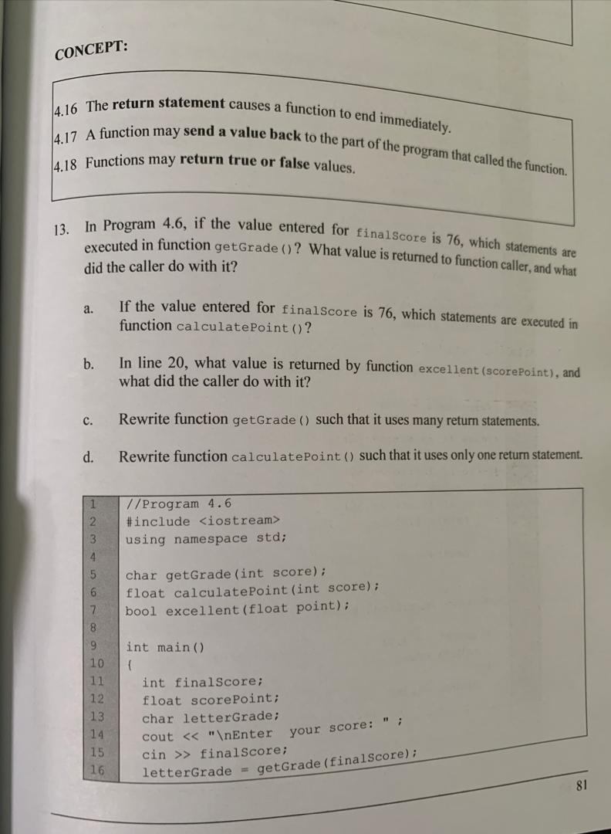
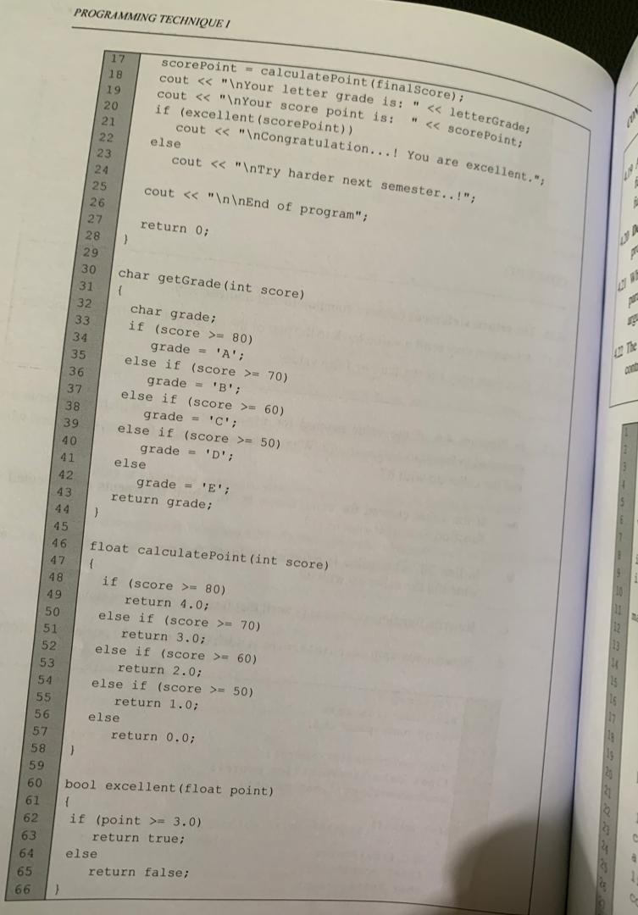

- Value input = 76
Statements executed is on line 50 and 51.

else if (score >= 70)
return 'B';

- The value return to function excellent(ScorePoint) is either true or false result. The calling function will first refer to the statement in the body function of bool excellent(float point) before executing the if statement on line 20. If the result is true, the output would be “Congratulation…! You are excellent.” otherwise the output is “Try harder next semester…!” if it is false.

- char getGrade(int score)
{
char grade;
if (score >= 80)
return 'A';
else if (score >= 70)
return 'B';
else if (score >= 60)
return 'C';
else if (score >= 50)
return 'D';
else
return 'E';
}

- float mark;
float calculatePoint (int score)
{
if (score >= 80)
mark = 4.0;
else if (score >=70)
mark = 3.0;
else if (score >= 60)
mark = 2.0;
else if (score >= 50)
mark = 1.0;
else
mark = 0.0;
return mark;
}

