Exercise 2

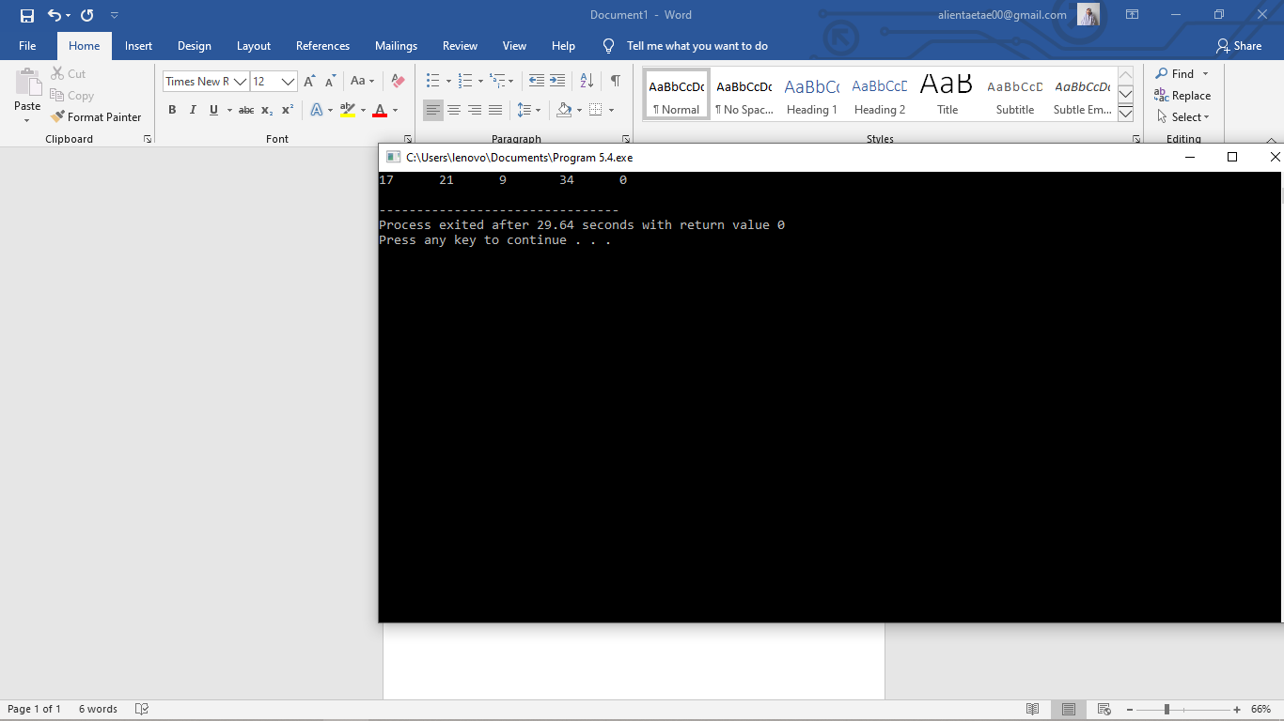1.a) The output is:

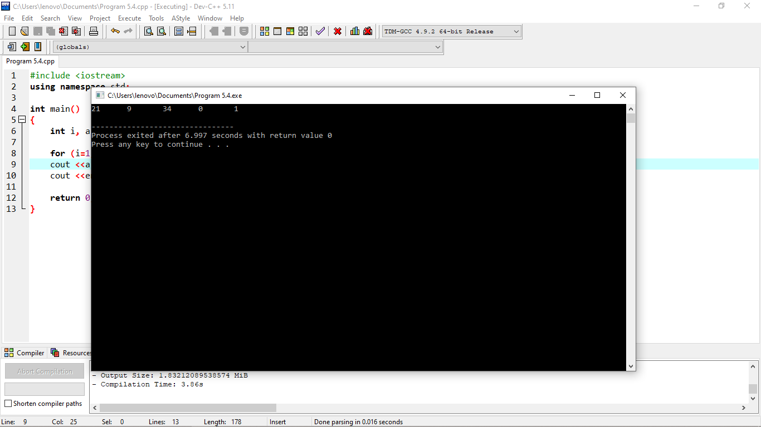 b) The output is:

c) The output is:

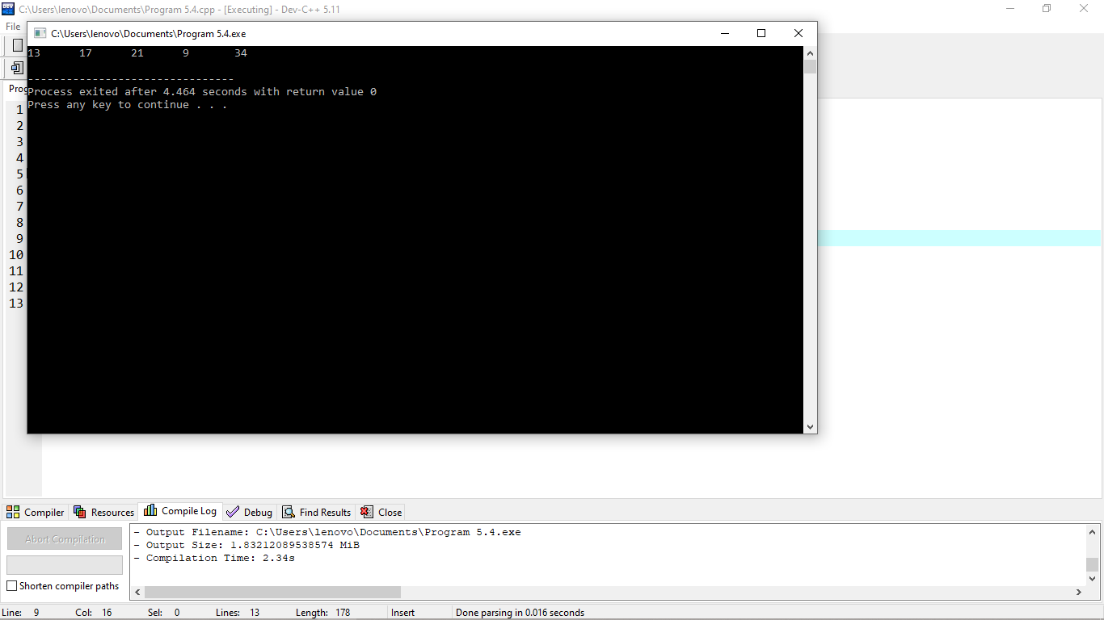

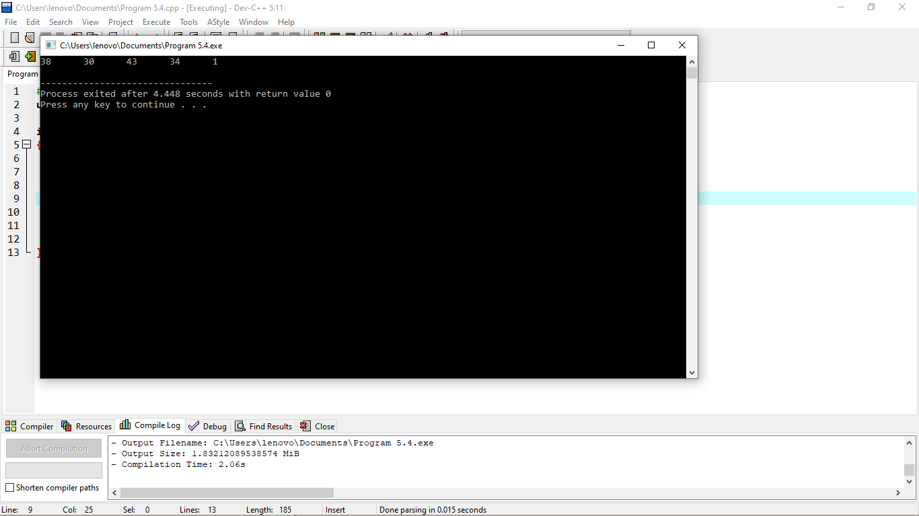 d) The output is:

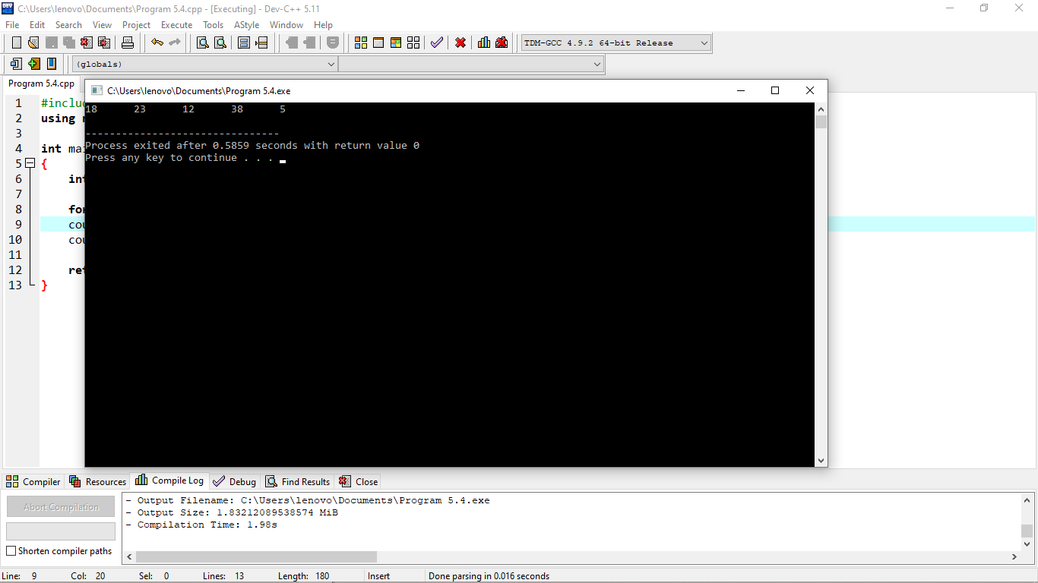 e) The output is:

4.

//Program 5.7

#include <iostream>

using namespace std;

int main()

{

char arr[] = "I like to program ";

int i;

for ( i = 0 ; i <= 9 ; i=i+1)

{

arr[i] = arr[9-i];

}

cout << arr;

cout << endl;

return 0;

}

1. When i is 0, arr[0] was changed to arr[9].
2. When i is 2, arr[2] was changed to arr[7].
3. When i is 9, arr[9] was changed to arr[0] .
4. The output of the program

ot ee to program

--------------------------------

Process exited after 2.714 seconds with return value 0

Press any key to continue . . .

5.

1. The lines of codes that will read data from data file into the program

fstream customer_order;

customer_order.open(“customer_order.txt”);

1. name item qty

|  |
| --- |
| Amin |
| Ariff |
| Iskandar |
| Hisham |
| Zaki |
| Khairi |
| 0 |
| 0 |

|  |
| --- |
| 111 |
| 222 |
| 333 |
| 0 |
| 0 |
| 0 |
| 0 |
| 0 |

|  |
| --- |
| 25 |
| 80 |
| 14 |
| 45 |
| 50 |
| 60 |
| 0 |
| 0 |

[0] [0] [0]

[1] [1] [1]

[2] [2] [2]

[3] [3] [3]

[4] [4] [4]

[5] [5] [5]

[6] [6] [6]

[7] [7] [7]

1. Values represented by total1 , total2 and total3 ?

total1 = 80 , 94 , 139 , 189 , 249 , 249

total2= 80 , 94 , 139 , 189 , 249 , 249

total3 = 80 , 94 , 139 , 189 , 249 , 249

8.

|  |  |  |  |
| --- | --- | --- | --- |
| a[0][0] = a | a[0][1] = , | a[0][2] =b | a[0][3] = , |
| a[1][0] = c | a[1][1] = , | a[1][2] =d | a[1][3] = , |
| a[2][0] = ╣ | a[2][1] = σ | a[2][2] =@ | a[2][3] = |

9. a .

#include <iostream>

#include <iomanip>

using namespace std;

int main()

{

int i,j;

string students[] = {"Ali", "Chong", "Muthu","Salmah"};

int midTestMark[] = {75,80,81,88};

int totalMark[4];

int SBtest[4][3] = { {10,7,6},{6,7,8},{9,7,8},{10,6,7} };

for (i=0 ;i <= 4; i = i+1)

cout <<setw(8)<<left<< students[i]

<<midTestMark[i] << endl;

return 0;

}

b.

#include <iostream>

using namespace std;

string students[] = {"Ali","Chong","Muthu","Salmah"};

int midTestMark[] = {75,80,81,88};

int totalmark[4];

int SBTest[4][3] = { { 10,7,6},{6,7,8},{9,7,8},{10,6,7} };

int main()

{

int i,j;

cout << "Name\tSBT1\tSBT2\tSBT3" << endl;

for (i = 0; i<4;i++)

{

cout << students[i] << "\t";

for (j = 0;j< 3; j++)

cout << SBTest[i][j] << "\t";

cout << endl;

}

return 0;

}