COMPRESSION TEST OF CONCRETE CUBE

Laboratory Work 2

[Author Name]

Class: 1 SBEQ/SBEC (GROUP 6)

Group members:

TEY CHAU YEN

KAW KEAN MENG

MUHAMMAD SHAZWI YADIY BIN ZAHARI

MUHAMAD FAEIZ BIN MOHD ZAINUDDIN

ROZANA BINTI OSMAN @ OTHMAN

NURUL AFIQAH BINTI AHMAD PUAD

SALIAH BINTI SHAMSUL KAMAL

NURUL FATIN HIDAYAH BINTI JAMALUDIN

XUE FEI

Department of Quantity Surveying, Faculty of Built Environment, Universiti Teknologi Malaysia

Dr. Kherun Nita Ali and Zuhaili Mohamad Ramly

©2009 Universiti Teknologi Malaysia - All Rights Reserve

Purpose

To determine the characteristic strength of the concrete

Cubes are properly cured and crushed at the ages of 7, 28 etc. Three cubes are crushed at a time and their mean crushing strength is taken as the compressive strength of concrete.

Materials

1. Cement
2. Fine aggregate (Sand)
3. Course aggregate
4. Water (must be clean enough to drink)

Equipments

1. Cube mold
2. Tamping rod
3. Hand scoop
4. Water tank
5. Compression Testing Machine

Sample for test

1. 2 numbers of 7 days old concrete cube
2. 2 numbers of 14, 21 **OR** 28 days old concrete cube

Procedure

Mixing the concrete (by hand)

1. Determine the portion of your concrete mixture
2. For mixing purposes, you can measure proportions by the bucket, by the shovelful, or with a measuring box. Use the same amount of each ingredient for each batch. Careful measuring ensures correct proportions.
3. Place the materials in layers on top of each other, beginning with the gravel, then the sand, and finally the cement.
4. Start mixing it by bringing the dry mix into a pile.
5. Do it again (and again) until you see the dry mix turn a uniform colour.
6. Make a shallow depression in the center of the dry mix using your shovel; then pour in a little water. Add the water slowly. The water used to make the concrete must be clean enough to drink.
7. Mix thoroughly by pulling dry material from the edges into the water.
8. Continue to add water until the mix reaches the proper consistency; not crumbly, not sloppy.

Preparing the mold (Step 1 to 3 will be prepared by the lab technician)

1. 150 mm x 150 mm x 150 mm standard cube mold is to be used for the concrete mix
2. Make sure the apparatus and associated equipment are clean before test and free from hardened concrete and superfluous water
3. Assemble the cube mold correctly and ensure all nuts are tightened.
4. Apply a light coat of proprietary mold oil on the internal faces of the mold
5. Place the mold on level firm ground
6. Fill with sampled concrete to a layer of about 50 mm thick
7. Compact the layer of concrete thoroughly by tamping the whole surface area with the tamping rod not less than 35 tamps
8. Repeat steps 6 & 7 until the mold is all filled
9. Remove the surplus concrete after the mold is fully filled and trowel the top surface flush with the mold
10. Mark the cube surface with an identification number (say simply 1, 2, 3, etc) with a nail or match stick
11. Cover the cube surface with a piece of damp cloth or polythene sheeting and keep the cube in a place free from vibration for about 24 hours to allow initial set
12. Strip off the mold pieces in about 24 hours after the respective pour is cast. Press the concrete surface with the thumb to see any denting to ensure the concrete is sufficiently hardened, or otherwise de-molding has to be delayed for one more day and this occurrence should be stated clearly in the Test Report.
13. Mark the test cube a reference number with waterproof marker pen on the molded side
14. Place the cube and submerge in a clean water bath or preferably a thermostatically controlled curing tank until it is delivered to the accredited laboratory for testing.

Testing (Testing should be carried out on the 7th and 21th OR 28th day)

1. Remove specified test specimen from the curing tank. Wipe to a surface dry condition and remove any loose sand grains for test surfaces
2. Determine the unit weight of the specimen by carefully weighing, and measuring the dimensions of, each cubical specimen.
3. Place specimen below the center of the upper bearing block of the testing machine ensuring the most flat and clean of the mold
4. Check the gauge and start the machine
5. Record the total maximum load as indicated by the testing machine.

Report

Sample concrete ratio : 1:3:6 Water (liter) : 2.5

|  |  |  |  |
| --- | --- | --- | --- |
| Schedule  (7th, 21st **OR** 28th day) | Sample no and weight | Result | Sketch (Fractures) |
| 7th day | 6A  7.85kg | 170kN |  |
| 28th day | 6B  7.8kg | 275kN |  |
|  |  |  |  |
|  |  |  |  |

Conclusions

Function why cube test is carried out because we want to determine the characteristic strength of the concrete. In this experiment, we already compress two concrete cube. First test is after seven day concrete have been harden and second test is after 28 day concrete have been harden. From this two experiment, we found that concrete in 28 day more strength because the result show the load that can be patch by the concrete is 275kN compare to concrete 7 day is only 170kN

Another function why cube test is carried out is to measure the workability of concrete. The workability of the fresh concrete shall be judged by its suitability for the condition of handling and placing so that after compaction, it surround all, reinforcement, tendons and ducts and completely fills the formwork. Our cube strength only 275kN this is because in our mixture of concrete, volume of water is higher so that our strength of concrete is lower. To get higher strength of concrete, volume of water must reduced. Problem of concrete we need to face is segregation and bleeding. Another problem is shrinkage, expansion, cracking, tension cracking and so on.

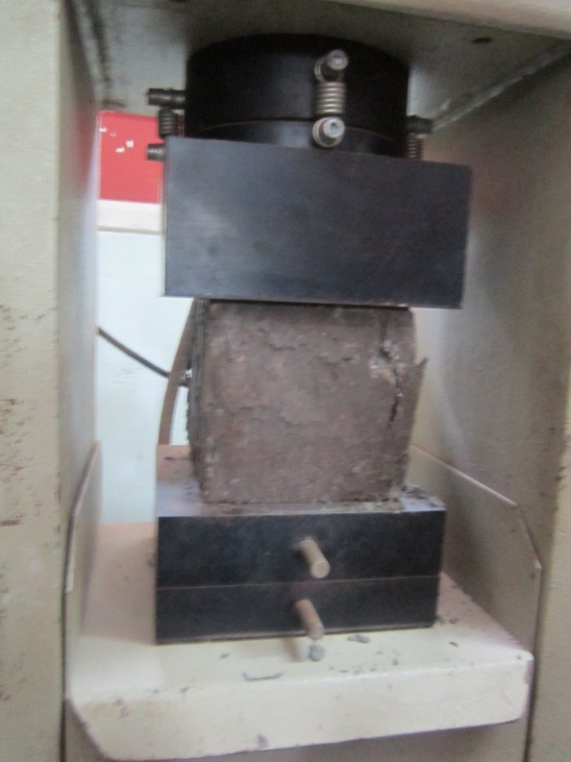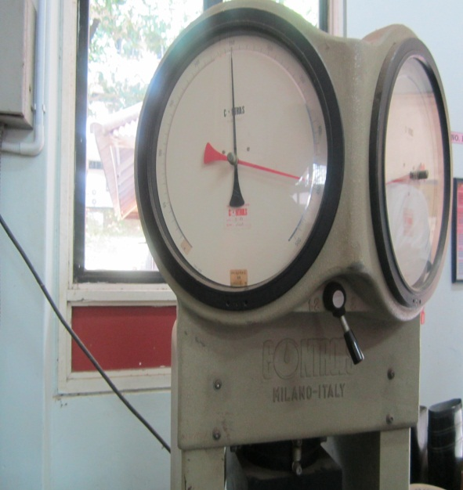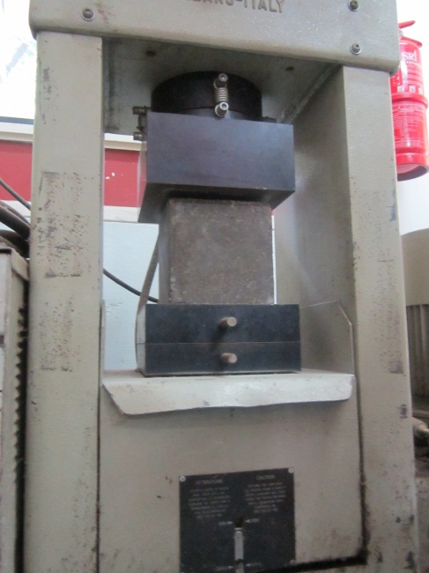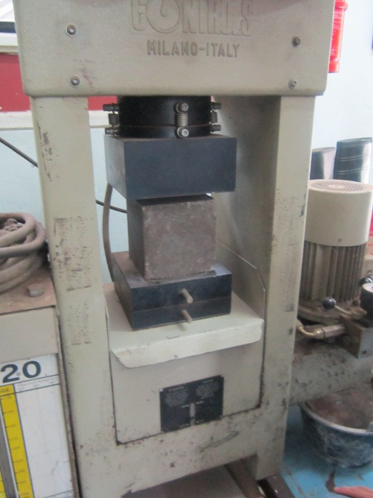

CRACKS OF THE CUBE

