

TECHNOLOGY AND INFORMATION SYSTEM

SECP1513 (SECTION 01)

DESIGN THINKING REPORT

LERCTURE NAME:

DR. ZURAINI BT. ALI SHAH

GROUP MEMBERS:

LEE BAO YI (A19EC0066)

NURUL HAZLEEN NATASYA BINTI YUSNI (A19EC0143)

NISHA PRITY A/P P.RAVICHANDAR (A19EC0120)

XU CHANG (X19EC0027)

|  |  |
| --- | --- |
| **CONTENTS** | **PAGES** |
| TABLE OF CONTENTS | 1 |
| INTRODUCTION | 2 |
| DETAILED DESCRIPTION | 3 |
| DESIGN THINKING ASSESSMENT POINTS | 4 |
| DESIGN THINKING EVIDENCES * | 5 - 10 |
| REFLECTIONS | 11 |

TABLE OF CONTENTS

*YouTube Video URL during project processes (page 10)

1. INTRODUCTION

Design thinking is a process of discovering a solution to solve problems in our daily lives with creative and collaborative thinking. There are five phases in recording design thinking evidence including empathy, define, ideate, prototype and test. Over recent decades, it has become crucial to develop and refine skills which allow us to understand and act on rapid changes in our environment and behaviour. The world has become increasingly interconnected and complex, and design thinking offers a means to grapple with all this change in a more human-centric manner.

Design thinking improves the world around us every day because of its ability to generate ground-breaking solutions in a disruptive and innovative way. Design thinking is more than just a process, it opens up an entirely new way to think, and offers a collection of hands-on methods to help us apply this new mindset.

The first stage of the design thinking process allows us to gain an empathetic understanding of the problem we are trying to solve, typically through user research. In the Define stage, we accumulate the information we created and gathered during the Empathize stage. After that, we analyse the observations and synthesize them to define the core problems our team have identified so far.

Designers are ready to generate ideas as they reach the third stage of design thinking. In this case, we look for alternative ways to view the problem and identify innovative solutions to the problem statement created. Prototype is an experimental phase, and the aim is to identify the best possible solution for each of the problems identified during the first three stages. Last but not the least, testing the prototype we have done to make sure it has achieved the aim of the project.

1. DETAILED DESCRIPTION

At the beginning, after conducting the interview session with a UTM student, we found that UTM students and also public users normally face the difficulties where ATM card being stuck in the ATM machine after exceeding the trial limits of entering correct PIN number. They have to find an alternative way to retrieve the card, which are approaching the bank officer at the counter for help or simply applying for a new ATM card. This is time-consuming whereby users spend their time waiting during the process.

We also noticed that the process of retrieving the card requires the users to fill in manually their details in the forms given and submit to the bank officer. They are asked to wait for the notification from the bank and they are unsure whether their ATM cards could be retrieved or not. This brings inconvenience to the users as they concern about the card safety issue.

To solve those problems, we decided to develop an emergency button system equipped with security questions on ATM machines. This is done based on our discussion. It is a system that facilitates users to solve the stuck ATM card problem without waiting for long time.

Users also find that the security questions appeared after pressing the ‘Emergency button’ ensure their card safety. This is because each security question is entitled to its security answer respectively provided by users during the card application. And users are required to answer them accordingly and correctly in order to retrieve their card.

1. DESIGN THINKING ASSESSMENT POINTS

Assessment points are the expected outcome from this design thinking project during the end of the project demonstration. At the end of the project, an idea to develop a prototype should be initiated and then a prototype should be created. Also, the problem stated should be solved using the prototype made.

During the end of the project demonstration, we should have been solved the problems stated by Mr. Muhammad Najib Fiqri bin Sulaiman, which is the time-consuming problem while waiting for his card to be retrieved. Our group has successfully thought of an idea by creating a safety-based system which is specially designed to cope with the problem stated by user. The idea is presented using the prototype made.

During the transition between design thinking phases, we should be able to apply the 5 human-centred design thinking skills processes. The processes are Empathize, Define, Ideate, Prototype and Test. We have gone through each of the processes stated to get the project done. Lastly, the feedbacks from users after test using the prototype are mostly of good reviews. This is indeed an important assessment point to conclude that our prototype has managed to achieve the goal of solving problems faced by users.

1. DESIGN THINKING EVIDENCE
2. Sample Work by Our Group

Some drafts are made and used as sample work before we start creating the prototype. Features on the ATM machine are included:

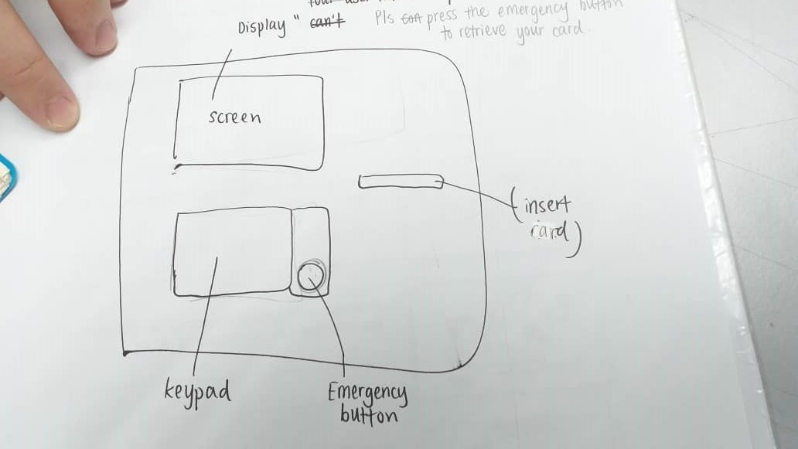

Figure 4.1: Prototype Sample Work

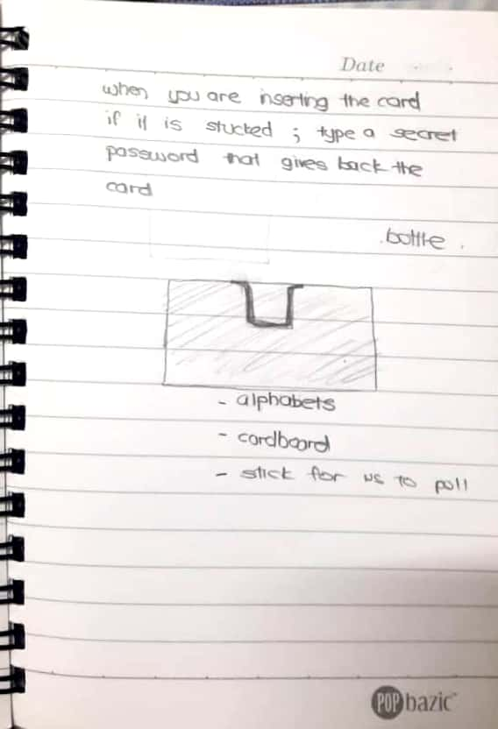 Figure 4.2: Prototype Sample Work

1. Record for Each Phase
2. EMPATHY

When we were figuring out what was the main problem faced by people in common , we got to know that incidents related where ATM card being stucked in the ATM machine after exceeding the trial limits of entering correct PIN number is been a troublesome. In order to get a clearer view on this issue, we interviewed an university student who had faced the similar problem. During the interview he had shared his experience where his card got stucked after exceeding the trial limits of entering the wrong pin number. In addition, according to the process he had to wait for 1 week to retrieve the ATM card and the worst part is he did not get back the card on time as he was asked to wait for few more days again. So he cancelled the process of retrieving the card and instantly he made a new card.

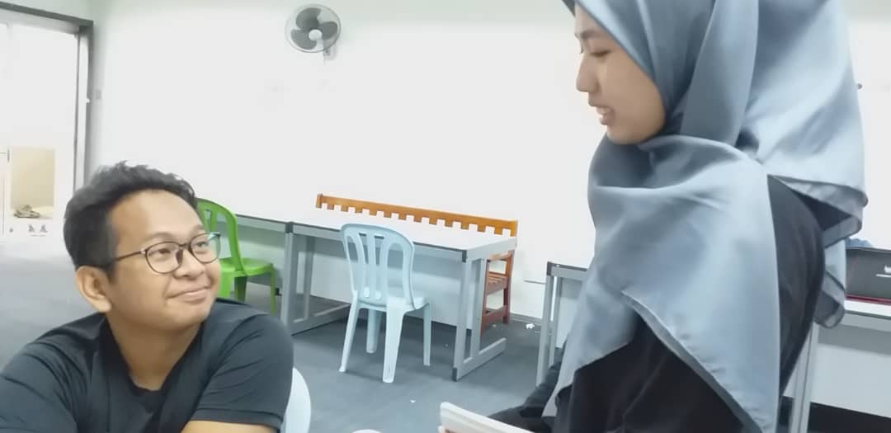

Figure 4.3: Interviewing session with the user

User’s details:

Name: Muhammad Najib Fiqri Bin Sulaiman

Age: 19 Years Old

Occupation: UTM Student

1. DEFINE

We have defined problem from the user in the interview:

• Difficulty to find a bank officer to approach especially during peak hours

• Time-consuming waiting process

• Card safety and privacy issue

Our group members have understood the problems faced by users and then came up with actionable steps to develop a prototype. Define step is needed to evaluate the possibilities of features should be included in the prototype.

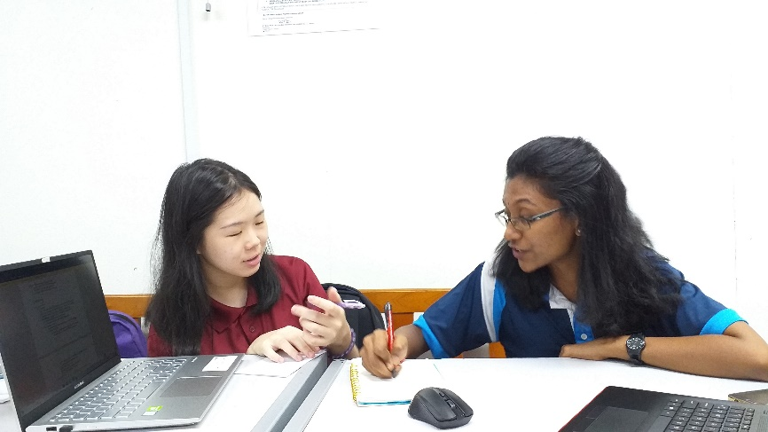

Figure 4.4: Defining the problem statement faced by the user

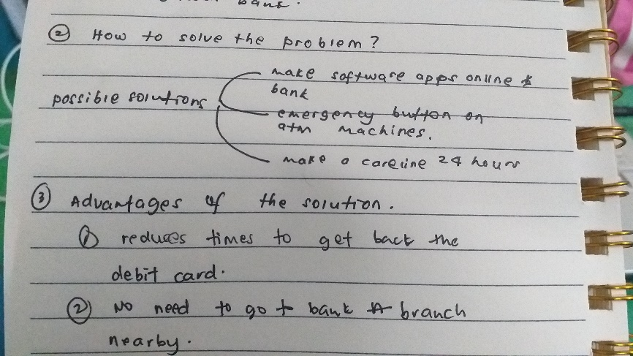

Figure 4.5: Define the possible solutions and advantages of the solution

1. IDEATE

After the interview session, our group had brainstormed and came up with several ideas to solve the problem faced by UTM students and also public users. We wanted to make sure that when their card is stuck, users will be able to retrieve the card from the ATM machine itself on the same day. In this case, an emergency button is added on the machine. The stuck card could be retrieved when users press the emergency button followed by answering security questions. We came to agreement that it would be the best solution for such problems. This process took around 15 minutes. We proceed to prototyping after the ideas are categorized.

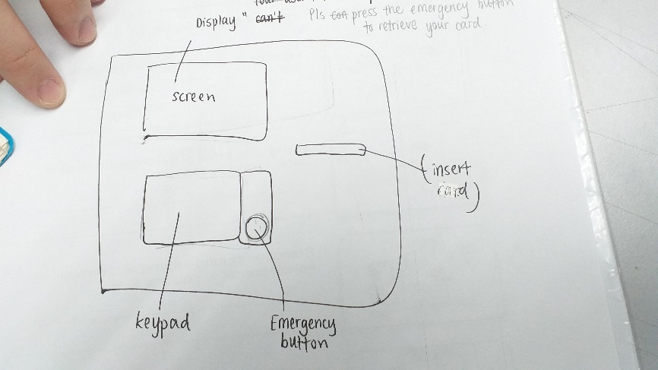

Figure 4.6: Draft of the prototype

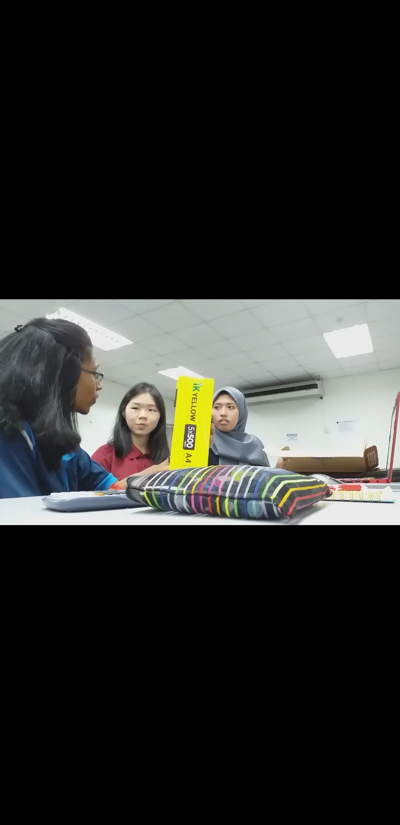

Figure 4.7: Discussing about how to build a prototype for the solution

1. PROTOTYPE

Before start creating our prototype, we identified the items needed for our prototype. There are cardboards (screen, emergency button and keypad), a card holder, mahjong paper, marker pens, scissors and cellophane tape. Most of the materials are reused.

The steps are as followed:

• A carton cover is wrapped with mahjong paper. (to make sure it looks neat and clean)

• Cut few pieces of cardboards and paste one of them on top of the wrapped cover.(to make it look like an ATM machine screen and the other cardboard at the bottom as the keypad)

• A round shaped cardboard written ‘Emergency button’ is pasted at the side of keypad.

• A card holder is placed besides the emergency button. (for users to insert or remove the debit cards)

• To be precise, instructions to be displayed to users before and inserting the card are written on small papers and pasted on the ‘screen’.

• To tighten the security of one’s personal, users are asked to enter ATM card PIN number after clicking the emergency button for verification. (Users have to answer one security question if the PIN number is INCORRECT)

• User will be able to retrieve the card without waiting for longer if all are answered correctly.

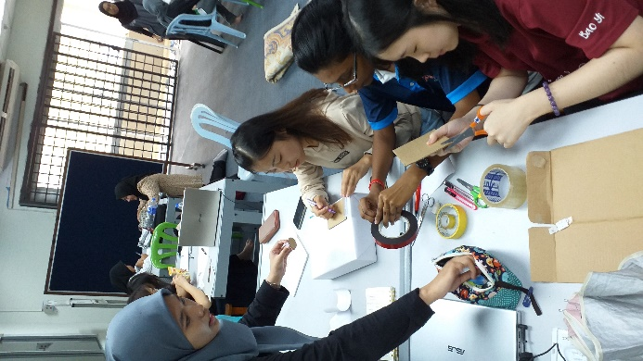

Figure 4.8: Our group in the process of making of the prototype

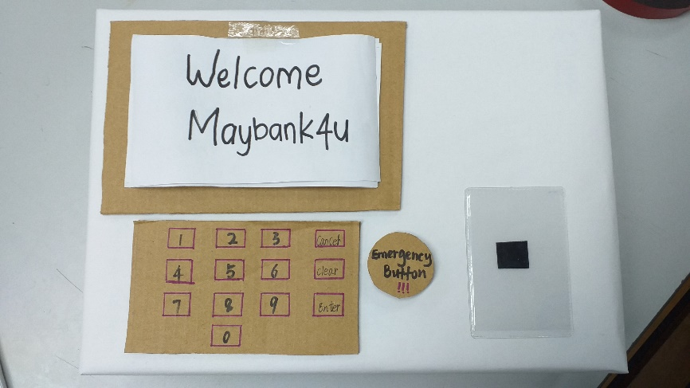

Figure 4.9: The end product of the prototype

1. TEST

We carried out a test to confirm if our project has reached our objectives. We were glad as it worked well. In conclusion after so much of trials we have come up with this solution. We do really hope that our idea on this matter will be really convenient to all the future youngsters for a better future.

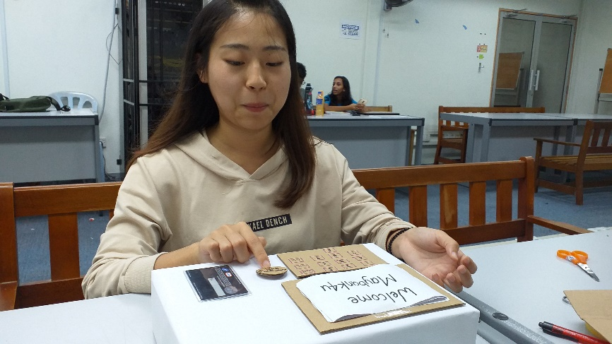

Figures 4.10: User testing the prototype

Some suggestions given by the user:

• Add tutorials to use the ‘Emergency Button’

• Add simple verification steps besides security questions

*Please refer to the following YouTube video URL for complete process during our project: <https://youtu.be/pN_DU6MaTW4>

5. REFLECTIONS

This course of Technology and Information System exposed us to get in contact with the technology system knowledge. This gives us a pre-understanding of how technology system works to suit human needs. As a student in Bioinformatics field, our goal is to implement and improvise the current technology especially in the Bioinformatics research.

In this design thinking project, many of us have come out with different interesting ideas for the solutions based on the problem identified from the user during the interview. As we are undergoing Revolution of Industry 4.0, the knowledge which is keep updating is more essential than the knowledge in books. Hence, we have put some effort in finding something new to be inserted in our project. Having this design thinking project provides us an opportunity to do a prototype sample using input and output technology concept. All the group members are able to get some hands-on experience. Also, teamwork spirit is important as tasks are distributed among the group members so that the project could be completed faster and more efficient. Besides that, we all learn to be more creative as various ideas with different viewpoints could be gathered. We also learnt to interact with people in an approachable way during the testing session of presenting our prototype to the users.

We all agreed that feedbacks from users from time to time is needed for us to improve the prototype system. This could be done through technology such as online survey forms. After that, we may have to update the system by adding in either some interfaces or functions. Therefore, we have to equip ourselves with the latest technology. Lastly, communication between group members has to be frequent and clear so that a better outcome could be produced.