The Importance and Trending of IT Project Management

Anatasya Humaira1, Haresh Naidu2, and Nur Aisyah1,2, *Member, IEEE*

1, 2, 1,2School of Computing, University of Technology Malaysia, Johor Bahru, MY;

[anatasyah35@gmail.com](mailto:anatasyah35@gmail.com), [hareshnaidu@graduate.utm.my](mailto:hareshnaidu@graduate.utm.my), [aisyah-01@graduate.utm.my](mailto:aisyah-01@graduate.utm.my)

***Abstract*—** ***Project management have been used as a method to accomplish a project as well in IT industry. It is referring to the application of knowledge, skills, tools, and techniques to any kind of project activities to meet the project requirements. Applying all project management phases can give us better outcome and settling the problems. IT project management trends keep changing along with advancement in industry. Gig economy has been used for its financial benefits. Big data become a medium to study the related area while emotional intelligence is needed for employee. Automation, artificial intelligence and tools can ease us in managing project. To involve ourselves in IT project management, we can start as programmer, system analyst and many more. The experiences that we gained before can be guidance before becoming as project manager.***

***Keywords—IT project management, project, plan***

1. INTRODUCTION

On 1st of December 2020, first year students from School of Computing attended online industrial talk entitled The Importance and Trending of IT Project Management. It is conducted from 10 am until 11 am. The speaker is Mr Mohd Khairul Reeza Ruslan, Head of Project Management from Office Commerce Dot Com Sdn Bhd.

1. IT PROJECT MANAGEMENT
2. *The Importance of IT Project Management*

Project management can bring leadership and directions to the project [1]; also, to ensure its environment such as cost, quality, benefit, risk and other elements of the project are managed properly. Unproper project management might cause issues and impact the whole project.

That is why project management is very important in industry areas like financial. For instance, the banker could lose money due to issues in system and affects the transaction.

Project management can guarantee the communication are deliverable. Bad communication within a team might affecting the performance, resulting the outcome are not satisfying enough.[2] In other hand, good communication can improve the outcome of the project.

Project management also prioritize us to do quality control. As shown in Table I, during 3rd phase, the progress will be monitored to ensure it fulfills the standard and control it if problem occurred.

TABLE I PROJECT MANAGEMENT PHASE [3]

|  |  |
| --- | --- |
| **Phase** | **Explanation** |
| Initiation | The phase where a project being analysed and defined on its value. A study on feasibility is also conducted during this phase. |
| Planning | The plan on project management is developed as well as a team to define the scope, tasks, budget, resources, materials and risks. |
| Execution | The most important phase, where the project is carried out using the developed plan. |
| Monitor & Control | This phase took place in the same time as execution phase, to make sure the project is managed smoothly and according to actual plan. |
| Closing | The project is closed once the project is delivered completely and all the contracts matters is ended. |

1. *Trending of IT Project Management*

* Gig Economy
  + - * + A labor market which positions are temporary using short-term contracts or freelance work and give benefits in financial scope.
* Big Data
  + - * + Large volume of data that used to analyze for important insight according to customer.
* Automation and Artificial Intelligence
  + - * + Both can assist us to execute project despite new challenges.
* Advanced project management tools and solutions
  + - * + Project management tools are software that help to organize work during project such as calculating budgets.
        + Solutions to any problem must updated with changing trends in industry.
* Emotional Intelligence (EQ)
  + - * + Skill to understand and manage the information while having awareness in emotion. [4]

1. RELEVANT IT CAREERS

* Programmer
* System Analyst
* Software/Application Developer
* Project Manager
* Chief Technology Officer [5]

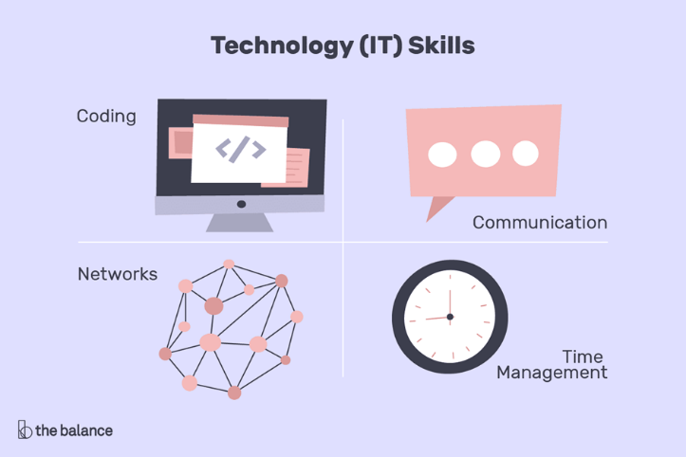

Fig. 1. Skills needed to work in IT area [6]

1. REFLECTIONS
   * My dream is to become one of all rounded game programmers who can work independently in multimedia and game designer. This talk has brought me motivation, give exposure on industry and influenced me to become a person who is beneficial to my environment. Beside my main goals, as a student, I have to finish my first degree in UTM with flying colors and get a lot of experiences. I have to study more and start to plan everything accordingly.
   * My goal in my current course is to gain knowledge about this course and graduate with best result. This talk has left a positive impact on myself where I learned to how to manage our project/goal to achieve success in it. I have to enhance my communication skills and also management skills which I think is very important to thrive in this industry. I also planned to do my own research about this industry to improve my potential.
   * Within this course, I hope I can be a student that well equipped with knowledge before entering industry. This talk makes me realized on how important is project management. A small change might give a huge impact on the whole project; thus, a project should be managed wisely. As a future employee, I have to be a well-managed person. Joining a society might give me experience that can be used in future.

ACKNOWLEDGMENT

We would like to thank Mr Mohd Khairul Reeza Ruslan for sharing information on IT Project Management. We also thanked Dr Sarina Sulaiman for her guidance and all lecturer for Technology and Information System course for successfully organizing this industrial talk.

REFERENCES

1. Downey, R., 2016. *The Importance Of IT Project Management: Why Expertise Isn’t Enough*. [online] Symmetry. Available: <https://symmetrycorp.com/blog/the-importance-of-it-project-management>
2. Kissflow. 2020. Why Is Project Management Important For Your Organizaton? [online] Available: <https://kissflow.com/project/importance-of-project-management>
3. Malsam, W., 2018. *Project Management Processes And Phases - Projectmanager.Com*. [online] ProjectManager.com. Available: https://www.projectmanager.com/blog/project-management-processes-phases
4. Khatnani, V., 2018. *The EQ Factor: Why Emotional Intelligence Matters For Project Managers*. [online] J2 Solutions. Available: <https://j2-solutions.com/the-eq-factor-why-emotional-intelligence-matters-for-project-managers>
5. Doyle, A., 2019. *A List Of Different Information Technology Job Titles.* [online] The Balance Careers. Available: https://www.thebalancecareers.com/list-of-information-technology-it-job-titles-2061498
6. Doyle, A., 2020. *Important Skills For Information Technology (IT) Jobs*. [online] The Balance Careers. Available: https://www.thebalancecareers.com/list-of-information-technology-it-skills-2062410