

**SCSP 1513**

**TECHNOLOGY AND INFORMATION SYSTEM**

**DESIGN THINKING:**

**Smart E-learning App**

**LECTURER:**

**Dr Azurah Abd Samah**

**SUBMITTED BY:**

**Felicia Chin Hui Fen (A20EC0037)**

**Erica Desirae Mauritius (A20EC0032)**

**Lue Guo Ming (A20EC0073)**

**Mohd Firdaus Bin Zamri (A20EC0080)**

**Semester 1 2020/2021**

**SMART E-LEARNING APP**

Team members’ name: Felicia Chin Hui Fen, Erica Desirae Mauritius, Lue Guo Ming, Mohd Firdaus Bin Zamri

School of Computing, Faculty of Engineering

UniversitiTeknologi Malaysia, 81310 Skudai,

Johor Bahru, Malaysia

**ABSTRACT**

During this pandemic season, students are required to attend classes by Open and Distance Learning (ODL) method. This project represents a smart learning application named Smart E-learning which supplied solutions to the problems encountered by students during ODL. This study investigates common problems faced by students with different backgrounds and the structured interviews and questionnaires were conducted with 15 participants. Analysis of the investigation is shown to solve the common problems faced by different students. As the result, it displays that the features of Smart E-learning justified most of the problems faced by the individual

**TABLE OF CONTENTS**

|  |  |  |
| --- | --- | --- |
| **CHAPTER** | **TITLE** | **PAGE** |
|  | **ABSTRACT** | I |
| **1.0** | **Introduction** | 1 |
| **2.0** | **Problem Background** | 1-2 |
| **3.0** | **Methodology** | 2-28 |
|  | 3.1 Empathize  3.1.1 Observation  3.1.2 Engagement  3.1.3 Question and Answer in the Online Questionnaire  3.1.4 Background of Interviewee  3.1.5 Immerse  3.2 Define  3.3 Ideate  3.4 Prototype  3.5 Test  3.5.1 Question and Answer in the feedback  Questionnaire  3.5.2 Background of users |
| **4.0** | **Task Assignment** | 28-30 |
| **5.0** | **Proposed Solution**  5.1 Acknowledgment of Similar Product  5.2 Features of Proposed Solution | 31-34 |

|  |  |  |
| --- | --- | --- |
| **6.0** | **Users Study**  6.1 Identifying Problems Faced by Students Related to Online Learning  6.2 Users Feedback | 35-38 |
| **7.0** | **Business Analysis** | 39 |
| **8.0** | **Future Works and Improvement** | 39-40 |
| **9.0** | **Reflection and Conclusion** | 40 |
| **10.0** | **References** | 41 |
| **11.0** | **Appendices**  11.1 Tabulation of data in the survey questionnaire  11.2 Tabulation of data in the feedback questionnaire | 42-44 |

**1.0 Introduction**

As we know, the outbreak of COVID-19 and due to cases increase day by day, almost 70% of world’s students are not attending schools (UNESCO 2020). This pandemic affects our country’s undergraduate students who are just starting a new semester. Online Distance Learning (ODL) method is a teaching method implied by most of the universities to conduct the teaching.

Based on ODL’s guidelines, there is no face-to-face teaching method is conducted due to disease outbreak. All of the classes are conducted online for the students to complete their study. Research found that ODL method has some advantages in teaching and learning sessions compared to face-to-face method. However, ODL method also brought us some disadvantages and problems to the undergraduate students.

**2.0 Problem Background**

Due to the virus outbreak, all of the teaching and learning activities are conducted by ODL method. For the method to be successfully conducted, it required electronic devices such as laptop, smart phone and internet connection to access online learning platforms such as UTM E-learning, Google Meeting and others. Due to these requirements needed and used, most of the students faced a few problems that can worsen the learning process.

As we know, our devices have a very limited storage and it is not enough for the students to download and save all of the files and documents given through online. Besides, after downloading a lot of documents, it is hard for some people to manage their folders which might cause some files cannot be found and some files keep on downloading without our consent.

In addition, by using online platforms have the potential for the devices to be attacked by hackers or viruses if we are not checking it frequently. As a result, it might

affect the productivity of the devices to run. Last but not least, online learning will be not effective due to many difficulties faced. As an example, bad quality of audio sounds during online meeting due to low internet connection or background noise. Hence, stable internet connection and better surrounding might be needed for the ODL to run smoothly.

**3.0 Methodology**

**3.1 Empathize**

**3.1.1 Observation**

Based on our observation and discussion, we found out that a lot of student have problems during online learning. For example, during online class, the audio of the meeting room is poor and students often cannot hear the lecturer’s voice clearly and even when they try to ask question, their microphone break up. Moreover, we found out that students sometimes faced difficulty when uploaded or downloaded documents via phone as their phone storage is limited. The documents downloaded are messy and hard to manage in the phone. Finally, we also found out students are lack of awareness where they rarely use virus detect application to check their phone regularly.

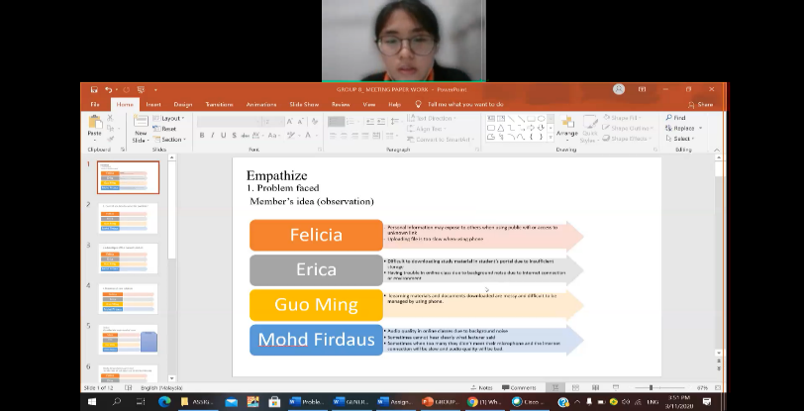Machine generated alternative text:
'n Course: SECP1513-Ol TEKNOLCC X I WhatsApp 
C meet.google.com/fjv-hgbv-qga?pli=l&authuser=() 
Meet 
- fiv-hgbv-qga 
how arrange document in phone 
5:48 
LUE GUO MING A20EC007 
SECP- 
Firdaus 
SECP 
Firdaus 
1m using my phone, everyone's in 
ERICA DESIRAE MAURITIUS A20EC0032 
50... Meet 
how to... 
Chapte... 
Week 2.. 
5:48 PM 
O "Z ENG 
26/10/2020 

Figure 1: Group discussion by online meeting

**3.1.2 Engagement**

To more understanding the user’s needs and problems, we have conducted scheduled interview and online questionnaire among the users. Generally, most of the interviewee claimed that they do faced problems when online learning especially during live meeting classes, where their audio system sometimes broke up. Besides, they also claimed that sometimes the teaching materials are hard to download and are difficult to manage it in the phone compared to in the computer. Moreover, they also faced problem when uploading the documents on the e-learning website when the website’s system down. In addition, interviewee also not aware the security problem faced when using their phone.

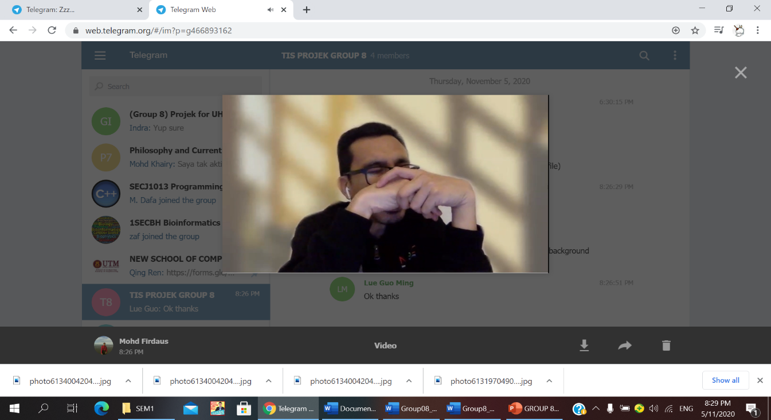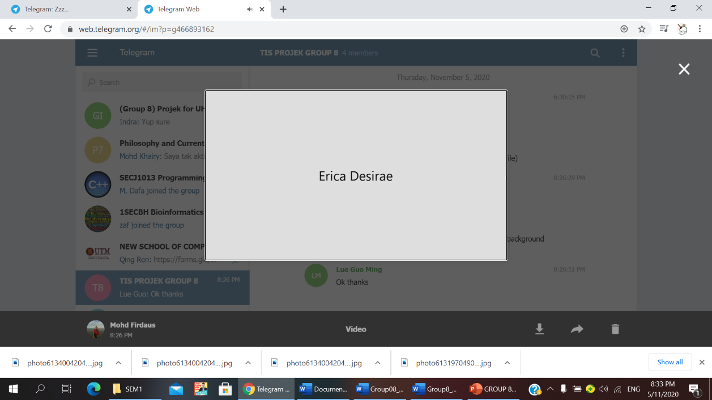

Figure 2: Scheduled interview with the experts, Dr Mohd Murtadha Mohamad, the Associate Professor in School of Computing, Faculty of Engineering, Universiti Teknologi Malaysia to get his opinions on the issue about insufficient phone storage

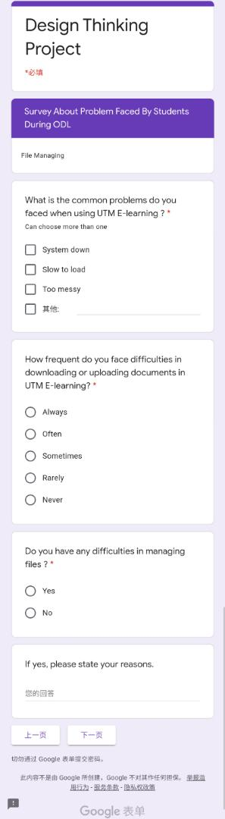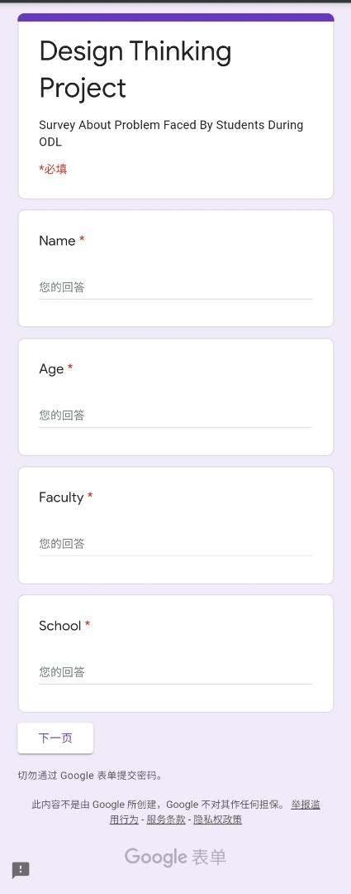

(a) (b)

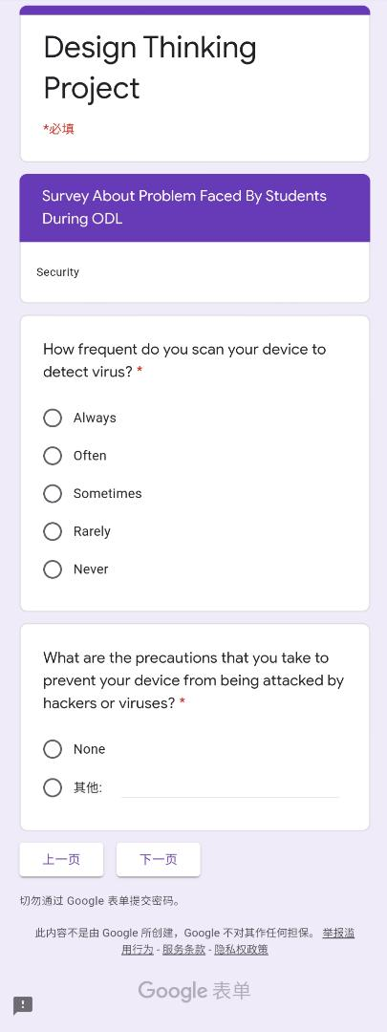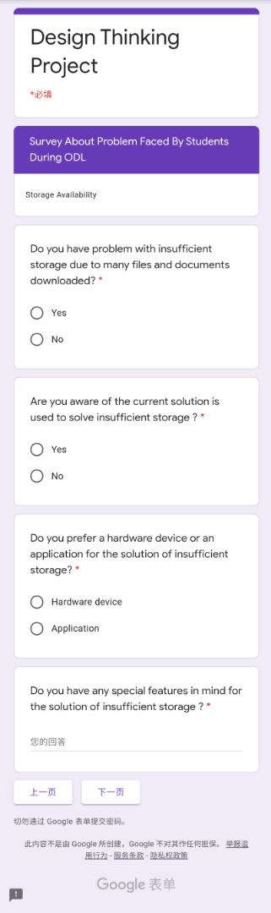

(C) (d)

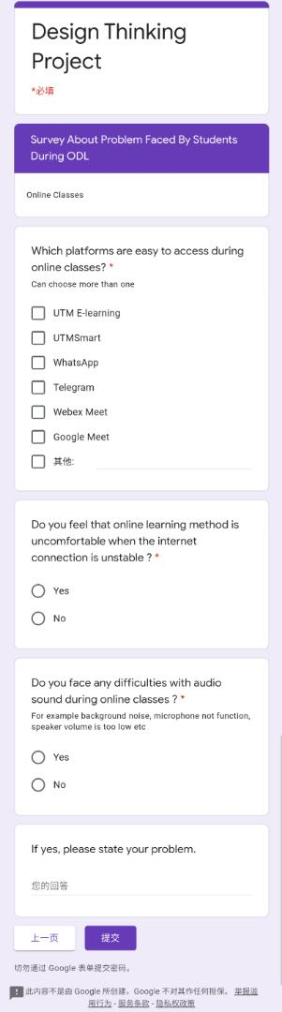

(f)

Figure 3: Online questionnaire prepared by the group member

**3.1.3 Question and Answer in the Online Questionnaire**

Table1: Question and answer in the online questionnaire for file managing, upload and downloading file

|  |  |  |  |  |
| --- | --- | --- | --- | --- |
| No. | What are the common problems do you faced when using UTM E-learning? | How frequent do you face difficulties in downloading or uploading documents in UTM E-learning? | Do you have any difficulties in managing files? | If yes, please state your reasons. |
| 1 | Hard to uploading files | Sometimes | No | Documents in store in phone hard to manage |
| 2 | System down | Always | Yes | My desktop is full with files that I’ve downloaded. I’ve to put it on desktop to make sure i can easily find the files needed |
| 3 | System down and hard to downloading study material | Sometimes | Yes | Sometimes the file was not compiled and need to be categorized by myself. |
| 4 | hard to downloading study material | Often | Yes | Phone storage is full |
| 5 | Slow to load, hard to downloading study material | Rarely | Yes | Files store in phone hard to edit |
| 6 | Hard to uploading file | Sometimes | No | - |
| 7 | System down, Slow to load | Sometimes | No | - |
| 8 | Hard to uploading files | Sometimes | Yes | Phone storage is full |
| 9 | System down, Slow to load | Always | Yes | Files store in phone hard to edit |
| 10 | hard to downloading study material | Sometimes | Yes | Phone storage is full |
| 11 | hard to downloading study material | Sometimes | Yes | I don’t know where to save my files |
| 12 | Slow to load | Always | Yes | Files store in phone hard to edit |
| 13 | System down | Rarely | No |  |
| 14 | System down | Rarely | Yes | Files store in phone hard to edit |
| 15 | hard to downloading study material | Sometimes | No | - |
| 16 | Slow to load and hard to downloading study material | Sometimes | Yes | Sometimes the file was not compiled and need to be categorized by myself. |
| 17 | System down, hard to downloading study material | Sometimes | Yes | - |
| 18 | System down, Slow to load | Sometimes | No | - |
| 19 | System down, Slow to upload | Often | No | - |
| 20 | System down, Slow to load, Too messy | Always | Yes | Phone storage is full |
| 21 | System down, Slow to load | Sometimes | No | - |
| 22 | System down, Slow to load | Rarely | No | - |
| 23 | System down | Sometimes | No | - |
| 24 | System down | Always | Yes | Hard to use phone to arrange document downloaded |
| 25 | System down, Slow to load | Sometimes | No |  |
| 26 | System down, Slow to load, Too messy | Sometimes | Yes | Not place to store documents |
| 27 | hard to uploading documents | Rarely | No | - |
| 28 | System down | Rarely | No | - |
| 29 | Slow to load and hard to uploading documents | Rarely | No | - |
| 30 | System down, Too messy | Sometimes | Yes | Limited phone storage to store files |

Table 2: Question and answer in the online questionnaire for storage availability

|  |  |  |  |  |
| --- | --- | --- | --- | --- |
| No. | Do you have problem with insufficient storage due to many files and documents downloaded? | Are you aware of the current solution is used to solve insufficient storage? | Do you prefer a hardware device or an application for the solution of insufficient storage? | Do you have any special features in mind for the solution of insufficient storage? |
| 1 | Yes | Yes | Hardware device | Uninstall unused apps |
| 2 | Yes | Yes | Application | Upgrade my laptop ram? But that is a hard work |
| 3 | Yes | Yes | Hardware device | If I don't have sufficient storage, I will buy a storage or using the cloud services. |
| 4 | Yes | No | Application | No |
| 5 | Yes | Yes | Hardware device | No |
| 6 | Yes | No | Hardware device | Buy a hard disk for your study |
| 7 | No | No | Hardware device | - |
| 8 | Yes | Yes | Application | No |
| 9 | Yes | Yes | Application | Use cloud storage |
| 10 | No | Yes | Hardware device | Nope |
| 11 | No | Yes | Application | No |
| 12 | No | No | Hardware device | I don’t have |
| 13 | Yes | Yes | Application | Cloud |
| 14 | No | No | Application | Cloud storage |
| 15 | Yes | Yes | Application | Get solution from YouTube |
| 16 | Yes | No | Application | Haven't think about it. |
| 17 | No | Yes | Application | Cloud storage |
| 18 | Yes | No | Application | An application with no limitation of storage |
| 19 | No | Yes | Hardware device | Use cloud |
| 20 | No | No | Hardware device | - |
| 21 | No | Yes | Application | No |
| 22 | Yes | No | Application | Regular clean-up of your machine |
| 23 | No | Yes | Application | Application that can help to clean storage |
| 24 | Yes | No | Application | - |
| 25 | Yes | Yes | Application | - |
| 26 | Yes | No | Hardware device | Cloud Storage |
| 27 | No | No | Application | Delete database |
| 28 | Yes | No | Application | Make use of Google drive |
| 29 | Yes | No | Application | Upgrade server |
| 30 | Yes | No | Hardware device | Bigger storage |

Table3: Question and answer in the online questionnaire for security problem

|  |  |  |
| --- | --- | --- |
| No. | How frequent do you scan your device to detect virus? | What are the precautions that you take to prevent your device from being attacked by hackers or viruses? |
| 1 | Often | None |
| 2 | Often | I didn’t easily download files from internet and close ads as soon as possible |
| 3 | Rarely | Frequently update the antivirus software database and avoid from clicking suspicious link on the internet. |
| 4 | Sometimes | None |
| 5 | Rarely | None |
| 6 | Rarely | None |
| 7 | Rarely | None |
| 8 | Often | Have an apps that can virus |
| 9 | Rarely | None |
| 10 | Sometimes | None |
| 11 | Rarely | None |
| 12 | Rarely | Use antivirus software |
| 13 | Always | Antivirus scanning and few extensions |
| 14 | Rarely | None |
| 15 | Often | None |
| 16 | Sometimes | None |
| 17 | Rarely | Antivirus software |
| 18 | Rarely | None |
| 19 | Rarely | None |
| 20 | Sometimes | Install antivirus software |
| 21 | Rarely | None |
| 22 | Sometimes | Look online for solution |
| 23 | Rarely | Clear cookies and cache |
| 24 | Rarely | None |
| 25 | Often | Using computer antivirus |
| 26 | Sometimes | McAfee Internet security |
| 27 | Rarely | None |
| 28 | Rarely | None |
| 29 | Rarely | None |
| 30 | Never | None |

Table 4: Question and answer in the online questionnaire for online classes

|  |  |  |  |  |
| --- | --- | --- | --- | --- |
| No. | Which platforms are easy to access during online classes? | Do you feel that online learning method is uncomfortable when the internet connection is unstable? | Do you face any difficulties with audio sound during online classes? | If yes, please state your problem. |
| 1 | UTM E-learning, WhatsApp, Webex Meet | No | No | - |
| 2 | UTM E-learning, UTMSmart, WhatsApp, Telegram, Webex Meet, Google Meet | Yes | Yes | The echo in audio makes it hard |
| 3 | UTMSmart, Webex Meet, Google Meet | Yes | Yes | The audio glitches because bandwidth is not good. |
| 4 | Webex Meet, Google Meet | Yes | No | - |
| 5 | UTM E-learning, UTMSmart, WhatsApp, Webex Meet | Yes | No | - |
| 6 | UTM E-learning, UTMSmart, Webex Meet | Yes | Yes | Background sound while some of friends speaking |
| 7 | WhatsApp, Telegram, Webex Meet, Google Meet | Yes | Yes | Sometimes got the line stuck so gonna have the problem with that one |
| 8 | UTM E-learning, UTMSmart, WhatsApp, Telegram, Webex Meet, Google Meet | Yes | No | - |
| 9 | UTM E-learning, WhatsApp, Webex Meet | Yes | Yes | Background noise |
| 10 | UTM E-learning, WhatsApp, Webex Meet, Google Meet | Yes | No | - |
| 11 | UTM E-learning, UTMSmart, WhatsApp, Telegram, Webex Meet, Google Meet | Yes | Yes | Cannot hear the sound |
| 12 | UTMSmart, WhatsApp, Telegram, Webex Meet | Yes | Yes | Can’t hear the sound clearly |
| 13 | UTM E-learning, Webex Meet, Google Meet | Yes | Yes | Background noise |
| 14 | UTM E-learning, UTMSmart, WhatsApp, Telegram, Webex Meet, Google Meet | Yes | No | - |
| 15 | UTM E-learning, UTMSmart, Google Meet | Yes | Yes | Background noise |
| 16 | UTM E-learning, WhatsApp, Telegram, Webex Meet | Yes | Yes | Background noise |
| 17 | UTM E-learning, WhatsApp, Telegram, Webex Meet, Google Meet | Yes | Yes | Speaker Background noise |
| 18 | UTM E-learning, WhatsApp, Webex Meet, Google Meet | Yes | Yes | have echo |
| 19 | WhatsApp, Telegram, Google Meet | Yes | Yes | Sometimes the voice is not clear |
| 20 | WhatsApp, Google Meet | Yes | No | - |
| 21 | Google Meet | Yes | Yes | Sound cannot hear clearly |
| 22 | UTM E-learning, UTMSmart, WhatsApp, Telegram, Webex Meet, Google Meet | Yes | Yes | Lecturer's side. Unstable internet connection leads to distorted voice |
| 23 | WhatsApp, Telegram, Webex Meet, Google Meet | Yes | No | - |
| 24 | Google Meet | Yes | No | - |
| 25 | UTMSmart, WhatsApp, Telegram | Yes | No | - |
| 26 | UTM E-learning, UTMSmart, WhatsApp, Telegram, Webex Meet- | Yes | No | - |
| 27 | UTM E-learning, UTMSmart, WhatsApp | Yes | No | - |
| 28 | UTM E-learning, UTMSmart, WhatsApp, Telegram, Webex Meet, Google Meet | Yes | No | - |
| 29 | UTM E-learning, asynchoronous learning video is the best. | Yes | Yes | Unstable internet service in my area |
| 30 | UTM E-learning, UTMSmart, WhatsApp, Telegram, Webex Meet, Google Meet | Yes | Yes | Laggy when bad internet connection |

**3.1.4 Background of Interviewee**

Table 5: Background of interviewee in the questionnaire

|  |  |  |  |  |
| --- | --- | --- | --- | --- |
| **No.** | **Name** | **Age** | **Faculty** | **School** |
|  | Amir Iskandar | 19 | Engineering | Computing |
|  | Bao Yi | 21 | Engineering | Computing |
|  | Chan Zhi Yi | 22 | Engineering | Computing |
|  | Chang Min Xuan | 19 | Engineering | Computing |
|  | Chee Wai Lum | 21 | Engineering | Computing |
|  | Chua Rui Ping | 20 | Science | - |
|  | Hasya Azyyati Syazwani | 19 | Engineering | Electrical Engineering |
|  | Hiew Jia Yee | 23 | Engineering | Computing |
|  | Huda Najihah | 19 | Engineering | Computing |
|  | Irene Wong Tze Chin | 23 | Engineering | Computing |
|  | Ji Tong Lin | 22 | Engineering | Computing |
|  | Kam Shwu Chin | 22 | Engineering | Computing |
|  | Keshiniy | 19 | Engineering | Computing |
|  | Khor Zhi Xin | 20 | Science | - |
|  | Lai Xiao Tong | 23 | Engineering | Computing |
|  | Lim Jia Yee | 22 | Engineering | Computing |
|  | Lim Lip Hong | 23 | Engineering | Engineering |
|  | Lim Wei Hsien | 21 | Engineering | Computing |
|  | Lim Wei Qin | 22 | Engineering | Computing |
|  | Maverick | 19 | Engineering | Civil Engineering |
|  | Muhammad Hafizh Syam | 19 | Engineering | Chemical and Energy Engineering |
|  | Ng Yen Thong | 20 | Engineering | Computing |
|  | Nur Haznirah Binti Hazman | 19 | Engineering | Computing |
|  | Nur Sabrina Binti Shamsul | 19 | Engineering | Chemical and Energy |
|  | Phang Cheng Yi | 20 | Engineering | Computing |
|  | Shafoora naz | 23 | Engineering | Computing |
|  | Thong Nyook Ann | 20 | Engineering | Computing |
|  | Timothy Lawrence | 19 | Engineering | Mechanical Engineering |
|  | Wong King Yun | 19 | Engineering | Mechanical Engineering |
|  | Wong Yit Khee | 22 | Engineering | Computing |

**3.1.5 Immerse**

To experience the problems faced by the users, we tried to experience what the users have experienced where we try to speak out in the online classes to test the audio system, uploading or downloading teaching materials and manage it in the phone. However, we found it difficult to work because the effect of environment during online classes, bandwidth, phone storage or the app used itself.

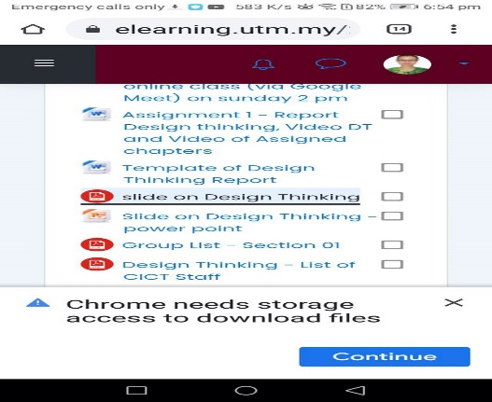

Figure 4: Screenshot taken when the group member faced insufficient storage problem when trying to download study material

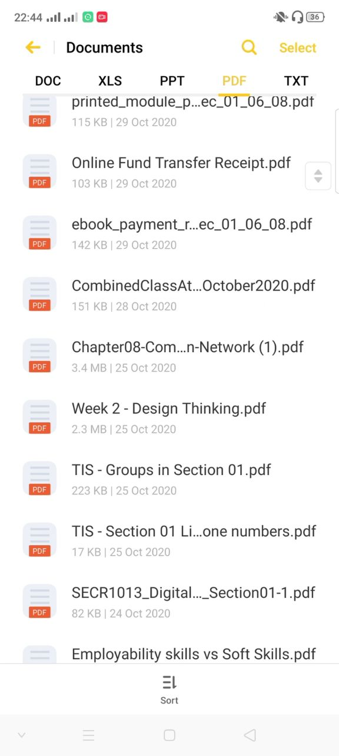

Figure 5: Screenshot of recording video when the group member is managing the files

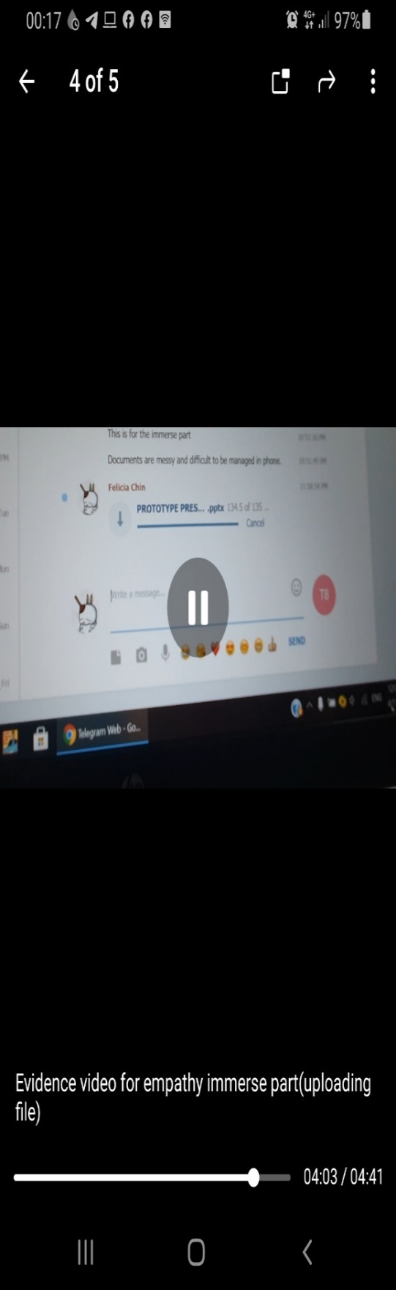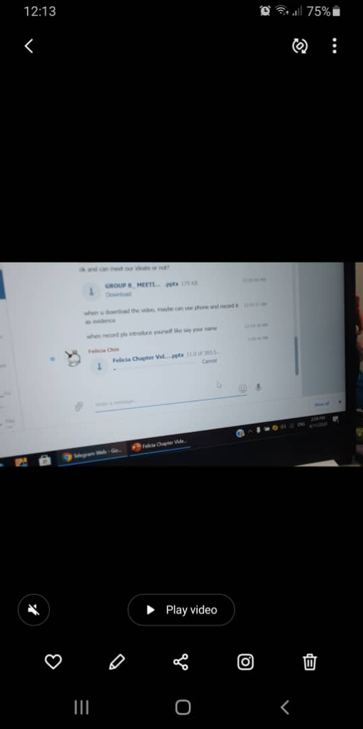

(a) (b)

Figure 6: Screenshot of recording video when the group member uploading files

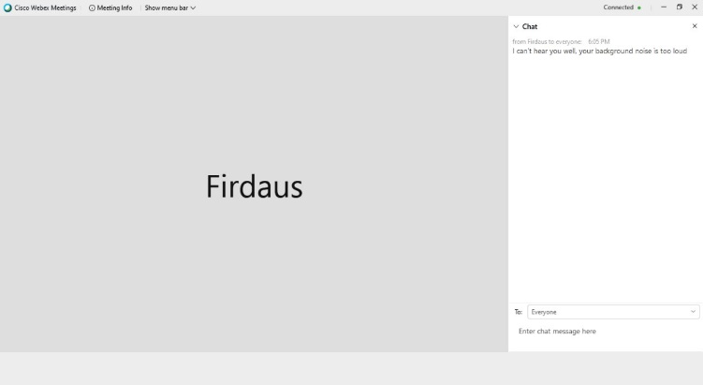

Figure 7: Testing the audio by the group member during online classes

**3.2 Define**

To have a better understanding of users and the design space, all group member of four have undergoes researched, analysis, discussion and come out with an actionable problem statement that have a point of view that focused on the users. We have identified and gathered the needs and problems faced by the users in the empathize mode. We all agree that create an advanced online learning app and installed by the users can solve their problems.

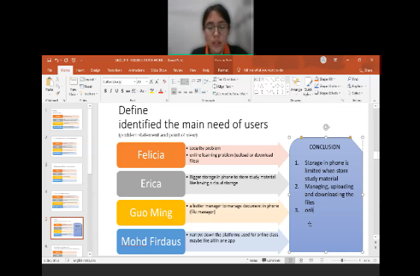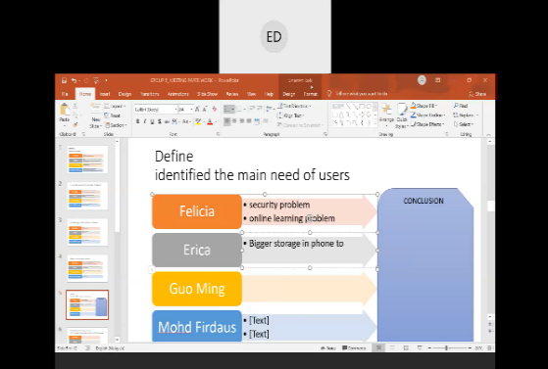

(a) (b)

Figure 8: Group discussion for defining the users’ needs

**3.3 Ideate**

We start up our designing by brainstorming ideas. We have discussed the main function of our advanced online learning app, Smart E-learning. For designing part, each group member has sketched out few creative designs. All the ideas are noted down by the meeting host during online meeting. For idea selection phase, each team member is voted based on some categories which included the rational choice, the darling, the long shot and the most likely to delight. The idea with the most vote (regardless of categories) is chosen.

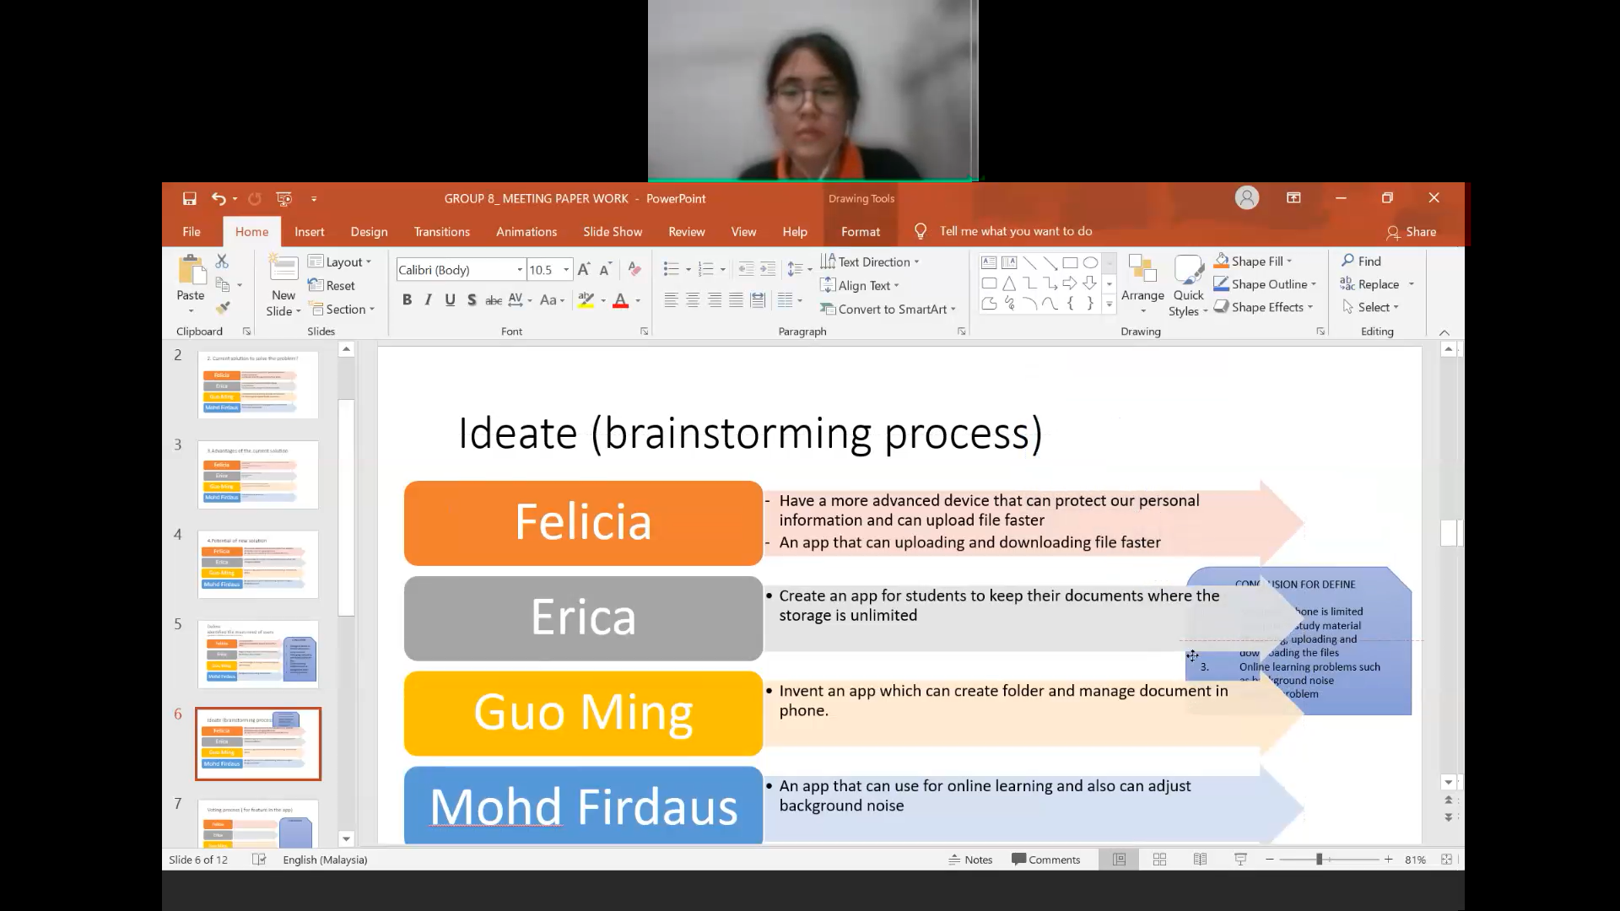

Figure 9: Group discussion for ideate process

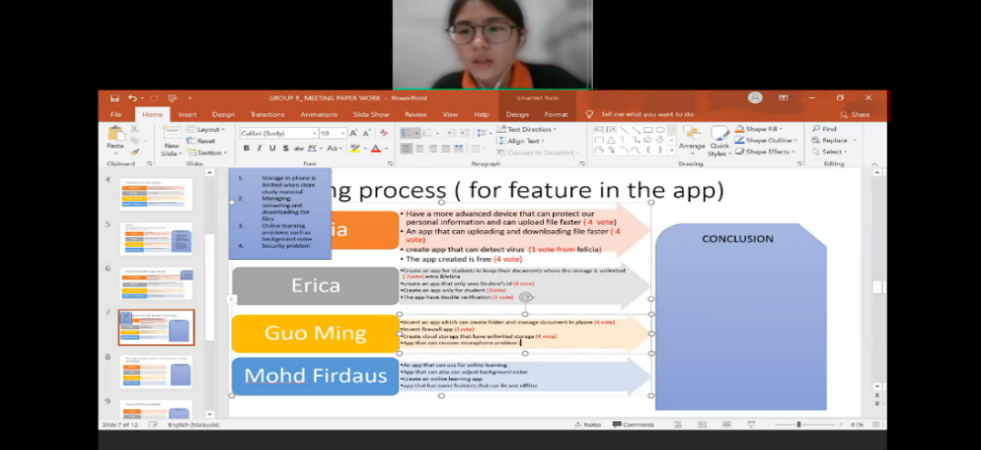

Figure 10: Group discussion for voting process

**3.4 Prototype**

In this part, we create our prototype using Microsoft PowerPoint. We did research on the Microsoft PowerPoint before using it to create the prototype.

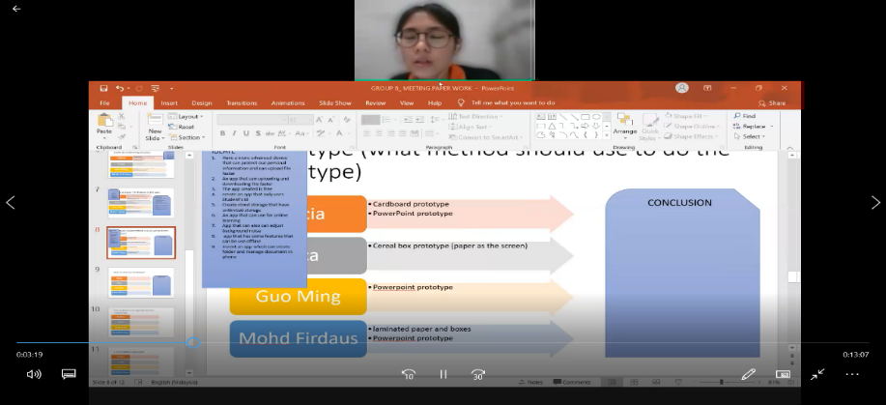

Figure 11: Group discussion for method of doing prototype

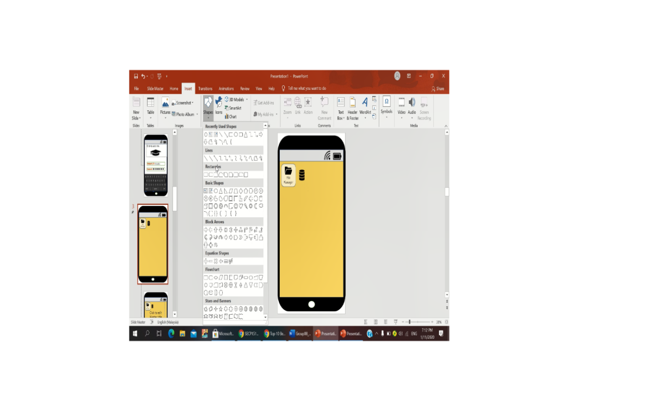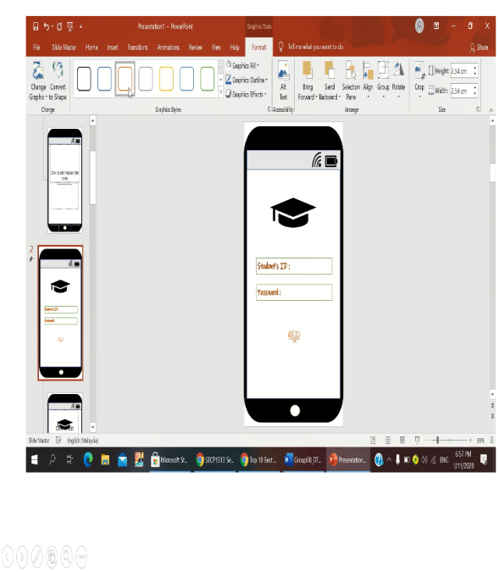

(a) (b)

Figure 12: Screenshot taken when student using PowerPoint to do the prototype

**3.5 Test**

To improve our design, we explained our prototype to the users through the video. We created online questionnaire for the users to respond after using the prototype. We asked for users’ experiences after using the prototype so that can gather more idea to solve the problems.

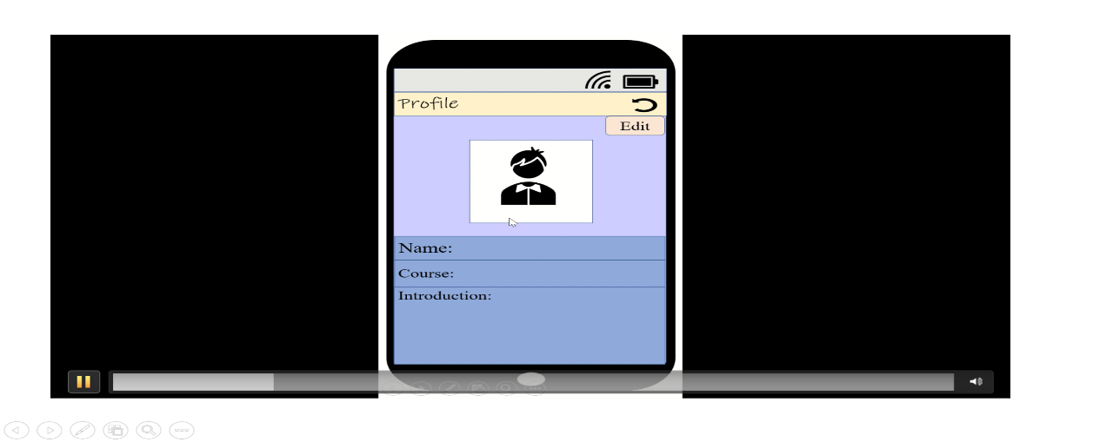

Figure 13: Video prototype prepared by group member to the users



Figure 14: Picture where the users answered the questionnaire

**3.5.1 Question and Answer in the Feedback Questionnaire**

Table 6: Question and answer in the feedback questionnaire of users

|  |  |  |  |  |  |  |
| --- | --- | --- | --- | --- | --- | --- |
| No. | Do you think the prototype can solve your problems? | How useful is the prototype | Is the prototype safe in terms of security? | Does the prototype make your online learning easier? | Does the prototype lessen your storage usage? | Does the prototype help you in managing your documents better? |
| 1 | Yes | 4 | 4 | 4 | 3 | 4 |
| 2 | Yes | 4 | 3 | 3 | 4 | 3 |
| 3 | Maybe | 3 | 2 | 3 | 2 | 5 |
| 4 | Maybe | 3 | 2 | 3 | 5 | 4 |
| 5 | Yes | 4 | 5 | 4 | 4 | 5 |
| 6 | Maybe | 4 | 4 | 4 | 5 | 4 |
| 7 | Yes | 5 | 5 | 5 | 5 | 5 |
| 8 | Maybe | 3 | 3 | 3 | 3 | 3 |
| 9 | Yes | 4 | 4 | 5 | 5 | 4 |
| 10 | Yes | 4 | 4 | 4 | 4 | 4 |
| 11 | Yes | 4 | 4 | 5 | 5 | 4 |
| 12 | Maybe | 3 | 3 | 3 | 3 | 3 |
| 13 | Yes | 4 | 4 | 3 | 4 | 3 |
| 14 | Yes | 3 | 4 | 3 | 4 | 3 |
| 15 | Yes | 5 | 5 | 5 | 5 | 5 |
| 16 | Yes | 4 | 3 | 4 | 5 | 5 |
| 17 | Yes | 4 | 4 | 4 | 4 | 4 |
| 18 | Yes | 5 | 3 | 4 | 5 | 4 |
| 19 | Yes | 4 | 4 | 4 | 4 | 5 |
| 20 | Yes | 4 | 3 | 4 | 3 | 4 |
| 21 | Maybe | 4 | 4 | 4 | 4 | 4 |
| 22 | Yes | 5 | 3 | 4 | 4 | 4 |
| 23 | Yes | 4 | 4 | 4 | 4 | 4 |
| 24 | Yes | 4 | 4 | 3 | 2 | 3 |
| 25 | Yes | 5 | 5 | 5 | 5 | 5 |
| 26 | Yes | 4 | 5 | 5 | 4 | 4 |
| 27 | Yes | 5 | 4 | 4 | 4 | 4 |
| 28 | Maybe | 4 | 4 | 4 | 4 | 4 |
| 29 | Yes | 5 | 5 | 5 | 5 | 5 |
| 30 | Maybe | 4 | 4 | 4 | 4 | 4 |

Table 7: Question and answer in the feedback questionnaire of users

|  |  |  |  |  |
| --- | --- | --- | --- | --- |
| No. | What are the advantages of the prototype? | What are the disadvantages of the prototype? | Are there any extra features can be improved or added? | Are there any applications similar to our prototype? |
| 1 | Save time | User confusion | - | No |
| 2 | The capacity of the storage is big. | It lacks of security features. | You can add the two factors authentication feature in the app for better security. | No |
| 3 | Can manage files and access everything easily. | Might cause smart phone to lose battery more and heat up the phone faster | No | No |
| 4 | Extra storage | Have to upload or insert the file to the prototype which mean it need time to do | - | Google Drive |
| 5 | Managing files well and lessen the storage | Does it need internet to access it? If yes it would be disadvantage | Improve on its appears maybe? To attract users | No |
| 6 | It has a lot of memory space | Can be a little bit confusing | - | No |
| 7 | User friendly interface | The user cannot have preview on file before downloading it | - | Google Classroom |
| 8 | Multi-function | Bad UI design | Uploaded file history for each subject | No |
| 9 | Help in storage | The interface is not really neat and bit messy | - | No |
| 10 | Clear | - | No | No |
| 11 | Lessen our storage | - |  | No |
| 12 | Save energy | Need storage | Nope | No |
| 13 | Improve current problem faced by student | - | - | No |
| 14 | Cloud Storage | Application Storage | - | No |
| 15 | Easy to use | Need deeper using before I could come to any conclusion | - | No |
| 16 | Could help me to organize my notes | If there so many users at one time, it could slow down the apps performance | Additional Notes from website that trustworthy | No |
| 17 | Easy to use | No name for files | - | No |
| 18 | Has useful utilities for students to use | None | - | No |
| 19 | In short time we can access to e learning | Creating the documents | - | No |
| 20 | Can manage your document | If too much document maybe cannot store | - | No |
| 21 | Easy | No | - | No |
| 22 | Easy to use | Not everyone can get it | - | No |
| 23 | Reduce time and cost | Could be confusing if not designed well | - | No |
| 24 | Very organized | Might take some storage | - | No |
| 25 | Easy to use | To blank | Navigation and compass | No |
| 26 | Make my life easier | Need a good connection of internet to use | Make the front page more interesting | No |
| 27 | Lessen our storage | Not interactive design | No need | No |
| 28 | Useful | Limited amounts for students | - | No |
| 29 | Idk | Idk | - | No |
| 30 | Easy to use | User interface design is simple | - | No |

**3.5.2 Background of Users**

Table 8: Background of users in the feedback questionnaire

|  |  |  |  |  |
| --- | --- | --- | --- | --- |
| **No.** | **Name** | **Age** | **Faculty** | **School** |
|  | Adrian | 20 | Engineering | Computing |
|  | Adrian Teo Wei Tak | 20 | Engineering | Computing |
|  | Afifa Jumana | 20 | Engineering | Computing |
|  | Ainin Sofiya Bt Azizi | 19 | Engineering | Computing |
|  | Amir Iskandar | 19 | Engineering | Computing |
|  | Amirul Akmal bin Mohamad Pauzi | 19 | Engineering | Computing |
|  | Baoyi | 21 | Engineering | Computing |
|  | Chan Zhi Yi | 22 | Engineering | Computing |
|  | ChuaRui Ping | 20 | Science | - |
|  | Edelin | 19 | Engineering | Chemical and Energy Engineering |
|  | Hiew Jia Yee | 23 | Engineering | Computing |
|  | Hilissa Hallyn | 19 | Engineering | Computing |
|  | Khor Zhi Xin | 20 | Science | - |
|  | Lai Xiao Tong | 23 | Engineering | Computing |
|  | Lim Jia Yee | 22 | Engineering | Computing |
|  | Lim WeiHsien | 21 | Engineering | Computing |
|  | Marluizki Enturan Anak Marzuki | 19 | Engineering | Civil Engineering |
|  | Mcdwayne Irvine Anak Macheal | 19 | Engineering | Electrical Engineering |
|  | Mikhel Adam | 20 | Engineering | Computing |
|  | Muhammad Haziq bin Azli | 23 | Engineering | Computing |
|  | Ng De Ken | 19 | Engineering | Computing |
|  | Nur Hisyam Bin Othman | 19 | Engineering | Electrical Engineering |
|  | Nur Sabrina Binti Shamsul | 19 | Engineering | Chemical and Energy Engineering |
|  | Nurin Nadhirah Suhaili | 19 | Engineering | Computing |
|  | Puteri Elisa Sabrina | 19 | Engineering | Chemical Engineering |
|  | Tan Ming Hui | 19 | Engineering | Computing |
|  | Thong Nyook Ann | 20 | Engineering | Computing |
|  | Timothy Lawrence | 19 | Engineering | Mechanical Engineering |
|  | Wong King Yun | 19 | Engineering | Mechanical Engineering |
|  | Wong Yit Khee | 22 | Engineering | Computing |

**4.0 Task Assignment**

After meeting and discussion, the task of the assignment is divided equally to each group member.

Table 9: Task assigned to the group members

|  |  |  |
| --- | --- | --- |
| No. | Task | Work Done by the Group Members |
|  | Abstract | Written by Mohd Firdaus Bn Zamri |
|  | Introduction | Written by Mohd Firdaus Bn Zamri |
|  | Problem background | Written by Mohd Firdaus Bn Zamri |
|  | Methodology | Written by Felicia Chin Hui Fen |
|  | Observation   * All group members are involved   Engage   * Erica Desirae Mauritius and Mohd Firdaus interview with the interviewee. * Erica Desirae Mauritius and Mohd Firdaus prepared the questionnaire to the users.   Immerse   * Lee Guo Ming immerse himself to the problem of file management. * Erica immerse herself to the problem of insufficient storage. * Felicia Chin Hui Fen immerse herself to the problem of uploading and downloading files. * Mohd Firdaus Bin Zamri immerse himself to the problem of background noise during online classes |
| A. Empathize | All group members discussed the main problem faced by the users during online learning. |
| B. Define | All group members involved themselves in the brainstorming process and give creative idea to solve users’ problem. |
| C. Ideate | * All group members discussed idea for the features in the prototype * All group members voted for the idea they prefer. |
| D. Prototype | * All group members discuss how to the prototype and decided to use Microsoft PowerPoint to present it. * All group member assist in the creation of prototype using PowerPoint. |
| E. Test | * Erica Desirae Mauritius and Mohd Firdaus Bin Zamri prepared the feedback questionnaire to the users * Felicia Chin Hui Fen prepared the introduction of prototype’s video to the users |
|  | Proposed solution | Written by Lue Guo Ming |
| A. Acknowledgement of similar product | Written by Lue Guo Ming |
| B. Features of Proposed Solution | Written by Lue Guo Ming |
|  | User study | * Written by Lue Guo Ming * Assisted by Felicia Chin Hui Fen |
|  | A. Identifying Problems Faced by Students Related to Online Learning | * Analysis data from the questionnaire by Felicia Chin Hui Fen * - Graph plotted by Mohd Firdaus Bin Zamri |
| B. User feedback | * Questionnaire prepared by Erica Desirae Mauritius and Mohd Firdaus Bin Zamri * Analysis data by Erica Desirae Mauritius * Graph plotted by Mohd Firdaus Bin Zamri |
| 7. | Business analysis | Written by Lue Guo Ming |
|  | Future works and improvement | Written by Lue Guo Ming |
|  | Reflection and conclusion | Written by Erica Desirae Mauritius |
|  | References | Written by Erica Desirae Mauritius |
|  | Appendices | * Tabulation of data by Felicia Chin Hui Fen and Erica Desirae Mauritus |

**5.0 Proposed Solution**

**5.1 Acknowledgment of Similar Product**

Figure 14: Pie chart of the user feedback on the similarity of the prototype with other application

Since Smart E-learning app is a multiple-function application, there are some similar characteristics with other products. For example, Google Drive app and our product both have the cloud storage function. Besides, Webex Meet, Google Meet, ZOOM apps have the same function with the meeting room in Smart E-learning app. File manager is exist in every smartphone. From the user review, majority of the users were not aware of any similar products to E-Learning app and a few users said that it is similar to Google Drive and Google Classroom. However, we make improvement toward those functions to solve the problems faced, we can say that Smart E-learning app, with the combination of multiple functions is a new idea from us.

**5.2 Features of Proposed Solution**

Due to separation of Coronavirus (Covid-19) across the world, most of the physical activities in universities are being postponed. Study and lesson plans are conducted online, meanwhile most of the students are not familiar with online learning and problems occur. From the problems faced by students, we have motivated the development of Smart E-learning, an app that is free and friendly to students. In this app, ID and password is required to create an account to protect users’ privacy and information. It contains multiple functions to help students in different dimensions. First of all, 200 GB cloud storage is prepared for every user. Users can upload their documents or learning materials to the cloud storage. It doesn’t occupy storage in phone because everything is uploaded and saved on Internet. Next, there is meeting room exists in the app, users can have online classes in the meeting room, they can take picture, record video, speak and type words in the meeting room during class session. Sometimes the learning environment is too noisy, users can reduce their background noise in the settings. Those functions make online learning more comfortable. Besides, users can arrange their documents in a proper way through file manager in the app. They can put in any documents that downloaded from WhatsApp, Facebook, Telegram or other sources to the file manager. Documents arranged in the file manager are neat and tidy, those documents will be uploaded to the cloud storage so users do not need to worry about the documents are expired or cannot be found. However, users can download their documents from cloud storage and save them in phone. The “Download” function existed in the app enables users to manage their downloaded documents in offline situation.

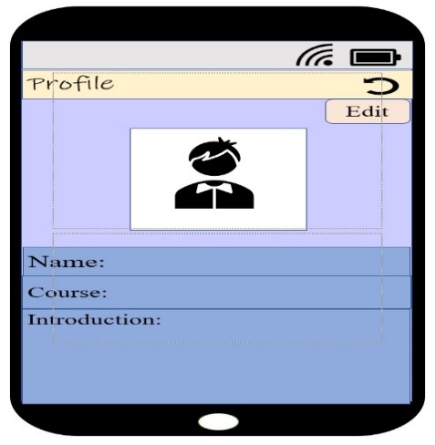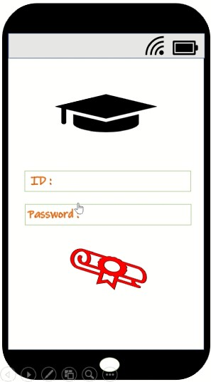

(a) (b)

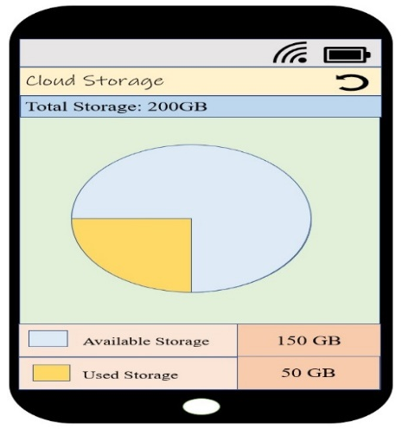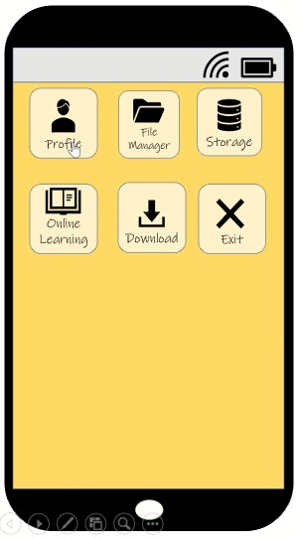

(c) (d)

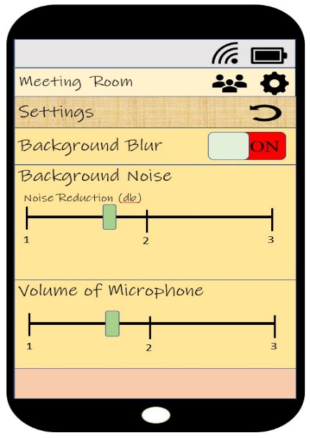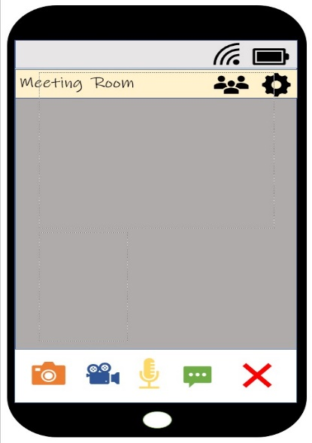

(e) (f)

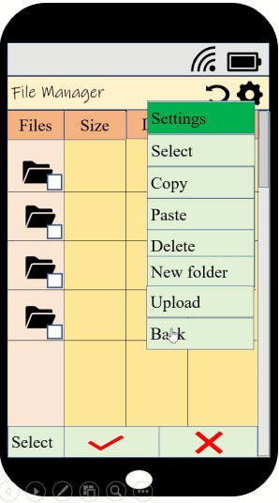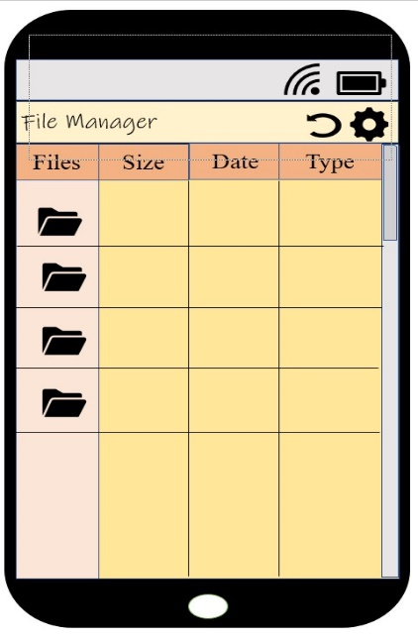

(g) (h)

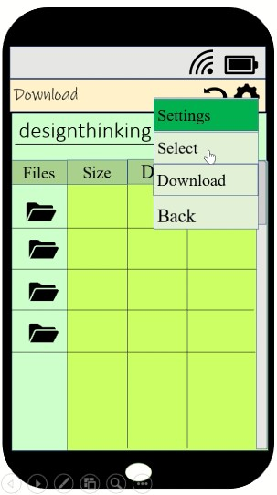

(i)

Figure 15: Main features in the prototype

**6.0 Users Study**

To further investigate the users’ problems and requirements, surveys were conducted through online questionnaire and we targeted university students as our interviewees. A total sample of 30 interviewees were involved in this user study

Apart from the students’ need, we also interviewed Dr. Mohd Murtadha Mohamad, the Associate Professor in School of Computing, Faculty of Engineering, Universiti Teknologi Malaysia to get his opinions on the issue about insufficient phone storage.

**6.1 Identifying Problems Faced by Students Related to Online Learning**

(a)

(b)

(c)

(d)

(e)

Figure 16: Graph of problem faced by the interviewee

Based on figure 16, the most common problem that faced by most of the students is online learning system always breaks down and the website loads very slow due to weak Internet connection or other problems. Many of them are also facing difficulties in uploading documents toward website or downloading documents from website. Students do feel that managing a file is difficult by using smartphone, the documents are various sorts and messy. Sometimes they cannot find the location of their documents in smartphone. They are more likely to use desktop or laptop to manage their learning materials. These is because they faced insufficient phone storage problem. Thus, they normally uploaded their documents to cloud storage to free up the space in their phone. Besides, many students faced problems during online classes. The students mostly faced difficulty with audio sound during online classes. Some of them cannot listen clearly what the lecturer said because of the echo in audio, unstable Internet connection, background noise and uncomfortable study environment. Many students faced security problem where they rarely using virus detection application to scan their phone.

Moreover, Dr Mohd Murtadha Mohamad have provided us some opinion about the insufficient phone storage issue. Based on what he had said, phone storage will never be enough for everybody because human usage is uncountable, not only for phone storage, but in any situation, human is never satisfied with things limited. We need to identify and select the things that we really need, the things that are important. We should have the responsibility to take care and manage our phone properly.

**6.2 Users Feedback**

Figure 17: Graph of the user feedback toward Smart E-learning app

Most of the users think that the idea of Smart E-learning application is useful and can solve their problems in terms of online classes, storage usage, uploading, downloading and managing documents. Besides, they also feel that the app is safe to be used. It protects the privacy and information of users well. The users stated that it has the advantages to be easy to use, can help them to organize their notes systematically and save a lot of phone space. However, there are also disadvantages and features can be improved. Some of the users said that it lacks of security feature. For file manager part, the users said that they cannot have preview on file before downloading it, cannot name a file and cannot create a new document. The users opine that we can add the two factors authentication feature for better security and file history for better management in the app. They also hope to improve the appearance of the application to be more attractive.

**7.0 Business Analysis**

SWOT (strengths, weaknesses, opportunities, threats) is being used for further evaluation of Smart E-learning app on business analysis.

Table 10: Business analysis for the Smart E-learning app

|  |  |
| --- | --- |
| ***Strengths*** | ***Weaknesses*** |
| * It is friendly to student user as it is free. * Combination of multiple functions. * Make online learning more comfortable. | * It is only available for school staff and student. * It is not suitable for business purpose. |
| ***Opportunities*** | ***Threats*** |
| * Can be further improved because it is suitable for company and office worker. | * Bugs may occur due to technical problem. * It may be hacked by hacker if security system breaks down. |

**8.0 Future Works and Improvement**

Throughout this project, we can identify our own problems as a student during online class sessions. We understand that learning is a lifelong process and it shouldn’t be stopped due to any situation. We have learnt to be better and improved ourselves for better adapting in this fast-changing world. We improved our communication skill and critical thinking skill during brainstorming session. We know that what we had learnt today will be the experiences for us to do better in future.

Although we cannot meet each other because of separation of Covid-19 virus, we believe that we can overcome any difficulty as we work as a team. Teamwork is still there and nobody is alone. We appreciate the cooperation and contribution of every team member to achieve the same goal.

**9.0 Reflection and Conclusion**

Throughout this assignment, we have realized some things regarding our life which one of it is knowing our goal in the future. So, our goal in life is to invent some new technologies or solutions for people to have an easier life as the world now is growing and becoming more advanced in technology. Moreover, by creating a new technology, it will make the people less suffering and have a comfortable life. Besides that, achieving our goal is not an easy thing. Therefore, by learning design thinking, it has taught us on how to plan our solutions and be creative with them. For instance, following the five steps of design thinking will lead us to the finding of our solutions. Furthermore, it also teaches us on how to know about people’s problem so that we can create a solution that can actually help to ease their burdens. Also, we have set a few plans in order for us to strengthen our potential in our desired industry. One of the plans is we will attend a variety of professional events so that we can enhance our skills and experiences as well as learning new things. In addition, we will do many researches about our dreams and study about them from time to time so that we can increase our knowledge about the goals we want to achieve.

On the other hand, we faced a few problems during this assignment. The major problem we faced is we have to do everything online due to the pandemic. It is indeed challenging for us because we have to discuss it virtually and not in person. For instance, when we did our first discussion, we had a hard time screen recording the session as an evidence. Another problem that occurred is insufficient time. For example, it took us a very long time to discuss because we had some technical problems such as audio problems during the discussion. However, we were able to face it courageously and hand in the assignments on time.

**10.0 References**

1. Noor Hazarina Binti Hashim & Normah Binti Mohd Ghazali & Ismail Bin Said & Rohayanti Binti Hassan & Mahadi Bin Bahari & Nur Hafizah Binti Abd Khalid & Junaidah Binti Abdullah & Siti Nisrin Binti Mohd Anis & Wan Zuki Azman Bin Wan Muhamad. (2018). *Thesis Guidelines.* Universiti Teknologi Malaysia, 81310, Johor Bahru, Johor. Retrieved from <https://sps.utm.my/wp-content/uploads/2020/05/Thesis-manual-26.5.2020_full.pdf>
2. Ryan, J. (2019, October 20). *UTM DESIGN THINKING TIS 2019 – GROUP 8* [Video File]*.* Retrieved from <https://youtu.be/g9J24NExPUQ> [Accessed 10 October 2020]
3. Solentscreencasts. (2015, April 18). *Device Rapid Prototyping with Microsoft PowerPoint* [Video File]. Retrieved from <https://youtu.be/oLCEKZy_QDg> [Accessed 31 October 2020]

**11.0 Appendices**

**11.1 Tabulation of Data in the Survey Questionnaire**

Table 11: Uploading and downloading file problem

|  |  |  |  |  |  |
| --- | --- | --- | --- | --- | --- |
| Response of the users | Never | Rarely | Sometimes | Often | Always |
| Number of users | 0 | 7 | 16 | 2 | 5 |

Table 12: File management problem

|  |  |  |
| --- | --- | --- |
| Response of users | Yes | No |
| Number of users | 16 | 14 |

Table 13: Insufficient storage problem

|  |  |  |
| --- | --- | --- |
| Response of users | Yes | No |
| Number of users | 19 | 11 |

Table 14: Security problem: using application to detect virus

|  |  |  |  |  |  |
| --- | --- | --- | --- | --- | --- |
| Response of users | Never | Rarely | Sometimes | Often | Always |
| Number of users | 1 | 17 | 6 | 5 | 1 |

Table 15: Online classes problem

|  |  |  |  |  |
| --- | --- | --- | --- | --- |
| Types of problem that faced by users | Internet connection | background noise | cannot hear the sound | have echo |
| Number of users | 5 | 6 | 4 | 2 |

**11.2 Tabulation of data in the Feedback Questionnaire**

Table 16: Users’ feedback on how useful is the prototype

|  |  |  |  |  |  |
| --- | --- | --- | --- | --- | --- |
| Response of users | **5** | **4** | **3** | **2** | **1** |
| Number of users | 7 | 18 | 5 | 0 | 0 |

Table 17: Users’ feedback on the security level of the prototype

|  |  |  |  |  |  |
| --- | --- | --- | --- | --- | --- |
| Response of users | **5** | **4** | **3** | **2** | **1** |
| Number of users | 6 | 15 | 7 | 2 | 0 |

Table 18: Users’ feedback on the prototype where it assists in online learning

|  |  |  |  |  |  |
| --- | --- | --- | --- | --- | --- |
| Response of users | **5** | **4** | **3** | **2** | **1** |
| Number of users | 7 | 15 | 8 | 0 | 0 |

Table 19: Users’ feedback on the prototype minimize storage usage

|  |  |  |  |  |  |
| --- | --- | --- | --- | --- | --- |
| Response of users | **5** | **4** | **3** | **2** | **1** |
| Number of users | 10 | 14 | 4 | 2 | 0 |

Table 20: Users feedback on the prototype in helping them managing their files

|  |  |  |  |  |  |
| --- | --- | --- | --- | --- | --- |
| Response of users | **5** | **4** | **3** | **2** | **1** |
| Number of users | 8 | 16 | 6 | 0 | 0 |

Table 21: Users’ feedback on the prototype’s similarity with other applications

|  |  |  |
| --- | --- | --- |
| Response of users | **Yes** | **No** |
| Number of users | 2 (Google Drive, Google Classroom) | 28 |