Universiti Teknologi Malaysia

**SCSV 2113**

HUMAN COMPUTER INTERACTION

(Session 2020/2021 Semester 2)

School of Computing

Universiti

**P2 - ESTABLISHING REQUIREMENT**

[VISION +]

**LECTURER**

NOR ANITA FAIROS BINTI ISMAIL

(Section 01)

**GROUP NO 5 (Auspicious)**

*Prepared by*

MAIZATUL AFRINA SAFIAH BINTI SAIFUL AZWAN A20EC0204

MADINA SURAYA BINTI ZHARIN A20EC0203

NAYLI NABIHAH BINTI JASNI A20EC0105

MADIHAH BINTI CHE ZABRI A20EC0074

NURFARRAHIN BINTI CHE ALIAS A20EC0121

SAFIRA NURUL IZZA A18CS0323

**Submission 1: For User Analysis**

**Title**

Vision +

**Proposed task**

1. Connect with devices
2. Set, view, edit and delete reminder
3. Keep and charge

**Persona**

1. **Students**

‘Z’ is a busy university student. As a final year degree student, he needs to complete a lot of assignments and projects at one time. During his third year, he almost forgot to submit his work before the due date, until someone reminded him. After that incident, he took an initiative to write some important information on sticky notes but the results were not what he expected. The papers were blown away by the winds. Next, he thinks that he needs to utilize his smartphone by making some reminders on the apps. Unfortunately, before he could type, he would visit through his social media until he forgot to set the reminder. It also became worse when he was negligent with social media until his grade getting worse.

Hence, this also led him to do a last minute work by staying up at night. Since he stays at the hostel, he needs to be considerate by allowing his roommate to switch off the lights when they want to sleep. Thus, he will stay up with the lights off which could lead to eye damage. He is already wearing the spectacles and from this, his eyes will get worse.

1. **Workers**

‘X’ has been working with Mega Holding for more than 6 years and now is the senior marketing executive for almost a year. As the senior marketing executive of the company, her job scope is varied in so many categories which includes overseeing and developing marketing campaigns, compiling and distributing financial and statistical information and many more. These responsibilities that she has been carrying for almost one year makes her life turn upside down since she had so many things to think about. Most of the time, her room is always in a mess because there are too many files that she had to check. Due to this reason, sometimes, she had some difficulties in remembering all of the things she needed to get done by the day. So, she took an initiative to start arranging her files according to her due dates but it seems that by doing this, her surroundings are still the same as before this.

Therefore, this leads to some sort of things to affect her working qualities to a lower level and this does not sit well with her employer. Her reports always miss the marks that should be included and her analysis sometimes were not as accurate as it was recorded in the system. Because of her poor schedule and time management, her working life has been affected in negative directions and it is surely bad for her.

1. **Parents**

‘A’ has been married to ‘B’ for eight years and had two beautiful daughters. ‘A’ is a working housewife. She is a barista in a very famous cafe in her town. She works five to six days every week for five hours each day. Her working shift is in the morning because she could not leave her lovely child at home during the night just with her husband. She loves her job so much that even her husband cannot make her quit the job even if he still can provide her necessities of needs and requests. Because of her dual responsibilities, as a housewife and as a barista, she faced some trouble to keep on track with her timing. Sometimes, she extended her working time to help the workers during busy days until she forgot to pick her kids up from nursery. She also forgot to do some house chores because she was too busy creating new recipes as a barista.

In consequence, her family and her house has been neglected by her without her realising it until recently her husband opens up to her about this matter. She starts to realise that she needs someone or something to keep her on track with her daily activities. She tried to make herself a better person with clear goals but it seems that it does not work as what she wanted. She has been in a dilemma because she does not want to abandon her family nor her job.

**Scenario**

**Connect with devices**

‘Z’ is a careless person and in order to make him stay alert, he uses Vision+. This device is a multipurpose spectacle. Since he is bespectacled, it is not a burden for him to wear it. In fact, it is light. Thus, he always feels comfortable using it. The first step to use this device is by connecting to other devices such as smartphones. After buying this product, Z connects it with his smartphone by pairing it with bluetooth and installing an app specialized for this device.

In order to mark it as his, he registers the apps by inserting his name, nickname, gender, and also password for security purposes. This password will always secure his reminder by any other disruption. Upon using the apps, he could change some features such as themes and so on that suits his needs. Since he is already bespectacled, it will automatically set up the glass according to his eye power and environment lights to keep his eye safe. After that, he can easily use the spectacles without having to open the apps again. The bluetooth will automatically connect it with the spectacles. As a first-time user, he tried using it by calling the spectacles with “Hey Vee”. Vision+ automatically shows his empty reminders on the glass that could only be seen by him.

**Set, view, delete reminder**

‘X’ is interested in Vision+ because it seems that Vision+ may be her best solution for her poor time management. X has a very eventful working life. She works five times a week for eight hours each day. Every week she at least needs to attend one meeting and every month needs to make a report of analysed statistical information for the company. In addition, at the end of the year, she must make a preparation and analyse all data collected for statistical purposes for the annual marketing presentation in front of the directors.

Vision+ can be used to act as her digital secretary which can record, view and delete her reminder. All of this can be activated using voice recognition function. To activate the device, she has to say “Hey, Vee” or just “Vee”. After that, she can start to set, view and delete the reminders. To set or delete any reminder she has to say “Add” or “Delete” followed by the rest of the reminder. For example, she can say “Add analyse January statistical information” or “Delete 30 minutes jog”. To view all the reminders that have been set, she has to say “View” and automatically it will show up on the glass and it can only be seen by her.

**Keep and charge**

‘A’ has a serious problem with the schedule of her daily activities. She needs someone or something to arrange it for her so she can strictly follow the permanent schedule. Vision+ is the device that she has been looking for as it can arrange all her daily activity according to her situations such as a busy worker as well as a housewife. Vision+ is accessible and transportable as every purchase of it includes a case and also a wireless charger.

The wireless charger technology includes a charging pads that use tightly-coupled electromagnetic inductive or non-radiative charging and uncoupled radio frequency (RF) wireless charging that allows a trickle charging capability at distances of many feet. Both tightly coupled inductive and loosely-coupled resonant charging. The operation uses the same principle as a time-varying magnetic field induces a current in a closed loop of wire. The spectacle case is specially designed to make it collect the induced current form by the contact between both the case and wireless charger which will make it charged as long as the spectacle is kept inside the case. The charging time is only required two hours at most and it can last for 11 hours.

**Submission 2: Task Analysis**

**Introduction**

Briefly explaining, the project and the application that we are working on and put for testing is a smart spectacle that can manage the users’ schedules easily without any sticky notes or any materials.

Therefore, what we are going to focus on this testing and observation process include the tasks:

1. Can connect with other devices
2. Can set, view, edit and delete reminders depending on the user.
3. 2 in 1 spectacle’s case which can keep and charge at the same time.

**Refinement of HTA**

**HTA for Task 1 -** Can connect with other devices

Link on User (students) doing to achieve Task 1:

<https://youtu.be/jEGTUs_RnCg>

Link on User (workers) doing to achieve Task 1:

<https://youtu.be/-zutUiem1uk>

Link on User (parents) doing to achieve Task 1:

<https://youtu.be/V6spNuMs_Bk>

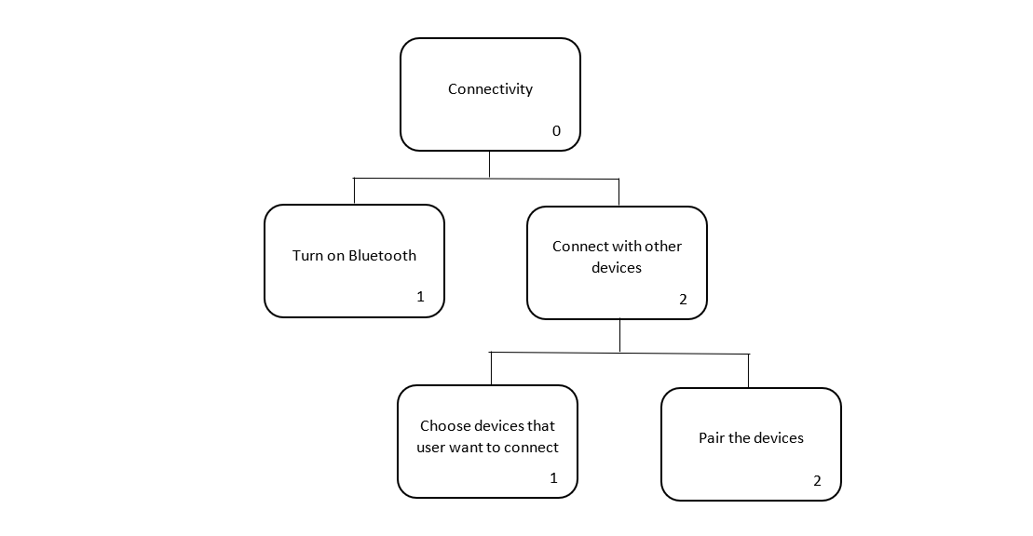

**Discussion on Findings from Task 1**

Based on the chart above, it shows clearly that the spectacles can connect with other devices like phones so the users are able to use it if they forgot to take the spectacles along. It is easy to use as they can just use bluetooth to connect it and no need to download any apps. So, we can say the spectacles use a consistent way to connect it with other devices as all of the personas know how to connect it via bluetooth. However, there is a certain aspect that we need to improve, which is that the user cannot use bluetooth for other purposes simultaneously with the spectacles.

Specification Requirements for Task 1

Functional requirement: Back-up device

Description: The users can access the schedule anywhere and anytime.

Justification: Users may want to use it when they forgot to wear the spectacles.

Functional requirement: Internet connection

Description: The users can use and perform the task like saved, insert and delete the schedule without internet connection.

Justification: Users might need it when there is no internet connection suddenly or they, especially students, might want to save the internet quota.

Non-functional requirement: Details representation

Description: More structured way and size of projecting information about the schedule and able to edit it.

Justification: User might need to edit or type his schedule if the voice recognition cannot recognise or have a problem.

**HTA for Task 2** - Can set, view, edit and delete reminders depending on the user.

Link on User (students) doing to achieve Task 2:

<https://youtu.be/XLZYejOd-20>

Link on User (workers) doing to achieve Task 2:

<https://youtu.be/8q1D5REA1rc>

Link on User (parents) doing to achieve Task 2:

<https://youtu.be/rwOMVgJTBhM>

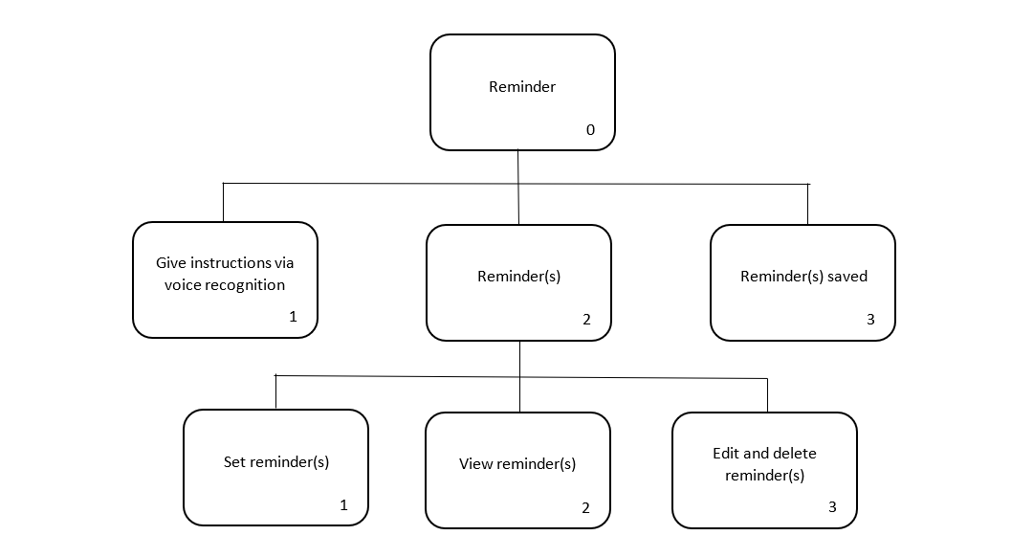

**Discussion on Findings from Task 2**

Based on the chart and video above, we can see that the task is really easy to understand and use by the users, especially elderly people as it performs the task via voice recognition method. Then, the spectacles will save the instructions automatically.

Specification Requirements for Task 2

Functional requirement: Set a reminder

Description: Users can set any reminder(s) that they want to manage their schedule.

Justification: Vision+ will save the reminder and will notify the user.

Functional requirement: View reminder

Description: Users can view reminder(s) that they made to make sure their schedules still stay on track.

Justification: Vision+ will show the reminder(s) that had been set by the users

Functional requirement: Edit and delete reminder

Description: Users can edit reminder(s) that they made in case there are any mistakes and they also can delete reminder(s) that they think are unnecessary to keep.

Justification: :

**HTA for Task 3 -** 2 in 1 spectacle’s case which can keep and charge at the same time.

Link on User (students) doing to achieve Task 3:

<https://youtu.be/lxxLe6lVmO8>

Link on User (workers) doing to achieve Task 3:

<https://youtu.be/CLndaRE4gMM>

Link on User (parents) doing to achieve Task 3:

<https://youtu.be/vHGiRstVkHA>

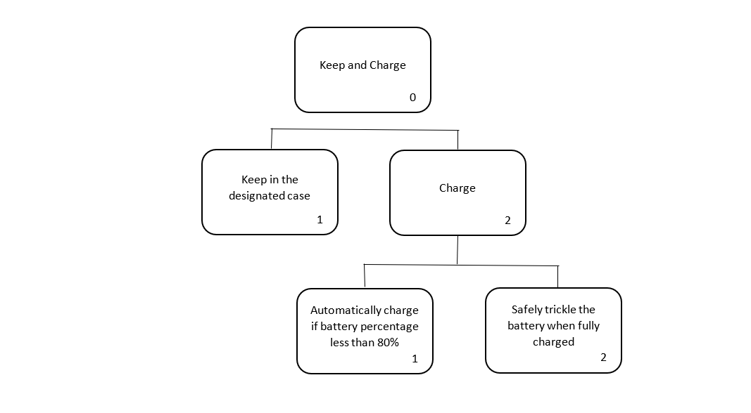

**Discussion on Findings from Task 3**

The chart above shows how to keep and charge the spectacles. Users do not have to worry about the case as they come along with the spectacles for free. Besides, the most interesting thing about these spectacles is that they are automatically charged. So, users can save space and use them in the long term without having to worry about the battery.

Specification Requirements for Task 3

Functional requirement: Wireless charging

Description: Wireless charging station that is built in a designated case to make sure users can use it everywhere they go without worry about the battery.

Justification:the charging station that can automatically charge our device when we keep it in the designated case.

Non-functional requirement: A case

Description: A container where we keep the device

Justification: To keep and protect the device from any damage or scratch.