**1.0 INTRODUCTION**

On 1.10.2018 (Monday), the department from the School of Computing organised an industrial visit for the students. The students were given a chance to visit Centre for Information and Communication Technology (CICT) which located in University Technology Malaysia (UTM), Skudai, Johor. Before the students visited CICT, they were given a short briefing by Mr. Mohd Zahari bin Zainal Abidin to make them more understand about CICT. Mr. Mohd Zahari bin Zainal Abidin works as an assistant officer who in charge of the information technology in CICT.

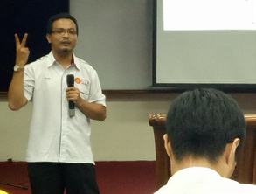

*( Picture 1 shows the photo of Mr. Mohd Zahari bin Zainal Abidin during his briefing.)*

Firstly, he introduced us about the history of the CICT and also mentioned about the vision and mission of CICT. Besides, he also introduced us regarding the organization structure, services, achievements and also the information systems that have been developed or maintained by them. He explained to the students that the school portal MyUTM which helps the students in their studies is developed by CICT. MyUTM is not only can be used by the students, it also can be used by the lecturers and the staffs. When the students log into the portal by using their Academic Computing ID (ACID) , they can select “E-learning” to revise the notes that had been given by the lecturers.

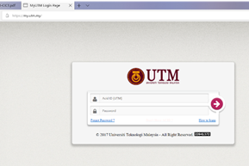

*(Picture 2 shows the login page of the portal MyUTM)*

After the briefing session, he brought the students to have a visit in CICT. He firstly brought the students to the computer lab of CICT. He explained to us that some of the students will come to CICT and use the computer for the purpose of completing their assignment as WIFI service is available in CICT.

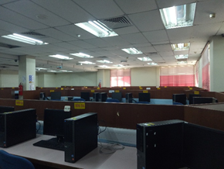

*(Picture 3 shows the condition in the computer lab of CICT.)*

After that, he brought the students to Gallerium CICT. In this Gallerium CICT, the students can explore the technology devices which had been used during the early 90’s. Mr Mohd Zahari also gave some information about the mainframe terminal, controller and also printing machine that had been used by CICT before.

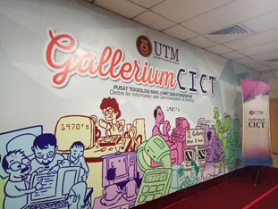

*( Picture 4 shows the entrance of Gallerium CICT.)*

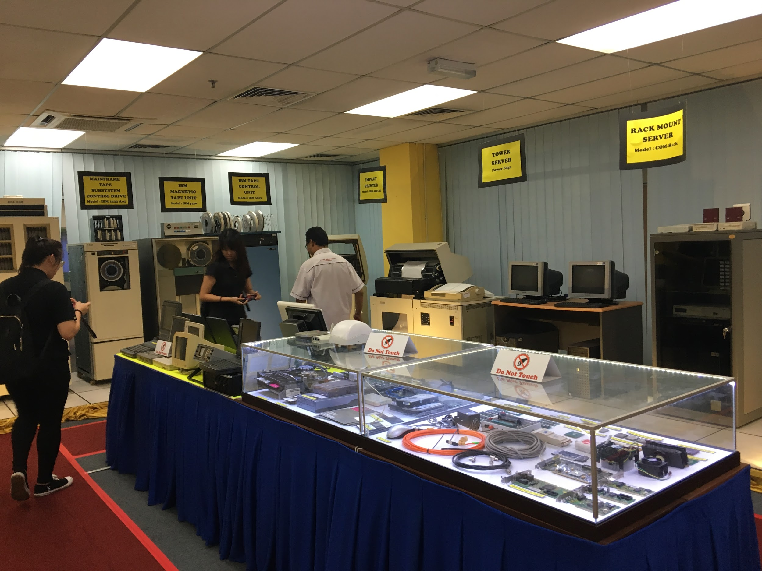

*( Picture 5 shows the entire space in the gallerium.)*

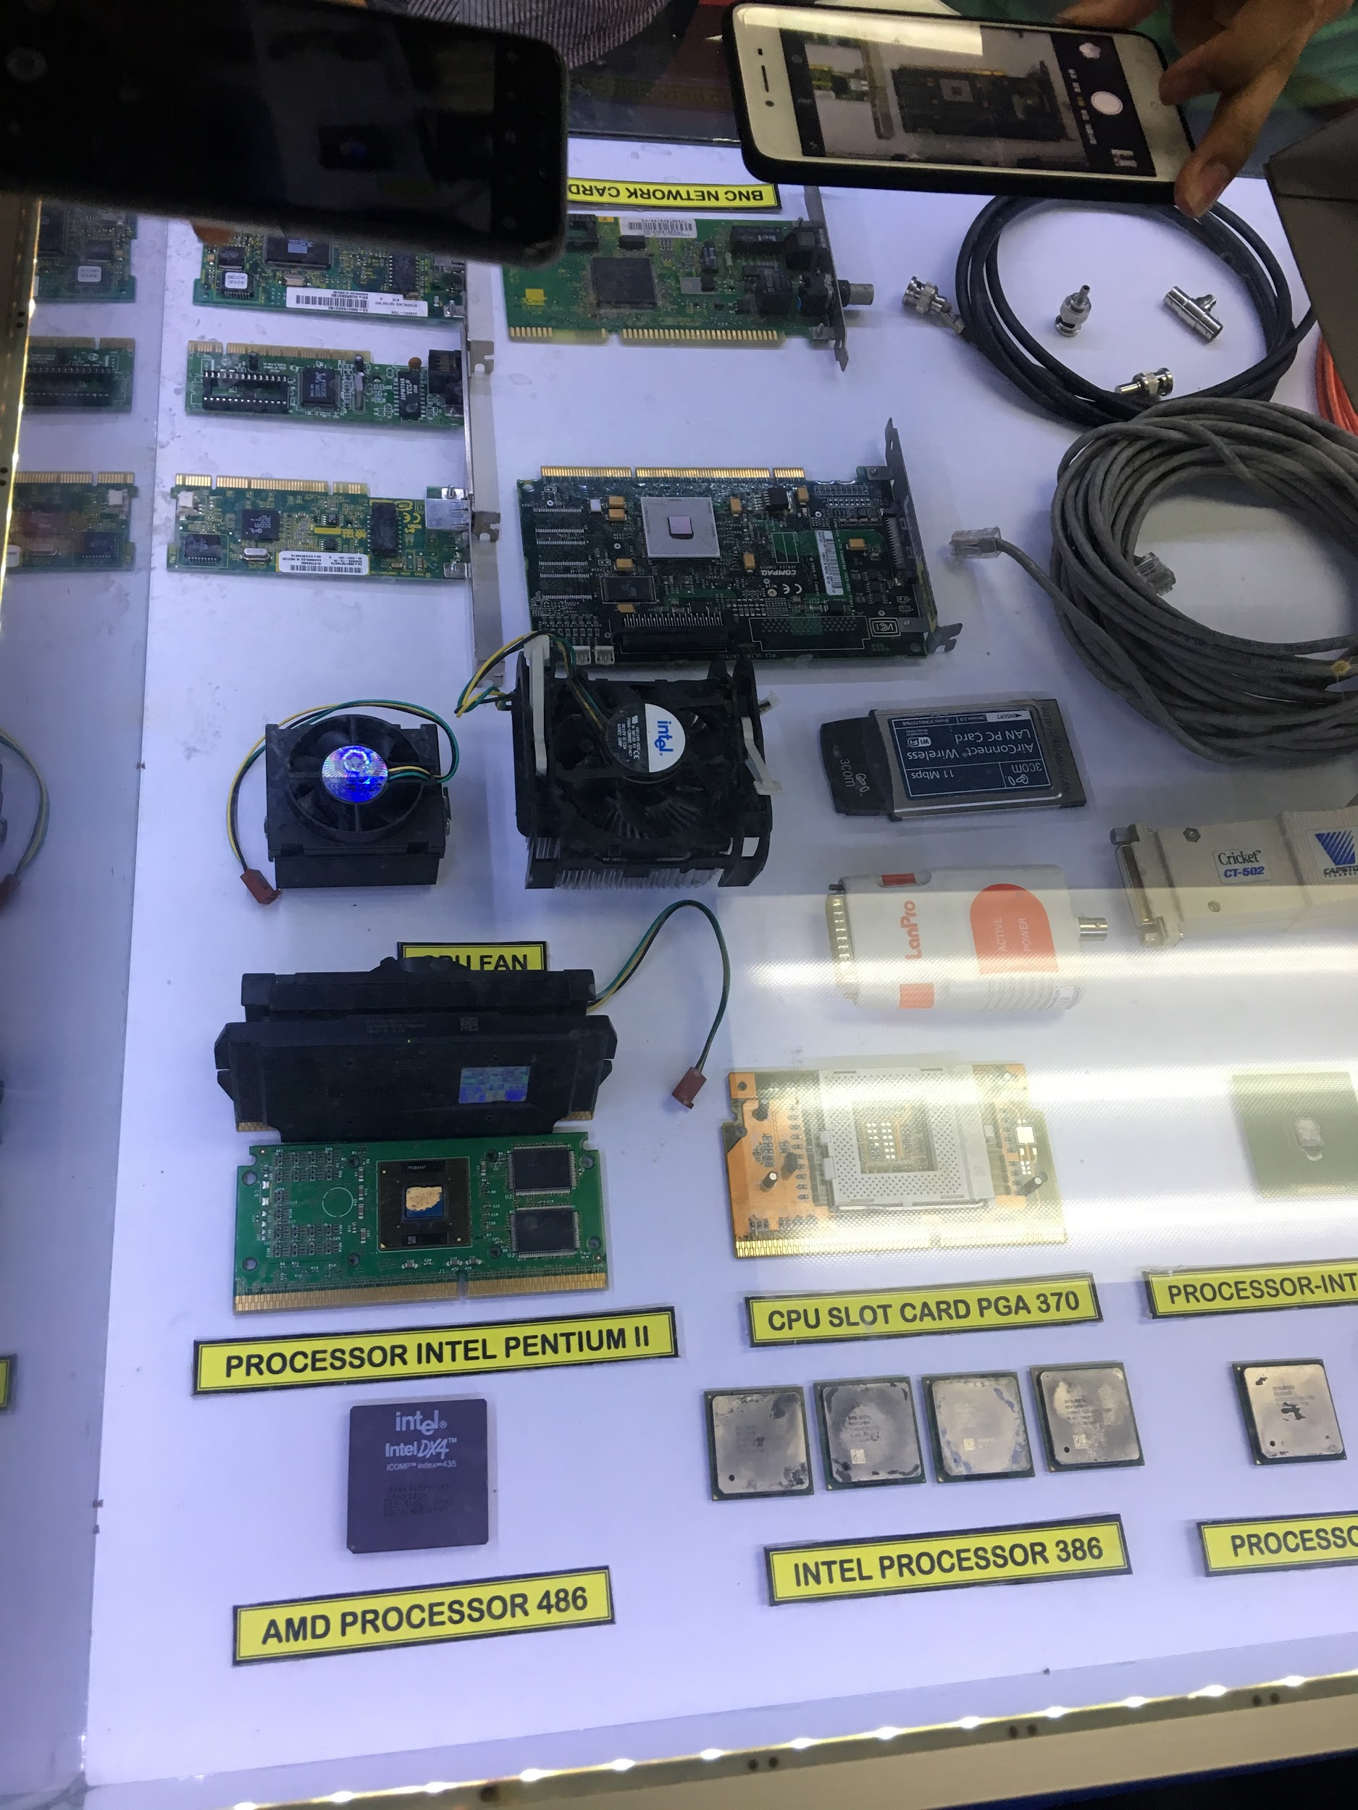

*( Picture 6 shows some of the old hardware. )*

**2.0 ORGANIZATION STRUCTURE**

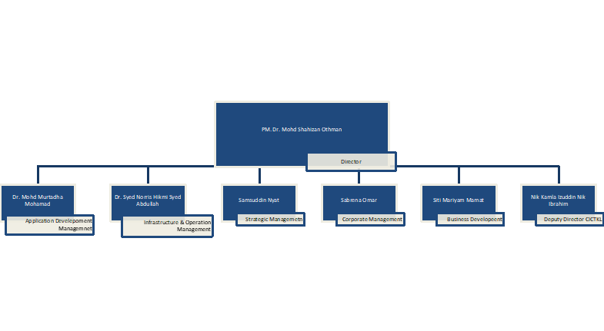

*(Picture 7 shows the organization structure in CICT)*

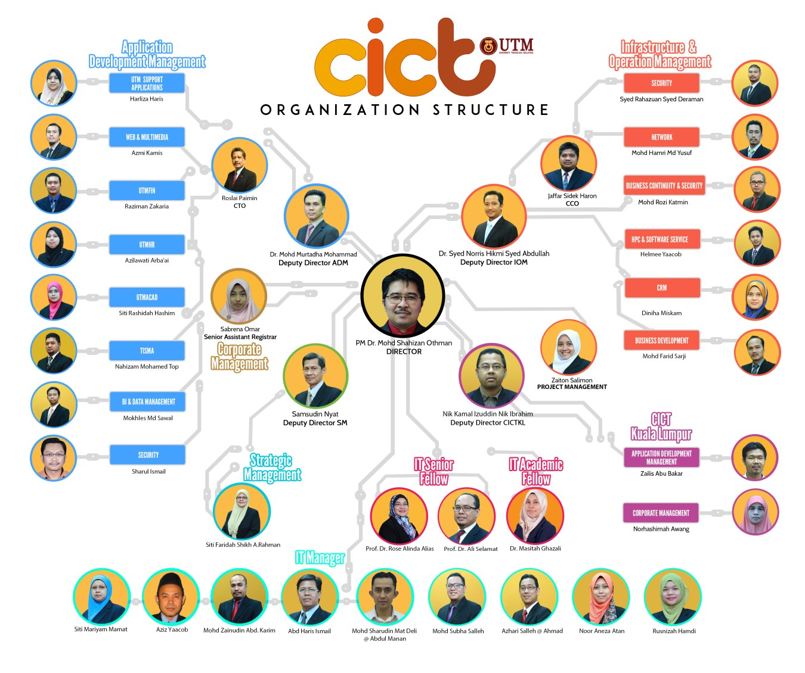

*( Picture 8 shows the organization structure in CICT UTM )*

**3.0 DEPARTMENT FUNCTION**

There were 4 main Function Departments in CICT with their perspective work fields and jobs. First, Application Development Management’s duty is to develop most of the applications that being used today such as UTM HR, UTMFin, UTM Acad and Service Support Application. This department also manages and develops Web & multimedia. Mobile apps for UTM also being developed by Application Development Management such as UTM Bus and Smart UTM.

Next, the department that hold count for Data center, ICT security, UTM Hosting, Customer Services and UTM Cert is Infrastructure & Operation Management. Their main job is to make sure that every applications or systems that provided by CICT are in a smooth and efficient condition. Infrastructure & Operation Department also responsible in High Performance Computing which is one of important thing that need to being supervised regularly.

Furthermore, Strategic management take a duty of management of Staff, Attachment and Ambassador. It also in charge of Strategic Planning and Report and maintaining the quality of CICT product & services. Lastly, all business-related field will be help by Business Management such as the development of *“Model Bisnes”* and Business Generate Management.

**4.0 SERVICES**

CICT provided whole range of services consists of IT and Data management mainly for UTM. There are 4 types of services CICT provided, which are Infrastructure & Security, Application Development, Software and ICT support.

Infrastructure & security’s objective is giving students and UTM staffs an easy access to all services provided by UTM. In conjunction of that, CICT develop unique ID for student and staffs which is ACID All students registered in UTM will have their own ID according to their perspective faculties. Meanwhile, staffs need to have official UTM domain email before registering to ACID account. Before 2015, UTM official emails are using Desknow Gmail for email domain. Now, CICT enhanced the email service by using UTM own domain, example; xxxx@utm.my. One of the advantages is that it can be access anywhere and have unlimited quota for mailbox. CICT also provide solid ICT security for Wi-Fi users in UTM such as Firewall policy, URL Filtering, Application Control and many more. High Performance Computer (HPC) also available for usage of large complex computation and large data sets. Last, CICT also provided video conferencing across the globe. With this accommodation, there will be more cost can be saved from travelling for meeting.

Lastly, licensed software are available for students or staffs that need to use. This is important because UTM encourages people to use the licensed product and not using crack or pirated product. Therefore, as a service provider, CICT have provides several rules that need to be followed by people who want to use it. Software that can be use are such as MatLab, Microsoft Product and many more.

**5.0 ACHIEVEMENT**

On 22nd November 2017, CICT UTM had been awarded Standard Accounting System for Government Agencies 2017 by Malaysia Accountant National Deputy. UTM was one of the agencies that awarded from 416 agencies that involved.

With the help of CICT, UTM Global Rankings have improved from time to time, especially in aspect of University Data Management and Business Intelligence. UTM was ranked 253 for World University QS, and then we also gained 5 stars Overall Rating from QS STARS 2017. Next, UTM is also achieved as the first public university in Malaysia for Data Centre and Design Certified (TIA-942 Tier 3 – 2017) and Operation Certified (ISMS + TIA 942 – 2018).

CICT is also the service leader for video streaming, conferencing and montage for significant event and program in UTM. As for 2017, 11 events had been streamed through Facebook and total of 142,562 viewers reached. Video Conferencing also provided facility needed such as Multipoint Conference Unit, Mobile Centre VC and support the Education 4.0.

**6.0 REFLECTION**

Nowadays, the world is dealing a lot with the technologies and we have the chance faster than other to in touch with them because we are the students of data engineering course. We are aiming to have a high – paid job after graduation and we dream to be an authority in the field of computer science and technology. Nowadays, the big data are too complex and massive that the traditional data processing application software is unable to deal with them perfectly. Thus, we are trying to modify the technologies or even create and design a new technology to deal with those big data. We have been encourage to improve ourselves in every aspect to devote our knowledge in this big data field after the visit.

We have to develop some skills to improve ourselves to achieve our dreams. Firstly, talking about the professional skill, we are now learning the skills with the lecturers in UTM but this is not enough for us. We have to widen our knowledge about the current technologies through the seminars or the industrial visit to some companies such as Microsoft, Intel and Apple. The technologies are continuously improving and replacing existing products meaning that we must have much more specialized and precise skills to manage them.

Moreover, we also must have creative thinking in our learning process. We have to set our minds free and think out of the box so that we could come out with creative solutions. People would surely prefer an alternative solution which is able to solve various problems one-off rather than to produce a specific solution for each problem. Hence, we should think creatively and let our imagination run wild.

Besides, we also need to learn some soft skills to improve our potential in the industry. As an example, communication is a critical soft skill. As a data engineer, we must able to communicate with the clients to describe the data that we processed and explain to them about the analysis of the data. Clear and effective communication skill is required for the purpose of conveying the complex technical information to the non-technical professionals.

Furthermore, we must have a lot of knowledge about the database system because it is a new thing to the public. So, we have to apply our skills by looking into the issue regarding the big data and understand it to enable us to innovate a brand-new technology or upgrade current technologies which are capable to deal with the big data. It is our time to utilize our strengths and contribute to the company so that we will hold an important position in the company and be the best among the experts and finally achieve our dream to become a high-paid data engineer.

In conclusion, the visit had encouraged us to improve ourselves to achieve our goals and dreams. It lets us know that everyone has the room of improvement as long as you want to do it. Let’s us make our dreams come true!

**7.0 CONCLUSION**

In conclusion, with this industrial visit that have been organized by the department from School of Computing, it gives many benefit to the students from data engineering. One of the benefit is that it gives us the chance to know more about the jobs that are related to our course. This helps us a lot because we can have the illustrations in the future on how the job related to our field can help to develop one of the major network centers in UTM, or other places.

This visit also gives experience to us about how the staffs from various departments work together to build and organize CICT. During the briefing from one of the staffs in CICT, we also managed to know how the system conducted by CICT which is MyUTM works. Other information such as e-learning, MOOCs, Job4U also have been briefly delivered to the students. These information make us realized that we can create many things which can make our life easier with all the knowledge that we learn now.

Finally, by visiting the Gallerium CICT , the student get to know more details about how the technological developments happened since the early 90’s until now. The students also get to see the real old hardware and see the changes happened on it. This visit really helps the student to know the history behind all the changes that happened throughout the year in IT field. In a nutshell, it was a great experience for all of us.

**8.0 REFERENCE**

1. *My.utm.my.* (n.d.). MyUTM Login Page. [online] Available at: https://my.utm.my/ [Accessed 7 Oct. 2018].
2. System Development | CICT UTM. (n.d) .[online] Available at http://cict.utm.my/ict-services/system-development/