****TECHNOLOGY AND INFORMATION SYSTEMS**

**SCSP 1513 (SEC-08)**

**SCHOOL OF COMPUTING**

**UNIVERSITI TEKNOLOGI MALAYSIA, 81310, JOHOR BAHRU**

**JOHOR, MALAYSIA**

GROUP REPORT

**INDUSTRY VISIT - CICT**

**25TH SEPTEMBER 2018**

PREPARED FOR

**Dr. AZURAH BTE A SAMAH**

PREPARED BY

**SHARIZZAT BIN SHAMSUL**

**BADRUL FITRI BIN SHAIFUL NAIM**

**MD. FARDIN MUTTAKI**

**MATHESH A/L KUMAR**

**YOUSSEF MOHAMED HAMED ABDO**

**Contents**

1. **introduction ………………………………………………………………3**
2. **content …………………………………………………………………….**
   1. **detail journey ………………………………………………………4**
   2. **CICT organization…………………………………………………6**
   3. **Services and achievement …………………………………………8**

**3.0 reflection …………………………………………………………………..10**

**Introduction**

A visit to Centre of Information & Communication Technology (CICT) was held on 25th of September 2018 which is on Monday. These industry visit was conducted by Technology and Information Systems subject unit. The visit is purposely to introduce the Centre of Information & Communication Technology (CICT) to the students especially us, first year student. During these visit, students were exposed to many thing about Centre of Information & Communication Technology (CICT) such as the policy and terms of UTM ICT services that provided by CICT to the students and staff and many more about the Centre of Information & Communication Technology (CICT). The first year student from two courses which is network and security computer and graphic designing from school of computing.

Centre of Information & Communication Technology (CICT) is now located in building D07, which start developed as computer center since 1975. Then the computer center become a part of computer science department in 1975. It is structured into Computer Science and Information System Faculty and UTM Computer Center in 1991. Then computer center been upgraded to Centre of Information & Communication Technology (CICT) until now.

The Centre of Information & Communication Technology (CICT) has it own vision and mission. Centre of Information & Communication Technology (CICT) vision is to make UTM become Digital University is a leader in academic-based service delivery. And their mission is developing an entrepreneurial digital ecosystem development by fostering innovative digital professionals and promoting collaboration in digital services. They committed providing high timeline ICT services and implement the continuous improvement to increase customer satisfaction with vision and mission CICT.

**JOURNEY WORK**

Visit session on 25th September 2018

**1350 hours** : CICT building

Our group members which is Sharizzat, Badrul Fitri, Md Fardin, Mathesh and Youssef arrives at the building and assemble at the foyer. We move into the building together while chatting and discussing on what we will get from this talk. Then we directly go to the 4TH floor to the conference hall where the talk been held.

**1400 hours** : conference hall

We entered the conference hall and filled an attendance into the system. The talk was given by one of the Customer Relationship Management (CRM) officer, Mr.Mohd Zahari Bin Abidin. He talked almost 1 hour about CICT from the first time their operation begin until now. Most of the ICT facilities are controlled by CICT department for example UTM wifi, student portal, E-learning and managing data and information in UTM. Before the talk end, we have the question and answer session.

**1520 hours** : CICT gallery visit

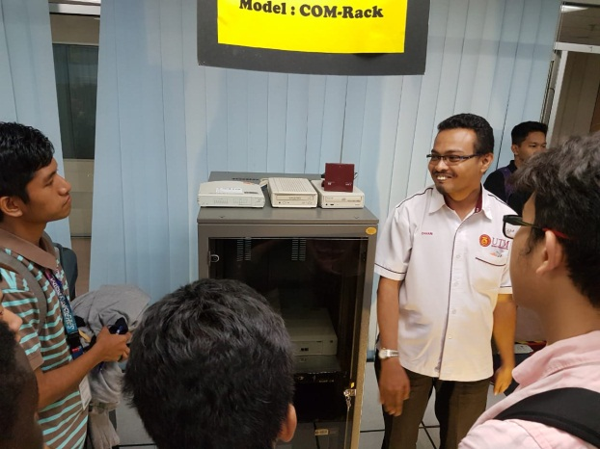Next event he bring us to the gallery of CICT which is at first floor. In the room, there are a lot of old computer stuff. There are a lot of stuff in there. We were so excited to see the old things where it is not available in the market nowadays. All of the stuff are still in good looking and some of it still can still use. We are not just looking at the old stuff but he explain how they used it back then and how struggle to use them compared to nowadays.

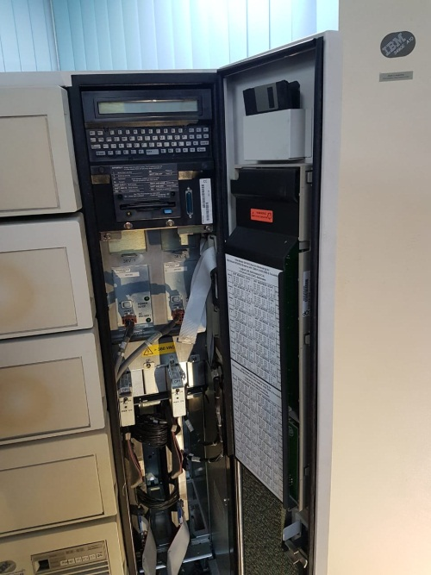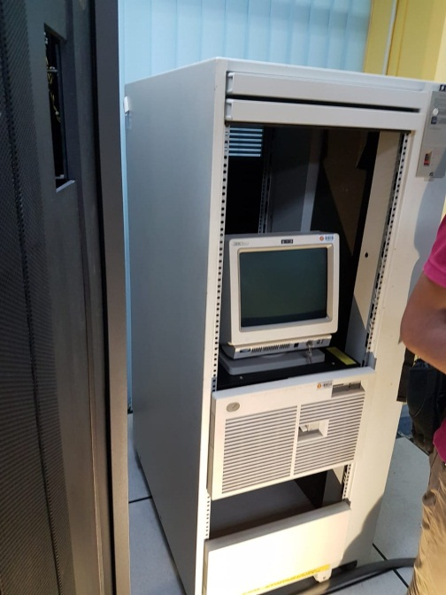

**1600 hours** : the end of the program

After a while looking the old stuff in the CICT, then we walk to the foyer of the building which mean the end of the programs and we can go back home.

**CICT ORGANIZATION**

Centre of Information & Communication Technology (CICT) organization was organizing by PM Dr. Shahizan Othman as a director of a CICT UTM and they have four deputy director, Deputy Director of Application Development Management – Dr. Mohd Murtadha Mohamad then Deputy Director of Infrastructure & Operation Management – Dr. Syed Norris Hakimi Syed Abdullah then Deputy Director of Strategic Management – Samsudin Nyat then Deputy Director of CICTKL – Nik Kamal Izuddin Nik Ibrahim. There are also have IT Senior Fellow ,IT Academic Fellow and several IT manager.

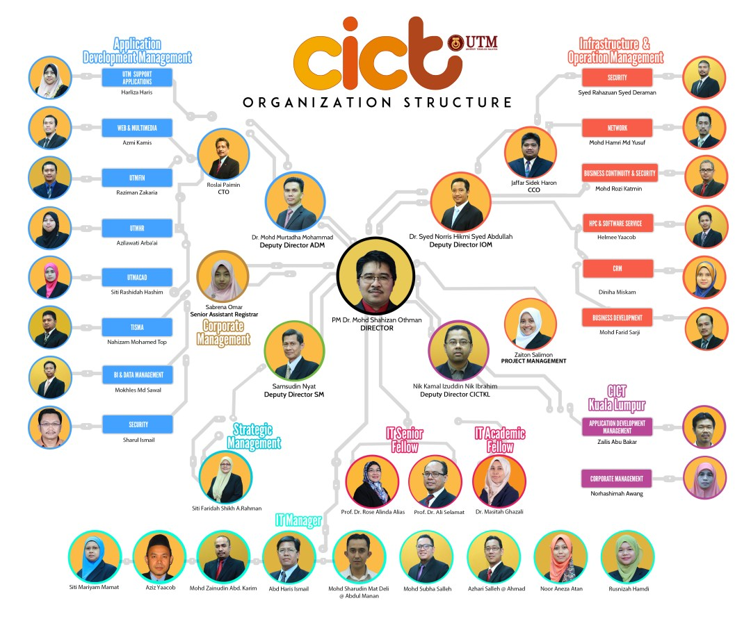

Centre of Information & Communication Technology (CICT) have a lot of staff that help every people have connection in UTM. Centre of Information & Communication Technology (CICT) structure organization has 7 department. The department divided to Top management,ADM, IOM,CM,PMO,BDO and SM. ADM is Application Development Management. They have to make sure that the application still can be usefull and help people to the problem. They have section :

* UTMHR
* UTMFIN
* UTMACAD
* E-learning Apps
* Web & multimedia
* TISMA

IOM is Infrastructure and Operation Management, their common job is to make sure that the web application is run smoothly and synchrony are good. Their section :

* ICT security
* Data center
* Networking

SM is Strategic Management and the common job is to promote CICT in different dimension to help people know more about CICT and they can come refer to the CICT if they have any problem about ICT. Their section :

* UTM Cert
* BDO (business development office)
* Senior executed

Then CM, Corporate Management job is to organize the basic organization like human resource and financial. Their section:

* Human Resource
* Financial Office
* Practice Lab

**SERVICES AND ACHIVEMENT**

Centre of Information & Communication Technology (CICT) offers many services to students and UTM staffs relating about IT. One the most affective services for students where CICT provide UTM wifi with larger coverage in the UTM campus. Not only at the faculty, there are provide us wifi coverage at hostel where every students can access it. This parallel to the CICT vision. But, to access into UTM wifi there required to have an account which is created by CICT to UTM staff and student. This is the way to make sure anything that the user surfing using UTM wifi is not over the limit and not accessing something that inappropriate. CICT controlled the user by blocking the website that are harmful and inappropriate. Now CICT planning to upgrade the wifi services at their coverage and the internet speed. They are increasing the coverage of wifi in the UTM to make sure there is a wifi connection everywhere. For now student still complaining about the speed of the wifi. Due to the report and complains, they are now planning to upgrading the speed of wifi to satisfied the client need.

Not only that, CICT also provide a service on providing the client a lot of software that are expensive. The software are needed by the student for some courses. The students just need to access the student portal to get the software and download it. Some software that need a key to activate it, the student just need to request the key and no need to pay. That the advantage of CICT for students. CICT also provide an antivirus software to make sure no virus spreading among the student in the UTM and in the CICT system and database. This is because the virus may harm and steal the information either about the student or the UTM.

The other special services is CICT provide a student lab where there are everything in there for student use. Back then there was no laptop and not everyone are afford to own a computer so CICT create the student lab for student to access and use the facilities provided. The student lab that provide the computer still active until now for those how need to use computer , printer or anything else. There are also have Specialize Multimedia & Content Authoring Production Lab (SMAL). This lab is special for multimedia usage because there have the very expensive item use to make a video and special effect. For example, they got mac pro, lighting and chroma key, whisper room and mixer. In the lab also have software for multimedia use in making video purpose.

Achievement that CICT achieve is that they manage to fulfill the students and UTM staff need in IT. There no such achievement that greater than that. CICT also manage to solve the problem that has been complain or report. For example the problem of E-learning and accessing the student portal. Good comment were given by the student to the CICT staff for good in their job.

Student portal is website that created by CICT department where this portal connect the student and the lecturer. This portal where the developing from time to time to ensure it give the best impact to the user. From the portal, student can do many thing related to UTM from the portal. Student can register their subject, apply the hostel, apply curriculum, access E-learning and many more from the portal. This should be maintain or upgrade base on client need to satisfied them

|  |  |  |
| --- | --- | --- |
| **SERVICES CICT** | **ICT SERVICES TO STUDENTS** | **ICT SERVICES TO STAFF** |
| 1. Provides ICT communication infrastructure throughout the campus 2. Provides infrastructure of computer and server infrastructure 3. Development and maintenance of university applications for staff and students 4. ICT Support Services, ICT Training and Consulting | 1. internet access facilities via Wired and Wireless UTM 2. Student ICT service center 3. Preparation of E-learning app, student Activity System, Lecturer Teaching Assessment system 4. ICT training and consultation | 1. Internet access facilities via Wired and Wireless UTM 2. Ease of Email 3. Facilities of ICT service complaints through the Adu @ IT system 4. Technical support services 5. Website and portal services, web streaming and video conferencing 6. Multimedia services 7. MYREN service for academic staff 8. ICT Training and Consultation |

.

**REFLECTION**

Centre of Information & Communication Technology (CICT) provides and delivers ICT services for staff and students of University Teknologi Malaysia. Throughout the visit, we saw how are we going to work regard to our course. We know that the job related to our course is more harder and extreme out there. Therefore, we need to be prepare in content of mental. This visit gives us motivation to study harder to archive our ambition and become someone that give benefit to everyone.

Centre of Information & Communication Technology (CICT) gives many benefit especially to the students. For example the benefit of CICT to the student is :

* Providing wifi
* Providing software and antivirus
* Help student that have problem about their student portal
* Created student account
* Provide ICT services and stuff

In our discussion, Centre of Information & Communication Technology (CICT) need to improve in certain part like the wifi speed where they need to improve the speed due to the student need. Next, their services upon the report and complains need to take a faster action. CICT also should provide a class or sharing their knowledge and experience to the student especially form faculty of computer so that they can prepare for future. Lastly, the promotion department need to improve their promotion so that student are more often go to the CICT to use the facilities provided. Our hope that CICT improving their services in the future.