INDUSTRIAL VISIT REPORT – CICT

GROUP 2 MEMBERS:
- ALUGE OSEI-AMAKA ELINOR (A19EC4005)
- CHEONG CHIEN LI (A19EC0186)
- MUHAMMAD KHAIRUL AMIRIN BIN KHAIRIL (A19EC0100)
- SYAFA ILYAS AL MUZANI (A19EC0288)

LECTURER NAME: DR. HASWADI HASSAN

UNIVERSITY NAME: UNIVERSITI TEKNOLOGI MALAYSIA (UTM)

PLANT NAME: CENTRE FOR INFORMATION & COMMUNICATION TECHNOLOGY (CICT)

DATE OF VISIT: 21 OCTOBER 2019

PLACE OF VISIT: PERPUSTAKAAN SULTANAH ZANARIAH (PSZ)

INTRODUCTION

On the 21st of October 2019, an industrial visit was carried out for students who are undertaking the course, Technology and Information Systems (SCSP1513). The industrial visit was proposed and organised by the course coordinator, Dr Aryati with the help of some other lecturers, including Dr Haswadi and Dr Adila. The students from Faculty of Engineering, School of computing, specifically software engineering students, have visited the Centre for Information and Communication Technology (CICT), located at the gallerium in Perpustakaan Sultanah Zanariah (PSZ), which is located inside Universiti Teknologi Malaysia (UTM). There were roughly 120 students who attended the industrial visit program, while there were around 5 faculty members in charge, making a total of around 125 persons involved in this program.

DETAILS OF JOURNEY/ WORK PLAN

The visit started at around 3:15pm after a lecture session from Dr Haswadi where the first group presented their design thinking project. Students started to head towards Perpustakaan Sultanah Zanariah from N28, Faculty of Engineering, School of computing building in Universiti Teknologi Malaysia. Some students walked while other students had their own methods of transportation. On average, it took students about 15 minutes to get to their destination and they waited at the foyer of the library for their lecturers. At roughly 3:40pm the industrial visit began and students headed into the gallerium inside the library, located at the first floor. Then, one of the faculty members introduced himself as the “guide” for the day. At around 4pm, the guide began giving a talk to the students about the history of computers and some of its components from back in the days. The talk lasted for nearly 30 minutes before the students started to explore around the gallerium. The students were given 20 minutes to look around the gallerium and take some pictures of their visit to the industry. Lastly, the visit ended at roughly 5pm and students were allowed to leave the gallerium after they are done with exploring it. Some students then stayed in the library for further discussion about what information they have gathered while other students headed back to their rooms after the visit.

DETAILED DESCRIPTIONS

During the talk given by the guide, students were introduced to the devices and information systems have been developed or maintained by CICT. Firstly, he showed us a server mainframe, and explained that the server mainframe contains Central Processing Units (CPU) for servers, which are much powerful than conventional CPUs. The picture below shows the IBM Powerserver 550, once considered as the fastest computer chip back in the 1990’s:
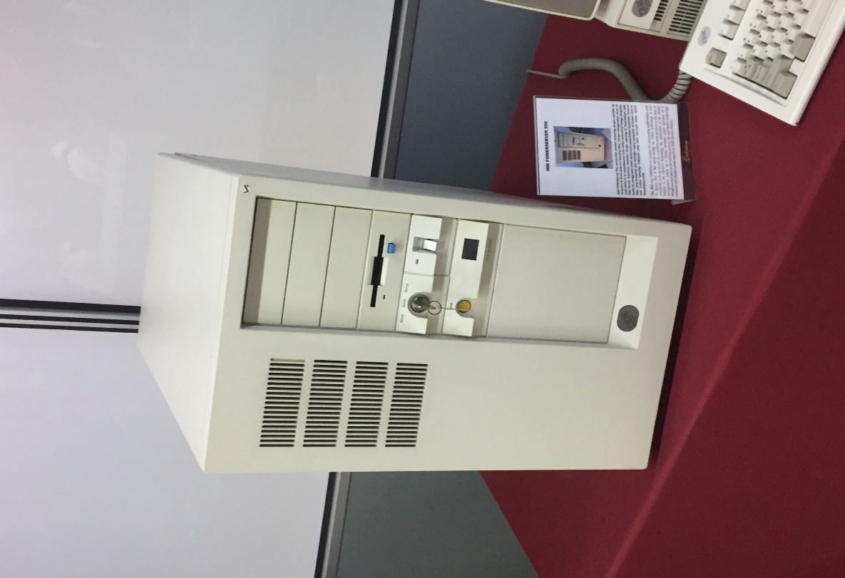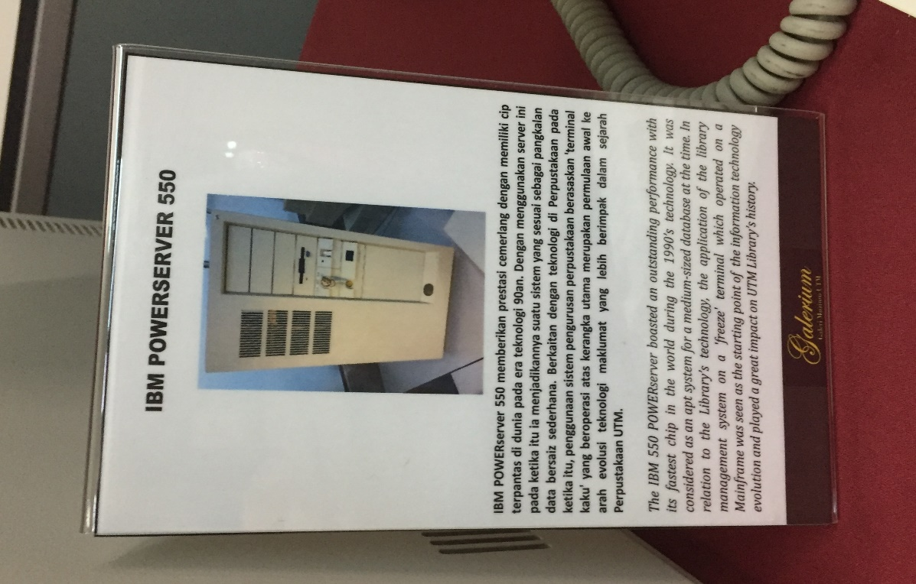

Then, the guide continued to talk about the data storage devices for servers. Particularly, the IBM 9435B22, which served as a data control of students and staff information in the 1970’s:
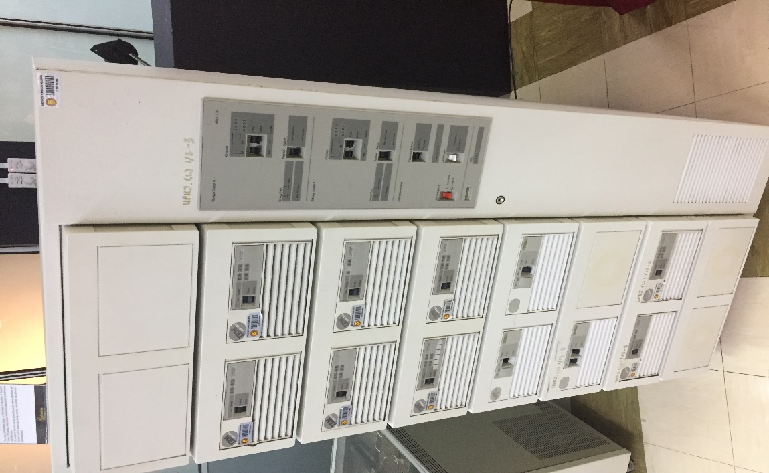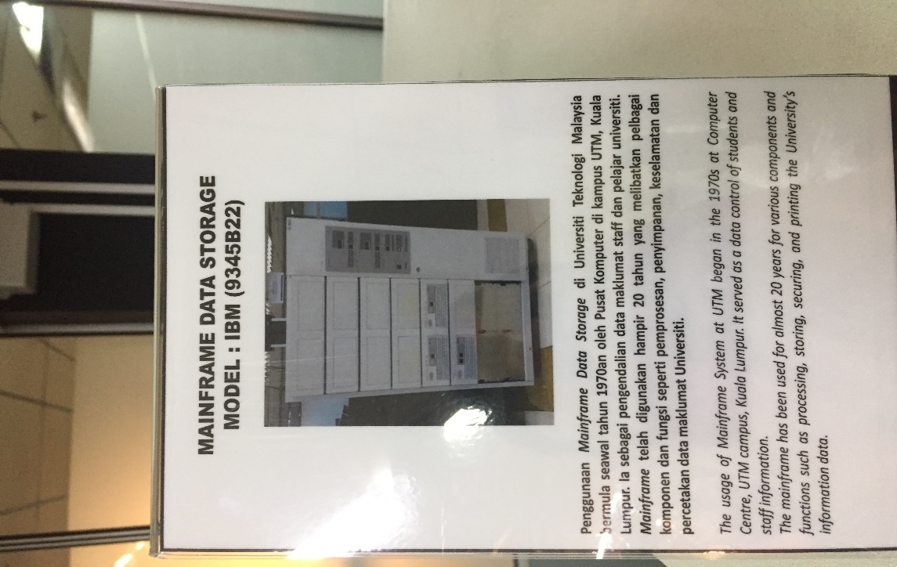

Next, the guide talked to us about old personal computers, specifically, the IBM Personal Computer 300GL model:
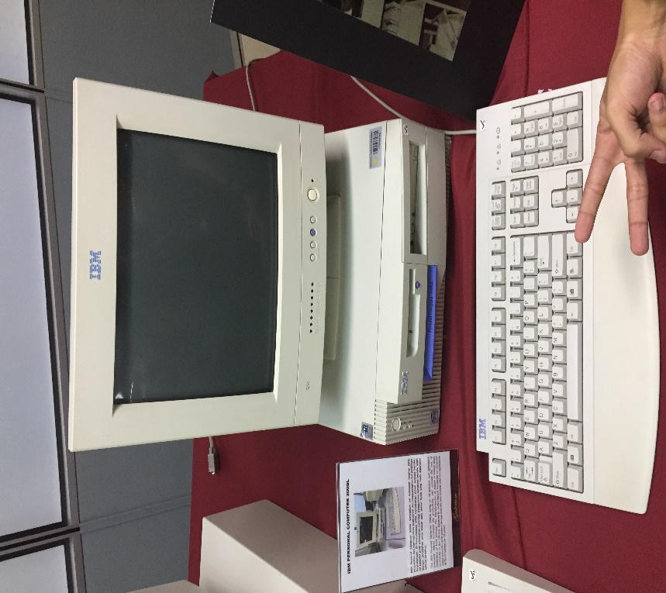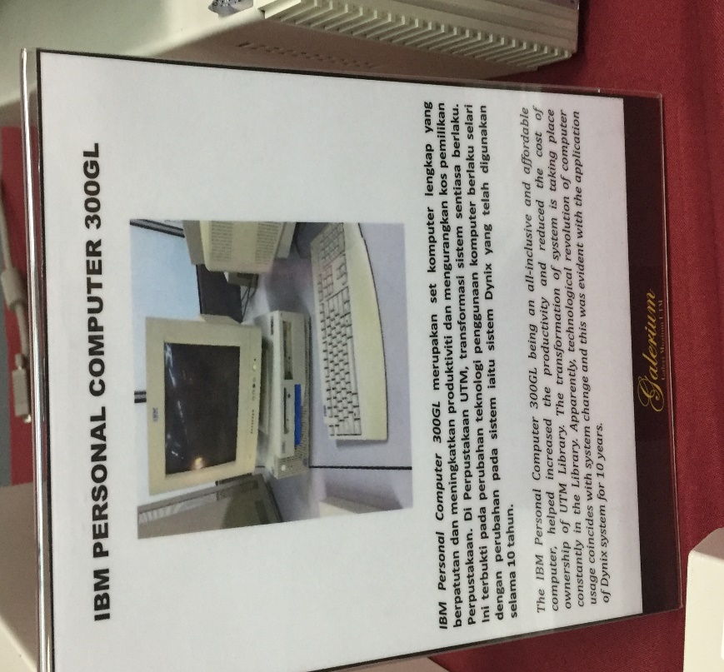
Then, the guide talked about the components of the current computer like the Random-Access Memory (RAM), Read-Only Memory (ROM), CPU Chips, Microprocessors, fans, hard disk, etc:
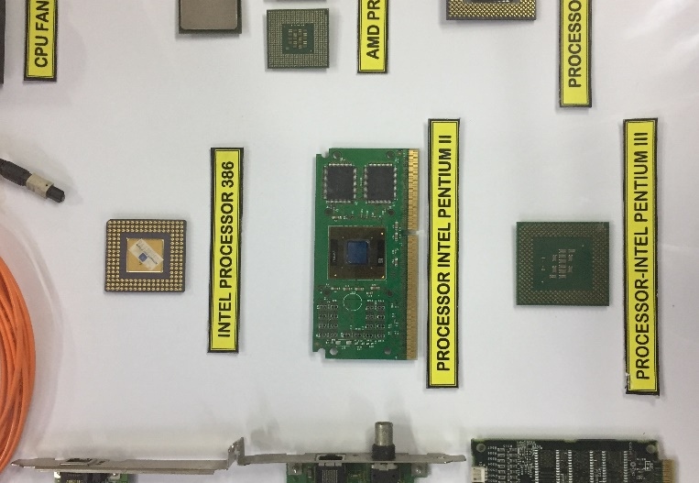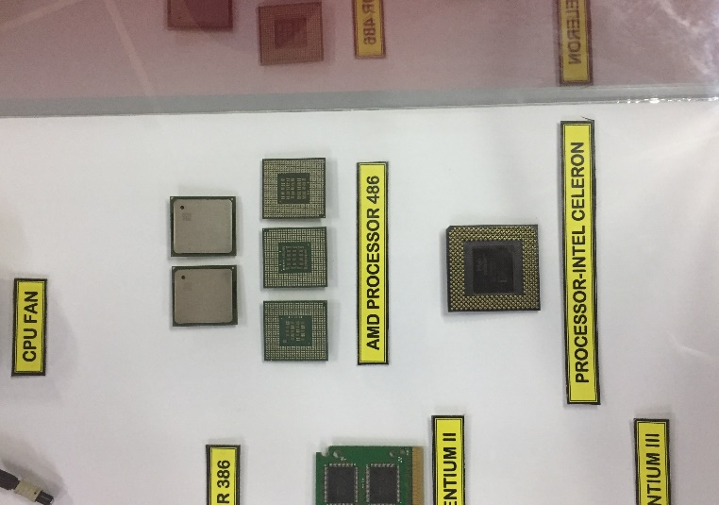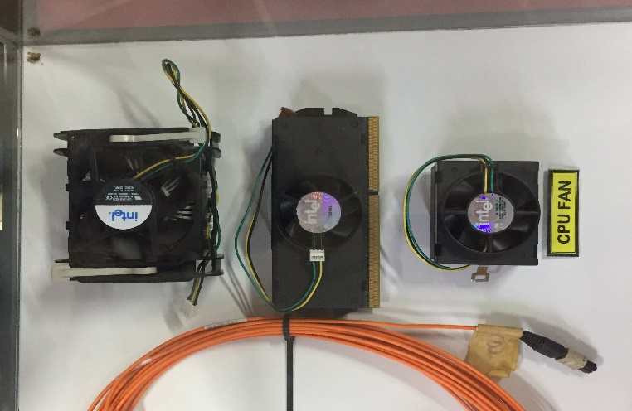

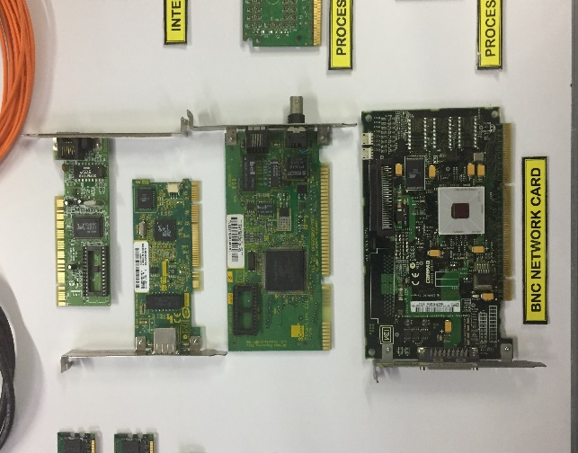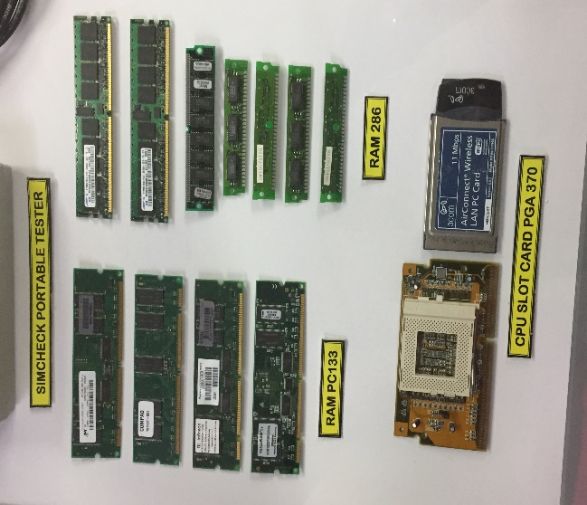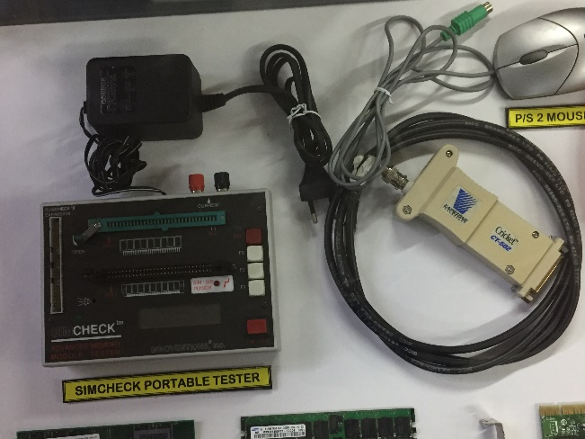

Lastly, the students were allowed to explore the galerium. During this session, our group asked the guide about the requirements and job specifications needed for a career in Information Technology. We were then told that the minimum qualification to start a career in Information Technology is a Diploma in Computer Science. Next, a person who is looking for a career in Information Technology should be a strong-willed person, passionate about solving problems and ready to undergo lifelong-learning because the field of computing is an ever-growing field. Then, we asked the guide about how a student should be able to recognize their potential for improvement. His answer was simple, he said that in order to recognize our potential for improvement, we must first identify the things that we do not understand well. Then we can easily think of ways to gain more knowledge and educate ourselves in order to improve our potential. We felt like this was a great answer to our question and thanked him before continuing to explore the place.

By the end of the visit, we have learned many things about the Centre of Information and Communication Technology (CICT). Some of the things we learned about it includes its organisation chart: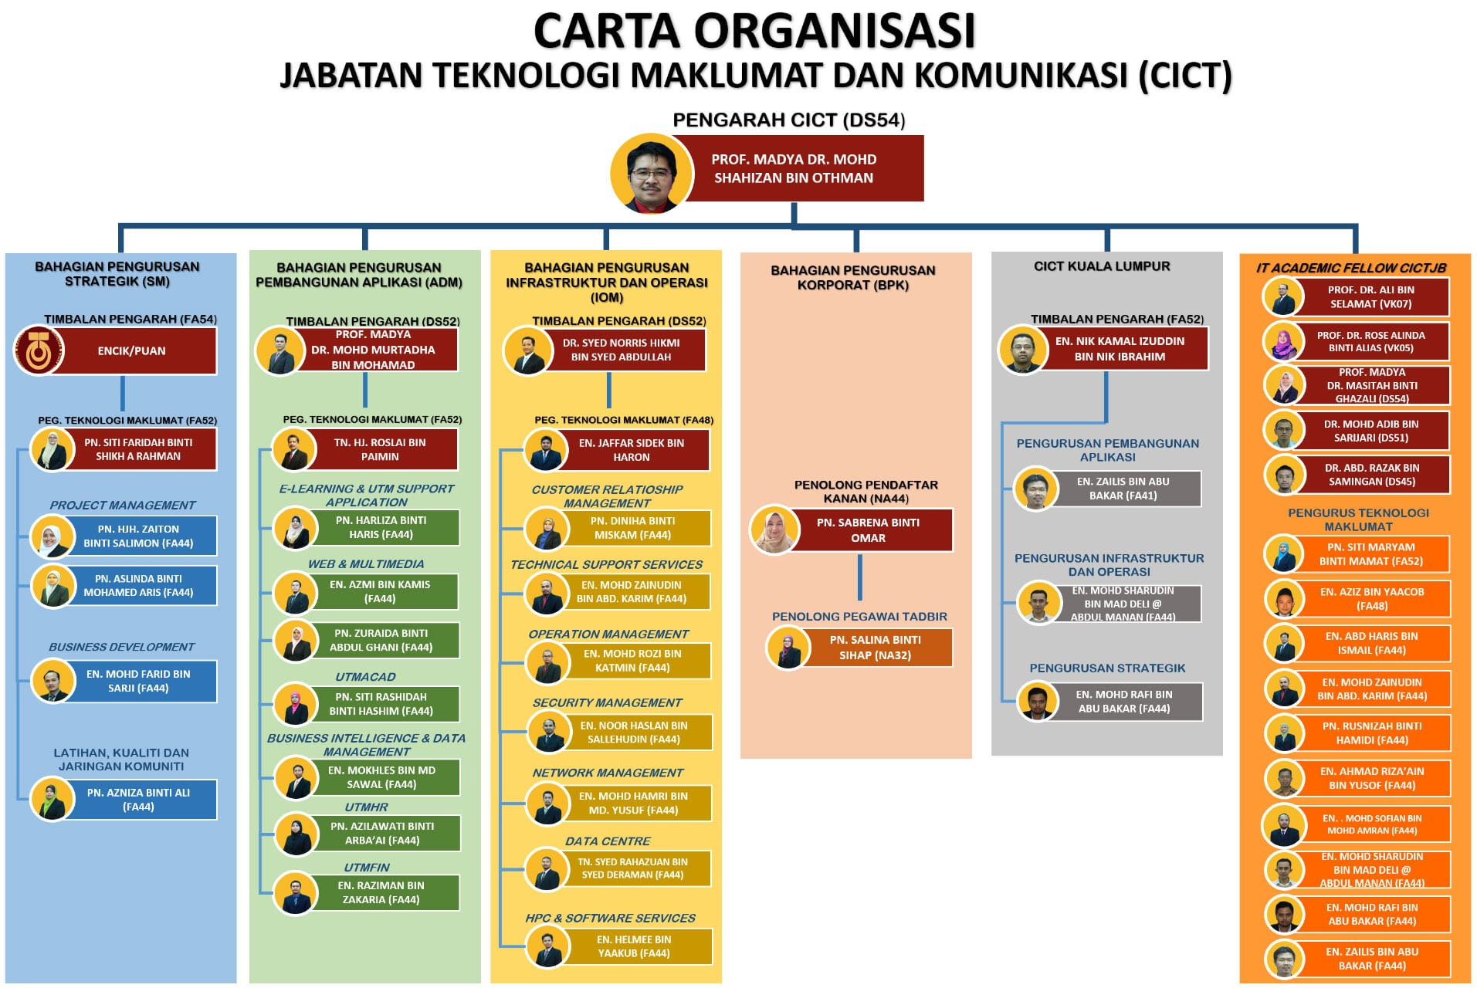
According to this chart, we can see that the director of CICT is Professor Madya Dr. Mohd Shahizan Bin Othman. Then, there are 6 departments that works under him which are the Strategic Management Department (SM); In-charged by Puan Siti Faridah Binti Shikh Abdul Rahman, The Application Development Management Department (ADM); in-charged by Professor Madya Dr. Murtadha Bin Mohamad, the Infrastructure and Operation Department (IOM); in-charged by Dr. Syed Norris Hikmi Bin Syed Abdullah, the Corporate Management Department (BPK); in-charged by Puan Sabrena Binti Omar, the CICT Kuala Lumpur Department; in-charged by Encik Nik Kamal Izuddin Bin Nik Ibrahim, and lastly the IT Academic Fellow CICT JB Department; in-charged by Professor Dr. Ali Bin Selamat, Professor Dr. Rose Alinda Binti Alias, Professor Madya Dr. Masitah Binti Ghazali, Dr Mohamad Adib Bin Sarijari, and also Dr. Abdul Razak Bin Samingan.
The services that are provided by CICT can be divided into four main sections, which are Infrastructure and Security, Application Development, Software, and Facilities. The services provided under the Infrastructure and Security branch includes UTM Hosting, UTM-Ads, ICT Security etc. Under the Application Development section there are system development, mobile apps, multimedia development etc. Under the software section there are antivirus, Wifi hotspot@utm extension, Software License etc. Lastly under the Facilities section there are CICT Galerium and also Training Labs. These are all the services that are provided by CICT.

The Centre of Information and Communication Technology (CICT) also has a few achievements under their belt. In 2017, CICT successfully prepared the best technical document that had carried UTM to receive the award for Standard Accounting System for Government Agencies, which was handed out by the Department of Accountants Malaysia on the 22nd of November 2017. Not just that, CICT was the most active organisation in the Premier Aerobics’ Series for the Arcturus Zone which is held on 7th of February 2017 at Stadium Azman Hashim UTM Johor Bahru. The attendance from the CICT organisation for this event was around 40.7% which was deemed to be one of the best attendances amongst the participants. Additionally, CICT also received a certificate of conformance design document in the 1st of December 2017. Lastly, CICT is also a leading provider of video streaming, conferencing, and also montaging.

STUDENT’S FEEDBACK

In general, all of us from our group have agreed that this industrial visit was very helpful to us in terms of greatly improving our knowledge on the history of computers and also the importance of CICT that we never knew about. The plant’s staff was very friendly and helpful to the students, he has patiently answered each and every question from the students and was of great help on that day. All in all, this visit has successfully peaked our interests in the field of computing and has motivated us to study harder and learn faster in order to get ourselves into this amazing field in the near future.

REFLECTIONS
- All of us in this group agrees that our main goal with our program of software engineering is to graduate and become successful software engineers in the future. On the other hand, our goal regarding this course (Technology and Information System) is learn the components of a computer thoroughly and to have a basic understanding of how computers function.
- This visit has taught us the history of computers and also motivated us to study harder to pursue our goal of becoming software engineers, which is a great help for us.
- In order to improve our potential in the industry, we plan to improve not only our knowledge in computers but also our skills as leaders and problem solvers so as to become better software engineers in the future.

TASKS
Group Members | Tasks
ALUGE OSEI-AMAKA ELINOR (A19EC4005) | Ask the guide some questions about the specifications needed for a career in the field and also about ways to improve students’ potential.
MUHAMMAD KHAIRUL AMIRIN BIN KHAIRIL (A19EC0100) | Explore the Galerium and take pictures to gather relevant information.
CHEONG CHIEN LI (A19EC0186) | Writing and completing the report for the visit using the information gathered by groupmates and making sure that the facts in the report are true.
SYAFA ILYAS AL MUZANI (A19EC0288) | Gather information either online or by asking the guide about the organisational structure, services, and achievements if CICT.

