

PROBABILITY AND STATISTIC DATA ANALYSIS (SECI 2143-02)

SEMESTER 2 2019/2020

TITLE: UTM Students’ Lifestyle

GROUP 4

|  |  |
| --- | --- |
| **NAME / MATRIC NO** | 1. FATIMA AZ DZIKRUN BINTI SAHROL NIZAM   (A19EC0046)   1. INTAN MARINA BINTI SULAIMAN   (A19EC0053)   1. NOR ARMIRANI BINTI MOHD MAZLAN   (A19EC0122)   1. SHAKIRAH BINTI MOHD SHUKUR   (A19EC0159) |
| **SECTION** | 02 |
| **SUBMISSION DATE** | 30 APRIL 2020 |
| **LECTURER'S NAME** | DR CHAN WENG HOWE |

# TABLE OF CONTENT

INTRODUCTION 1

CONTENT 2

Bar plot 2

Relative frequency 3

Boxplot 4

Pie chart 5

Stem and leaf 6

Histogram 7

Scatter plot 8

CONCLUSION 9

# INTRODUCTION

We carried out a survey about UTM Students’ Lifestyle. We created a google form which consists of 19 questions. We collect 40 responses for our questionnaire. We had shared the link into our WhatsApp group to allow respondents to answer our questionnaire.

We choose students’ lifestyles as our topic because we want to investigate the effect of students' lifestyle and involvement in extracurricular activities on their academic performance. Extracurricular activities are activities that we join which are not based on your studies requirement. Extracurricular activities are important things for a student's life. This is because the students can try something new and gain more knowledge that will benefit their career opportunities or they can just continue what they had been interested in. For example, you can have been in football and you may continue your sport in university or you never been active in volunteering and you give it a try.

There will be many benefits for students that join extracurricular activities. One of the benefits is it can help students to improve their academic performance. Participating in many activities will help you to be more passionate to increase our brain function which will help us to be more concentrated and able to manage our time more efficiently. Other than that, students can improve their self confidence. As they will meet new people, social opportunities will occur and this will help them to be braver to expose themselves. This will encourage the student to keep challenging in the group and be more competitive. They will be more open to take risks in all aspects. The most advantage that can be gained by the students are skills. Skills that will be developed were problem solving, teamwork, time management, leadership, public speaking and many more.

In conclusion, extracurricular activities are non-academic activities which allow students to perform better in external and internal skills. Each student should grab any opportunity to participate in at least one activity that suits their interest or personality. Unfortunately, if the student is too active and keeps involved in their extracurricular activities might affect their academic performance. Hence, students need to have a balance between their academic and extracurricular activities.

# CONTENT

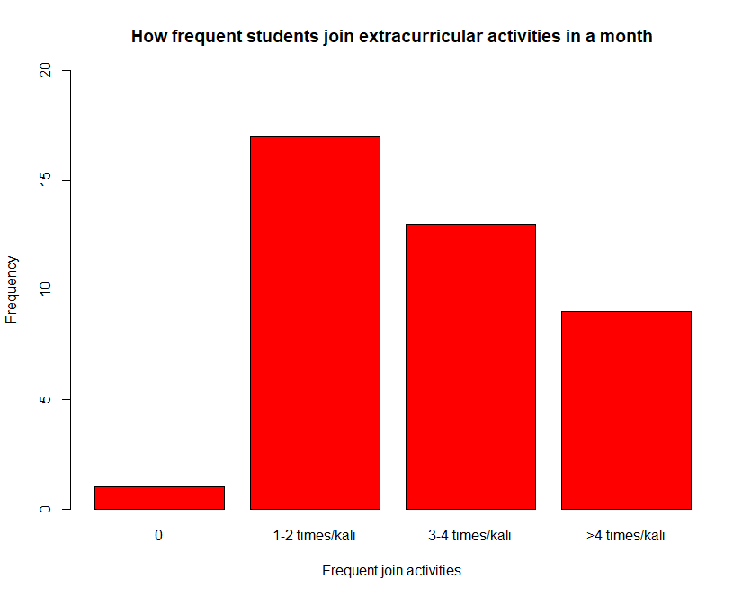

## Bar plot

The bar plot shows the frequency of students joining extracurricular activities in a month. From the bar, we can see that a few students did not join any extracurricular activities in a month which indicates that they are not active. Other than that, we can also see that most of the students join about 1 or 2 activities while some of them joined about 3 to 4 activities in a month. There are also some of them that joined more than 4 activities in a month and it shows that they are very active in it.

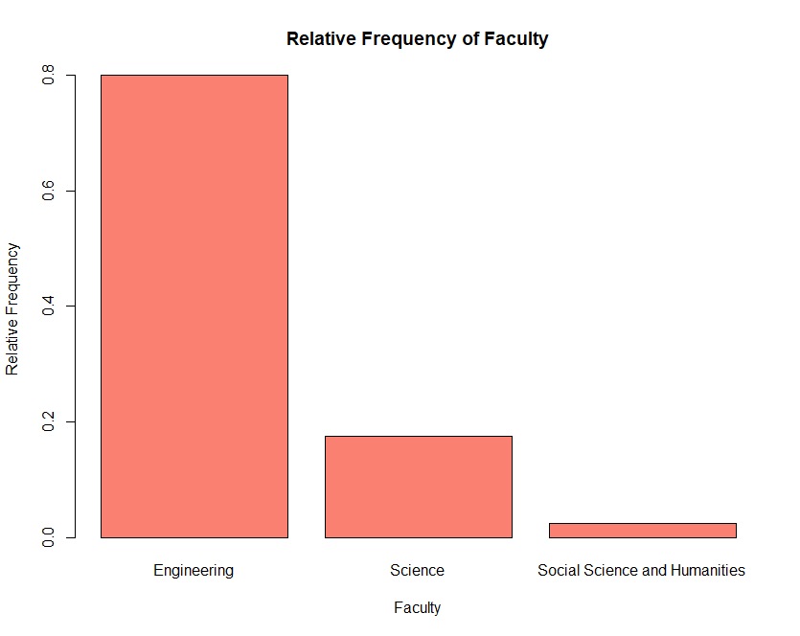

## Relative frequency

The graph shows the relative frequency of faculty of students that answered our survey questions. From here we can conclude most of our responses were from the faculty of engineering which its relative frequency was 0.8. Meanwhile the least was from faculty of social science and humanities which its relative frequency was less than 0.1. There are some students from the faculty of science also answering our questionnaire but it is approximately 0.2. Total of students that answered our survey was 40. Hence, 32 students from faculty of engineering, 7 students from faculty of science and 1 student from faculty of social science and humanities had our survey.

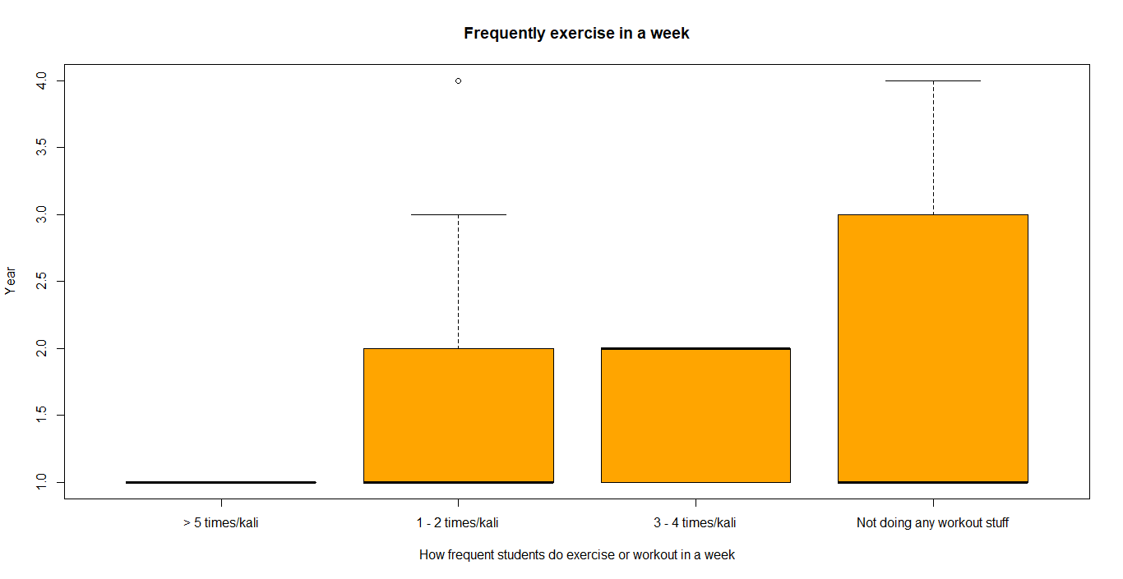

## Boxplot

The box plot show of how frequent the students exercise in a week based on their current year study. This graph tells us that only first year students exercise or workout more than 5 times in a week. We can conclude that the students are really healthy and very good at taking care of their health. Meanwhile, the majority of the students start from first year until fourth year students do not do any workout or exercise in a week and mostly are first year students. Probably they are busy with their studies or do not have friends to do the exercise together. But this is not good for their health. They should at least let their body sweat to stay healthy. There are a few fourth year students and mostly first year students exercise about once or twice a week. Second year students actively exercise 3 to 4 times a week. Overall, the students spent about 1 to 4 times in a week. This is a good range for the students to have a healthy lifestyle.

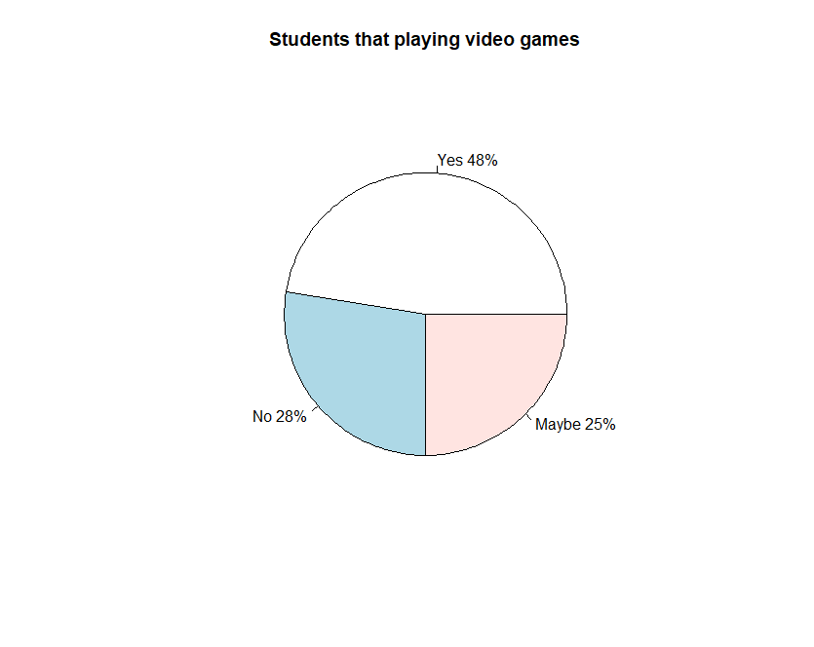

## Pie chart

Figure shows a pie chart that represents the number of students that are playing video games. We assume most of the students were playing video games and it is approximately 50% from the total respondent. They must have a good time when playing the games and a way for them to release their stress. About 25% were not sure whether they were playing video games or not as they answered ‘Maybe’ in the survey. Meanwhile there were around 25% students who said that they were not into playing video games, maybe they not really into gaming.

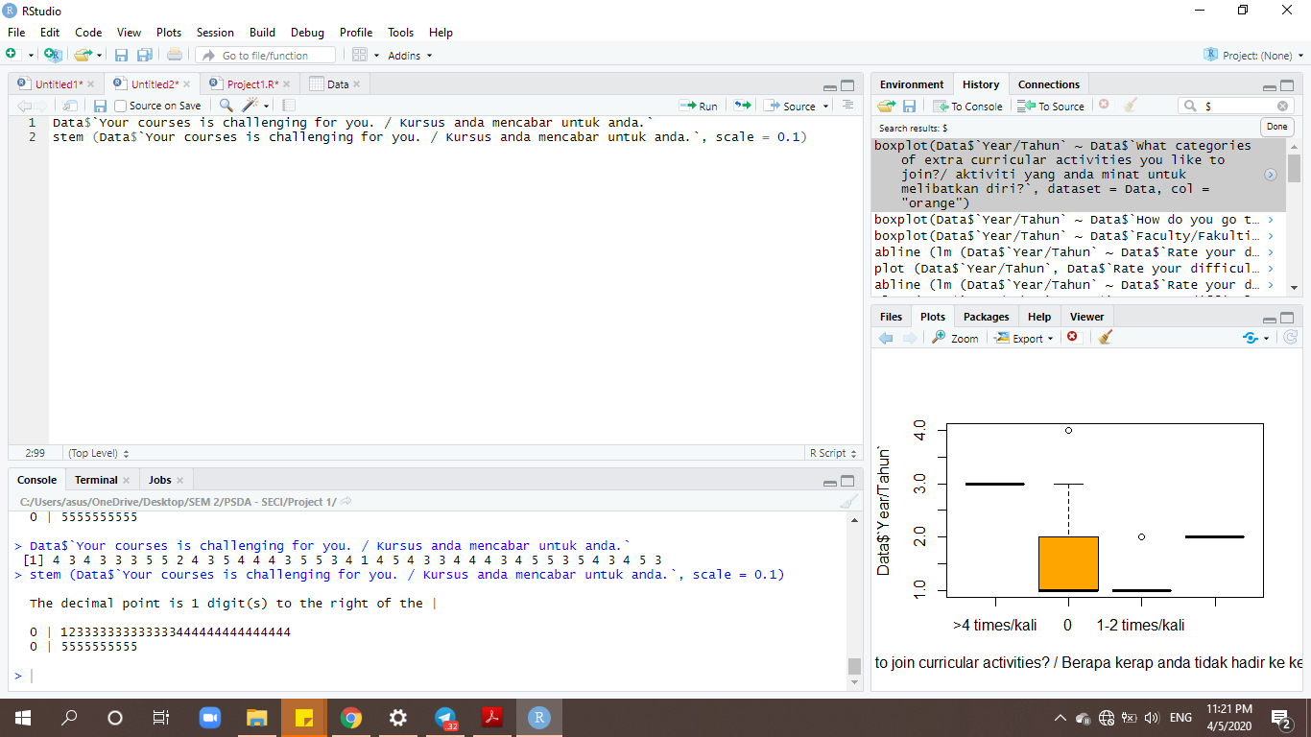

## Stem and leaf

Figure shows the stem and leaf plot. For this plot, we choose based on how respondents feel challenging their course. There were 5 options being provided that allow them to choose.

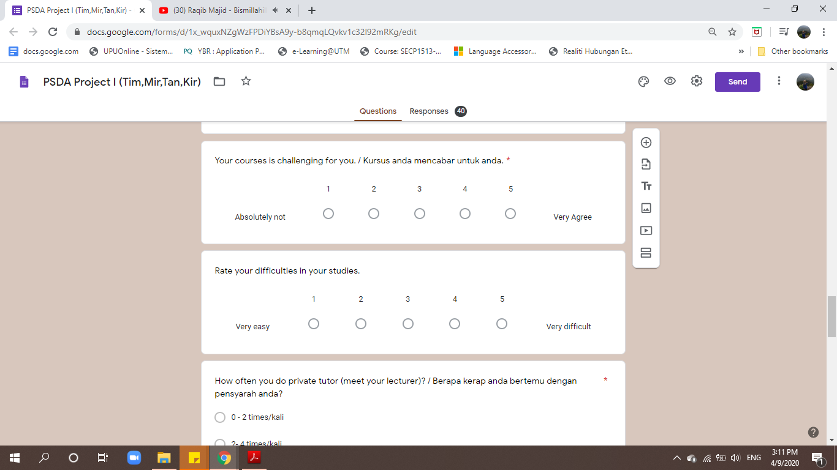

Most of the students vote for ‘4’ as they agree that their courses are challenging for them. But there is a student who voted for ‘1’ and ‘2’ respectively. They feel the course is absolutely not or not really challenging for him/her. Maybe the students picked the right course that was suitable for them and they probably had prepared a positive thought on focusing their studies. Meanwhile some feel it is hard as they had a new environment to be adapted or it is new things for them. It doesn't matter if it is challenging or not we as a student need to face it in a proper way.

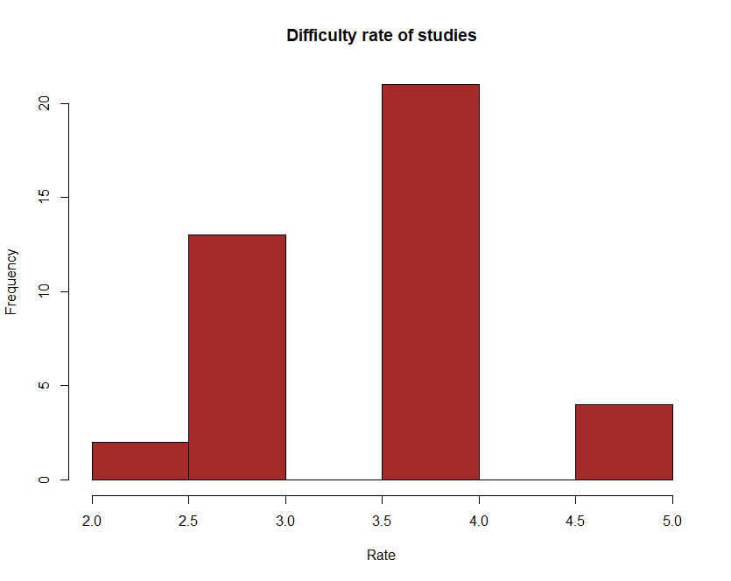

## Histogram

The graph above shows the frequency of students that rates the difficulty of their courses or studies. From the graph, we can see that only a few of them rate their courses’ difficulty as 2 out of 5 while some of them rate it as 3 out of 5. However, we can see that most of the respondents rate their courses’ difficulty as 4 out of 5 which shows that indeed most of them feel that their courses are hard to study. But there’s also a few of respondents who chose 5 out 5 to rate their courses’ difficulty in the questionnaire given.

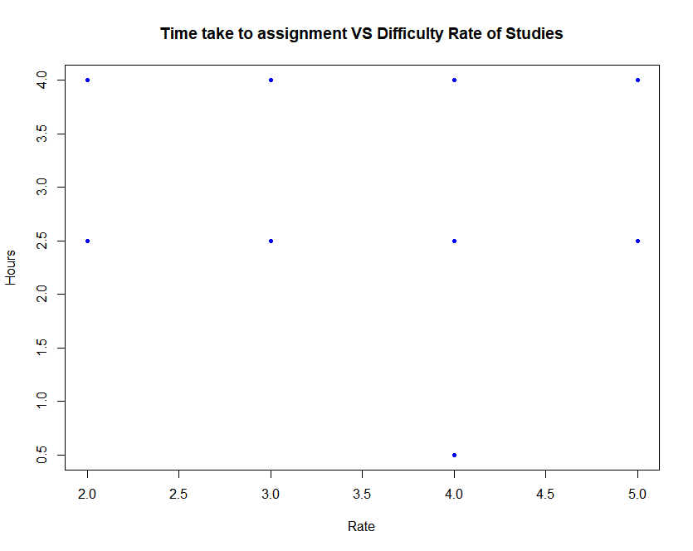

## Scatter plot

The above scatter plot shows about the difficulty of studies against time taken for the students to complete their assignments. From the figure, we can see that the respondents that rate their studies’ difficulty as 2 out of 5 are divided into 2 which some need around 2.5 hours and another need 4.0 hours in order to complete the given assignments. Other than that, the students that rate their courses’ difficulty as 3 out 5 take time around 2.5 hours and 4.0 hours also to complete their assignments. However, for the students that rate the difficulty as 4 out of 5, some of them say that the time taken in order for them to complete the assignments are around 0.5 hours, while some say around 2.5 hours and 4.0 hours. For the students that rate theirs as 5 out of 5, half of them say that they need around 2.5 hours and another half of them say that they need around 4.0 hours in order to complete the assignments given.

# CONCLUSION

The conclusion that we can get from this research is that the students of UTM have different lifestyle, some of them are active while some of them are not which is completely normal for all universities students. Other than that, from the responses that we obtained, it can be used for university in order to plan something. For example, by using the graph that shows the frequency of students that join extracurricular activities, it is easier for the club in UTM to plan their activity based on the graph so that they can expect approximately how many students will join their activities and the budget needed. In this way, it will not lead to waste of time or money if the responses from students are not that favorable. So, this kind of research is important so that we can know the students’ lifestyles in each university.