

# MALAYSIA STUDIES

# (UHMS 1022)

**TAJUK**

**WAU BULAN GUIDED REFLECTION**

**NAMES MATRIC CARD**

1. IQBAL MUZAKKI A19CS5049
2. MUHAMMAD RAFLY A19CS5073
3. SYAFA ILYAS AL MUZANI A19EC0288
4. MUHAMMAD IRFAN HILMI A19EC0263

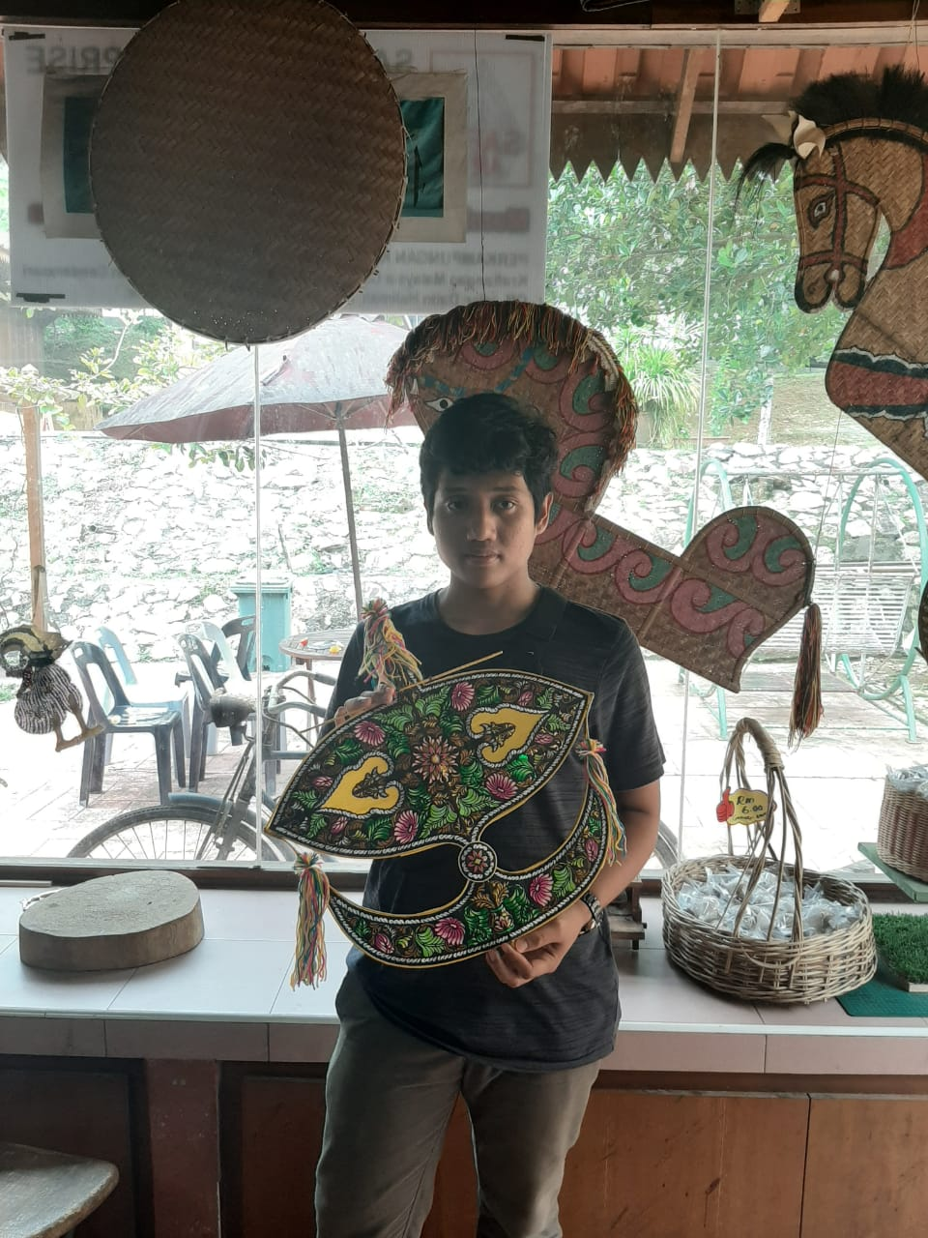

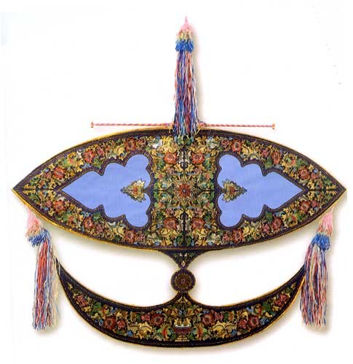

## WAU BULAN

Wau is the types of kite but it more big and with more unique motif. Wau is the games of the traditional games from Malaysia since hundreds of years ago. The game contains elements of authentic Malay culture. This can be seen in the form of patterns and designs available on the wau. The word wau is said to derive from the word Thailand as the state of Kelantan, Terengganu, Perlis and Kedah use the word. Word kite is used in many states in the West and South Coast of Peninsular Malaysia such as Kuala Lumpur, Malacca and Johor. In addition, the appearance of the name is also associated wau resulting sound of a tied bow wau. When raised into the air, the leaves ibus installed on the bow will produce a sound "wau", wau is the rhythmic. Before wau bulan is used as a tool for traditional games, wau bulan using it as flying scarecrows to frighten off birds in the field. There is many types of wau for example wau kucing, wau daun,wau seri negri,wau jalabudi, wau merak,wau puyuh,wau kapal,wau kapal,wau kebayak, wau dodo helang, wau helang,wau kikik, wau kangkan,wau seri bulan, and wau kenyalang. But wau bulan is the most famous among them all. Wau bulan is Malaysian traditional games that looks like a kite but it with more a variety of patterns and shapes that are not like ordinary kites. Wau bulan is so beutifull when you playing it, you can see it from down below. Wau bulan motif also has to wear bright colors so that it can emit a great kite. colours that clash or show strong contrast are frowned upon.complementing or harmonious colours reflect on the emotional state of the kite-maker. Soft colours such as shades of blues and purples indicate that the kite-maker has a serene nature. So choosing a colour of the kite is kind a big deal to reflecting yourself.

On the other hand wau bulan is so hard to find around johor, we have been search wau bulan for almost 4 days and I find nothing. I have also searching on the internet to find the store who sold the wau bulan but still I cannot find it. Finally I found one store that sold wau bulan but the store is kinda hard to find because the location on the map is not clear enough. So with our enthusiasm we visit the store. As we get there turns out the store is closed and I am so upset because we have been search it for 4 days and now the store is close. I almost desperate to find wau bulan. And then my friend suddenly find the wau bulan store, is far enough from UTM but I think is worth it. When my friend got there he found small wau bulan and it very expensive for the size of kite for me. Usually from my hometown kite cost 5rm to 10rm but here at Johor almost cost 300rm. The cost it so unbelievable. I have search on the online shop also to find the cost of the wau bulan is. And I found cost of wau bulan is 700rm and that’s the cheapest wau bulan I can find on the online shop. On the other hand I found also wau bulan that cost 1200 rm, 2000rm, and even have cost 3000rm. On my mind think what makes wau bulan is so expensive that can cost 3000rm. I can pay my kolej for 1 semester if I have that wau bulan and also it can feed me for two months straight. It so unbelievable wau bulan can cost that much. Maybe is the handmade or the material they use that can get that expensive but I will never buy such a thing that cost so expensive and yet its no useful for me.

However there is a festival wau that they show off every type of wau and from every area. It called international kite festival which is held every year. The reason why this festival is held is to introduce various types and variations of kites to the world. This festival is held by Majlis Perbandaran pasir Gudang, Johor. Every type of wau and kite is show in this festival start from the smallest into the biggest wau, and also many kin of wa is show in this festival likes wau bulan, wau kucing, wau daun,wau seri negri,wau jalabudi, wau merak,wau puyuh,wau kapal,wau kapal,wau kebayak, wau dodo helang, wau helang,wau kikik, wau kangkan,wau seri bulan, wau kenyalang, and many more in this festival. But the most famous among them all is wau bulan because of the beauty and elegance when flown in the air.

Usually in this festival they just did not show the kite or the wau but also they show you how to play it in the air. When all the type of wau is been deployed into the air you can see how magnificent and beutifull they are. There is also a contest for all the type of kite. The contest is to show who is the most beutifull kite and how elegance they are. And also you can see jumbo size kite at there with a magnificent pattern. In the other hand there is also a contest that shows who has the strongest kite. We just play it and fight with other kite until one of the kite string is break, then we got a winner. And you can tell how good your kite is one that rises quickly and remains flying, no matter what the wind conditions are. The sound it produces, how it looks the colours tell of the maker’s personality and mood while making the kite and how straight up it can fly are the other “wow” factors.

Characteristic

Wau bulan came with many size and pattern, some wau bulan came with cats pattern, batik patterns and many more. The size of wau bulan is bigger than any other Malaysian traditional kite. And also the size is very various. The typical size is 2.5 meters in width and 3.5 meters in length and the larger size can reach up to 5 to 7 meters. and usually the wau bulan is colored with a bright color, so can be seen from down below

However wau bulan is almost the same like any kite in Malaysia, The framework of wau bulan is made from bamboo stems which split into two thin strips. The type of bamboo that is recommend to made a wau bulan is the thorn bamboo. Because thorn bamboo is strong and flexible, so is highly recommend to use thorn bamboo. Each frame of kite there must have a head, tail, spine, waist and a wing. So at least it need 7 splits bamboo. When the frame is done been constructed For the pattern usually they use Floral motifs and destitute clouds that are torn. To design a wau bulan, wau bulan is cover with glossy colored and glossy paper and then carefully cut and paste it on the paper glued to the bamboo frame. The humming bow is attached to the head of the kite, which is finally decorated with tassels at the tail to produce the 'song' of the kite.

## How to play

Wau bulan is so fun Playing wau bulan is almost the same like any kite else. First we need a long string, this string must be long, flexible, and the important it must be strong. The string must be tied up into the wau bulan especially at the head, spine, and the tail. And all of the string must be tie together to form a single string. Second we need some handle to tied the string so is easy for us to controlled the wau bulan. After you have done that, then flying the wau bulan is usually take two person to make it fly. One is to hold the wau bulan and the other is hold the string. And then the one who hold the wau bulan start to run a little bit until the person who hold the string can pull the wau bulan and make the wau bulan flying. When the wau bulan is cannot reach a standard high or is not high enough, the holder must pull and release the string until it gets high enough to fly independently. When wau bulan reach a specific high you don’t need to hold the string anymore, you can just tie the string to a thing that something sturdy and then you can enjoy the magnificent of the wau bulan is without worry it about to fall down. Because the good quality of wau bulan it takes time to wait for it to fall down. But there is a method if you want to take the wau bulan if the wau bulan is already flying high enough. I have heard that you must prepare a coconut, that coconut you cut it into half. And then you pull the string as hard as you can until the wau bulan reach the ground. So someone said the function of the coconut is to reduce the damage of the wau bulan if the wau bulan is fall down hard, so it won’t be broken if it falling hard.