

**Semester 1 2020/2021**

Subject : Technology and Information

Systems (SECP 1513)

Section : 08

Assignment : Step by step AC Assembly

Group number : 06

|  |  |  |
| --- | --- | --- |
| 1 |  | **Name:** Lai Kin Yong  **Matric Number:** A20EC0059 |
| 2 |  | **Name:** Aiman Na'im Bin Ariffin  **Matric Number:** A20EC0008 |
| 3 |  | **Name:** Ieskandar Zulqarnain Bin Ghazali  **Matric Number:** A20E0046 |
| 4 |  | **Name:** Hibban Kamil Hizbuttahrir  **Matric Number:** A20EC5022 |
| 5 |  | **Name:** Syaza Syaurah Binti Mohd Yusran  **Matric Number:** A20EC0227 |

PART A

**1.0 Number-2 Phillips-Head Screwdrivers**

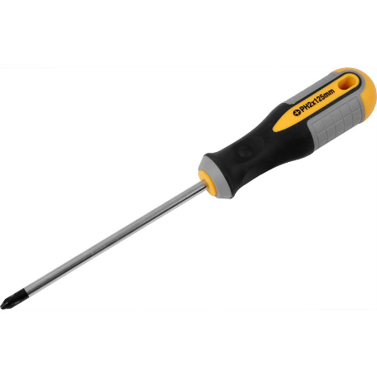

|  |  |
| --- | --- |
| Function | Importance |
| To tighten and loosen the screws on the computer’s parts. A Numebr-2 Phillips-head screwdriver is typically the best size to use for a modern PC design. | The modules can be quickly assembled and removed. A long shaft screwdriver is also necessary for holding the handle out of place. |

**2.0 Anti-Static Equipment**

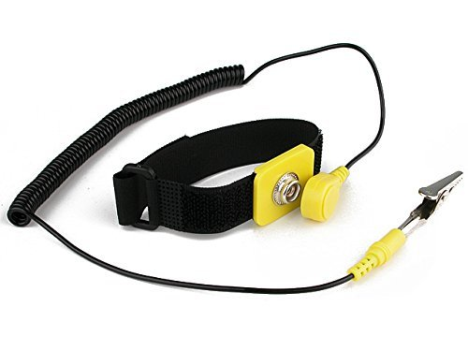

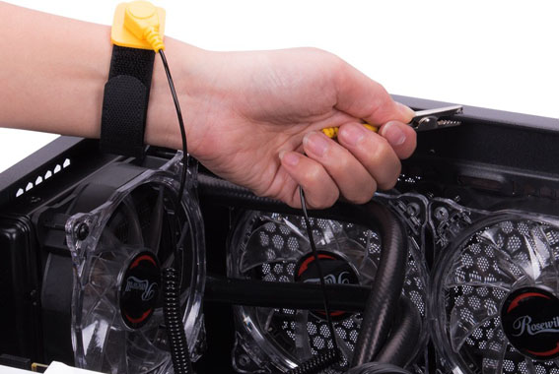

|  |  |
| --- | --- |
| Function | Importance |
| Device that eliminates or reduces the discharge of static electricity. In other words, it helps in stopping the static sparks on your body as you create your PC. | Prevent damage and harm to sensitive electronic devices such as computer hard drives. |

**3.0 Light Soure**

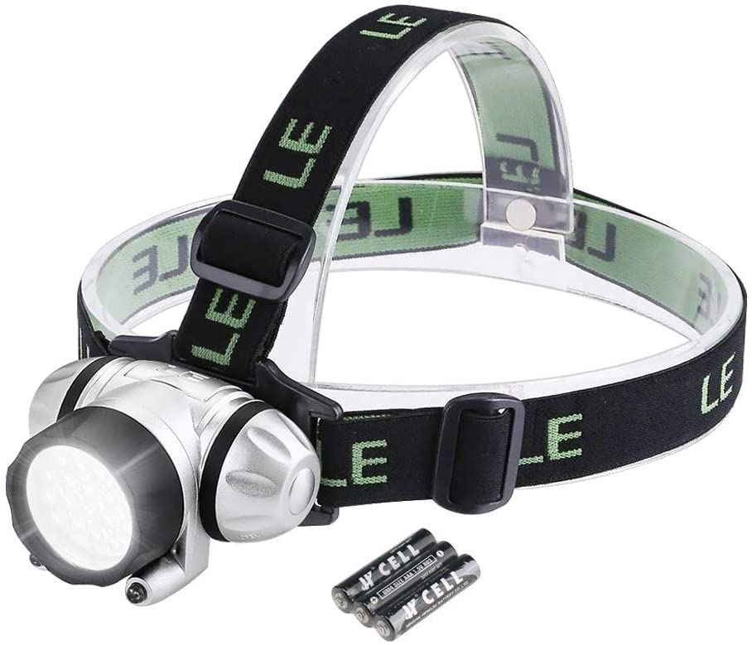

|  |  |
| --- | --- |
| Function | Importance |
| Provide light when working with the dark corners or position in the computer case. | Making the screwing process more efficiently and faster because it help to see the screw holes at darkest corner or place. |

**4.0 Cable and zip ties**

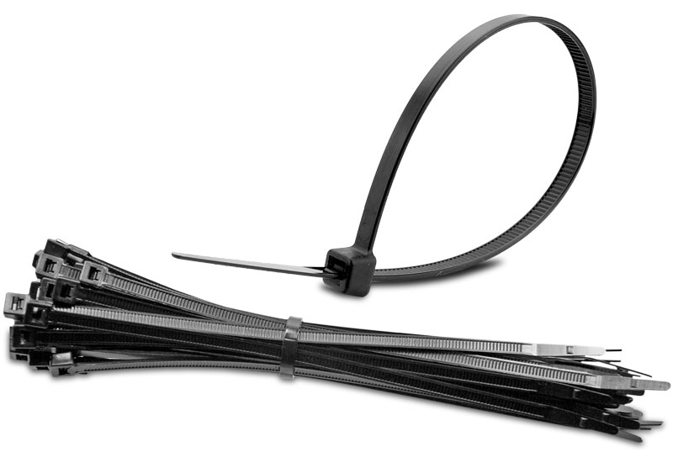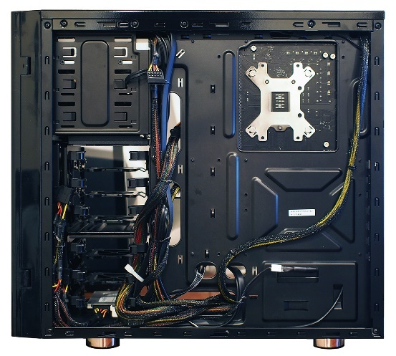

|  |  |
| --- | --- |
| Function | Importance |
| To tie the loose wires and categorise them to keep them clean and tidy. | Make the completed Desktop build look cleaner, cooler, improved cable management, and encourages proper airflow in the PC case. |

**5.0 Pliers**

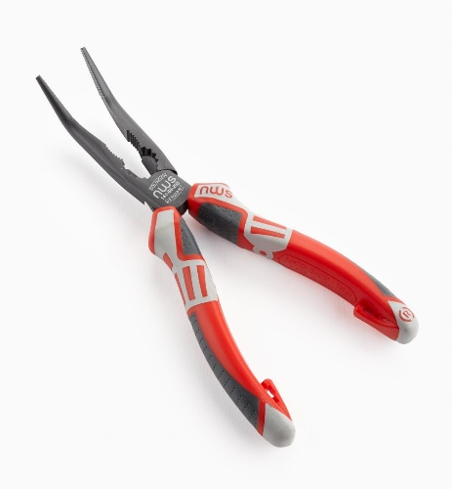

|  |  |
| --- | --- |
| Function | Importance |
| Usually used as a wire cutter that could be used to snip the excess part off the cable or zip ties. It also helps to pick the screw if the screws fall down at certain corners. | Make the cable management more easily and nice, because did not have a excess cable ties. |

**6.0 Magnetic Screw Tray or Bin**

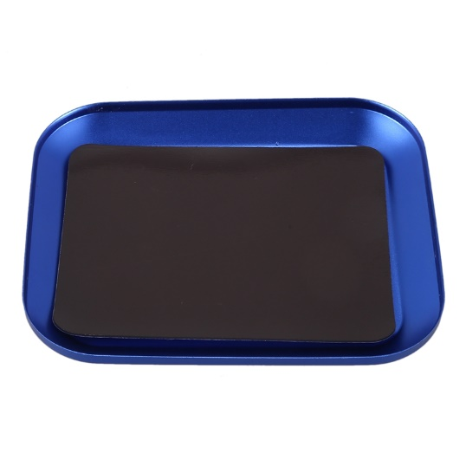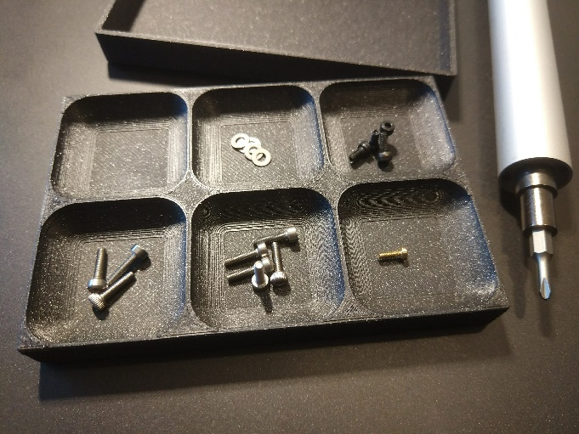

|  |  |
| --- | --- |
| Function | Importance |
| To put the screw that want to be used in PC assembly and help us to label the types of the screws. | So that screw did not fall down if we hit the tray and making the work more easily because we can pick up the screw that we want. |

PART B

|  |  |
| --- | --- |
|  |  |
| **Figure 1**  **Type of motherboard:** ATX  **Size:** 12x13 inches | **Figure 2**  **Type of motherboard:** Micro-ATX  **Size:** 9.6x9.6 inches |

**Keywords:**

1. **Graphic Card –** Allow the computer to display or produce graphics or images more quickly. It is connected to the connector like AGP and PCI-E on the motherboard to the computer, which will help it accept information from CPU and send it to monitor to display. The models of the graphic cards are Integrated Graphic Card, PCI, PCI-Express and AGP.
2. **USB Cable –** Used to connectcomputers to peripheral devices. The examples of USB models are USB type-C and USB type-B Micro.
3. **IDE Cable –** Used to connect hard drives andoptical drives to each other and to the motherboard. The models are ATA-standard, ATA-2, ATA-3, ATA / A TAPI-4, AT/ ATAPI-5 and ATA / ATAPI-6.
4. **CPU / Processor –** Perform basic arithmetical, logical operations and input/output in a computer system. The models are Intel Core i5 / i7 H Series, AMD Ryzen Mobile 5, Intel Atom Series and so on.
5. **Slots (IDE / PC) –** Provides an installation point for a hardware expansion card to be connected. There are mini PCI, or PCI-X, Parallel PCI and so on.
6. **Power Supply –** Supply the electric current to give power to the computer. The models are Switched Mode Power Supply (SMPS) and Uninterruptible Power Supply (UPS).
7. **Heat Sink –** Used to cool the CPU and transfer heat from the CPU into another medium such as air. There are 6 models which are CNC Machines, Stamped, Forged, Skived, Bonded and Extruded.
8. **RAM** – Provide fast temporary storage for the system, will memorize the data even if the computer is off**.** RAMs have two types which are static and dynamic RAM – (SRAM , DRAM, etc.)

PART C

*\* Precaution throughout the whole installation:*

When holding the motherboard, always grab it from its edges/plastic components/cooler backplate to prevent any direct contact between hands with the PCB as the greasy fingerprint could affect the operation of the motherboard.

**Step 1: Install the CPU on the motherboard.**

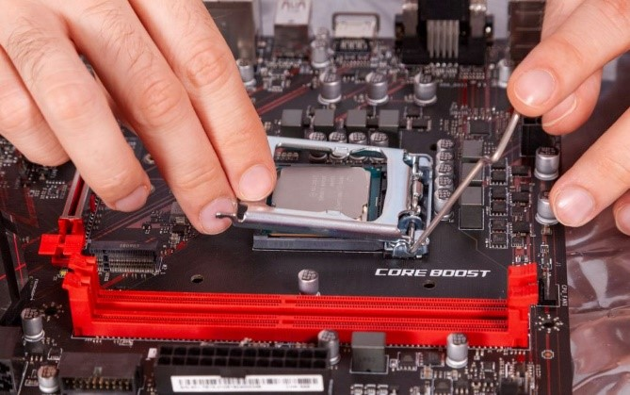

1. Make sure the CPU socket model whether is compatible with the CPU that we want to install.
2. Lift up the retention arm besides the CPU socket and the socket cover but do not remove the socket cover.

*\* Precaution:*

When holding the CPU, always grab it by its edges and do not leave any fingerprint on the CPU especially on its top (heat spreader) and bottom (golden pins) as it may affect the performance of CPU.

1. When mounting the CPU, identify the indentations (small golden triangle) on the CPU and align them with other indentations (small triangle) which locates on the CPU socket for correct orientation.
2. Lift down the socket cover and push down the retention arm to firmly secure the CPU in the socket.
3. The socket cover would pop out by itself, remove it and store it for warranty purposes.

**Step 2: Install the memory (RAM).**

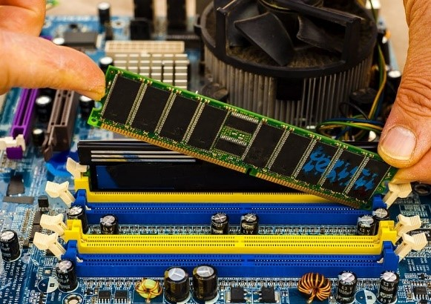

1. Identify the DIMM slots and opens the latched on both sides of the slots.
2. Check the position of the notch on the memory and make sure it is lined up with the slot for the correct orientation.
3. Place the memory into the slot and push it down firmly from both sides until a “click” sound is heard.

**Step 3: Install the M.2 SSD.**

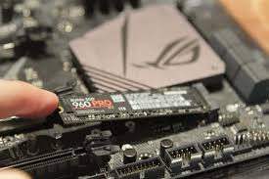

1. Identify the M.2 slots for M.2 SSD to be installed on the motherboard.
2. Install the mounting posts on the M.2 slot by hand-screwing it.
3. Install the M.2 SSD by sliding it into the slot at a small angle above the motherboard.
4. Hold down the other end of M.2 SSD and line it up with the mounting post.
5. Using a screwdriver, screw down the M.2 SSD at the mounting post.

**Step 4: Install the CPU cooler.**

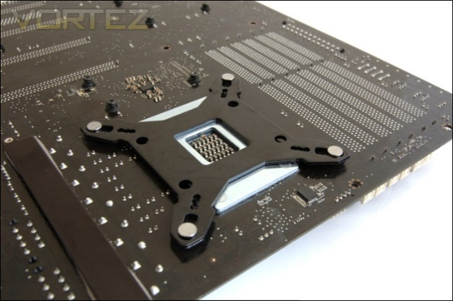

1. Insert the cooler backplate into the motherboard from its back at the correct orientation.
2. Turn to the front side and place the spacers onto each of the protruding ends of backplate. The spacer could provide the optimum mounting pressure by the cooler onto the CPU.
3. Depending on the type of cooler and CPU case, the cooler could be installed at different orientations that determine which direction the cooler would face to:
4. Front-to-back orientation: cooler fan blows toward the top of the CPU case
5. Down-to-up orientation: cooler fan blows toward the rear of the CPU case
6. Horizontal orientation: cooler fan blow toward the side panel of the CPU case
7. Place both of the mounting bars on the spacers.
8. Tighten the mounting bars by hand-screwing down the thumb nuts onto the mounting bars.

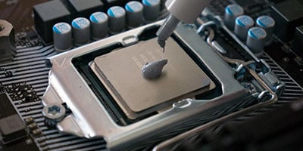

1. Apply the suitable amount of thermal compound on the CPU (green-pea method).

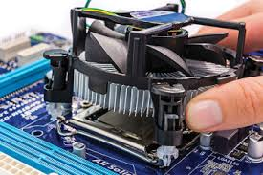

1. Place the heat sink onto the CPU and press it down with a little pressure to let the thermal compound spread out evenly on the CPU’s surface and have a good contact surface area with the heat sink.
2. After lining up the heat sink at both mounting posts besides it, tighten up the screws at both sides.

*\*Precaution:*

Tighten the screws with minimum difference in mounting pressure at both sides to prevent any motherboard deformation that damages the motherboard itself.

1. Locate the CPU cooler fan slot first, then install the CPU cooler fan by connecting its cable to the slot.

*\* Tip:*

Install as many components as possible onto the motherboard before installing the motherboard into the case.

**Step 5: Install the motherboard into the case.**

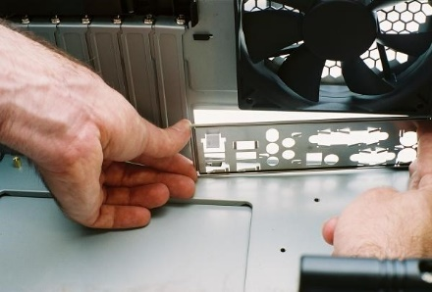

1. Lay down the case horizontally on a flat surface.
2. Mount the I/O shield at the rear of the case from its inside.
3. Apply a small amount of strength while installing the I/O shield to make sure it is firmly fit into the case.
4. A “click” sound would signify that the I/O shield is firmly installed.

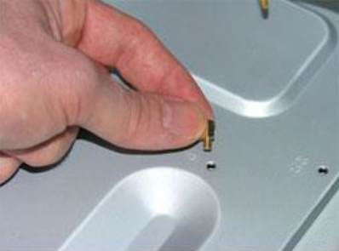

1. Check the case where it has standoffs installed on it, as some of the cases come with pre-installed standoffs. If not, install the standoffs manually.
2. Standoffs prevent the physical contact between the motherboard with the surface of the case because it may scratch the motherboard and causes damage.
3. Identify the type of motherboard and configuration of standoffs in the case. For example, the common type is ATX, so many cases naturally come with standoffs pre-installed in ATX-configuration.
4. However, if the type of motherboard does not match the standoff configuration on the case, standoff rearrangement has to be done manually. Otherwise, the presence of extra standoff may scratch the motherboard and cause damage. In contrast, absence of essential standoff may cause failure in installing the motherboard onto the case.

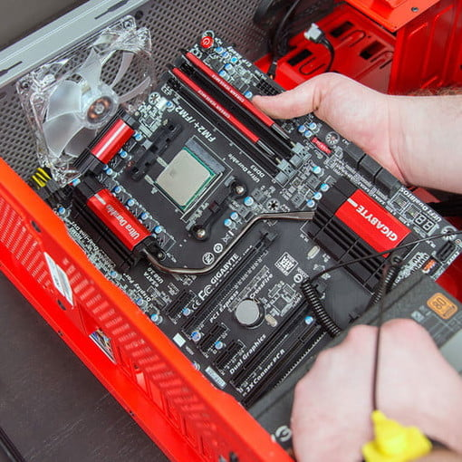

1. Place the motherboard into the case and make sure the I/O ports of the motherboard are aligned with the I/O plate.
2. Tighten the screw at every standoff which is visible from the front of the motherboard.

*\* Precaution:*

Do not over tighten the screws at the standoffs.

1. Connect the cable of case fans to the motherboard.

**Step 6: Install the power supply unit (PSU).**

1. Identify the types of PSU:
   1. Modular: No cables come in permanently attached to the PSU
   2. Semi-modular: Some of the cables come in permanently attached to the PSU
   3. Non-modular: All of the cables come in permanently attached to the PSU

*\* Tip:*

It is recommended and easier to plug the cables into PSU before placing the PSU in the case.

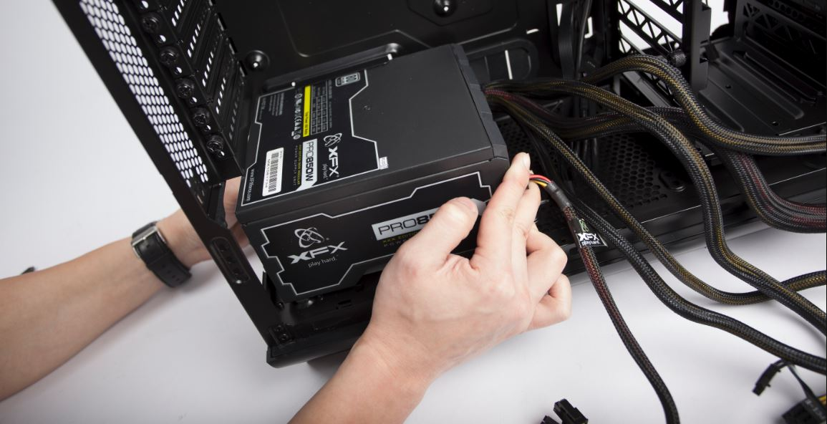

1. Slide the PSU into the bottom of the case and always make sure the fan on PSU is facing towards a ventilation outlet which allows the PSU fan to draw air in for cooling.

*\* Tip:*

Installation of PSU will locate at the top of the case if an old computer case is used.

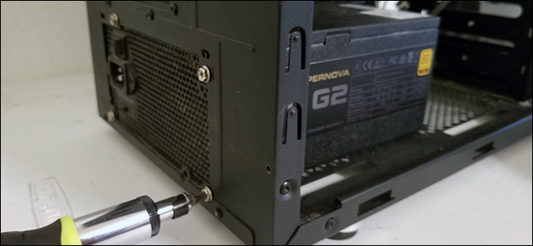

1. Tighten the screws at the back of the case which holds the PSU in place.
2. Identify the 24-pin power cable. Then, identify the 8-pin EPS cable based on its label or one of its ends that could split into 4+4 connectors. The PCI-E cable also has 8-pin but one of its ends could be split into 6+2 connectors. All of these cables would have a clip on one side of their ends, and those ends would be plugged into the motherboard. Therefore, the modular PSU would always have the cables plugged in from the ends without the clip.
3. Plug the 24-pin power cable to the port with the corresponding pin number on the motherboard.
4. Plug the EPS cable into the motherboard which supplies power sorely to the CPU socket.

*\* Precaution:*

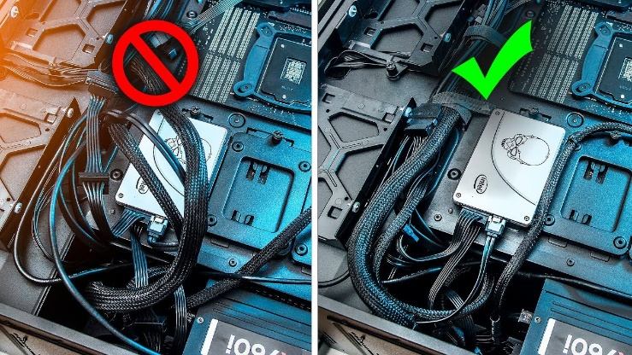

While plugging in the cables, always have proper cable management to ensure the cables won’t inhibit the airflow in the case or have any physical contact with heat-generating components in the case.

**Step 7: Connect the front I/O panel cables to the motherboard.**

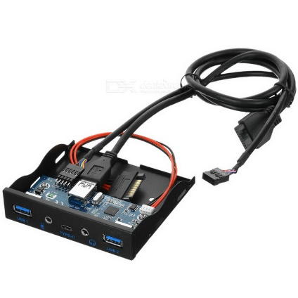

1. Front I/O panel cables which included cables of the power button, reset button, power and hard drive LEDs, USB 3.0 and 2.0 ports, earphone jack and microphone jack.
2. By referring to the motherboard manual or the labels on motherboard, identify the slot for every front I/O panel cables and gently plug the cables into the slots to avoid damage on cables’pins.

**Step 8: Install the hard disk drive (HDD)/ solid-state drive (SSD).**

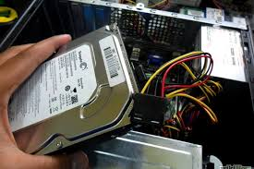

1. Modern-day hard disk drives commonly use Serial Advanced Technology Attachment (SATA) instead of Parallel Advanced Technology Attachment (PATA) as its interface.
2. Hard disk drives that use PATA are also known as IDE hard drives.

*\* Precaution:*

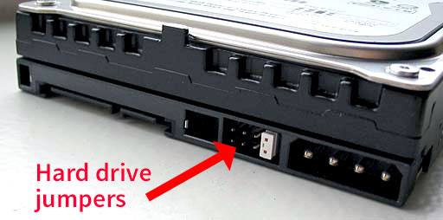

To connect 2 IDE hard disks to the motherboard, each of the hard disks must be configured to “master” or “slave” settings by using the jumper. The “master” hard disk would be recognised as primary storage to always be booted at first. Meanwhile, the “slave” hard disk would become secondary storage which acts as an extra storage device. If the jumper configuration is not implemented, the computer will not function with 2 IDE hard disks installed at the same time.

1. Slide the hard disk into the case with correct orientation and make sure a “click” sound is heard. Some of the hard disk installations may involve screwing.
2. Plug the power cable and the data cable into the hard drive. SATA cables would be used for SATA hard drives, while IDE cables would be used for IDE hard drives.
3. Types of SATA and IDE cables could be identified based on the pin number:
4. SATA power cable (15-pin)
5. SATA data cable (L-shaped, 7-pin)
6. IDE power cable (4 pins)
7. IDE data cable (40 pins)

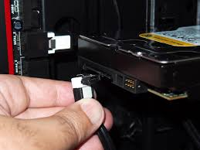

1. Identify the compatible sockets for SATA and IDE cables: SATA cables would be connected to SATA sockets while IDE cables would be connected to IDE sockets.
2. Connect the hard drive power cable to the PSU.

**Step 9: Install the CD-ROM drive.**

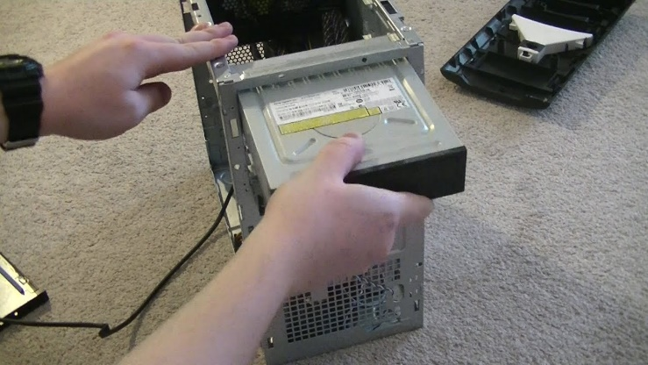

1. Remove the drive bay cover.
2. Slide the CD-ROM drive smoothly and gently into the drive bay
3. Fasten the CD-ROM Drive with its locking mechanism to hold the drive in place.
4. Plug the SATA/IDE power cable and the data cable into the CD-ROM Drive
5. Connect the other end of the power cable to the power supply.
6. Connect the other end of the data cable to the motherboard.

**Step 10: Install the graphic card.**

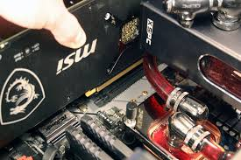

1. By referring to the manual, identify the PCI-E slot with 16-pin on the motherboard and lower the latch on that slot.
2. Identify the expansion slots at the back of the case that has to be removed to allocate free space for the graphic card. Generally, a common graphic card would occupy the space of 2 expansion slots.
3. Remove the screws which hold the expansion slots.
4. Identify the position of the notch on the graphic card and align it with the PCI-E slot. Then, plug in the graphic card and make sure the “click” sound is heard.
5. Tighten back the screws that are removed just now.
6. Plug the PCI-E cable into the graphic card.
7. Plug the HDMI/VGA/DVI cable from the monitor into the graphic card’s corresponding port.

*\* Tip:*

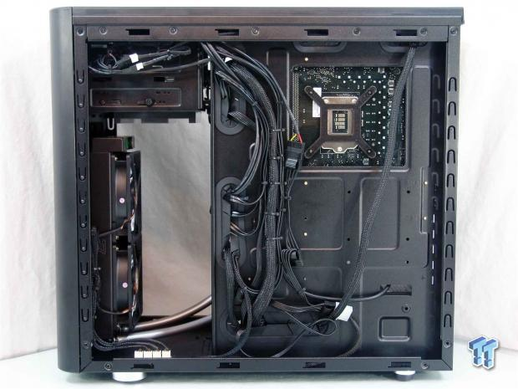

By using zip ties, orgranise all the wires and cables properly. This could favour any maintenance or replacement of the components installed on the motherboard as it is easier to trace the connection of certain cables.

1. Close the CPU case with its filters and panels.
2. Connect the cables of the mouse, keyboard, speakers and DSL cable to the back of the CPU case.

**Step 11: Switch on the computer.**

1. Connect the power cord to the PSU
2. Switch on the I/O button at the back of the PSU
3. Switch on the power button at the front panel
4. Enjoy your new computer!