

Technology and Information Systems (SCSP1513)

SEMESTER1 (2018/2019)

|  |  |
| --- | --- |
| Group | 13 |
| Name | RISSHE A/L PETER  FATHI MOAHMED FATHI REZQ BEKHIT  HABIB HADMY ZULKAFFLI  HARIES HASHEMEEN ALIAS |
| MATRIC NO | A18CS0241  A18CS0301  A18CS0067  A18CS0070 |
| LECTURER | DR. ARYATI BINTI BAKRI |
| SECTION | Section 9 |

**Table of Contents**

1 INTRODUCTION 3

2 COOL CODE 4

3 SERVICES 5

4 Products and Achievements 6

5 Reflection 7

6 BIBLIOGRAPHY 7

**Table of Figure**

Figure 1 : Boys Group 3

Figure 2 Cool Code CEO 4

Figure 3 Cool Code Academy 5

Figure 4 Didi & Friends Application 6

# INTRODUCTION

On Thursday, 15th November 2018 all SCSV students that takes Technology and Information Systems (SCSP1513) had to visit a popular company named Cool Code Sdn Bhd that placed at Skudai, Johor Bahru, Johor. We had to make a report on this visit in a group that had been divided by the lecturer.

All students gathered at Resak parking space at 2 p.m. and depart at 2.30 p.m. but there are 4 female student went with Dr. Aryati and others went with a bus. We arrived there at 3.00 p.m. and had been divided into two group where each group went into the building for 1 hour while the other group stayed in the bus waiting for the others to finished and be ready to depart back to UTM. We all finished the visit at 5.45 p.m. and straight went home.

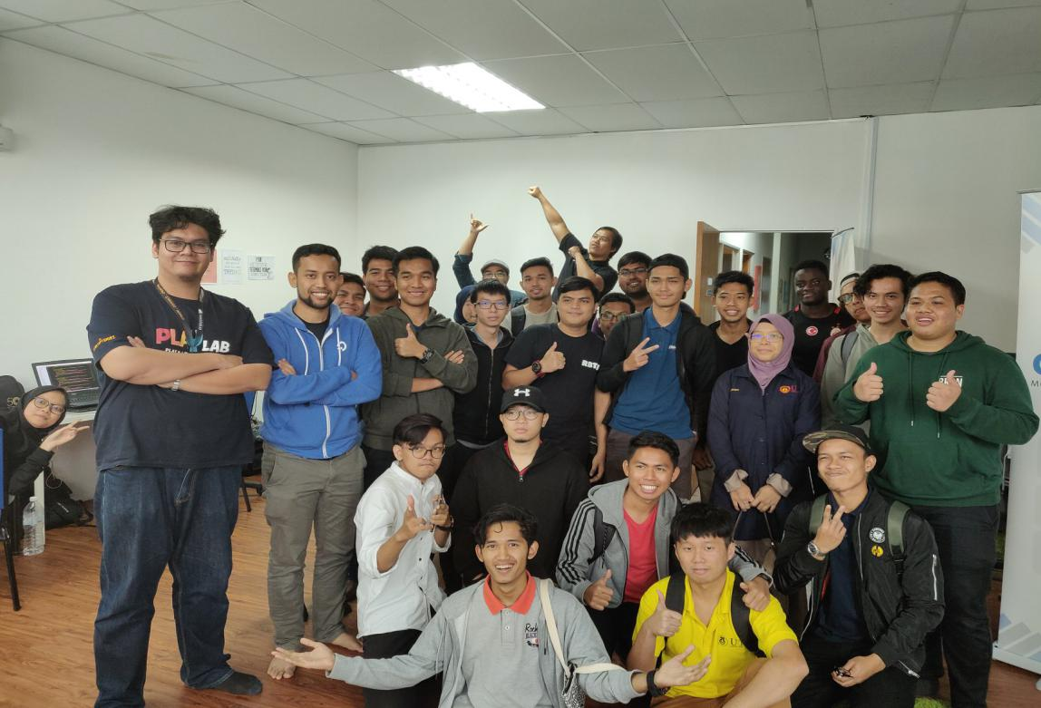

Figure 1 : Boys Group

# COOL CODE

Cool code is a local well known company that created by UTM alumni, Arif Tukiman a SCSV student. Cool code mainly focuses on Programming Program which involve computing engineering aspects. This company expert in Mobile Application Development, Game Development, Interactive Content, Web Application Development, Web Design and Portal Development and Training Course & Consultant. The CEO of cool code is also a part of prominent digital talent alumni network of Premier Digital Tech University.

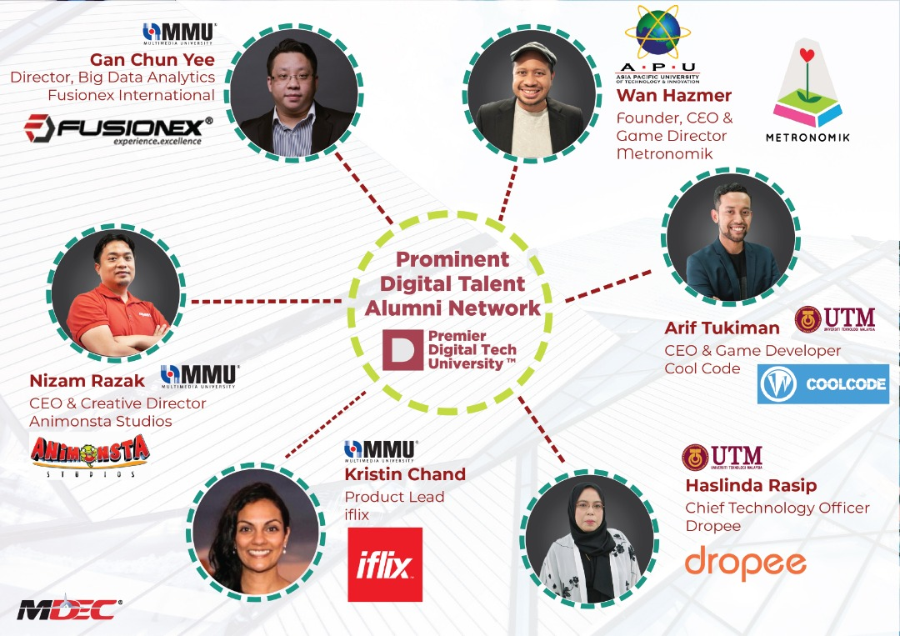

Figure Cool Code CEO

Cool code is consists of as we mentioned earlier the CEO is Arif Tukiman, the team CTO Ahmad Fikrizaman, COO Amir Fazwan, Project Executive Muhammad Ridzwan, Business Development Executive Muhammad Ariff Aizat, Creative Content Developer Muhammad Hafizuddin, Senior Game Developer Shariff Tariq, Junior Game Developer Mohd Alwi, Senior Mobile Developer Abdul Hadi, Senior Web System Developer Muhammad Kamarool, Junior Web System Developer Muhammad Nazrin, Junior Web System Developer Muhammad Asyraf, Digital Marketing Executive Muhanmmad Haqqi, Account and Finance Badrul Hisyam and Sales Executive Nadia.

# SERVICES

Cool Code also provide some training for people who need new skills or to enhance existing skills in the Cool Code Academy by implementing knowledge from their expert in application development. For now, the course availability are mobile native application development using Android Studio, Mobile hybrid development using ionic framework, Game development using Unity 3D and Web application development using Laravel Framework. The training is available for everyone where it have 3 class level beginner, intermediate and advance. It is located 52-2, Jalan Setia Tropika 1/18 Setia Tropika, 81200 Johor Bahru, Johor, Malaysia.

They also provide internship for the university students especially University Technology Malaysia Students (UTM) for their industrial training. Even though, they have a strict selection process of who they will be interning, it can be said one of a productive place to learn as the intern can have a chance to involve himself or herself into a project they are working on.

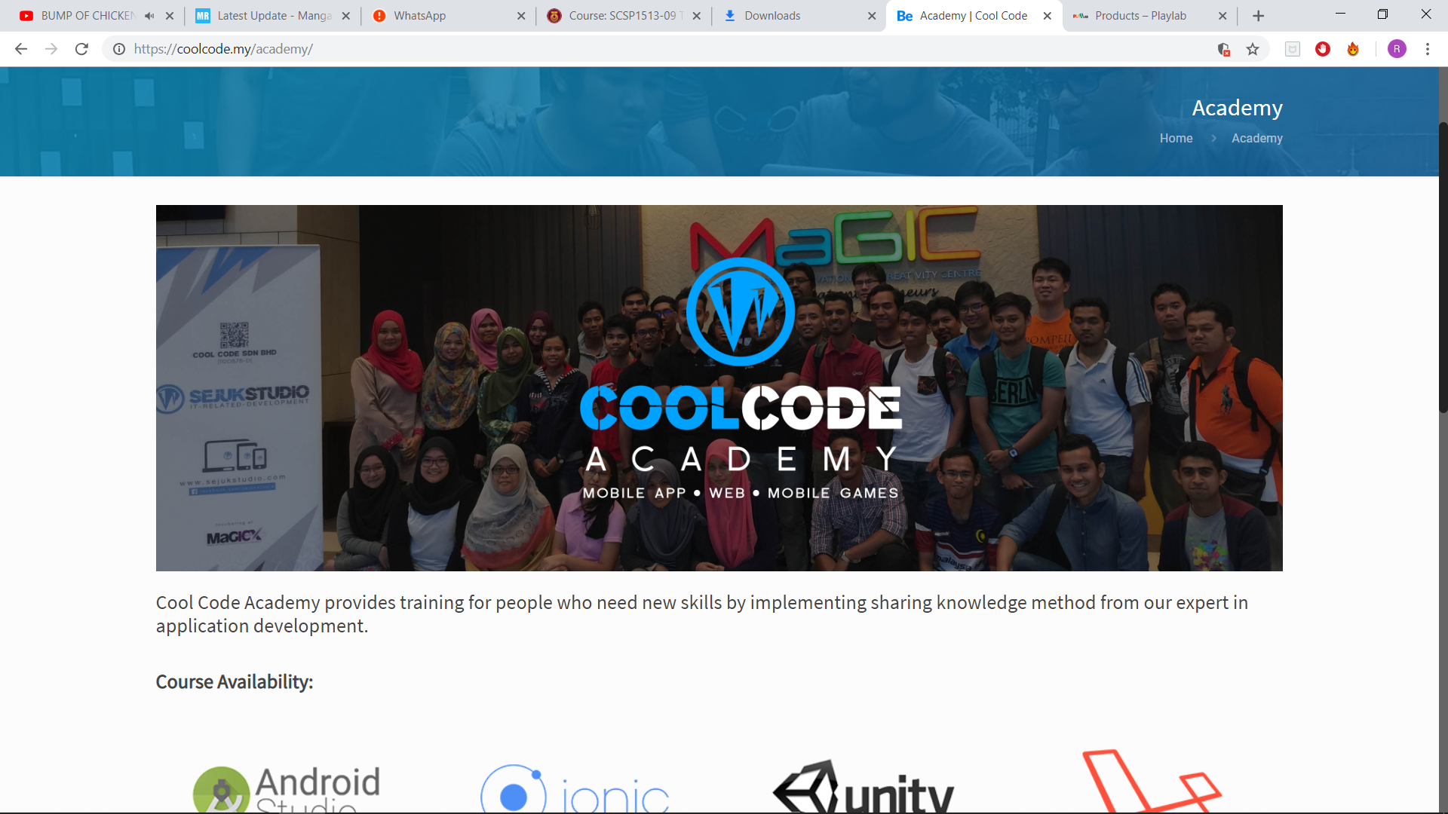

Figure Cool Code Academy

# Products and Achievements

Cool Code has been involved in many projects and have created many products each with its own achievements. One of the most noticeable project is the mobile app which is known as Didi & Friends PAYTOWN. It is an educational game which combines 12 games based on popular Didi’s songs. It had been one of the top 3 and top grossing educational game for two years since its release which is June 2016.

Other than that, there is the Rainbow IQRA, another educational game which provides an interactive way for learning basic Jawi. They managed to win the Digital Games which has been organised by MDEC. They got a prize money of RM50,000 for their innovative app.

There is also Puteri Harbour Theme Park app. This app is used during the launch of Puteri Harbour Theme Park which is located in Johor. It provides the user a map of Puteri Harbour Theme Park. It also has some games which encourages the user to go and visit Puteri Harbour Theme Park.

Next is GIGA BITE! This is a simple app where the user has given a task to perform in real life. When the user successfully finished the task, he or she will be provided points accordingly. The points then can be changed into internet data for mobile. This app is used during a Cyberjaya event.

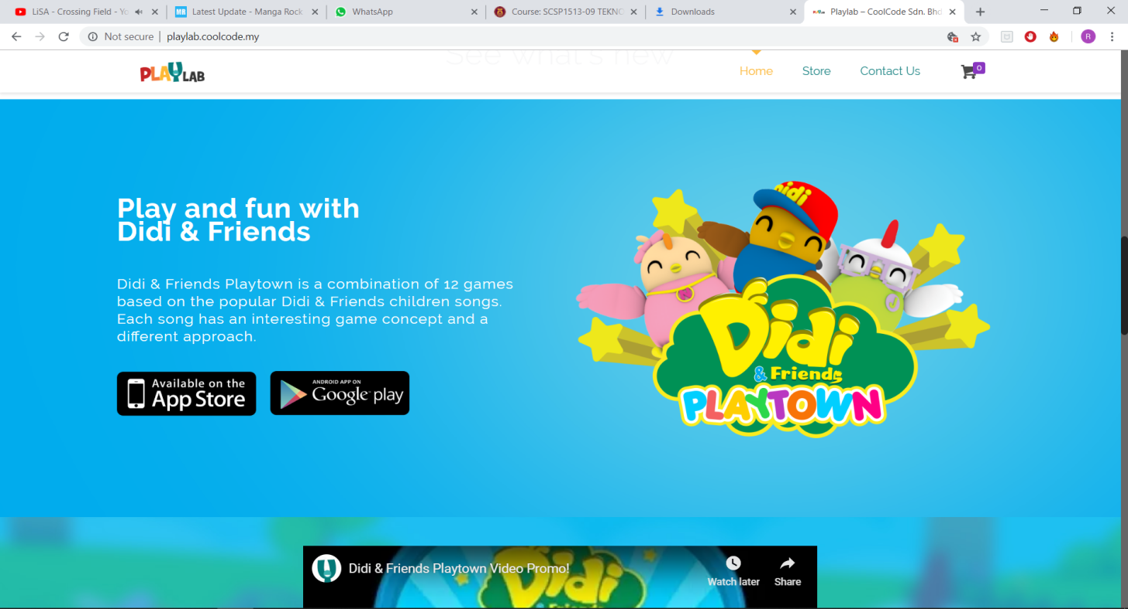They also did an app called Smart Tabika Kemas. This app is especially created to aid teachers in a particular elementary school. The teachers can use this app to take attendance and give the students the chance to learn through games. This is app is created because the upcoming generation is growing in a digitalised environment. This app can provide their need to study through phones and tablets.

Figure Didi & Friends Application

# Reflection

Goals is what makes us proceed in our life, which is way I set too many goals to achieve in my life. I have to many goals to do in my future, but my most goal I want to achieve is to be a game and animation movie creator, it a big dream/goal but I will work hard for it and I will do my best in it, to show the world that nothing is impossible.

The first the CEO ARIF TIKIMAN, started his talk to us about his story in school of computing, it was about how did he start COOLCODE company, at the end of the talk he told us that we need to start doing our goals and don’t stop whatever happened, we also saw some of their works and it was about game and video animation, from here I start thinking about how to start my goal from today. He also told us even though that at first he didn’t want to be in a computer science course, he started to like it as he started to learn. He then started doing small business and finally reached where he is now.

My action to gain more skills to improve my goal is to be a good listener, whenever someone is telling you that my work isn’t good you need to hear the reason and try to find how to fix it. Practice more on my works stop being lazy, start the right way to improve yourself to people, don’t say that you can’t do it, because you failed once you have to try until you reach to your goal.

# BIBLIOGRAPHY

Playlab CoolcCode . (2018). *Info*. Retrieved from CoolCode Sdn. Bhd.. :

# http://playlab.coolcode.my/

Didi & Friends Playtown. (2018). *App Store Preview*. Retrieved from App Store :

# https://itunes.apple.com/my/app/didi-friends-playtown/id1093776920?mt=8