

**SCSI2143: Probability & Statistical Data Analysis**

**PROJECT 1**

Topic

**Effective Teaching Methods through Analysis of the Learning and Thinking Styles**

**Members:**

* **AMIT HASAN SADHIN (A19EC4006)**
* **MD.ABU SALEH NAYEEM (A19EC4012)**
* **SHARMARKE HUSSEIN IBRAHIM (A19EC4022)**
* **NAIMUL HASAN SHIMON (A19EC4054)**
* **REZWANUL ASHRAF RUDDRO (A19EC4020)**

**LECTURER: Dr. ARYATI BINTI BAKRI**

Table of Content

Abstract

Focus on topic (Content)

* Introduction
* Methodology

1. Pie char

Figure 1.1

Figure 1.2

1. Histogram

* Figure 2.1
* Figure 2.2
* Figure 2.3

1. Box plot
2. Bar plot
3. Frequency Distribution
4. Scatter Plot

Conclusion

Appendix

***//*** *Introduction*

***Abstract*** This Survey includes the “**Effective Teaching Methods through Analysis of the Learning and Thinking Styles**”. This survey illustrates the medium of teaching a student is most likely to accept and commemorate. Although there is myriad of methods, most are not adjusted to all. Some students require a more face to face approach while others require in home teaching with access to the internet for a greater range of acquisition.

This survey potentializes the three most common types of method: Visual, Auditory and Kinesthetic.

Visual learning method is where the teaching is conducted via videos, pictures, infographics with included comments. It is basically a ‘what you see is what you learn’ type of approach. It can compress immense amount of knowledge in a single video with additional examples for a better understanding.

Auditory and kinesthetic are phonic and practical type of learning respectively. Listening to a speaker on a certain topic and its contents is considered auditory teaching method. Kinesthetic is the more hands on type of approach where students take up practicality in their ways instead of theories.

This survey will highlight the various parameters a student selects on their preferred method of learning.

**Introduction**

Methods of learning were created to suit various need of a diverse group of students. One single method is not only inefficient but it can also cause duress to an entire group. Visual, Auditory and Kinesthetic are proven methods of learning selected for students that need a wider scope of literacy.

Each of them provides students with its own unique blend of instructions designed to illuminate and enlighten them in the ways of education. These methods are a means of education for a legion of students with multitudes of criteria. Using different graphs like bar, pie, line, histogram, sketch the innumerable choice of personalized teaching has been presented.

***//*** *Focus on topic (Content)*

**Methodology**

Our Data was collected was collected through survey. We have conducted the survey in the form of Google Form and it consists of 2 parts which are personal information, and learning styles among the student as our survey is based on “**Effective Teaching Methods through Analysis of the Learning and Thinking Styles** “so we have less numerical data that’s the reason we may have less graph then others. But we tried our best to find out the potential learning styles for our students.

As in our data all the data are in Nominal way so we follow international learning style to decide the data in to 3 standard learning style which is visual, auditory and kinesthetic. By dividing them in different way we cam into a solution. **In this survey we use r programing for all the 7-requirement graph procedure which is Pie chart, Histogram, scatter plot, bar plot, stem-leaf, box plot & frequency distribution. Rather than we give some other graph from excel sheet in the appendix just to clarify and make it easier for the user or for the person who are watching it.**

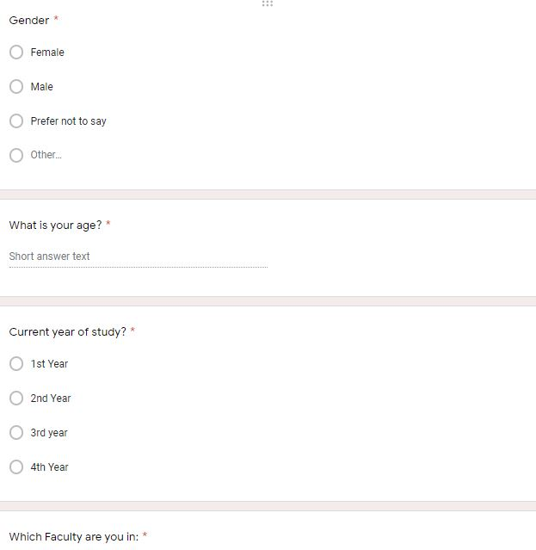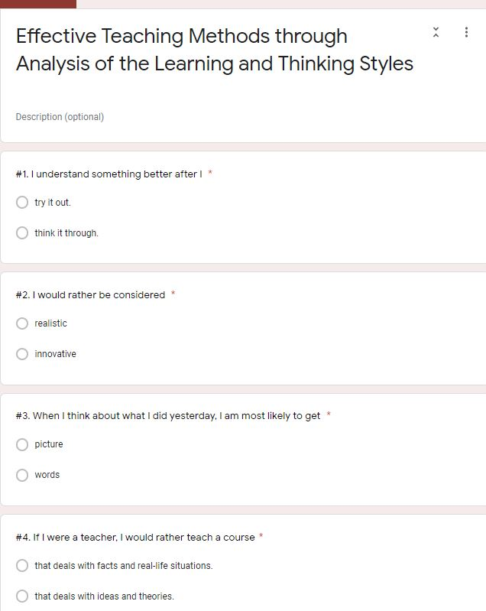

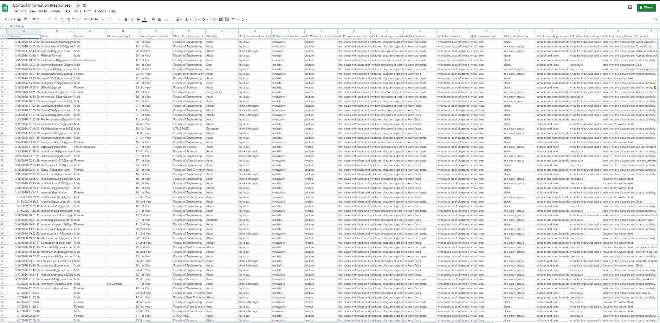

***//*** *Support for topic (Content)*

After the process of data collection, the data was then transferred into excel for further representation of data. The data collection took almost 2 weeks to have 100 respondents.

The parameters and variables of the question asked and data collected.

|  |  |  |
| --- | --- | --- |
| Data Collected  Gender | Data Type Data Collected  Nominal | Male, Female |
| Year | Ordinal/interval | 1st,2nd,3rd,4th, |
| 1. I understand something better after I | Nominal | A-try it out B-think it through |
| 2. I would rather be considered | Nominal | A-innovative B-realistic |
| 3. When I think about what I did yesterday, I am most likely to get | Nominal | A-pictures B-words |
| 4. If I were a teacher, I would rather teach a course | Nominal | A-that deal with facts B-that deals with ideas |
| 5. I prefer to get new information in | Nominal | A-pictures, diagram B-written direction |
| 6. I find it easier | Nominal | A-to learn concept B-to learn facts |
| 7. I like teachers | Nominal | A-who put a lot of diagrams B-who spend a lot of time |
| 8. I remember best | Nominal | A-what I see B-what I hear |
| 9. I prefer to study | Nominal | A-alone B-study group |
| 10. In a study group working on difficult material, I am more likely to | Nominal | A-jump in and contrib B-sit back and listen |
| 11. When I see a diagram or sketch in class, I am most likely to | Nominal | A-the picture B-what the instructor said |
| 12. In a book with lots of pictures and charts, I am likely to | Nominal | A-look over the picture B-focus on the written text |
| Visual | Ratio | Calculation of the number of visual supporter |
| Auditory | Ratio | Calculation of the number of Auditory supporters |
| Age | Ratio | Different age |
| Mean term | Ordinal/interval | Q1, Q2, Q3 etc. |
| Differences | Ordinal/interval | A certain difference |
| Frequency | Ratio | Ratio type data |
| Kinesthetic | Ratio | Ratio type data |

**//Pie chart 01**

**Gender Distribution:** Around 100 students were participated in our survey on the “Effective Teaching Methods Through analysis of the learning styles” and based on the data representation in **Figure 1.1**, and **1.2** most of the participants are male (57%) and (41%) are female and 2% prepare not to say.

**FIGURE: 1.1**

**AGE:** There are 100 participates in our survey where we found various ages people. The age of participates is in between 17 to 45 where more than 60 participates are in between the age of 20 to 25 and the lowest participates age in between 40 to 45.

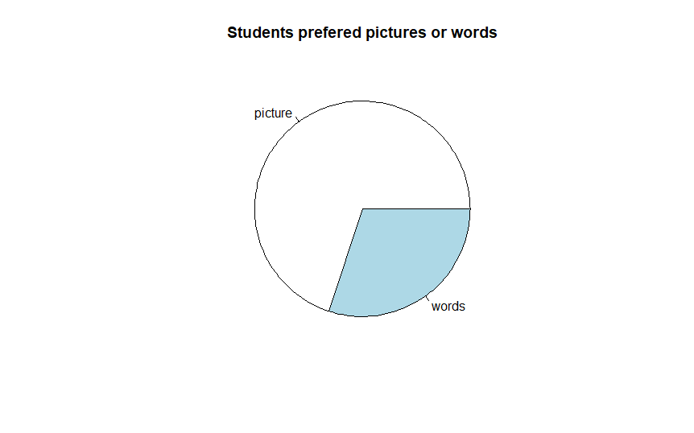

Figure 1.2

R Program: think.freq<-table(Ass2[,8])

pie(think.freq, main = "Students prefered pictures or words")

The pie chart illustrates students preferred pictures or words. This graph shows the results of a survey in which students aged 17 and over were asked about their understanding something what the preferred pictures or words. To compare the percentage here picture percentage is higher than words. Here picture capture almost 75% on the other side words holds the smallest portion that is 25%.From the pie chart it is clear that the majority of participants prefer to picture. Only a small minority prefer words

***//Histogram 02***

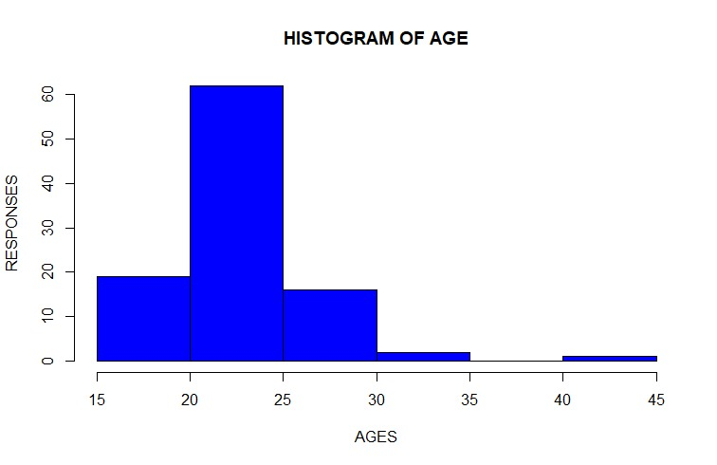

**Figure 2.1**

**R script:**

*Age<-(SurveyData$`What is your age?`)*

*hist(Age, xlab="AGES", ylab="RESPONSES", col="blue",main="HISTOGRAM OF AGE")*

***//Boxplot 03***

|  |  |  |  |
| --- | --- | --- | --- |
|  |  | Difference | |
|  |  |  | |
| min | 17 | 17 |  |
|  |  |  |  |
| Q1 | 21 | 4 |  |
| Med | 23 | 2 |  |
| Q3 | 25 | 2 |  |
| max | 45 | 20 |  |
|  |  |  |  |

Box plot by Excel 3.1

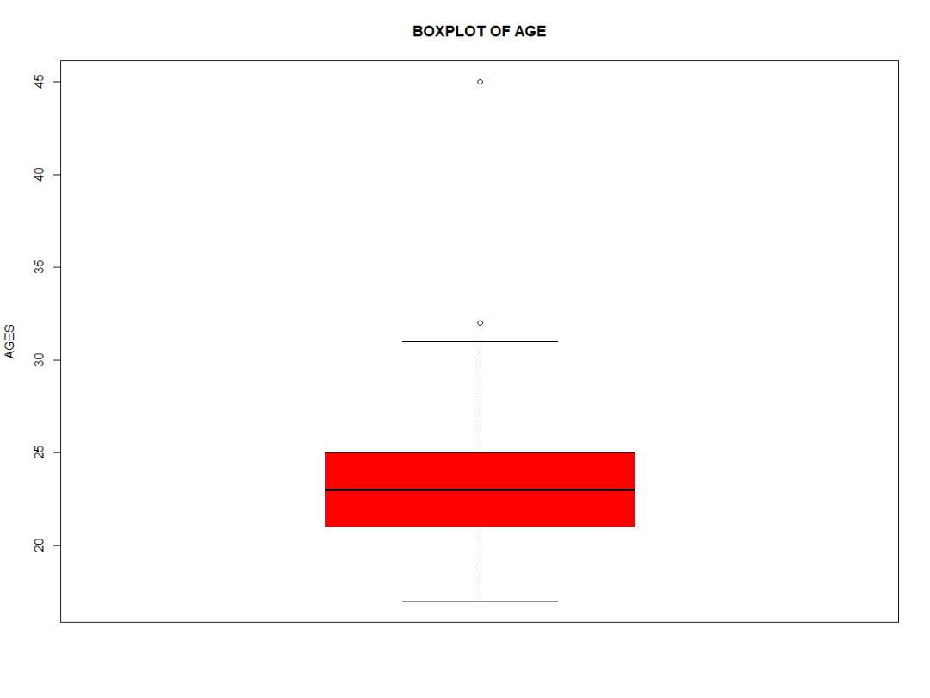

Boxplot by R 3.2

R script:

*summary(Age)*

*boxplot(Age,col="red",ylab="AGES", main="BOXPLOT OF AGE" )*

In 1920s a psychologists developed a learning style model which showed the most common ways that people learn. According to that model it showed that people learn in one of three ways: Visual, Auditory or kinesthetic which nowadays we call as VAK.

* **Visual:** a visually-dominant learner absorbs and retains information better when it is presented in, for example, pictures, diagrams and charts.
* **Auditory:** an auditory-dominant learner prefers listening to what is being presented. He or she responds best to voices, for example, in a lecture or group discussion. Hearing his own voice repeating something back to a tutor or trainer is also helpful.
* **Kinesthetic:** a kinesthetic-dominant learner prefers a physical experience. She likes a "hands-on" approach and responds well to being able to touch or feel an object or learning prop.

|  |  |
| --- | --- |
| **Visual** | **Auditory & Kinesthetic** |
| Option/’s | Option/’s |
| Realistic  A Picture  That Deals with real Life  Pictures, diagram, Graph or maps,  Look over the pictures  Who put a lot of diagrams?  What I see  The pictures | Think it out, words, that deals with ideas & theories, sit back and listen. To learn fact, focus on written text, what I hear, alone, try is out, innovative , written direction, jump in and contribute ideas to learn concepts, who spend a lots of time to explain, groups, what the instruction given etc. |

So, for our Project we mixed Auditory and kinesthetic together. This is because we found that Auditory and kinesthetic almost same.

|  |  |  |  |  |  |  |  |
| --- | --- | --- | --- | --- | --- | --- | --- |
| **Age** |  | **Total Participate** |  | **Visual** |  | **Auditory & Kinesthetic** |  |
| **17-19** |  | **10** |  | **7** |  | **3** |  |
| **20-22** |  | **35** |  | **27** |  | **8** |  |
| **23-25** |  | **35** |  | **26** |  | **9** |  |
| **26-28** |  | **13** |  | **5** |  | **8** |  |
| **29-31** |  | **4** |  | **3** |  | **1** |  |
| **32-34** |  | **2** |  | **1** |  | **1** |  |
| **35-rest** |  | **1** |  | **1** |  | **1** |  |

According to our survey we found that 70% of people choose Visual where only 30% people choose Auditory and kinesthetic. The table showed the responds according to ages.

Figure 2.2

Figure 2.3

We run our data in R programming we got the Bar chart for the visual, Auditory and kinesthetic learning style. As we see in our bar chart the figure showing that from age 17-19 there are 7 people choose visual and 3 people choose Auditory and kinesthetic, from age 20 to 22 there are 27 people choose visual and 8 people choose Auditory and kinesthetic, from age 23 to 25 there are 26 people choose visual and 9 people choose Auditory and kinesthetic, from age 26 to 28 there are 5 people choose visual on the other hand 8 people choose Auditory and kinesthetic rest of them almost similar.

//Bar plot 4

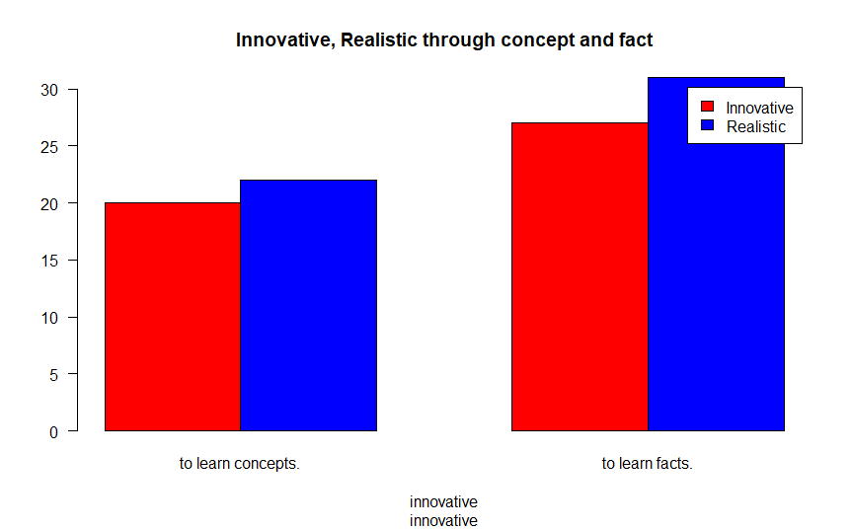

Figure 4.1

R Program:

table(considered,Easier)

table1<-table(considered,Easier)

barplot(table1, beside=TRUE, legend.text=c("Innovative","Realistic"), main= "Innovative, Realistic through concept and fact", xlab= considered, las=1,col=c(2,4))

A bar chart uses either horizontal or vertical bars to comparisons among two or more categories axis of the chart shows the specific categorizes being compared and the other axis represents a given value. This bar plot based on two questions. Where first question is “I would rather be considered” and second one is “I find it easier”. For the first question has two options those are 'innovative and realistic' and second one option is 'to learn concepts and to learn facts'.

Here, we use two colors in chart. For innovative we use red color and realistic we use blue color.

To learn concepts, here support of

* Innovative is 20%
* Realistic is 22%

To learn facts, Here support of

* Innovative is 27%
* Realistic is 30%

Basically, people prefer to learn facts is higher than other and most important part is they are realistic. Most of them want to learn in realistic way whatever it is to learn concepts or learn facts.

**//Frequency Distribution 5**

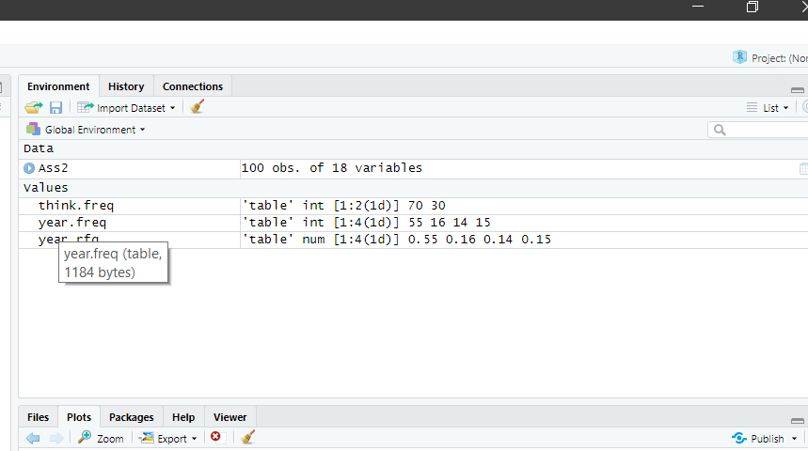

Figure 5.1

year.freq<-table(Ass2[,3])

year.rfq<-year.freq/100

This is the frequency distribution table for the total data which is 100 with the complementation with year. Here the total frequency is 1:2 and 1:4 as mention in the screenshot given on figure 5.1

**// Scatter Plot 6**

|  |  |  |  |
| --- | --- | --- | --- |
| Ethnicity | Visual | Auditory & Kinesthetic | |
| **Asian** | **41** | **17** |  |
| **European** | **1** | **4** |  |
| **Arab** | **9** | **3** |  |
| **Africa** | **12** | **7** |  |
| **Others** | **4** | **2** |  |

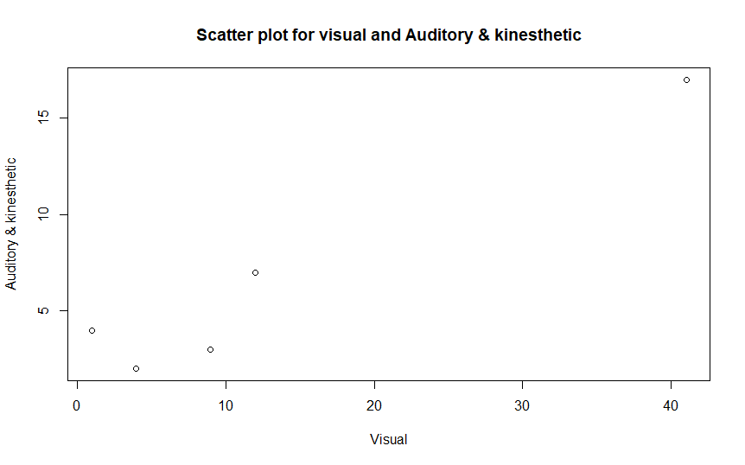

Figure 6.1 (Via R programing)

**R script:**

library(readxl)

Es2 <- read_excel("C:/Users/User/OneDrive/Desktop/PSDA Project 01/R prog/Es2.xlsx")

View(Es2)

attach(Es2)

names(Es2)

class(Visual)

class(`Auditory & Kinesthetic`)

summary(Visual)

summary(`Auditory & Kinesthetic`)

cor(Visual, `Auditory & Kinesthetic`)

plot(Visual,`Auditory & Kinesthetic`, main = "Scatter plot for visual and Auditory & kinesthetic", xlab = "Visual", ylab = "Auditory & kinesthetic")

This is the scatter graph that is Auditory & kinesthetic Vs Visual learning style. If we take a closer look on it, we can easily find that comparing with two different choice data Visual data is always in a dominating condition. The data collected here is based on ethnicity. Among the responder Asia are is the top position 41% of Asian preferred Visual learning style where 17% of them preferred Auditory & kinesthetic learning style that is the reason in the scatter plot its in the top position. On the other hand, there was a dramatic change in European where 4% of them preferred Auditory & kinesthetic and only 1% of them preferred Visual learning style. And in the rest from this scatter plot that visual learning is style is more preferable than Auditory & kinesthetic.

***//Stem-Leaf 7***

1 | 7888999999

2 | 000000000111111111111122222222222222333333333333344444444444

2 | 555555555556666677777888999

3 | 12

3 |

4 |

4 | 5

Figure 7.1

R script:

library(readxl)

Ass2 <- read_excel("C:/Users/User/OneDrive/Desktop/PSDA Project 01/R prog/Ass2.xlsx")

View(Ass2)

attach(Ass2)

names(Ass2)

#Stem & Leaf

stem(Age)

This is the stem-leaf for ages of each participant, her clearly, we can see that most of the respondent are in the age of 20 to 24 which is the highest number of respondents, right after that we have age between 25-29 which is the second highest participants reply ages leaf. On the other hand, there is no respondent in the age 35-44. We take this as normal because our survey is most likely focus on the university students of UTM so it is very common that we will get most of the respondents from the age between 17 to 30.

*// Conclusion (Organization)*

**Conclusion**:

In the survey, from a total of 100 participants a somewhat margin can be drawn differentiating the preferred method of study. It is seen that the majority of the respondents chose Visual learning method as their strong point for studying while a small minority chose the other option Auditory & Kinesthetic.

Looking into ethnicity, majority of the respondents from Africa chose Auditory & Kinesthetic as their strong point. But the other respondents of various respondents strongly preferred Visual.

Going into age of the respondents, the majority were from the combined age of 17-25 totaling to an astounding 80. Among the 80, 60 of them preferred Visual outnumbering those who prefer Auditory & Kinesthetic 3 to 1 in favor of the former. It is evident that the younger generation is more keen to Visual Aid than its latter counterpart. But it to note that among the age group of 26-28, the majority prefers Auditory & Kinesthetic instead of Visual which strikes a into the psychology of the mid 20’s and early 30’s attitude. They are more fond of Auditory stimulus than Visual. But the later ages once again evens out in favor of Visual.

Going into overall choice, Visual was the most selected option. So, it can be concluded that the students prefer Visual learning method as their preferred teaching method from the analysis of the survey.

From the survey, it can be analyzed that Visual is the more advent form of teaching for students. It is new, impressionable and it can compress much information in a fun and exciting package that can be reviewed over and over again. Teacher should pay heed to this form of teaching and adjust their teaching method somewhat following new guidelines and specifications. Visual form of teaching is now more prevalent due to stay at home orders and consequently in-home teaching. It can be said, Visual is the new underdog ready to overtake the conventional throne.

**Appendix**

**The whole R script :**

***library(readxl)***

***Ass2 <- read_excel("C:/Users/User/OneDrive/Desktop/PSDA Project 01/R prog/Ass2.xlsx")***

***View(Ass2)***

***attach(Ass2)***

***names(Ass2)***

***#Stem & Leaf***

***stem(Age)***

***#Boxplot***

***quantile(Age,probs = c(0.25,0.50,0.75,1))***

***boxplot(Age~Gender, main="Boxplot of Age by Gender")***

***#pie***

***think.freq<-table(Ass2[,8])***

***pie(think.freq, main = "Students prefered pictures or words")***

***#Frequency Distribution***

***year.freq<-table(Ass2[,3])***

***year.rfq<-year.freq/100***

***#Barplot***

***table(considered,Easier)***

***table1<-table(considered,Easier)***

***barplot(table1, beside=TRUE, legend.text=c("Innovative","Realistic"), main= "Innovative, Realistic through concept and fact", xlab= considered, las=1,col=c(2,4))***

***#Scatterplot***

***library(readxl)***

***Es2 <- read_excel("C:/Users/User/OneDrive/Desktop/PSDA Project 01/R prog/Es2.xlsx")***

***View(Es2)***

***attach(Es2)***

***names(Es2)***

***class(Visual)***

***class(`Auditory & Kinesthetic`)***

***summary(Visual)***

***summary(`Auditory & Kinesthetic`)***

***cor(Visual, `Auditory & Kinesthetic`)***

***plot(Visual,`Auditory & Kinesthetic`, main = "Scatter plot for visual and Auditory & kinesthetic", xlab = "Visual", ylab = "Auditory & kinesthetic")***

***#Histogram***

***library(readxl)***

***Es1 <- read_excel("C:/Users/User/OneDrive/Desktop/PSDA Project 01/R prog/Es1.xlsx")***

***View(Es1)***

***attach(Es1)***

***names(Es1)***

***hist(Visual,col = "blue")***

***hist(`Auditory & Kinesthetic`,col = 'Green')***

**#Boxplot**

***summary(Age)***

***boxplot(Age,col="red",ylab="AGES", main="BOXPLOT OF AGE" )***

***#Histogram***

***Age<-(SurveyData$`What is your age?`)***

***hist(Age, xlab="AGES", ylab="RESPONSES", col="blue",main="HISTOGRAM OF AGE")***

*Appendix on different aspect by using excel*

|  |  |  |  |
| --- | --- | --- | --- |
| Age | Total Participant | Visual | Auditory & Kinesthetic |
| **17-19** | **10** | **7** | **3** |
| **20-22** | **35** | **27** | **8** |
| **23-25** | **35** | **26** | **9** |
| **26-28** | **13** | **5** | **8** |
| **29-31** | **4** | **3** | **1** |
| **32-34** | **2** | **1** | **1** |
| **35-present** | **1** | **1** | **0** |

The stacked graph for the student desired learning style displays comprehensive individualized date among the responders. Among the age group of 17-19, there were 10 total participants of which 7 preferred Visual and 3 preferred Auditory & Kinesthetic. In addition, there were total 35 respondents in the group of 20-22 where 27 preferred Visual and 8 chose Auditory & Kinesthetic. Furthermore, in the age group of 23-25 there were also 35 and 26 of them chose Visual while the rest 9 chose Auditory & Kinesthetic. Again, the age group of 26-28, 13 responded and 5 of them preferred Visual whereas 8 chose Auditory & Kinesthetic. In the age group of 29-31, 4 participated of which 3 picked Visual and 1 picked Auditory & Kinesthetic. In the the age group of 32-34, there were 2 participants and both chose two different. Finally, in the age of 35-present, there was only 1 respondent and the choice was visual.

In the demographic of responders according to age, the lowest range was 17 and highest continued from 35 to present. The maximum number of respondents were from the age group of 20-22 and 23-25, where there was 35 in each group, so in short, the highest number of participants were from the age range of 20-25 totaling to 70. The lowest was in the age of 35-present amounting to only one respondent. In the age bracket of 17-19, 26-28, 32-34 the number of corresponding participants were 10, 13, 4 and 2 respectively.

Bracketing the participants into their respective ethnicity, a total of 58 of the respondents were of Asian descent of which 41 preferred Visual and 17 preferred Auditory & Kinesthetic. From European origin, 5 responded where 1 preferred Visual and 4 preferred Auditory & Kinesthetic. Forwarding to the ethnicity of Arab, 12 answered where 9 picked Visual and the rest 3 chose Auditory & Kinesthetic. Looking at African descent, 19 responded of which 12 had their choice on Visual and 7 picked Auditory & Kinesthetic. Finally, there were 6 participants of unknown origin where 4 preferred Visual and 2 held Auditory & Kinesthetic as their choice. In this bracket, the highest number of participants were from Asian origin amounting to a staggering 58 in total and the lowest known ethnicity was from the European nationality.

|  |  |  |
| --- | --- | --- |
| Age | Visual | Auditory & Kinesthetic |
| **17-19** | **7** | **3** |
| **20-22** | **27** | **8** |
| **23-25** | **26** | **9** |
| **26-28** | **5** | **8** |
| **29-31** | **3** | **1** |
| **32-34** | **1** | **1** |
| **35-present** | **1** | **1** |

The dot plot represents the number of respondents that chose visual or Auditory & Kinesthetic in an exponential curve. The dots correspond to the number of participants in the y-axis that chose their particular method as per the age group in the x-axis. From the graph, it is evident that the maximum number of participants are from the age group 20-22 and 23-25 while the least number comprises from the range 35-present.

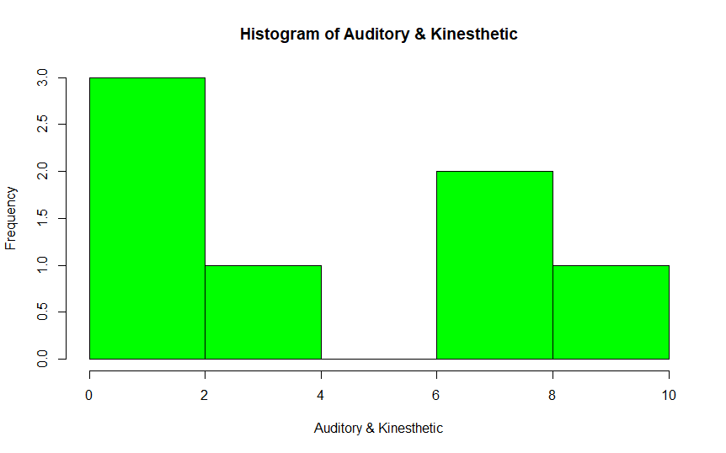

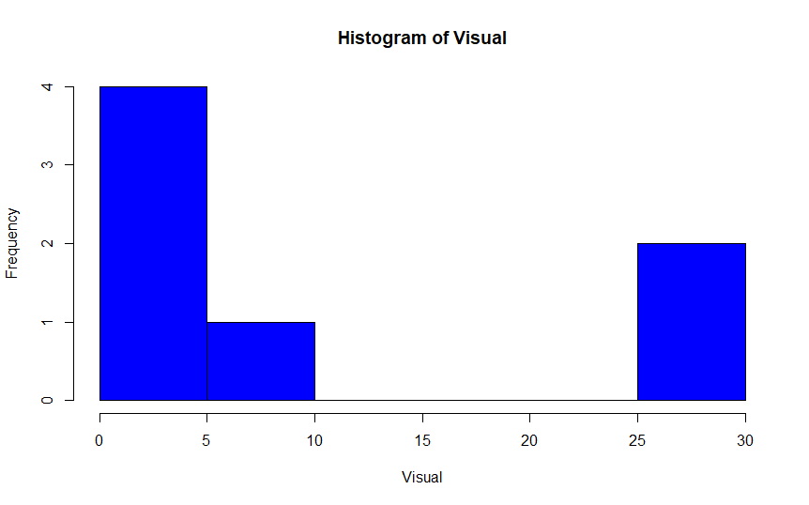

This 2 Histogram is for Visual, Auditory & kinesthetic by using R programming. Here we want to show that how its look like if we want to put Our desire data into R