SCSP 1513 (SECTION 6)
TECHNOLOGY AND INFORMATION SYSTEM

PREPARED FOR:
DR. NORBAHIAH BINTI HAJI AHMAD

INDUSTRIAL VISIT 2 (ONE MAKER)

PREPARED BY:
NURUL HANA BINTI AZAM (A18CS0219)
NURUL AIN NADHIRAH BINTI SHAMSUL BAHRIM (A18CS0213)
SAFIRA NURUL IZZA (A18CS0323)
NUR IZZAHTUL SYAFIQAH BINTI MOHAMAD FADZIL (A18CS0197)
MD SAMSUL ALAM RONY (A17CS4024)
Introduction
On Saturday 24, 2018 all software engineering students from school of computing of UTM went for second industrial visit to OneMaker, Medini Mall. Almost 150 students and less than 4 lecturers were hosted by OneMaker Group staff. The program is to open student’s mind about technology and be more creative in making use of technology for the future. The tentative are :
Table 1.1 : Tentative for industrial visit 2.0.
8.00 am | Registration and Gather at front of N24, UTM
8.30 - 9.30 am | Start Journey to Forest City (sight tour)
9.30 - 10.00 am | Journey to OneMaker Medini, Medini Iskandar Puteri
10.00 am. | Arrive at OneMaker Medini
10.30 - 1.00 pm | Disruption of Technologies Learning Journey
1.00 -2.00 pm | Lunch Break and Zuhur prayer
2.00 - 4.30 pm | Virtual Reality Talk & QuirkyBot Making
4.30 - 5.00 pm | Break and Asar prayer
5.00 - 7.00 pm | Design Thinking & Making
7.00 - 8.00 pm | End session and Maghrib prayer
8.00 pm. | Back to UTM

Before arrived at Onemaker, we went to Forest City to observe and take a look of plan for future development that focuses on the concept plant in the city. Students were divided into two sessions A and B according to groups and section respectively. As for group three, we were assigned to be in session A first: Disruptive Technologies Learning Journey. In this session, we had participated actively in five activities. To make the program run smoothly, we were split into much smaller group and alternate to each activity for 20 minutes together. A lot of us were highly anticipated to this program and eager to experience in these kind of activities as it only happen once in a lifetime. After lunch break, we had a talk called ‘Virtual Reality Talk’ and even more activity like ‘QuirkyBot Making’

(Session 1 activities with OneMaker Group at Medini)

Details description include organization structure
One Maker Group (OMG) - A leading Maker-centric service provider in the region. Since 2014, they have been support the nascent Marker movement in Singapore. OMG have revolves many core business such as Maker education, digital prototyping services and corporate professional development. OMG’s experience in cooperate for both educational and institutions allows to better understand our clients’ needs and to serve them well. Now, they have contacted to operate and manage other makerspaces with another new overseas outlet at Medini Iskandar, Johor, Malaysia.

Services
Makerspaces Development | (Makerspace Specialist)  Offer consultation and building services to customize the makerspace requested to set up.  Added services such as supply of tools, materials, machines, and equipment.
Prototyping & Consulting Services | (3D printing )  Offer 3D printing consultancy, printing services or rental of 3D FDM and SLA printer for your design and model.  Materials:  ABS, PLA, resin  (Laser Cutting )  Offer digital fabrication using laser machine for design and model  Material: acrylic, cardboard, fabric, foam, lather, wood.  (Computing Numerical Control (CNC) Routing )  Offer digital fabrication using CNC routing machine for your design and model. Engraving is possible.  Material : acrylic, aluminium, cardboard, copper plate, fiberglass, hardwood, high density foam, marble, stone, wood
Makerspace | (Flexi Access Pass)  Offer a flexible access pass to the space where a wide range of tools and equipment are available. Offer induction courses for new users before they start working in our space.
Event Consultancy and Management | (Customization to needs)  Offer curated, customized, and highly engaging content for events. We organize and conduct:  >Craft classes (sewing, leather crafting, water coloring, cosmology & maths in art, and many more)  >Digital Creatives learning journeys & workshops (3D printing, augmented reality, design thinking, digital fabrication, drones, Internet of Things, physical computing & embedded systems, virtual reality, and many more)  >Student Innovation & Product Development Programs  >Corporate Creative Technology Innovation & Team Building  >Hackathons
Official Certification  Professional Certification | Arduino Creative Technology in the Classroom (Arduino CTC 101)  CTC is Arduino’s one-of-a-kind STEAM (Science, Technology, Engineering, Arts, and Mathematics) program for upper secondary education*. Students are introduced to the foundations of programming, electronics, and mechanics through a series of playful, well-documented projects and easy-to-assemble experiments.  CTC is an immersive educational experience consisting of an online platform, video tutorials, detailed documentation with step-by-step instructions, a classroom toolbox with more than 20 hands-on experiments based on themed modules.  One of the achievements of OMG is having a partnership with Fast Lane Asia. Advanced IT training courses, offers complete training solution for Cisco, IBM, Symantec and many more are the activities that Fast Lane provided. So, OMG is the company that Fast Lane company rely on because OMG have those who master in develop technology skills to cope with modern high-end challenges.  .

Detailed description of Session1. (Disruptive Technologies Learning Journey)
GOOGLE ASSISTANT
It’s not all about the G-assistant we have learnt. Actually Google assistant worked as an example for us. The facilitator wanted us to realize the relation between human and machine. He also showed us some videos on machines capability. There was an example video of a machine that can write story.
Google assistant assists us answering our questions and doing various task like booking a ticket or fixing an appointment with doctor. To do this G-assistant generate its own code. The facilitator focused on that term and asked a very important question.

ROBOT-COLOR COMMAND
We have been introduced with a small robot. It comes with a round shape and a light on its head. This robot can follow a line and also able to recognize the color.
If we program red color as a stop point for this robot, it will stop when it faces the red line. The programmer of this robot made some color patterns. If we draw the patterns correctly the robot will do as the patterns tell.

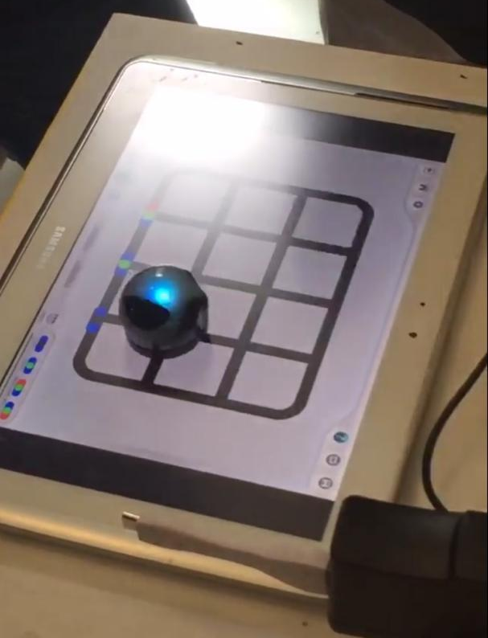

FLYING DRONE
We know the drone that flies in the sky according to our action to the controller. But the drone from the event was totally different. By the outlook it may seem same ordinary drone we know but it’s not. We can make some commands for it using computer. It follow our command and fly on its own. Thus, one man can run thousands of drones at a time.
It can be beneficial in various ways to us. We were using fireworks for very long time to light up the sky. It makes noises and also not good for the environment. But don’t worry, here comes this drone. That can light up sky as you like.
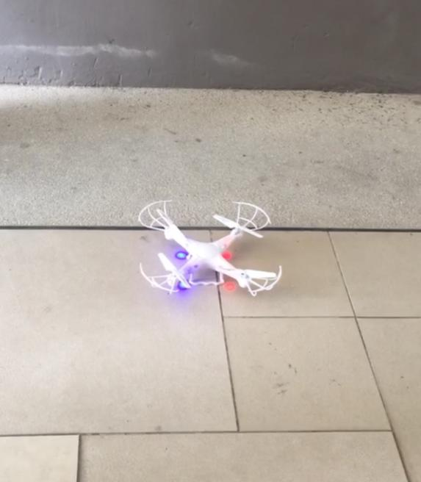

3D- SKETCHING
Are you creative? Can you make a word or logo in 3d? Make whatever you want using SketchUp with your laptop. It doesn’t matter what you draw. Draw it in 3d must. That’s all.

3D- PRINTING
After finishing our 3d-Sketchup we had a chance to come our drawing to reality. We saw an assistant to do it. He did it with a 3d printing machine that made in Malaysia. The machine is small so the printing was limited with words only. But they also have the machine that can print a prototype of a car. As it takes hours to print that kind of prototype they skip it.
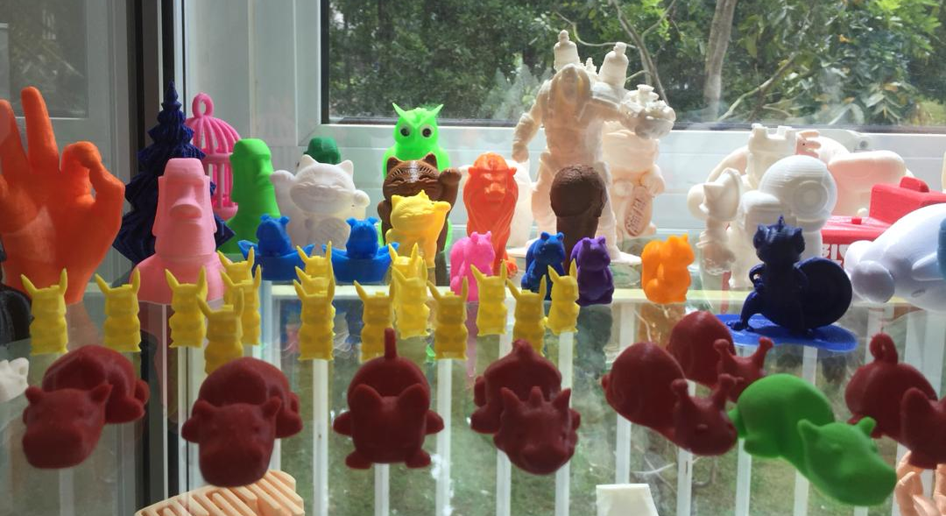
3d printer can use various materials like rubber or wax. Before starting to print, the machine needs to heat up with 325 Kelvin. The printer that only able to print simple model like words come with RM4000 in Malaysia. The printer that can print a complicated prototype comes with RM10000++

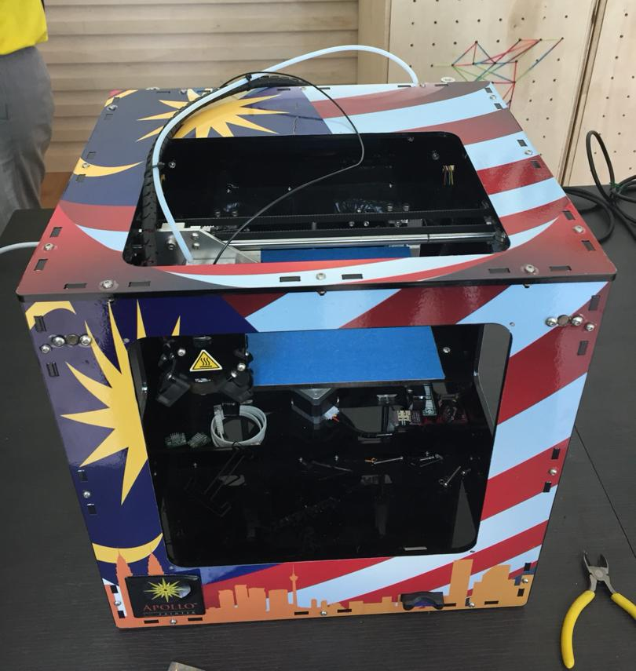

(Machine to print the 3d designs)
Detailed description of Session2. (‘Virtual Reality Talk’)
In Virtual Reality Talk, the speaker explained to us about Biodegradable plastic. Biodegradable plastic is a plastic that decomposes naturally in the environment. This is achieved when microorganisms in the environment metabolize and break down the structure of biodegradable plastic. The end result is one which is less harmful to the environment than traditional plastics.
The speaker asked one of students to be a volunteer, and then a student named Raja Aidid came forward. He asked to put the biodegradable plastic into a glass of water and stir it until the plastic and water mixed, after that he asked to drink that water. But unfortunately the water wasn’t hot enough to make the plastics dissolve into the water. The plastics can dissolve in water above 80°C.
Biodegradable plastics are made from all-natural plant materials. These can include corn oil, orange peels, starch, and plants. Traditional plastic is made with chemical fillers that can be harmful to the environment when the plastic is melted down. With biodegradable plastic, you get a substance made from natural sources that does not contain these chemical fillers, and does not pose the same risk to the environment.
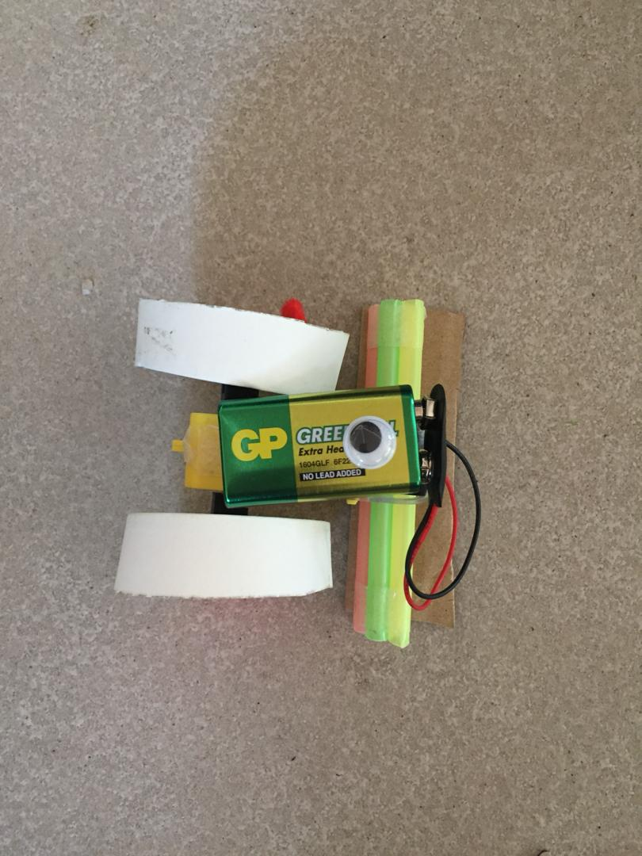
In QuirkyBot Making, we were assigned in a group of two to creatively build a robot that can move using recycled materials. Materials given were straw, paper cups, ice cream stick, skewers, plastic bottle, scissor, cutter, double tape and motor. The robot then tested in a competition with another robot from other group. Robot that last the longest is the winner of competition

Reflection
I am feeling that this will be one of the career I am looking at. I am so impressed looking at the background of OneMaker Group. They have advocate and support the nascent Maker movement in Singapore. So, for me what the improvements and actions should I improve my potential in the study is I should be more open minded as we are know that we are leaving in technology and technology are always be updated. I should be one of the person who are involve in this IT to help people solving problem. (Nurul Hana Binti Azam)

After visiting One Maker Group, I really interested in joining their company during my internship and to stay as a member of the group because I really love the environment and also the work space. I also gain more knowledge about technologies that needs in the future. So that we as the IT students know what to work for in the future especially as a software engineers. (Nurul Ain Nadhirah Binti Shamsul Bahrim)

These activities reminds me that technology is an essential part of our lives today. We achieved a lot with the help of technology, for example we have the possibility to travel, keep in touch with friends on the other side of the earth and cure many illnesses. It means more freedom and choices for people but at the same time we have to consider the social imbalance, weapons of mass destruction and natural resource depletion. My dream is to become a programmer, this visit makes me more excited about learning software and programming, and more to know about technology. (Safira Nurul Izza)

From these activities, I learn that creativity is the most important thing in the era of technologies. This visit give me motivation to pursue my dream as a florist that have software engineering study as a background. I still can get my work done easily by benefiting artificial intelligence (a.i) when doing my business. Now, there's competition between humankind and robot. With new inventions day by day, human workforce seems to be deteriorated by robots when all the works of human is passed to them. For me, we need to be active and dynamic so that these new technologies are meant only for helping us and not to rise above us. Indeed, increasing needed skills in various areas will make us so capable in every aspects. (Nur Izzahtul Syafiqah Binti Mohamad Fadzil)

Coding skill of a machine is increasing day by day. One day may be the world will not need a human coder at all. And the time is not very far. It's coming in our era. First time I was shocked. But the facilitator gave me a solution. Now I know only coding is not enough for me. I need to learn more about the technologies and the machine. Developing skill in information and communication technology (ICT) will be the solution for a human coder at the job. (MD Samsul Alam Rony)

References
- Team OMG, retrieve December 1, 2018, from World Wide Web https://www.onemakergroup.com/
- Biodegradable Plastics (2016), retrieve December 1, 2018, from World Wide Web http://www.pepctplastics.com/resources/connecticut-plastics-learning-center/biodegradable-plastics/
- Dilan91 (July, 2018), retrieve December 1, 2018, from World Wide Web https://www.eoi.es/blogs/marieglueck/2012/06/30/the-role-of-technology-in-today%E2%80%99s-world-and-in-the-future/

