

**SCSP 1513**

**SECTION 07**

**SEMESTER 1 2018/2019**

**TECHNOLOGI AND IFORMATION SYSTEM**

**REPORT:**

**STEP TO ASSEMBLE A COMPUTER HARDWARE**

|  |  |
| --- | --- |
| **NAME :** | **IDZNI BIN MOHAMED RASHID** |
| **I/C NO :** | **980517-04-5233** |
| **MATRIC NO :** | **A18CS0075** |

**LECTURER:**

**Mr HAIRUDIN BIN ABDUL MAJID**

Objectives.

When I completed this practical test, I will able to:

* Identify, disconnect, and reconnect the computer’s cables and cover.
* Identify the external connectors on a typical personal computer.
* Identify and explain the purpose of the major internal components.

**Important things to remember** when assembling a computer.

1. Always documents everything.
2. Where cards are located.
3. How cables are routed.
4. Orientation of cables and connectors.
5. Grasp connectors by shells not leads.
6. Never use force.
7. Always work with dry hand and encourage using glove.

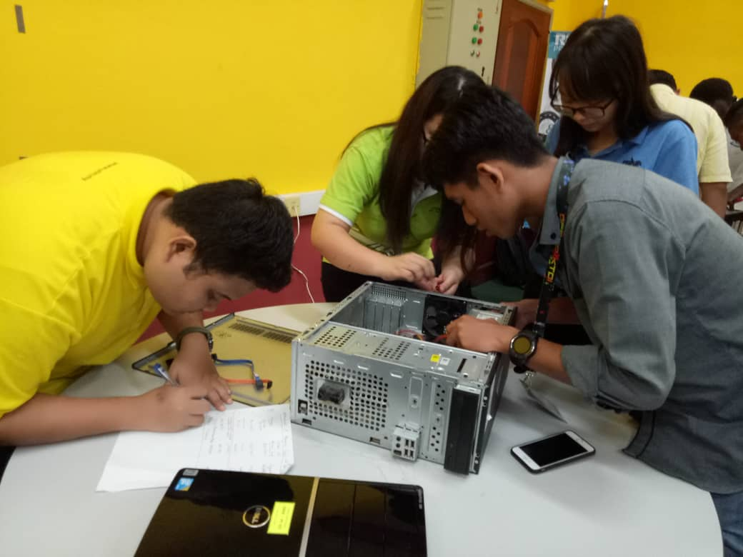

Figured 1: My team always work together.

Step by step how to assemble internal hardware.

1. Gather the suitable tools such as screwdriver for unscrewing the casing and hardware.

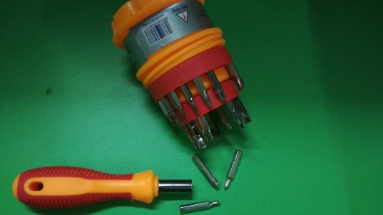

Figured 2: I used Phillips head screwdriver to unscrew

1. Procuring parts: Gather all parts of hardware that necessary to build the computer.

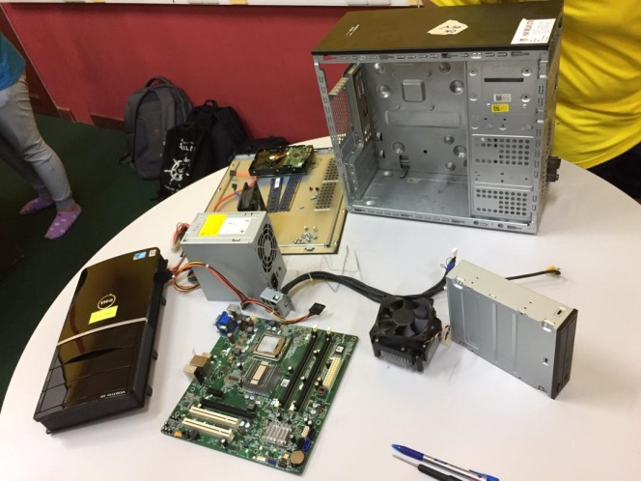

Figured 3: Arrange all the components of an orderly and uncluttered

1. Lay down the empty casing of PC and wipe all the dust with a clean cloth.
2. Installing the ATX power supply unit (ATX-PSU).

* There are two types of power supply AT and ATX power supply.
* Make sure you grasp by its shell without any sweat or wet hand
* Carefully install the ATX-PSU align with casing’s holes and tightly screw it.

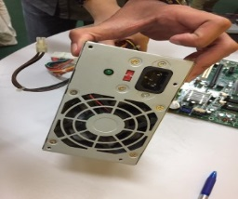

Figured 4: WARNING do not touch by the edges of the shell

1. Installing the Motherboard.

* Known as system board, planar board, baseboard, mainboard, and logic board.
* Lower the motherboard into the case and align with the I/O bezel and carefully install it.
* Make sure all the screw holes on the motherboard are put correctly on the designated marked holes on the PC’s casing and tightly screw it.

Integrated peripherals

PCI slots

CPU chips

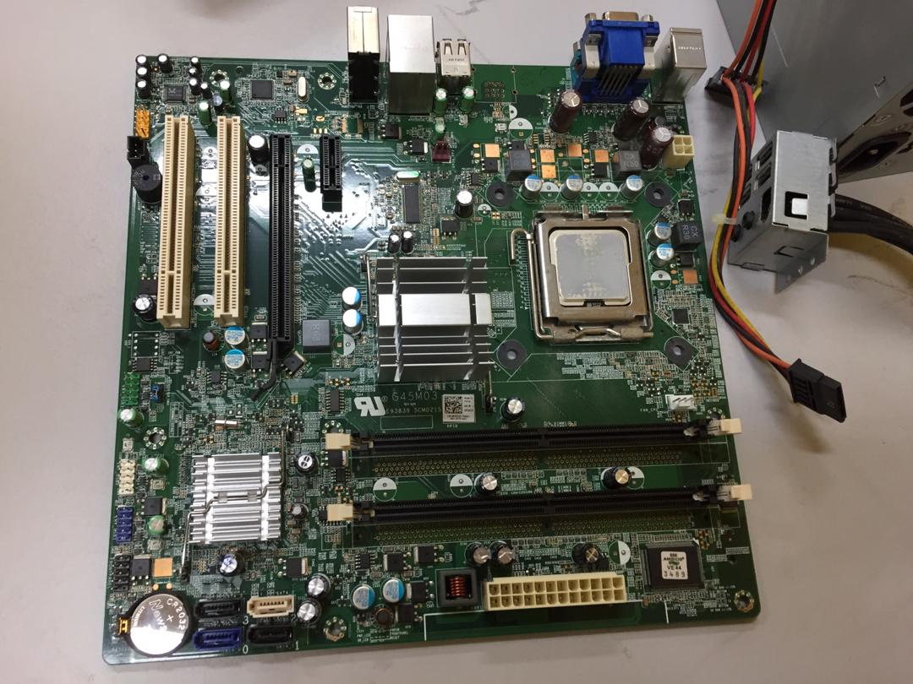

CMOS backup battery

Heatsink

Figured 5: Showed the label components

ATX power Connector slot

Memory (RAM) slots

1. Installing the Hard Drive.

* Hard Disk Drive (HDD) is a magnetic storage device. The storage capacity is measured in gigabytes (GB).
* Magnetic HDD have a drive motors designed to spin magnetic platters and move the drive heads.
* Slowly insert the drive into it drive bay and screw tightly.

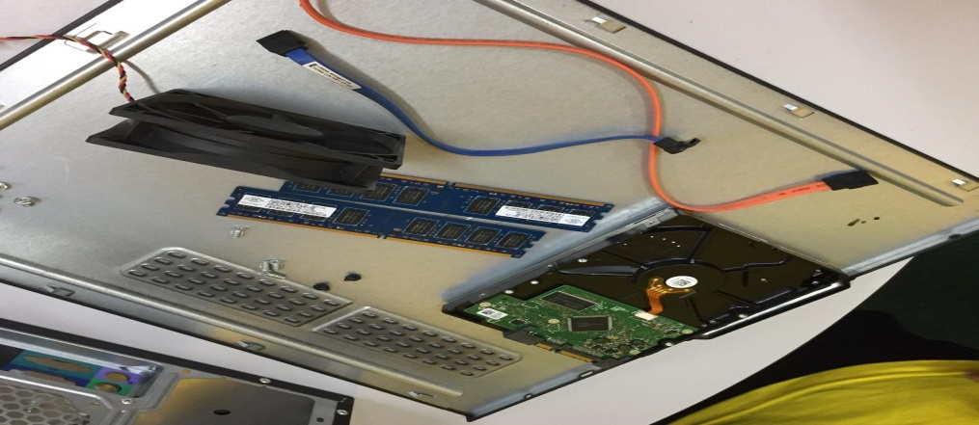

Figured 6: Hard drive

1. Installing the Optical Drive/CD-ROM Reader.

* Slide the drive into the drive bay until the screw holes are lined up and the front drives is flush with the front of the case then screw it.

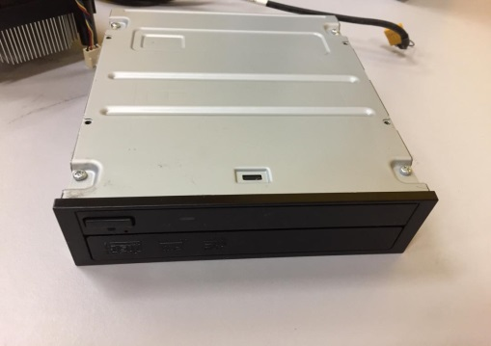

Figured 7: Optical Drive

1. Installing the CPU Cooling Fan and Casing fan.

* Put Cooling fan on the CPU and align with the screw holes in motherboard then tightly screw and connect the cable in the slot.
* Screw the Casing fan on the wall side of the casing and connect the cable in the slot.

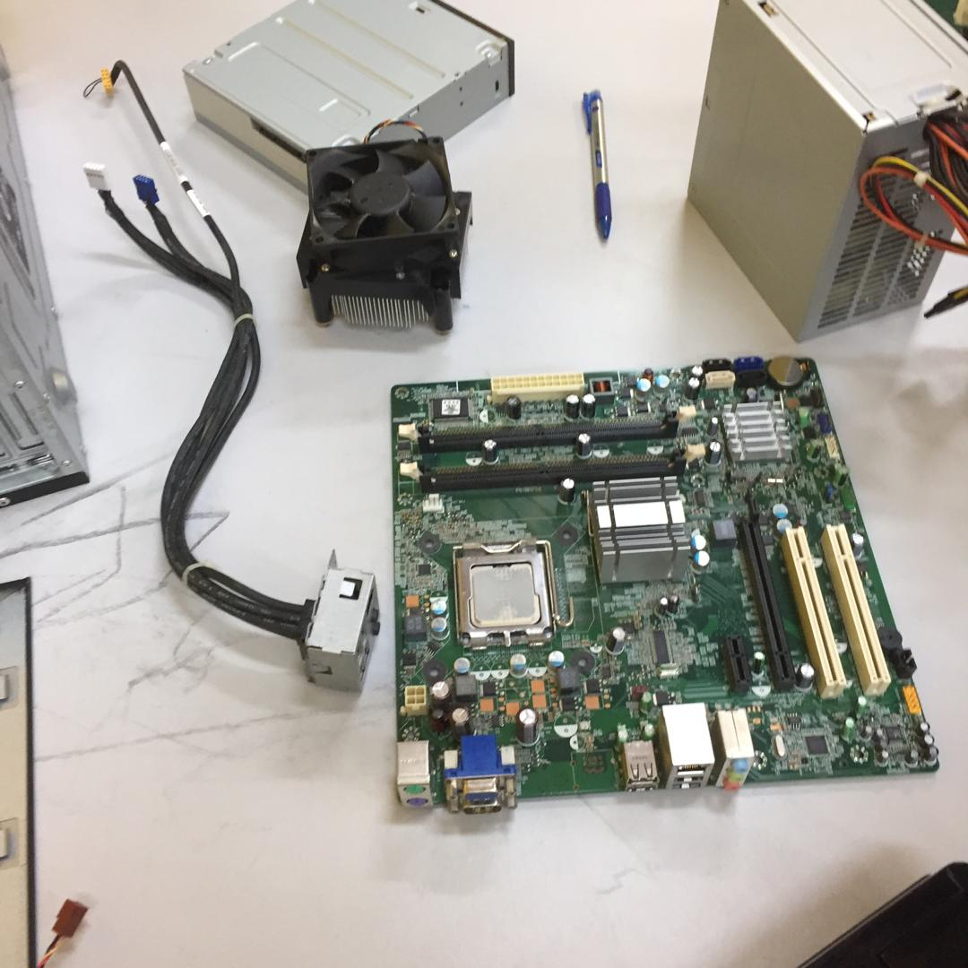 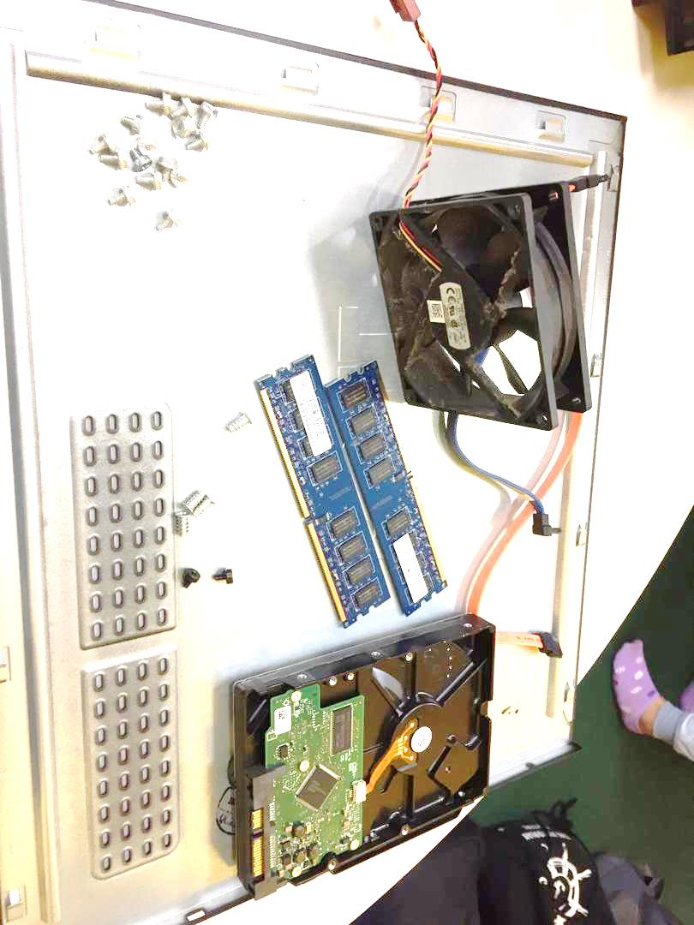

Figured 9: Casing fan

Figured 8: CPU Cooling Fan

1. Installing RAM.

* Firmly press on the both ends of the board to set into the slots.
* Press the RAM until you hear the “TICK” sound.
* Double check it to make sure the RAM is in the slot correctly.
* CAUTION: Pressing the boards in when the tab is not aligned could cause damage to the RAM boards as well as the mainboard.

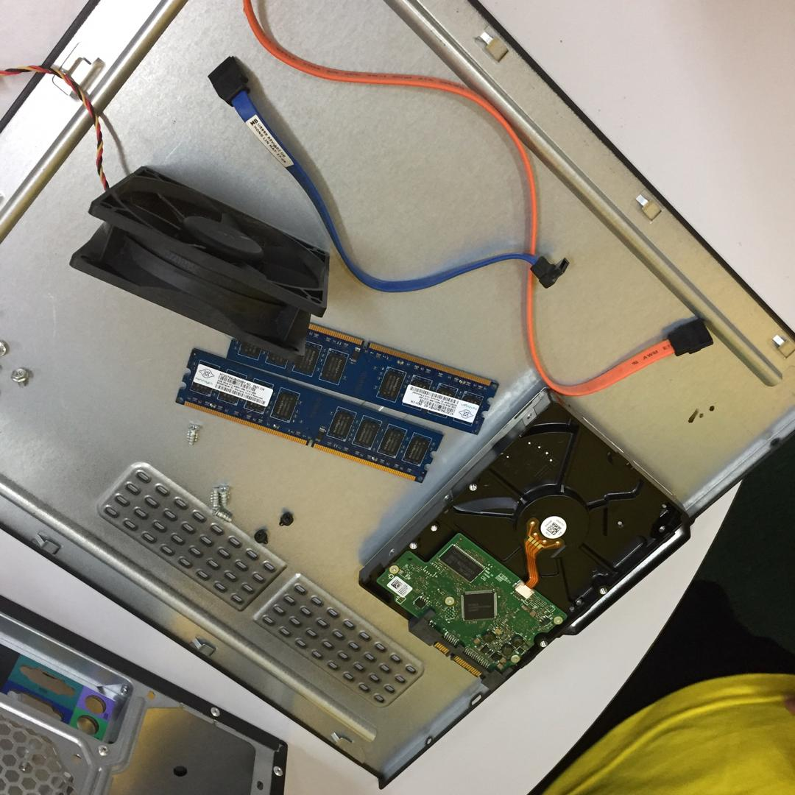 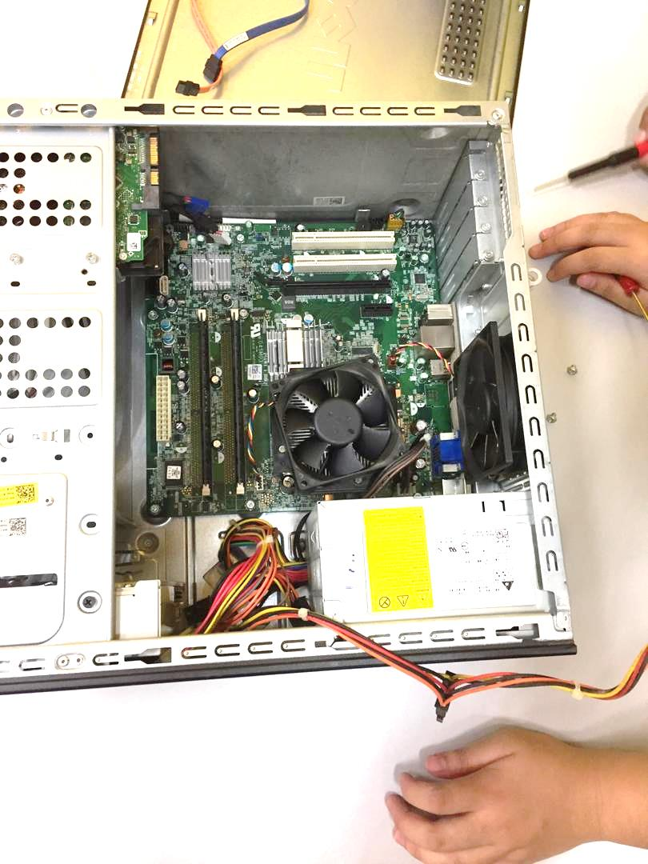

RAM tab

Figured 11: RAM slots

Figured 10: RAM

1. Connecting the cables.

* Connect the 20-pins and P4 4-pin ATX power connector to it’s slot and grasp by it shell.

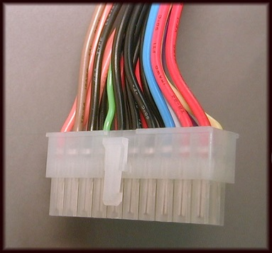 

Figured 13: 20-pins ATX slot

Figured 12: 20-pins ATX

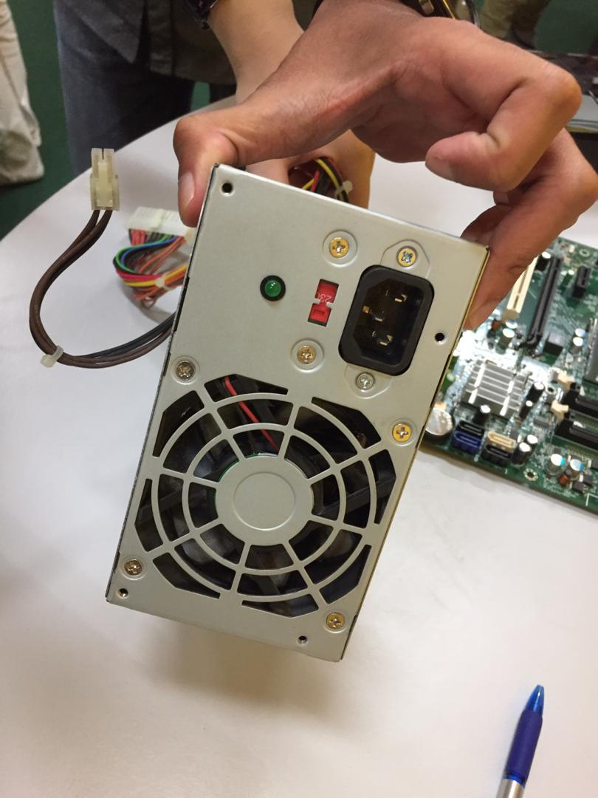 

Figured 15: P4 4-pin slot

Figured 14: P4 4-pins

* Connect the SATA cable to the mainboard and Hard drive (grasp by the shell).

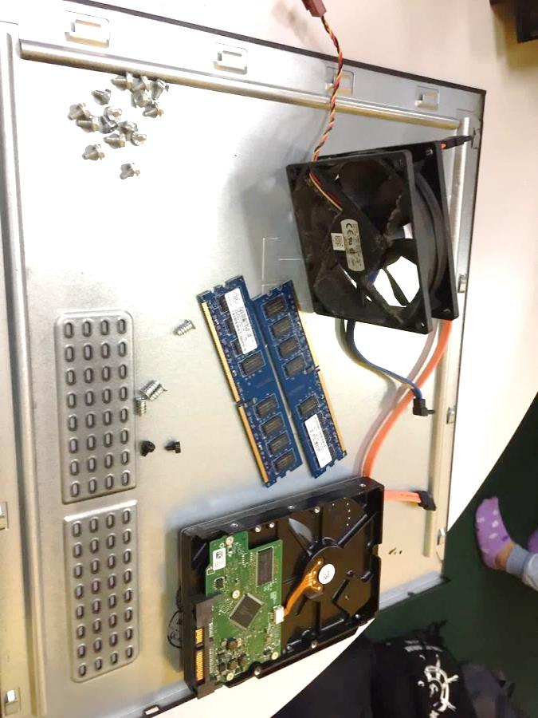  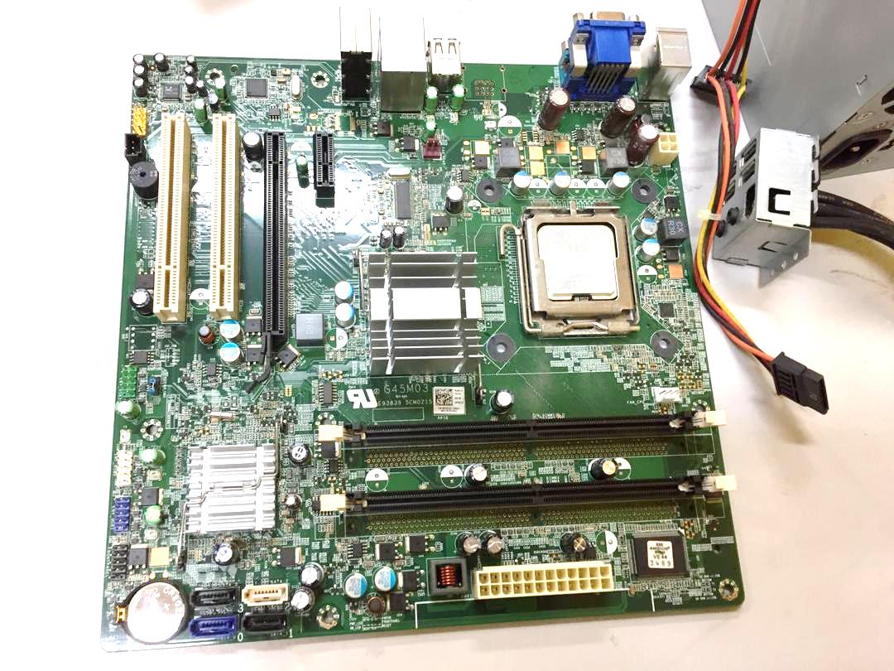

Figured 16: SATA cable

Figured 17: SATA slot

Figured 16: Hard disk drive

* Connect the SATA cable to the mainboard and Optical Drive/CD-ROM Reader.

 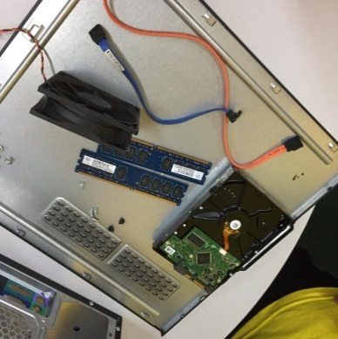 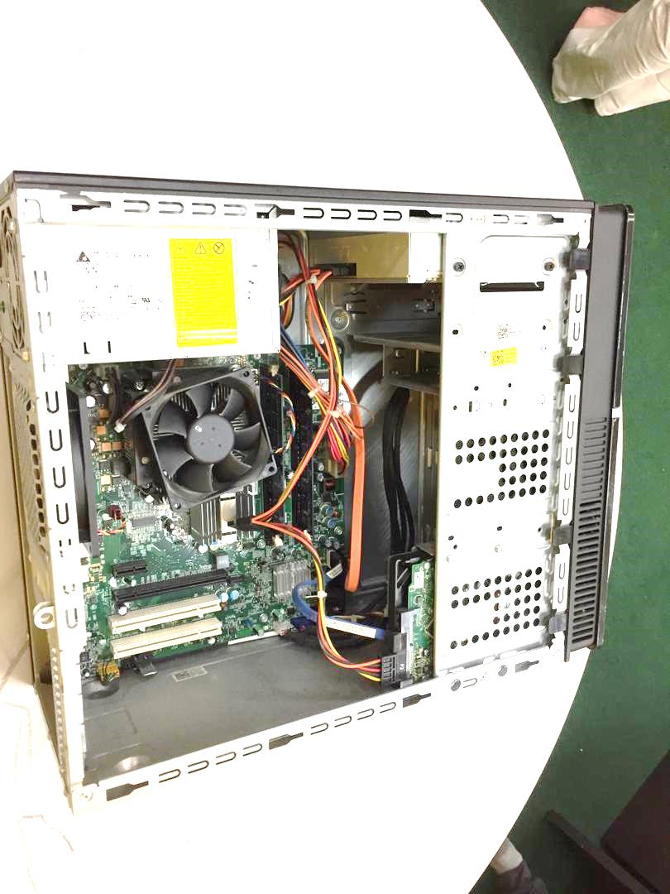

Figured 19: Optical Drive

Figured 18: SATA cable

Figured 17: SATA slot

* Connect all the remainder power connector to each slot on the motherboard.

1. PLEASE double check when the entire steps above are done. If not, please reread again and detect the error.
2. Close the casing wall neatly and try to run the completed PC to the monitor to display the BIOS.

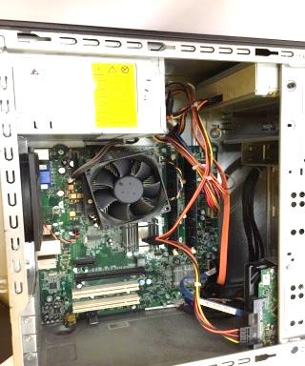 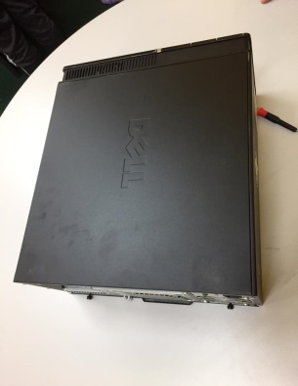 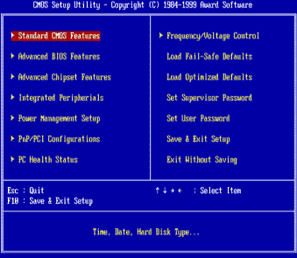

Figured 22: BIOS display

Figured 21

Figured 20: Complete connected PC