

TECHNOLOGY AND INFORMATION SYSTEM

SEMESTER I 2019/2020

SECP1513-02

DESIGN THINKING REPORT GROUP 9 SYSTEM ANALYSIS AND DESIGN

|  |  |
| --- | --- |
| **NAME OF STUDENTS** | **MATRIC NO.** |
| NURUL ALIS ALIA BINTI MOHAMAD ZAMRI | A19EC0141 |
| SAHARULNIZAM HAKIMY BIN SHOBRI | A19EC0205 |
| SHAKIRAH BINTI MOHD SHUKUR | A19EC0159 |
| SHASITHER A/L SANDRAN | A19EC0160 |

**LECTURER** :DR. ARYATI BINTI BAKRI

**SUBMISSION DATE** :**7th** OCTOBER 2019

# Table of Contents

Table of Contents i

Table of Figures ii

Table of Tables ii

1.0 Introduction 1

2.0 Detailed Steps and Descriptions 2

3.0 Phases in System Analysis and Design 3

4.0 Assessment Points 4

5.0 Detailed Descriptions and Evidences of Each Phase in Design Thinking 6

5.1 Empathy 6

5.2 Define 9

5.3 Ideate 10

5.4 Prototype 12

6.0 Team working 15

7.0 Reflections 16

7.1 Nurul Alis Alia Binti Mohamad Zamri 16

7.2 Saharulnizam Hakimy Bin Shobri 16

7.3 Shakirah Binti Mohd Shukur 16

7.4 Shasither A/L Sandran 17

8.0 The Task for Each Member 18

9.0 References 19

# Table of Figures

Figure 1: Six phases of System Analysis and Design. 1

Figure 2: Our log journal. 2

Figure 3: Detailed explanations of phases in System Analysis and Design. 3

Figure 4: Details of assessment points at empathy and define. 4

Figure 5: Details of assessment points at ideate and prototype. 5

Figure 6: Shasither, Shakirah and Saharul interviewing Miss Suraya Ibrahim (on the left). 6

Figure 7: We took a picture with Miss Suraya Ibrahim (third from left) at CICT. 6

Figure 8: Informations about Dr. Rashidah. 7

Figure 9: Shasither and Shakirah interviewing Dr. Rashidah (on the right). 8

Figure 10: We watched the video that we recorded. 9

Figure 11: Problems that we identified. 9

Figure 12: The solutions to every problem. 10

Figure 13: The final ideas that we came up with to solve the problems. 11

Figure 14: Our group members brainstorming to come up with the best solution. 11

Figure 15: Shasither and Saharul designing the user interface of our software. 12

Figure 16: Alis and Shakirah cutting cardboard boxes to make the prototype. 12

# Table of Tables

Table 1: The user interface of our software and its features. 12

# 1.0 Introduction

Design thinking is a methodology that solves problems creatively based on people’s needs. There are 5 phases in design thinking which are empathy, define, ideate, prototype and test.

         System Analysis and Design is the process of developing a new system or analyzing an existing system to make it a more effective and efficient information system. It is an approach used by organizations to create and maintain their information systems that carry out tasks such as keeping track of employees’ information and salary, processing orders and many more. The major purpose of systems analysis and design is to enhance the organizational systems and data management by applying the procedures that can help improve the usability of the system.

               There are six phases in System Analysis and Design (refer Figure 1). All these steps should be followed accordingly to develop an information system that meets the expectations of users. This helps determine how good the system functions and the quality of its output to the users. For this assignment, we are required to investigate about system analysis and design. We need to find out what problems do users face and their needs in system analysis and design. Then, we have to provide solutions to fulfill users’ requirements and lastly make a prototype.

Figure : Six phases of System Analysis and Design.

# 2.0 Detailed Steps and Descriptions

We keep track of our progress and steps by writing a log journal. The detailed steps and progress can be seen in Figure 2.

Figure : Our log journal.

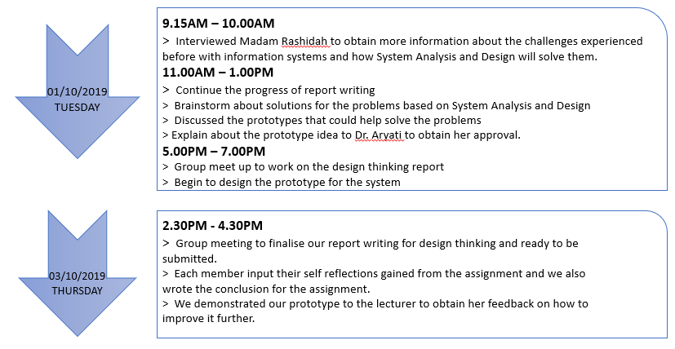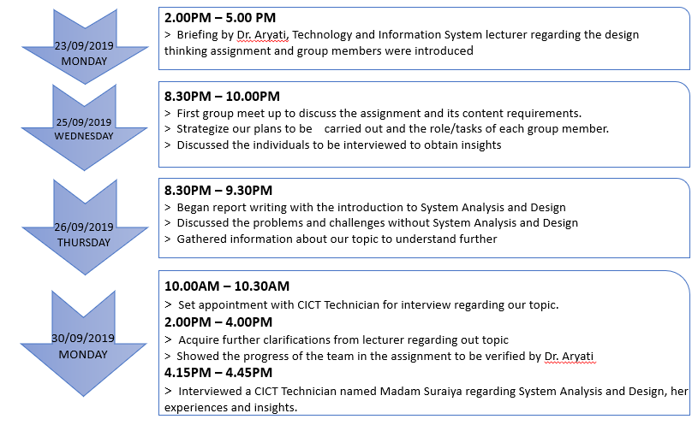

# 3.0 Phases in System Analysis and Design

The six phases in System Analysis and Design are Preliminary Investigation, System Analysis, System Design, System Development, System Implementation, System Maintenance. The detail explanation of each phases are described in Figure 3.

Figure : Detailed explanations of phases in System Analysis and Design.

# 4.0 Assessment Points

The process of assessment and evaluating the project from time to time is a vital part in design thinking. This is because this will enable us to value our own progress in the project and the quality of our work. Assessments are usually done after each phase in design thinking approach to assess the designs’ ability to fulfill the system, functional and operational requirements. Thus, skipping any of the phases will largely impact the system analysis and design task. Therefore, assessment point which are the design thinking phases will help identify whether a system’s ultimate goal of achieving the mission objectives are accomplished or not. Assessment points are can be carried out during the end of project demonstration as well as during the transition between design thinking phases. Details of assessment points at each design thinking phase are described below in Figure 5 and Figure 6.

Figure : Details of assessment points at empathy and define.

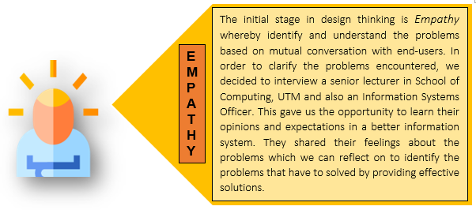

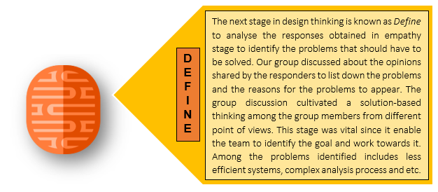

Figure : Details of assessment points at ideate and prototype.



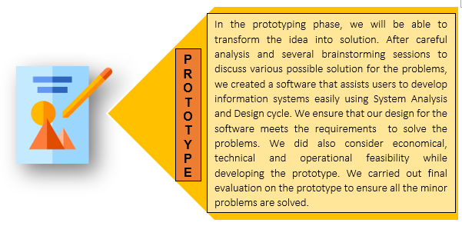

Although the evaluation was done in the prototyping phase, we also assess our progress at the end of each design thinking phase.  During the transition between the design thinking phases, we verified whether me meet the outcomes of each phase in order for us to stay on track towards solving our problems. The final assessment was done at the end of project demonstration to obtain feedback from the end-users on the improvements that can be done on the prototype. Here, the assessment point helps shape our point of view in relation to the user’s point of view.

# 5.0 Detailed Descriptions and Evidences of Each Phase in Design Thinking

There are 5 phases in design thinking which are empathy, define, ideate, prototype and finally testing. In this project we are not required to test our product so the detailed descriptions and evidences of what we do in the 4 phases are explained below. We also filmed our design thinking process and uploaded it on YouTube (https://youtu.be/gf0zWD4XreQ).

## 5.1 Empathy

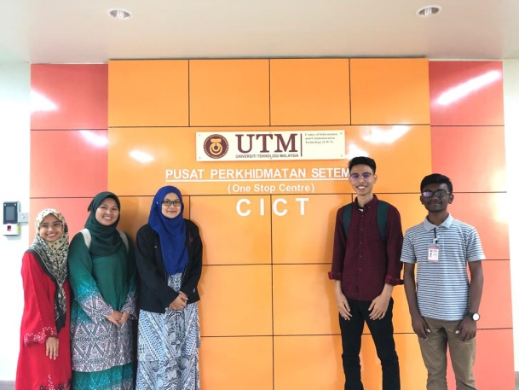We use interview method to collect information based on our topic. We had interviewed one technician, Miss Suraya Ibrahim (Figure 6 and Figure 7). She is an information technology officer at CICT. She has been working at CICT for 9 years. She started working in networking infrastructure then ventured into ICT Business a few years later. She finally moved system development starting 2018. Here is some of our conversations.

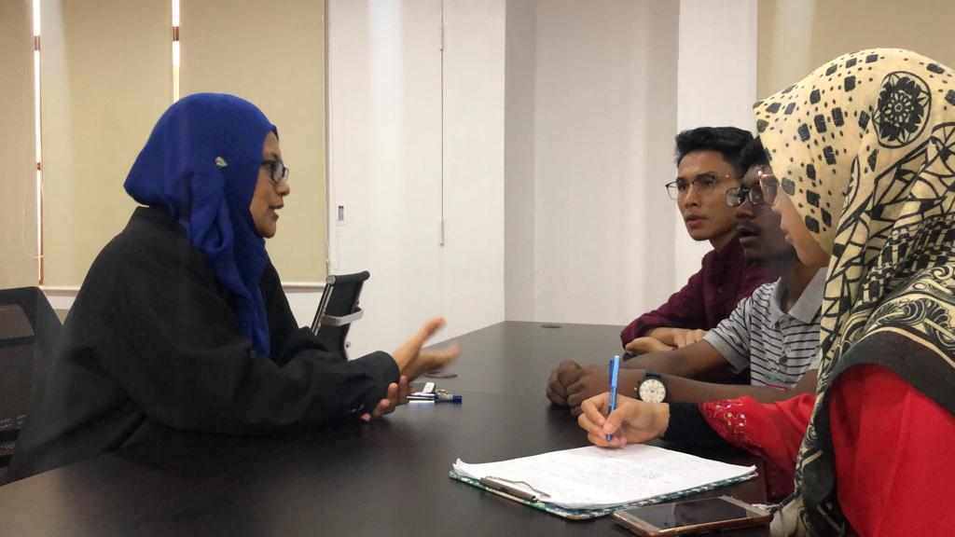

Figure : Shasither, Shakirah and Saharul interviewing Miss Suraya Ibrahim (on the left).

Figure : We took a picture with Miss Suraya Ibrahim (third from left) at CICT.

***Q: How does the data being processed before the system analysis software being built?***

A: Everything being done manually. All the files being kept and a lot of workers needed to complete the process. It is inefficient due loss of document and the difficulty to trace it.

***Q: What is the advantage of using the system analysis and design software?***

A: All the data being centralized and can avoid human error. Efficient and all the process can be settled in a short time.

***Q: What is the most important in system analysis and design?***

A: To collect requirements from product owner, we need to interview and asked them to explain the flow of their process before we can start to analyze and design the suitable system for them. When we had developed the system, we use TAIGA system to allow the product owner to keep track progress of development of the system.

***Q: Which characteristic must have in every system?***

A: Meet client requirement, the security of data, user friendly or easy to handle, have suitable hardware and database.

***Q: What is your opinion about the conversion of the system?***

A: It depends on the old technology whether it needs to be upgraded or need to create a new one. Usually we will have a discussion with client if they want to create a new system. 

Next, we had interviewed a lecturer, Dr Rashidah Kadir (refer Figure 8 and Figure 9). She has been teaching at UTM about 21 years. She specializes in Computer Network and Security.

Figure : Informations about Dr. Rashidah.

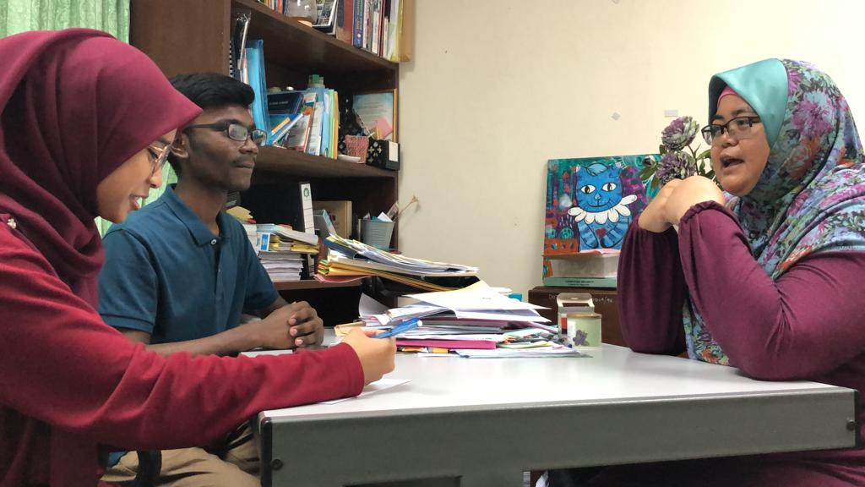

Figure : Shasither and Shakirah interviewing Dr. Rashidah (on the right).

***Q: What do you think about system analysis and design software?***

A: Easy to use and able to conduct a project that has a large number of data.

***Q: What is the difference between nowadays and before the existence of the system analysis and design software?***

A: The different is the way the data being processed and collected. Before, all the system needs to be handled manually but now with a single click everything can be done in a short period.

***Q: What is the disadvantage of having system analysis and design software?***

A: Human fully depends on computer. If the system went down, work will be hard to carry out because all the data being computerized.

***Q: In your opinion, what characteristics should have in a system?***

A: The system must meet user requirements, user friendly and help user to solve their needs.

## 5.2 Define

We sat together like in Figure 10 to gather all the information from the interview and analyze them to identify the problems and user’s needs. We also suggested possible problems faced by users that are not mentioned in the interview. This phase is vital as it enables the team to identify the goal and work towards it. The problems identified are illustrated in Figure 11.

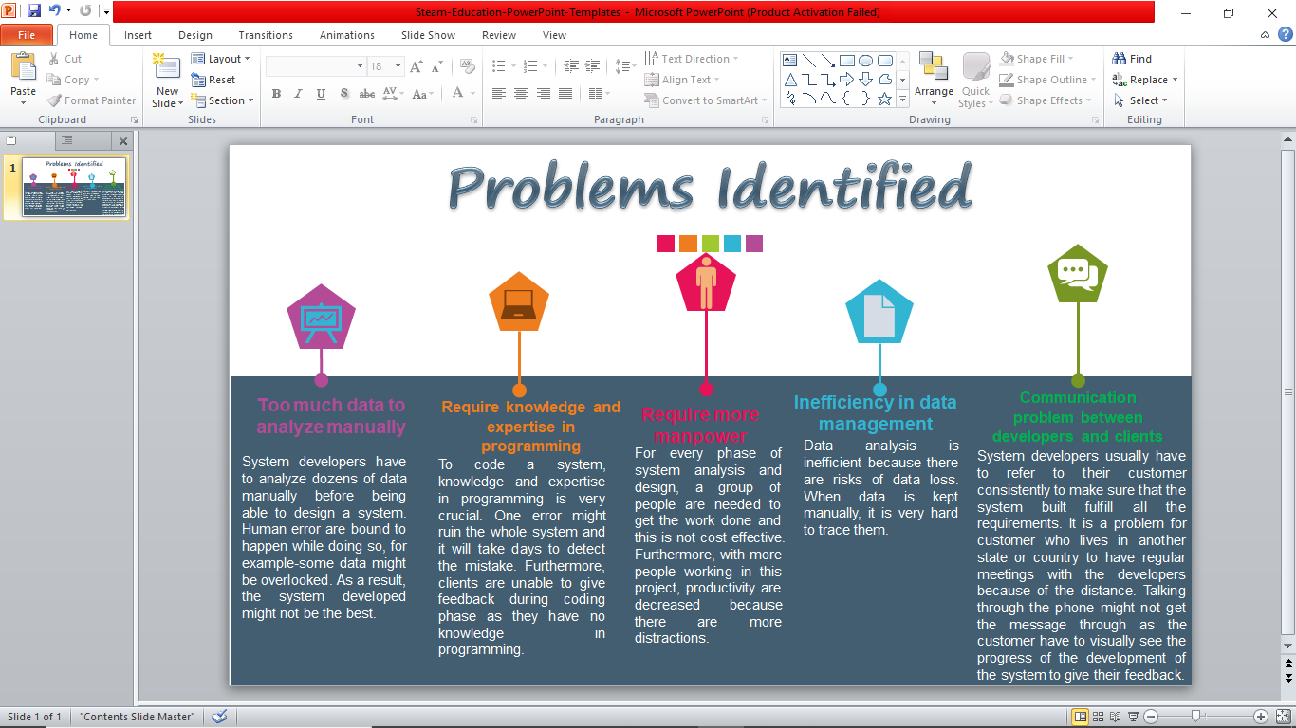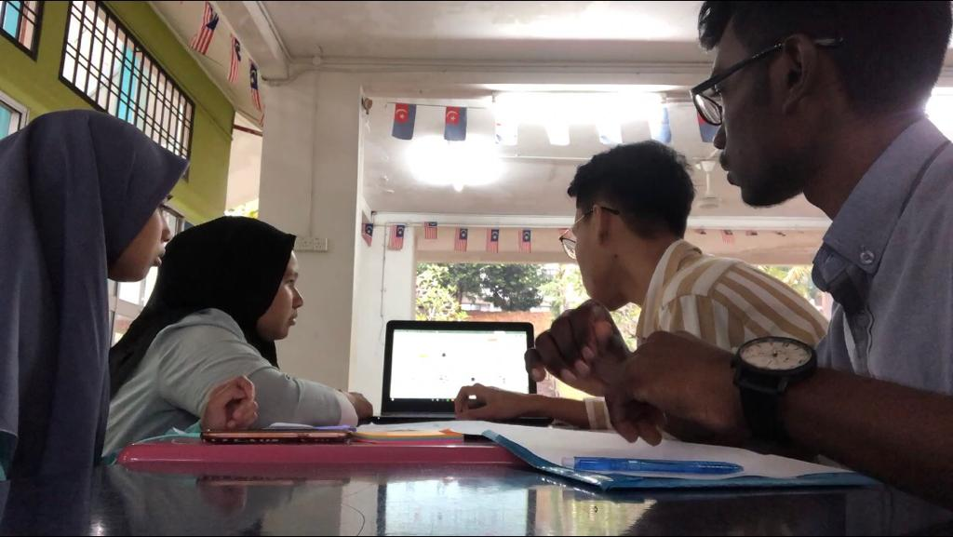

Figure : We watched the video that we recorded.

Figure : Problems that we identified.

## 5.3 Ideate

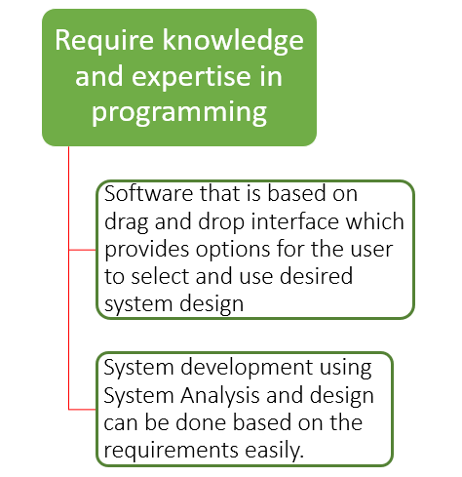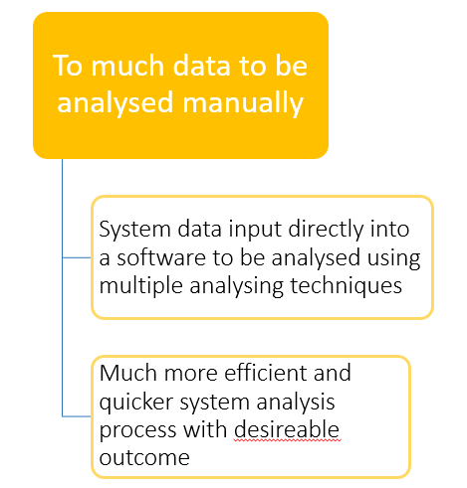In this phase, we utilize the by-product of the define phase which was the problems identifications to come up with ideas to solve the problems. This is a very important phase since this is the breaking point in solving the problems in information systems development. There were numerous ideas from each group members which was then filtered based on user requirements, economical feasibility, technical and operational feasibility. Our group used the sticky notes method to present our ideas (refer Figure 13 and Figure 14). This step is vital because the functionality of the idea could solve each and every problem identified. Through Ideation, we tried to generate ideas for every problem identified (refer Figure 12) in order to solve them as a whole. Therefore, we put in all our efforts to come up with a software that go along with every stage in System Analysis and Design to guide the users in developing information systems.

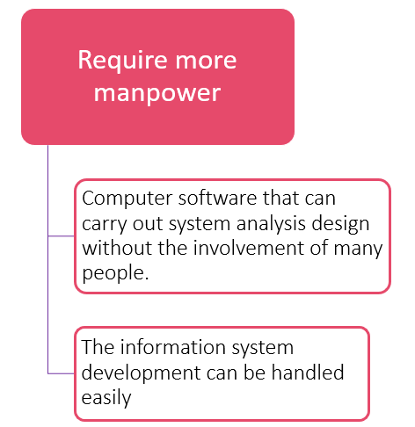

Figure : The solutions to every problem.

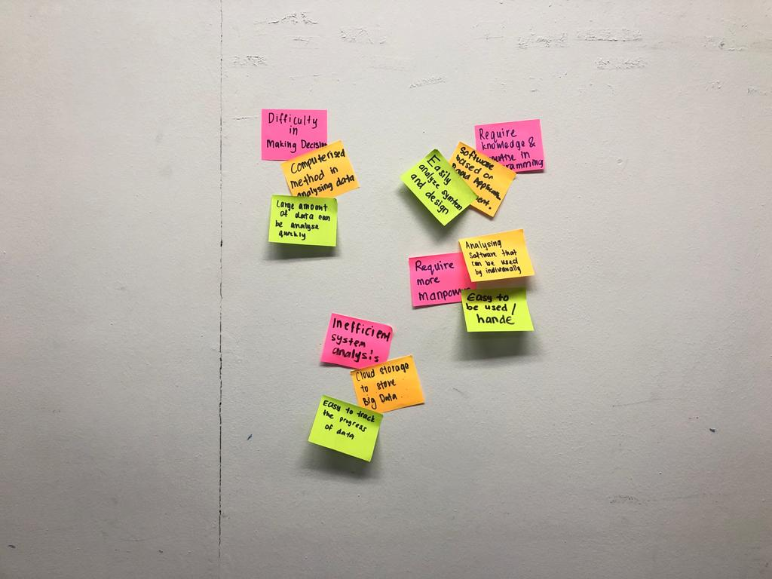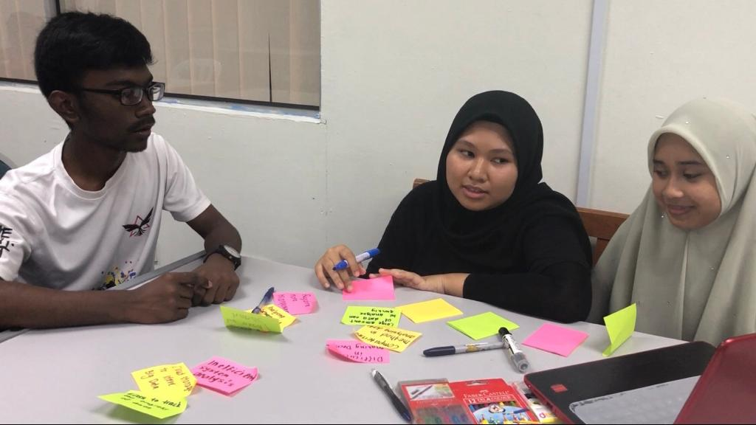

Figure : The final ideas that we came up with to solve the problems.

Figure : Our group members brainstorming to come up with the best solution.

## 5.4 Prototype

In this phase, we create a software that can carry out all the 6 phases in system analysis and design which are preliminary investigation, system analysis, system design, system development, system implementation and system maintenance. We create the monitor by using cardboard boxes and cellophane tape (refer Figure 16). The user interface is created using Microsoft PowerPoint (refer Figure 15) and printed out. The user interface and its feature are illustrated in Table 1.

When the prototype is done, we test it out to make sure it fulfills all the requirements.

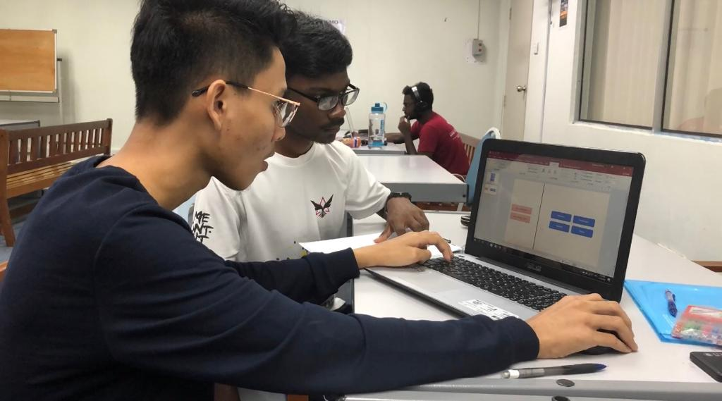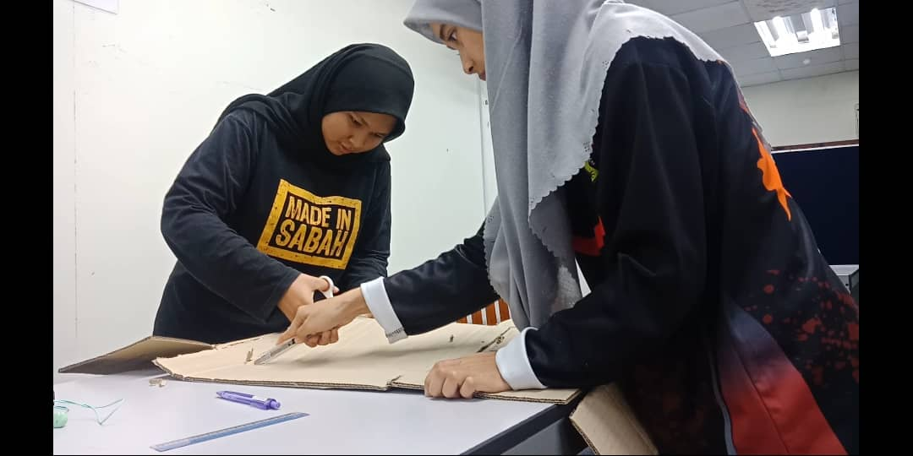

Figure : Shasither and Saharul designing the user interface of our software.

Figure : Alis and Shakirah cutting cardboard boxes to make the prototype.

Table : The user interface of our software and its features.

|  |  |
| --- | --- |
|  | This is the home page of the software. User can create a new project or continue an ongoing project that is displayed on the yellow honeycomb icon. User also can share their progress with their client anytime by sending link of their project. |
|  | User can choose the suitable type of the system they are developing. User also can insert the data that they already have by clicking the “Open data source” icon. |
|  | User can choose how to analyze their data. |
|  | User just needs to drag and drop to design and develop their system. |
|  | User can choose which type of system conversion they want to carry out. The software will then help user by giving instructions on how to carry them out. |
|  | The software provides a few maintenance services to help user maintain and enhance their system to work efficiently. |

# 6.0 Team working

During the empathy phase, we discussed and decided on the questions to ask during the interview. In order for the interview to run smoothly, tasks like asking questions, filming the interview session and taking notes are divided evenly among our group members. For the define phase, we watched the interview video and read through the notes taken together to identify the problems faced by the two individuals. Some group members also gave suggestions about the problems they thought are crucial in System Analysis and Design. After that, we listed down all the problems. Next, we brainstormed together the solutions for the problems listed. Everyone in the group gave different useful ideas. We considered all of them and finally chose the best solutions. Lastly, two of our members built and decorate the prototype together by using cardboard boxes and cellophane tape. At the same time, the other two members designed the user interface for our prototype by using Microsoft PowerPoint. We divided our works so that the prototype can be done in a shorter time.

# 7.0 Reflections

## 7.1 Nurul Alis Alia Binti Mohamad Zamri

After graduating with a degree in Data Engineering, I wish to be involved in the industry for a few years to gain experience and further my studies to broaden my knowledge. After that, I hope that I can contribute to the development of big data technology and perhaps solve some challenges that are faced by big companies now. From this design thinking project, I gained a lot of knowledge and experience. I get to improve my social skills by interviewing people and interacting with my group mates. Other than that, design thinking taught me to think critically to solve a problem. I realized that to achieve my dream is not easy, I need to equip myself with important skills such as design thinking skills and more. To make myself more employable and to appeal more to companies I will try to be an all-rounder who has all the necessary skills.

## 7.2 Saharulnizam Hakimy Bin Shobri

Studying this course related to Data Science make me want to make a better future for human with a better life for mankind. Data Science is as important as technology is for mankind. Design thinking gives great impact on my dream as I get to know a proper and more efficient way on how to manage and run a project. I also plan to start training by doing work even faster then before because it is important and essential to do work in short time. Also, a better teamwork also needed to be trained because in career field we do not work alone and we require communication to work either with colleague or client.

## 7.3 Shakirah Binti Mohd Shukur

My goal in this course is I want to gain more knowledge and have more experience in this field. This will help me in understand more about this course. So, I will be able to set a proper future. Design thinking help me to solve a problem. By following each of the steps help me able to think out of the box and try to do new things. It also allows me to build self-confident in handling each of the task especially my soft skills. Hence, I will try to be more confident to achieve my goals in life.

## 7.4 Shasither A/L Sandran

My desire is to create a system that is easily accessible and user-friendly. This will enable the users to have  a seem less experience in using the information system. There are various benefits of developing a good information system. Information systems are vital in improving the efficiency of business operations for maximum profitability. Efficient information systems are able to process more data and outputs valuable and accurate information for an organization. Next, the information systems developed should provide the right tools for individuals to enable them monitor, plan and forecast business strategies. Improved decision-making skills will provide the individuals to make the right decision at the right time for their business purposes. Besides, safe and secure information systems are also a must and part of my goals. Systems users should be able to securely access their personal information without any potential data leakages. Utilizing system analysis and design procedures will enable the development of information systems occur more easily.

Design thinking was a really helpful formula that helps development of information systems to be user-ready and full fill all its requirements. The design thinking approach which consists of Empathy, Define, Ideate, Prototype and Test phases help create systems which are technologically feasible, economically viable and increases the human desirability towards making their lives easier. It is also proven that systems developed based on design thinking has outperformed the other systems. Design thinking impacted on my dreams in various ways such as it enables me to look into problems in different perspectives to generate better and effective solutions. Design thinking process which involves brainstorming and generation of new ideas do also help broaden my knowledge horizon. On the other hand, design thinking makes it easier for me to understand the core objectives of the system and potentially develop systems which meets user expectations.

In order to take full advantage of design thinking to improve my potential in the industry, I have to completely understand and integrate every phase in design thinking into information system development. Every phase in design thinking has a significant value which adds to the quality of information system that is being developed. Therefore, I have to be very knowledgeable about different things related to System Analysis and design. Continuously gaining knowledge and experience is the key to potentially improve in this industry. The rapid transformations in technology expect people to adapt to the change continually. Design thinking is not just a trend that will fade away in a month. It is definitely gaining some serious traction, not just in product companies, but also in other fields such as education and science. Thus, it is very important to work hard to improve my potential in the industry.

# 8.0 The Task for Each Member

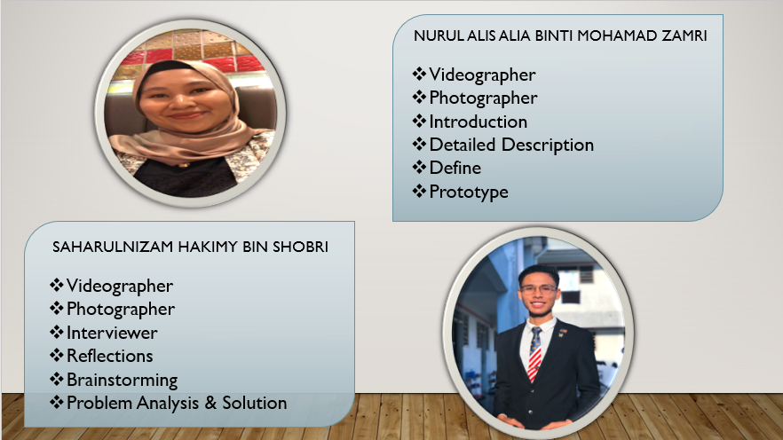

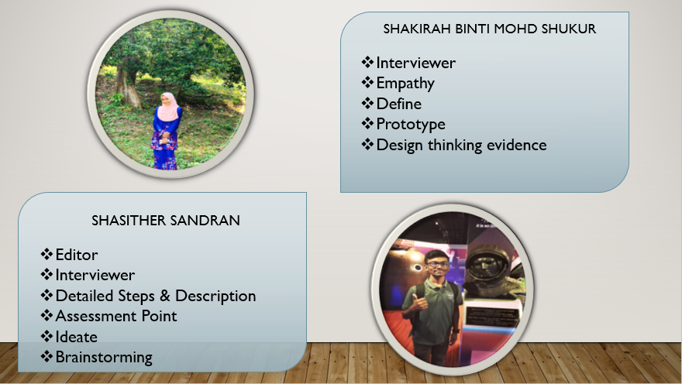

# 9.0 References

1. Dam, R., & Teo, S. (2019, September 14). *5 Stages in the Design Thinking Process*. Retrieved October 2, 2019, from Interaction Design Foundation: https://www.interaction-design.org/literature/article/5-stages-in-the-design-thinking-process
2. Shah, B. (2008, September 12). *Stages of System Development Life Cycle (SDLC)*. Retrieved October 5, 2019, from System Analysis & Design: http://systemanalysisanddesign.blogspot.com/2008/09/stages-of-system-development-life-cycle.html
3. *Systems Analysis and Design (SAD) Tutorial*. (n.d.). Retrieved October 5, 2019, from W3 Computing: https://www.w3computing.com/systemsanalysis/
4. Thakur, D. (n.d.). *What is system maintenance? What are its different types*. Retrieved October 3, 2019, from EComputer Notes: http://ecomputernotes.com/mis/implementation-and-evaluation/what-is-system-maintenance-what-are-its-different-types

Link our video: https://youtu.be/gf0zWD4XreQ