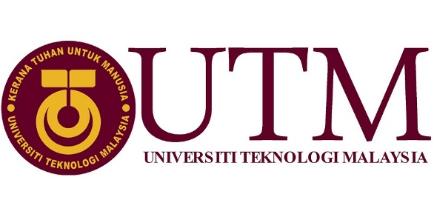

**SCHOOL OF COMPUTING**

FACULTY OF ENGINEERING

INDUSTRIAL VISIT 1 – CICT UTM REPORT

PREPARED BY:

1. YASMEEN BINTI ABU BAKAR
2. NADIAH BINTI MOHD HANIM
3. AMIRUL SYAFIQ BIN MOHD QISTI
4. HAMZEH

1.0 Introduction and Details of Journey

On 12th October 2019, we had our first industrial visit regarding this course. The industrial visit was held at Perpustakaan Sultanah Zanariah, Universiti Teknologi Malaysia. In the library, there is a CICT Gallerium which was the place that we visited. The purpose of this visit is to expose the students about the revolution of information technology since UTM was established. In the gallery, there were a lot of antique technologies that have been contributing to the students and staffs of UTM. Our visit was guided by Mr. Mohd Zahari Zainal Abidin, the assistant IT officer of CICT UTM. He shared a lot of informations on how UTM organize the network system. During the visit, all members paid full attention to the briefing. In order to ensure that every information were accurate, we made sure to record the briefing. We also took some pictures of the antique technologies that have been used by UTM before.

2.0 Detailed Descriptions

2.1 Organization Structure

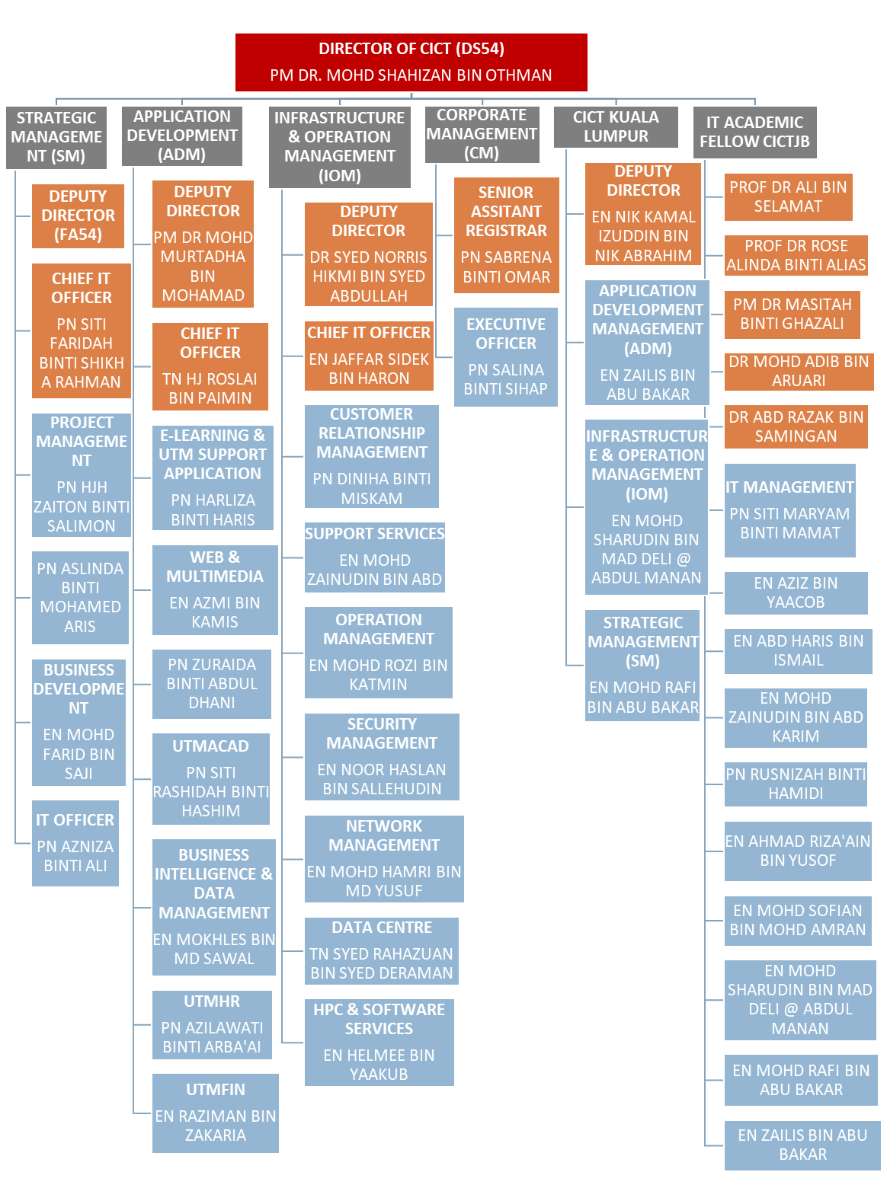

2.2 History Component

Throughout history, humans needed a way to record the important information and events that happened in their time. The human kind used a lot of ways to record information, starting from the writing on animal skins as well as the clay slabs , then with the time and the increasing of the information amount the humans started discovered and develop new ways to record data ,they discovered the papers and they use them for centuries until they reach the time that they needed an efficient technology instead of papers, so therefore they create computers and the storage devices. Storage device went through a lot of changes and development during the last 50 years. UTM as one of the biggest universities in Malaysia that has over 20 thousand students, they needed an efficient ways to record the store the students’ data , so they used the benefits of the storage devices and the keep pace with the development of the storage devices.In this timeline we will go through the history of the data storage in “UTM Centre for Information and Communication Technology (CICT)”

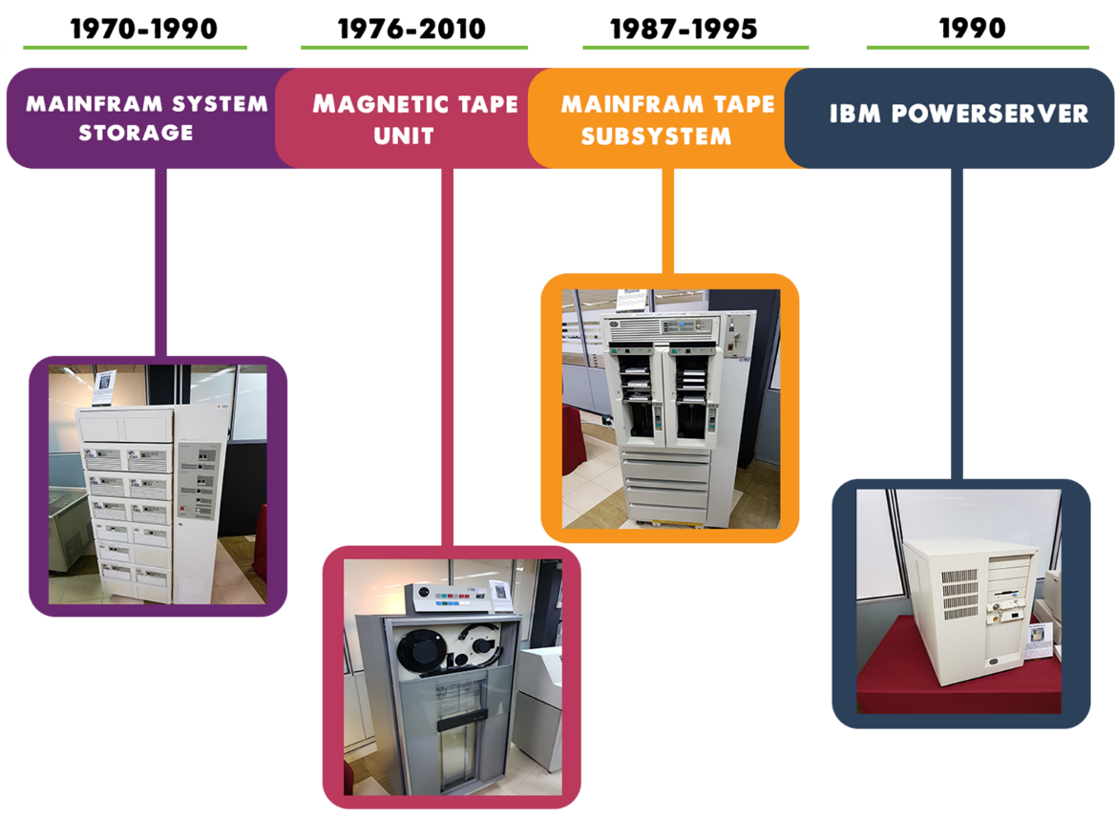

**Mainframe system storage**

The usage of mainframe system at UTM began in the 1970s at computer center, UTM campus, Kuala Lumpur. It served as a data control of students and staff information. The mainframe has been used for almost 20 years for various components and functions such as processing, storing ,securing, and printing the University's information data.

**Magnetic Tape Unit**

The magnetic tape unit was used as a 'back up' for the mainframe system and information database of staff and students as well as others University's information system during the year 1976 until 2010.Initially, this model used around shape tape before converting to a square shape tape.

**Mainframe Tape Subsystem**

The mainframe tape subsystem was used as a 'back up' for the mainframe system and information database of staff and students as well as others University's information system during the year 1987 until 1995. This model used a square shape tape after the round tape was no longer in use.

**The IBM 550 Poweserver**

The IBM 550 Poweserver boasted an outstanding performance with its fastest chip in the world during the 1990's technology. It was considered as an apt system for a medium-sized database at the time.In relation to the Library's technology. the application of the library management system on a 'freeze' terminal which operated on a Mainframe wa seen as the starting point of the information technology evolution and played a great impact on UTM library's history.

2.3 Information System Developed

1. Typewriter

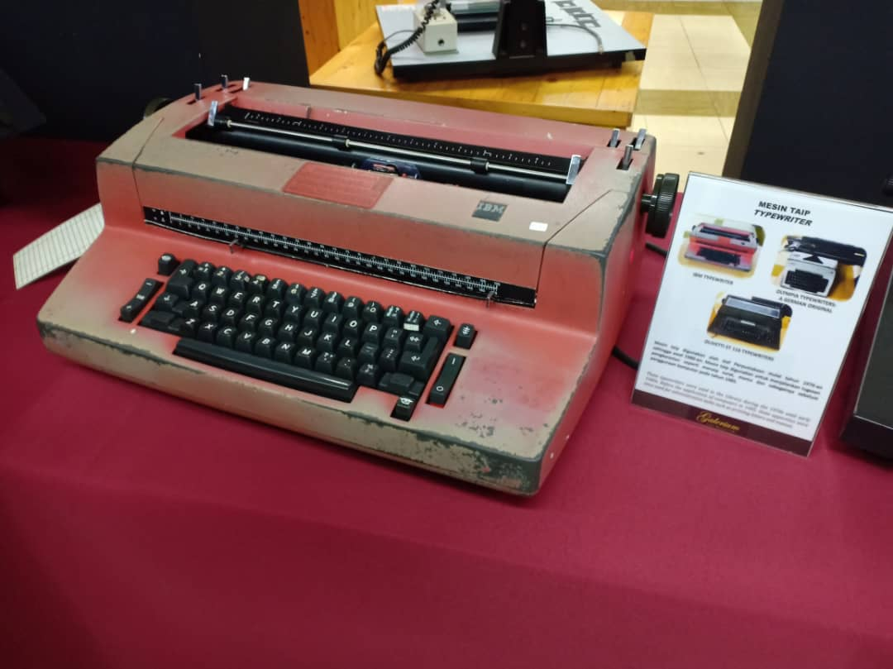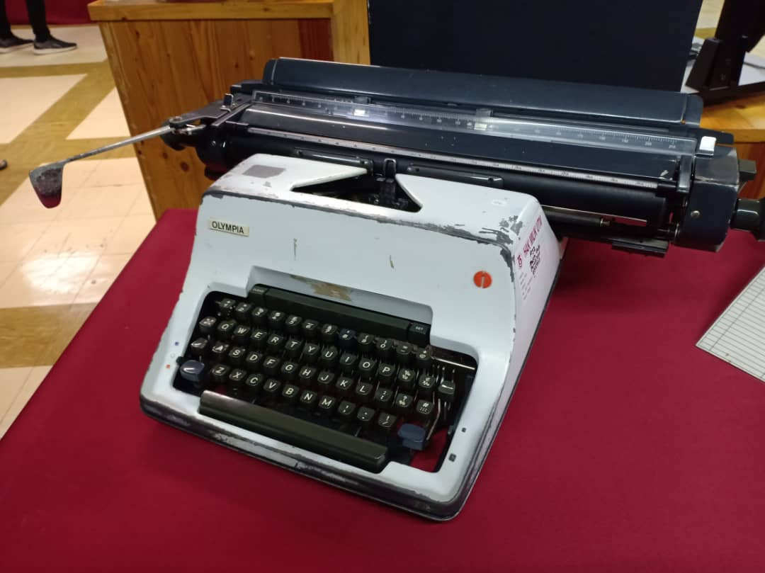There were three types of typewriters that were displayed at the gallery. They have IBM typewriter, Olympia Typewriter: A German Original and Olivetti ET 116 Typewriter. These typewriters were used by the staff’s library during the 1970s until early 1980s. These technologies were used for administrative tasks.

Figure 1: IBM Typewriter

Figure 1.1: Olympia Typewriter, A German Original

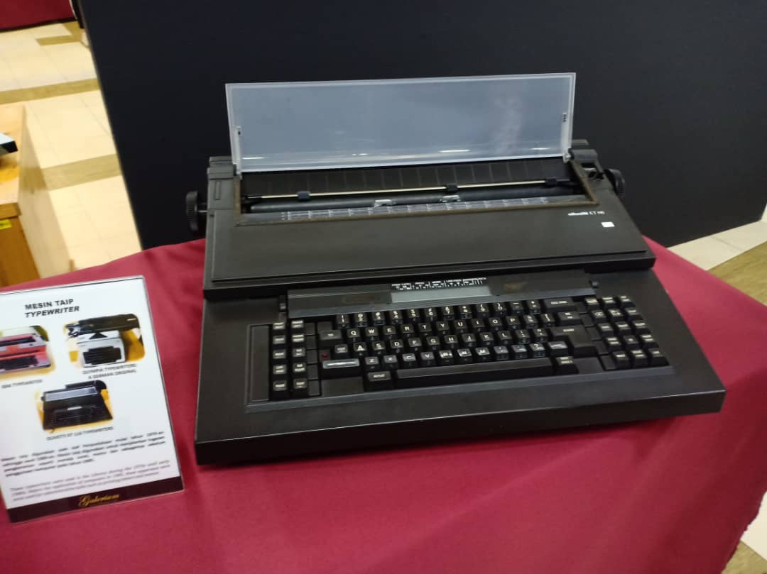

Figure 1.2: Olivetti ET 116 Typewriter

2.Image Magnifying Machine ‘Dunco 67C Model’

The ‘Film Enlarger’ is a device used to increase the size of images to produce photo prints from a negative film. It could be adjusted according to a preferred image size. This device was only used in the dark room to prevent light from entering. It was firstly used in UTM Library around 1985.

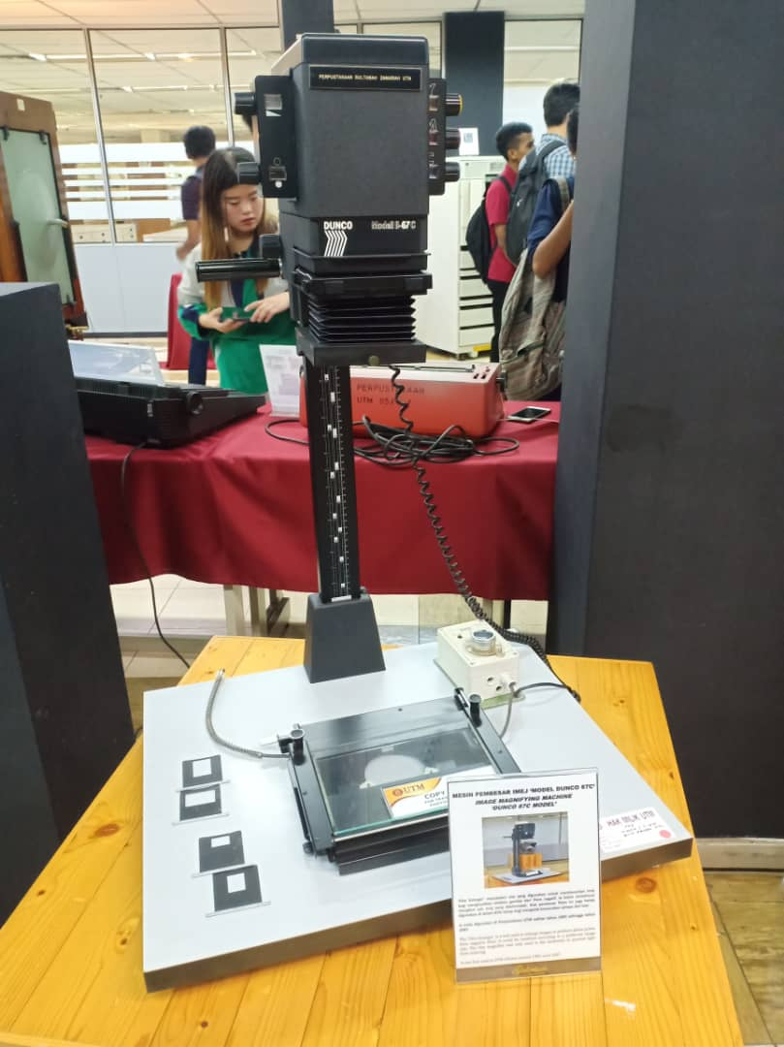

Figure 2: Dunco 67C Model

3.Time Control Device ‘Gralab Model’

This device is also called ‘Darkroom Timer’. The device is a time control tool used in the darkroom. The time control process was carried out during the process of soaking the microfilms manually int the chemical solution. This tool was needed to control the period of soaking according to the procedure in order to ensure the quality of the microfilm.

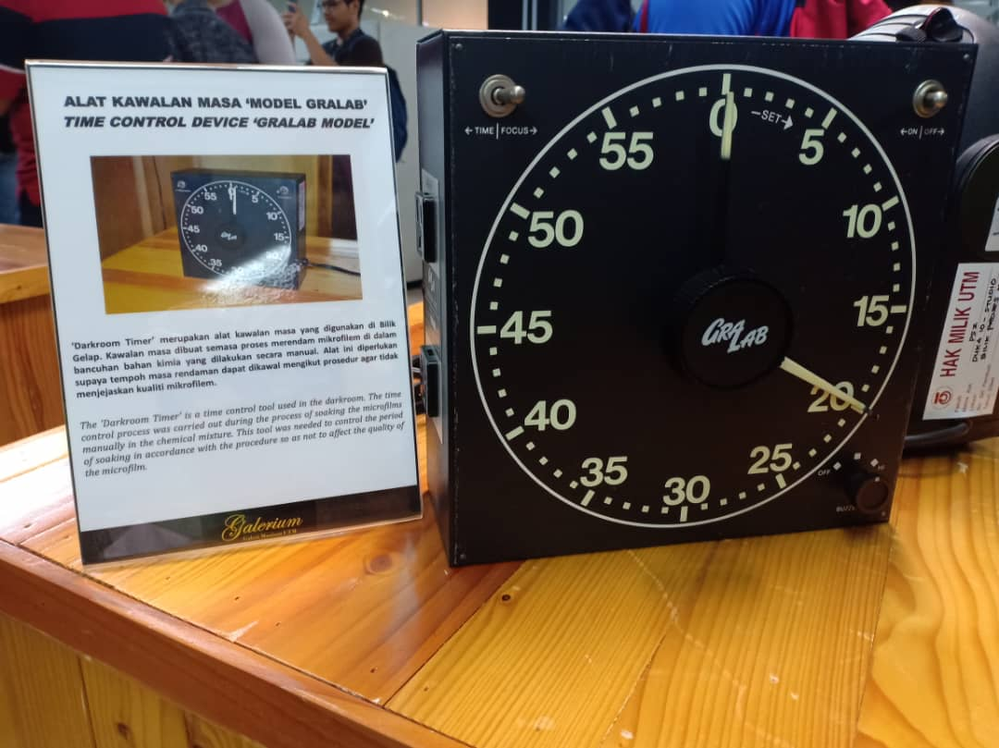

Figure 3: Gralab Model

4.Microfilem Camera ‘Zeutschel OK 102 Model’

This device is a high accuracy camera used to photograph small images in UTM theses. The images were recorded into microfilms or microfiche. This device was firstly used in UTM Library in 1986.

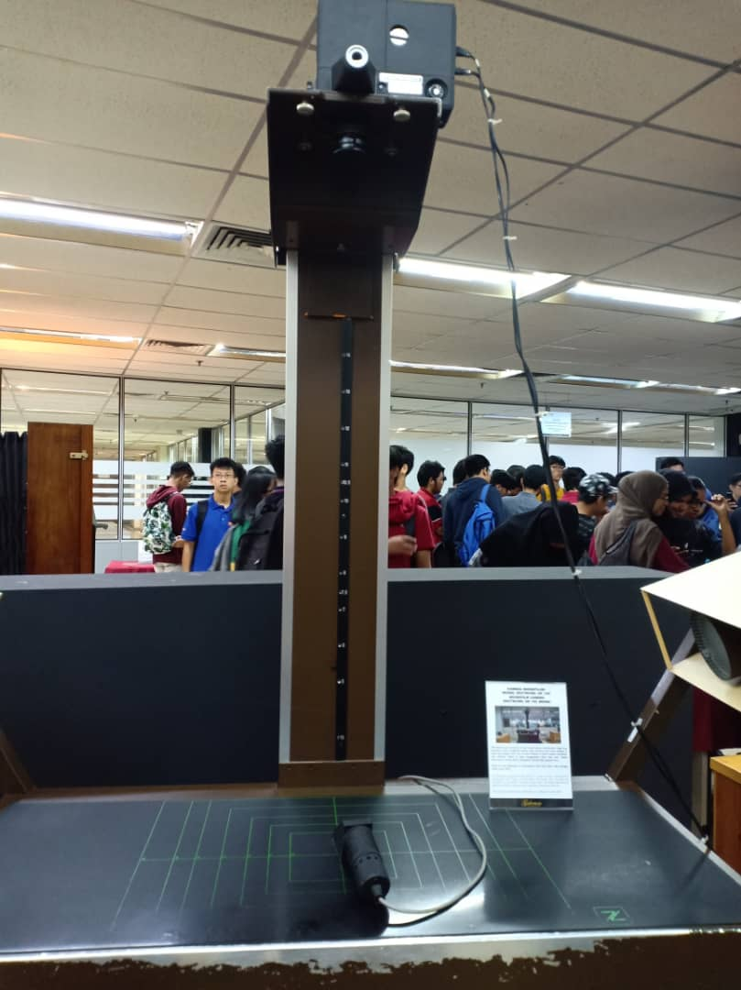

Figure 4: Zeutschel OK 102 Model

5.Microfilm

A microfilm is a media item which was actively used as a learning and reference medium in UTM back in the 1980s. it used a special 35mm size film and was stored in boxes for storage. There are almost 15,000 titles of microfilms in UTM Library collection. The microfilming process was carried out to duplicate theses and research project. This is to preserve the security of the intellectual property and to ensure the primary source of information can still be referred. The microfilm collection is stored in an environmentally controlled storage at the Media Materials Room, UTM Library.

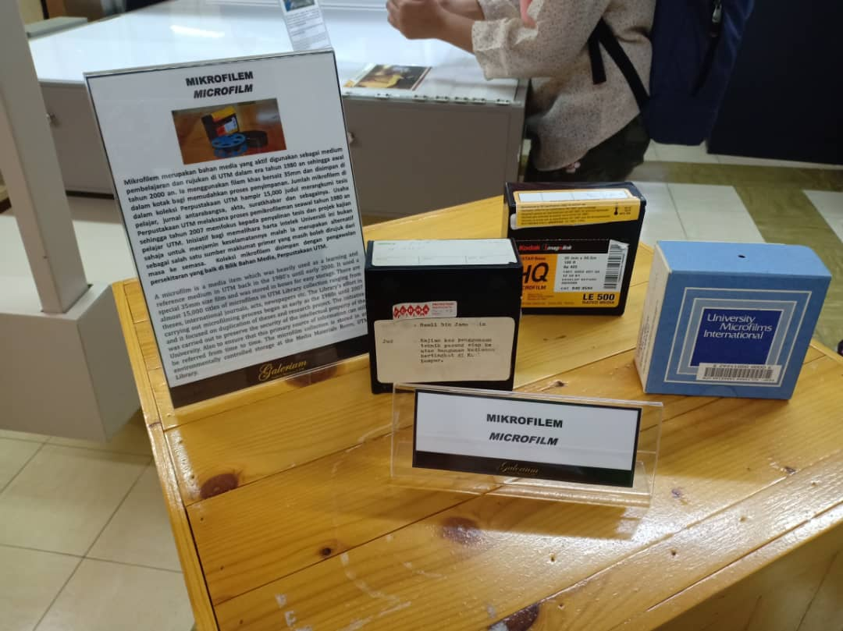

Figure 5: Microfilm

3.0 Achievements

1. Anugerah UTMFin SAGA Compliance (AG), 22nd November 2017

CICT UTM fulfilled many criteria required to obtain this certificate. The criteria are integration between systems, secured data safety and user access control. This achievement has made UTMFin innovation product recognized by the National Accountant

1. Persijilan Rekabentuk Datacenter Tier3, 1st Disember 2017

The strategy that CICT UTM took to achieve this certificate was having a data centre with a redundant infrastructure where any maintenance done on the equipment will not interrupt other ICT services.

4.0 Reflections

In this course, we hope that we can widen our knowledge in information systems and technology. They are used a lot in our daily life, especially in helping our studies. In addition, we also want to learn the history of technologies that we currently have and how they have improved from the past.

Industrial visit to CICT had helped us fulfill our goals. In the exhibition, we learnt about a lot of technologies that were used by UTM in past. Being there were great experience as we get to see the technology that we had learnt in the class theoretically. For instance, we learnt about the server and supercomputers. Moreover, there were some technologies in the exhibition that we never see or even know that they existed before. The revolution of technology has made people forget the past technology. As computer science students, it is crucial for us to know and understand about the past technology in order to improve and bring the technology to the next level for a better future.

Looking forward for our future, in order to improve our potential in industry, we must always be up to date with the latest development of technology which can be done by attending conferences and having industrial visit. Apart from that, we need to know various programming languages such as Java, C++ and Python. This is to gain more work opportunities as the more languages we know, the higher chance we will have to get employed. Lastly, we will need to contribute in open- source projects to build our credibility in this area.