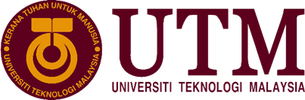

**UNIVERSITI TEKNOLOGI MALAYSIA**

**JOHOR BAHRU (UTM JB),**

**81300 JOHOR BAHRU,**

**JOHOR**

**SCHOOL OF COMPUTING**

FACULTY OF ENGINEERING

**REPORT: Center for Information and Communication Technology (CICT) Visit**

|  |  |  |
| --- | --- | --- |
| **Name** | Lim Sin Jie | A19EC0073 |
| Anis Farzana Binti Ismail | A19EC |
| Chan Yi Lin | A19EC |
| Rakesh A/L Kannapathy | A19EC0153 |
| **Course Code & Name** | SECP1513/SCSP1513 – Section 03 (SECJ)  Technology & Information System | |
| **Lecturer** | Dr Haswadi Hassan | |
| **Submission Date** |  | |

**Table of Contents**

|  |  |  |
| --- | --- | --- |
| No. | Content | Page |
| 1.0 | Introduction | 3-5 |
| 2.0 | Details of Descriptions | 6-8 |
| 3.0 | Reflections | 9 |
| 4.0 | Task of Each Member | 10 |
| 5.0 | Evidence |  |

1. **Introduction**

**Detail of visits**

The industrial visit for Technology and Information System course was conducted at 3.15pm on 21 October 2019. We were supposed to have a visit to Centre for Information and Communication Technology (CICT), but since the gallerium in CICT had been moved to PSZ, we ended up visiting PSZ, Perpustakaan Sultanah Zanariah, University Technology Malaysia. The industrial visit was a program held for first-year students from School of Computing to introduce them about CICT. During the visit, we had been given a talk on CICT background and their services.

**Detailed Descriptions about CICT**

CICT is a unit that provides ICT services to meet the needs of university especially for staffs and students in ICT infrastructure, system development and academic or administrative activities.

1. Organization Structure

The Chief Information Officer or Director of CICT is Professor Madya Dr. Mohd Shahizan Bin Othman. For infrastructure and operation management, Dr. Syed Norris Hikmi is the deputy director and Mr. Jaffar Sidek as the chief IT officer.For application development management, Dr. Mohd. Murtadha Mohamad serves as deputy director, Mr. Roslai Paimin as chief IT officer and Mr.Sharul Ismail as IT officer for security. Also, Ms. Siti Faridah is the chief IT officer for strategy management.

For more details, please refer to the figure below in page

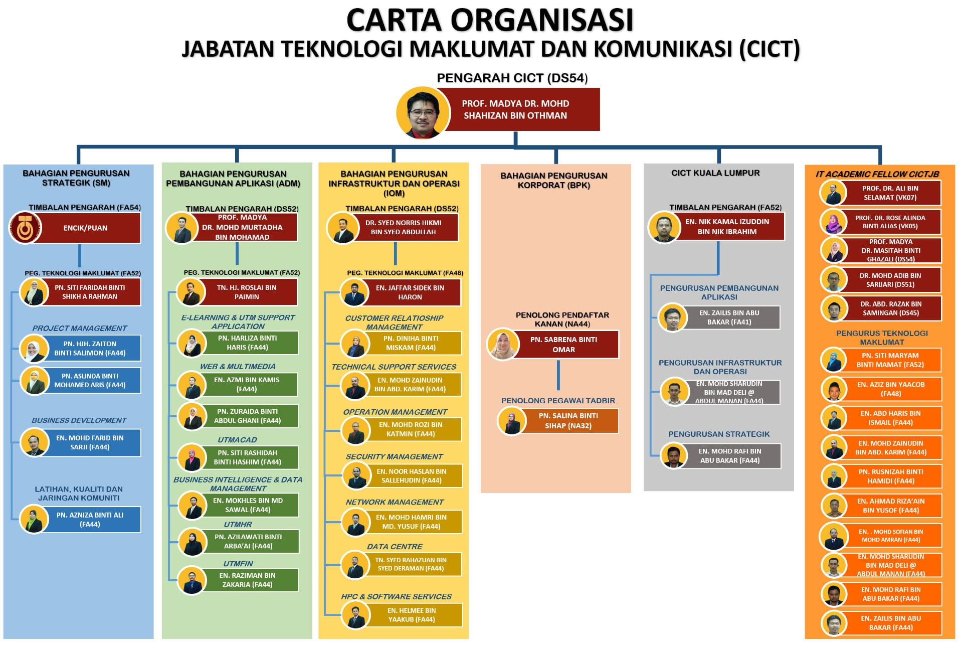

1. CICT services

The services provided by CICT include internet, infrastructure and security, application development, web management, software and ICT support. Firstly, internet is a globally interconnected computer networks in which internet protocol suite (TCP/IP) is used to transmit data via a variety of media, so it enables staffs and students of UTM to have access to internet which eases them in doing all sorts of works. Next, for infrastructure and security, students and staffs will have ACID ID which is a unique ID to log into the university systems, so students can get their own ID after registration and staffs can apply ACID account with an official mail account UTM, which is another feature of it. Next, ICT security, high performing computing, video conferencing and streaming are included. Besides, for application development, administrative, support, multimedia, teaching and learning applications for web and mobile are developed and maintained. Also, mobile apps such as UTMSmart and GuideMe@UTM are built for convenience of students and staffs. For web development, CICT offers web development which includes theme or template design, building domain name or URL, website development and so on, hosting services for conference, association and events with affordable prices and intranet portal. Furthermore, since licensed software is encouraged, CICT is responsible for providing Microsoft’s software by Ministry of Education for free. Last but not least, CICT is accountable for ICT support within UTM.

1. Achievements

In 2017, CICT team was successful in preparing the technical document and thus was among 59 from 416 agencies that had been awarded with SAGA (Standard Accounting System for Government Agencies) by Accountant General Departments of Malaysia.

1. Information System by CICT

There are a few information systems developed and maintained by CICT which include UTM Acad, UTMFin, UTMHR, eLearning and UTM support system. UTM Acad is about the applications for undergraduate and postgraduate students and UTMFin is related to financial management system which includes main financial processes or online payment system. UTMHR means Registrar Office system services. UTM support system is about eLearning, Opencourseware, eReservation and so on.

1. **Detailed Descriptions**

Detailed descriptions include the history component related to computing as show in the Gallerium, PSZ.

|  |  |
| --- | --- |
| IBM Personal System/2 Model 70 386 | It has a high-density memory technology and a series integration functions which enable it to outstandingly support the library in performance improvement for desktop operation and suitable with the most software products needed in UTM Library. |
| Mainframe Tape Subsystem (Model: 2BM9309) | It was used for back up mainframe system and information data base of every member of UTM and UTM information system for 8 years from year 1987. |
| Magnetic Tape Unit | It has the same features as Mainframe Tape Subsystem and was used during 1976 until 2010. |
| IBM 550 POWER server | It had possessed an excellent performance, due to its fastest chip in the world, and was an apt system for a medium sized data base during 1990’s technology. It was used in the library management system on operating the mainframe which was the starting point of the information technology evolution and this affect much in UTM Library’s history. |
| Film Copy Machine ‘Extek 2101 Model’ (Silver Film Duplicator) | It was used in producing negative to positive microfilm copies which negative copies are reference for users and positive copies are stored in UTM Library. This caused the master copy of UTM thesis is preserved and traceable. |
| Microfilm Machine ‘Recordak Model’ | It was used to capture small images of UTM thesis and convert into microfilms with ‘Kodak Ektachrome’ which has capacity of 100ft per film roll. |

|  |  |
| --- | --- |
| Microfiche Reader ‘Micron750 Model’ | It was used to read the content of microfiche, which bring out a source of information in small medium, based on the order of the letters on the machine and display it. |

1. **Reflection**

Each of us has our own dreams and goal. One of the ways to secure our dreams and goal are through taking this course that is Technology Information System. Our ultimate goals are we are able to serve our country after we graduate so that our country, Malaysia. It is our dream to be able to see Malaysia to be one of the top countries that have good technology development especially in system development. When we were given opportunity to attend the CICT industry visit, we were excited as we are going to learn new knowledge that we are going to use after we graduate from UTM. After we attend the gallerium, we have learnt that it is important to know the history of tools and components of technology because learning it from the basic components is way better to get a better understanding about the components and tools. This industry visit also gives a good impact to us as we were brief about the components that we had never seen before. We obtained a better understanding about the components and tools through this industry visit. We think that this visit will somehow give a good impact with regards to our courses because we cannot obtain the experience of attending the gallerium other than in UTM. So, we wouldn’t want to waste the one in a thousand opportunity for us to see how the technology are evolving from the 70s until now. We think that by going a lot of industry visit will improve our knowledge in this course as we get to learn new things. Other than that, we will also improve our potential in this industry by doing more research about the components, and how the components are able to function well. The old components are being replaced with new components because the new technology is better than the old one. Hence, we think that every component that were invented have the room of improvement that are able to improve the function of it. In conclusion, this industry visit gives a good impact on us as we were given opportunity to create a better understanding about technology components.

1. **Task of each members**

During this visit to Gallerium CICT, after our discussion, the tasks are evenly distributed among our group members.

Anis Farzana Binti Ismail was responsible to record down what we had learned during the visit.

Lim Sin Jie was responsible in finding the information about CICT and the gallerium so that we can have a deeper understanding.

Rakesh A/L Kannapathy was responsible to take the photo in the gallerium so that we can make research on the things in gallerium.

Chan Yi Lin was responsible in concluding the report based on the information given by group members.