

**1 SCSR, FACULTY OF COMPUTING**

**UNIVERSITI TEKNOLOGI MALAYSIA, 81310 UTM JOHOR BAHRU, JOHOR MALAYSIA.**

**Semester I 2018/2019**

**DESIGN THINKING PROJECT**

NAME : MUHAMMAD FAKHRUL HADI BIN NORAINI

MUHAMMAD SHUKRI BIN WAGIMAN

FAREL RIVALDO

AIN AFIQAH BINTI AGUS SALIM

SUBJECT : Technology and Information Systems (SCSP1513)

SECTION : 07 – Dr. Hairudin A. Majid

TASK : Assignment – Design Thinking

DUE : 10th December 2018

DESIGN THINKING | CONTENT

Introduction to design thinking …………………………………………………2

Empathy ....…………………………...…………………………………………4

Ideate…………………………………………………………………………....6

Prototype ……………………………………………………………………….7

Testing ………………………………………………………………………….8

Conclusion ……………………………………………………………………...9

DESIGN THINKING | INTRODUCTION

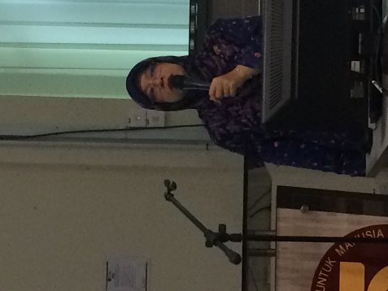

On 22th November 2018, a talk about design thinking was held in the Seminar Hall, Block N28a at the School of Computing from 2.00 p.m. to 4.00 p.m. All students of 1SCSR were attending the talk that was being delivered by Madame Aryati. Based on the talk given, there are many stages that need to be considered in design thinking which includes empathize, define, ideate, prototype and testing. In the empathize stage, it was described as the foundation of human-centred design since we need to know the problems in order to solves it. So, in order to get the information, we, the inventors, have to observe that people encountered in their everyday life, interact with them to know how serious the problem is to them and eventually experience it to ourselves.

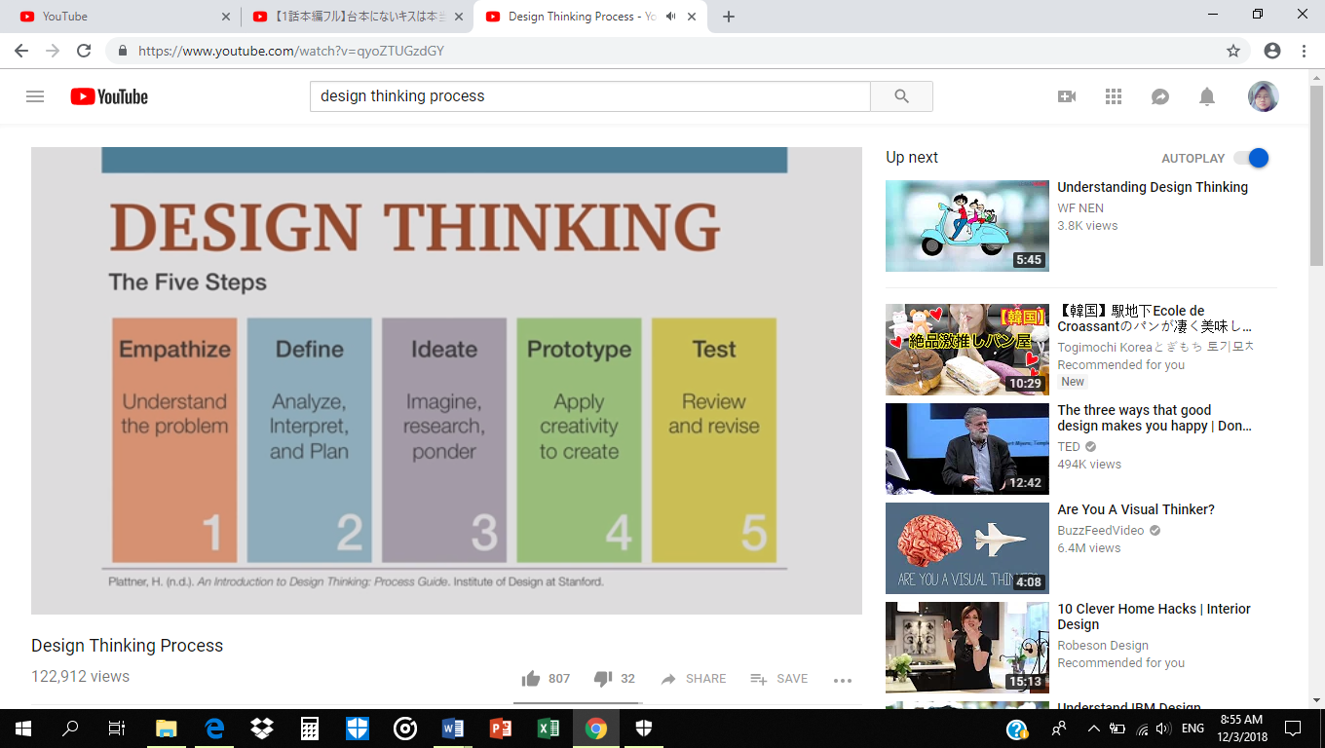

F*igure 2: Five stages of design thinking process*

From the information gathered, we go to the next stage which is define and during this phase, we will try to interpret the problem deeply and try to come up with the best solutions. We also need to select who we want to focus on for the solutions that we have gathered. It could be for the students or adult workers or even for the elderly. When we have all of these points, we must generate the ideas that not only are applicable enough to overcome the challenge in daily life but also bring new innovations to the world of technology.

To make the idea came to life, we need to enter the fourth stage that is prototype. In this step we usually use materials that are easy to find for the project such as cardboards, papers, ropes etc. Basically, prototyping is to show how we convert from sketching to physical model that have functions.

After completing prototype stage, we need to test it to know the effectiveness of the model in real life. This is where we are applying testing stage by giving the clients to review and test the model if it is suitable to use in daily life. We also need to check if the model has any lacks from the feedback and try to do some adjustment and retest it. The testing stage have to be repeated to accomplish the final product. After the talk session ended, all of us were assigned to do a design thinking project in our respective group. Our section’ s lecturer, Dr. Hairudin gave us the accessibility to pick our desired topic. Therefore, our group had chosen to make a smart lift project. Below will be the details of the project.

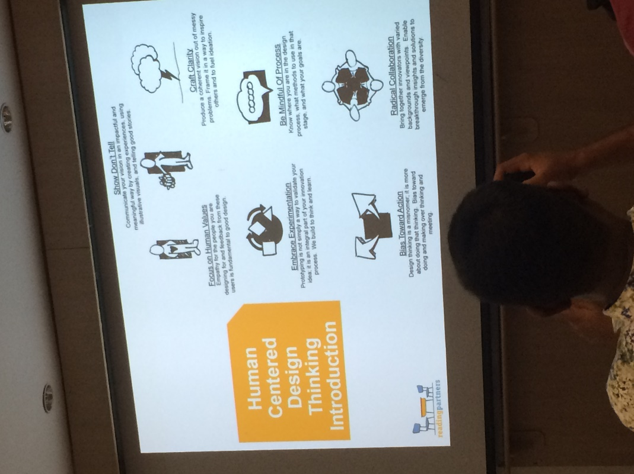

DESIGN THINKING | EMPATHIZE

****The first stage of the Design Thinking process strains gaining an empathic understanding of the problem you’re trying to solve, typically through some form of user research. Empathy is crucial because it allows you to set aside your own assumptions about the world in order to gain insight into users and their needs. This stage involves entering the realm of the users and, as far as possible, “becoming” them so as to begin work on custom-designing a solution.

For our groups, we have asked 5 people to give a feedback for our projects which is ‘Smart Lift’ and they give a great feedbacks and ask many questions to us and also give some idea to improvise our projects. Some of the questions they asked sounds:

* “Does the motion sensor will detect a static person in front of the lift?” *Respondence number 1*
* “Is it waste of electric?”
* “Does the system work at night?”

And this is our answers:

* We will add a double motion sensor which is heat sensor and motion sensor.
* The system only activates when the button is push by the user.
* Yes, because we will add the heat sensor to detect the presence of human heat from their body.



*Respondence number 2*

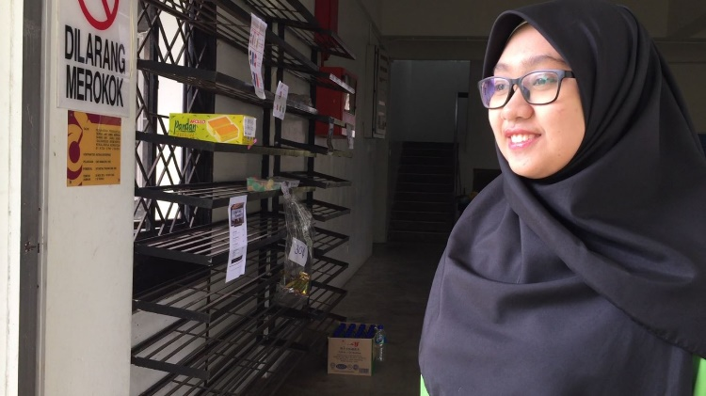They also give a feedback to improvise our project which was make the wider view sensor to detect the person more accurately. From this stage, it was very beneficial because we have gained a lot of inputs and improvements for our projects. By asking people, we will know our mistakes and will satisfy the user needs. We also can make the project more successful and better from this stage. *Respondence number 3*

DESIGN THINKING | DEFINE AND IDEATE

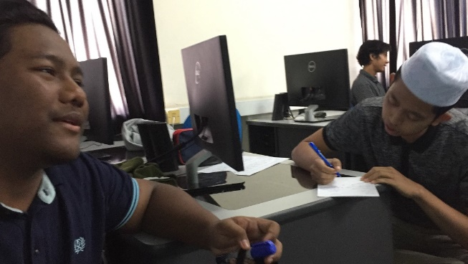

This process stage finds you ready to start generating ideas. With the knowledge you have gathered in the first two phases, you can start to “think outside the box” to identify new solutions to the problem statement you’ve created, and you can start to look for alternative ways of viewing the problem.

For this stage, we have made some creative solutions to think about idea and solve the problems stated on the previous stage.

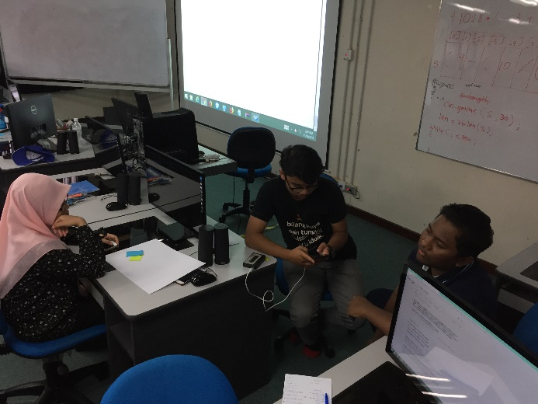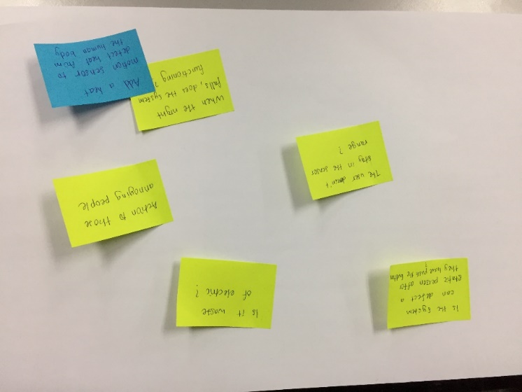By using this method, it will ease our work and make it clearer to think about the idea and problem solving. From this stage, we think about the function of our project and planning on how to make our own prototype for our project smart lift. Many problems have been solved from this stage as our groups discuss with diligence and all sharing opinion to make our projects successful.

*Figure shows the problems and its solutions. Figure shows the discussion*

*between groupmates*

DESIGN THINKING | PROTOTYPE

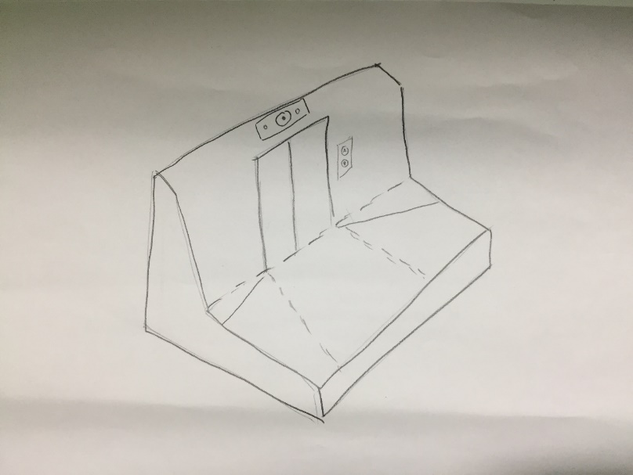

One of the best ways to really understand an idea is by doing some sort of prototyping which it is why became a stage in Design Thinking Process. The prototype does not have to be a fully functioning product of what you are designing, but rather a scaled down version of your ideas that is built with inexpensive material. This step will give the designer about how practical the idea in real life situation, how practical the current design is and some thought of to improve the idea and current design. It also the greatest way to get what people really feel and think of your ideas since they did not need to visualize the idea to understand it.

For our project, to really build a working prototype that equipped with cameras and heat motion sensor will need a few expensive materials. So, we decided on the usage of inexpensive material which is cardboard to visualize our ideas and our current design. We use a box to represent the space in front of elevator door so that we can imagine how much area should the sensor covered. Then we make a working elevator door to replicate either the door will open or not after the sensors are activated. We also use a piece of cardboard to represent the placement of the camera and the sensor that being places above the elevator door. Few buttons also being drawn next to the elevator door to replicate the button of calling the elevator since the sensors will only work after the button is pressed.

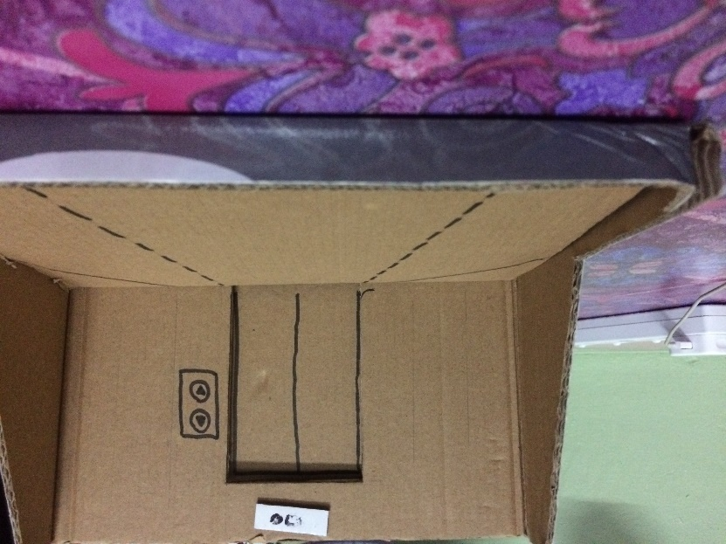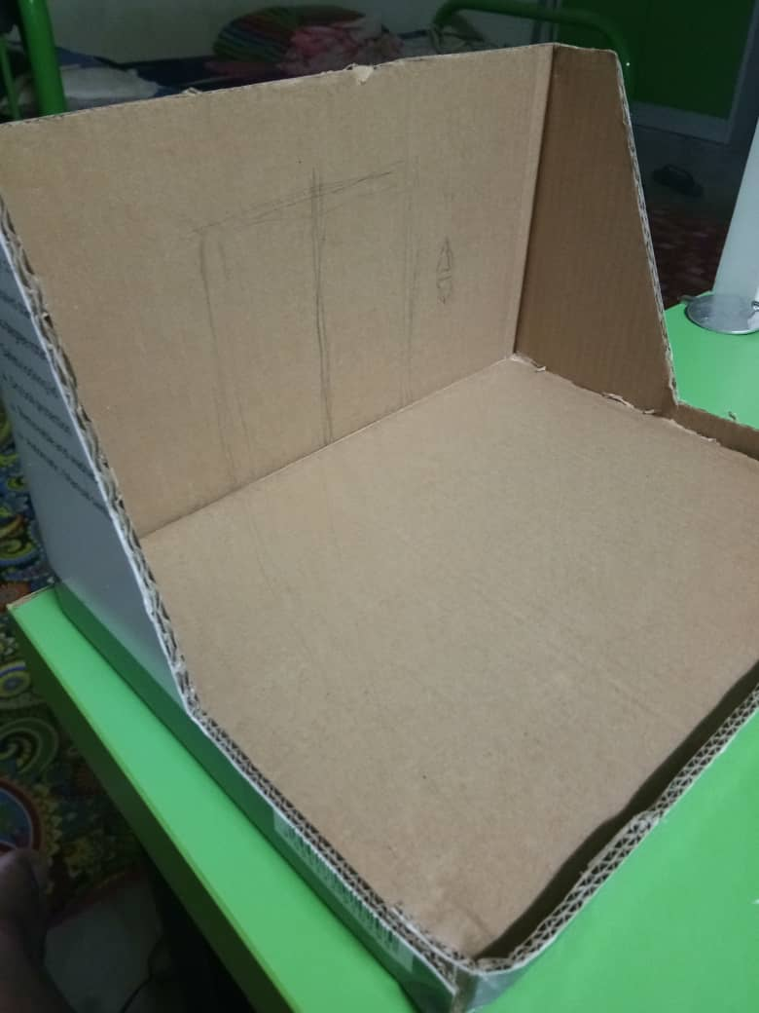

*Ongoing process of prototype*

DESIGN THINKING | TEST

After the prototype is done and shown to a few peoples, we make changes on the placement of the camera and the sensors to maximize the area covered by it. We decided to put the camera and sensors at the ceiling in front of the elevator mainly because the previous placement had a blind spot that are quite crucial. The blind spot for the previous placement is near the wall where the elevator door is placed, hence making it a problem if we keep the previous placement since it is a common place to wait for the elevator. This shows that by making a prototype, it could help you to make the ideas better since it can show what kind of problem you may face in real life when doing your ideas.

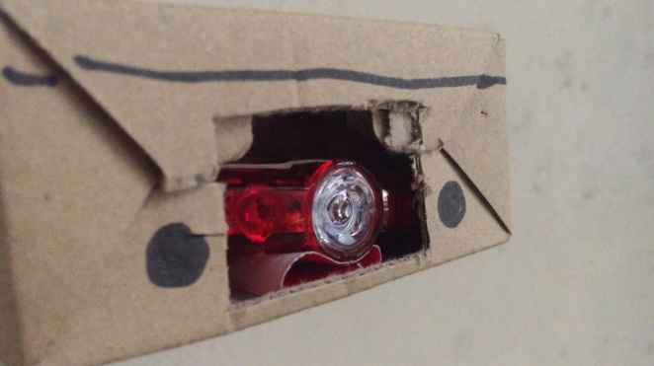

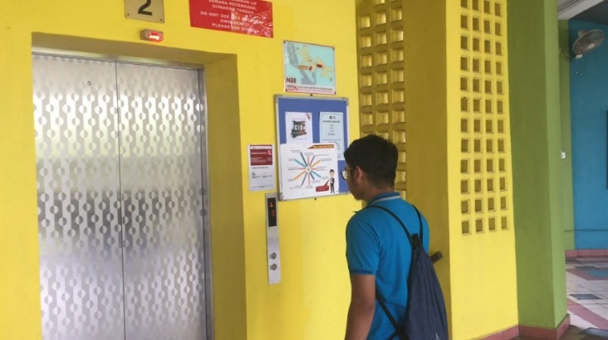

DESIGN THINKING | CONCLUSION

From the design thinking project, we learn that we must have a goals and dream about our course in the future. Firstly, I must apply knowledge and aptitudes to tackle issues successfully and productively that advances computer science in applied regions. To achieve this goal, we must achieve the associated learning goals when we graduate which is:

* Analyze an issue, recognize and characterize the computing necessities fitting to its solution.
* Apply outline and improvement standards in the development of programming frameworks of fluctuating multifaceted nature.
* Apply computer science standards in an expansive scope of non-computing applications.

Next, I must apply communication and hierarchical skills with regards to moral issues influencing the discipline or society. To achieve this goal, we must achieve the accompanying learning goals when we graduate which is:

* Understand the expert, moral, legitimate, security and social issues and responsibilities.
* Function successfully on multidisciplinary groups to achieve a goals.
* Communicate successfully with a scope of gatherings of people.

Besides that, during the making of the design thinking project, there is an impact to us as a network and security students. We are exposed to many things such as the soft skills to communicate to each other and cooperation among each other. In the future, cleverness is not enough because we need a lot of soft skills to get employed. For our goals as a Network and Security students and to become a future network and security expert, it is a wakeup call for us to learn more about the technology of security. It is important to know this as a knowledge because it can increase our knowledge.

Next, as a student, we must know how to improve ourselves in order to achieve greater potential in the industry when we want to start our career. So these are a few action that you could take to achieve that. Before knowing anything else, we must always know ourselves first. You should know what your strength and what is your weakness first in order to improve.

By dealing with your weakness, you could erase the weakness that will usually holds you back from achieving many great things and holding you from showing your true potential. You also should always keep honing your strength in order for people to see it as your defining feature as it is good when recruiter for companies are looking for people since you have something that people do not have it.

In conclusion, this project was made in such a way as to hope to minimize the possibility of elevator users waiting for the actual passengers not on the floor and this is also useful to minimize the level of ignorance of prank people so that lift users can shorten the time in the elevator and can get to class early.

How to use it is quite easy, if someone presses the button and the person is in front of the elevator entrance, then the elevator door will open. But if someone presses the button but the person is not inside the area of detection sensor, the elevator door will not open. This principle also applies at night where the sensor detector will detect the body temperature of the person in front of the elevator door. So, this does not have affect from the time or temperature of the environment.

We hope that this project will be able to help lift users especially students and workers to solve problems in reducing the use of time in the elevator as closely as possible.