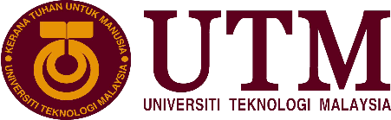
Group 01 Members:
- Ali Hilmi bin Ismail
- Almuhannad Lutfi Darwesh
- Amit Hasan Sadhin

Industrial Visit (CICT)
Lecturer: Dr. Aryati binti Bakri

C o n t e n t s

- Introduction
- History of component
- CICT Services
- CICT Achievements
- Reflection
- Team work
- Conclusion
- Additions

Introduction

The CICT gallerium visit at PSZ was held on 20th October 2019 for Section 27 arranged bt Dr. aryati binti bakri and presented by Encik Muhd zahari bin zainal abidin. In the brief symposium, we were taught about the cascading age of computer and its components, about CICT and their job.

In this report we will mention the details of the visit and explain how technology has evolved dramatically and how CICT contributed to its development, we will compare the past and now and we will mention the most important services and achievements of CICT over the past years, also we will explain how we benefited from the visit and how it has an impact on our future's career.

History of Component

Literally, the only constant found in this colloquium was development. With the flow of time, all components were replaced by something more advanced, intricate and better than its predecessor.
The precursor for such a rapid pace of technological revolution was demand. Low resolution black and white monitors were the custom during that era, no extra graphics processing was required but now we have professional grade color accurate monitors being the CPUs with onboard integrated graphics processing units called APUs are in existence.
At a time, few megabytes of RAM was the industrial standard, but at this day and age, gigabytes of ram clocking over 3000MHz with XMP is common.
As shown in Picture 9.3 Floppy disks were once the most popular medium of data exchange, but now 1.44MB floppy disks has been replaced with terabytes of PCIE NVMe SSDs. Colossal sized CPUs was featuring only a few megahertz of clockspeed but it has been replaced with multicore hyper threaded chipsets clocking over 5Ghz, even the trackball mouse has been replaced with optical mice.
IBM as shown in Picture 9.4, a subdivision military company is now turned commercial, was once the dominant alpha of the computing industry but even the mighty has bowed down to other successors.
UTM has undergone several technological upgrades and has now some of the state of the art equipment in its grasp according to the instructor, Mainframes have been replaced with much more advanced network grade servers running precision hardware. UTM also has possession of two real time linked data center, one in KL and the other one in Johor so in the event of a major failure, with multiple failing drives, the chance of data loss would be almost nothing.

CICT Services

Center for Information and Communication Technology (CICT) is the backbone of UTM for making sure that everything related to systems running smoothly and maintained throughout the day. Staff will slide in their staff id for their presence to their designated office using iHadir, a system that record time when they came in and out of the office hour replacing a punch card. While students scanning QR code in lecture room for their attendance. Students can evaluate their lecturer through evaluation system provided. As shown in Picture 9.9, CICT services includes internet, infrastructure and security, application development such as UTMSmart and UTMFleet as shown in Picture 9.8 , web management, software, and ICT support. Staffs and students of UTM are the targeted user for the systems available in UTM. CICT also handles maintenance for UTM human resource management, support system, academic management, academic computing, data management and financial management. Student can view their progress throughout their studies with MyUTM portal such as UTM Libraries, achievements, activity list, admission, immigration management student, Elearning, collage parcel, faculty and school, graduate studies management system (GMS), student evaluation of teaching, hostel, E-Portfolio, job on campus, staff directories, student registration, software center and student profile. Student and staff also can access UTM intranet services from outside UTM campus via virtual private network (VPN UTM Services) by using their ACID account. They also provide software that has been licensed by vendor such as Microsoft Office, Antivirus, research software and few others.

CICT Achievements

CICT has made many achievements in the past few years, most notably:

- Providing the best technical documents and at the same time leading the University to receive the SAGA Compliance Certificate (Standard Accounting System For Government Agencies) 2017 as shown is picture 9.9 presented by the Accountant General's Department of Malaysia on November 22, 2017.

- The most active PTJ Prime Minister of the 2/2017 Series for the Arcturus Zone, which was held on February 7, 2017 at Azman Hashim Stadium of UTM Johor Bahru.

Reflection

This visit showed us how technology has evolved tremendously over the past years and how it can evolve in the coming years. We learned about CICT's plans for the future and how they work, which gives us an idea of how we can make a company in the future and how we can develop an information center (which is the base of any company) and coordinate it perfectly to improve our work.

Team Work

Each member in our group has taken a part in doing this report, to collect the information, Amit's task was recording videos and taking pictures for everything while Ali's task was writing notes as much as he can, Almuhannad was asked to visit PSZ again to cover anything missing in the report. Then we all wrote one report together.

Conclusion

This visit to Gallerium, Perpustakaan Sultanah Zanariah has opened our eyes and minds on the importance of computer science, technology and information system that gave a huge impact in daily life both at home and work. Huge aspects of technology and information system has been displayed and explained include hardware, software, network, communications, internet, multimedia and graphics. Imagine an institute without a proper system. Almost everything has to be in manual which will put a waste on time and effort. It is a relief that UTM provide an excellent services for their student and staff whether working or studying.

Additions

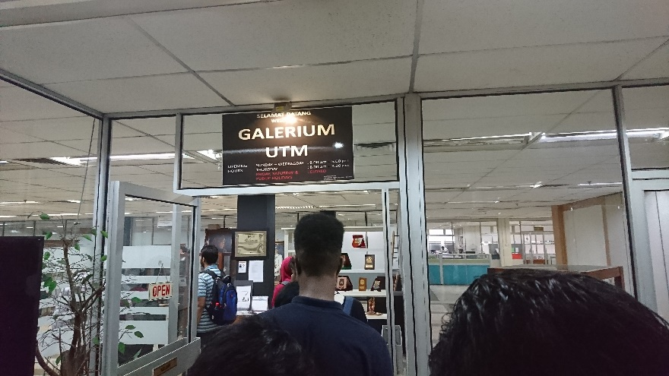
Picture 9.1 Entrance to Galerium UTM

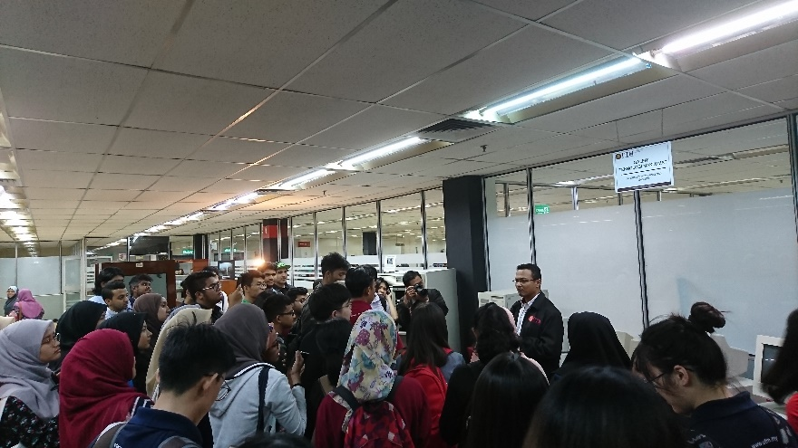
Picture 9.2 Explanation session by En. Zahari bin Zainal Abidin

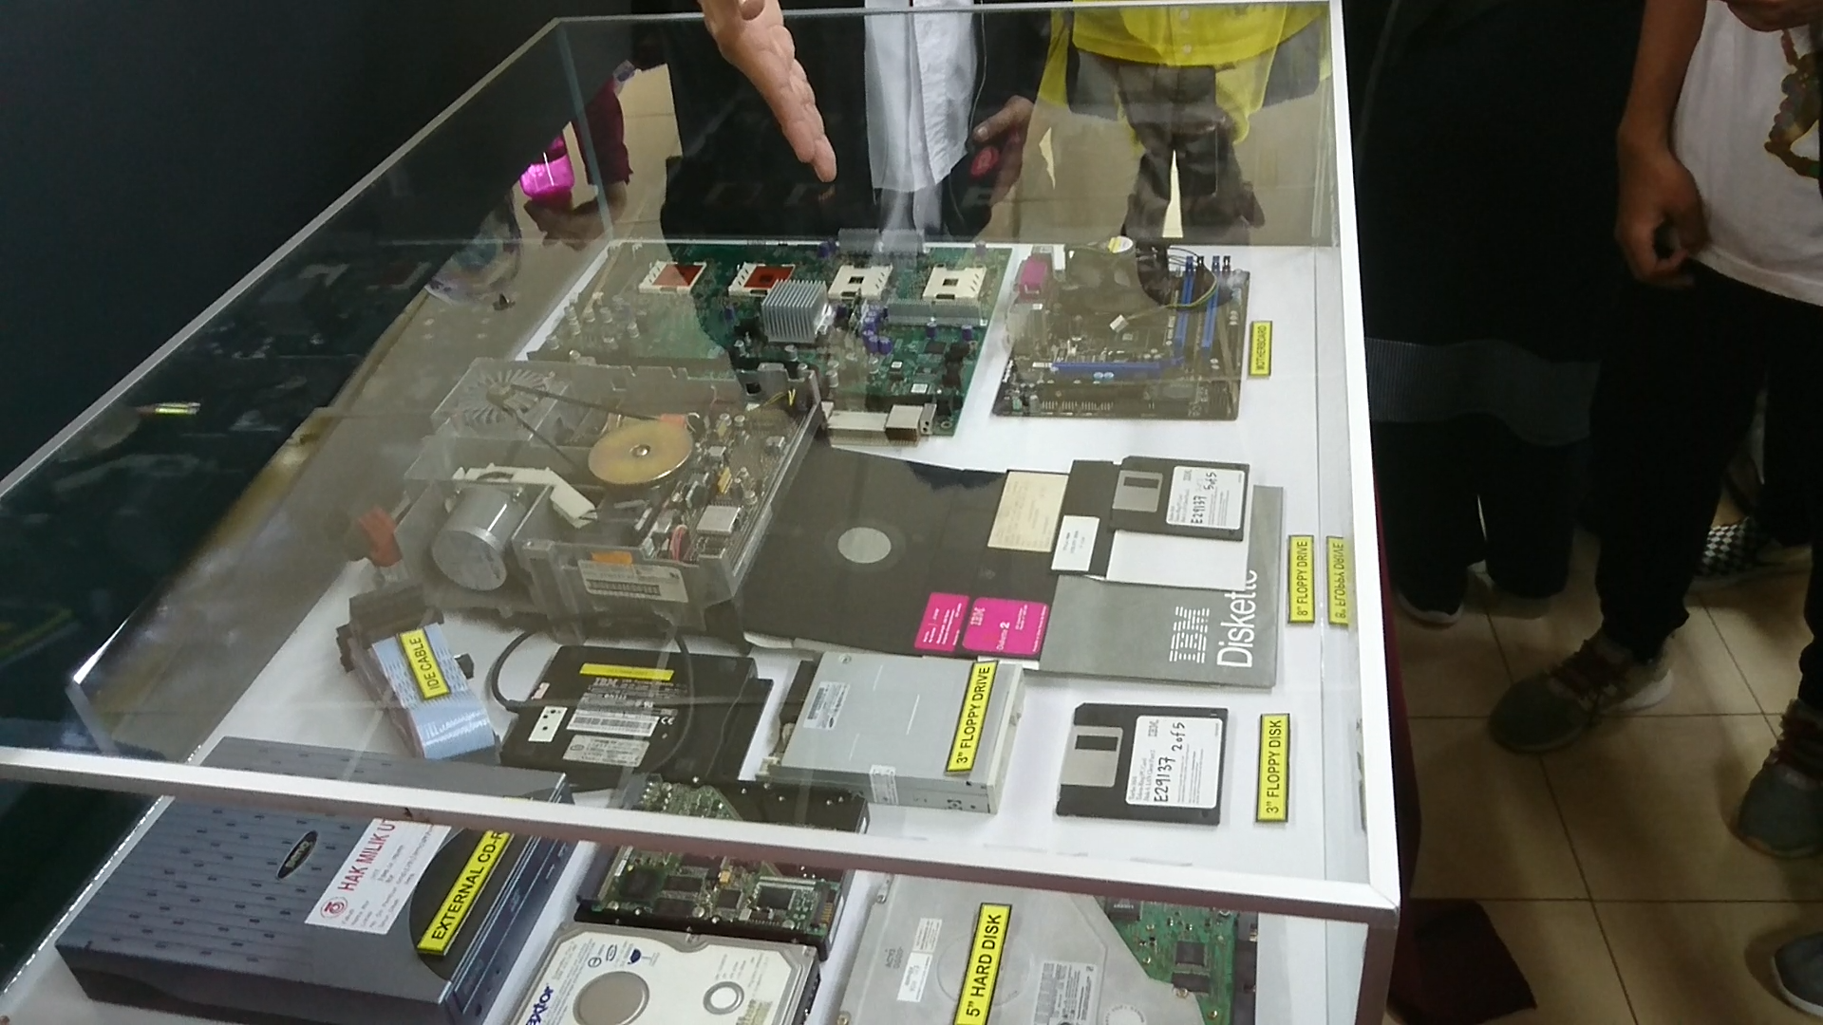
Picture 9.3 Computer Hardware such as motherboard, diskettes and hard disk drive.
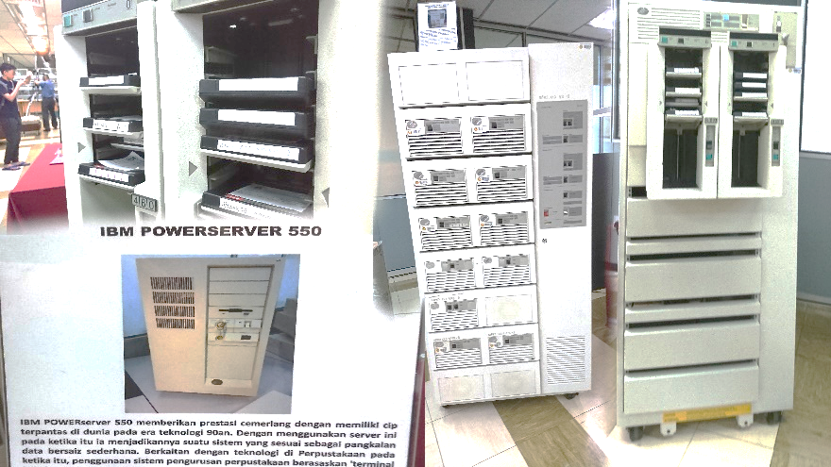
Picture 9.4 IBM

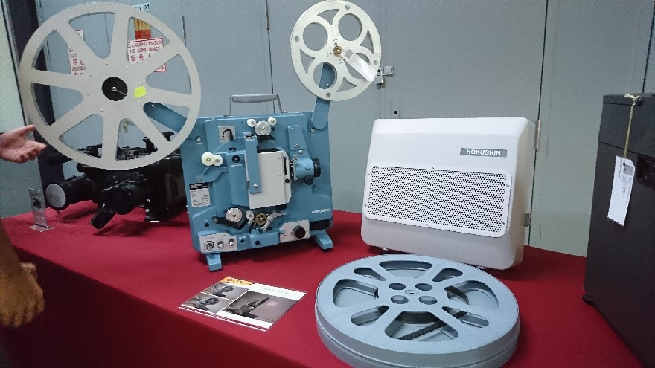
Picture 9.5 HOKUSHIN Film projector

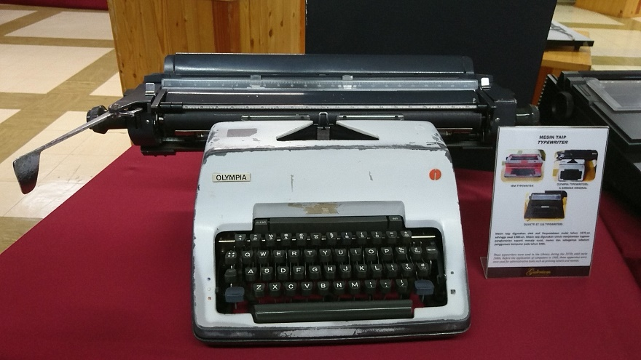
Picture 9.6 Typewriter

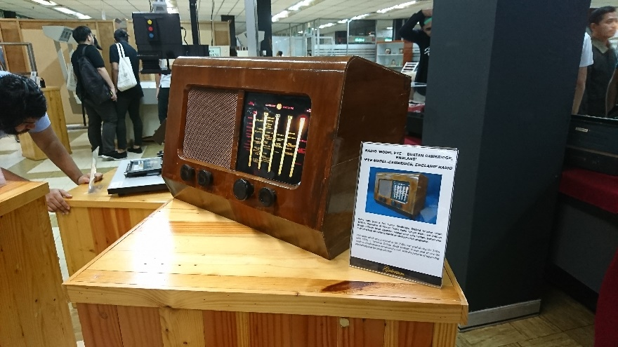
Picture 9.7 ‘PYE Model-Cambridge, England’ Radio

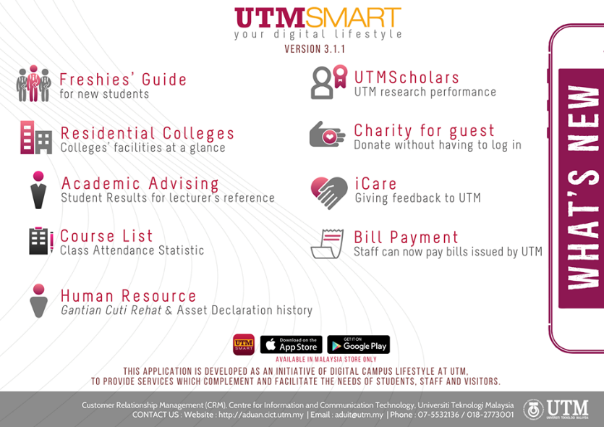
Picture 9.8 UTMSMART Mobile app services

Picture 9.9 CICT website and its list of services.

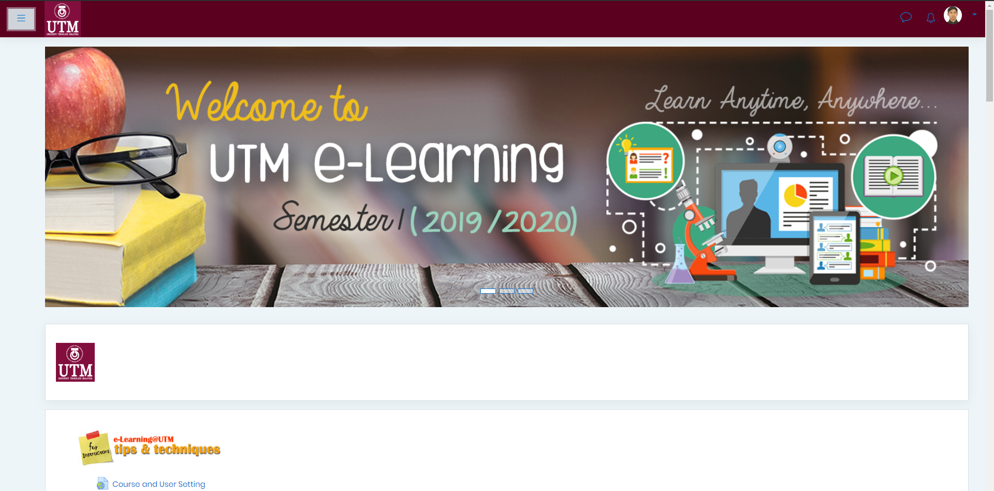
Picture 9.10 E-Learning

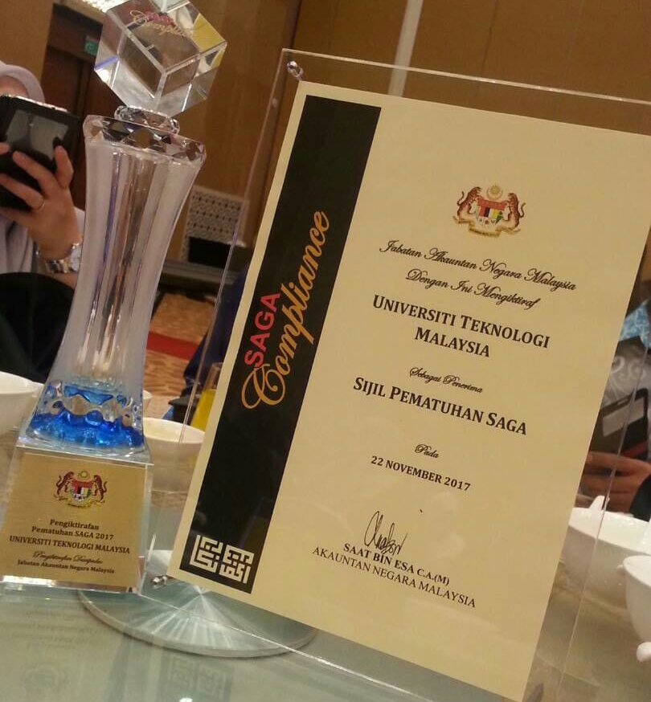
Picture 9.11 CICT Achievement 22,Nov,2017

