**Lab Exercise 1**

**Name: Eunice Lim Xian Ni**

**Matric No: A20EC0034**

**Section: 08**

Please answer the questions. Any picture format answer is not accepted

1.

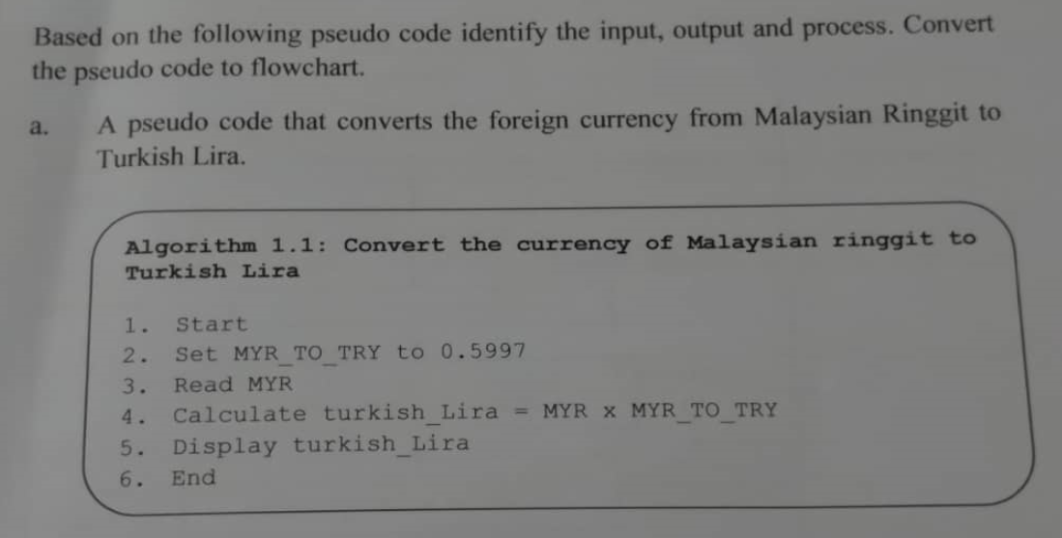

**Input** : Read MYR

**Process** : Set MYR_TO_TRY to 0.5997

Calculate turkish_Lira = MYR * MYR_TO_TRY

**Output** : Display turkish_Lira

**Flowchart**

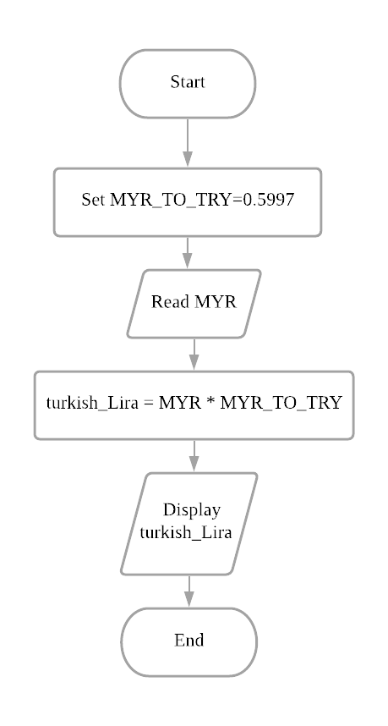

b. 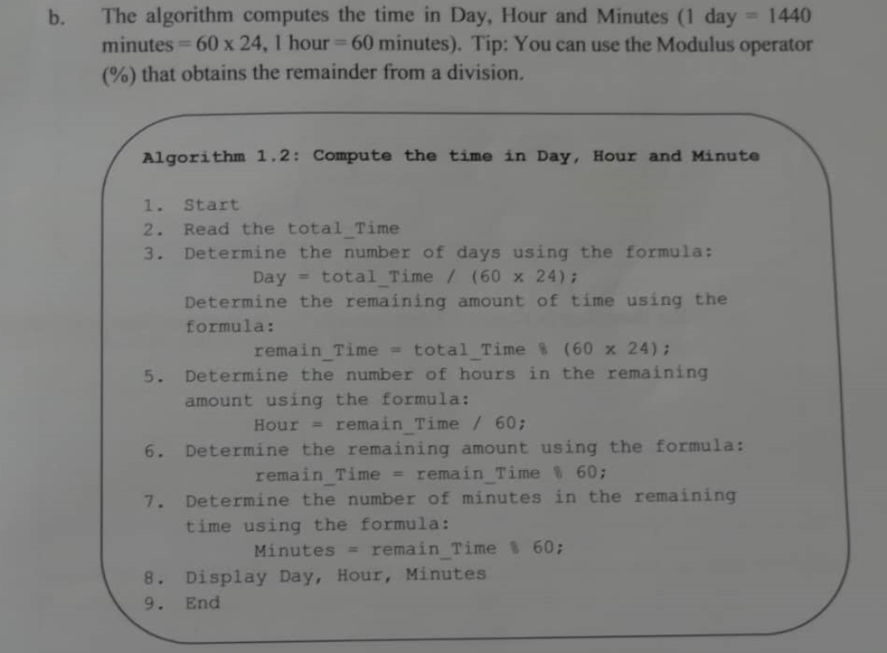

**Input** : Read total_Time

**Process** :

- Calculate number of days: Day = total_Time/ (60x24)

- Calculate remaining amount of time: remain_Time = total_Time % (60x24)

- Calculate number of hours in remaining amount of time: Hour = remain_Time/ 60

- Calculate remaining amount of time: remain_Time = remain_Time % 60

- Calculate number of minutes in remaining time: Minutes = remain_Time % 60

**Output** : Display Day, Hour, Minutes

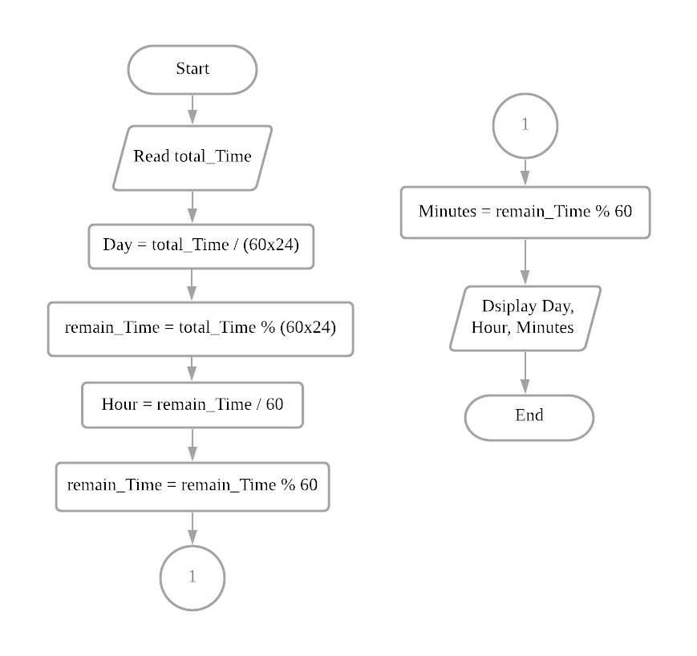**Flowchart**

2.

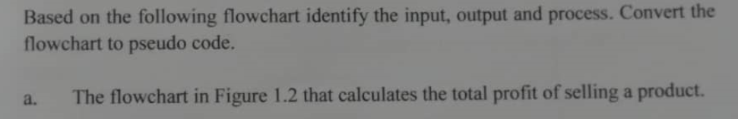

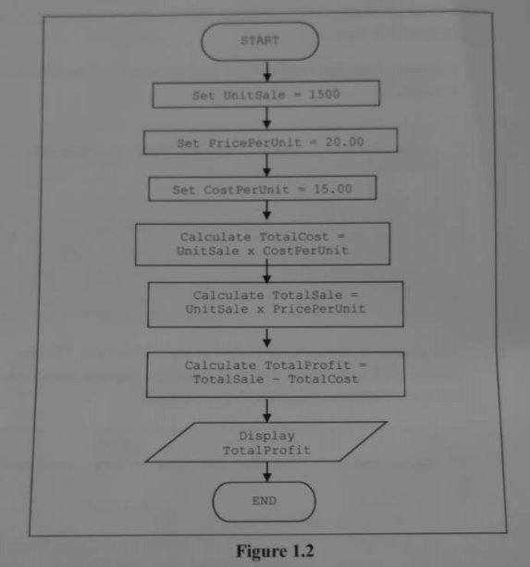

**Input** : -

**Process** :

- Set UnitSale = 1500

- Set PricePerUnit = 20.00

- Set CostPerUnit = 15.00

- Calculate TotalCost using formula: Calculate TotalCost = UnitSale * CostPerUnit

- Calculate TotalSale using formula: Calculate TotalSale = UnitSale * PricePerUnit

- Calculate TotalProfit using formula: Calculate TotalProfit = TotalSale - TotalCost

**Output** : Display TotalProfit

**Pseudo code**

1. Start
2. Set UnitSale = 1500
3. Set PricePerUnit = 20.00
4. Set CostPerUnit = 15.00
5. Calculate TotalCost = UnitSale * CostPerUnit
6. Calculate TotalSale = UnitSale * PricePerUnit
7. Calculate TotalProfit = TotalSale - TotalCost
8. Display TotalProfit
9. End

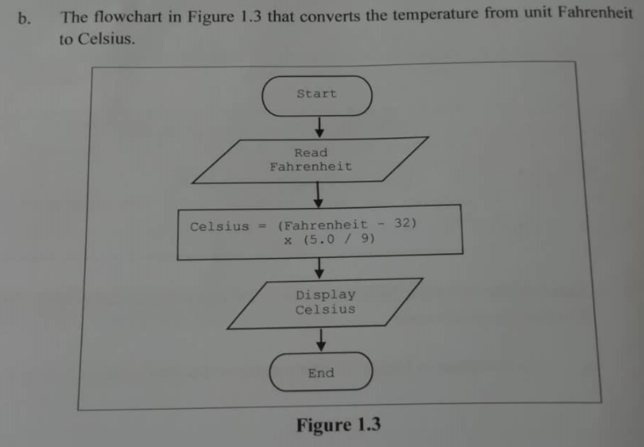

**Input** : Read Fahrenheit

**Process** : Convert Fahrenheit to Celsius: Celsius = (Fahrenheit - 32) * (5.0 / 9)

**Output** : Display Celsius

**Pseudo code**

1. Start
2. Read Fahrenheit
3. Calculate Celsius = (Fahrenheit - 32) * (5.0/9)
4. Display Celsius
5. End

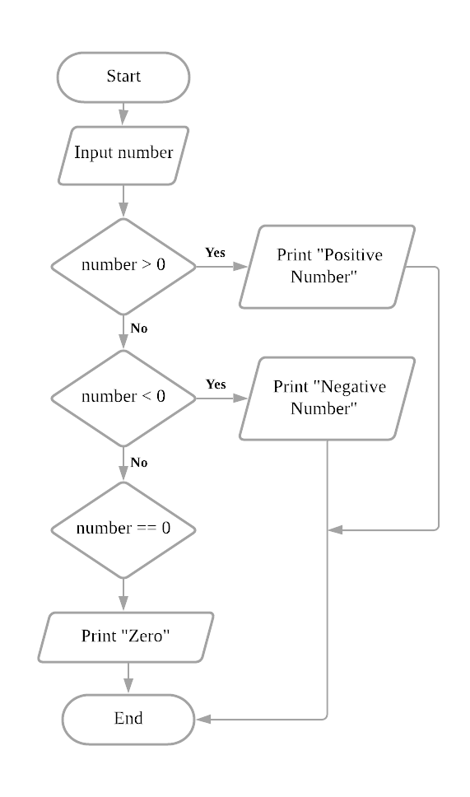3. 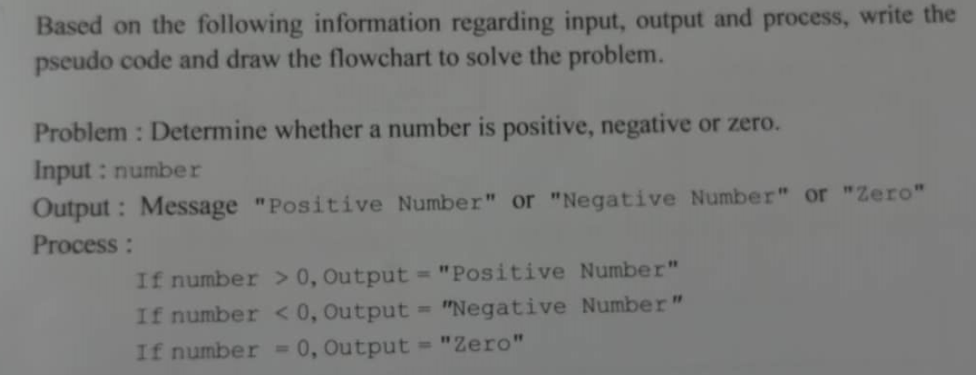

**Pseudo code Flowchart**

1. Start
2. Input number
3. If number > 0

3.1 Print “Positive number”

3.2 Go to step 7

4. else if number < 0

4.1 Print “Negative number”

4.2 Go to step 7

5. else if number == 0

5.1 Print “Zero”

6. End_if

7. End

4. 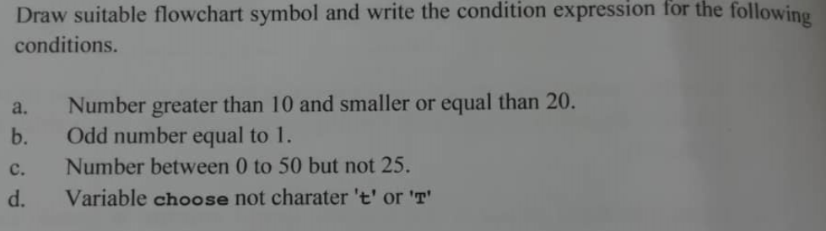

1. (Number>10) && (Number<=20)

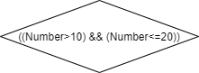

1. (Number==1) && (Number%2==1)

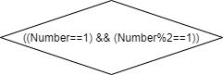

1. (Number<50) && (Number>0) && (Number!=25)

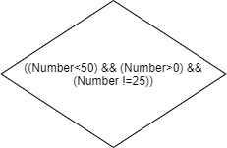

1. (choose != ’t’) || (choose != ’T’)

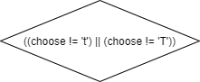

5.



**Variables**

- UnitSale

- PricePerUnit

- CostPerUnit

- TotalCost

- TotalSale

- TotalProfit

|  |  |  |  |  |  |  |
| --- | --- | --- | --- | --- | --- | --- |
| **UnitSale** | **PricePerUnit** | **CostPerUnit** | **TotalCost** | **TotalSale** | **TotalProfit** | **Output** |
| 1500 | 20.00 | 15.00 | 1500*15.00 = 22500 | 1500*20.00 = 30000 | 30000-22500  = 7500 | 7500 |

**Output** : 7500

6.



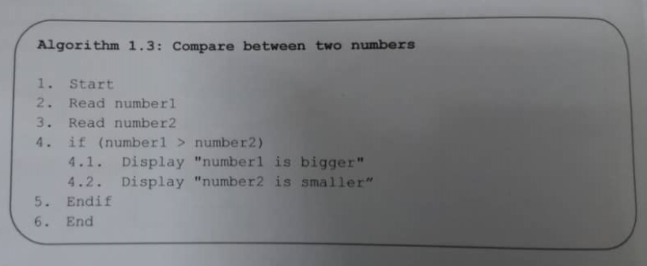

|  |  |  |
| --- | --- | --- |
| **number1** | **number2** | **Output Statement** |
| 103 | 25 | number1 is bigger  number2 is smaller |
| 90 | 120 | - |
| 15 | 15 | - |

1. No output from second and third data.
2. 1. Start
3. Read number1
4. Read number2
5. If (number1 > number2)
   1. Display “number1 is bigger”
   2. Display “number2 is smaller”
   3. Go to step 8
6. else if (number1 < number2)

5.1 Display “number2 is bigger”

5.2 Display “number1 is smaller”

5.3 Go to step 8

6. else if (number1 == number2)

6.1 Display “number1 is equal to number2”

7. End_if

8. End