SCSV 2113
HUMAN COMPUTER INTERACTION
(Session 2020/2021 Semester 2)
School of Computing
Universiti Teknologi Malaysia

A3 – ASSIGNMENT 3
[[HEURISTIC EVALUATION GROUP CASE STUDY REPORT]

(Section 01)

EXPERT’S TEAM
GROUP NO 5 (Auspicious)
Prepared by
MAIZATUL AFRINA SAFIAH BINTI SAIFUL AZWAN A20EC0204
MADINA SURAYA BINTI ZHARIN A20EC0203
NAYLI NABIHAH BINTI JASNI A20EC0105
MADIHAH BINTI CHE ZABRI A20EC0074
NURFARRAHIN BINTI CHE ALIAS A20EC0121
SAFIRA NURUL IZZA A18CS0323

____________________________________________________________________________

DESIGNER’S TEAM

GROUP NO. 6

PROJECT TITLE

Automated Solar Recycle Bin

____________________________________________________________________________
- INTRODUCTION

Heuristic evaluation is a method for the experts to measure the usability of the user interfaces in reporting issues. Hence, they can assist designers to improve their product usability. Moreover, it is a practical approach and only takes a little time.

The prototype that we as an expert team will evaluate is an automated solar recycle bin. As we all know, there are a lot of waste accumulations in landfills and many pollution cases are reported nowadays. Therefore, it is necessary to raise awareness and determination among the community by providing them a convenient application for recycling purposes.

There are three main tasks for us to carry out user testing. The first task is to login the apps as a security step and identity verification. Meanwhile, the first time user like us will have to sign up first in order for the apps to save our information.

The second task is to find the nearest cycling bin using the Global Positioning System (GPS ). With the GPS system, the cycling bin can be tracked in a blink of an eye. Additionally, the recycling bin is able to arrive at the user’s destination based on the user’s request.

The third task is the feedback submission for the purpose to let the users rate and comment about the applications. This is useful for the designers in improving their applications. As a result, a better application can be built and will be used in a long lasting time if the user is satisfied with the service.

- METHODS

For this assignment, we are using Heuristics Evaluation in order to evaluate the usability of user interfaces. Heuristics Evaluation is one of the well-known methods on interpreting users' experience on any design either in applications or websites. This method can be used to improve the usability, utility and desirability of the design.

In Nielsen’s Heuristics Evaluation, there are 10 different categories that need to be considered as we conduct this method. Each one of them has its own significant reason behind it so that we can improve any design. As the expert’s for Group 6 (designers), we are required to analyse their design to make sure that the design is suitable and helpful for the users. According to the tasks given by the designers, we need to test and experience each task one by one so that we can point out the violation of Heuristic Evaluation made by the designers.

We are also required to add the severity rating of the designers’ design for each violation identified. The severity rating consists of four levels and their cruciality increases as the level increases. The first level is cosmetic issue, second is minor issue, third is major issue and fourth is catastrophic issue. The higher the severity rating indicates that the part of the design needs to be paid extra attention to it because it can cause the users to not be able to experience the design correctly as it should have been.

Every violation we found was attached with a screenshot of the design to prove to the designers that their design does not meet the user experience expectation. The designers also can be more alert as we had to point out the critical points on which they need to reconsider again in order to meet the users expectation and to avoid any major users problem with the design.

- RESULTS

Table 1.1: HE Table for task 1

Experts’s Critics
Prototype Image | Problem | Heuristic and Average Severity Rating
 | The function of apps is not clearly stated. The user cannot identify it by only seeing the logo. | S2: Minor issue  H2: Match between system status and the real world
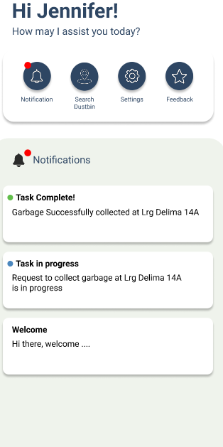 | No button for removing all the notifications (user need to slide one-by-one) | S2: Minor issue  H3: User control and freedom
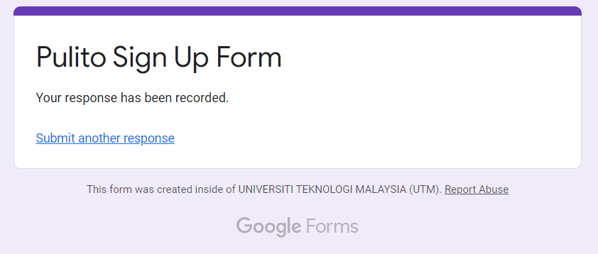 | No context or information to resume work through the apps | S4: Catastrophic issue  H6: Recognition rather than recall
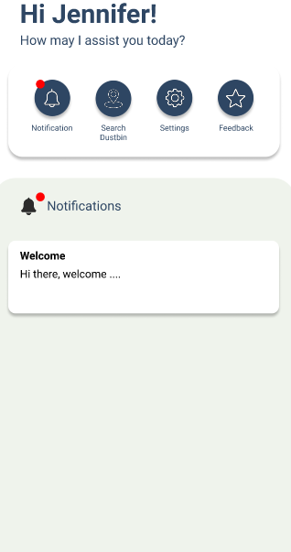 | The interface only enables advanced users as it is difficult for the first timer to identify which is the main thing that the apps will lead to. | S3: Major issue  H7: Flexibility and efficiency of use

Table 1.2: HE Table for task 2

Experts’s Critics
Prototype image | Problem | Heuristic and Average Severity Rating
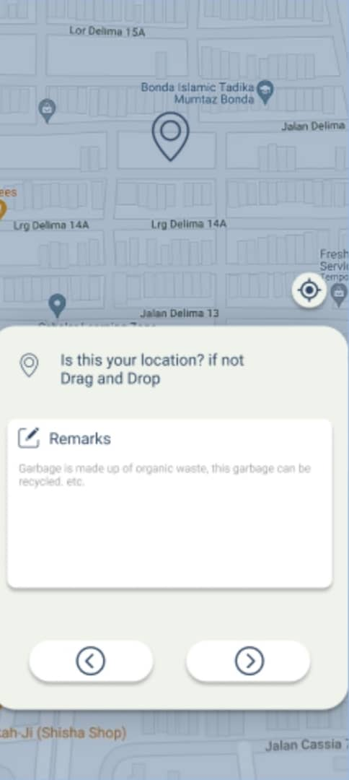 | There is no feedback whether the address is the exact user’s address or not after the user drag and drop the pin. | S4: Catastrophic issue  H1: Visibility of system status
 | Users need to press the ‘back’ button at each page if they want to undo or cancel their work (emergency exit). | S4: Catastrophic issue  H3: User control and freedom
 | The user does not have freedom to search the address using his keyboard. | S4: Catastrophic issue  H3: User control and freedom
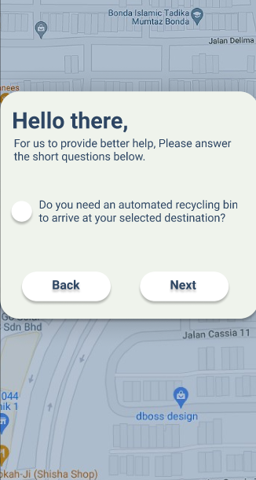 | Too long instruction requires more decision time | S4: Catastrophic issue  H8: Aesthetic and minimalist design
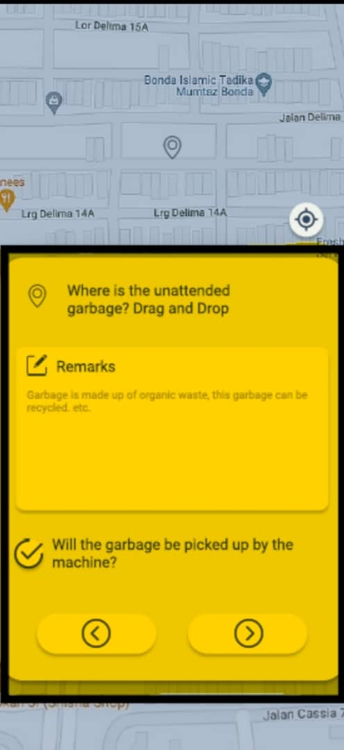 | The colour is too highlighted causing discomfort for the eyes and users might have difficulties in order to respond to the instructions. | S4:  Catastrophic issue  H8: Aesthetic and minimalist design

Table 1.3: HE Table for task 3

Experts’s Critics
Prototype image | Problem | Heuristic and Average Severity Rating
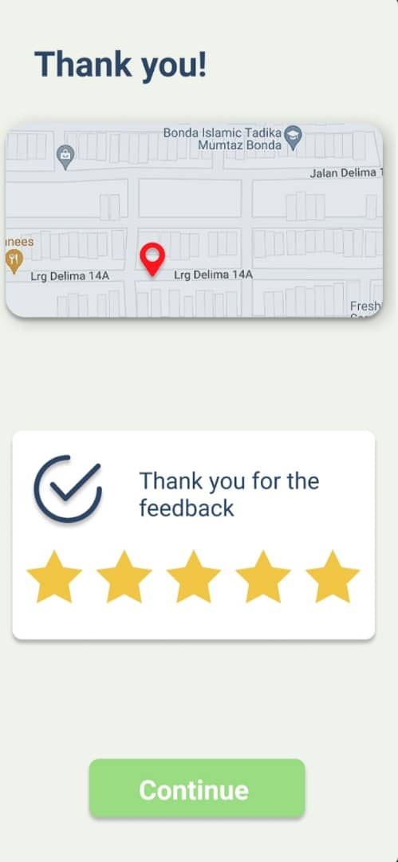 | The user is unable to edit the feedback. | S4: Catastrophic issue  H3: User control and freedom
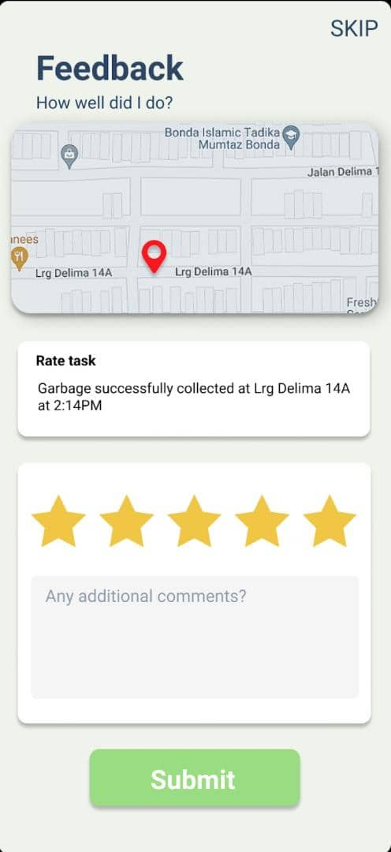 | The font size of SKIP is too large | S1:  Cosmetic issue  H8: Aesthetic and minimalist design

- DISCUSSION

Based on the Heuristic Evaluation (HE) table, there are 11 heuristic problems that we found. From all of them, we will be discussing some of the violations summary and improvement or suggestions that we can do in order for the designer to make some improvement.

The first problem that we found is regarding the Heuristic 2, “Match between system status and the real world”. From the prototype, we can see that the function of the apps are not clearly stated. This is because the user cannot understand it by simply seeing the logo. This app was created to help people find dustbin but the logo with bulbs, rather than the dustbin icon, makes some people, especially the first timer , confused. This is important as it is the first page that the user will see before proceeding to signup or login. For safety purposes, we are sure that the user will be alert on which applications they are signed up to. Therefore, some improvement can be made by redesigning the logo with dustbin icons so that the user will not hesitate to sign up to these apps and know that these are the correct apps which are being downloaded according to what the user desires.

Secondly, the violation is Heuristic 3, “User control and freedom”. From the prototype, we can see that there are no buttons for removing all the notifications at once. The user needs to slide one by one in order to delete it. Moreover, most of the users will be distracted with many notifications pop ups which can lead the user to be less alert on the newest or the most important one. Time consuming is the best as most users have a lot of things to do. Thus, we suggest that the user can make a button to clear all of the notifications at once so that it will save time.

Thirdly, the violation of Heuristic 6, “Recognition rather than recall”. From the prototype, we can see that in order for the first timer to use the apps, they need to sign up or register first but after clicking the sign up button, the apps bring them to a new window and they need to register into the google form. This can actually waste the user's time, especially someone with a bad internet connection as it takes some time to load another tap. After registering, the user also are not able to go back to the apps immediately. Hence confused the user on what’s next they need to do. Thus, some improvement can be made by making a signup form in the apps and the data also will be saved in those specific apps without involving something outside.

Next, violation of Heuristic 7, “Flexibility and efficiency of use”. After login, the user will lead to a home page and in this page, the user will see some icons but the interface only enables advanced users as it is difficult for the first timer to identify which is the main thing that the apps will lead them to. Thus, the navigating recycle bin icon should be prioritised making the button much bigger.

Other than that, the problem occured on the second task which violated Heuristic 3, “User control and freedom”. Upon performing the main process, the user needs to press the ‘back’ button at each page if they want to undo or make an emergency exit. This can actually waste their time. Thus, in order to improve this, a menu button should be included at every page so that the user can stop their work whenever they want to.

The next violation is Heuristic 8, “Aesthetic and minimalist design”. To perform the main task, which is task 2, they need to follow some instructions but the instructions given are too long and require more decision time.Thus, short and precise statements should be made in order to consume the user's time to understand the statement. Using some icons also can be one of the best approaches so that the user will recognise it easily with images.

Moreover, we also found out a problem that violated Heuristic 1, “Visibility of system status” since there is no feedback when the user entered their address. The apps also did not give any feedback whether the address that the user entered is the exact address or not. This problem will not only affect advanced users but it also will affect new users. So, the apps need to be enhanced more, such as produce a sound when the location is confirmed by the user or pop up a new screen that asks the user again to make sure the location that they entered in order to make sure the apps works smoothly and successfully without any problem.

In task 2 also, there is a problem that violates Heuristic 3, “User control and freedom” in which the user does not have access to search the address using their own keyboard. So, there is a possibility that the apps will face an error and will give false information and results to the users. In order to make sure the apps give the correct information and result to the users, an improvement must be made such as give the user an access to enter the address by themselves using their keyboard.

We also found another violation, Heuristic 8 which is “ Aesthetic and minimalist design”. This is because the used colour is too highlighted and this will cause discomfort to the user's eyes especially to the users that have severe astigmatism and the user also might face difficulties in order to respond to the instructions. Thus, to make sure the user can use the apps comfortably, the background colour need to be changed to a softer colour and not too bright.

Besides that, there is a problem that violated Heuristic 3, “User control and freedom” when performing task 3. As an example, there is a situation when the user accidently gives 5 stars as a feedback but the service was actually worth only 1 star, so there was no edit button to edit the feedback given. So, in order to improve this, the user must have access to edit the feedback as it is one of the important things for the developer and designer to know how smooth their apps perform.

Last but not least, there is a violation of Heuristic 8, “Aesthetic and minimalist design”. The font size of the word “SKIP” is too large and it seems not suitable for the whole layout design. Hence the font size should be smaller than the previous one and must be adjusted according to the layout design.

Category | #Violations No.
H2-1: Visibility of Status | 1
H2-2: Match System & World | 1
H2-3: User Control & Freedom | 4
H2-4: Consistency & Standards | 0
H2-5: Error Prevention | 0
H2-6: Recognition not Recall | 1
H2-7: Flexibility & Efficiency of Use | 1
H2-8: Aesthetic & Minimalist Design | 3
H2-9: Help Users with Errors | 0
H2-10: Help & Documentation | 0
Total Violations | 11

Table 2.0: Summary of Violations

Automated Solar Recycle Bin | Problem | Average Severity Rating | Heuristic category
 | There is no feedback whether the address is the exact user’s address or not after the user drag and drop the pin. | 4.00 | 1. Visibility of system status
 | The function of apps is not clearly stated. The user cannot identify it by only seeing the logo. | 2.00 | 2. Match between system status and the real world
 | No button for removing all the notifications (user need to slide one-by-one) | 2.00 | 3. User control and freedom
 | User need to press the ‘back’ button at each page if they want to undo or cancel their work (emergency exit). | 4.00
 | The user does not have freedom to search the address using his keyboard. | 4.00
 | The user is unable to edit the feedback. | 4.00
 | No context or information to resume work through the apps | 4.00 | 6. Recognition rather than recall
 | The interface only enables advanced users as it is difficult for the first timer to identify which is the main thing that the apps will lead to. | 3.00 | 7. Flexibility and efficiency of use
 | Too long instruction requires more decision time | 4.00 | 8. Aesthetic and minimalist design
 | The colour is too highlighted causing discomfort for the eyes and users might have difficulties in order to respond to the instructions. | 4.00
 | The font size of SKIP is too large | 1.00

Figure 1: Summary of Usability Issues and Severity Ratings by Nielsen

- CONCLUSION

Interaction design aims to create products that enable the user to achieve their objective(s) in the best way possible. Simplifying and attracting the user's attention is the primary goal of this application. As much as possible, the designer must create a design that can make the user feel comfortable in using this application. Based on the discussion that the expert team did, paying attention to interface design starting from typeface, coloring, copywriting, spacing is crucial in making prototypes; a user will feel more comfortable if the colors used in the application use warm tone colors so that user can use this application comfortably for a long time. Furthermore, it is critical to give users ample flexibility to deal with any errors; sometimes, users make mistakes using the application; providing the undo/edit feature will make the user's job easier.

- REFERENCES

- Atkins, N., Bennett, L., Domit, B., & Jones, J. (2011). Heuristic Evaluation Sponsored by IEEE and ASME: Prepared for Dr. Carol Barnum, 6120-Usability Testing Prepared by Hufflepuff Team. http://booksite.mkp.com/barnum/testingessentials/pdfs/hufflepuff_he_report.pdf
- BERNAMA. (2021, June 18). Cooking oil in polybags have quality, not recycled - MPOB. BERNAMA. https://www.bernama.com/en/general/news.php?id=1973508
- Bravo, W. (2017, August 12). Heuristic Evaluation of Two Travel Websites. Medium. https://wendybravo.medium.com/heuristic-evaluation-of-two-travel-websites-13f830cf0111
- Nielsen, J. (1994, April 24). 10 Heuristics for User Interface Design. Nielsen Norman Group. https://www.nngroup.com/articles/ten-usability-heuristics/

