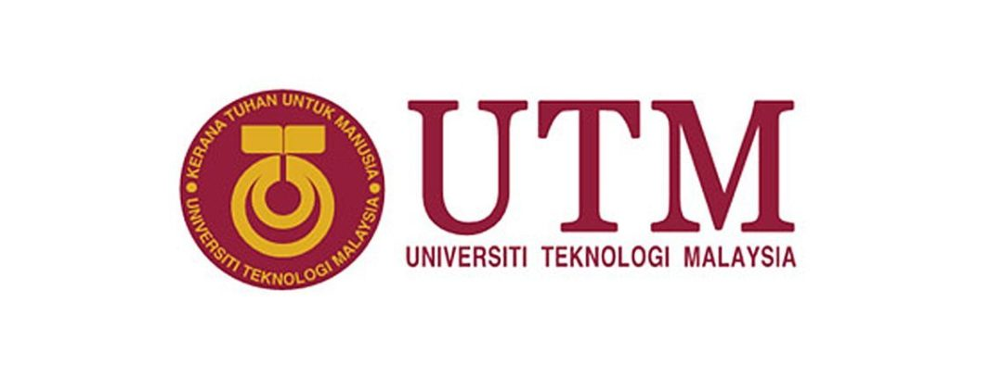

PUBLIC LECTURER TALK 1 – MDEC e-Rezeki

Name : Tan Rouxuen

Section : SCSP 1513 (Technology and Information System) – Section 03

Lecturer : Dr Sharin Hazlin Binti Huspi

**CONTENT**

|  |  |  |
| --- | --- | --- |
| **No** | **Title** | **Page** |
| 1. | Introduction | 3 |
| 2. | Executive Summary | 4 |
| 3. | Detailed Description | 5 - 8 |
| 4. | Reflection | 9 |
| 5 | Conclusion | 10 |
| 6. | Reference | 11 |

**1.0 INTRODUCTION**

This industrial talk by Malaysia Digital Economy Corporation (MDEC) on their program e-Rezeki and Global Online Workforce (GLOW) are organized by the School of Computing for all the first-year computer science undergraduates. The talk is held at Block N28A, Universiti Teknologi Malaysia. The purpose of this industrial talk is to introduce first-year computer science undergraduates about the e-Rezeki and Global Online Workforce (GLOW) which are organized by Malaysia Digital Economy Corporation (MDEC), government-owned agency launched in 1996 to pioneer the transformation of Malaysia’s digital economy.

**2.0 EXECUTIVE SUMMARY**

The industrial talk was on the 24th of September 2018. Students were required to gather at the Block N28A by 11.00 a.m. Then, we moved into seminar hall to attend a talk by the Mr. Mohd Ihsanuddin Jamhari who is a Global Online Workforce Master Trainer. The talk took 1 hour and a short Q&A session was held for 10 minutes. The question proposed by the students were answered patiently by Mr. Mohd Ihsanuddin Jamhari. The industrial talk ended at 12.00 p.m.

**3.0 DETAILED DESCRIPTION**

The talk by the Mr. Mohd Ihsanuddin Jamhari in the seminar hall includes introduction of e-Rezeki and GLOW, benefits, the participants and the impact of the program to Malaysia.

The first part of the talk was about GLOW workshop initiative which is one of the largest programs for the digital academic in Malaysia. MDEC organized programs which are e-Rezeki and GLOW for the citizen to increase the economy of Malaysia digitally. E-Rezeki and GLOW are a global platform for people to work on Internet and also creating a community of capable digital worker. These programs let the people can work at anywhere, any time when free because the workers just need do their work on the Internet and without going to the office. Participants in the program will be profiled, trained, qualified and matched against suitable works on the digital platform.

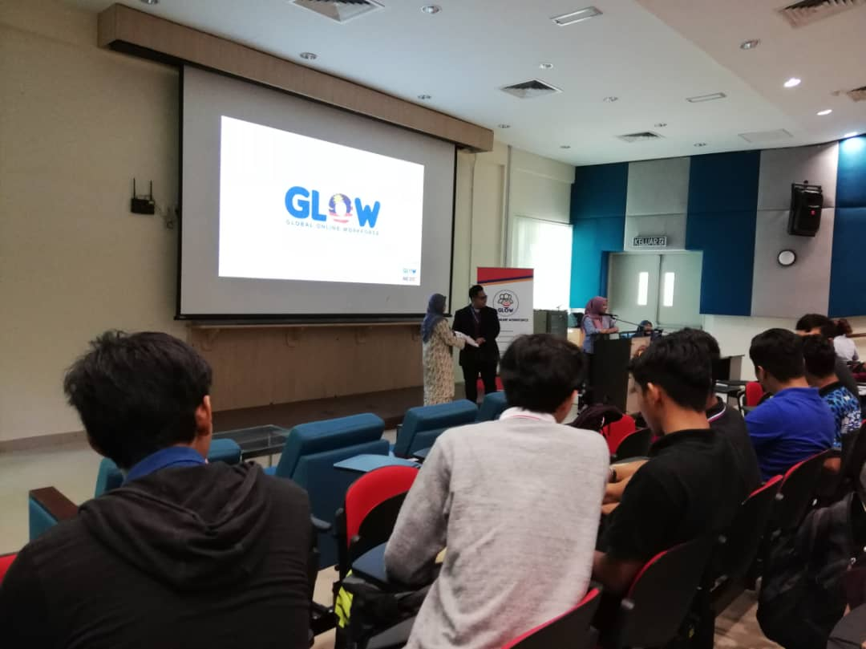

Figure 1

The e-Rezeki program allows people, particularly the low-income groups to get extra financial gain by working via online crowdsourcing platform. The e-Rezeki participants will be matched with digital work in line with their respective skills such as accounting and finance, data entry, programming and design. The e-Rezeki program offer part-time employment opportunities through digital crowdsourcing, is capable of providing the participants with additional income up to RM 500 per month. Freelancers contribute an estimated 1 trillion annually in freelance earning to our economy. In this case, Malaysia will undergoes the transformation from a developing country to a developed country because the e-Rezeki program will stimulate our economy as the citizen are not low-income groups again. Moreover, this program also provide a faster output and lower cost compare to full-time jobs. They will produce a high quality of work to fulfil the demand of the enterprise.

**These are the few examples of the successful freelaners:**

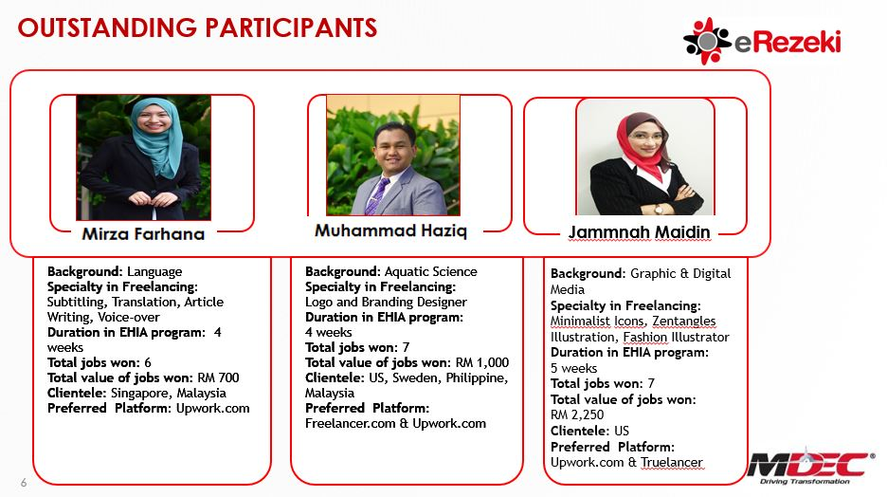

(Figure 2)

Source from [*https://sitimunirahblog.blogspot.com/2017/07/kisah-kejayaan-program-erezeki-global.html*](https://sitimunirahblog.blogspot.com/2017/07/kisah-kejayaan-program-erezeki-global.html)

MDEC organized a lot of seminars to introduce their programs such as e-Rezeki, e-Usahawan and GLOW to the universities students such as University Teknologi Malaysia (UTM), University of Malaya (UM) and University Tunku Abdul Rahman (UTAR) to enlarge their knowledge that every people can have the job opportunities on the Internet. MDEC also created a campaign called*“YouCanDuit”*  to explain to students and also B40s which is the bottom 40% of households with monthly income of RM3,900 and below. This program is easy for everyone to learn and they could ready increase their financial gain.

**Table below summarized the 3 categories of work on e-Rezeki :**

|  |  |  |
| --- | --- | --- |
| **Work Category** | **Description** | **Examples** |
| Digital Works | Domain specific work / tasks such as application development, creative work and language-based work. Requires specific skills to perform the work / tasks. | * Web Development * Mobile Application Development * Creative Design * Software Testing * Audio/Video Transcription |
| Digital Enabled Tasks | Work / Tasks such as survey, running errands and domestic services which were distributed online but has to be performed offline / on-site | * Survey / Census / Price Watch * Mystery Shopper * Part-time work * Delivery Service * Domestic Services |
| Digital Micro Tasks | Simple task involving data entry, processing of images or action that requires no-specific skills or high level of skills to perform the tasks. Tasks can be performed and completed within few minutes. | * Data Entry * Data Cleasing * User Experience (UX) Feedback * Search Engine Optimization(SEO) |

Source from [*http://www.fke.utm.my/wp-content/uploads/2017/03/eRezeki-for-HLIs Collaboration.pdf*](http://www.fke.utm.my/wp-content/uploads/2017/03/eRezeki-for-HLIs%20Collaboration.pdf)

( Table 1 )

To address students and B40s’ worries about the digital economy, MDEC and Astro work together to “distract” them through comedy and entertainment. In this case, students and households will understand what is the e-Rezeki and what are the benefits when they join the program. The e-Rezeki platform allows individuals who are SPM leavers, unemployed, households, college students, the unemployed graduate, retrenched workers and also retirees to register as digital workers and perform simple digital-based tasks to generate additional income. In summary, everyone can join the e-Rezki program as long as the participants have the skills in technology and computer, creative and design and linguistic and language to become a digital worker.

From the economic point of view, e-Rezeki is a booster for our Malaysia economy, citizen increase their income through e-Rezeki, in this case, the consumption capacity will be raised so that it will stimulate our economy. Additional, the program also increases the development of science and technology in these few years. The government would also provide grants worth RM245 million under the Domestic Investment Strategic Fund to upgrade Smart Manufacturing services, aimed at supporting investment and business activities under the fourth industrial revolution (Industry 4.0) published by Malay Mail on 28 October 2017 ([*https://www.malaymail.com/s/1497357/mdec-budget-2018-to-give-digital-economy-a-boost*](https://www.malaymail.com/s/1497357/mdec-budget-2018-to-give-digital-economy-a-boost)). Our country now is more trend to technological compare to industrialization in a few years ago as the government launched Digital Free Trade Zone (DFTZ) to further promote the growth of the nation’s digital economy. This is a good transformation because our country Malaysia will become a developed country because of the digital economy.

**4.0 REFLECTION**

As a student of computer science, we have to know a lot of information about technology and also the trend in the new era. We are no longer able to only study in classroom without realizing the changes in our world. The world does no need the bookworm to help them develop the world but they need a person who fulfils all the demands such as professional skills, soft skills and also the creative thinking. Through the talk, MDEC gives me a lot of information about the e-Rezeki, GLOW, and e-Usahawan and let me understand deeply about what can I do to have a better life.

As we know that e-Rezeki is a global platform to find the part-time job through the whole world, it provides the opportunities for the enterprise and the freelancers to solve their problems and earn more income on the Internet. In this new era, people more prefer to work on the Internet than the full-time job because the working time is flexible. We can decide where to work and when to work, thus our life may not be so stressful to accomplish all the works perfectly from the boss. Besides, we can meet a different kind of clients, companies and enterprises through the e-Rezeki when we get the job. We can get different experiences in the work by solving different problems that proposed by the clients.

In the e-Rezeki program got an abundance of talents in the crowdsourcing platform, the enterprise can reduce their budget by hiring a freelancer that need a shorter time to solve the problems and produce a high quality of work rather than hiring a worker who does not have enough knowledge or experience to solve the problems. A faster output and lower cost are always the choices of the enterprise. The e-Rezeki program is a stimulant for the digital economy in Malaysia because this program is a worldwide program, freelancers will contribute as estimation RM 1 billion annually in freelance earning to our economy. Nowadays, Malaysia is changing from an industrialized country to a technological country because of the new trend of our world is all about technology.

Overall, e-Rezeki program let me know about the new trend in the world that I can work anywhere if I want, not like the traditional job which is being restricted by time and place. Everyone can be the participant as long as they has the professional skills that can solve the task given by the enterprise.

**5.0 CONCLUSION**

In conclusion, the industry talk is beneficial to all the students who had participated. We have certainly obtained some new information about the e-Rezeki and GLOW that organized by MDEC. On the other hand, the speaker was very helpful and patient in giving brief yet clear explanations throughout the talk. This industry talk has brought us into deep thoughts on what can we do for our future, what is our plan to achieve the goal and how does this talk would improve our potential to achieve the goal.

**6.0 REFERENCE**

1. [*https://www.malaymail.com/s/1497357/mdec-budget-2018-to-give-digital-economy-a-boost*](https://www.malaymail.com/s/1497357/mdec-budget-2018-to-give-digital-economy-a-boost)
2. [*https://www.thestar.com.my/news/nation/2017/11/10/digital-economy-growth-benefiting-many/*](https://www.thestar.com.my/news/nation/2017/11/10/digital-economy-growth-benefiting-many/)
3. [*http://www.therakyatpost.com/news/2014/10/23/erezeki-project-connect-maysians-bottom-40-income-pyramid-digital-income/*](http://www.therakyatpost.com/news/2014/10/23/erezeki-project-connect-maysians-bottom-40-income-pyramid-digital-income/)
4. [*http://www.thesundaily.my/news/1604124*](http://www.thesundaily.my/news/1604124)