SCSV 2113
HUMAN COMPUTER INTERACTION
(Session 2020/2021 Semester 2)
School of Computing
Universiti Teknologi Malaysia

P4 – PROJECT 4
[COMPUTER PROTOTYPING & EVALUATION]

(Section 01)

EXPERT’S TEAM
GROUP NO 5 (Auspicious)
Prepared by
MAIZATUL AFRINA SAFIAH BINTI SAIFUL AZWAN A20EC0204
MADINA SURAYA BINTI ZHARIN A20EC0203
NAYLI NABIHAH BINTI JASNI A20EC0105
MADIHAH BINTI CHE ZABRI A20EC0074
NURFARRAHIN BINTI CHE ALIAS A20EC0121
SAFIRA NURUL IZZA A18CS0323

INTRODUCTION

Project 4 is the continuation of Assignment 3 in which we had done before as an expert group. In this project, we as the designers, should try to fix all the issues identified by the expert group in our prototype earlier. This project requires us to figure out the possible way to overcome the issues found so that our prototype can be more user-friendly and easier to be handled.

In this project, we had to modify and update our prototype according to the problems and criticisms we had received from an expert group in order to achieve the usability goals for the users. Nielsen’s Heuristic Evaluation (HE) has been considered while we are trying to modify the issues as the purpose of it is to satisfy the usability of any product. By applying HE, as a designer, we can see clearly the issues and how to solve the problems identified earlier. Therefore, based on the criticisms we get from the expert group, we come out with the solution and redesign of our application so that it can meet the users’ expectation as well as make it easier to be handled.

USABILITY PROBLEMS & SOLUTIONS

No. | Usability Problem  Prototype (https://bit.ly/3dRNr6x) | Solution & Redesign  Prototype (https://bit.ly/3qTwONh)
1. | 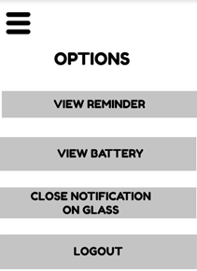 | 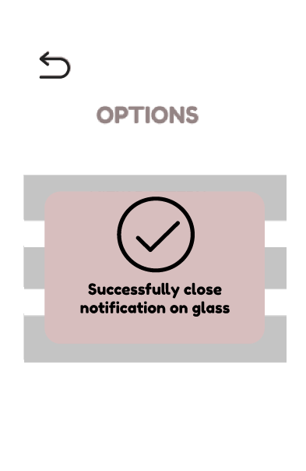
 | “CLOSE NOTIFICATION ON GLASS” button does not give any feedback to the users whether the notification has been turned off or not.  H1: Visibility of system status  S3: Major issue | The application has been updated with a feedback on the button “CLOSE NOTIFICATION ON GLASS”.  A pop-up window will be generated on the screen after the button is clicked to notify the users that their action has been done.
2. | 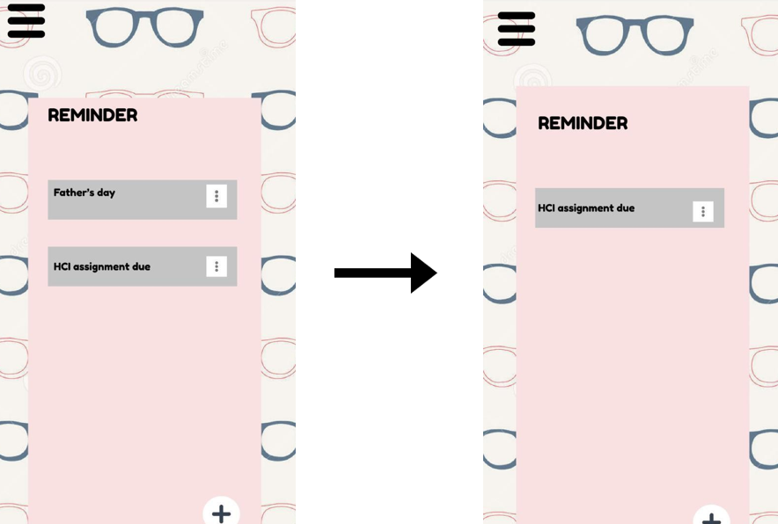 | 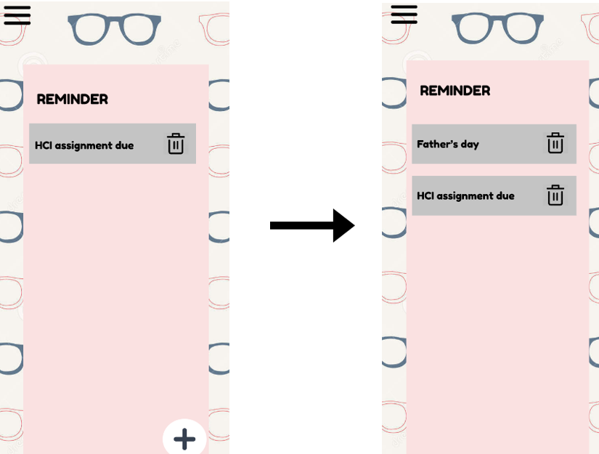
 | The previous reminder was missing when users wanted to add other reminders. This shows that the application does not accept more than one reminder hence it blocks the usability of the users.  H7: Flexibility  and efficiency of use.  S4: Catastrophic issue | On the reminder page, we had modified it so that every reminder will still be there as long as it is not deleted. This means that even if the users add any new reminder, the old reminder will still be saved and will only disappear when it is deleted by the users’ themselves.
3. | 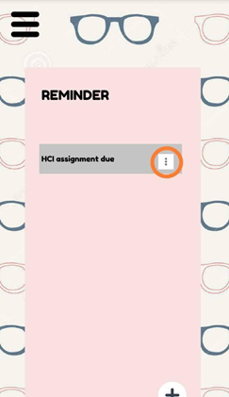 | 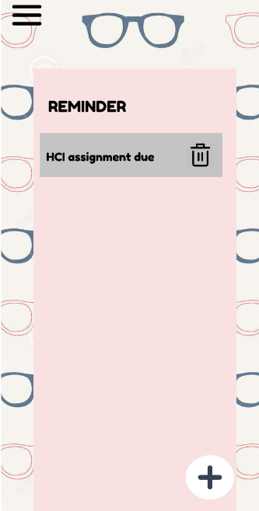
 | The triple dot button on the reminder page does not have any function and it can confuse the users especially for the first timers.  H7: Flexibility and efficiency of use.  S1: Cosmetic issue | The triple dot button in the previous prototype has been removed because it is a non functional key. A functional dustbin icon was replaced in order to let the users delete the reminder that they already completed or any unnecessary reminder whenever they want to.
4. | 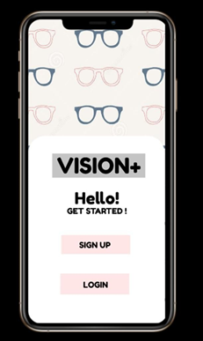 | 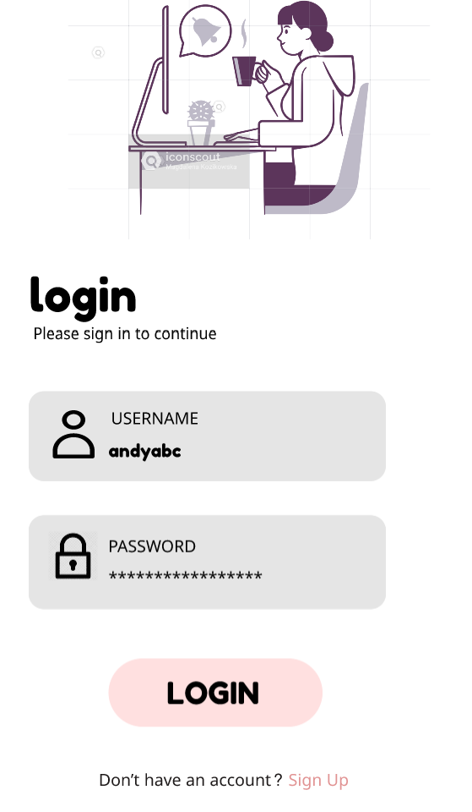
 | According to the Heuristic evaluation, this page is unnecessary to be displayed.  H7: Flexibility and efficiency of use.  S1: Cosmetic issue | The previous page has been modified to this one. It gives priority to the regular users to login the application. For first time users, they can find the “Sign up” button at the bottom of the “login” button if they do not have any account for this application yet.
5. | 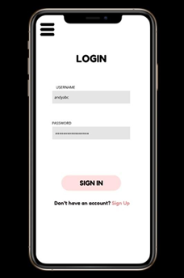 | 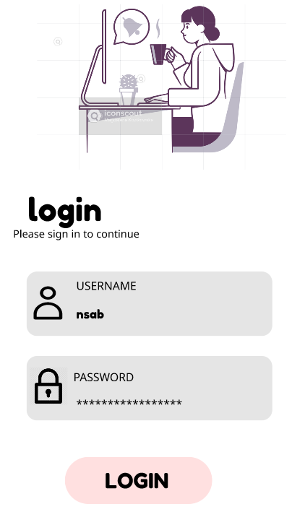
 | The security of the application is not working. The three line button still can be accessed by users without log-in or sign-in the application. This actually can harm the system from being invaded.  H7: Flexibility and efficiency of use.  S4: Catastrophic issue | Three line buttons have been removed to make sure the users log in or sign in the application first before using any features or any function keys of the application. This can ensure that all users who are using the application are authorized users.
6. | 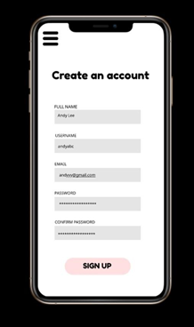 | 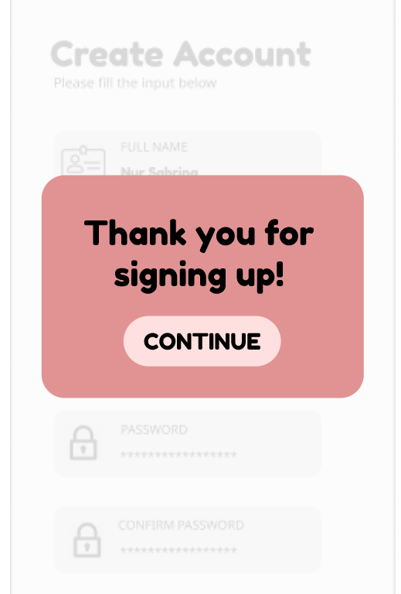
 | There is no feedback when users press the “SIGN UP” button. Hence, users can not make sure whether they already signed in the applications or not. Users will probably sign in the application a few times because of this matter.  H1: Visibility of system status  S2: Minor issue | The applications should give feedback to the users who just signed in the system. From the feedback, users can know whether they successfully signed in the system or not or else they will try to sign in several times until they get confirmation.
7. |  | 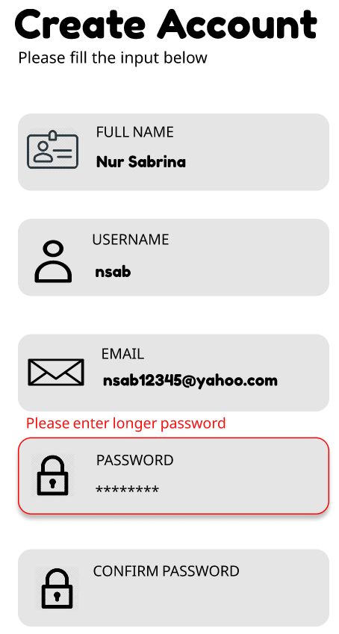
 | The application did not trigger and display any message when the user entered any data. The application should display a warning message if users entered wrong data in the space given.  H5: Error prevention  S1: Cosmetic issue | The application has been set to display messages when users enter wrong data. If users entered the password without following the terms given, the system will trigger and display an error or warning message to make sure users enter the correct data.
8. | 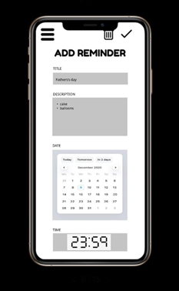 | 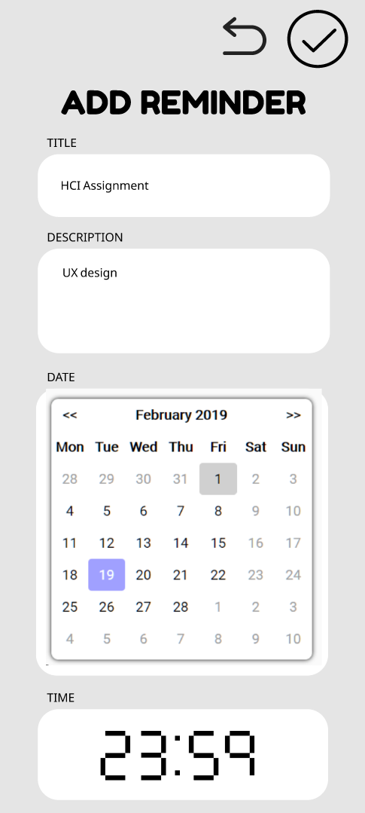
 | This page contains icons that can confuse users such as the dustbin icon. This icon actually does not have any function as it must be used after the users have set the reminders. Other than that, this page does not have a “return” or “back” button in case the users do not want to set any reminders.  H4: Consistency and Standards  S2: Minor issue | Dustbin icon has been removed to make sure users are not confused on how to use the system and the return icon has been added to ease the users’ tasks in case they do not want to set reminders.

