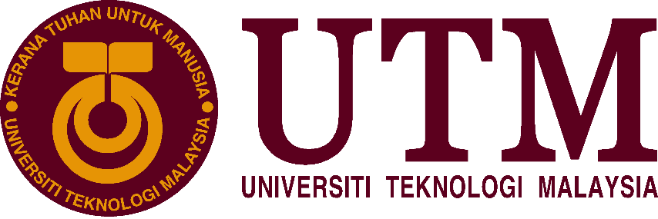

**SECP1513-02**

**School of Computing, Faculty of Engineering**

**Subject: Technology and Information Systems**

**Lecturer: Dr Aryati Bakri**

|  |  |  |
| --- | --- | --- |
| 1. |  | Name :Goo Ye Jui  Matric Number : A20EC0191  Phone Number : 018-4040438  E-mail : yjyejui626@gmail.com |
| 2. |  | Name : Kelvin Ee  Matric Number : A20EC0195  Phone Number : 011-21584699  E-mail : kelvinee2001@gmail.com |
| 3. |  | Name : Ahmad Muhaimin Bin Ahmad Hambali  Matric Number : A20EC0006  Phone Number : 019-4703276  E-mail : ahmad.muhaimin@graduate.utm.my |
| 4. |  | Name : Yong Zhi Yan  Matric Number : A20EC0172  Phone Number : 011-61284629  E-mail : zhiyanyong01@gmail.com |
| 5. |  | Name : Myza Nazifa Binti Nazry  Matric Number : A20EC0219  Phone Number : 010-9802910  E-mail : m.nazifa@graduate.utm.my |

**Alumni Sharing Session – Inspiring Work Experience and Covid-19 Pandemic Challenge**

December 29, 2020 – School of Computing in University of Technology Malaysia (UTM) has held an online webinar talk about alumni sharing sessions for students who are taking the course Technology and Information. This talk was conducted online through an application called Webex and the talk was about inspiring work experience and Covid-19 pandemic challenge. It was hosted by Dr. Johanna Ahmad and there were three UTM alumni present in the session as the speakers. The three alumni who were present were Tan Yong Keong who is currently working as a data science engineer for around a year and a half, Qistina Batrisyia who is currently working as a social media data analyst for a year now and lastly Mohamad Zamarul Akmal who is currently working as a data engineer. Each and every one of them are currently excelling in their own respective jobs and career. They delivered their talk by giving their own opinions and sharing their experiences based on the questions asked by Dr. Johanna Ahmad and also by the students during the Q&A session at the end of the talk.

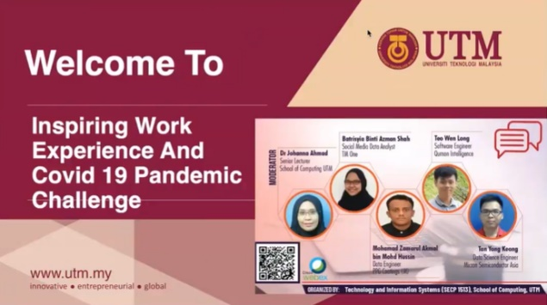

*Figure 1: Alumni Sharing Session Poster*

The purpose of this talk that was initiated by the lecturers of the subject Technology and Information is to provide exposure on the chances and challenges to secure a job in this pandemic since the Covid-19 pandemic has given a big impact on our country’s economy and this has affected a lot of people in many ways. For example, a lot of people have lost their jobs due to the unstable economy and getting a job during this pandemic is getting harder. With that, the lecturers hope that the students can use this sharing session as an opportunity to get as many tips and information on getting employed from their alumni to apply it in the future.

There were several important aspects and questions that were discussed by the alumni including the host regarding the work experience for future graduates during the talk. The first question that was asked by the host to the three alumni was how they managed to secure a job in this pandemic. With that, Tan Yong Keong shares that he managed to gain his internship during one of his competitions and that he had gone to participate in various competitions throughout his university life. By doing so, he was able to gain professional skills and also improve his presentation skills. He also did some freelancing to gain technical skills and highlighted that having good soft skills plays a big role in getting employed. However, for Zamarul and Qistina, they shared that the main reason they managed to secure their jobs was by being proactive during their internships. Zamarul says that he always exposes himself by giving his own opinions and that by proposing his ideas, his supervisors started to give him more attention. Meanwhile, Qistina shared that she always shows her efforts by joining various projects during her internship and the effort shown by her has caught her supervisor’s attention.

Next, the alumni were asked to give tips on increasing the future graduates’ chances on getting employed. They have shared that we should be using this opportunity to learn new technical skills by joining online courses and programs during this pandemic as there are a lot of resources available in the Internet. It is also important for us to improve our soft skills such as communication and teamwork skill by being more outgoing. Moreover, the alumni also discuss about how to gain confidence. All of the alumni agreed that gaining confidence can be learnt and trained by presenting and joining a lot of programs. The most important thing is we should not be afraid to speak out. Furthermore, they talk about the difference between study life and career life. Zamarul says that study life is more relaxing as we have a lot of free time compared to career life. He also said that we need to try and discipline ourselves more as there are more responsibilities that we have to carry during our career life.

After that, the alumni answered some questions from the students. One of the questions asked was how to stay motivated on a daily basis. The alumni shares that we need to love what we do and also have a good mindset such as thinking that we are going to make a difference and that we are making something new to help people. Before ending the session, the alumni answered a few more questions about their hobbies and CGPA needed. The host then asked them to share their last words and thanked the alumni for sharing their experiences to the audience.

The speech delivered by Tan Yong Keong, Qistina Batrisyia and Mohamad Zamarul Akmal were very informative and helpful especially for future graduates as they have covered a lot on their working experiences from every aspect. The talk made us grasp on the importance of gaining skills to secure a job especially during this poor economy due to Covid-19 pandemic. This educative talk will open the student’s eyes on the difference of the working environment compared to what they are going through now. Overall, this talk has given us a lot of new beneficial information and knowledge that can be applied in our daily lives now or in the near future.

“These alumni sharing session has really opened my eyes on the importance of having great communication and teamwork skills in the working environment. The talk has made me realised that only being book smart will not help much on securing a job but being proactive and having the right attitude will help us in the long run as most companies especially the private sectors will mostly look on our soft skills compared to our CGPA. By attending this seminar, my motivation to improve myself into becoming a better and high-skilled student has increased and it also motivated me to try and become more sociable and braver to speak out as I am a shy person. However, the only flaw I can say about the webinar is that I hope that there will be more alumni that can share their experiences and that the session will be longer as I would love to hear more various experiences. All in all, I think this talk is very helpful and I enjoyed listening to the alumni’s experiences.” said Myza Nazifa, a first-year student of Data Engineering.

“From this sharing session, I’ve gained a lot of new important information about the future career looks like. Other than that, this sharing also gave me the motivation for pursuing this course. Next, I got to view other people's perspective on how to be a successful student. CGPA is not the only thing that defines a successful student and a failure. There is a lot of factors that must be count in before determining success. The soft skill also very crucial nowadays, since we have a lot of students that were very good in academic but some of them didn’t obtain good generic skill making them hard to get a good job. I enjoy the talk a lot.” said Ahmad Muhaimin, a first-year student of Data Engineering.

“From this sharing session, it really highlights what and how you should play your part in both study life and career life. Those information are very precious for us who are still in study life and will be stepping in to career life soon in the next few years. This session really motivates me to participate in more programs that allows me to build up my softskills and confidence. I can see that both of them are the one of the key of employment these days. It’s unfortunate that we couldn’t meet the alumni during this COVID-19 pandemic, it would be great to attend it offline and feel the vibes. All in all, I still enjoy all the informations and experiences shared by the alumni online. All of them were priceless to me and my future path. ” said Goo Ye Jui, a first-year student of Data Engineering.

“Throughout the sharing session given by the UTM Alumni, I have gained opportunity to learn new technical skills by joining online courses and programs during this pandemic as there are a lot of resources available on the Internet. I knew that it is also important for us to improve our soft skills such as communication with people and teamwork skill by being more outgoing. The most important thing is we should not be afraid to speak out. This session really inspires me to participate in more programs that allows me to build up my soft skills and confidence for my future career. However, it is unlucky that we could not have the chance to face-to-face meeting with the UTM alumni due to the Covid-19 pandemic. I enjoy the talk a lot and looking forward for next sharing session.” said Kelvin Ee, a first-year student of Data Engineering.

“From this sharing session, I had a great opportunity to know deeper regarding the working life in IT sector. As a student, we mostly focus on our academics, trying to score as high as possible for our examinations. However, the reality is in one’s career life, a good grade is merely just acting as an additional mark, instead soft skills such as communication skills, team-working skills, leadership skills and critical thinking skills are what the employers look for. Therefore, during my university life, I need to improve all my soft skills by participating in different kinds of activities, get to meet more people in order to train my communication skills as I am quite an introvert. In the nutshell, I am grateful to attend this sharing session which really opened my eyes and gave me an insight on my future career path.” said Yong Zhi Yan, a first-year student of Data Engineering.