

*JANUARY, 6 2021*

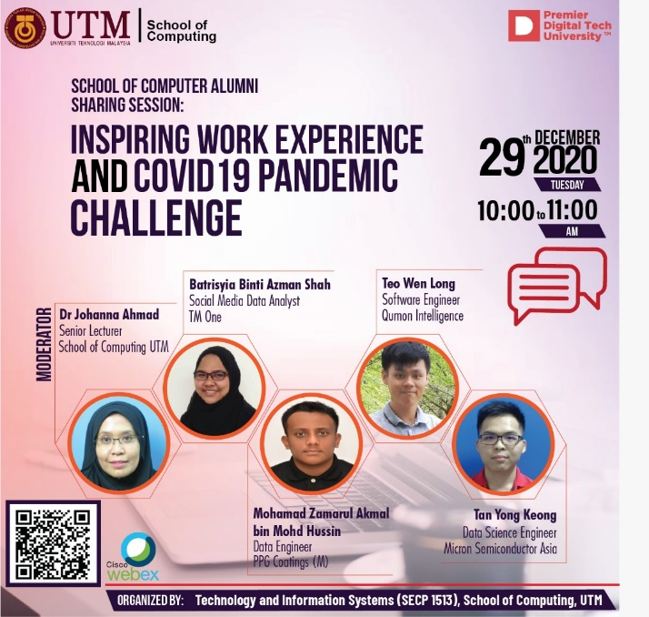

This talk has been held on December 29, 2020 and Puan Joanna Ahmad as the moderator. The topic of the talk is about the Inspiring Work Experience and Covid-19 Pandemic Challenge. The talk invited four alumni from School of Computing, UTM as speakers which four of them just graduated in the year of 2020. Unfortunately, one of the alumni has not attended the talk due technical issue. All of them are successful now with their own career.

The first speaker is Tan Yong Keong which graduated as software engineering student in 2019. Currently, he is a data science engineer in Micron Semiconductor Asia. The second speaker is Qistina Batrisyia binti Azman Shah. She graduated in data engineering and now as a social media data analyst in TM One for almost one year including her internship. The last speaker is Mohamad Zamarul Akmal bin Mohd Hussin who currently working as data engineer in PPG Coatings (M) Sdn Bhd. He is a fresh graduate from data engineering student.

In the talk, we can see how these people manage to secure your job, gain their confidence and stay motivated. They share some tips to increase chance of getting hired and how to improve and love programming.

The purpose of the talk was to hear the experiences of these graduates on how they got the job and how they become successful in their career. Furthermore, they shared their method of how they maintain their work as an employee due to covid-19 pandemic. Moreover, they also share tips on how to manage their time between curriculum and studying when they were students. In addition, they also share how do they manage to concentrate in their career. The session was important so students are able to be motivated in their studies during this pandemic period as well as to motivated the student’s spirit to focus on their studies to ensure their futures and follow their dream jobs in the future.

The session started off with self-some introductions from the alumnis and hear their current positions etc. The first question asked by the moderator was “How did you manage to secure your job?”. YK(Yeong Keong) talked about during his life in Universities he entered a lot of competition and gained achievements which also enhances his soft skills. He also did freelancing during his free time and he got an internship at a big company which lead to his current job. Thereafter Zamarul talked about how he secured his job because he was active during his day as an intern and a proposal for the company’s project. Qistina also says she was active as an intern by giving ideas and participate in projects.

We moved on to the next topic which was tips to increase chance of getting hired. We had Qistina to start off with the question. She talked about being good in programming language. Mastering a programming language will increase the chance of us getting employed and also during her intern, she was active and always interact with people. We should not limit ourselves and ask people if we don’t understand anything. We had Zamarul to continue off with question. He suggested that we join in e-learning courses online to get extra knowledge. There are free ones that we can join and may get certificates for a price.

Right after that, Puan Joanna opened the Q&A session with the alumni.   
“Do we need to succeed in competitions?”.Response from Yeong Keong “Losing in a competition does not mean we lose. We win in terms of experience and knowledge that we get.”  
“How to stay motivated?”. Again from Yeong Keong, he wants to contribute to the his country which is key to his motivation.  
“How does the company treat you?”. Zamarul explained his experience where he is treated as an employee and a as a friend.  
“Work as a media analyst?”. Qistina explains her job where she analyses user engagement example click-through and bounce rates and reporting on the web traffic for all social media.

The talk had a great insight on how we can improve ourselves especially during university so that we would have a better chance on landing a job. They talk about being proactive and participate in a lot of competitions to improve our soft skill which helps big time with getting a job. The speaker can also relate to the student because they’re still fresh graduates and are able to share a little bit about after graduation. However, the weakness is probably that the talk has alumnus who got jobs as soon as they graduated. Hearing the side of only successful alumnus could be slightly one sided because we don’t get to know how it would be like if we didn’t strike a job right after graduation. Lack of explanation is also something that can be consider as weakness where the speakers did not explain in detail about their experiences during internship and work.

**Put your reflection here(erase this later)no. 2 from rubric**

**REFLECTIONS**

To summarize the talk, landing a permanent job is hard these days because it is required that you have competent soft skills because communication is key in business. It was mentioned that being highly active university and joining competitions can improve soft skills as well as make connections. The networking between other people is important and the experience that comes with being in the competitions can help to possibly secure you a job.

Internship are always good since it exposes you to how things work in the industry, as mentioned by the speakers as well as contributing ideas during the internship increasing rate of employment. As a software engineer, learning a new language can be challenge but we are advise to understand the concept as that are the fundamentals. Programming Languages are all different but the fundamental concepts are all the same.

Being motivated is also very important especially during this pandemic. Having the right mind set is important as that what affects your motivation. Look forward to new things to learn in the upcoming future as a fresh graduate.

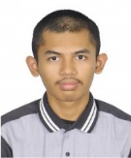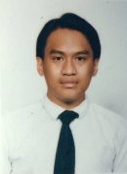

From left to right: Harun, Amirul, Jeevan, Muiz, Syamimi