Industrial Exhibition Report– NALI Symposium 2019

Subject : Technology and Information Systems (SECP1513)
Section : 07
Lecturer : Dr. Sarina binti Sulaiman

Group 9
Members:
- Chai Ming Choy (Leader)
- Wan Nur Atiqah binti Junaidi
- Goh Jo Ey
- Zaimi Mohamed
- Ramadhan Muhammad Jumantoro

- INTRODUCTION

New Academia Learning Innovation (NALI) 2019 is an exhibition that promotes a new framework of teaching and learning. This event was held at the FABU UTM Johor Bahru. The objective and purpose of this event are : To recognize NALI research and innovation in teaching and learning through exhibition and competition, To be a platform for sharing of research and innovation in teaching and learning, To enhance educators competency in practicing teaching and learning in the 21st Century through NALI workshops and also to enhance STEM awareness among educators in practicing NALI.

- DETAIL OF THE WORK PLAN

First of all, the visit to the event started at 10:00 a.m from a quick forum that explains the space area.
Then the tour started on the booths below in the table :
Holoread (Learning via pyramid hologram)
Automobile Virtual Reality Module (AVRM)
Non-conventional L&T strategies in Soil Mechanics course
PBL through Agro-STEM
Smart Mini Town Game
The Periodic Table Games for Interactive Learning in Chemistry
Pneumatic Projectile Motion Kit
The Game About Mathematical Battle Innovative Thinking (GAMBIT)
Clino Trimeter
Augmented Reality Plan and Elevation (ARPE)
Snazzy Sets Game Cards
Invisible Confusion: Infrared Spectral (IR) Interpretation

The happening was supposed to end at 4:30 p.m, But our journey ended at 10.30 a.m due to us having classes at 12:00 p.m.

- TRAVEL DETAILS

We walked to the convention hall of the Faculty of Built Environment and Surveying (FABU) after our morning class around 10.00 a.m.. The distance between our faculty and Fabu is about 1 km. Some people who are not from our university came to the event by car or bus (Private Vehicle) and parked their vehicles in the parking space provided. Maybe students from our university can take a walk or use Buses that have been provided. It takes around 20 minutes from School of Computing campus with walking and maybe around 10 minutes by taking the bus.

- POSTER EXPLANATION
POSTER 1: PNEUMATIC PROJECTILE MOTION KIT
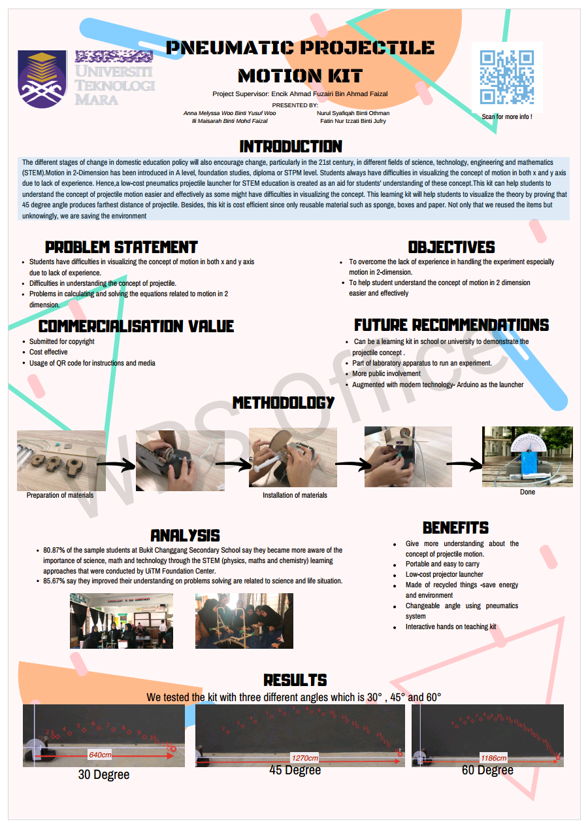

- Exhibition Content

- Needs: What are the client's needs?
Firstly, the students having difficulties in visualizing the concept of motion in both the x and y-axis due to lack of experience in answering that type of question. Secondly, they are having difficulties in understanding the concept of projectile which they couldn’t get the view on how projectile motion actually works. Lastly, they are having difficulties to answer the problems in calculating and solving the equations related to motion in 2-dimension (2D) due to the confusion which equation to use for which type of question.

- Approach: What is their compelling solution to the specific client’s needs?
Due to many difficulties in understanding the concept of projectile motion, they did a kit to help the students and giving experience to them especially in 2-dimension (2D). Thus, students could understand the concept of motion in 2-dimension (2D) more easily and effectively.

- Benefits: What are the client benefits of their approach?
The kit is portable and easy to carry which wouldn’t burden the students. Secondly, the kit uses low-cost projector launcher thus it would be affordable for the students to buy the kit. It is also made of recycled things that save energy and the environment (environmental-friendly). Other than that, the students can easily change the angle by using pneumatics system. With their help, the students could have more understanding of the concept of projectile motion because of the interactive kit (hands-on activity).

- Competition/Alternatives: Why are their benefits significantly better than the competition?
Firstly, it is submitted for copyright purposes in which preventing anyone from plagiarising their innovation. The kit is also cost-effective as it helps students for better understanding and not just fully memorize the equations and the concept as well as it’s not too costly for students to buy the kit. Lastly, usage of QR code for instructions and media for the kit can reduce the amount of paper used in order to print the instructions paper. Plus, this kit is towards the environmental-friendly approach which they only uses the materials that they have at home (recycled things).

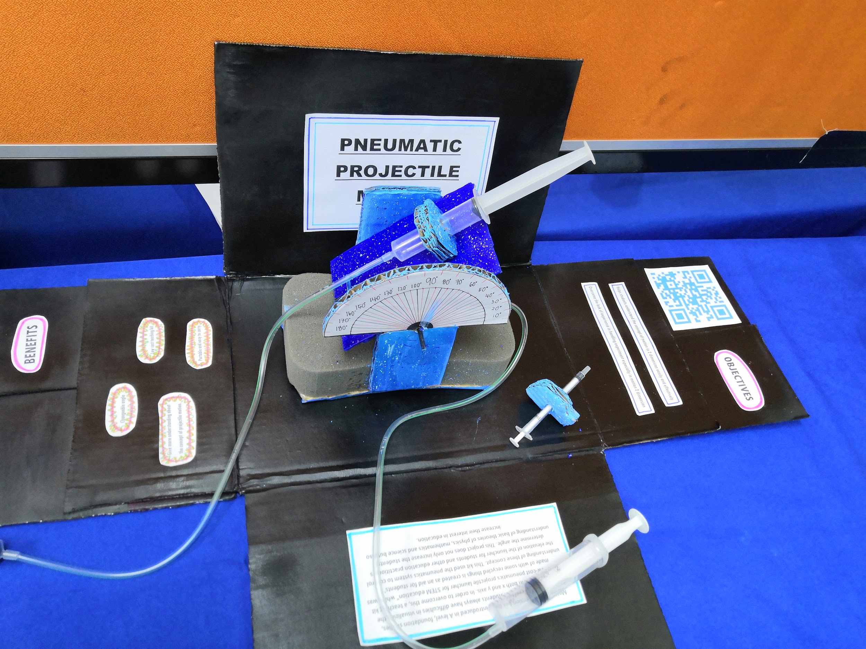

POSTER 2: THE GAME ABOUT MATHEMATICAL BATTLE INNOVATIVE THINKING (The GAMBIT)

1. Exhibition Content
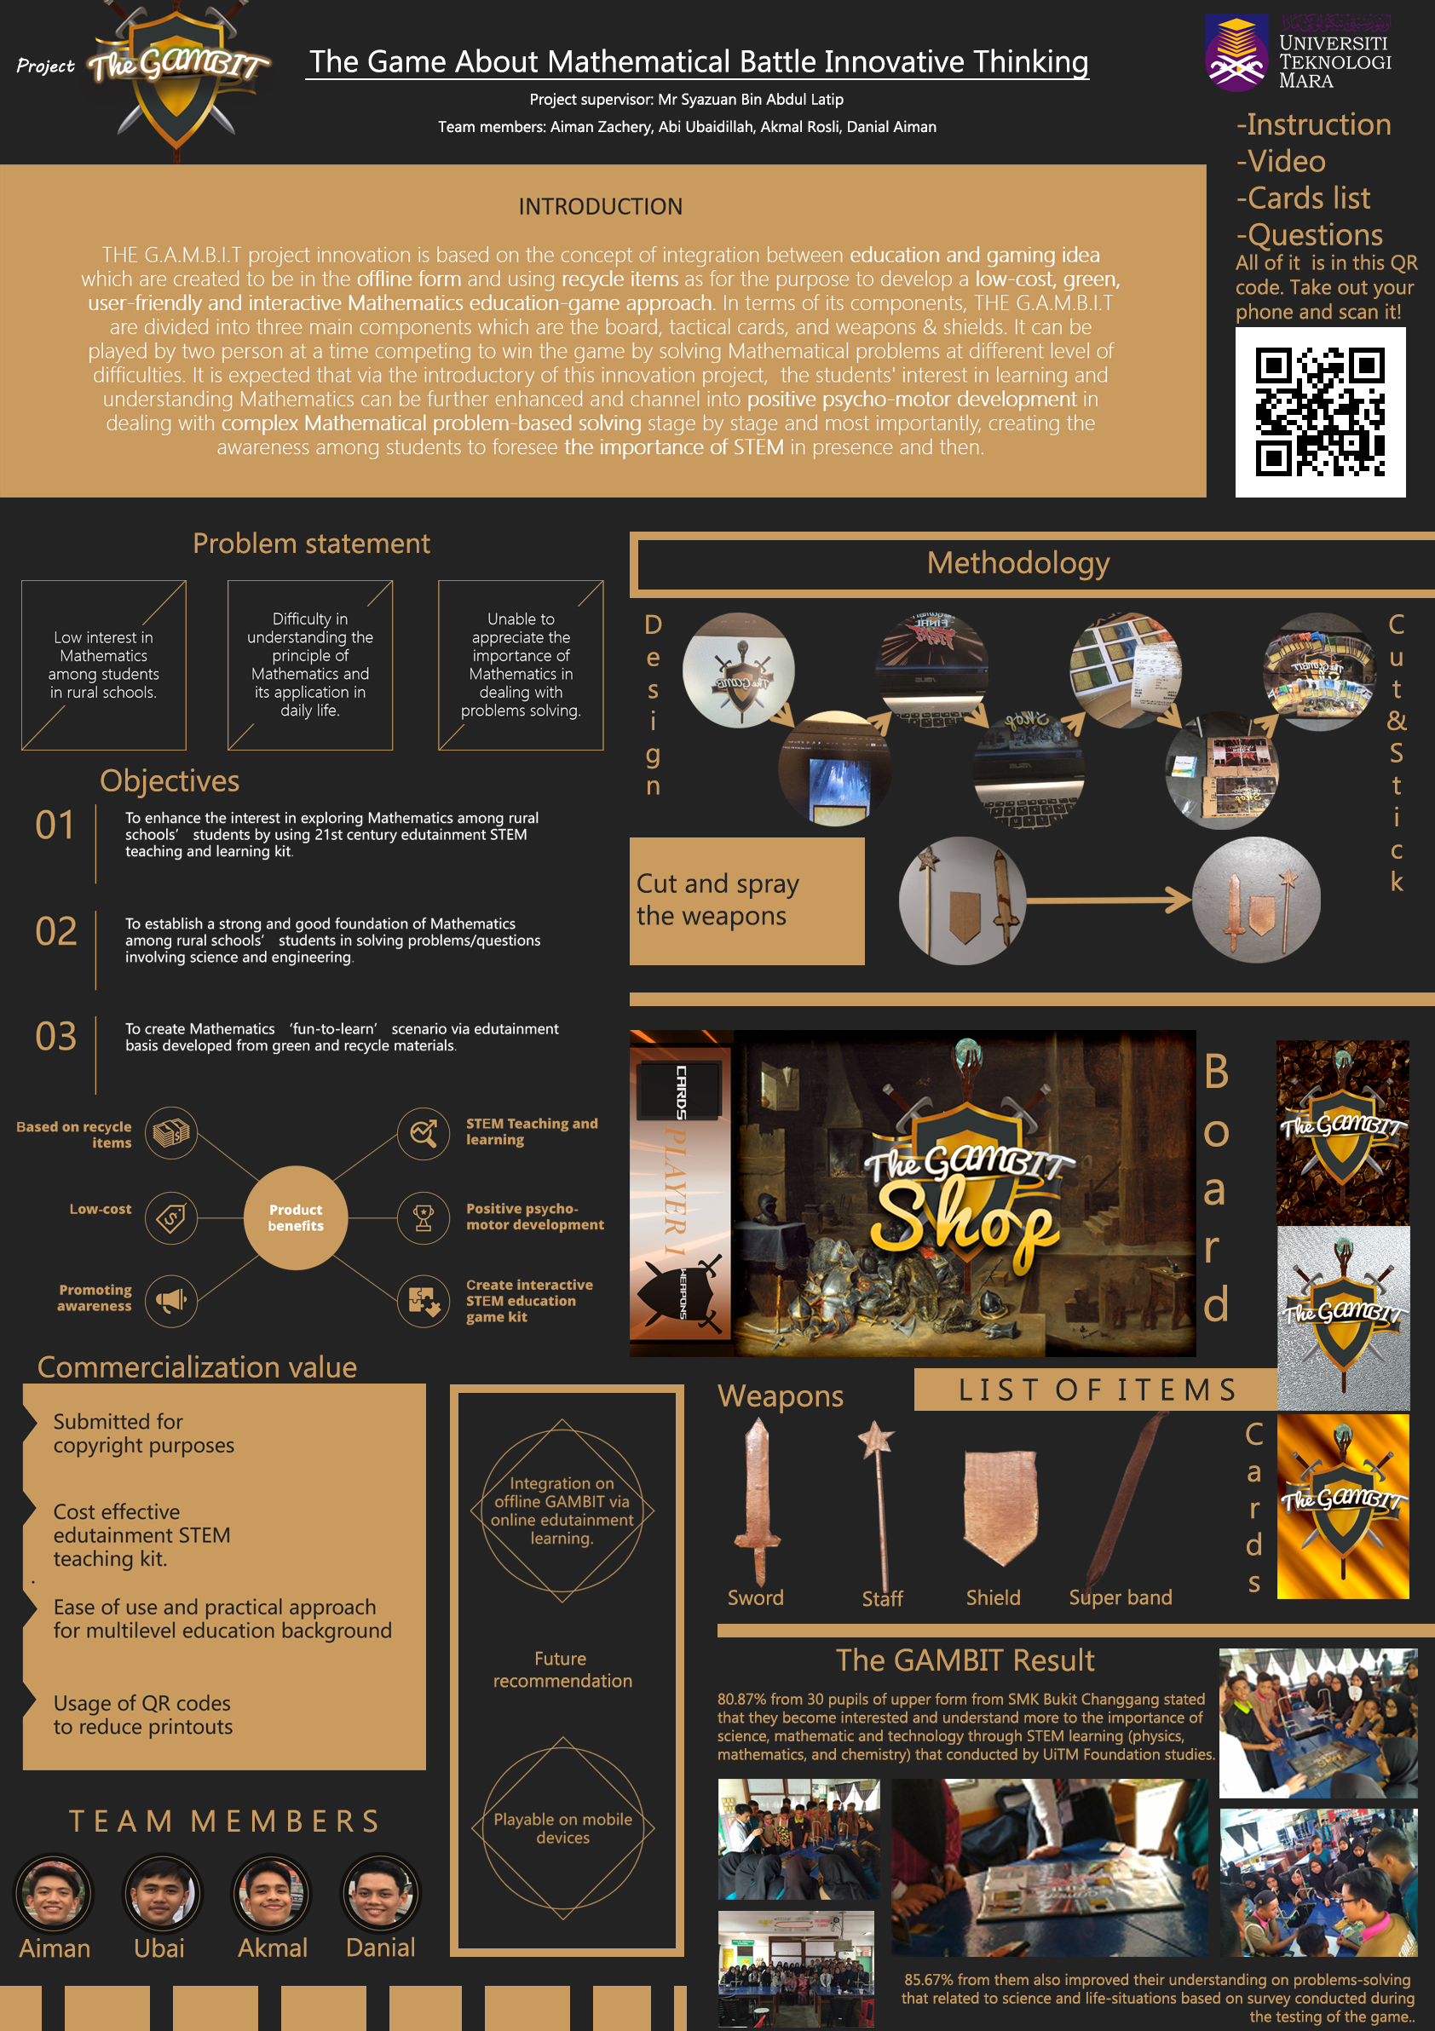
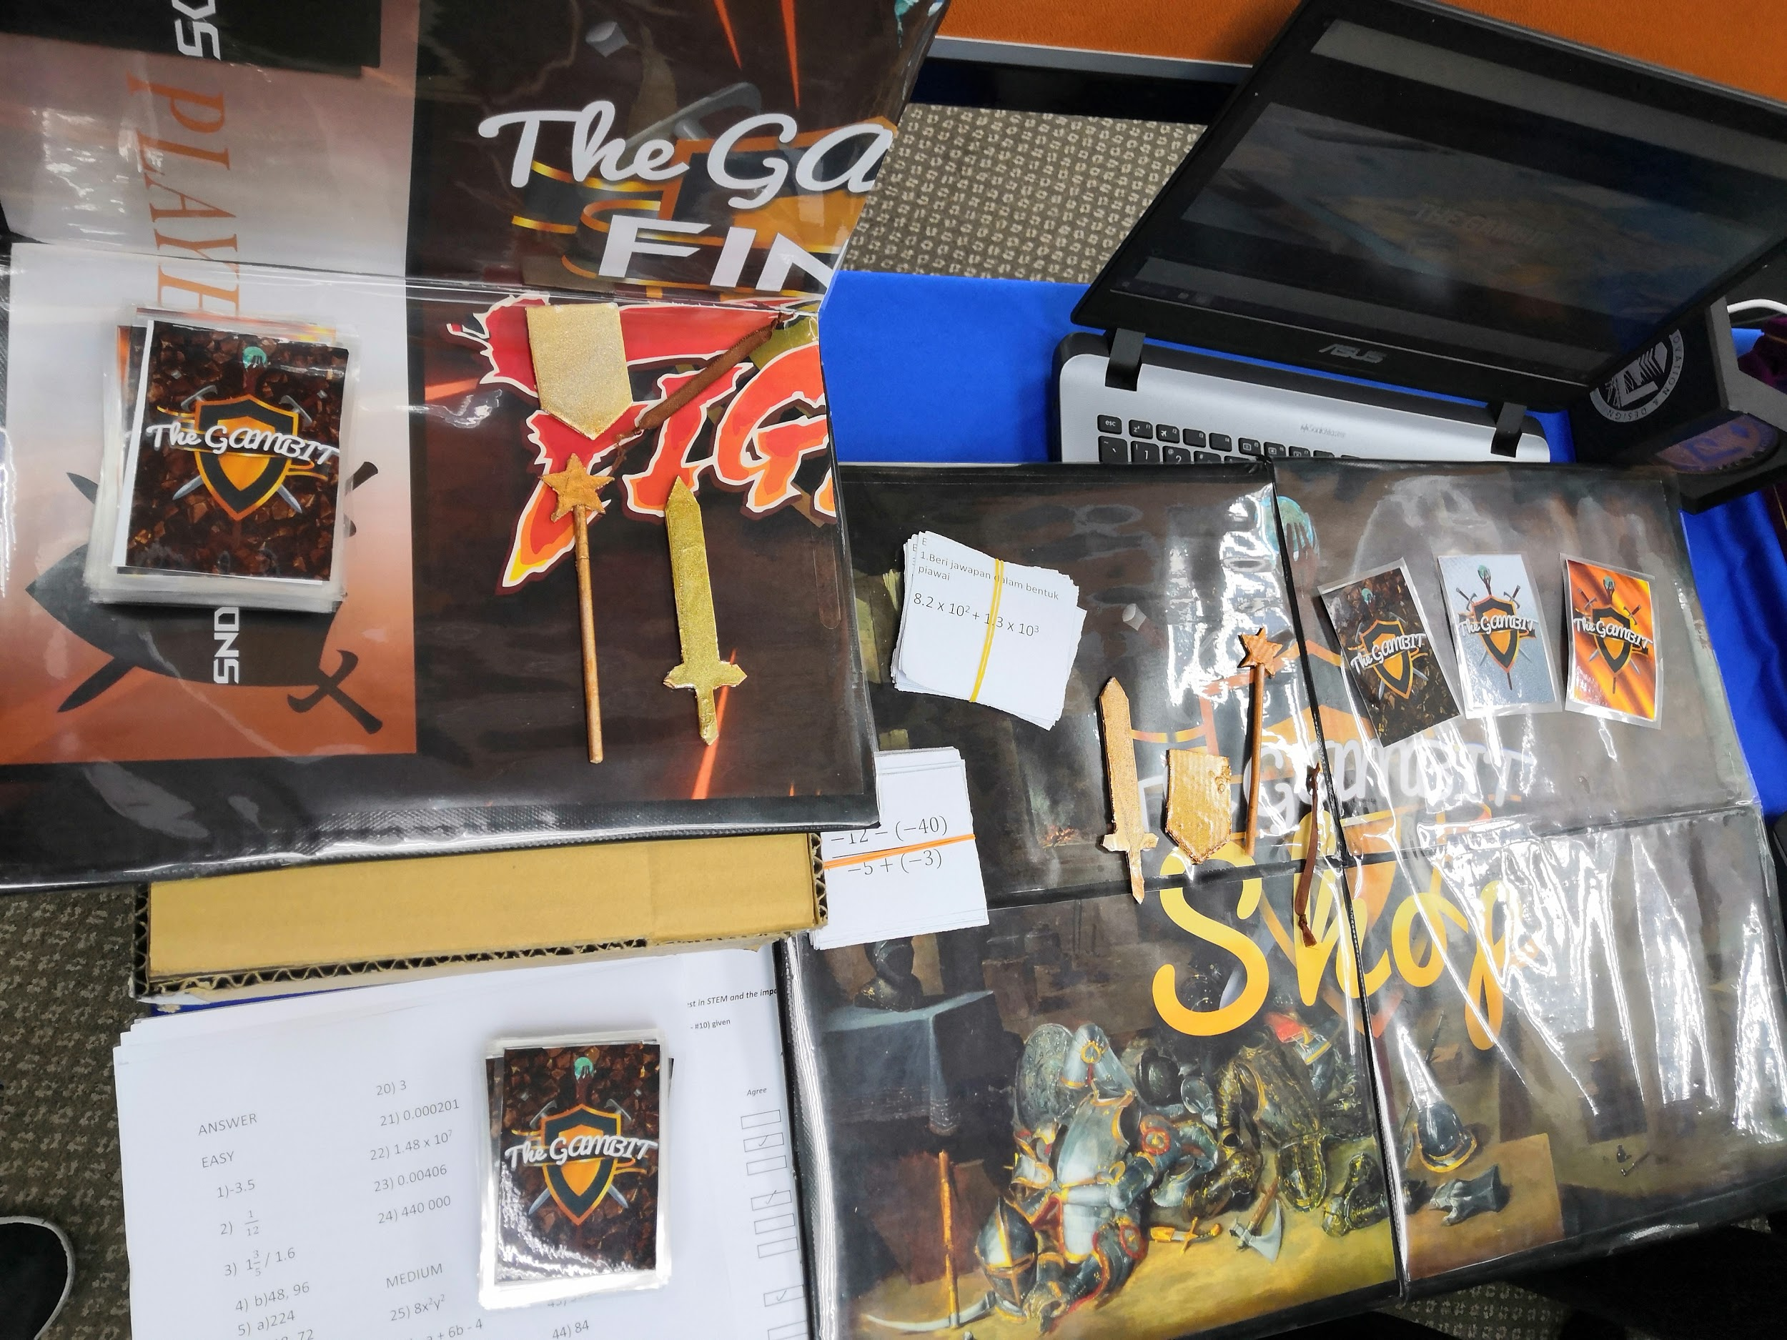

- Need: What are the client's needs?
There is a low interest in Mathematics among students in rural and city schools. Low interest might cause difficulty for students in understanding the principle of Mathematics and its application in daily life. When the students have low interest and do not have enough understanding of the principle of Mathematics, they are unable to appreciate the importance of Mathematics in dealing with problem-solving in their daily life.

- Approach: What is their compelling solution to the specific client need?
This innovation is made to enhance the interest in exploring Mathematics among rural and city school students by using 21st-century edutainment STEM teaching and learning kit. This project is also made to establish a strong and good foundation of Mathematics among students in solving problems or questions involving mathematics, science, and engineering. Lastly, this kit is also made to create Mathematics ‘fun-to-learn’ scenario via edutainment basis developed from green and recycled materials.

- Benefits: What are the client benefits of their approach?
The game kit’s materials and equipment are made from recycled items, which makes it cost-effective compared to other creative learning methods. This project can be also used to promote the awareness of the importance of learning mathematics and problem-solving skills to our daily life. In addition, STEM Teaching and Learning can also be promoted among school students in order to make them more skilled and knowledgeable in the field of science, technology, engineering, and mathematics. The game also creates a positive motor development among students, which is a type of progressive attainment by the child of skills that involve both mental and muscular activity. Lastly, this game also helps create interactive STEM education game kit trend among schools which helps to make learning and teaching more interactive and fun activity.

- Competition/Alternatives: Why are their benefits significantly better than the competition?
There are a few reasons why this game kit is significantly better than its competition. First, this game is submitted for copyright purposes to prevent any plagiarism issues and also to secure the idea of making learning mathematics fun and interactive. Next, this game kit is also a cost-effective edutainment STEM teaching text, which enables students to entertain themselves while not needed to face text-form paragraphs or books which is not interactive. Other than that, this game kit is also easy to be used and can be considered as a practical approach to students for multilevel education backgrounds. Lastly, the usage of QR codes in the game kit in order to reduce the amount of printouts which will waste paper or other materials makes this game kit a more environmental-friendly approach compared to the other learning method which requires paper.

POSTER 3:The Periodic Table Games For Interactive Learning In Chemistry

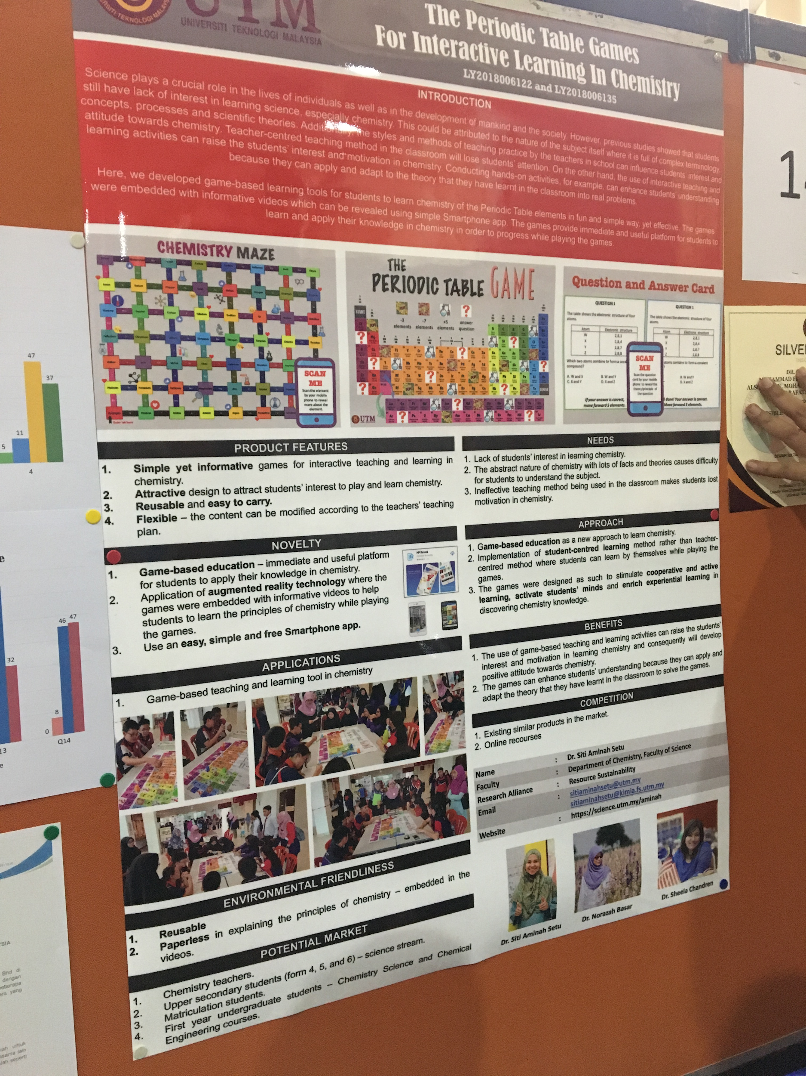

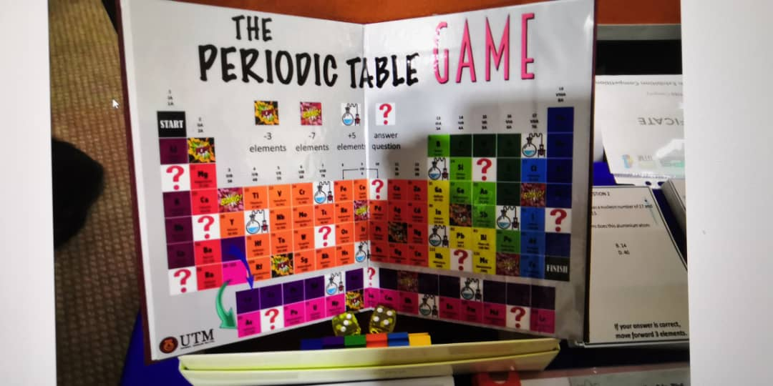
- Exhibition content
- Need: What are the client's needs?
In school, it is the table that should be memorized by the science stream student. Since students need to memorize this huge amount of information from the periodic table, students may start to feel bored and lack of interest in learning chemistry. The periodic table consists of 118 elements and arranged with its chemical properties. It contains abstracts nature of chemistry with lots of facts and theories cause difficulty for students to understand the subject in a short time. In the traditional teacher-centered teaching and learning method, the teacher retains full control of the classroom and the activities which will lead to a student lost their motivation in chemistry as a student cannot express themselves and ask questions during the lesson.

- What are their approaches to their clients?
“The Periodic Table Games For Interactive Learning In Chemistry” is a game-based education as a new approach to learn chemistry. Students can learn the periodic table through games such as “Chemistry Maze” and “The Periodic Table Maze”.Through the “Question and Answer Card” activities, students are divided into few groups and each group finds the answer before the presentation. After the time given by the teacher, each group presents their questions and answers. The game consists of all of the information about the periodic table. The main objectives of this convert traditional teacher-centered teaching and learning method to student-centered teaching and learning method. Student-centered learning methods more focus on students’ understanding and opinion. Students are not longer as a listener in class, they can discuss the topic together and ask the question about the lessons immediately. This makes students’ mind not to wander during the lesson. The game also designed as such to stimulate cooperative and active learning, activate students' minds and enrich experiential learning in discovering chemistry knowledge. Students also can improve communication skills and build a spirit of cooperation.
- What are the client benefits of their approach?
With this innovation, students can easily memorize the element in the periodic table through “The Periodic Table Maze”. Students play a more active role in this concept as they will cooperate with their teammates to complete the task given. It enhances students' understanding as they can apply and adapt the theory that has learned in the classroom to solve the game. The use of game-based teaching and learning activities can raise the student interest and motivation in learning and chemistry and consequently will develop a positive attitude towards chemistry.
- Why are their benefits significantly better than the competition?
Although there are a lot of online resources or similar products in the market that promotes the same concept, “The Periodic Table Games For Interactive Learning In Chemistry” is better than others as it creates a fun and interesting environment yet effective in learning chemistry. It is also an environmental friendliness innovation as it is reusable and paperless in explaining the principles of chemistry by embedded in the videos instead of photocopying all of the information about the periodic table. Teachers also can modify the content according to their teaching plain. teaching method is the main factor that influences student interest and attitude towards the subject. With its flexibility of content, it is more convenient for most of the teachers.

5. Trends in NALI

New Academia Learning Innovation 2019 (NALI 2019) is the model introduced in 2013 in the “Akademia Baru Inovasi Pembelajaran” book. Blended learning mode, student-centred learning, multiple learning modes and materials towards achieving entrepreneurial academia are the concepts that advertise in NALI. Student-centred learning is the concept that students and teachers interact equally. This type of learning is not just focused on teachers. Students and teachers share the focus. Students may be divided into small groups to discuss a certain topic and make a presentation. Students can learn communication skills and improve students’ engagement through group work. Blended learning mode is the combination of face-to-face learning and online learning method. As people nowadays are not surprised to hear E-learning, BLOSSOMS, and any learning through the internet, all of these are categorized into digital learning. Any interactive teaching and learning can be done through digital learning. For instance, the forum in the E-learning provides the opportunity for the student to speak out their opinion and asks the questions about the topics. Otherwise, students can scan the QR code given by the teacher to access any program or activities. Students can gain knowledge by completing the task given. It can prove that students will pay more attention to digital learning mode as it is interesting and fun. Therefore, in NALI 2019, new learning innovation is promoted which contains all these new learning styles and elements. All these innovations which make use of new teaching or learning methods are to be improvised and suggested in NALI exhibition in order to let lecturers and students able to explore more and more ways in learning and also teaching by the usage of different innovation and technology.

6. General : Motivation and insights on how innovation is used in teaching and learning
Since the new era has begun, the ways of teaching and learning are also not limited to the traditional ‘chalk and talk’ method, which is usually done by lecturers or teachers. In my view as a student, I think that we should make use of our modern innovation and technology in education in order to enable us to learn better, and at the same time, making learning a fun and entertaining process. Through this NALI exhibition, this experience has widened my view and perspective about obtaining knowledge and learning through innovations. There are many approaches that can be made in learning in order to make learning a fun experience for the students or for the lecturers. Some examples of new innovations in learning are playing cards or board games, augmented reality module (AR), virtual reality module (VR), real-life model and also by using some online applications. Some of the innovations are shown in this report such as the Pneumatic Projectile Motion Kit, The Game About Mathematical Battle Innovative Thinking (The GAMBIT) and also The Periodic Table Games For Interactive Learning In Chemistry. All these are new approaches for students to learn, whether through answering questions for the card and board games or by applying the principle that they have learnt by using the module or kit built or suggested. All of these actions or interactive based learning methods will require students to conduct experiments on their own or interact with people while learning. This can help students to remember or learn even better as they will remember about the theory or facts even clearer and better when action is applied during the learning process. In addition, these methods will be more interesting and easier to understand than the ordinary teaching method which will make it more effective to create enthusiasm and motivation in students due to its creative and innovative element. These motivations and enthusiasm in students are essential in order to let students build up the foundation for their knowledge in the specific subjects. These will help the students to further improve themselves in their respective subjects. The digital resources such as UTM e-Learning, UTM-MIT BLOSSOMS, UTM OpenCourseWare (OCW) and more should be really well used by the students. This will ensure that students can get benefits from this type of learning. Through the different modes of teaching and learning that introduces in NALI, different qualities can be developed among students such as leadership, communication and collaborative plus creativity. In a conclusive note, NALI is an important framework that should be practiced in the education system.

7. Students’ Feedback:
General:
One of the most attractive things in NALI are the different types of creative innovations and the new fresh methods of learning. On the other hand, nothing is perfect in this world, the event itself had some inconveniences like the space was messy and crowded to a certain point but the overall decoration was acceptable. Also, the date and time were killer points to the event because it was held in a week-day and at working hours which made it difficult for us to be there and classes at the same day.
Suggestions:
By finding a more spacious hall and also to make the lighting better. Also make some manual instructions to show layout or position of the booths.
Students’ Words:
“Overall, the idea and innovation there really inspired me on many different and creative ways to learn other than the traditional methods” by: WAN NUR ATIQAH
“The innovation are interesting and fun, the forum in NALI quite impressed me as learning is not only limited in a classroom” by: GOH JO EY

8. Task for Each Members

Members | Task
Chai Ming Choy | Divide and distribute work, One poster section including a picture of the poster, Exhibition contents, Motivation and insights on how innovation is used in teaching and learning (your REFLECTION)
Goh Jo Ey | One poster section including a picture of the poster, Exhibition contents, Motivation and insights on how innovation is used in teaching and learning (your REFLECTION)
Wan Nur Atiqah | One poster section including a picture of the poster, Exhibition contents, Motivation and insights on how innovation is used in teaching and learning (your REFLECTION)
Zaimi Mohamed | Title, Graphical interface, Introduction, Detailed Journey/Work plan, Detailed Descriptions, Travel Details, Overall Design
Ramadhan Muhammad Jumantoro | Detailed Journey/Work plan, Detailed Descriptions, Travel Details
All | Check overall report

9. Conclusion

We as students have learnt a lot of things through the NALI exhibition and it has greatly benefited us in terms of knowledge and information about new innovation in learning and teaching. It has widened our view on the different perspectives and methods in learning things, which is not just limited to the classroom or lecture hall learning. The technologies used in the innovation shows that how much technology and information system has evolved throughout the years and it can be applied perfectly in education in order to make education or learning a fun and interesting process for students and a wonderful teaching experience for lecturers and teachers too. In a clear and positive note, we can see that the future of teaching and learning is very diverse and will surely make the learning experience of future students better and enable students and lecturers to be passionate and have more interest in both teaching and learning.

